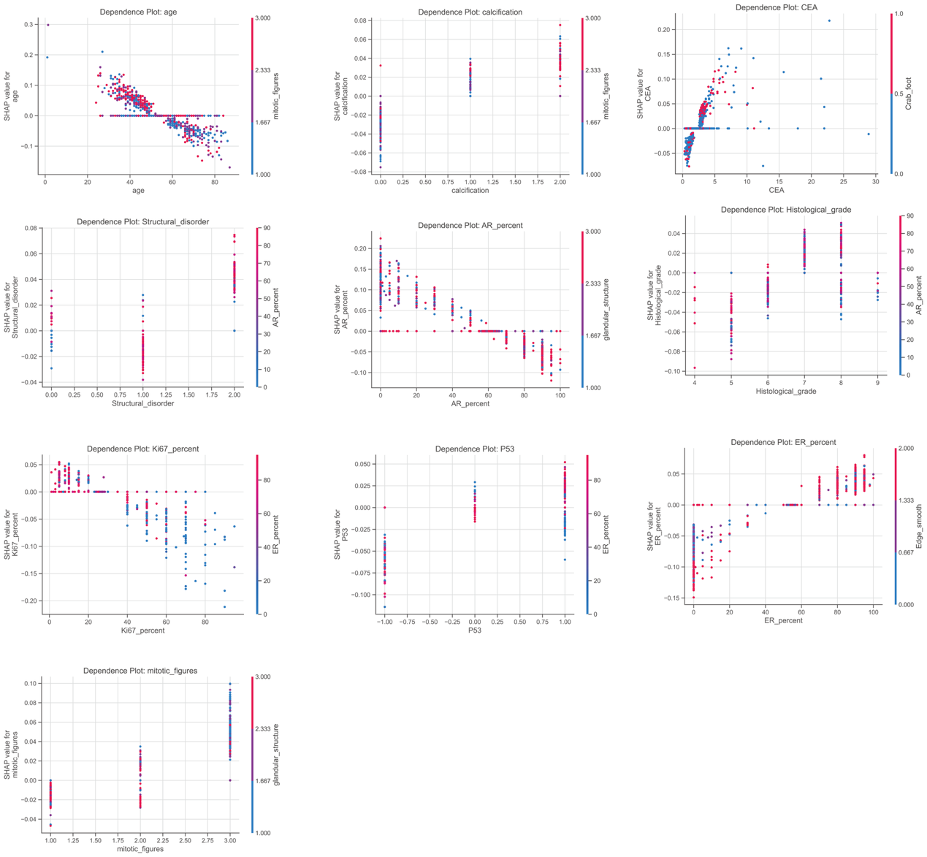
Supplementary Figure S6. SHAP dependence plot with interaction showing feature effects on SLNM risk.
The plot illustrates interactions between variables and how individual features contribute to the model predictions, aligned with the SHAP-derived feature effects.

