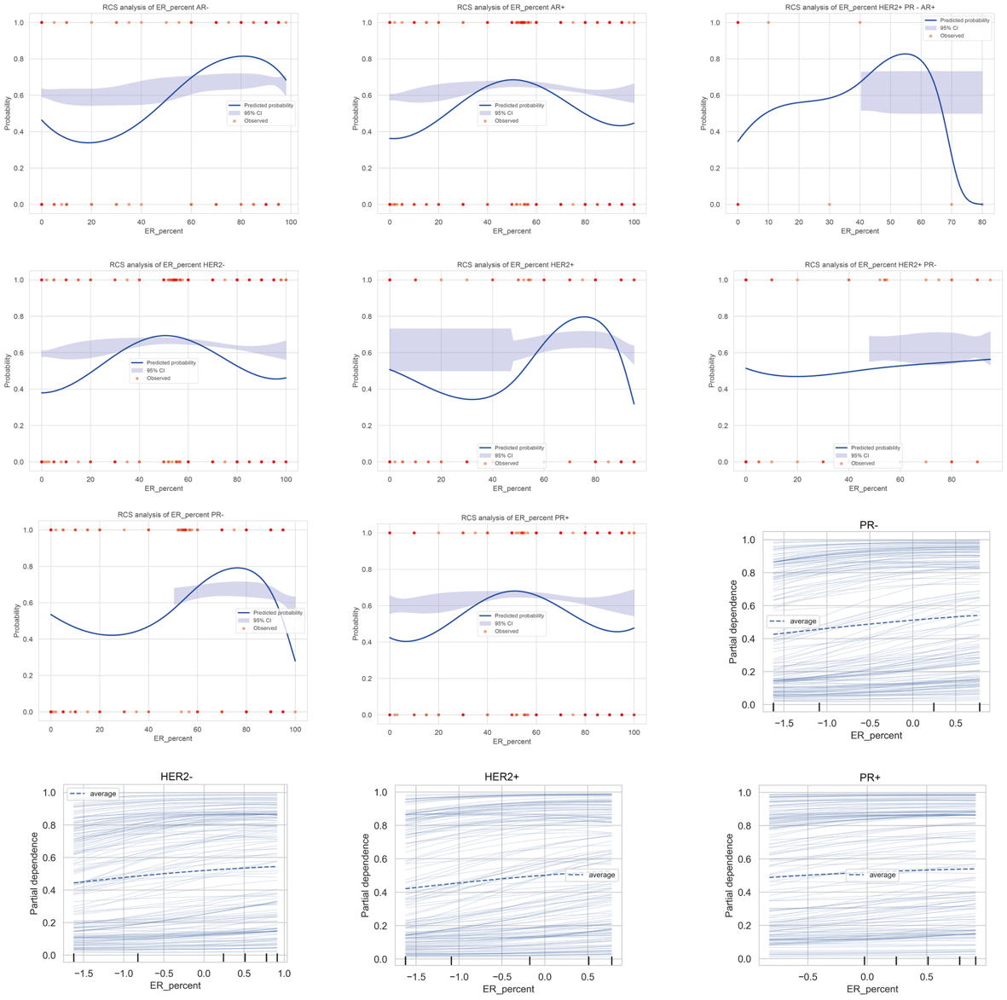
Supplementary Figure S7. Subgroup analysis of ER expression and SLNM risk.
PD curves, ICE curves, and RCS plots stratified by hormone receptor and HER2 status demonstrate that the impact of ER expression on sentinel lymph node metastasis (SLNM) varies across subgroups. These analyses highlight differences in ER-SLNM associations among different receptor and HER2 status combinations.

