Tumor cell JAGGED-1 promotes regional lymphatic metastasis and predicts recurrence in node-positive breast cancer
Benjamin Gordon^{1,2,3}, Bhairavi Swaminathan^{1,3}, Seock Won Youn^{1,3}, Natalia Anna Obacz^{1,3}, Rahul Vadakath^{1,4}, Pamela Teneqexhi^{1,3}, Isabel Alvarez-Lopez^{5,6}, Marta Rezola^{5,6}, Sara Manzano^{5,9}, Zuhara Telletxea^{,9}, Ziqiao Xu^{3,7,8}, Zhengjia Chen^{3,7,8}, Ekrem Emrah Er,^{1,3}, LA Naiche^{1,3}, María Muñoz Caffarel^{5,9}, Jan Kitajewski^{1,3}

Supplementary Data

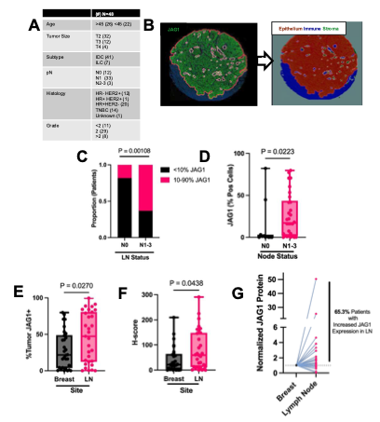
Supplemental Figure S1. Analysis of a second TMA shows higher JAG1 expression in patient lymph nodes than primary breast tumors across multiple breast cancer histological subtypes. (A) Patient characteristics from a 96-core, 48 patient commercial breast cancer TMA (Reveal Biosciences, BC06). IDC= invasive ductal carcinoma; ILC= invasive lobular carcinoma. Pathological node status (pN) and tumor staging (T) is according to American Joint Committee on Cancer (AJCC) TNM system. All patients were negative for distant metastasis at time of resection. (B) Multiplex OPAL-based staining of E-Cadherin (tumor) and JAG1 with representative associated HALO classifier markup of cell populations. (C) Categorical comparison of JAG1 positivity in primary breast tumors of patients with (pN+) and without (pN0) lymph node metastasis. N=48. Fisher’s exact test. (D) Comparison of JAG1 positivity in primary breast tumors of patients with (pN+) and without (pN0) lymph node metastasis. N=48. Unpaired student’s t-test. (E) Paired comparison of percent positivity for JAG1 expression in E-cadherin positive cells in breast and synchronous lymph nodes. N=36. Paired student’s t-test. (F) Paired comparison of JAG1 H-score in E-cadherin positive regions in breast and synchronous lymph nodes. N=36. Paired student’s t-test. (G) Normalized JAG1 H-Score per patient, indicating fold change between breast and node.

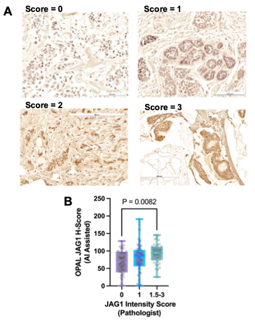
Supplemental Figure S2. Comparison of JAG1 immunohistochemical staining to OPAL multiplex staining of tumor microarray. (A) Representative images of JAG1 stained immunohistochemical sections separated by JAG1 intensity scored performed by clinical pathologist. Scale bar, 100 µm or 200 µm. (B) Comparison of IHC JAG1 immunohistochemical intensity score with OPAL multiplex JAG1 H-score. One-way ANOVA.

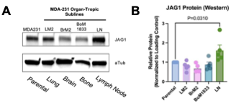
Supplemental Figure S3. Characterization of JAG1 expression in human breast cancer cell lines with various organotropisms. (A) Representative western blot showing JAG1 protein expression in the MDA-MB-231 cell line series with indicated tropisms. (B) Quantification of A in independent replicate blots. One way ANOVA.

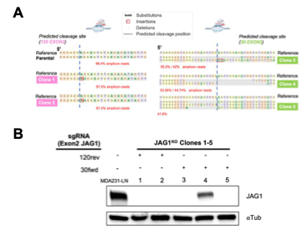
Supplemental Figure S4. Confirmation of CRISPR/Cas9 knockout of and characterization of generated cell lines. (A) JAG1 was knocked out in MDA-MB-231-D3H2LN cells by transfection with Cas9 protein and the two different guide RNAs indicated. Single cells were plated for clonal expansion. Five JAG1 knockout colonies were identified (JAG1^{KO} Clones 1-5) via next generation sequencing. Images adapted from CRISPResso. (B) Representative western blot of MDA231-LN JAG1^{KO} clones.

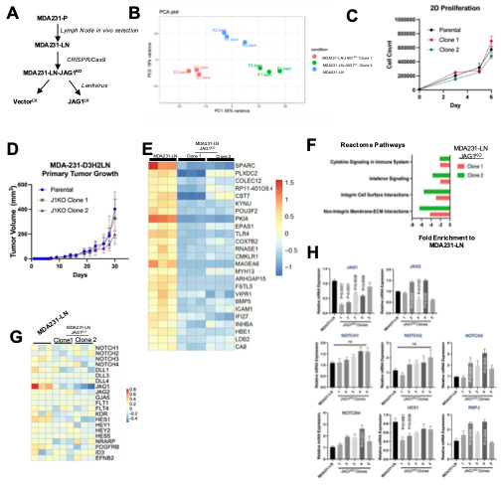
Supplemental Figure S5. Transcriptional and functional analyses between MDA231-LN and two JAG1^{KO} clonal cell lines developed targeting JAG1 with CRISPR/Cas9. (A) MDA231-P = MDA-MB-231 parental line; MDA231-LN = MDA-MB-231-D3H2LN (lymph node tropic, Jenkins et al 2005 Breast Cancer Res); MDA231-LN JAG1^{KO} = MDA231-LN treated with JAG1-targeting CRISPR/Cas9. (B) PCA plot from RNAseq data of MDA231-LN and MDA231-LN JAG1^{KO} Clones 1 and 2. The parental line and subclones form distinct clusters, with the greatest amount of transcriptional variance exhibited between the two subclones. (C) Primary cell growth of MDA231-LN and MDA231-LN JAG1^{KO} Clones 1 and 2 in culture. (D) Primary tumor growth of MDA231-LN and MDA231-LN JAG1^{KO} Clones 1 and 2 in NCG mice. (E)Top 25 genes downregulated in both MDA231-LN JAG1^{KO} Clones 1 and 2 compared to MDA231-LN-P. Heat map scale generated from z-score. (F) Reactome pathways downregulated in both MDA231-LN JAG1^{KO} Clones 1 and 2 compared to MDA231-LN with FDR<0.05. (G) Comparison of Notch-related genes in in MDA231-LN JAG1^{KO} Clones 1 and 2 compared to MDA231-LN. JAG1 and HES1 are downregulated in both clonal cell lines with FDR<0.05. Heat map scale generated from z-score. (H) Quantification of relative mRNA expression of Notch genes using qRT-PCR of MDA231-LN JAG1^{KO} Clones 1-5 compared to MDA231-LN. qRT-PCR relative mRNA values calculated from 2^{-ΔΔCT} equation. Experiment performed at least three times. One-way ANOVA.

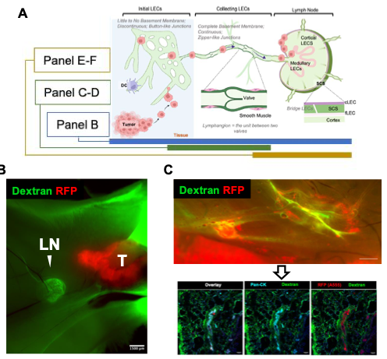

(continued next page)

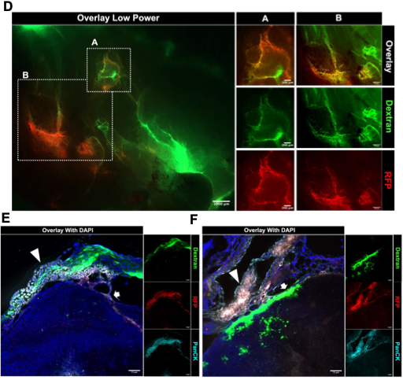
Supplemental Figure S6. Confirmation of sequential steps of lymphogenous metastasis including lymphovascular invasion and lymph node metastasis. (A) An overview of the lymphogenous metastasis cascade and associated subpanels within the figure. Cancer cells first invade the subcapsular sinus from the afferent lymphatic vessel. (B) Representative wholemount image of retracted undissected abdominal fatpad in a 66cl4 tumor bearing BALB/c mouse after intratumoral 2000 kDa Dextran-FITC injection with subiliac node (LN) and tumor (T) labeled. Scale bar, 1500 µm. Representative MDA231-LN RFP+ intralymphatic tumor invasion in fatpad in NCG mouse using 2000 kDa Dextran-FITC lymphangiography. (C) Representative wholemount image (top) of retracted undissected fatpad in axillary region of NCG mouse with associated representative 50 µm sections (bottom) with LVI demonstrated by overlapping regions of tumor derived RFP and PanCK (MDA231-LN). Scale bar, 100 µm. (D) Representative ex vivo wholemount images of NCG fatpad with LVI at both high and low powers. (E-F) Representative confocal tile stacked maximum projection images of 66cl4 lymphovascular invasion of afferent lymphatic vessels (arrowheads) and early invasion of subcapsular sinus (arrows) in BALB/c mice. Scale bar, 75 µm.

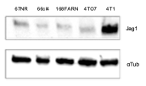
Supplemental Figure S7. JAG1 protein levels in mouse 4T1-related breast cancer cell lines.

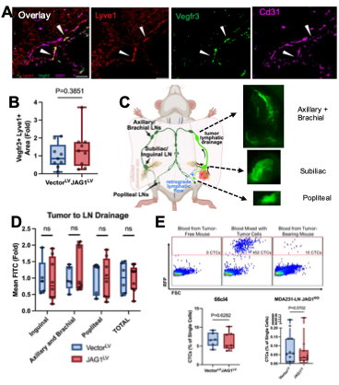
Supplemental Figure S8. Tumoral JAG1 expression does not affect tumor lymphatic growth, lymphatic function, or amount of circulating tumor cells (CTCs). (A) 66cl4 tumor section stained with lymphatic endothelial markers Lyve1 (red) and Vegfr3 (green), as well as pan-endothelial CD31 (magenta), White arrowheads point to lymphatic vessels. Scale bar, 25 µm. (B) Quantification of intratumoral Vegfr3+Lyve1+ lymphatic area in 66cl4 Vector^{LV} and JAG1^{LV} tumors normalized to control Vector^{LV}. Unpaired t-test. (C) Schematic representation of lymphatic drainage experiment in NCG mice containing in MDA231-LN JAG1^{KO} Clone 1 Vector^{LV} and JAG1^{LV} tumors. 2000 kDa Dextran-FITC was injected into center of the tumors and drainage was assessed in mammary fatpads in subiliac, popliteal, and axillary/brachial regions. (D) Quantification of 2000 kDa Dextran-FITC lymphatic drainage from tumor in all regions combined or individual anatomical regions, normalized to control. One-way ANOVA. (E) Representative FACs gating of RFP+ CTCs from blood. Blood from tumor-free mice is negative control (left) and blood from tumor-free mice mixed with cultured tumor cells is positive control (middle). Quantification (bottom) of CTCs from BALB/c and NCG mice with 66cl4 and MDA231-LN Vector^{LV} and JAG1^{LV} tumors, respectively, as percentage of total single nucleated circulating cells. Unpaired t-tests.

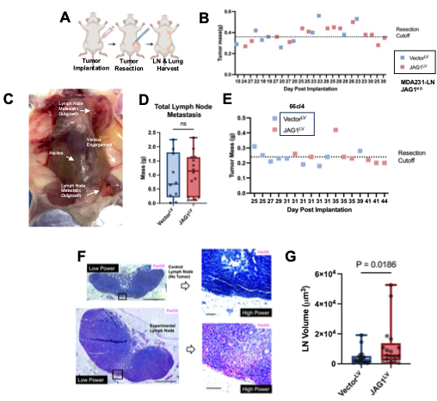
Supplemental Figure S9. Orthotopic models with tumor resection shows differences in lymph node metastasis in NCG human and BALB/c syngeneic mouse models. (A) JAG1^{LV} and Vector^{LV} transduced breast cancer cells were orthotopically implanted into the fourth mammary fatpad of BALB/c and NCG female mice and resected at same size. Ipsilateral subiliac and axillary lymph nodes were harvested four weeks post-resection. (B) Resection dates and associated mass at time of resection for each tumor in MDA231-LN/NCG orthotopic model. (C) Wholemount brightfield imaging of NCG mouse with axillary and popliteal lymph node metastatic outgrowths. (D) Cumulative lymph node metastasis in NCG mice bearing MDA231-LN JAG1KO Clone 1 JAG1LV and VectorLV tumors as measured by total metastatic lymph node mass. Each dot = separate mouse. Unpaired t-test. (E) Resection dates and associated mass at time of resection for each tumor in 66cl4/BALB/c orthotopic model. (F) Representative H&E images of subiliac lymph node from BALB/c mouse with 66cl4 tumor and tumor-free negative control, stained with PanCK (pink) and counterstained with hematoxylin. Black box corresponds to regions of associated high magnification images. (G) Comparison of lymph node volumes originating from 66cl4 JAG1^{LV} and Vector^{LV} tumor bearing mice four weeks post-surgical resection using equation $\frac{4}{3}×π×a×b×2b$. Unpaired t-test.

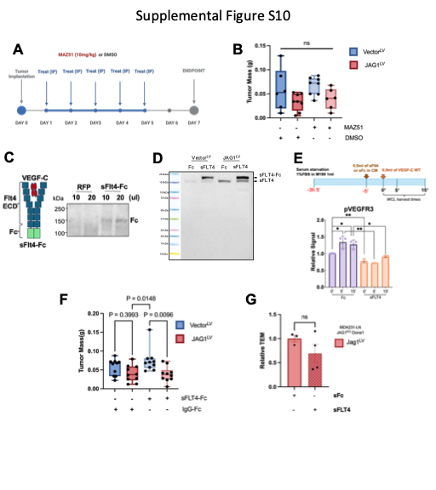
Supplemental Figure S10. Blockade of VEGFR3 signaling via multiple strategies in lymph node metastasis models. (A) Schematic of MAZ51 dosing protocol in female BALB/c mice inoculated with 66cl4 Vector^{LV} or JAG1^{LV} cells. (B) Tumor masses at endpoint in MAZ51 and control treated groups. One way ANOVA. (C) Schematic of sFLT4-Fc generation and secreted protein in HEK293T cells. (D) Western blot of conditioned media in 66cl4 cells secreting the sFLT4-Fc. (E) Confirmation of sFLT4-Fc blocking Vegfc-mediated phosphorylation of Vegfr3 in HDLECs treated with 66cl4 conditioned media using sandwich ELISA specific for phosphorylated receptor. One-way ANOVA. (F) Tumor masses at endpoint in sFLT4-Fc and control secreting groups. One way ANOVA. (G) TEM across HDLEC monolayers in JAG1-expressing cancer cells secreting sFLT4-Fc or control. Unpaired t-test.3

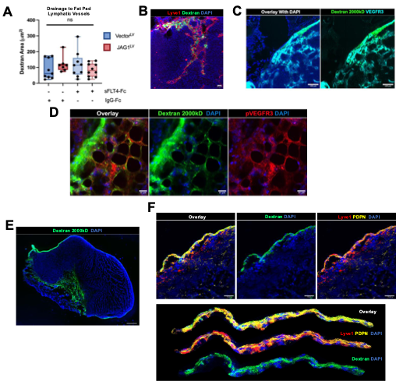
Supplemental Figure S11. Confirming specificity of lymphatic mapping using dextran. (A) Quantification of dextran drainage to the lymphatic vessels in the fat pad surrounding the tdLN in 66cl4 JAG^{LV} and Vector^{LV} groups with and without sFLT4-Fc. One-way ANOVA. (B) Dextran drainage into the medullary sinus of the lymph node, confirmed with Lyve1 staining. Scale bar = 25μm. (C) Dextran drainage into the subcapsular sinus and medullary sinus of the lymph node, confirmed with Vegfr3 staining. Scale bar = 100μm. (D) Dextran drainage into collecting lymphatics and lymphatic capillaries in mammary fatpad, confirmed with pVEGFR3 staining. Scale bar = 25μm. (E) Dextran drainage from injection site in center of tumor to peritumoral area. Scale bar = 100μm. (F) Peritumoral lymphatics confirmed by overlapping regions of dextran, PDPN, and Lyve1. Detailed isolation of lymphatics below. Scale bar = 50μm.

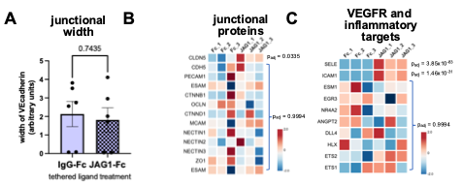
Supplemental Figure S12. Alterations in LEC junctions and VEGFR signaling induced by JAG1 signaling. (A) Width of VEcadherin junctions is not altered in HDLECs plated on JAG1-coated dishes, indicating that junctional stability is not overtly disrupted. Numbers represent averages from two separate wells in three independent experiments. In each well, two fields of view were examined and the width of each cell-cell junction was measured at 3 points and averaged. (B) Expression of CLDN5 is upregulated in HDLECs stimulated by recombinant hJAG1-Fc in a tethered-ligand assay, but mRNA expression of other junctional proteins is not altered (RNAseq analysis). (C) Inflammatory adhesion targets of VEGF signaling, E-selectin (SELE) and ICAM1, are upregulated in HDLECs stimulated by recombinant hJAG1-Fc in a tethered-ligand assay, but expression of other canonical endothelial VEGFR targets are not altered (RNAseq analysis).

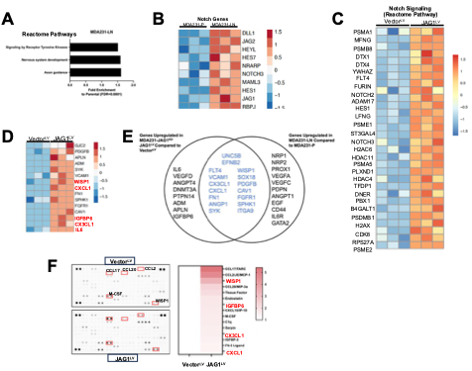
Supplemental Figure S13. Genes regulated by lymph node tropism and JAG1. (A) Upregulated Reactome pathways in MDA231-LN cells compared to MDA231-P cells using RNAseq. FDR < 0.05. (B) RNAseq heat map of Notch-related genes (Reactome) in MDA231-LN compared to MDA231-P cells. (C) RNAseq heat map of Notch-related genes (Reactome) in MDA231-LN JAG1^{KO} Vector^{LV} versus JAG1^{LV}. (D) Heatmap of upregulated lymphangiogenic genes identified by RNAseq in MDA231-LN JAG1^{KO} Clone 1 Vector^{LV} and JAG1^{LV} cells. Genes in red correlate with related mouse proteins upregulated by JAG1 overexpression identified in E. (E) 2866 genes were significantly upregulated (p_{adj}<0.05, ≥1.2 fold increase, FDR<0.05) by JAG1 expression, of which 767 were also upregulated in the lymph node-tropic MDA231-LN line. The Venn diagram indicates which of these sets upregulated a curated set of genes associated with lymphangiogenesis (Muley et al 2022 Angiogenesis, Figure S3B). (F) Quantification of cytokine profiler array generated from conditioned media from 66cl4 Vector^{LV} and JAG1^{LV} cells with top cytokines increased in JAG1^{LV} conditioned media highlighted.

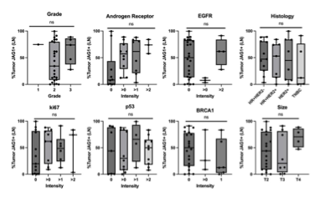
Supplementary Figure S14. Associations of JAG1 protein staining in lymph node metastatic tumor cells with multiple patient characteristics in a commercial TMA (Reveal Biosciences, BC06). One-way ANOVA.

Table S1. Patient Characteristics in HUD/ONK TMA
Characteristic | N = 284^{A}
Hospital
HUD | 130 (46%)
ONK | 154 (54%)
Age | Median (Range): 59 (48, 72);  Mean (SD): 60 (15)
Unknown | 82
Subtype
IDC | 187 (66%)
ILC | 42 (15%)
Unknown | 55 (19%)
Tumor Grade
1 | 24 (9%)
2 | 111 (39%)
3 | 58 (20%)
Unknown | 91 (32%)
Estrogen Receptor
Positive | 227 (80%)
Negative | 0 (0%)
Unknown | 57 (20%)
Progesterone Receptor
Positive | 188 (66%)
Negative | 39 (14%)
Unknown | 57 (20%)
HER2 Status
Score = 0 | 159 (56%)
Score = 1 | 43 (15%)
Score = 2 | 11 (4%)
Score = 3 | 14 (5%)
Unknown | 57 (20%)
Menopause
No | 65 (23%)
Yes | 136 (48%)
Unknown | 83 (29%)
Tumor Size (mm) | Median (Range): 25 (20, 35);  Mean (SD): 29 (16)
Unknown | 82
Surgery
Lumpectomy | 105 (37%)
Mastectomy | 96 (34%)
Unknown | 83 (29%)
Adjuvant Chemotherapy
No | 50 (17%)
Yes | 149 (53%)
Unknown | 85 (30%)
Radiotherapy (RT)
Breast Conserving RT | 105 (37%)
No RT | 39 (14%)
Chest-wall RT | 59 (21%)
Unknown | 81 (28%)
Hormone Therapy
None | 1 (0%)
Tamoxifen (Tmx) | 72 (25%)
Aromatase Inhibitor (AI) | 50 (18%)
Tmx->AI | 73 (26%)
Other/unknown | 88 (31%)
5 Year Survival (95%CI) | 88% (83%, 93%)
5 Year Recurrence Free (95%CI) | 83% (78%, 89%)
^{A} TMA consists of breast cancer and lymph node samples from patients from Donostia University (HUD) and Onkologikoa Hospitals (ONK) from 2000 to 2014. Numbers of patients with indicated characteristics are represented as n (%). Patient measurements are indicated as Median (Interquartile Range); Mean ± standard deviation. IDC = invasive ductal carcinoma. ILC = invasive lobular carcinoma. Tmx->AI indicates tamoxifen treatment followed by aromatase inhibitor therapy.

Table S2. Patient Characteristics of JAG1 high/low by median.
 | JAG1 Low (Breast) | JAG1 High  (Breast) | JAG1 Low (LN) | JAG1 High  (LN)
n | 113 | 114 | 110 | 111
Mean Proportion JAG1 Positive in Breast | 0.37±0.18 | 0.73±0.13 | 0.41±.023 | 0.63±0.199
Mean Proportion JAG1 Positive in LN | 0.54±0.29 | 0.74±0.24 | 0.44±0.28 | 0.83±0.14
Mean JAG1 H-Score in Breast | 39.00±19.54 | 83.07±19.18 | 44.13±26.59 | 69.99 ± 24.53
Mean JAG1 H-Score in LN | 58.57±33.68 | 86.30±35.51 | 46.01±29.26 | 100.24±30.2
Tumor Size | 28.23±14.99 | 29.67±17.28 | 28.87±16.53 | 29.32±15.41
Age | 57.29±13.56 | 63.48±15.36 | 56±15.84 | 62.63±13.80
Grade 1 | 6 | 13 | 7 | 14
Grade 2 | 36 | 40 | 49 | 45
Grade 3 | 24 | 27 | 15 | 34
Unknown Grade | 47 | 34 | 39 | 18
# LN Mets | 3.83±4.24 | 4.33±3.75 | 4.6±5.74 | 4.64±4.26

Additional Methods

Cell Lines

All cells were maintained in incubators at 37°C/5%CO2/95%humidity and subcultured with 0.05% trypsin/EDTA solution. MDA-MB-231-D3H2LN human mammary tumor cell line (Perkin Elmer, further abbreviated MDA231-LN ) and parental MDA-MB-231 cells (gifted from Alexandria Naba, UIC, and Joan Massague, MSKCC) were maintained in high-glucose Dulbecco's Modified Eagle Medium (DMEM, Gibco) supplemented with 10% FBS (VWR). 66cl4, 4T1, 67NR, and 4T07 murine mammary cancer cell lines were received as gifts from Alexandra Naba, (UIC) and cultured in RPMI 1640 (Gibco) supplemented with 10% FBS. The cell lines derived from MDA231-LN and 66cl4 are described below and were cultured in 10%FBS DMEM and 10%FBS RPMI 1640, respectively.

Use of Human Dermal Lymphatic Endothelial Cells (HDLECs)

HDLECs were purchased from Promo Cell (Heidelberg, Germany) and isolated from human juvenile foreskin. According to the product specifications, the cells were tested for morphology and the cell markers CD31 and Podoplanin via flow cytometry. The cells were confirmed to be negative for HIV-1, HBV, and HCV. Upon arrival, HDLECs were thawed at P2, cultured, and expanded with Endothelial Cell Growth Medium MV2 using an appropriate Growth Medium MV2 kit (both Promo Cell). The plates were freshly coated with fibronectin (10µg/ml, Sigma) before plating. Cells were cultured in incubators at 37°C/5%CO2/95%humidity and subcultured with 0.05% trypsin/EDTA solution until P4. The cells were then frozen in 10% DMSO freezing solution until use in experiments. Cells never reached beyond P7 during the experiments.

CRISPR/Cas9 JAG1 Knockout Generation
Cas9 protein (IDT 1081058) and single-guide RNAs (3’GTATGTGTCACACTCGTCGC5’ and 5’GGCCTCGGGTCAGTTCGAGT3’ ) complex (RNP Complex) specific to two different locations of Jag1 exon2 were assembled, then transfected into MDA231-LN cells (PolyPlus jetCRISPR® Transfection). Knockout clones were first isolated by serial dilution to select single cell-derived clonal colonies. Then clonal, homozygous knockouts were confirmed via next generation amplicon sequencing (Illumina miniSeq 2x150) and western blotting. In total, five clonal JAG1-knockout MDA231-LN cell lines were developed, two from the sgRNA treatment at 120th position in JAG1 exon 2 and three from the and three from the sgRNA treatment at the 30th position in JAG1 exon 2.

Plasmids

For generating JAG1-overexpressing cell lines, full-length human JAG1 was PCR amplified from PCR3.1 hJAG1-FLAG vector using forward primer 5’ AAGAGGATCCGCTAGCGTTTAAACTTAAGCTTGGAGTAGCCG and reverse primer 3’ GATTGTCGACTCTAGACTCGAGCGGCCGCC. An empty pCCL.PKG-WPRE vector was cut with SALI and BAMHI restriction enzymes and the PCR fragment was inserted using T4 DNA ligase (New England Biolabs). After gel electrophoresis, the 3.6kb product was isolated using the GeneJET Gel Extraction and DNA Cleanup Micro Kit (Thermo) according to company’s instructions. The plasmids were cloned in NEB10b Competent E. coli (New England Biolabs) and six colonies were selected for amplification followed by Miniprep using QIAprep Spin Miniprep Kit (QIAGEN). Sanger sequencing using multiple primers along hJAG1 sequence were used to confirm lack of indels during cloning.

Generation of sFLT4-Fc

To generate lentivirus soluble Flt4-Fc (sFlt4-Fc), we amplified the human Flt4 extracellular domain (sFlt4, 25-775 a.a.) by PCR (NEB, Phusion Taq). The DNA fragment of the amplified sFlt4 was inserted into a lentivirus plasmid (pccL), which has a PGK promoter. To enhance the secretion of sFlt4, a signal peptide (5htLight1.1, 1-24 a.a.) was inserted in front of sFlt4 with a start codon. The human Fc fragment was inserted into the C-terminal sFlt4 to improve stability (pCCL-PGK-sFlt4-Fc). A signal peptide and an Fc fragment were used to control the lentivirus (pCCL-PGK-Fc). Lentivirus was generated in HEK293T (ATCC) with transfection of lenti-expression vector (pCCL-PGK-sFlt4-Fc or pCCL-PGK-Fc) and lentivirus package vectors (pMDLg/pRRE, pRSV-Rev, pVSVg, 3rd generation) using PEI transfectant (Polysciences). After 3 days of the transfection, lentivirus was collected and filtered with 0.45 μm syringe filters. Appropriate cell lines were then transduced.

Generation of JAG1-Overexpressing Mammary Cancer Cell Lines

HEK293T cells were grown to 70% confluence in high glucose 10%FBS DMEM and then transfected with 3µg of pVSVG, 5µg of pMDLg/pRRE, 2.5µg of pRSV-rev, and 10µg of pCCL lentiviral plasmids containing human JAG1. To achieve transfection, calcium phosphate-based method was employed. 48 hours after transfection, the lentiviral particles were collected, filtered through a 0.45µm filter, and then used for transduction of target cells. 48 hours after transduction, cancer cells were subcultured. Shortly after, RNA and protein was collected for confirmation of successful cell line generation. In addition, fluorescence microscopy and flow cytometry were employed to check for uniformity of transduction. Before every experiment, levels of JAG1 were checked to ensure consistent levels.

Transendothelial Migration Assay

Transwell inserts with 3µm pores (Corning) were coated with fibronectin (10µg/ml, Sigma) before seeded with 120,000 HDLEC cells P4-P7 in HDLEC media detailed above. A strong endothelial monolayer was allowed to form over the course of 48 hours. 24 hours before experimental time, cancer cells were acclimated in 0.02%FBS endothelial growth media without growth factors. At time of experiment, the endothelial cell’s full growth media were replaced with 0.02%FBS endothelial growth media without growth factors after three washes. The bottom wells of the transwell inserts were replaced with 3%FBS endothelial growth media without growth factors. Tumor cells were trypsinized and resuspended in 0.02%FBS endothelial growth media without growth factors at a concentration of 70,000 cells per 250µl. Then, media was removed from the top of the transwell inserts and 250µl of cancer suspension were added to triplicate wells per group. After six hours, the wells were washed three times with endothelial media and then both sides of the transwell were fixed in 4% PFA for ten minutes. After three PBS washes, the bottom of the transwell were imaged for RFP+ cancer cells on an inverted Revolve microscope (Echo). Cell counts were computed on ImageJ and data analysis was performed via three separate experiments.

Tumor Models and Therapeutic Dosing

Tumor volumes were performed via caliper measurements (volume=0.5LxWxH) and tumor masses were measured on standard balance at endpoints. In small molecule inhibitor experiments, mice were treated every day for five days by intraperitoneal injections of MAZ51 (10mg/kg, Sigma) or DMSO (Sigma). For VEGFR3 inhibition with soluble sFLT4-Fc, cancer cells underwent lentiviral mediated transduction and stably secreted either sFLT4-Fc or control IgG-Fc. For resection experiments, mice were checked routinely both by researchers and veterinary staff for clinical endpoint criteria, which included hunching, lethargy, loss of locomotion, masses >2.0cm, 20% weight loss, labored breathing, and ulceration.

MDA231-LN Breast Cancer Surgical Resection Mouse Model

MDA231-LN RFP+ human breast cancer cells (3x10⁵ in PBS) were injected into the left fourth mammary fatpad in NCG mice (Charles River). Primary tumors were surgically resected at equal mass (~0.4g). Mice with resected tumors were monitored for four additional weeks or reaching humane endpoints. At endpoint, metastatic masses were weighed and then fixed in 4%PFA O/N before washing and embedding in OCT. Smaller, nonpalpable metastatic masses were identified by whole-body scanning of RFP fluorescence using an AxioZoom V16 (Zeiss) microscope. These were also documented, fixed, and embedded.

MDA231-LN Breast Cancer Lymphovascular Invasion Mouse Model (Lymphangiography)

MDA231-LN RFP+ human breast cancer cells (3x10⁵ in PBS) were injected into the left fourth mammary fatpad in NCG mice (Charles River) and then allowed to grow to identical size (~0.4g). At endpoint, tumors were injected with 10µl of 2000kDa FITC-Dextran (Thermo, 10mg/mL) with a Hamilton syringe while mice were anesthetized with isoflurane. Thirty minutes later, the dextran was found throughout the lymphatics of all mammary fatpads of the iso-tumoral side. Wholemount areas of the subiliac, axial, and brachial lymph nodes were imaged with AxioZoom V16 (Zeiss) microscope using FITC (dextran) and RFP (tumor cells) fluorescence filters, captured at identical power and exposure. The tissues were embedded directly into OCT and frozen for confirmational histological analysis. Using ImageJ software, the mean fluorescence area of RFP channel was calculating using FITC-Dextran to create ROIs so only intralymphatic areas were scored. Unless indicated otherwise, the values were normalized to the average of the control samples to accommodate analysis of independent experiments. For representative confocal acquisitions, images were collected on a Zeiss 880 scanning confocal microscope at either 20x or 63x.

66cl4 Breast Cancer Surgical Resection Mouse Model

66cl4 murine breast cancer cells (2x10⁶ in PBS) were injected into the left fourth mammary fatpad in BALB/c mice (Charles River). Primary tumors were surgically resected at equal mass (~0.22g). Mice with resected tumors were monitored for four additional weeks or reaching humane endpoints. At endpoint, mouse subiliac and axial lymph nodes (ipsilateral) were harvested, fixed O/N in 4%PFA, and then embedded into paraffin blocks. Lungs were also harvested, fixed, and embedded after 1mL intratracheal inflation with PFA followed by 4%PFA.

66cl4 Breast Cancer Locoregional Metastasis Mouse Model

66cl4 RFP+ murine breast cancer cells (3x106 in PBS) were injected into the fourth mammary fatpad in BALB/c mice (Charles River). After seven days, mice were sacrificed and the primary tumors and associated draining subiliac lymph node were harvested, fixed O/N in 4% PFA, and embedded in paraffin. In experiments with lymphangiography, Dextran-2000kDa-FITC was employed as described above. In experiments with MAZ51 treatment, cells without RFP were used and drug treatment was administered Days 1-5, as described above.

Immunofluorescence (Cryosections)

Tumors and organs were embedded in Tissue-Tek OCT compound (VWR). Tumors were sectioned into 10µm sections while lymph nodes were sectioned into thick 10µm sections to preserve the surrounding white adipose tissue and associated vessels. Ice-cold methanol was used to fix the cryosections for 10 minutes followed by washes in PBS. An hour of blocking was performed in 3% donkey serum (Sigma)/ 0.1%TritonX-100 (Fisher) at RT for one hour, which also permeabilized the tissue. O/N incubation was performed at 4°C with appropriate antibodies (Table S3). Next day secondary antibody staining with Alexa-Dyes were performed at RT in blocking buffer for one hour. Then, the sections were mounted with VECTASHIELD® PLUS Antifade Mounting Medium with DAPI and coverslips were sealed with nail varnish. Images were acquired with 10x objective on Leica DMi8 inverted microscope and thresholds were set based on negative controls (lymph nodes from mice without tumors) on ImageJ. PanCK+ or PanCK+ and RFP+ double positive metastatic areas were calculated as a gated fraction of total lymph node area. For lymphovascular invasion, the metastatic cells were calculated in relation to total lymphatic area surrounding the lymph node. At least five sections evenly spaced throughout each lymph node were used to score metastasis. For representative confocal acquisitions, images were collected on a Zeiss 880 scanning confocal microscope at either 20x or 63x.

Immunofluorescence (Cells)

Cells from culture were fixed for 10 minutes with 4%PFA on ice either directly on an 8-well µ-Slide (Ibidi) or in microtube after trypsin treatment. After fixation, cells were permeabilized and blocked in 0.02%TritonX-100/3%BSA/PBS for an hour at room temperature. O/N incubation was performed at 4°C with appropriate antibodies (Table S3). Next day secondary antibody staining with Alexa-Dyes were performed at RT in blocking buffer for one hour. For flow cytometry, cells were resuspended in 1%BSA/PBS after the final washes and fluorescence signal was detected on a BD LSRFortessa™ Cell Analyzer. For cell staining on µ-Slides, VECTASHIELD® PLUS Antifade Mounting Medium with DAPI was directly added to the wells and imaged on the slide.

Immunohistochemistry

Tissues were fixed in 4% PFA, embedded in paraffin, and sectioned at 10µm. The slides were processed with proper hydration and dehydration steps and stained with hematoxylin and eosin (Vector Labs). For pan-cytokeratin immunohistochemistry, sections were blocked at RT with Vector Labs Avidin/Biotin blocking kit and the BLOXALL blocking kit, per company’s instructions. Then samples were subjected to 30 minutes RT blocking in 3% donkey serum/PBS. Slides were then incubated O/N in primary antibody at 4°C. After washes the next day, 1:500 Goat Anti-Rabbit biotinylated antibody (Vector labs) stained slides at RT. Following, 1:1000 streptavidin alkaline phosphatase tertiary staining was performed (Vector Labs) and then slides were imaged with an Axio Imager.Z2 (Zeiss) with 10x tile scans (Figure 11). QuPath software was employed to measure lymph node metastatic area. To estimate lymph node volume, we employed volume of ellipsoid equation at the longest point of the lymph node, $volume=\frac{4}{3}×π×a×b×2b$.

Profiling Circulating Tumor Cells (CTCs)

At endpoint, 150µl blood was collected retro-orbitally using heparinized capillary tubes (Fisher) from each mouse bearing RFP+ tumors under isoflurane anesthesia. The blood was directly transferred into 1mL of 1x RBC lysis buffer (Biolegend), gently inverted several times, and incubated at RT for 30 minutes. Afterwards, samples were spun and non-lysed cells were fixed in 4% PFA. After three washes, the cells were resuspended in 1%BSA/PBS and endogenous RFP+ cells were detected on a BD LSRFortessa™ Cell Analyzer. Gates were generated by RFP positive and negative cell lines from culture. The collected data was quantified on FlowJo software and the number of CTCs were plotted as a percentage of total single live cells.

Tethered Ligand Assay (TLA)- RNA Collection

hJAG1-Fc (Sino Biologicals), which contains the extracellular portion of human JAG1, or IgG-Fc (Sino Biologicals, 40ng/μL), was tethered to the bottom of 6-well plates coated by mixing with fibronectin (10µg/ml, Sigma) and incubating plates overnight at 4°C. HDLECs were grown to 80% confluence before they were then trypsinized and 2.0x10⁵ cells were seeded onto TLA-prepared plates for six hours. The experiment was performed in triplicate. RNA was collected from the HDLECs using the RNeasy Mini Kit (QIAGEN) according to manufacturer instructions.

Tethered Ligand Assay (TLA)- HDLEC Wound Assay

TLA preparation was performed per above, except 8-Well Chamber μ-slides (IBIDI) were used, which are optically appropriate to perform direct imaging. After 6 hours of HDLEC seeding on TLA coated wells, with or without E7011 treatment, before fixing with 4% PFA and staining for VE-Cadherin. The wells were imaged with an Axio Imager.Z2 (Zeiss) with 10x tile scans and area of monolayer disruption was elucidated with FIJI ImageJ Software.

Cytokine Profiling

Equal amounts of conditioned medium were collected from experimental groups of 66cl4 breast cancer cells. The media was incubated with a Proteome Profiler Mouse XL Cytokine Array (R&D System) according to the manufacturer’s instructions. The array was imaged on a ChemiDocTM MP Imaging System (BioRad), and each spot density doublet was scored using ImageJ as the mean intensity. The results were normalized to those of the control and displayed as a heatmap generated using GraphPad Prism.

mRNA Sequencing

RNA was isolated using the RNEasy Mini Kit (QIAGEN) and then sent to Novogene (https://en.novogene.com/), where quality control analysis included RIN ≥5.8 and OD260/280>2.0. MDA23-1LN and related cell line RNA were sequenced at a depth of 20 million paired-ends with 150-based fragments. Raw reads were mapped to the reference human genome (ENSEMBL/GRCh38) using the STAR (2.5. oa). Further processing was achieved using Samtools (v1.4.1), with counts obtained by FeatureCounts(v1.5.2). DESeq2 (v1.18.1) was used to analyze counts to identify differentially expressed genes between the experimental and control groups. All RNA sequencing data is available in superseries GSE253036.

Gene Expression Analysis

RNA was isolated using RNEasy Mini Kit (QIAGEN) and cDNA was made using High-Capacity cDNA Reverse Transcription Kits (Applied Biosystems), per company’s’ instructions. qRT-PCR were performed in triplicates for each primer pair (Table S4) using Fast SYBERTM Green Master Mix and run on an ABI ViiA7 Real-Time PCR System (Applied Biosystems). Gene expression was normalized to ß-actin levels and were performed at least three times for each gene. The mean cycle threshold (Ct) values were computed into relative mRNA expression via the 2^{-ΔΔCt} method. In this method, 2^{(1-Ct[ß-actin])} is divided by 2^{(1-Ct[GOI])} to get the gene of interest (GOI) relative mRNA expression.

Table S3. List of Antibodies

Antibody (host) | Use | Vendor | Catalog Number
JAG1 (Rabbit) | WB | Cell Signaling | 2620s
JAG1 (Rabbit) | IHC (TMA)/ OPAL | Abcam | Ab109536
JAG1 (Rabbit) | IHC (TMA) | Sigma | HPA021555
ɑ-Tubulin  (Mouse) | WB | Sigma | T6074
Pan-Cytokeratin (Rabbit) | IF/IHC | Thermo/Bioss | BS-10403R
Pan-Cytokeratin (Mouse AE1/AE3) | IHC (TMA) | Agilent | M351501-2
Lyve1 (Rabbit) | IF | Abcam | ab14917
Lyve1 (Rat) | IF | Thermo | 14-0443-82
Lyve1 (Rabbit EPR21857) | IHC (TMA) | Abcam | ab219556
Podoplanin (Mouse D2-40) | IHC (TMA) | Sigma | 322M-18
Podoplanin (Hamster) | IF | Thermo | MA5-16113
RFP (Chicken) | IF | Rockland | 600-901-379S
RFP (Rabbit) | IF | Rockland | 600-401-379S
E-Cadherin (Mouse 4A2) | IHC (TMA) | Cell Signaling | 14472
VE-Cadherin (Rabbit) | IF | Abcam | ab33168
VEGFR3 (Goat) | WB | R&D | AF743
Anti-human IgG-Fc (Goat) | WB | Sigma | A0170

Table S4. List of qRT-PCR Primers
Gene | Forward (Starting w 5’) | Reverse (Starting w 5’)
hNOTCH4 | AACTCCTCCCCAGGAATCTG | CCTCCATCCAGCAGAGGTT
hNOTCH2 | TCCACTTCATACTCACAGTTGA | TGGTTCAGAGAAAACATACA
hNOTCH3 | GGGAAAAAGGCAATAGGC | GGAGGGAGAAGCCAAGTC
hJAG1 | GAATGGCAACAAAACTTGCAT | AGCCTTGTCGGCAAATAGC
hNOTCH1 | GTCAACGCCGTAGATGACC | TTGTTAGCCCCGTTCTTCAG
hJAG2 | AGCCATGCCTTAACGCTTTT | CACACACTGGTACCCGTTCA
hACTIN | CTCGTAGATGGGCACAGTGTG | CGAGGCCCAGAGCAAGAGAG
hCXCL2 | ATTGTTTATTTTAGGTCAAACCCAAG | GCTGACATGTGATATGTCATCACGA
hRND1 | CTATCCAGAGACCTATGTGCC | CGGACATTATCGTAGTAGGGAG
hSELE | GGCAGTGGACACAGCAAATC | TGGACAGCATCGCATCTCA
hICAM1 | GGCCGGCCAGCTTATACAC | TAGACACTTGAGCTCGGGCA
hCCL2 | AGGTGACTGGGGCATTGAT | GCCTCCAGCATGAAAGTCTC
hRBPJ | GCTGACTTATGCATTGCCTCAGGA | CCACTGCTGTGAACTGGCATGAAA
hHES1 | ACGACACCGGATAAACCAAA | CGGAGGTGCTTCACTGTCAT
hRND1 | CTATCCAGAGACCTATGTGCC | CGGACATTATCGTAGTAGGGAG

