Supplementary material
Temporal and treatment-specific risk of herpes zoster among female breast cancer survivors in Japan

eTable 1. Code lists to define each outcome and covariate
eFigure 1. Definition of postherpetic neuralgia
eTable 2. Treatment details of the breast cancer survivors during the first year
eFigure 2. Cumulative incidence curves plotted on a logarithmic scale
eTable 3. Results of the sensitivity analysis for the period before the herpes zoster vaccine introduction
eTable 4. Results of sensitivity analysis starting the follow-up from the month of breast cancer surgery
eFigure 3. Kaplan-Meier curves of the cumulative incidence of each group by chemotherapy
eFigure 4. Kaplan-Meier curves of the cumulative incidence of each group by radiotherapy
eTable 5. Baseline characteristics of each group after 1 year from the index month, by combination of chemotherapy and radiation therapy
eFigure 5. Kaplan-Meier curves of the cumulative incidence of each group by combination of chemotherapy and radiation therapy
eTable 6. Incidence rate and hazard ratios of herpes zoster in each group 1 year after diagnosis, by combination of chemotherapy and radiation therapy

eTable 1. Code lists to define each outcome and covariate
Outcomes/Covariates | Diagnosis (International Classification of Diseases and Related Health Problems, 10th Revision code) | Medication (ATC code or EphMRA code) | Medical procedures (Japanese original code)
Herpes Zoster | B02 | ATC code; J05AB01, J05AB03, J05AB09, J05A
Postherpetic neuralgia |  | ATC code; M01AX, N02AE01, N02AJ03, N02AX02, N03AX12, N03AX16, N06AA02, N06AA09, N06AA10, N06AX21,  EphMRA code; N02A
Hypertension | I10, I11, I12, I13 , I15 | EphMRA code; C03, C07, C08, C09, C11
Diabetes | E10, E11, E12, E13, E14 | EphMRA code; A10
Asthma (including coughing asthma) | J45, J46 | ATC code; R03DC01, R03DC02  EphMRA code; R03D1, R03F1, R03B2
Anxiety/depression | F32, F33, F34, F40, F41, F42, F43, F48 | EphMRA code; N05B, N06A
Chronic renal failure with dialysis |  |  | J038 (hemodialysis, hemofiltration, or hemodiafiltration)
Immunosuppressant/chemotherapy |  | ATC code; L04AD01, L04AD02, L04AX01, L04AA06, L04AA18, L04AA10, L01AA01, L01BA01, L04AA13, L04AX, L04AB01, L04AB02, L04AB04, L04AB05, L04AB06, L04AC07, L04AC14, L01FA01, L04AA29, L04AA37, L04AA44, L04AC02  EphMRA code; L01
Steroid therapy (injectable or oral) |  | EphMRA code; H02
ATC = Anatomical Therapeutic Chemical, EphMRA = European Pharmaceutical Market Research Association.
eFigure 1. Definition of postherpetic neuralgia
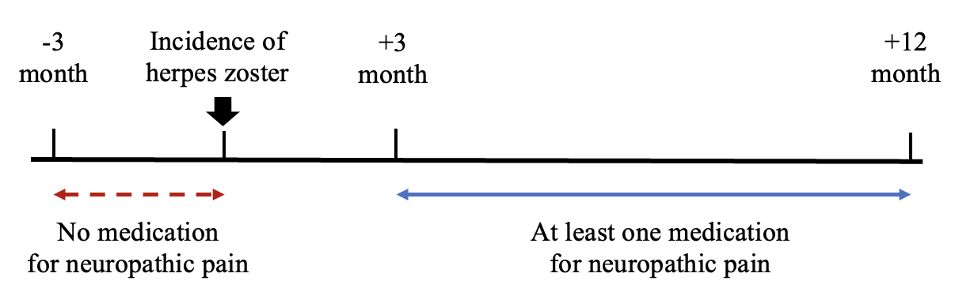

eTable 2. Treatment details of the breast cancer survivors during the first year
No. of breast cancer survivors
N=23,169
 | n (%)
Chemotherapy regimen
No chemotherapy (no anthracycline nor taxane) | 14,955 (64.5)
Anthracycline only | 758 (3.3)
Taxane only | 2,052 (8.9)
Anthracycline-plus-taxane | 5,404 (23.3)
Radiotherapy | 12,122 (52.3)
Axillary dissection | 6,274 (27.1)
Hormone therapy
Tamoxifen | 10,317 (44.5)
Aromatase inhibitor | 5,622 (24.3)

eFigure 2. Cumulative incidence curves plotted on a logarithmic scale
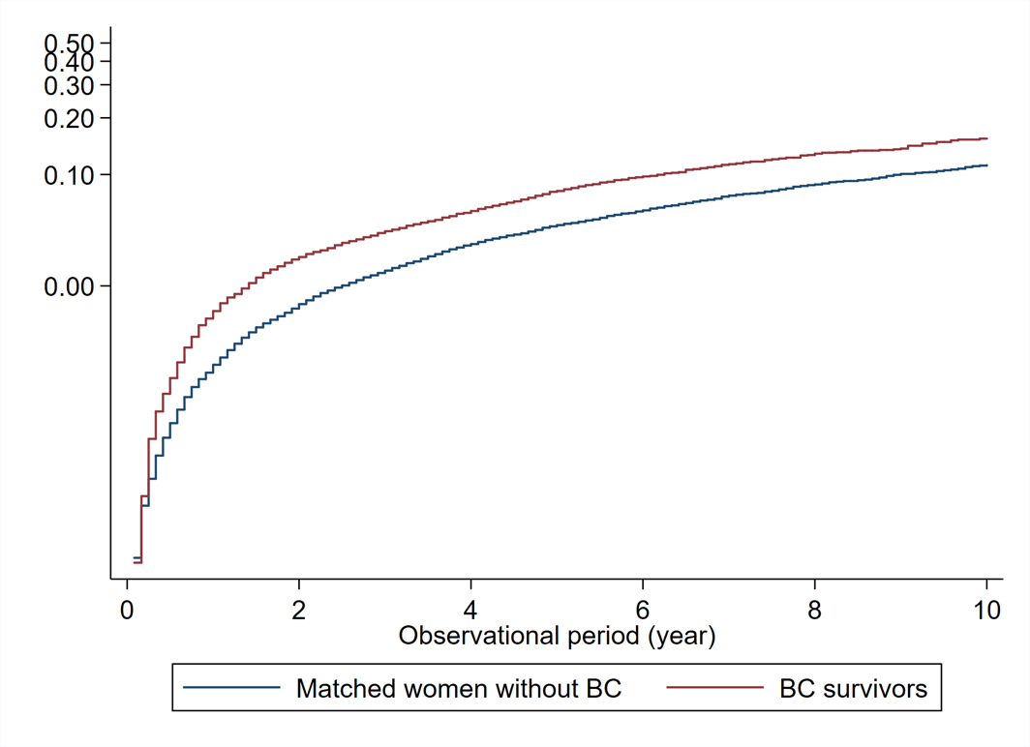

BC = breast cancer

eTable 3. Results of the sensitivity analysis for the period before the herpes zoster vaccine introduction (Incidence rate of each outcome in each group and its difference and ratio between the groups with and without breast cancer)
 | Women with breast cancer |  | Women without breast cancer |  | Crude rate difference  (95% CI)  (/1000 PY) | Crude rate ratio  (95% CI) | Hazard ratio (95% CI)
 | No. of outcomes/  No. of womenª | Incidence rate (95% CI) (/1000 PY) | No. of outcomes/  No. of womenª | Incidence rate (95% CI) (/1000 PY) | Crude rate difference  (95% CI)  (/1000 PY) | Crude rate ratio  (95% CI) | Model 1 | Model 2 | Model 3 | Model 4
Herpes zoster
Overall | 144/5,004 | 13.1  (11.1–15.4) | 385/19,979 | 8.73  (7.90–9.65) | 4.36  (2.05–6.68) | 1.50  (1.23–1.82) | 1.49  (1.22–1.82) | 1.46  (1.20–1.78) | 1.44 (1.01–2.06) | 1.47  (1.20–1.80)
(a) divided by age
Aged <50 | 64/2,758 | 9.52  (7.45–12.2) | 192/11,084 | 7.08  (6.14–8.15) | 2.44  (-0.10–4.98) | 1.35  (1.00–1.79) | 1.68 (1.52–1.86) | 1.42  (1.06–1.92) | 1.18 (0.66–2.13) | 1.43  (1.06–1.93)
Aged ≥50 | 80/2,246 | 18.7  (15.0–23.3) | 193/8,895 | 11.4  (9.89–13.1) | 7.34  (2.94–11.8) | 1.65  (1.25–2.15) | 1.53  (1.17–2.02) | 1.51  (1.15–2.00) | 1.62  (0.98–2.67) | 1.54  (1.16–2.04)
CI = confidence interval, PY = person years,
ª Women with a previous history of herpes zoster were excluded from the analysis.
Model 1: without additional adjustment.
Model 2: adjusted for comorbidities (hypertension, diabetes, asthma, anxiety/depression, and dialysis), and immunosuppressant/chemotherapy/steroid therapy administered during the 3 months before the index month.
Model 3: further adjusted for BMI, smoking history, and drinking habits as a complete case analysis. The sample size in each complete case analysis was 11,271 for overall, 6,278 for aged <50 years and 4,993 for aged ≥50.
Model 4: with multiple imputation for BMI, smoking history, and drinking habits.

eTable 4. Results of sensitivity analysis starting the follow-up from the month of breast cancer surgery
 | Women with breast cancer |  | Women without breast cancer |  | Crude rate difference  (95% CI)  (/1000 PY) | Crude rate ratio  (95% CI) | Hazard ratio (95% CI)
 | No. of outcomes/  No. of womenª | Incidence rate (95% CI) (/1000 PY) | No. of outcomes/  No. of womenª | Incidence rate (95% CI) (/1000 PY) | Crude rate difference  (95% CI)  (/1000 PY) | Crude rate ratio  (95% CI) | Model 1 | Model 2 | Model 3 | Model 4
Herpes zoster
Overall | 1,119/22,741 | 16.3  (15.3–17.2) | 2,918/89,963 | 10.6  (10.2–11.0) | 5.65  (4.62–6.68) | 1.53  (1.43–1.64) | 1.58  (1.47–1.70) | 1.55  (1.44–1.67) | 1.45 (1.30–1.61) | 1.55  (1.44–1.67)
(a) divided by age
Aged <50 | 564/11,991 | 14.0  (12.9–15.2) | 1,413/47,687 | 8.77  (8.32–9.24) | 5.21  (3.97–6.45) | 1.59  (1.44–1.76) | 1.67  (1.51–1.86) | 1.65  (1.49–1.83) | 1.54  (1.32–1.79) | 1.65  (1.48–1.83)
Aged ≥50 | 555/10,750 | 19.5  (17.9–21.1) | 1,505/42,276 | 13.2  (12.6–13.9) | 6.27  (4.51–8.02) | 1.47  (1.33–1.63) | 1.50  (1.35–1.67) | 1.48  (1.33–1.64) | 1.39  (1.19–1.62) | 1.48  (1.33–1.65)
CI = confidence interval, PY = person years,
ª Women with a previous history of herpes zoster were excluded from the analysis.
Model 1: without additional adjustment.
Model 2: adjusted for comorbidities (hypertension, diabetes, asthma, anxiety/depression, and dialysis), and immunosuppressant/chemotherapy/steroid therapy administered during the 3 months before the index month.
Model 3: further adjusted for BMI, smoking history, and drinking habits as a complete case analysis. The sample size in each complete case analysis was 70,009 for overall, 36,666 for those aged <50 years, and 33,433 for those aged ≥50.
Model 4: with multiple imputation for BMI, smoking history, and drinking habits.
eFigure 3. Kaplan-Meier curves of the cumulative incidence of each group by chemotherapy
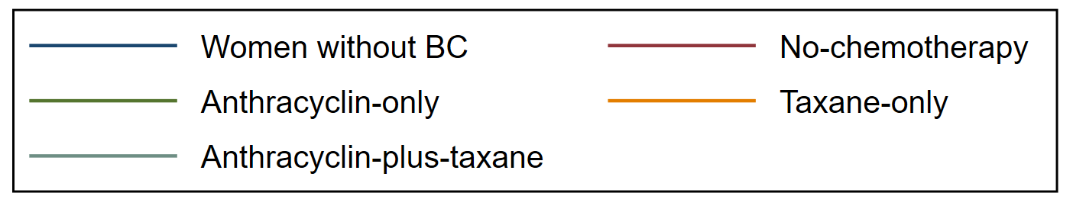

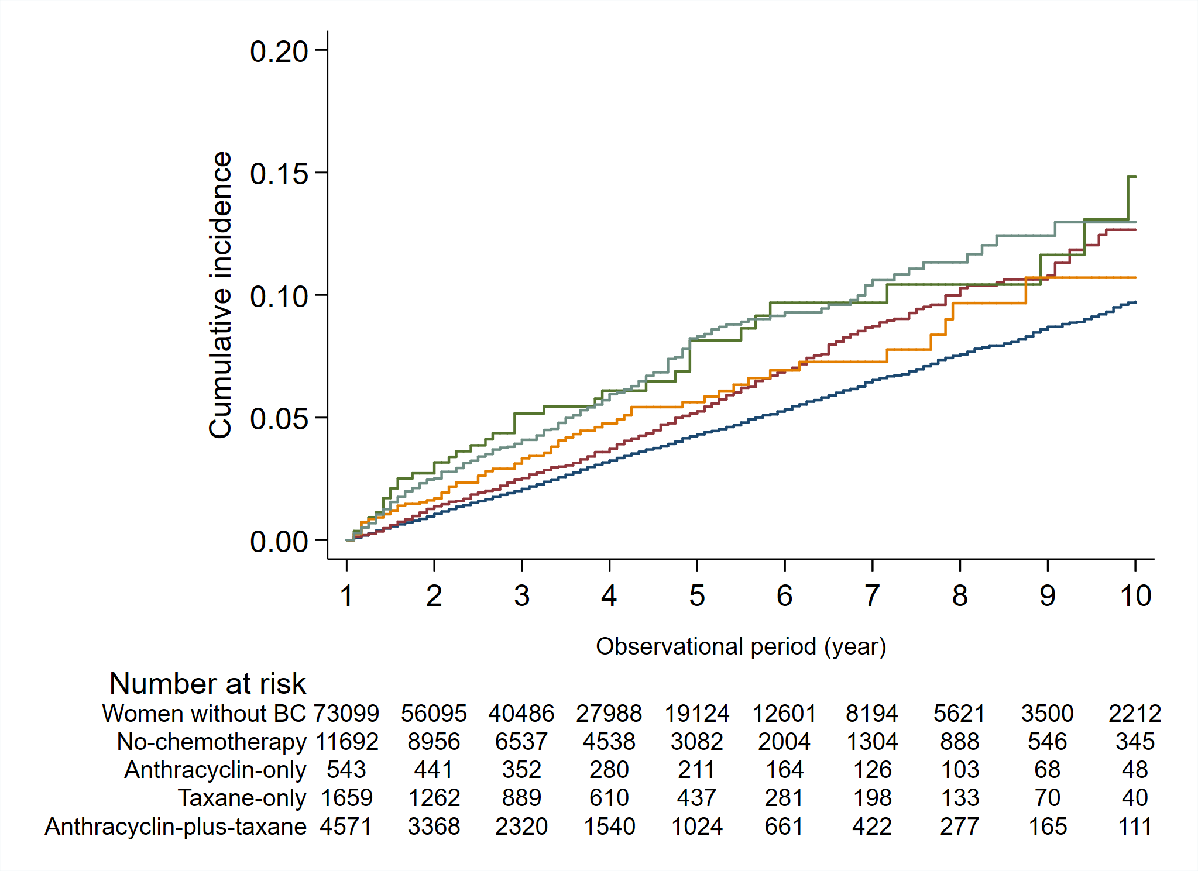

BC = breast cancer
eFigure 4. Kaplan-Meier curves of the cumulative incidence of each group by radiotherapy
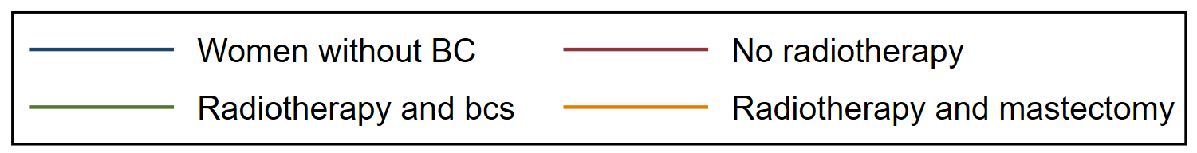

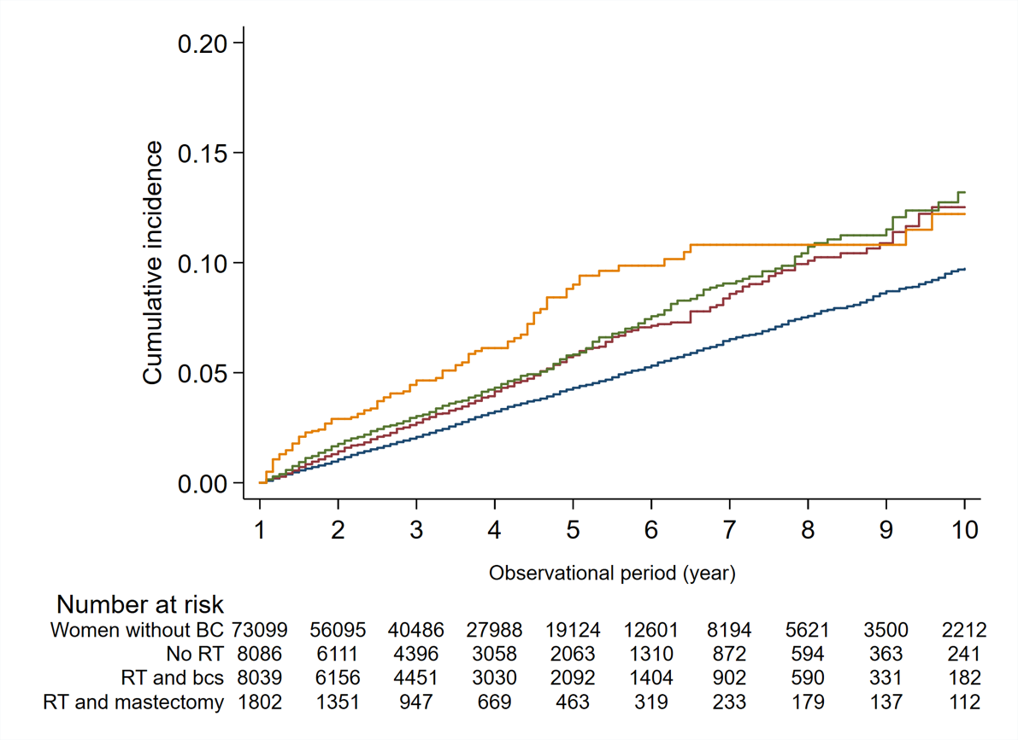

BC = breast cancer, RT = radiotherapy, bcs = breast-conserving surgery

eTable 5. Baseline characteristics of each group after 1 year from the index month by combination of chemotherapy and radiation therapy
 | Women without breast cancer | Breast cancer survivors
 | Women without breast cancer | No-chemotherapy/  radiotherapy | Chemotherapy-only | Radiotherapy-only | Chemotherapy-plus- radiotherapy
 | n=73,099 | n=5,279 | n=2,807 | n=6,084 | n=3,757
Age of the index month (years, median [IQR]) | 49.1 (44.3–55.3) | 49.0 (44.6–55.2) | 48.9 (43.7–55.3) | 49.5 (45.1–55.5) | 48.7 (43.3–54.9)
Body mass index, n (%)
Underweight (<18.5 kg/m²) | 6,014 (8.2) | 512 (9.7) | 191 (6.8) | 571 (9.4) | 227 (6.0)
Normal weight (18.5–24.9 kg/m²) | 3,1880 (43.6) | 2,666 (50.5) | 1,217 (43.4) | 3,133 (51.5) | 1,627 (43.3)
Overweight (25–29.9 kg/m²) | 6,531 (8.9) | 495 (9.4) | 262 (9.3) | 642 (10.6) | 439 (11.7)
Obese (≥30 kg/m²) | 1,959 (2.7) | 111 (2.1) | 74 (2.6) | 185 (3.0) | 117 (3.1)
Missing | 26,715 (36.6) | 1,495 (28.3) | 1,063 (37.9) | 1,553 (25.5) | 1,347 (35.9)
Smoking status, n (%)
Non-smoker/ex-smoker | 40,804 (55.8) | 3,420 (64.8) | 1,533 (54.6) | 4,053 (66.6) | 2,111 (56.2)
Current smoker | 4,984 (6.8) | 321 (6.1) | 182 (6.5) | 420 (6.9) | 253 (6.7)
Missing | 27,311 (37.4) | 1,538 (29.1) | 1,092 (38.9) | 1,611 (26.5) | 1,393 (37.1)
Drinking habits, n (%)
None | 24,636 (33.7) | 1,944 (36.8) | 937 (33.4) | 2,240 (36.8) | 1,231 (32.8)
Sometimes | 13,432 (18.4) | 1,156 (21.9) | 483 (17.2) | 1,428 (23.5) | 695 (18.5)
Every day | 5,776 (7.9) | 508 (9.6) | 227 (8.1) | 627 (10.3) | 336 (8.9)
Missing | 29,255 (40.2) | 1,671 (31.7) | 1,160 (41.3) | 1,789 (29.4) | 1,495 (39.8)
Comorbidities, n (%)
Hypertension | 9,262 (12.7) | 802 (15.2) | 576 (20.5) | 880 (14.5) | 749 (19.9)
Diabetes | 2,343 (3.2) | 208 (3.9) | 132 (4.7) | 209 (3.4) | 147 (3.9)
Asthma (including coughing asthma) | 11,314 (15.5) | 882 (16.7) | 468 (16.7) | 1,004 (16.5) | 619 (16.5)
Anxiety/depression | 4,614 (6.3) | 614 (11.6) | 418 (14.9) | 612 (10.1) | 477 (12.7)
Chronic renal failure with dialysis | 73 (0.1) | 15 (0.3) | 6 (0.2) | 6 (0.1) | 2 (0.05)
IQR = interquartile range
eFigure 5. Kaplan-Meier curves of the cumulative incidence of each group by combination of chemotherapy and radiation therapy
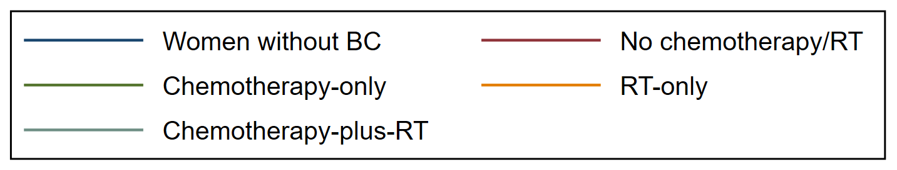
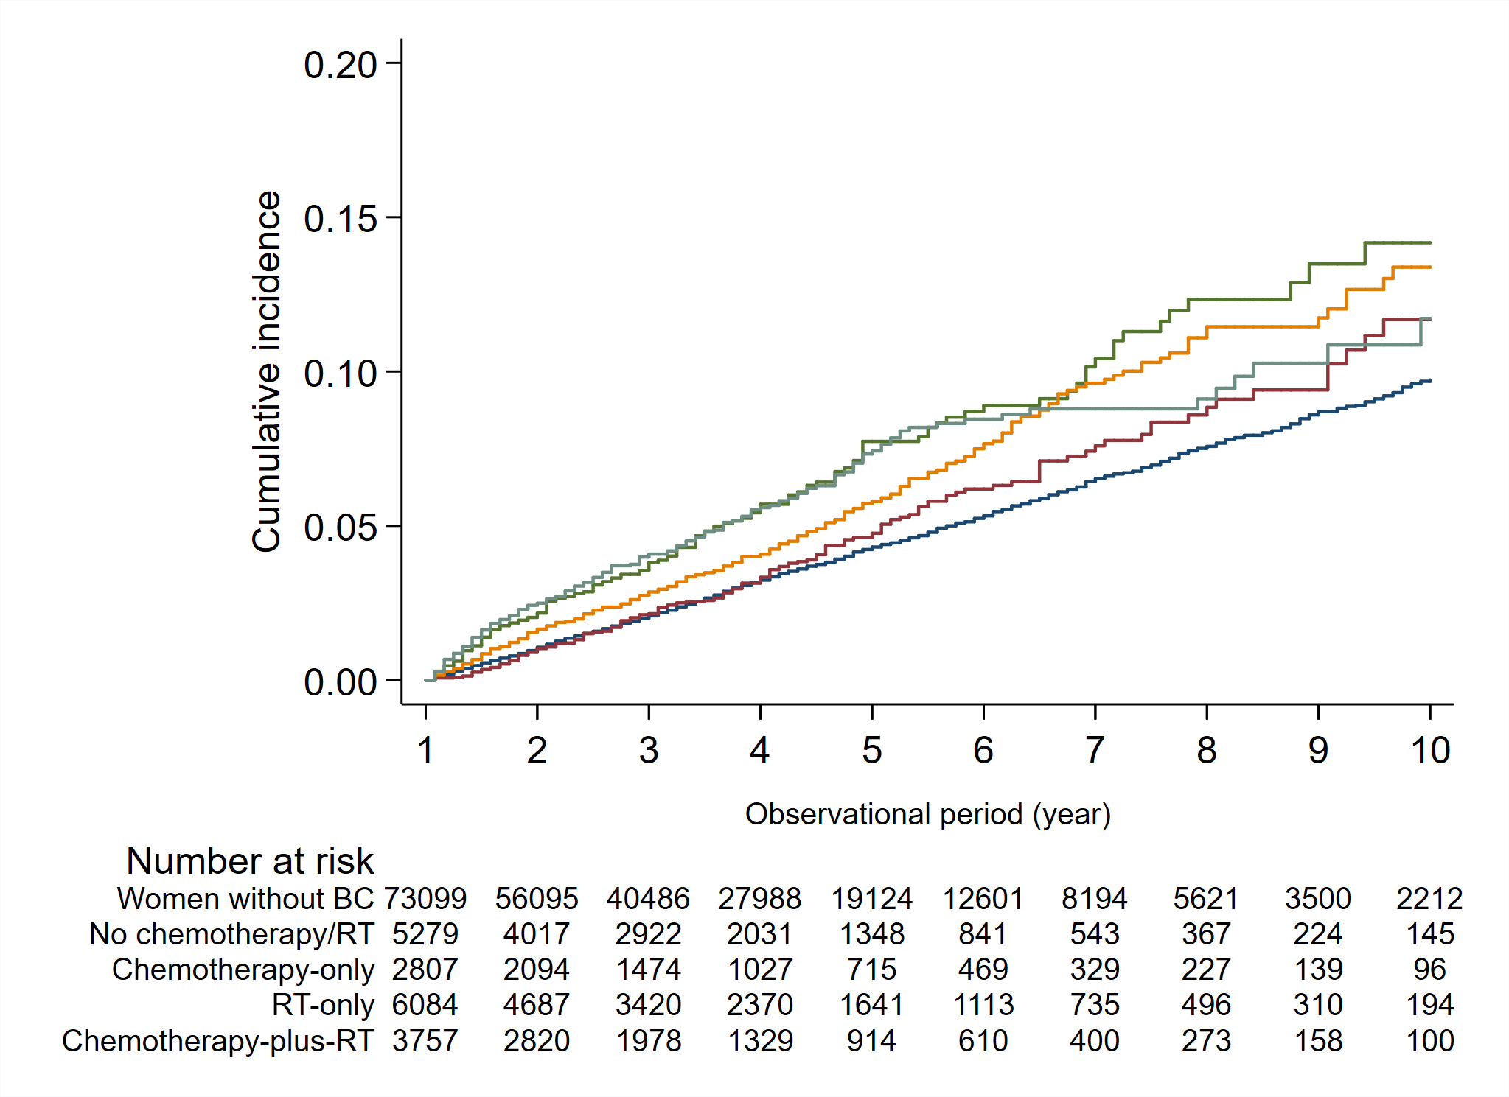
BC = breast cancer, RT = radiotherapy

eTable 6. Incidence rate and hazard ratios of herpes zoster in each group 1 year after diagnosis by combination of chemotherapy and radiation therapy
 | Women without breast cancer | Breast cancer survivors
 | Women without breast cancer | No-chemotherapy/ radiotherapy | Chemotherapy-only | Radiotherapy-only | Chemotherapy-plus- radiotherapy
 | n=73,099 | n=5,279 | n=2,807 | n=6,084 | n=3,757
Observational years (median [IQR]) | 2.3 (1.1–4.3) | 2.3 (1.0–4.0) | 2.1 (0.92–4.0) | 2.3 (1.1–4.2) | 2.1 (1.0–3.9)
No. of outcomes/No. of womenª | 2,294/73,099 | 179/5,279 | 149/2,807 | 275/6,084 | 187/3,757
Incidence rate (95% CI) (/1000 PY) | 11.0 (10.6–11.5) | 12.1 (10.5–14.0) | 19.0 (16.2–22.4) | 15.6 (13.8–17.5) | 18.3 (15.8–21.1)
Adjusted hazard ratio (reference: women without breast cancer) ^{b} | 1 (Reference) | 1.10 (0.92–1.32) | 1.71 (1.39–2.11) | 1.44 (1.21–1.71) | 1.65 (1.35–2.01)
Adjusted hazard ratio (reference: no chemotherapy) ^{b} | / | 1 (Reference) | 1.55 (1.24–1.95) | 1.32 (1.09–1.59) | 1.49 (1.20–1.86)
IQR=interquartile range, PY=person years
ª Women who experienced herpes zoster or loss to follow-up within the first year were excluded from the analysis. The proportion of women who experienced herpes zoster within 1 year of the index month was 0.88% (817/92,801) in women without breast cancer, 0.94% (66/7,017) in the no-chemotherapy/radiotherapy group, 2.8% (103/3,679) in the chemotherapy-only group, 1.1% (81/7,521) in the radiotherapy-only group, and 3.2% (136/4,281) in the chemotherapy-plus- radiotherapy group.
^{b} Adjusted for age, diagnosis year, BMI, smoking history, drinking habits, comorbidities (hypertension, diabetes, asthma, anxiety/depression, and chronic renal failure with dialysis), and breast cancer treatment within 1 year of the index month (axillary dissection, tamoxifen, and aromatase inhibitors). BMI, smoking history, and drinking habits were supplemented using multiple imputations.

