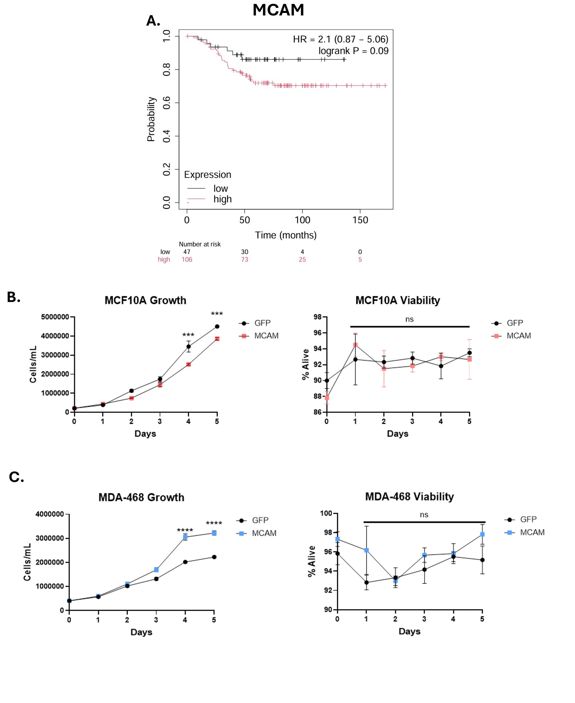
Supp Figure 1: MCAM expression is correlated with TNBC and overexpression alters cellular growth
A) Gene Chip analysis of altered MCAM mRNA in breast cancer patients from KM Plotter. Overall survival of breast cancer patients with triple-negative subtyping. Auto-select best cutoff for percentiles was used. B) Cell growth and viability of MCF-10A GFP and MCAM cells determined using a trypan blue exclusion assay using automated cell counter at 0, 1, 2-, 3-, 4-, and 5-days post plating. Error bars indicate ± standard deviation, n = 3. *** p<0.001 (Multiple unpaired two-tailed t-test) C) Cell growth and viability of MDA-468 GFP and MCAM cells determined using a trypan blue exclusion assay using automated cell counter at 0, 1, 2-, 3-, 4-, and 5-days post plating. Error bars indicate ± standard deviation, n = 3. **** p<0.0001 (Multiple unpaired two-tailed t-test).
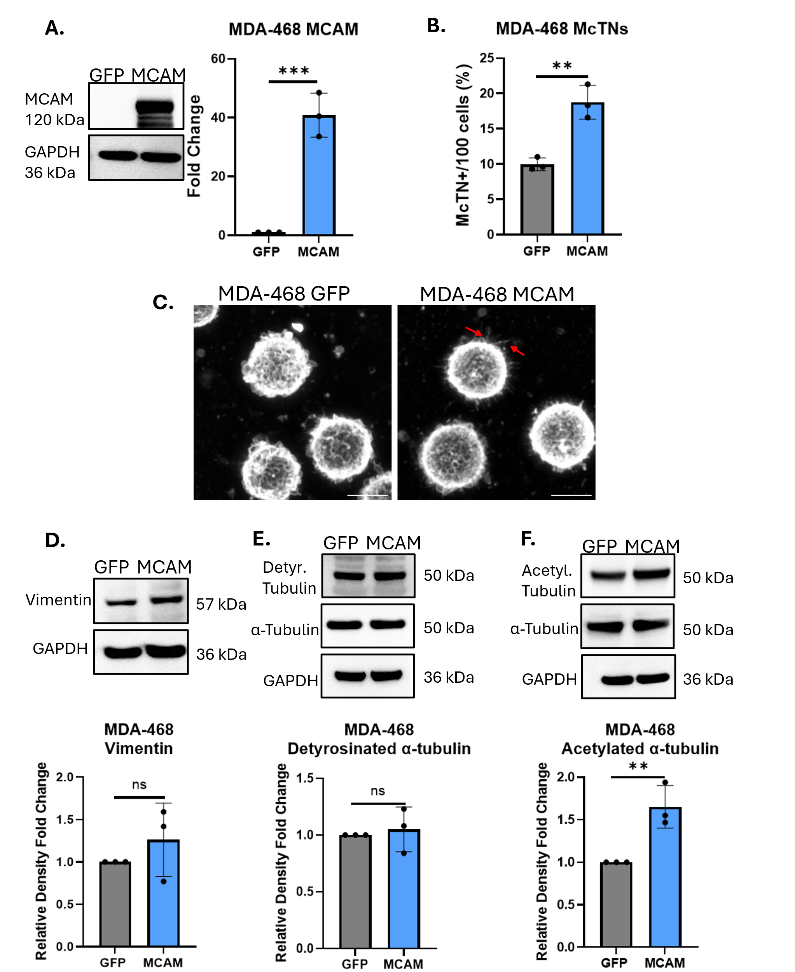
Supp Figure 2: MCAM overexpression in TNBC increases McTNs and acetylated tubulin.
A) Immunoblot analysis of MDA-468 cell lines stably expressing either GFP or MCAM, probed for MCAM and GAPDH (Left). Densitometry fold change analysis for MCAM protein expression. Error bars indicate mean ± standard deviation, n=3 (Right). *** p<0.001 (Two-tailed t-test). B) McTN quantification of tethered and fixed MDA-468 GFP and MCAM OE cells. Data represents the quantification of McTN frequency from three independent experiments, with 100 cells counted in each. Error bars indicate ± standard deviation, n = 3. ***p<0.001(Two-tailed t-test). C) McTN images of MDA-468 GFP and MCAM cells stained with WGA. Images were taken at 60x magnification with 3 zoom using Nikon Ti2-E inverted microscope. Images were denoised in a post-processing step using NIS Elements. Scale bar = 10um. D) Protein levels of vimentin and GAPDH (top) in MDA-468 GFP and MCAM OE cells measured via immunoblot analysis. Densitometric fold change analysis (bottom) of vimentin expression. Error bars indicate ± standard deviation, n = 3 (Two-tailed t-test). E) Protein levels of detyrosinated α-tubulin, GAPDH, and α-tubulin (top) in MDA-468 GFP and MCAM cells measured via immunoblot analysis. Densitometric fold change analysis (bottom) of acetylated α-tubulin expression. Error bars indicate ± standard deviation, n = 3 (Two-tailed t-test). F) Protein levels of acetylated α-tubulin, GAPDH, and α-tubulin (top) in MDA-468 GFP and MCAM cells measured via immunoblot analysis. Densitometric fold change analysis (bottom) of acetylated α-tubulin expression. Error bars indicate ± standard deviation, n = 3 (Two-tailed t-test).

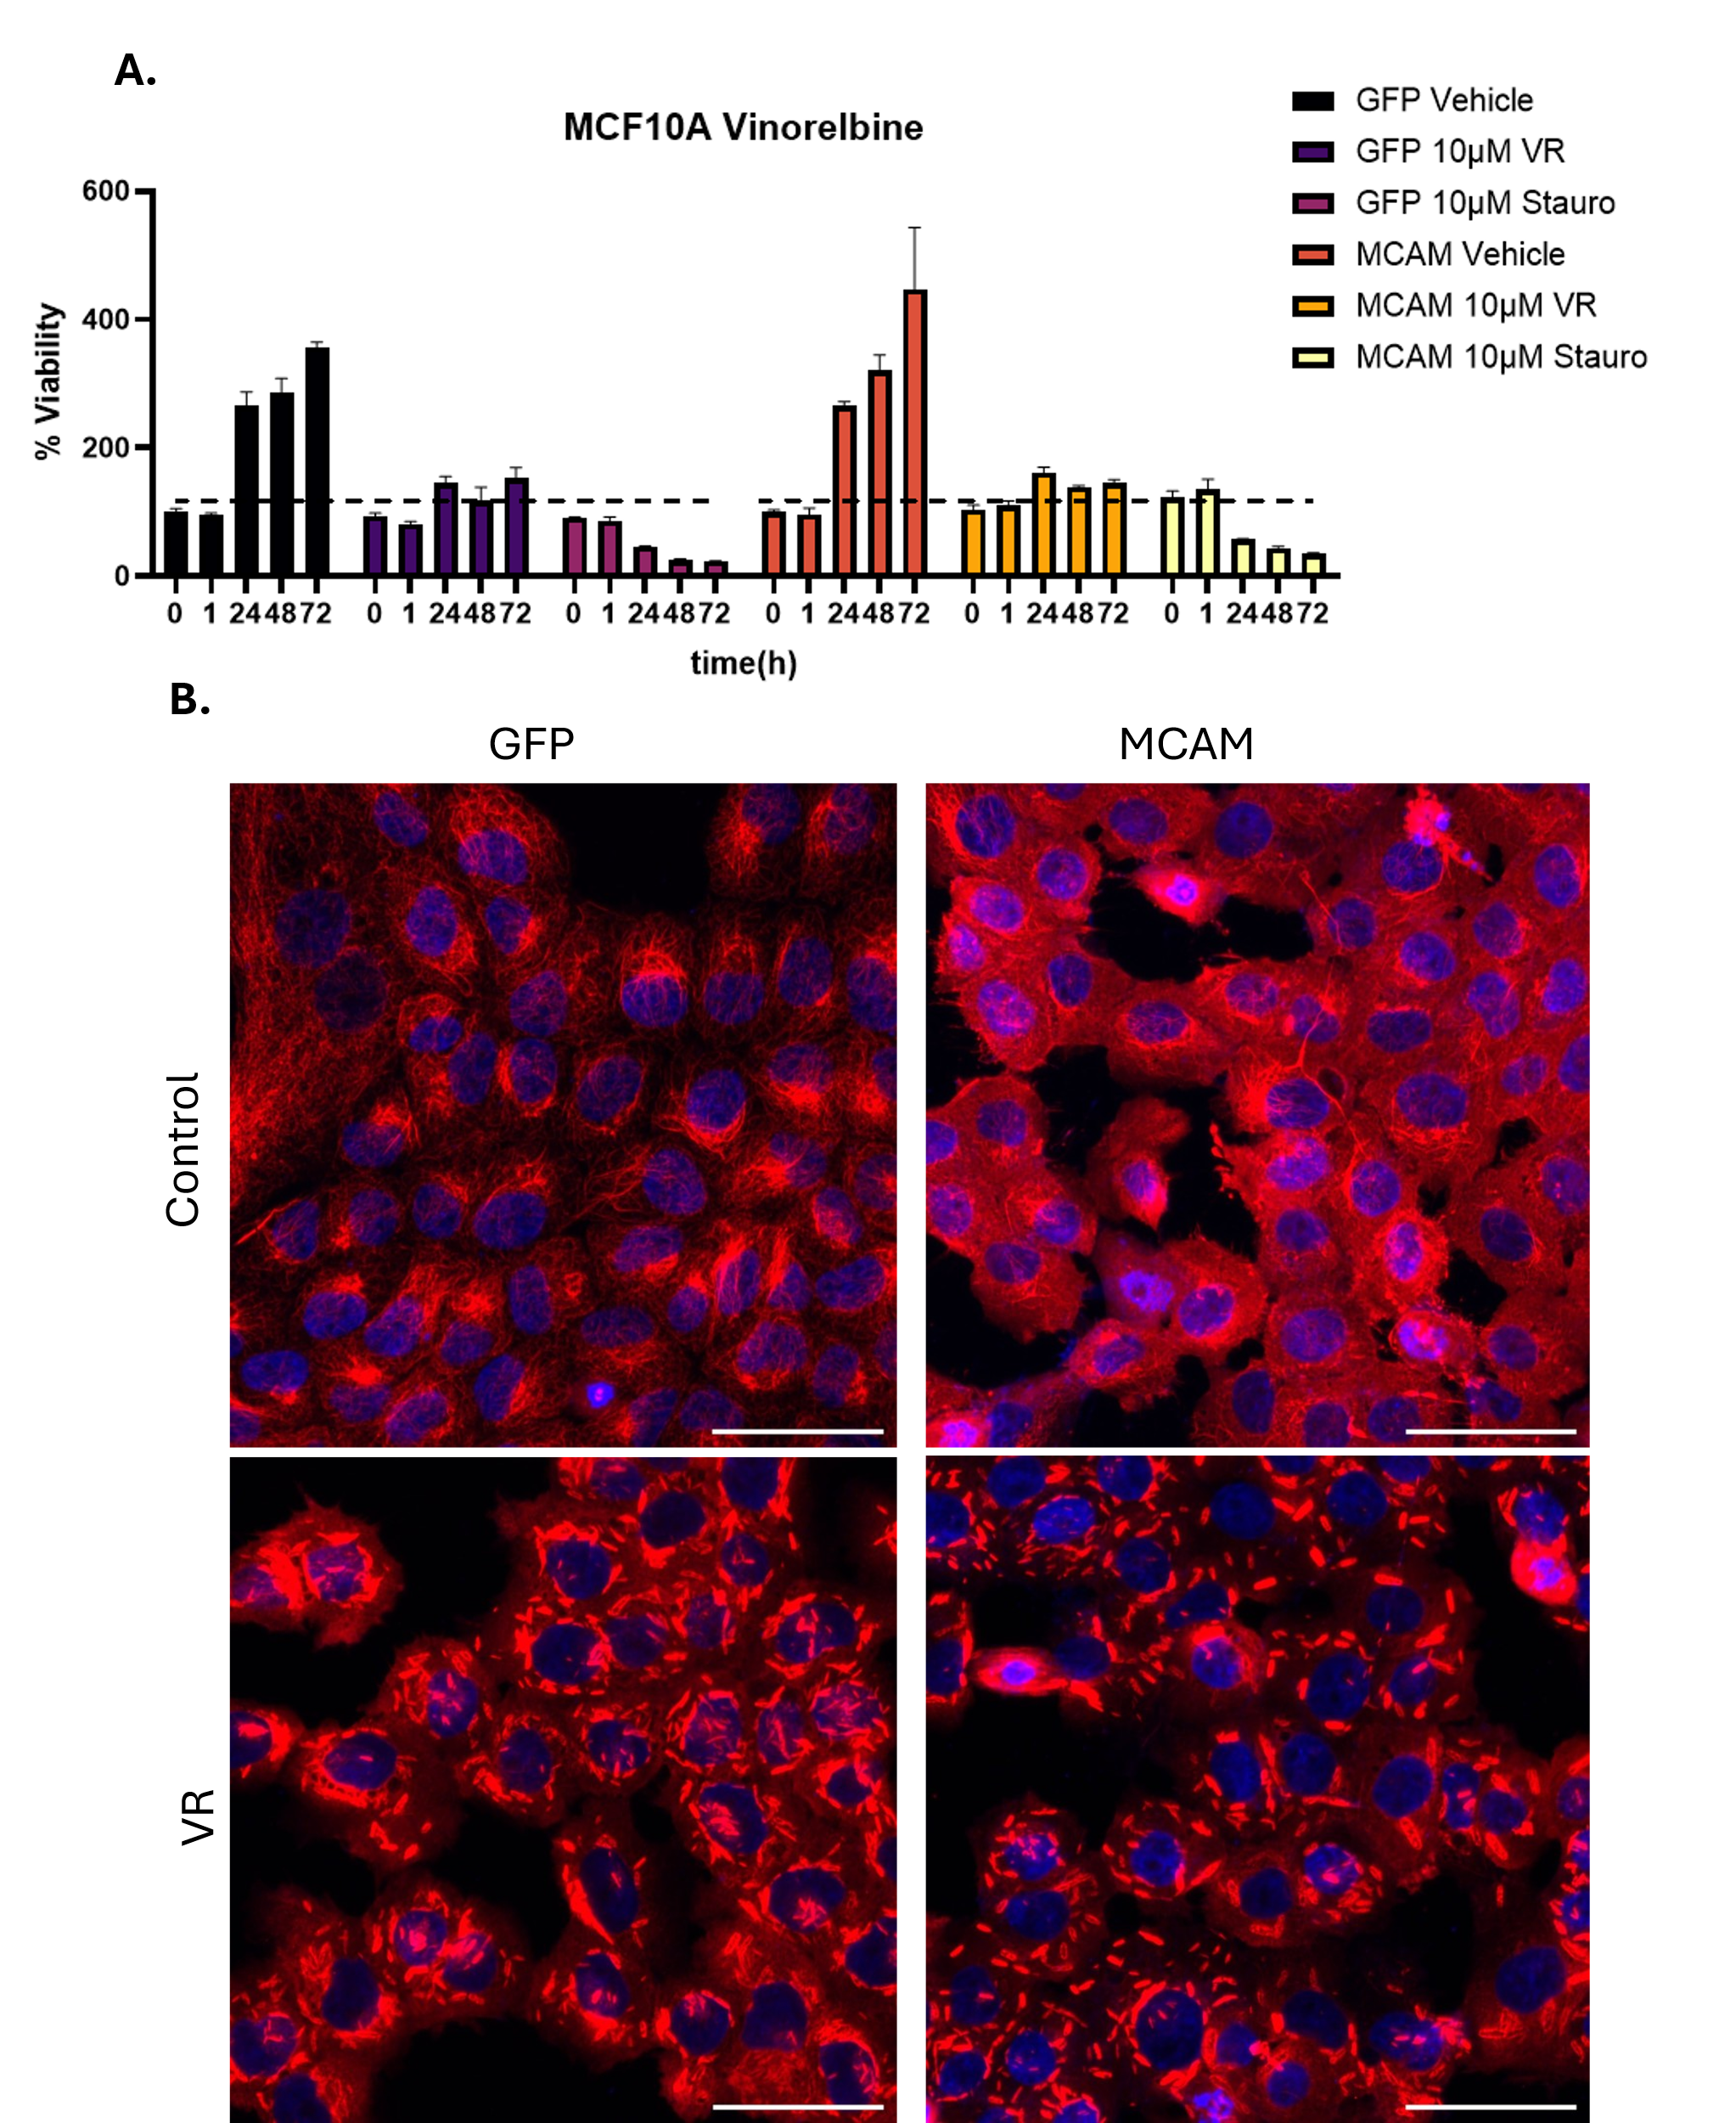
Supp Figure 3: Vinorelbine viability and α-tubulin immunofluorescence.
A) Representative viability of MCF-10A GFP and MCAM OE cells determined with a cell titer assay, observing up to three days post-treatment of vinorelbine(10 µM). Error bars indicate mean ± standard error of mean, n = 3. B) Immunofluorescent images of vinorelbine (10 µM) treated MCF-10A GFP and MCAM OE cells stained with α-tubulin (red) and Hoechst were taken at 20X magnification using a Nikon Ti2-E inverted microscope with a Nikon AX-R confocal system. Images were denoised in post-processing step using NIS elements. Scale bar = 50 μm.
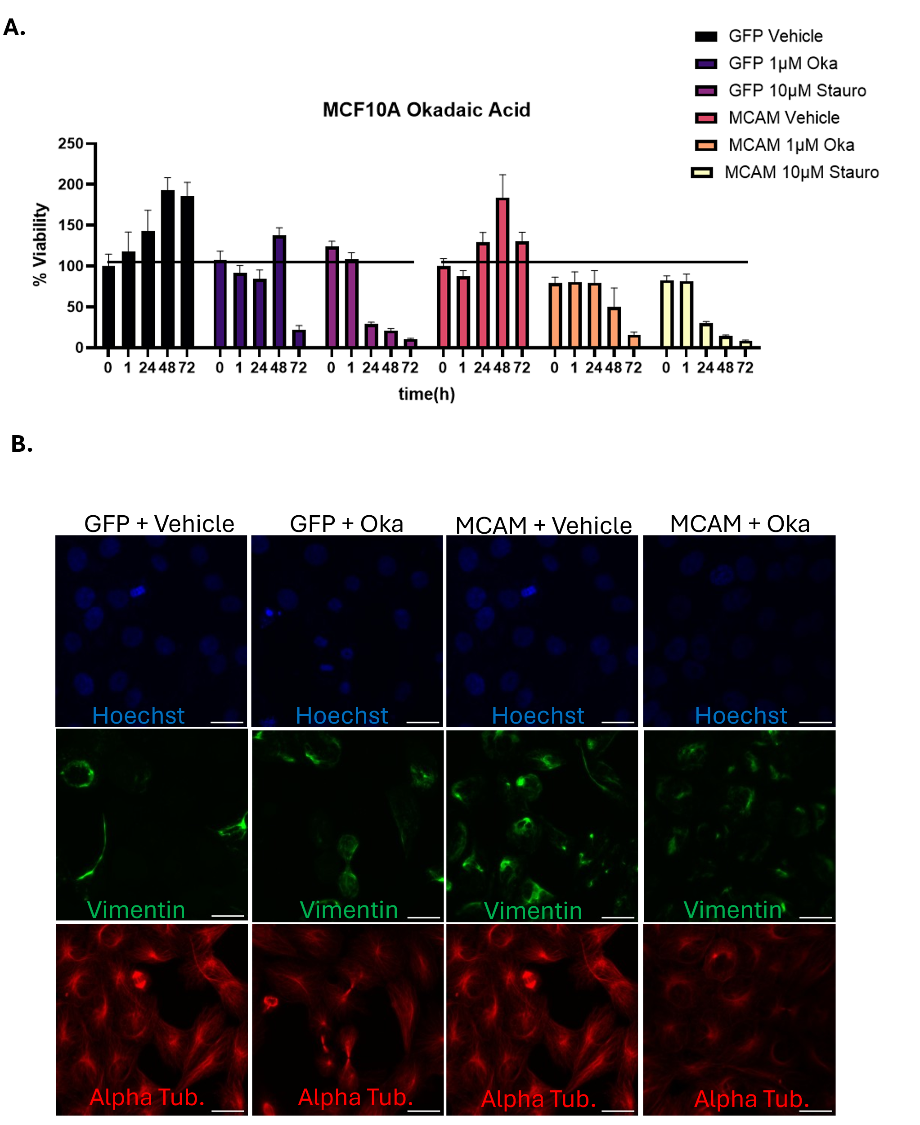
Supp Figure 4: Okadaic acid viability and vimentin immunofluorescence post-treatment.
A) Representative viability of MCF-10A GFP and MCAM OE cells determined with a cell titer assay observing up to three days post treatment of 1µM Okadaic acid. Error bars indicate mean ± standard error of mean, n = 3. B) Immunofluorescent images of 1 µM okadaic acid treated MCF-10A GFP and MCAM OE cells stained with alpha tubulin, vimentin, and Hoescht were taken at 40X magnification using a Nikon Ti2-E inverted microscope with a Nikon AX-R confocal system. Images were denoised in post-processing step using NIS elements. Scale bar = 25µm.

