MANUSCRIPT TITLE: Trop-2 overexpression as a prognostic marker in early triple-negative breast cancer: results from the GEICAM_CIBOMA trial
Supplementary material

Supplementary Figure S1. CONSORT flow diagram for cases included in the TNBC GEICAM_CIBOMA translational study cohort.
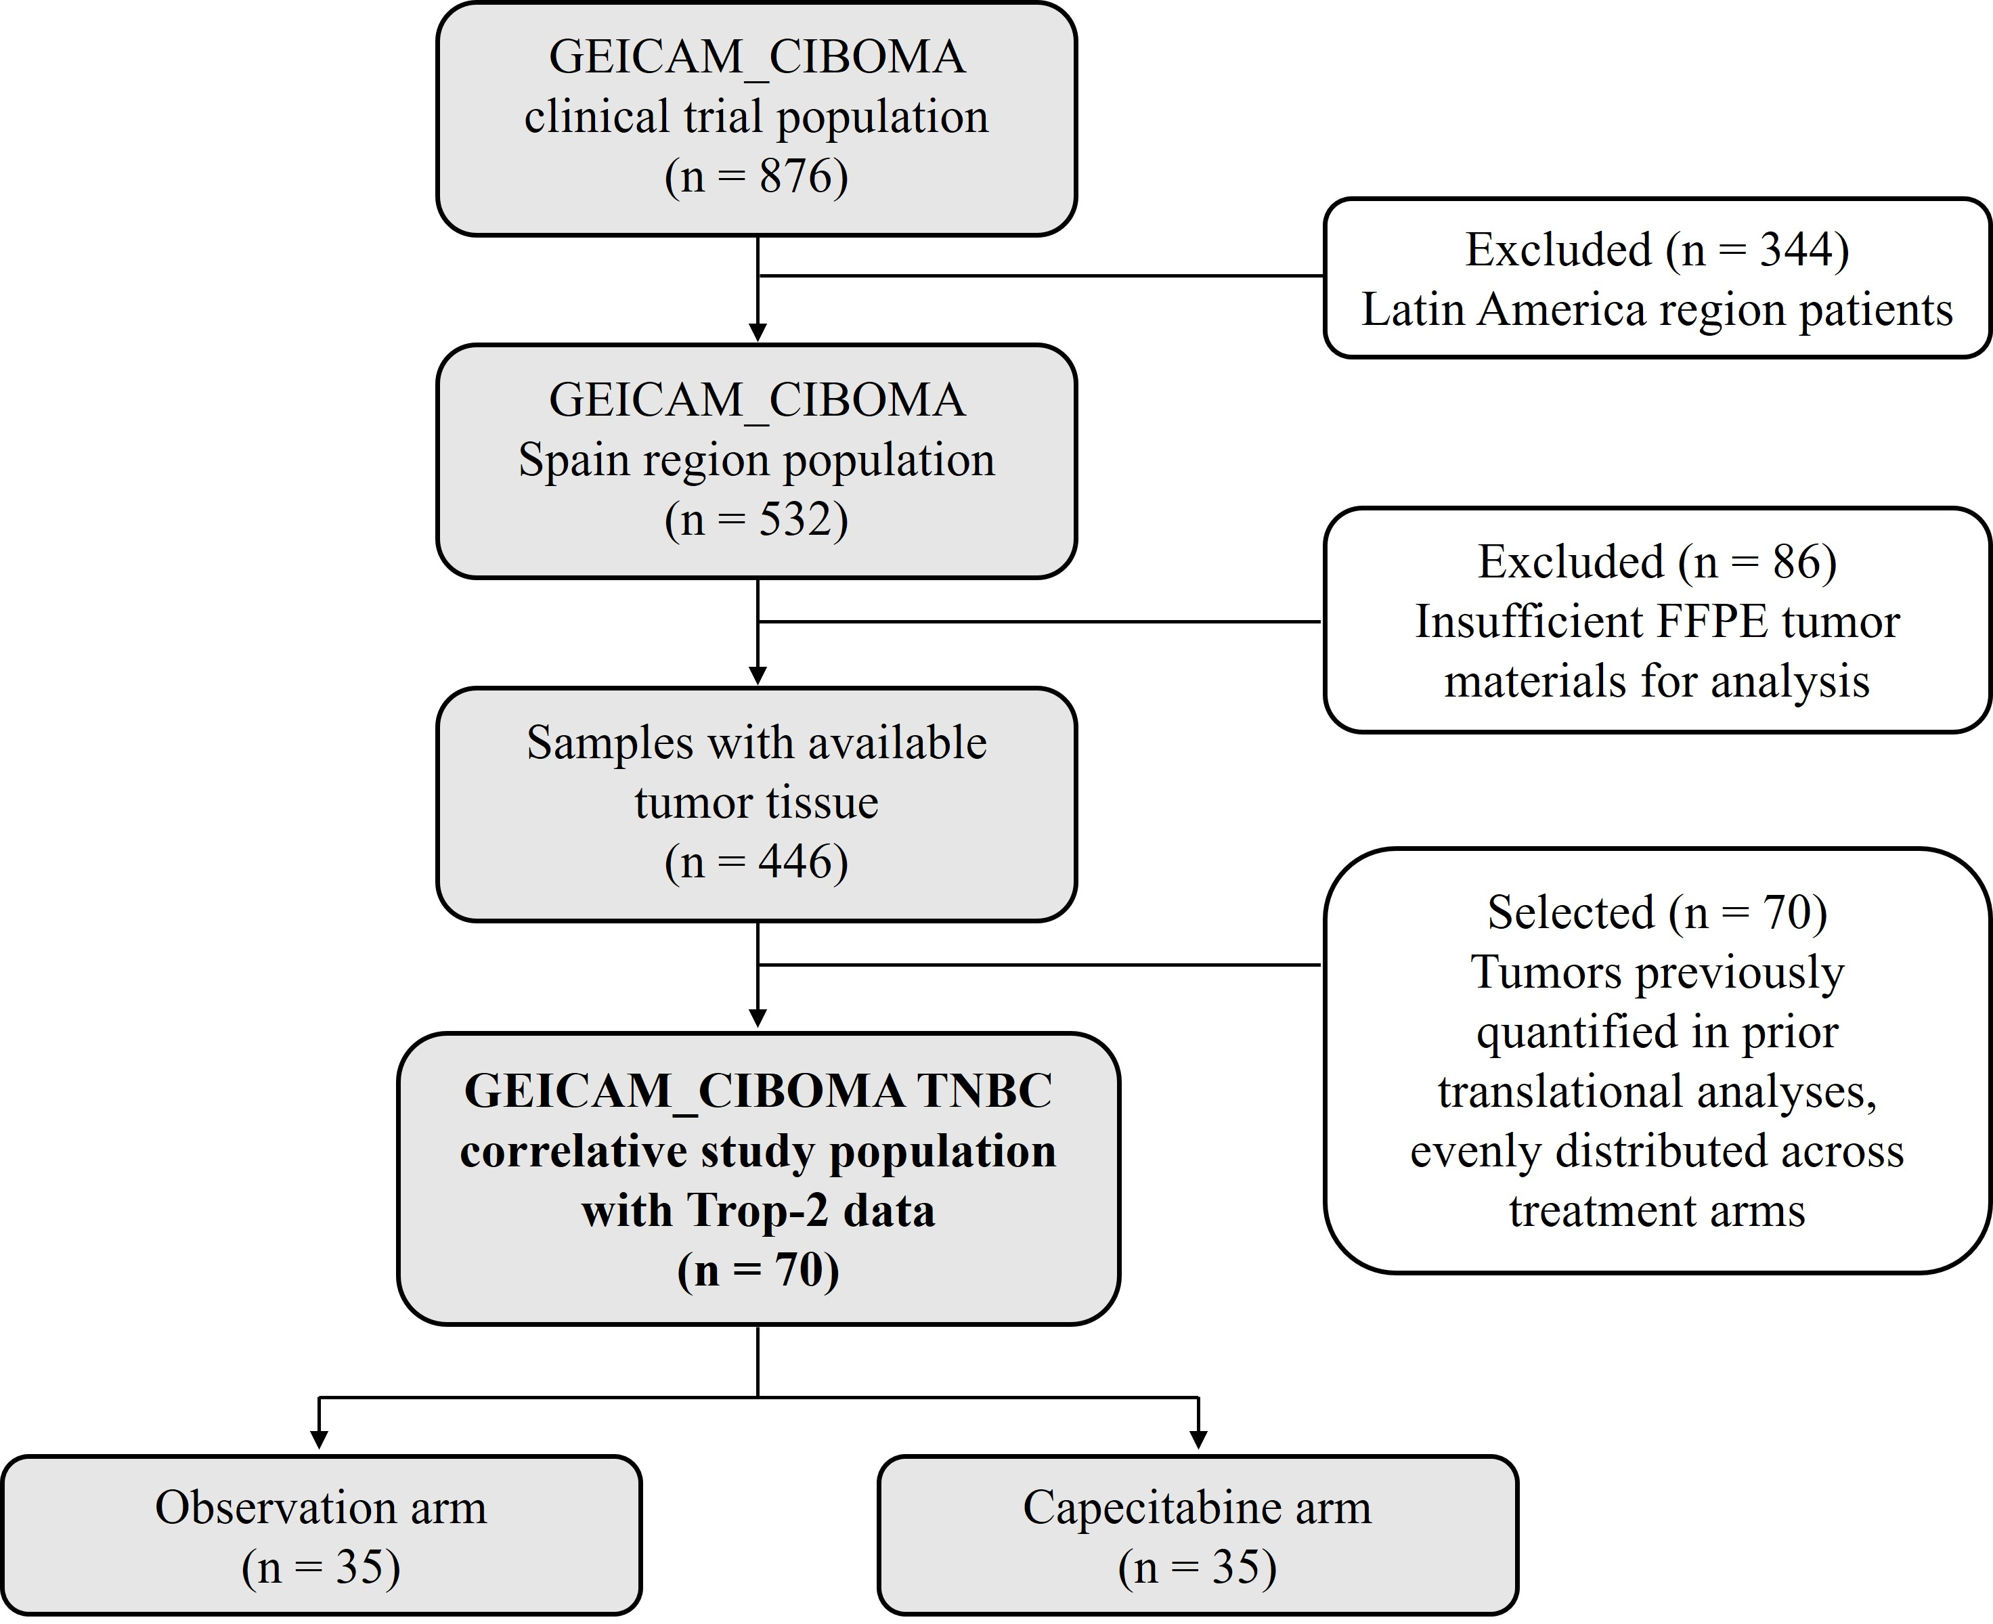
The analysis of the translational study cohort followed a prospective–retrospective design testing prespecified primary and secondary hypotheses using high-quality clinical trial materials with adherence to REMARK criteria and to the guidelines for use of archived clinical trial specimens for predictive biomarker evaluation on clinical trials. Molecular targets previously quantified in GEICAM_CIBOMA FFPE tumor materials: EGFR and CK 5/6 IHC expression (Lluch A et al, 2020, J Clin Oncol); customized nCounter gene expression panel (Asleh K et al, 2023, Clin Cancer Res); FOXC1 and Ki67 IHC expression (Rojo F et al, 2025, Clin Cancer Res). Abbreviations: TNBC, triple-negative breast cancer.

Supplementary Figure S2. Trop-2 membrane IHC staining in GEICAM_CIBOMA tumors.
Immunohistochemical detection of Trop‑2 using the anti–Trop‑2 monoclonal antibody (clone SP295), illustrating high (A–C), intermediate (D–F), low (G–I), and near‑absent (J–L) membranous Trop‑2 expression in representative TNBC tumor samples from the GEICAM_CIBOMA trial cohort. Negative control staining in tonsil tissue is shown in panels M–O. Scale bars correspond to 50 µm, 100 µm, and 200 µm for each TNBC tumor sample (rows). Abbreviations: TNBC, triple-negative breast cancer.

Supplementary Table 1. Clinicopathological characteristics comparing GEICAM_CIBOMA translational study cohort versus GEICAM_CIBOMA intention-to-treat whole cohort.
Characteristic | GEICAM_CIBOMA Translational study cohort  (n=70) No. (%) | GEICAM_CIBOMA Intention-to-treat whole cohort  (n=876) No. (%) | p-value*
Treatment arm |  |  | 0.953
Experimental - Capecitabine | 35 (50.0%) | 428 (48.9%)
Control - Observation | 35 (50.0%) | 448 (51.1%)
Histological Grade |  |  | 0.066
G1 | 5 (7.1%) | 27 (3.1%)
G2 | 7 (10.0%) | 163 (18.6%)
G3 | 55 (78.6%) | 622 (71.0%)
GX | 3 (4.3%) | 64 (7.3%)
Stage at diagnosis |  |  | 0.832
I | 12 (17.1%) | 156 (17.8%)
II | 43 (61.5%) | 558 (63.7%)
III | 15 (21.4%) | 162 (18.5%)
Karnofsky performance status |  |  | 0.141
80 | 2 (2.9%) | 25 (2.8%)
90 | 16 (22.9%) | 124 (14.2%)
100 | 52 (74.2%) | 727 (83.0%)
Menopausal status at diagnosis |  |  | 0.278
Premenopausal | 27 (38.6%) | 276 (31.5%)
Postmenopausal | 43 (61.4%) | 600 (68.5%)
Histological Type |  |  | 0.211
Infiltrating Ductal Carcinoma | 59 (84.3%) | 764 (87.2%)
Infiltrating Lobular Carcinoma | 0 (0%) | 19 (2.2%)
Carcinoma of other types | 11 (15.7%) | 93 (10.6%)
Tumor size |  |  | 0.799
≤2 cm | 21 (30.0%) | 264 (30.1%)
>2 and ≤5 cm | 43 (61.4%) | 515 (58.8%)
>5 cm | 6 (8.6%) | 97 (11.1%)
Nodal status |  |  | 0.437
Negative | 34 (48.6%) | 492 (56.2%)
1-3 | 22 (31.4%) | 246 (28.1%)
≥4 | 14 (20.0%) | 138 (15.7%)
Type of chemotherapy prior to randomization |  |  | 0.052
Adjuvant | 63 (90.0%) | 706 (80.6%)
Neoadjuvant | 6 (8.6%) | 164 (18.7%)
Unknown | 1 (1.4%) | 6 (0.7%)
pCR in patients with neoadjuvant chemotherapy |  |  | 0.338
No | 6 (100%) | 123 (75.0%)
Yes | 0 (0%) | 41 (25.0%)
Chemotherapy regimen |  |  | 0.762
Anthracyclines and Taxanes | 49 (70.0%) | 591 (67.5%)
Anthracyclines without Taxanes | 21 (30.0%) | 285 (32.5%)
Breast surgery |  |  | 0.740
Conservative | 40 (57.2%) | 479 (54.7%)
Mastectomy | 29 (41.4%) | 390 (44.5%)
Unknown | 1 (1.4%) | 7 (0.8%)
Axillary surgery |  |  | 0.207
ALND ± SLNB | 47 (67.1%) | 655 (74.8%)
SLNB | 23 (32.9%) | 221 (25.2%)
Radiotherapy |  |  | 0.415
No | 52 (74.3%) | 698 (79.7%)
Yes | 17 (24.3%) | 172 (19.6%)
Unknown | 1 (1.4%) | 6 (0.7%)
*Chi-squared test for categorical variables, and Mann-Whitney for continuous variables.
Abbreviations: pCR, pathologic complete response; ALND, axillary lymph node dissection; SLNB, sentinel lymph node biopsy.

