Supplemental Methods

Imaging Protocol
(1) Cohort 1: MR examinations were performed on a 3.0-T MRI scanner (Siemens Healthineers, Erlangen, Germany) using a 16-channel phased-array breast surface coil. Before contrast injection, all patients underwent T1-weighted imaging (T1WI; fast spin-echo sequence, TR/TE 8600/4.7 ms; thickness 5.0 mm), T2WI (short time inversion recovery, TR/TE 5600/56 ms; thickness 5.0 mm), and DWI (single-shot echo-planar imaging, TR/TE 5600/75 ms; thickness 5.0 mm; b value 0/800 s/mm²), followed by DCE-MRI (spoiled gradient echo, TR/TE 4.4/1.8 ms; thickness 1.5 mm). A contrast agent (Magnevist, Bayer HealthCare Pharmaceuticals Inc., Wayne, USA) was injected (0.1 mmol/kg, rate of 2.0 ml/s) after a plain scan and was followed immediately by a 20-ml saline flush. Post-contrast images were acquired at 90, 150, 210, 270 and 330 s after injection, at 60-s intervals.
(2) DUKE datasets [1]: MR examinations were performed on 1.5T or 3T MRI scanner (GE Medical Systems, Siemens or MPTronic software). The imaging protocols included a pre-contrast non-fat saturated T1-weighted sequence and a fat-saturated gradient echo T1-weighted sequence. Typically, three to four post-contrast T1-weighted sequences with fat suppression were acquired after the IV administration of contrast agent using a weight-based protocol of (0.2 mL/kg). The contrast-enhanced series consisted of a high-resolution (≤1 mm in-plane spatial resolution), three-dimensional, fat-suppressed, T1-weighted gradient-echo sequence (flip angle, 7°-12°; field of view, 250–480 mm; minimum matrix, 320 × 320; section thickness, 0.9-2.5 mm).
(3) I-SPY 1 datasets [2]: MR examinations were performed on 1.5T MR scanner (GE Medical Systems, Siemens or Philips Medical Systems). The imaging protocols included a localization sequence and T2-weighted sequence followed by a contrast-enhanced T1-weighted series. The early-phase and delayed-phase were performed at 2.5 mins and 7.5 mins after injection of the contrast material, respectively. All imaging was performed unilaterally over the symptomatic breast in the sagittal orientation. The contrast-enhanced series consisted of a high-resolution (≤1 mm in-plane spatial resolution), three-dimensional, fat-suppressed, T1-weighted gradient-echo sequence (repetition time msec/echo time msec, ≤20/4.5; flip angle, ≤45°; field of view, 16–18 cm; minimum matrix, 256 × 192; 64 sections; section thickness, ≤2.5 mm).

Image Standardization Process:
Due to variations in imaging acquisition parameters (e.g., matrix size and slice thickness), image standardization was performed prior to peritumoral region generation and feature extraction. First, breast segmentation across all imaging phases was performed using the nnU-Net framework. Image-level intensity normalization was subsequently applied within the segmented breast regions to reduce inter-scan signal variability [4]. Images and corresponding segmentation masks were then resampled once to a uniform isotropic voxel spacing (1×1×1 mm³) in three-dimensional space to ensure spatial consistency across patients and imaging sequences. Linear interpolation was applied to image intensities, whereas nearest-neighbor interpolation was used for segmentation masks. Gaussian filtering was subsequently applied to reduce image noise and improve smoothness prior to feature extraction [5].

Volume of interest (VOI) Segmentation
- Whole-tumor region
VOIs were placed on all slices of the whole-tumor. For multiple lesions, only the largest lesion was delineated and analysed in the following process. Two radiologists (X.X and Y.Y, with 6 and 2 years of breast MRI experience) randomly delineated VOIs for 100 patients using 3D Slicer software to validate the repeatability of features. Interobserver repeatability was assessed using the intraclass correlation coefficient (ICC), as follows: poor (0.0-0.50), moderate (0.51-0.75), good (0.76-0.90) and excellent (0.91-1.0) [6].
(2) Peritumoral region
The peritumoral region was defined as a three-dimensional ring extending 5 mm outward from the tumor boundary. To ensure geometric consistency, all images and corresponding tumor masks were resampled to isotropic voxel spacing prior to region generation. Peritumoral expansion was implemented in physical space based on the Euclidean distance between voxels, accounting for voxel spacing in all directions. Specifically, for each voxel outside the tumor mask, its Euclidean distance to the nearest tumor voxel was computed as:
$$D=\sqrt{{[s₁(x-x₀)]}^{2}+{[s₂(y-y₀)]}^{2}+{[s₃(z-z₀)]}^{2}}$$
where (x, y, z) and (x₀, y₀, z₀) denote the spatial coordinates of a given voxel and its nearest tumor voxel, respectively, and s₁, s₂, s₃ represent voxel spacing along each axis.
Voxels with a distance less than or equal to 5 mm were included in the peritumoral region. The original tumor mask was then subtracted to obtain the final peritumoral ring. This procedure yields a region with a uniform 5-mm thickness around the tumor boundary, independent of voxel anisotropy, and is mathematically equivalent to a standard three-dimensional distance transform.
To avoid inclusion of non-breast tissues, the generated peritumoral region was constrained within the breast parenchyma using the breast mask. Voxels extending beyond the breast boundary were excluded. In cases where the expanded region intersected anatomical boundaries or included implausible regions, manual consensus adjustment was performed by experienced readers. The choice of a 5-mm distance was based on our prior study [7], providing a standardized definition of the peritumoral region.
(3) Intratumoral subregions
Intratumoral subregions were defined using an unsupervised k-means clustering approach applied at the individual tumor level. For each tumor, four voxel-wise kinetic parameters were calculated from multiphase DCE-MRI based on the time–signal intensity curve, including wash-in slope (WIS), washout slope (WOS), signal enhancement ratio (SER), and percentage enhancement (PE). WIS quantifies the early enhancement rate, WOS reflects delayed signal washout, while SER and PE characterize enhancement magnitude and persistence. These parameters characterize different aspects of contrast enhancement behavior, which were used for intratumoral subregion clustering, following the previous studies [8-9].
The kinetic parameters were defined as follows (Supplementary Figure E1a):
$$WIS=\frac{S_{early}-S_{pre}}{t_{early}-t_{pre}}$$
$$WOS=\frac{S_{early}-S_{late}}{t_{late}-t_{early}}$$
$$SER=\frac{S_{early}-S_{pre}}{S_{late}-S_{pre}}$$
$$PE=\frac{S_{early}-S_{pre}}{S_{pre}}$$
where $t_{pre}$, $t_{early}$, and $t_{late}$ represent the acquisition times of the corresponding phases.
$S_{pre}$, $S_{early}$, and $S_{late}$ represent pre-contrast, early post-contrast, and late post-contrast phases.
The number of clusters (k) was determined using data-driven methods, including the elbow method and the Calinski-Harabasz index. Across the development cohort, k = 3 was consistently identified as the optimal or near-optimal clustering solution in majority of cases. This finding was further confirmed in the external validation cohort, where k = 3 also yielded the best clustering performance (Supplementary Figure E1b-c, Table E1).
In line with prior DCE-MRI studies, the three clusters were interpreted as imaging-defined perfusion regions (low, intermediate, and high) based on the relative distributions of enhancement-related kinetic parameters (WIS, WOS, SER, and PE; Supplementary Figure E2a). Specifically, the cluster exhibiting relatively lower values across these parameters was labeled as low-perfusion (visualized in red), the cluster with intermediate values as intermediate-perfusion (green), and the cluster with relatively higher values as high-perfusion (blue). These regions reflect imaging-derived enhancement differences rather than direct biological measurements and were visualized using color-coding to illustrate their spatial distribution (Supplementary Figure E2b).

Radiomics Features Extraction
All radiomic features were extracted from multiregional ROIs using the PyRadiomics package (version 3.0) in Python (version 3.6) [10].
(1) Traditional radiomic features
A total of 851 radiomic features were extracted for each region according to the Image Biomarker Standardisation Initiative [10]. These comprised 14 shape features derived from the original images and corresponding segmentation masks, as well as first-order and texture features (GLCM, GLRLM, GLSZM, NGTDM, and GLDM) extracted from the original image and eight wavelet-filtered images. Wavelet decomposition was performed using a one-level three-dimensional discrete transform with the Coiflet 1 mother wavelet, generating eight sub-band images (LLL, LLH, LHL, LHH, HLL, HLH, HHL, and HHH). Detailed feature composition is provided in Tables E2-E4.
These traditional radiomic features were extracted from seven regions: three whole-tumor regions (pre-, early-, and late-contrast), the peritumoral region, and three intratumoral subregions (poor-, moderate-, and high-perfusion). The serial number of radiomic features is provided in Table E5. This multiscale feature extraction strategy was designed to comprehensively capture both global and localized textural variations across different spatial directions, thereby improving the robustness and predictive power of the models.
(2) Kinetic features
Kinetic features were calculated to characterize temporal enhancement patterns across three DCE-MRI phases: precontrast, early postcontrast, and late postcontrast. The workflow was adapted from our previously described kinetic radiomics strategy and comprised two steps [7]:
- Extraction of conventional radiomic features from the whole-tumor volume of interest in each DCE phase.
- Calculation of the mean and variance across the three phases for each radiomic feature.
Shape features were excluded from the kinetic analysis because they were derived from an identical tumor segmentation across phases and therefore did not represent phase-dependent enhancement information. Consequently, 837 non-shape first-order and texture features were included. For a given radiomic feature with phase-specific values $x_{1},x_{2},x_{3}$, the following temporal summary measures were calculated:
Statistic | Formula (for values $x_{1},x_{2},x_{3}$) | Interpretation
Mean | $$\overset{ˉ}{x}=\frac{1}{3}∑x_{i}$$ | Average enhancement magnitude
Variance | $$\frac{1}{3}∑(x_{i}-\overset{ˉ}{x})^{2}$$ | Variability across phases

(3) Multiregional spatial interaction (MSI) features
A multiregional spatial interaction (MSI) matrix was constructed to quantify spatial heterogeneity and interactions among the intratumoral subregions and the peritumoral region, following previously reported approaches (Figure E3) [9]. Each tumor was partitioned into three intratumoral subregions (poor-, moderate-, and high-perfusion) together with the surrounding peritumoral region. To construct the MSI matrix, a 3D neighborhood was defined using 26-connectivity (i.e., each voxel was considered adjacent to its surrounding voxels in all directions). For each voxel, all adjacent voxels were identified, and each neighboring voxel pair was assigned to a region pair based on their labels. To avoid double counting, each unordered voxel pair was considered only once, and interactions between region pairs were accumulated into a symmetric 4×4 matrix. In this matrix, diagonal elements represent the connected size of each region, whereas off-diagonal elements represent the extent of spatial interfaces between different regions. The raw MSI matrix was further normalized by dividing each element by the total number of neighboring voxel pairs, yielding relative interaction measures.
Based on the MSI matrix, a total of 22 features were extracted. Absolute-count features were computed directly from the raw matrix, reflecting the size of individual regions and their interfaces. Normalized features were derived from the normalized matrix, representing the relative proportions of spatial interactions. In addition, second-order statistical descriptors (e.g., contrast, homogeneity, and energy) were calculated to summarize overall spatial heterogeneity patterns.
Intraclass correlation coefficient (ICC)
Interobserver reproducibility was assessed for each eligible radiomic feature after exclusion of the skewness- and kurtosis-derived kinetic features. The intraclass correlation coefficient (ICC) was calculated using a two-way random-effects model with absolute agreement for single measurements. For each repeated 70/30 split of Cohort 1, the patients assigned to the training subset were intersected with the prespecified 100-patient double-segmentation subset. ICCs were calculated exclusively from the paired feature measurements available within this training-set reproducibility sample. Patients assigned to the corresponding internal test subset were excluded from both the ICC calculation and the resulting feature-retention decision. Features with an ICC ≥0.75 were retained for subsequent analysis in that iteration.
No additional segmentations were performed during repeated splitting. Instead, the previously obtained paired segmentations and their corresponding feature measurements were used according to the patient assignments in each iteration.
The ICC can be expressed as:
$$ICC(2,1)=\frac{MS_{R}-MS_{E}}{MS_{R}+(k-1)MS_{E}+\frac{k(MS_{C}-MS_{E})}{n}}$$
where $MS_{R}$ is the mean square for rows (subjects), $MS_{C}$ is the mean square for columns (raters), $MS_{E}$ is the residual mean square, $k$ is the number of raters, and n is the number of subjects.
This formulation corresponds to the ICC (2,1) model described by Shrout and Fleiss, reflecting absolute agreement between measurements obtained by different raters.
Bioinformatic Analysis
The biological relevance of the MRI-based model was investigated in Cohort 3, which comprised 49 I-SPY1 patients from Cohort 2 with matched pretreatment MRI and transcriptomic data. Differential expression analysis between MRI-predicted responders and non-responders was performed using the limma package (version 3.58.1) in R software (version 4.3.0). Differentially expressed genes were identified using moderated t tests with Benjamini–Hochberg false-discovery rate correction, with |log2 fold change| ≥2 and an FDR-adjusted P<.05 as the significance criteria.
Pathway-enrichment analysis was performed using the BioEnricher package (version 0.1.0) to identify biological processes associated with MRI-predicted response. Immune-cell infiltration was evaluated using single-sample gene set enrichment analysis implemented in the GSVA package (version 1.48.3), and enrichment scores were compared between the predicted response groups. Protein–protein interaction network analysis of the differentially expressed genes was performed using Cytoscape software (version 3.10.1), and core genes were selected according to network connectivity and biological relevance. The identified core genes were used to construct a gene-based classifier, which was independently evaluated in Cohort 4, comprising 257 patients from GSE25066.

Identification of SNF Subtypes in HR+HER2− Breast Cancer
- Histological and Immunohistochemical Staining Procedures
Paraffin-embedded tissue sections were deparaffinized at 60°C for 20 minutes, cleared in xylene, and rehydrated through graded alcohols. For H&E staining, Mayer's hematoxylin (Sigma-Aldrich) and 0.1% sodium bicarbonate were used, followed by eosin Y (Sigma-Aldrich). IHC involved antigen retrieval in saline-citrate buffer at 95-100°C. After cooling, slides were blocked with a solution of 2% goat serum, 2% BSA, and 0.05% Tween in PBS at room temperature, then incubated with primary antibodies at 4°C. Endogenous peroxidase activity was quenched with 0.3% H₂O₂. Slides were then treated with HRP-conjugated secondary antibodies (Genetech) at room temperature and developed using 3,3′-diaminobenzidine (Genetech). Hematoxylin was used for counterstaining, and slides were dehydrated through graded alcohols. Positive staining density was quantified using a Leica DFC420 camera connected to a DM IRE2 microscope (Leica Microsystems Imaging Solutions) [11].
- Whole‑slide image (WSI) processing and deep learning‑based SNF subtype classification
Hematoxylin and eosin (H&E)‑stained slides were scanned at ×40 magnification using a NanoZoomer S210 digital pathology scanner to generate WSIs. On each WSI, one or two ROIs containing the majority of invasive carcinoma were manually annotated using ImageScope software (v12.4.0.5043), excluding background and non‑informative tissue areas. Within each ROI, images were tiled into non‑overlapping 256 × 256 pixel patches using MATLAB (v2021a) and the OpenSlide library. Blurred and non‑informative background patches were discarded. A previously established tissue‑type classifier was then applied to classify each patch into five categories: tumor, stroma, immune infiltrate, normal breast gland, or necrosis/hemorrhage. For SNF subtype prediction, a one‑versus‑rest strategy with patient‑level three‑fold cross‑validation was adopted. The distribution of the four SNF subtypes was kept balanced across the three folds. For each subtype model, 500 patches were randomly sampled from each patient’s WSI, and all patches inherited the corresponding patient’s label. Class balance in the training set was achieved by downsampling. A ResNet‑18 model pretrained on ImageNet was fine‑tuned using PyTorch (v1.10.0) in Python (v3.6). Training was performed for 100 epochs with cross‑entropy loss, batch size 256, learning rate 0.001, and the Adam optimizer. Patient‑level prediction scores were calculated by averaging the patch‑level probabilities of all sampled patches from that patient. The best model for each subtype was selected based on the highest area under the AUC in the validation fold. For an unlabeled WSI, the four subtype‑specific models were applied; if only one model returned a positive prediction, the case was assigned that SNF subtype; if multiple models were positive, the result from the model with the highest overall cross‑validation accuracy was used. Additional technical details are available in the original study [1].
- Pathological Features of the Four SNF Subtypes
SNF1 is characterized by partial preservation of normal breast morphology. SNF2 shows high immune cell infiltration. SNF3 is marked by a high abundance of atypical tumor cells. SNF4 features clusters of tumor cells enriched with surrounding fibroblasts [11].

Figures
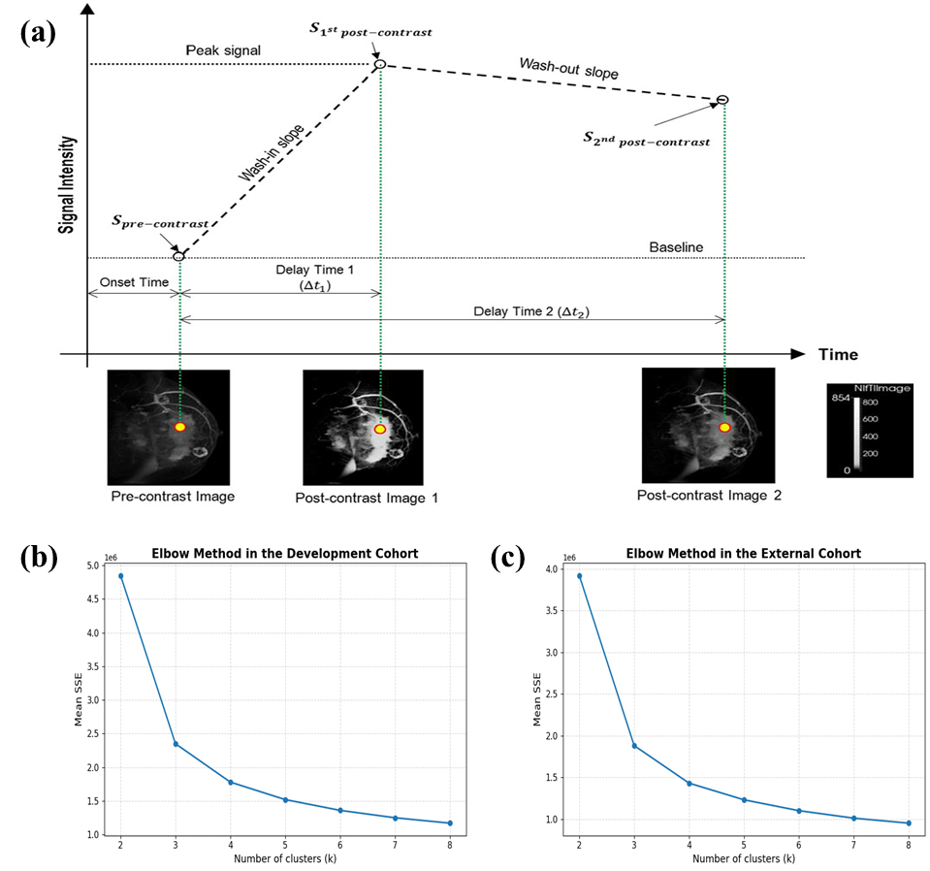
Figure E1. Definition of kinetic parameters and determination of the optimal number of clusters for intratumoral subregion analysis.
(a) Schematic illustration of the time-signal intensity curve (TIC) derived from multiphase DCE-MRI, showing the calculation of enhancement-related kinetic parameters, including uptake slope (WIS), washout slope (WOS), signal enhancement ratio (SER), and percentage enhancement (PE). This schematic is adapted from a previously published study [9].
(b) Elbow method for determining the optimal number of clusters (k) in the development cohort. The curve represents the average within-cluster sum of squares (SSE) across all patients.
(c) Elbow method for determining the optimal number of clusters (k) in the external validation cohort, showing a consistent inflection point at k = 3.
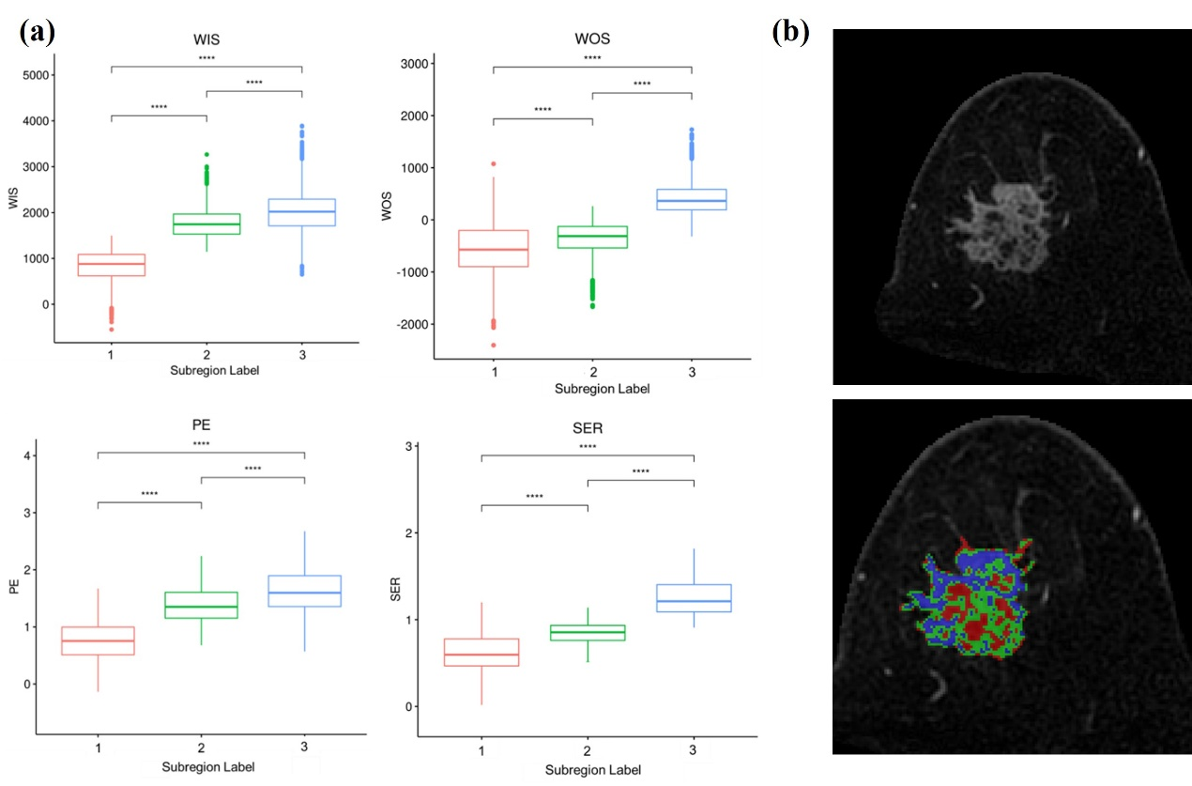
Figure E2. Imaging-defined intratumoral subregions based on multiphase DCE-MRI kinetic parameters.
(a) Distribution of wash-in slope (WIS), washout slope (WOS), percentage enhancement (PE), and signal enhancement ratio (SER) across the three intratumoral subregions identified by k-means clustering. *P < 0.001.
(b) Representative example of color-coded intratumoral subregions on DCE-MRI, including low-perfusion (red), intermediate-perfusion (green), and high-perfusion (blue) regions.

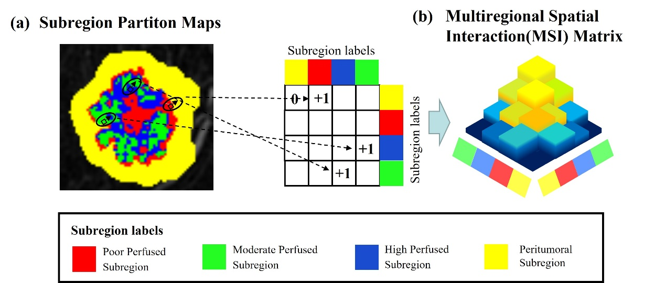
Figure E3. Schematic illustration of multiregional spatial interaction (MSI) feature extraction.
(a) Each voxel within the tumor and peritumoral region is assigned to one of four regions, including three intratumoral subregions and the peritumoral region. Spatial adjacency between regions is quantified by examining neighboring voxel pairs in three dimensions.
(b) The frequency of adjacent voxel pairs for each region combination is accumulated to construct a 4×4 MSI matrix, which summarizes both the connected size of individual regions (diagonal elements) and the spatial interfaces between different regions (off-diagonal elements). A total of 22 MSI-derived features were subsequently extracted from the MSI matrix to characterize spatial heterogeneity.

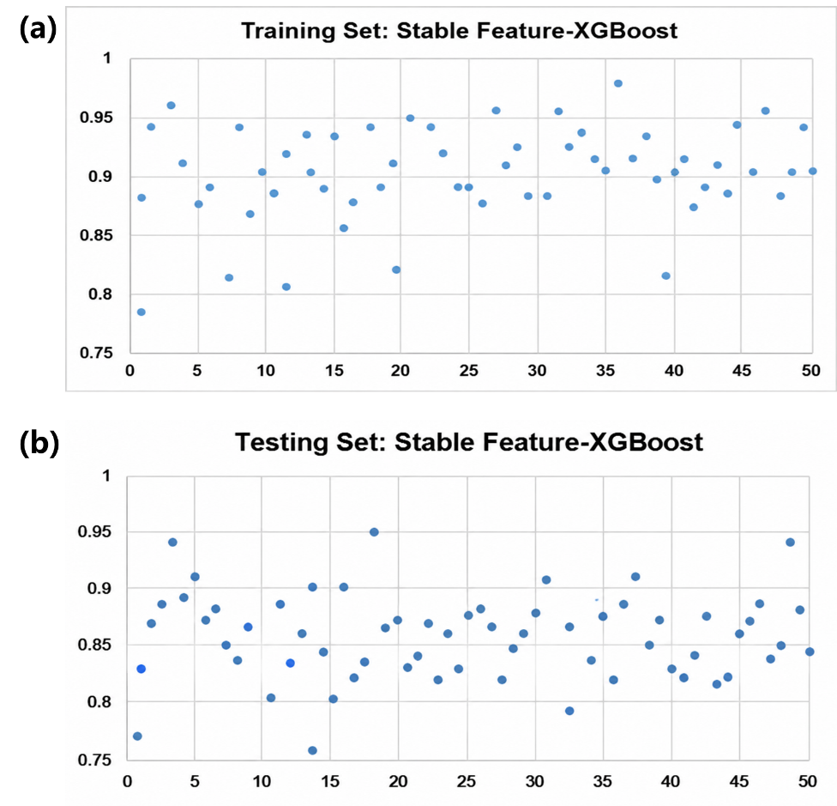
Figure E4. Stability Analysis of the Stable Feature–XGBoost Model in the Training and Testing Sets
Scatter plots illustrating the predictive stability of the stable feature–XGBoost model across 50 repeated runs in the training set (top) and testing set (bottom). Each point represents the area under the receiver operating characteristic curve (AUC) obtained from one repeated random split. The model demonstrated consistently high predictive performance with limited variability across repeated experiments, indicating good robustness and reproducibility of the stability-driven feature selection strategy.

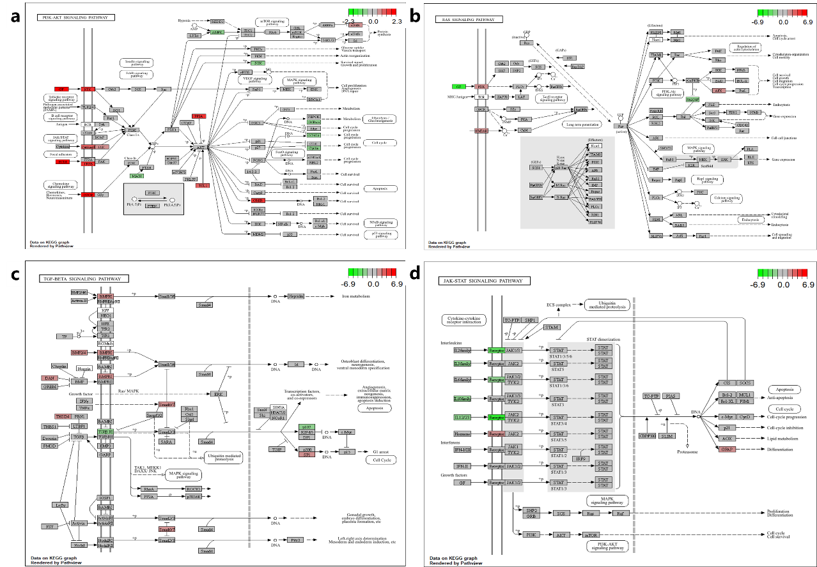
Figure E5. Illustrations for the PI3K-AKT, RAS, TGF-β, and JAK-STAT signaling pathways

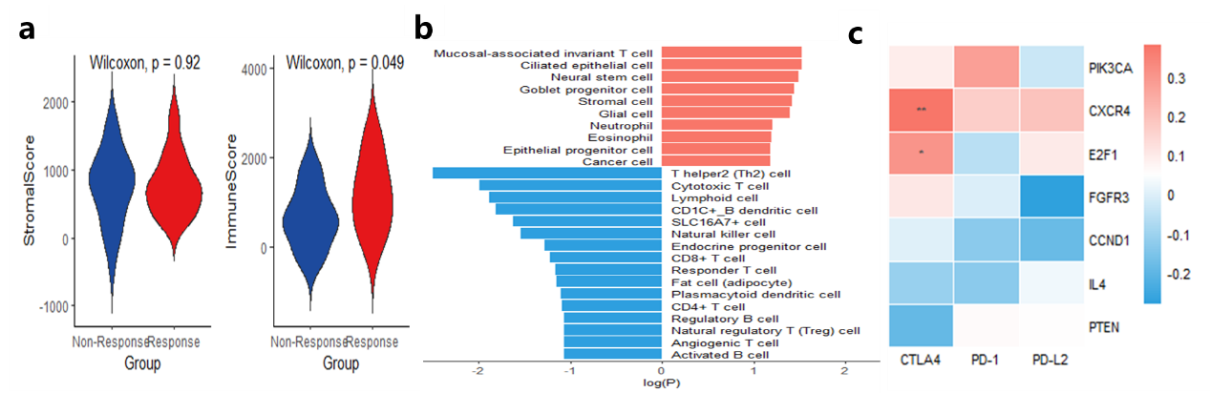
Figure E6. Exploration of the Immune Microenvironment in NAC Response and Non-Response Groups
(a) Stromal score and immune score. (b) CellMarker enrichment analysis confirming the activation of multiple T-cell immune-related pathways in the NAC-responsive group. (c) Relationship between core genes and immune checkpoint inhibitors.

References
[1] Saha, A., Harowicz, M. R., Grimm, L. J., Weng, J., Cain, E. H., Kim, C. E., Ghate, S. V., Walsh, R., & Mazurowski, M. A. (2021). Dynamic contrast-enhanced magnetic resonance images of breast cancer patients with tumor locations [Data set]. The Cancer Imaging Archive. https://doi.org/10.7937/TCIA.e3sv-re93
[2] David Newitt, Nola Hylton, on behalf of the I-SPY 1 Network and ACRIN 6657 Trial Team. (2016). Multi-center breast DCE-MRI data and segmentations from patients in the I-SPY 1/ACRIN 6657 trials. The Cancer Imaging Archive. https://doi.org/10.7937/K9/TCIA.2016.HdHpgJLK
[3] Clark K, Vendt B, Smith K, Freymann J, Kirby J, Koppel P, Moore S, Phillips S, Maffitt D, Pringle M, Tarbox L, Prior F. The Cancer Imaging Archive (TCIA): Maintaining and Operating a Public Information Repository, Journal of Digital Imaging, Volume 26, Number 6, December, 2013, pp 1045-1057. https://doi.org/10.1007/s10278-013-9622-7
[4] Isensee F, Jaeger P F, Kohl S, et al. nnU-Net: a self-configuring method for deep learning-based biomedical image segmentation [J]. Nature Methods, 2021, 18(2): 203-211.
[5] Al Shalabi L., Shaaban Z., Kasasbeh B. Data mining: A preprocessing engine[J]. Journal of Computer Science, 2006, 2(9): 735-739.
[6] Koo TK, Li MY. A Guideline of Selecting and Reporting Intraclass Correlation Coefficients for Reliability Research. J Chiropr Med. 2016 Jun;15(2):155-63.
[7] Jiang L, You C, Xiao Y et al. Radiogenomic analysis reveals tumor heterogeneity of triple-negative breast cancer. Cell Rep Med. 2022 Jul 19;3(7):100694.
[8] Wu J, Gong G, Cui Y, et al. Intratumor partitioning and texture analysis of dynamic contrast-enhanced (DCE)-MRI identifies relevant tumor subregions to predict pathological response of breast cancer to neoadjuvant chemotherapy. J Magn Reson Imaging. 2016 Nov;44(5):1107-1111.
[9] Wu J, Cao G, Sun X, et al. Intratumoral Spatial Heterogeneity at Perfusion MR Imaging Predicts Recurrence-free Survival in Locally Advanced Breast Cancer Treated with Neoadjuvant Chemotherapy. Radiology. 2018 Jul;288(1):26-35.
[10] Zwanenburg A, Vallières M, Abdalah MA, et al. The Image Biomarker Standardization Initiative: Standardized Quantitative Radiomics for High-Throughput Image-based Phenotyping. Radiology. 2020 May;295(2):328-338.
[11] Jin X, Zhou YF, Ma D, et al. Molecular classification of hormone receptor-positive HER2-negative breast cancer. Nat Genet. 2023 Oct;55(10):1696-1708.

Supplemental Tables
Table E1. Calinski-Harabasz index for different numbers of clusters (k) in the development and external validation cohorts.
k | Development cohort | External cohort
2 | 36,482.51 | 24,816.37
3 | 42,965.84 | 29,473.62
4 | 39,218.76 | 26,905.44
5 | 35,742.93 | 24,381.58
6 | 33,105.27 | 22,764.19
7 | 31,486.65 | 21,593.47
8 | 30,274.18 | 20,806.31
The Calinski-Harabasz index reached its maximum at k=3 in both the development and external cohorts.

Table E2. The eight wavelet filter configurations.
Sub-band | Filtering Along x-axis | Filtering Along y-axis | Filtering Along z-axis | Description
LLL | Low-pass | Low-pass | Low-pass | Represents the approximation component (low-frequency information)
LLH | Low-pass | Low-pass | High-pass | Edge details along z-axis
LHL | Low-pass | High-pass | Low-pass | Edge details along y-axis
LHH | Low-pass | High-pass | High-pass | High-frequency details in y-z plane
HLL | High-pass | Low-pass | Low-pass | Edge details along x-axis
HLH | High-pass | Low-pass | High-pass | High-frequency details in x-z plane
HHL | High-pass | High-pass | Low-pass | High-frequency details in x-y plane
HHH | High-pass | High-pass | High-pass | High-frequency noise and fine texture

Table E3. Composition of radiomic features in this study.
 | Feature category | Image type | Number | Total
Traditional radiomic features | Shape features | Original images and corresponding segmentation masks | 14 | 851
Traditional radiomic features | First-order features | Original image | 18 | 851
Traditional radiomic features | Texture features | Original image | 75 | 851
Traditional radiomic features | First-order features | 8 wavelet-filtered images | 18×8=144 | 851
Traditional radiomic features | Texture features | 8 wavelet-filtered images | 75×8=600 | 851
Traditional radiomic features | Traditional radiomic features were extracted from seven regions: three whole‑tumor regions (pre‑, early‑, and late‑contrast), the peritumoral region, and three intratumoral subregions (poor‑, moderate‑, and high‑perfusion). |  |  | 851 features/region × 7 regions=5957
Kinetic Features | Mean | Original image  Whole-tumor region | 837 | 1674
Kinetic Features | Variance | Original image  Whole-tumor region | 837 | 1674
MSI Features | First-order features, absolute counts based on MSI matrix | Original image | 9 | 22
MSI Features | First-order features, relative counts based on normalized MSI matrix | Original image | 9 | 22
MSI Features | Second-order features | Original image | 4 | 22
Total |  |  |  | 7653

Table E4. The explanation of radiomic features in this study.
Feature types | Radiomics Significance
Original Shape (n=14) | original_shape_Elongation
Original Shape (n=14) | original_shape_Flatness
Original Shape (n=14) | original_shape_LeastAxisLength
Original Shape (n=14) | original_shape_MajorAxisLength
Original Shape (n=14) | original_shape_Maximum2DDiameterColumn
Original Shape (n=14) | original_shape_Maximum2DDiameterRow
Original Shape (n=14) | original_shape_Maximum2DDiameterSlice
Original Shape (n=14) | original_shape_Maximum3DDiameter
Original Shape (n=14) | original_shape_MeshVolume
Original Shape (n=14) | original_shape_MinorAxisLength
Original Shape (n=14) | original_shape_Sphericity
Original Shape (n=14) | original_shape_SurfaceArea
Original Shape (n=14) | original_shape_SurfaceVolumeRatio
Original Shape (n=14) | original_shape_VoxelVolume
First-Order (n=18) | original_firstorder_10Percentile
First-Order (n=18) | original_firstorder_90Percentile
First-Order (n=18) | original_firstorder_Energy
First-Order (n=18) | original_firstorder_Entropy
First-Order (n=18) | original_firstorder_InterquartileRange
First-Order (n=18) | original_firstorder_Kurtosis
First-Order (n=18) | original_firstorder_Maximum
First-Order (n=18) | original_firstorder_MeanAbsoluteDeviation
First-Order (n=18) | original_firstorder_Mean
First-Order (n=18) | original_firstorder_Median
First-Order (n=18) | original_firstorder_Minimum
First-Order (n=18) | original_firstorder_Range
First-Order (n=18) | original_firstorder_RobustMeanAbsoluteDeviation
First-Order (n=18) | original_firstorder_RootMeanSquared
First-Order (n=18) | original_firstorder_Skewness
First-Order (n=18) | original_firstorder_TotalEnergy
First-Order (n=18) | original_firstorder_Uniformity
First-Order (n=18) | original_firstorder_Variance
Texture Features (n=75)
GLCM (n=24) | lbp-2D_glcm_Autocorrelation
GLCM (n=24) | lbp-2D_glcm_ClusterProminence
GLCM (n=24) | lbp-2D_glcm_ClusterShade
GLCM (n=24) | lbp-2D_glcm_ClusterTendency
GLCM (n=24) | lbp-2D_glcm_Contrast
GLCM (n=24) | lbp-2D_glcm_Correlation
GLCM (n=24) | lbp-2D_glcm_DifferenceAverage
GLCM (n=24) | lbp-2D_glcm_DifferenceEntropy
GLCM (n=24) | lbp-2D_glcm_DifferenceVariance
GLCM (n=24) | lbp-2D_glcm_Id
GLCM (n=24) | lbp-2D_glcm_Idm
GLCM (n=24) | lbp-2D_glcm_Idmn
GLCM (n=24) | lbp-2D_glcm_Idn
GLCM (n=24) | lbp-2D_glcm_Imc1
GLCM (n=24) | lbp-2D_glcm_Imc2
GLCM (n=24) | lbp-2D_glcm_InverseVariance
GLCM (n=24) | lbp-2D_glcm_JointAverage
GLCM (n=24) | lbp-2D_glcm_JointEnergy
GLCM (n=24) | lbp-2D_glcm_JointEntropy
GLCM (n=24) | lbp-2D_glcm_MCC
GLCM (n=24) | lbp-2D_glcm_MaximumProbability
GLCM (n=24) | lbp-2D_glcm_SumAverage
GLCM (n=24) | lbp-2D_glcm_SumEntropy
GLCM (n=24) | lbp-2D_glcm_SumSquares
GLDM (n=14) | lbp-2D_gldm_DependenceEntropy
GLDM (n=14) | lbp-2D_gldm_DependenceNonUniformity
GLDM (n=14) | lbp-2D_gldm_DependenceNonUniformityNormalized
GLDM (n=14) | lbp-2D_gldm_DependenceVariance
GLDM (n=14) | lbp-2D_gldm_GrayLevelNonUniformity
GLDM (n=14) | lbp-2D_gldm_GrayLevelVariance
GLDM (n=14) | lbp-2D_gldm_HighGrayLevelEmphasis
GLDM (n=14) | lbp-2D_gldm_LargeDependenceEmphasis
GLDM (n=14) | lbp-2D_gldm_LargeDependenceHighGrayLevelEmphasis
GLDM (n=14) | lbp-2D_gldm_LargeDependenceLowGrayLevelEmphasis
GLDM (n=14) | lbp-2D_gldm_LowGrayLevelEmphasis
GLDM (n=14) | lbp-2D_gldm_SmallDependenceEmphasis
GLDM (n=14) | lbp-2D_gldm_SmallDependenceHighGrayLevelEmphasis
GLDM (n=14) | lbp-2D_gldm_SmallDependenceLowGrayLevelEmphasis
GLRLM (n=16) | lbp-2D_glrlm_GrayLevelNonUniformity
GLRLM (n=16) | lbp-2D_glrlm_GrayLevelNonUniformityNormalized
GLRLM (n=16) | lbp-2D_glrlm_GrayLevelVariance
GLRLM (n=16) | lbp-2D_glrlm_HighGrayLevelRunEmphasis
GLRLM (n=16) | lbp-2D_glrlm_LongRunEmphasis
GLRLM (n=16) | lbp-2D_glrlm_LongRunHighGrayLevelEmphasis
GLRLM (n=16) | lbp-2D_glrlm_LongRunLowGrayLevelEmphasis
GLRLM (n=16) | lbp-2D_glrlm_LowGrayLevelRunEmphasis
GLRLM (n=16) | lbp-2D_glrlm_RunEntropy
GLRLM (n=16) | lbp-2D_glrlm_RunLengthNonUniformity
GLRLM (n=16) | lbp-2D_glrlm_RunLengthNonUniformityNormalized
GLRLM (n=16) | lbp-2D_glrlm_RunPercentage
GLRLM (n=16) | lbp-2D_glrlm_RunVariance
GLRLM (n=16) | lbp-2D_glrlm_ShortRunEmphasis
GLRLM (n=16) | lbp-2D_glrlm_ShortRunHighGrayLevelEmphasis
GLRLM (n=16) | lbp-2D_glrlm_ShortRunLowGrayLevelEmphasis
GLSZM (n=16) | lbp-2D_glszm_GrayLevelNonUniformity
GLSZM (n=16) | lbp-2D_glszm_GrayLevelNonUniformityNormalized
GLSZM (n=16) | lbp-2D_glszm_GrayLevelVariance
GLSZM (n=16) | lbp-2D_glszm_HighGrayLevelZoneEmphasis
GLSZM (n=16) | lbp-2D_glszm_LargeAreaEmphasis
GLSZM (n=16) | lbp-2D_glszm_LargeAreaHighGrayLevelEmphasis
GLSZM (n=16) | lbp-2D_glszm_LargeAreaLowGrayLevelEmphasis
GLSZM (n=16) | lbp-2D_glszm_LowGrayLevelZoneEmphasis
GLSZM (n=16) | lbp-2D_glszm_SizeZoneNonUniformity
GLSZM (n=16) | lbp-2D_glszm_SizeZoneNonUniformityNormalized
GLSZM (n=16) | lbp-2D_glszm_SmallAreaEmphasis
GLSZM (n=16) | lbp-2D_glszm_SmallAreaHighGrayLevelEmphasis
GLSZM (n=16) | lbp-2D_glszm_SmallAreaLowGrayLevelEmphasis
GLSZM (n=16) | lbp-2D_glszm_ZoneEntropy
GLSZM (n=16) | lbp-2D_glszm_ZonePercentage
GLSZM (n=16) | lbp-2D_glszm_ZoneVariance
NGTDM (n=5) | lbp-2D_ngtdm_Busyness
NGTDM (n=5) | lbp-2D_ngtdm_Coarseness
NGTDM (n=5) | lbp-2D_ngtdm_Complexity
NGTDM (n=5) | lbp-2D_ngtdm_Contrast
NGTDM (n=5) | lbp-2D_ngtdm_Strength
MSI Features (n=22)
First order, absolute counts based on MSI matrix (n=9) | Volume of each subregion (diagonal) and borders of two differing subregions (off-diagonal)
First order, relative counts based on normalized MSI matrix (n=9) | Proportion of each subregion and borders of two differing subregions
Second order, (n=4) | Summary statistics of spatial heterogeneity of intratumor subregion maps, including contrast, homogeneity, correlation, and energy based on normalized MSI matrix.

Table E5. The serial number of radiomic features in this study.
Feature types | Numbers
Poor Intratumoral Subregion (n=851) | V1-V851
Moderate Intratumoral Subregion (n=851) | V852-V1702
High Intratumoral Subregion (n=851) | V1703-V2553
Peritumoral Region (n=851) | V2554-V3404
Whole-tumor Region (pre-contrast) (n=851) | V3405-V4255
Whole-tumor Region (early-contrast) (n=851) | V4256-V5106
Whole-tumor Region (late-contrast) (n=851) | V5107-V5957
Kinetic features (n=1674) | V5958–V7631
Mean (n=837) | —
Variance (n=837) | —
MSI features (n=22) | V7632–V7653
First-order absolute counts derived from the MSI matrix (n=9) | —
First-order relative counts derived from the normalized MSI matrix (n=9) | —
Second-order contrast, homogeneity, correlation, and energy derived from the normalized MSI matrix (n=4) | —

Table E6. Selection frequencies of radiomic features across 50 repeated training subsets and the resulting high-frequency candidates.
Selection method | Feature group | Feature IDs and selection frequencies
Stepwise regression | Intratumoral subregions | V1730 (29), V1844 (26), V952 (23), V2229 (5), V2312 (3), V1633 (2), V2500 (1)
Stepwise regression | Peritumoral region | V2567 (32), V3043 (25), V2664 (12), V2581 (5), V3137 (3), V2703 (1)
Stepwise regression | Whole-tumor region | V4639 (36), V5382 (27), V5145 (16), V4484 (5), V4568 (3), V5033 (2), V5193 (1)
Stepwise regression | Kinetic features | V6112 (19), V6235 (13), V7235 (9), V6891 (7), V6660 (5), V6263 (3), V6207 (2), V5974 (1)
Stepwise regression | MSI features | V7632 (35), V7633 (12), V7637 (9), V7641 (5), V7644 (3), V7636 (2)
Stepwise regression | High-frequency features (n=7) | V1730, V1844, V2567, V3043, V4639, V5382, V7632
LASSO | Intratumoral subregions | V1324 (37), V1844 (28), V1837 (23), V946 (11), V1209 (7), V1712 (5), V1823 (3), V2492 (2)
LASSO | Peritumoral region | V2673 (27), V2568 (8), V2675 (5), V3163 (3), V3404 (2), V2857 (1), V2644 (1)
LASSO | Whole-tumor region | V4639 (29), V5200 (13), V5525 (6), V4456 (4), V4567 (3), V4828 (2), V5016 (1)
LASSO | Kinetic features | V6662 (26), V6235 (22), V7388 (8), V7079 (5), V6207 (3), V6823 (1)
LASSO | MSI features | V7632 (37), V7637 (31), V7638 (12), V7644 (8), V7633 (4), V7641 (2)
LASSO | High-frequency features (n=7) | V1324, V1844, V2673, V4639, V6662, V7632, V7637
RFE | Intratumoral subregions | V1324 (36), V1844 (30), V952 (21), V1833 (16), V1902 (5), V1809 (3), V2500 (2), V1947 (1)
RFE | Peritumoral region | V2673 (35), V2982 (27), V3207 (15), V3345 (8), V2921 (4), V3404 (2), V3013 (1)
RFE | Whole-tumor region | V4673 (28), V4476 (21), V4356 (17), V4339 (11), V4573 (5), V4335 (2), V4967 (1), V5010 (1)
RFE | Kinetic features | V7309 (29), V5974 (26), V6032 (22), V5986 (9), V6096 (5), V6123 (3), V6738 (2), V6364 (1), V6927 (1)
RFE | MSI features | V7632 (33), V7633 (29), V7639 (6), V7642 (4), V7638 (2)
RFE | High-frequency features (n=9) | V1324, V1844, V2673, V2982, V4673, V5974, V7309, V7632, V7633
GBM-based embedded selection | Intratumoral subregions | V1324 (32), V1711 (29), V1730 (26), V2500 (8), V1525 (5), V2547 (3), V1377 (1), V968 (1)
GBM-based embedded selection | Peritumoral region | V2673 (32), V2857 (14), V2679 (9), V2784 (6), V2938 (4), V3200 (2), V3376 (1), V3404 (1)
GBM-based embedded selection | Whole-tumor region | V4639 (35), V5732 (26), V5933 (23), V4987 (7), V4578 (5), V4636 (2), V4436 (1), V5016 (1)
GBM-based embedded selection | Kinetic features | V7309 (28), V7079 (11), V6660 (8), V6823 (5), V6264 (3), V6207 (2)
GBM-based embedded selection | MSI features | V7640 (34), V7639 (16), V7637 (10), V7642 (4), V7644 (2), V7641 (1)
GBM-based embedded selection | High-frequency features (n=8) | V1324, V1711, V1730, V2673, V4639, V5732, V7309, V7640
Stable features | Intratumoral subregions | V1324, V1730, V1844
Stable features | Peritumoral region | V2673
Stable features | Whole-tumor region | V4639
Stable features | Kinetic features | V7309
Stable features | MSI features | V7632
Stable features | Total (n=7) | V1324, V1730, V1844, V2673, V4639, V7309, V7632
LASSO, least absolute shrinkage and selection operator; RFE, recursive feature elimination; GBM, gradient boosting machine. Selection frequencies were calculated from the final cross-group feature subsets obtained after within-group screening and cross-group integration. Features selected in at least 50% of the iterations (≥25 iterations) were defined as high-frequency features and are shown in bold. Stable features were defined as high-frequency features identified by at least two of the four selection methods.

Table E7. Detailed definitions of high-frequency and stable features.
Feature ID | Region | Feature category | Radiomic descriptor | Stepwise | LASSO | RFE | GBM | Stable feature
V1324 | Moderately perfused intratumoral subregion | GLSZM | Wavelet-LHH_GLSZM_LargeAreaHighGrayLevelEmphasis |  | ✓ | ✓ | ✓ | ✓
V1711 | Moderately perfused intratumoral subregion | GLCM | Wavelet-HLH_GLCM_ClusterTendency |  |  |  | ✓
V1730 | Highly perfused intratumoral subregion | GLCM | Wavelet-HHH_GLCM_ClusterProminence | ✓ |  |  | ✓ | ✓
V1844 | Highly perfused intratumoral subregion | GLCM | Wavelet-HHH_GLCM_ClusterShade | ✓ | ✓ | ✓ |  | ✓
V2567 | Peritumoral region | First-order | Wavelet-HLH_FirstOrder_Entropy | ✓
V2673 | Peritumoral region | GLSZM | Wavelet-LLH_GLSZM_ZonePercentage |  | ✓ | ✓ | ✓ | ✓
V2982 | Peritumoral region | GLDM | Wavelet-LHL_GLDM_DependenceEntropy |  |  | ✓
V3043 | Peritumoral region | GLRLM | Wavelet-HLH_GLRLM_RunEntropy | ✓
V4639 | Whole-tumor region | GLSZM | Wavelet-HLH_GLSZM_ZoneEntropy | ✓ | ✓ |  | ✓ | ✓
V4673 | Whole-tumor region | GLCM | Wavelet-HLH_GLCM_Correlation |  |  | ✓
V5382 | Whole-tumor region | GLSZM | Wavelet-HLH_GLSZM_ZoneEntropy | ✓
V5732 | Whole-tumor region | GLRLM | Wavelet-LLL_GLRLM_RunVariance |  |  |  | ✓
V5974 | Kinetic feature | First-order | Original_FirstOrder_Mean_Mean |  |  | ✓
V6662 | Kinetic feature | GLCM | Wavelet-LHL_GLCM_JointEntropy_Mean |  | ✓
V7309 | Kinetic feature | GLCM | Wavelet-HLH_GLCM_DifferenceEntropy_Variance |  |  | ✓ | ✓ | ✓
V7632 | MSI feature | MSI | MSI_PHAP | ✓ | ✓ | ✓ |  | ✓
V7633 | MSI feature | MSI | MSI_PMAP |  |  | ✓
V7637 | MSI feature | MSI | MSI_HeterogeneousAdjacencyProportion |  | ✓
V7640 | MSI feature | MSI | MSI_SpatialHeterogeneityDescriptor |  |  |  | ✓
LASSO, least absolute shrinkage and selection operator; RFE, recursive feature elimination; GBM, gradient boosting machine; GLCM, gray-level co-occurrence matrix; GLDM, gray-level dependence matrix; GLRLM, gray-level run-length matrix; GLSZM, gray-level size-zone matrix; MSI, multiregional spatial interaction.
High-frequency features were defined as features selected in at least 25 of the 50 repeated iterations for a given selection method. Stable features were defined as high-frequency features identified by at least two of the four selection methods.

Table E8. Iteration-Specific AUCs of the Stable Feature–XGBoost Model Across 50 Repeated Random Splits
Round | Training Set | Testing Set | Round | Training Set | Testing Set
1 | 0.78 | 0.77 | 26 | 0.85 | 0.82
2 | 0.91 | 0.83 | 27 | 0.96 | 0.85
3 | 0.94 | 0.87 | 28 | 0.87 | 0.84
4 | 0.96 | 0.89 | 29 | 0.90 | 0.86
5 | 0.95 | 0.91 | 30 | 0.88 | 0.88
6 | 0.89 | 0.87 | 31 | 0.95 | 0.91
7 | 0.90 | 0.88 | 32 | 0.90 | 0.79
8 | 0.88 | 0.85 | 33 | 0.93 | 0.87
9 | 0.93 | 0.84 | 34 | 0.88 | 0.84
10 | 0.92 | 0.86 | 35 | 0.92 | 0.89
11 | 0.81 | 0.80 | 36 | 0.90 | 0.82
12 | 0.95 | 0.89 | 37 | 0.94 | 0.91
13 | 0.90 | 0.86 | 38 | 0.89 | 0.85
14 | 0.75 | 0.76 | 39 | 0.91 | 0.87
15 | 0.93 | 0.84 | 40 | 0.87 | 0.83
16 | 0.86 | 0.82 | 41 | 0.95 | 0.82
17 | 0.95 | 0.90 | 42 | 0.89 | 0.84
18 | 0.91 | 0.95 | 43 | 0.88 | 0.81
19 | 0.93 | 0.86 | 44 | 0.90 | 0.82
20 | 0.89 | 0.87 | 45 | 0.89 | 0.86
21 | 0.88 | 0.83 | 46 | 0.91 | 0.87
22 | 0.92 | 0.84 | 47 | 0.93 | 0.89
23 | 0.89 | 0.82 | 48 | 0.88 | 0.85
24 | 0.90 | 0.83 | 49 | 0.96 | 0.94
25 | 0.91 | 0.88 | 50 | 0.90 | 0.88
Summary statistic |  | Training AUC |  | Internal test AUC
Mean |  | 0.902 |  | 0.855
SD |  | 0.042 |  | 0.039
AUCs are reported for each of the 50 repeated random splits. Summary performance is presented as the mean and standard deviation because the repeated training and internal test subsets contained overlapping patients.

Table E9. Separate external validation performance of the final stable-feature XGBoost model in the Duke and I-SPY1 cohorts.
Cohort | N | Responders | AUC (95% CI) | Sensitivity | Specificity
Duke cohort | 98 | 18 | 0.813 (0.68-0.91) | 0.78 | 0.73
I-SPY1 cohort | 78 | 15 | 0.750 (0.60-0.87) | 0.73 | 0.68
When evaluated separately, the Stable Feature–XGBoost model demonstrated discriminatory performance in both the Duke and I-SPY1 cohorts. The relatively wide confidence intervals likely reflected the limited numbers of responders in the individual cohorts; therefore, the subgroup estimates should be interpreted cautiously. The pooled external imaging-validation cohort provided a more precise overall performance estimate.

