Table S1. Sequence and mapping data for bisulfite-treated (BS-seq) and non-bisulfite-treated (WG-seq) genomic DNA.

sample | library/ strategy | # raw reads | # uniquely mapped | mapability | read length | coverage per strand (X)
FLM | BS-seq | 122,903,319 | 78,983,505 | 64.26% | 100 | 31.61
FB | BS-seq | 184,692,678 | 86,778,157 | 46.99% | 100 | 34.73
ECM | BS-seq | 182,286,685 | 3,268,721 | 1.79% | 90 | 1.18
5-aza treated | BS-seq | 58,665,936 | 41,349,427 | 70.48% | 51 | 8.44
5-aza untreated | BS-seq | 50,362,313 | 35,348,536 | 70.19% | 51 | 7.21
FLM | WG-seq | 57,386,669 | 45,239,191 | 78.83% | 51 | 9.23
FB | WG-seq | 70,844,918 | 50,646,551 | 71.49% | 51 | 10.34

Table S2. Bulk methylation levels: “common cytosines” shared by FB and FLM, and FB, FLM and ECM.

 | CG | CHG | CHH
49M common sites shared by FB and FLM

FB | 30.8% | 12.1% | 10.6%
FLM | 30.2% | 9.8% | 9.9%
260K common sites shared by FB, FLM, and ECM

FB | 8.7% | 5.2% | 3.7%
FLM | 7.8% | 3.4% | 2.8%
ECM | 8.4% | 4.7% | 3.5%

Table S3. Bulk methylation levels: total “common cytosines” shared by untreated and 5-aza-treated genomic DNA from free-living mycelia.

 | CG | CHG | CHH
36M common sites shared by
5-aza treated and untreated samples

5-aza untreated | 23.62% | 7.98% | 9.46%
5-aza treated | 23.57% | 6.59% | 7.87%

Table S4. Bulk methylation levels: TE “common cytosines” shared by untreated and 5-aza-treated FLM genomic DNA.

 | CG | CHG | CHH
11M common sites within TEs shared by
5-aza treated and untreated samples

5-aza untreated | 77.76% | 17.33% | 20.06%
5-aza treated | 77.62% | 14.28% | 16.69%

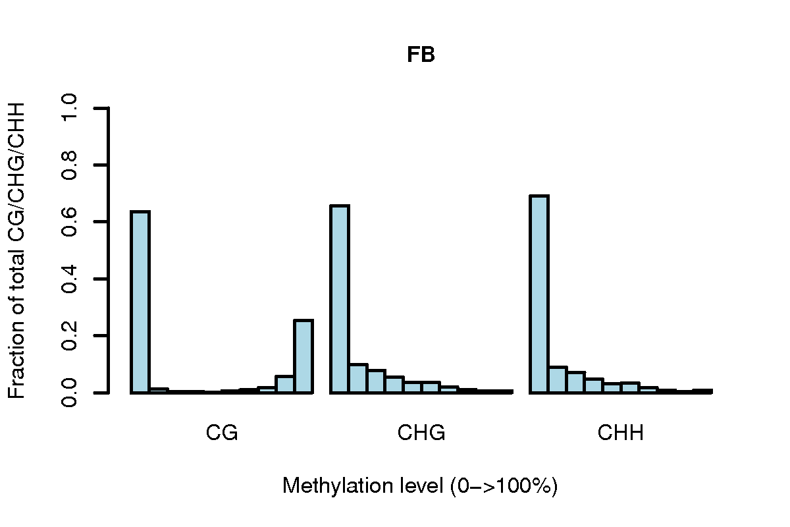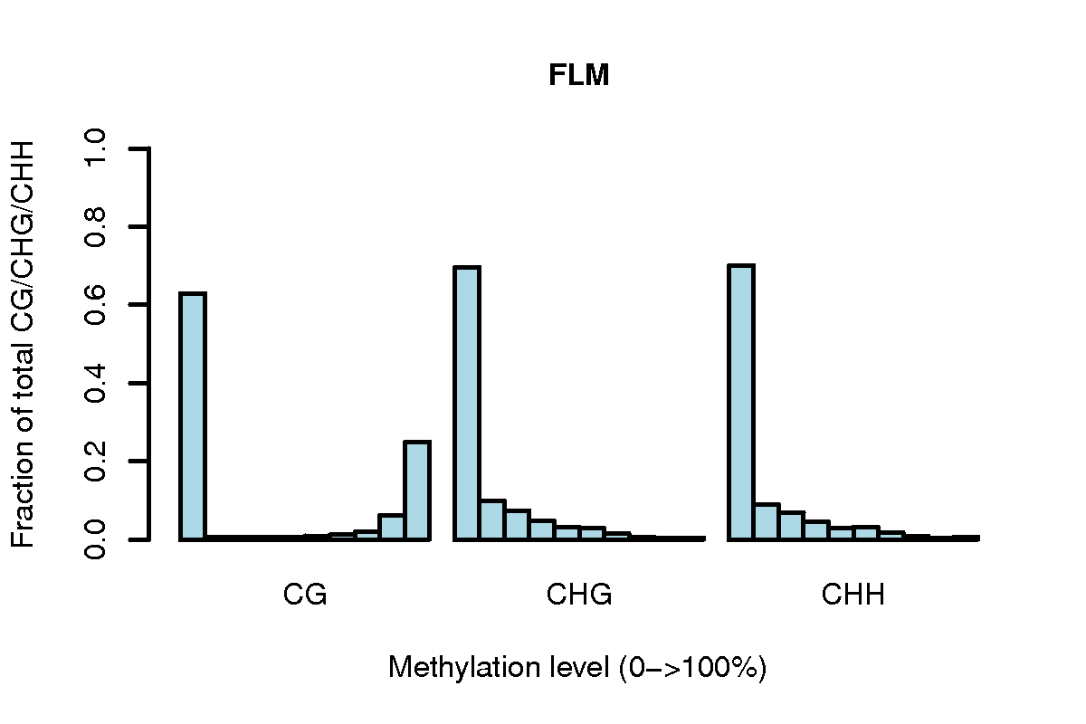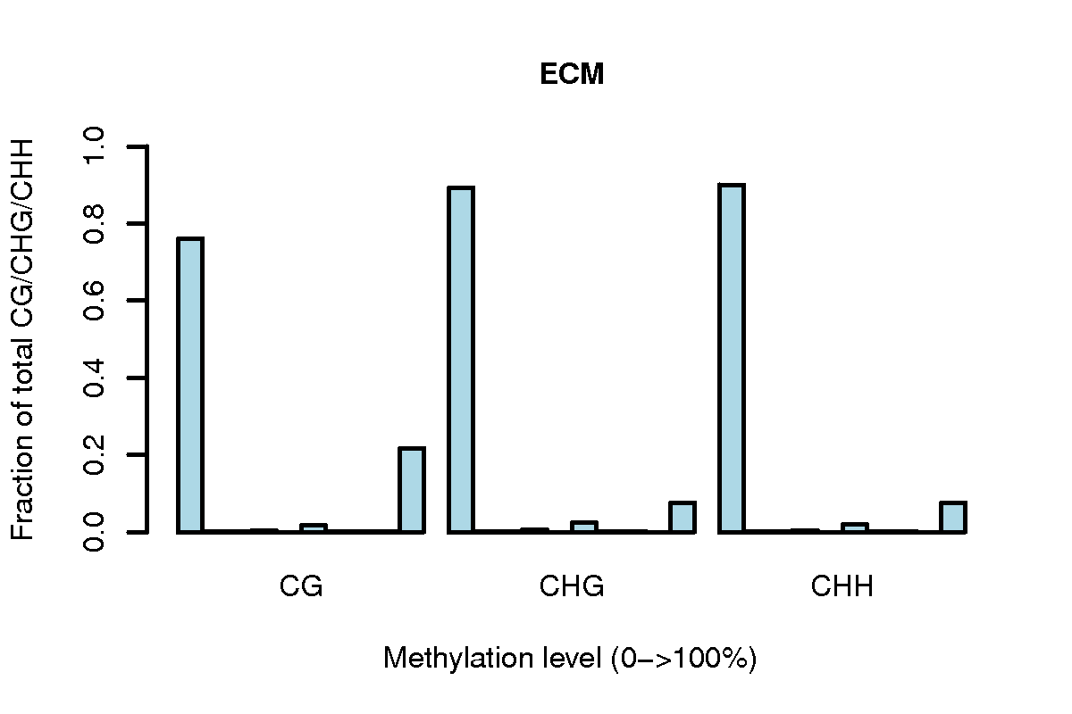

Figure S1. Histogram representation of DNA methylation levels (0-100%) in FB, FLM, and ECM as a function of sequence context (CG, CHG, and CHH).

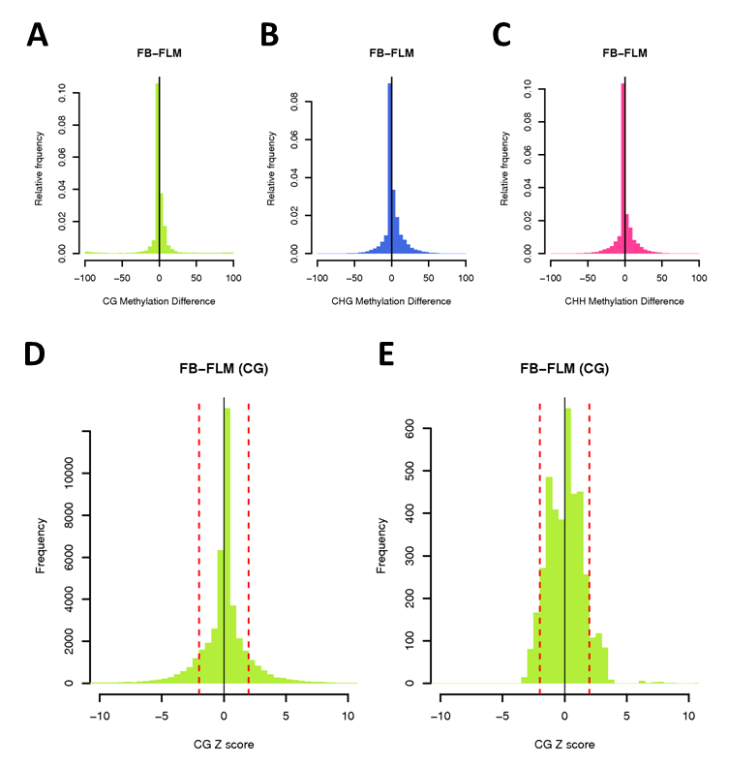

Figure S2. Histogram of ∆ methylation levels (FB-FLM). Average ∆ methylation of FB vs. FLM was 0.57 (A), 2.32 (B) and 0.77% (C) for CG, CHG, and CHH sites, respectively. The distributions of standardized Z scores for ∆ methylation levels (FB vs. FLM) within TEs and genes are shown in panels (D) and (E).

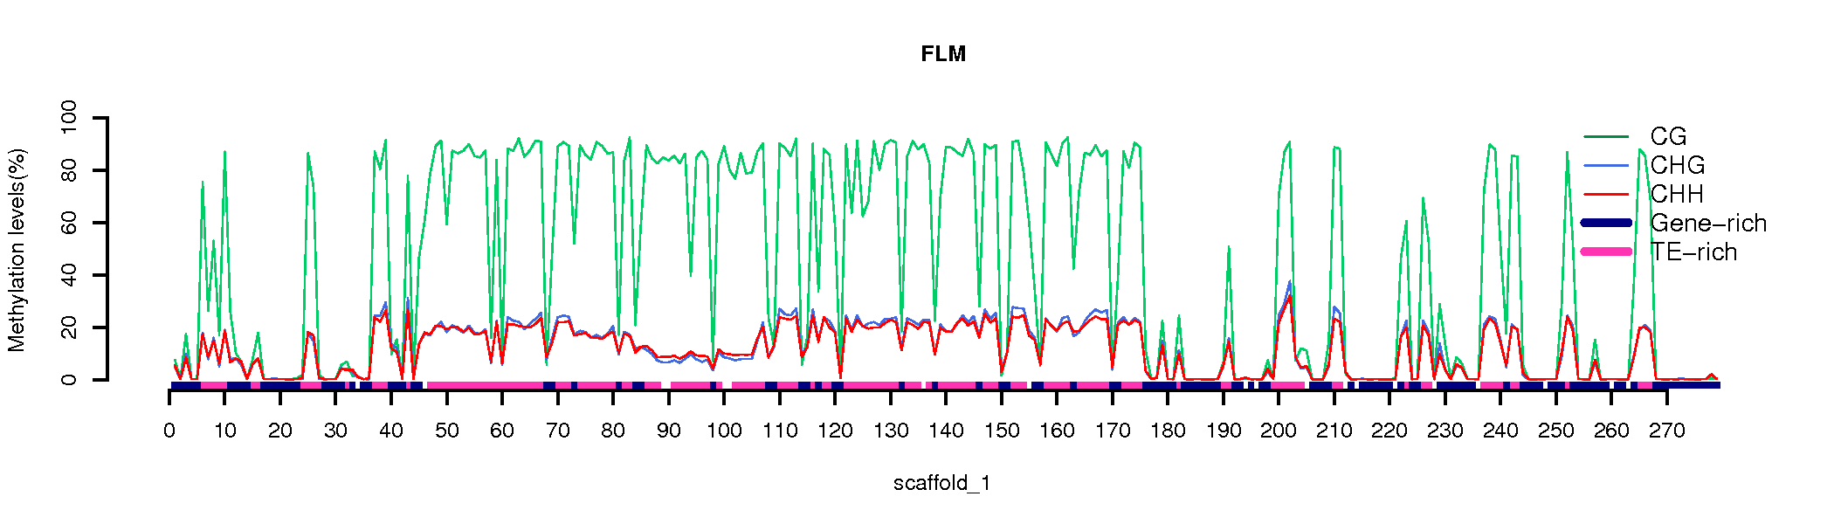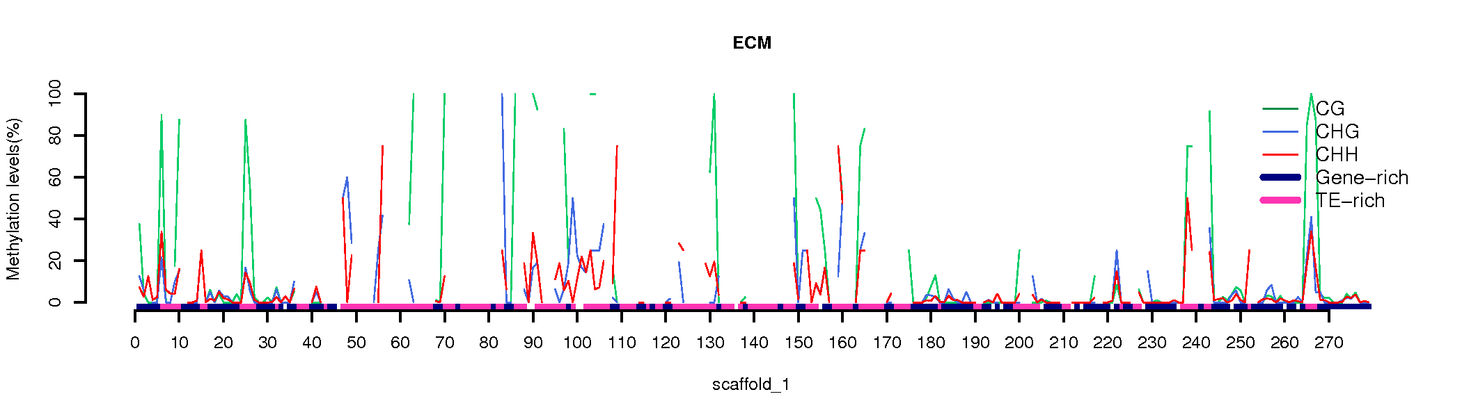

Figure S3. Large-scale view (scaffold 1) of DNA methylation levels in FLM and ECM. Methylation levels at CG, CHG, and CHH sites are plotted along scaffold 1 for FLM (top) and ECM (bottom); gene- or TE–rich regions are shown in the bottom tracks.

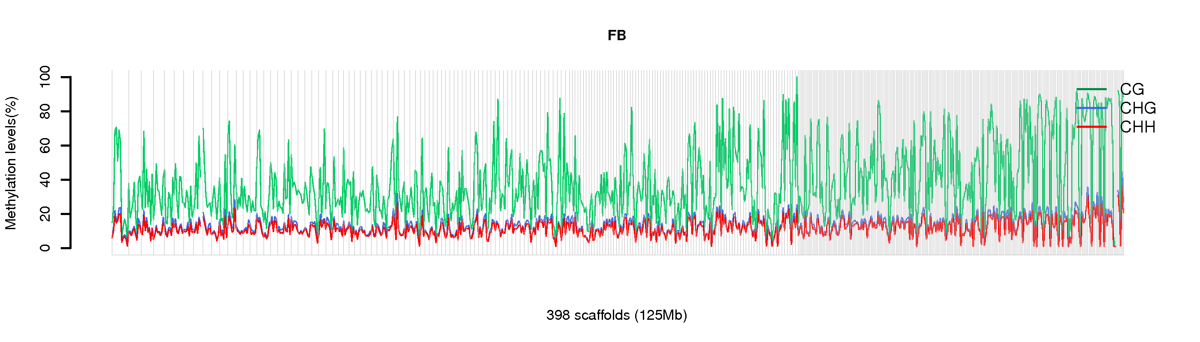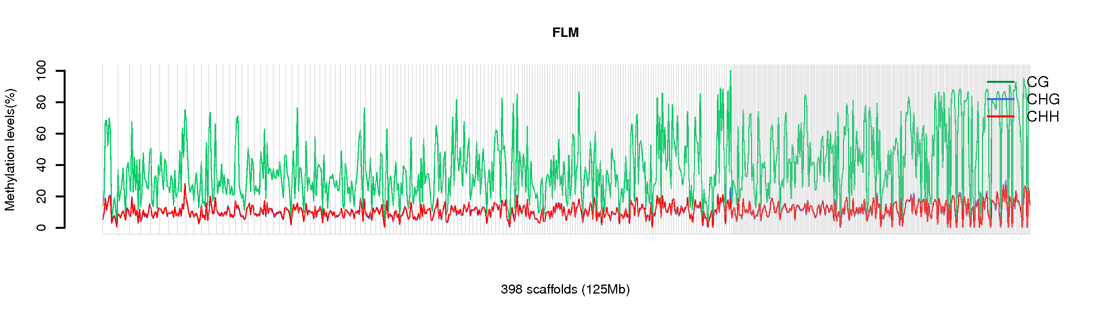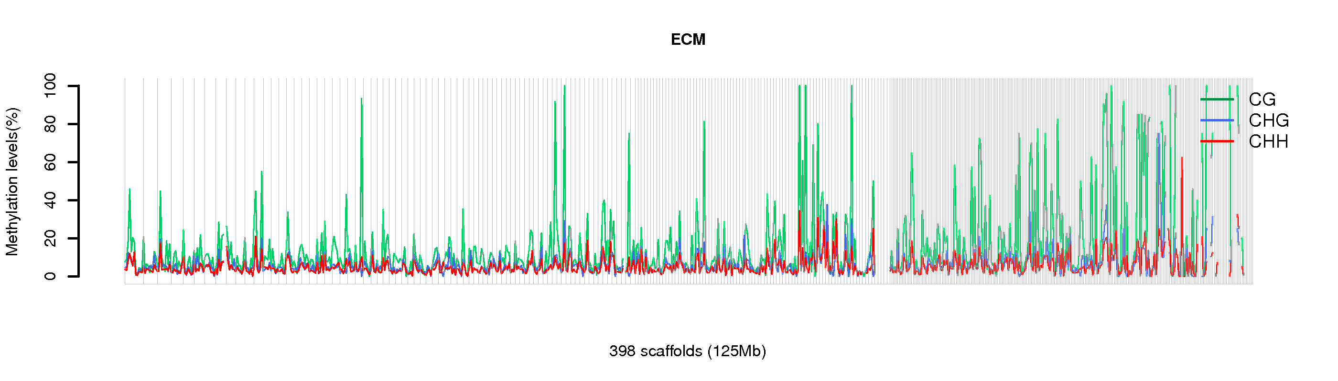

Figure S4. Genome-wide view of DNA methylation levels at CG, CHG and CHH sites in FB (top), FLM (middle) and ECM (bottom).

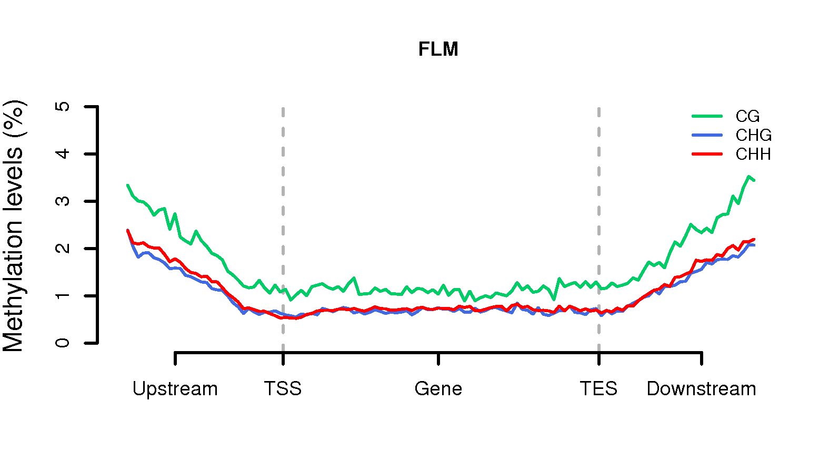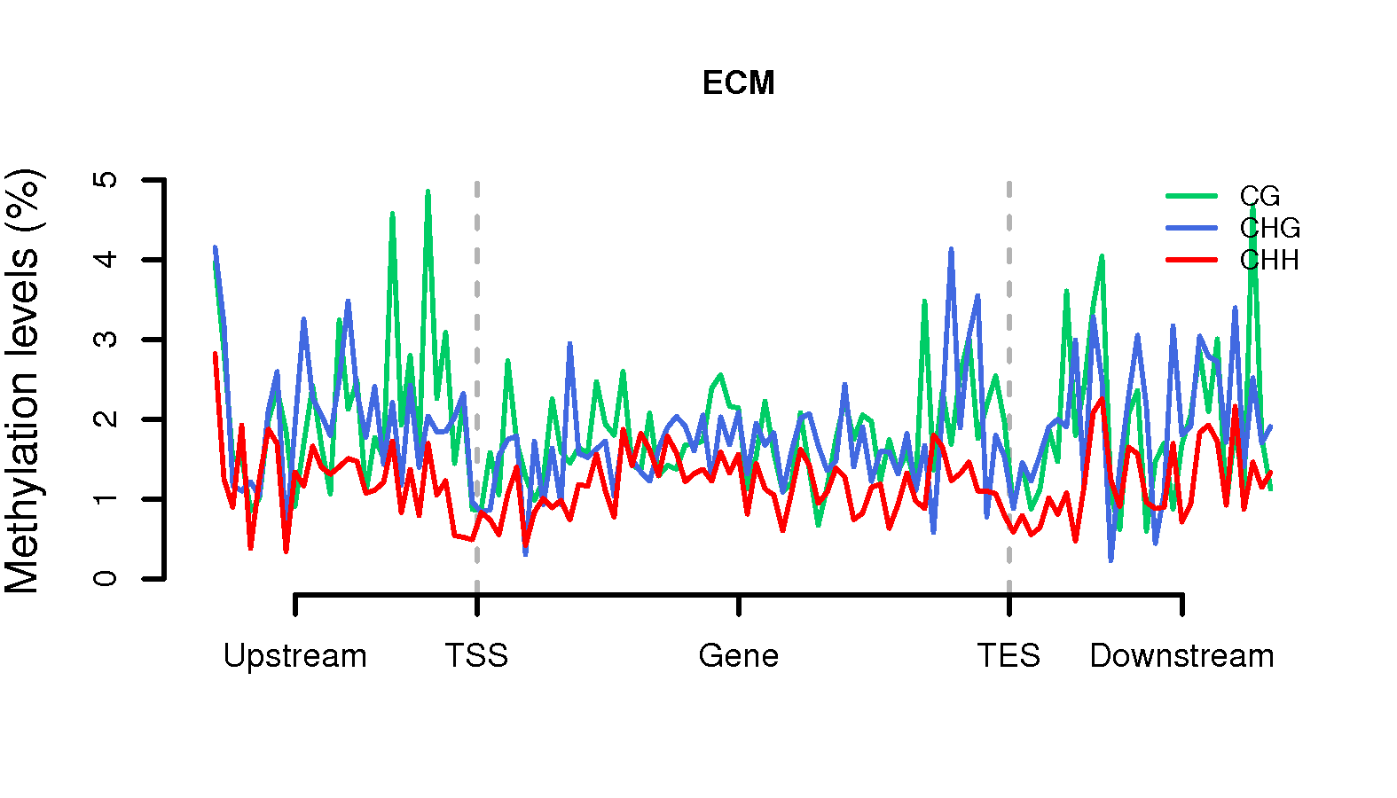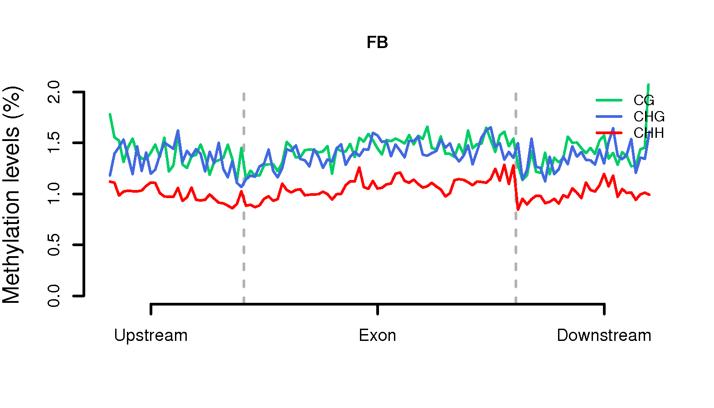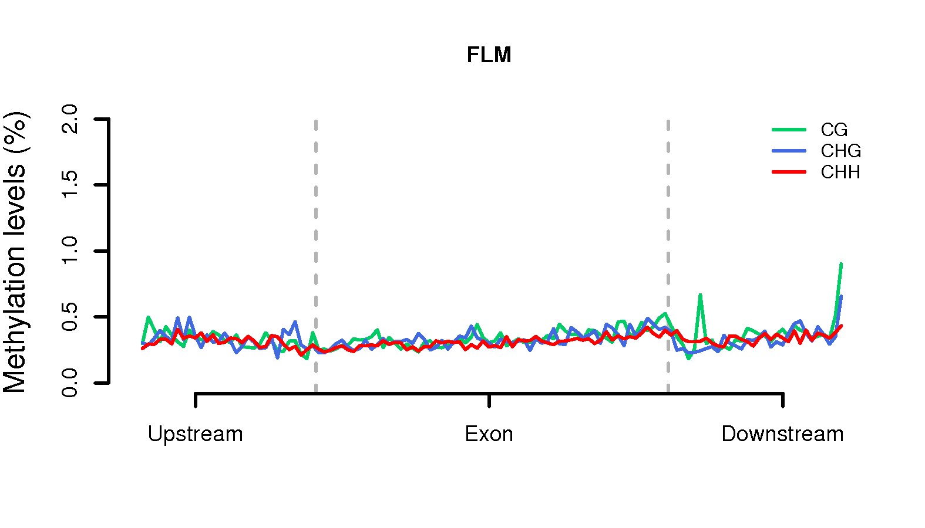

Figure S5. Meta-plots of DNA methylation levels in genes (top panels: FLM and ECM) and exons (bottom panels: FB and FLM). Plotted values are average methylation levels within upstream, core genomic (genes, exons) and downstream regions.

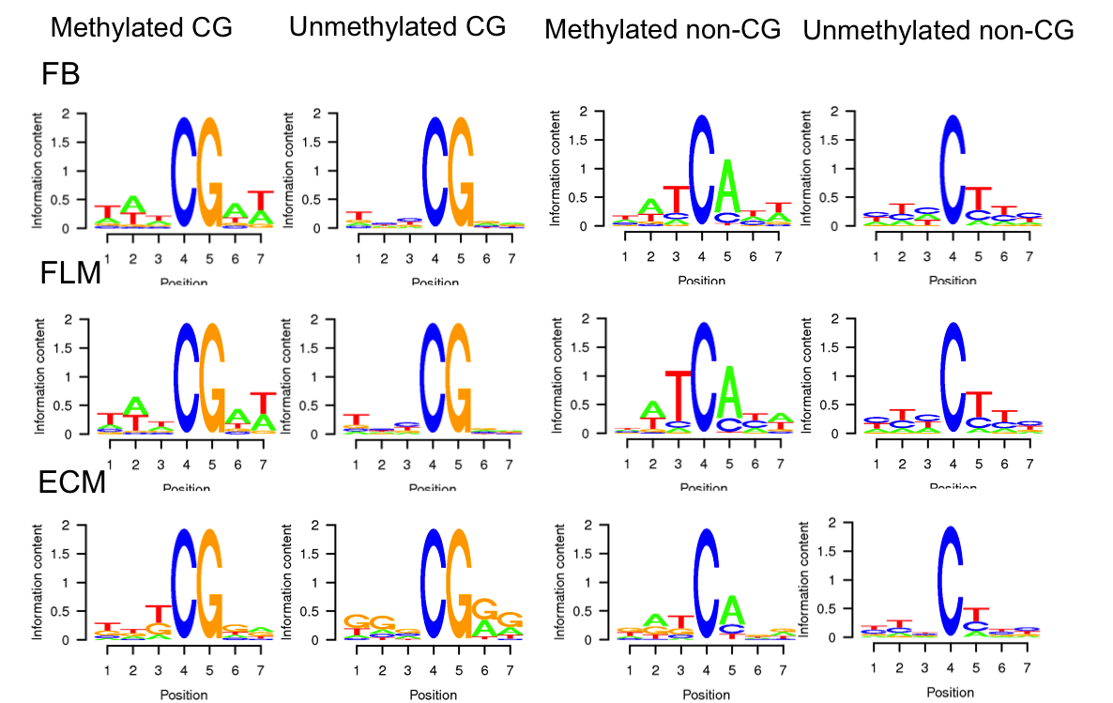

Figure S6. Logo-plots of sequences proximal to methylated and unmethylated sites in CG and non-CG sequence contexts.

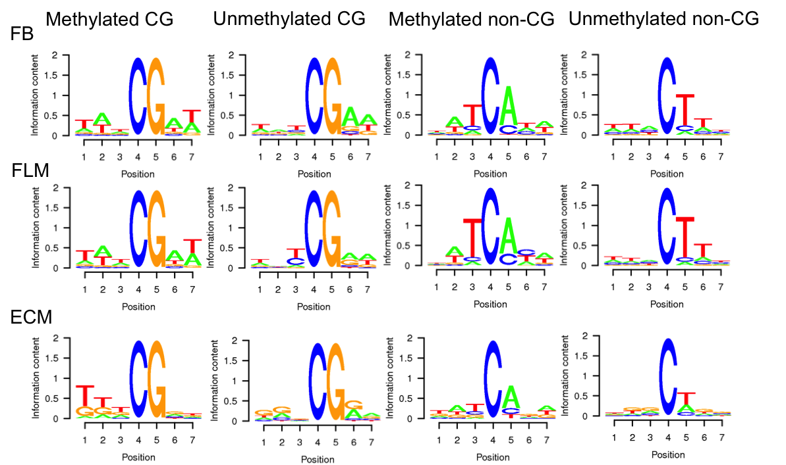

Figure S7. Logo-plots of sequences proximal to transposon-associated, methylated and unmethylated sites within CG and non-CG sequence contexts.

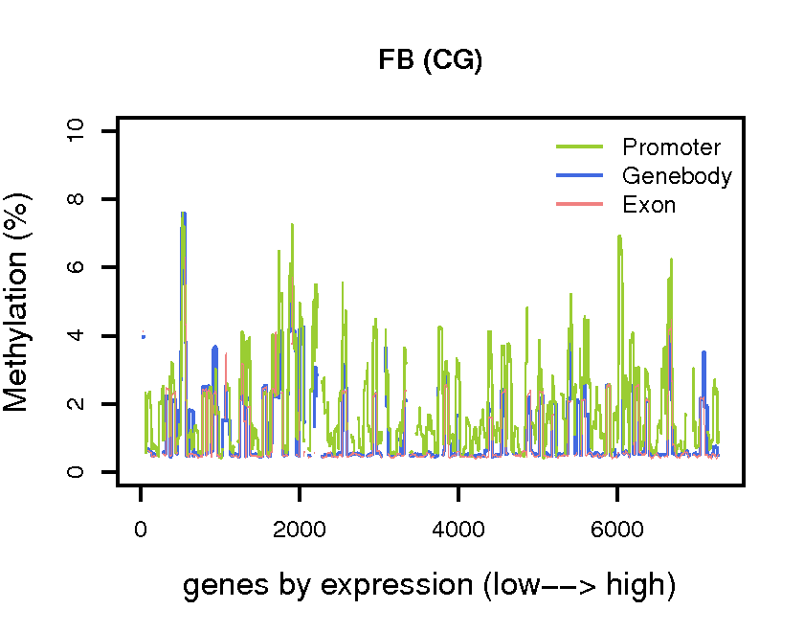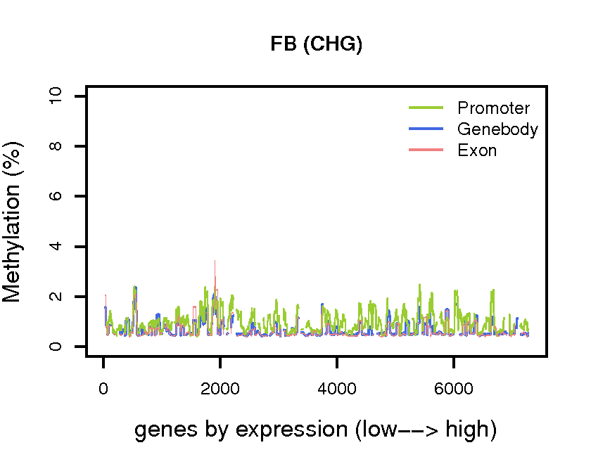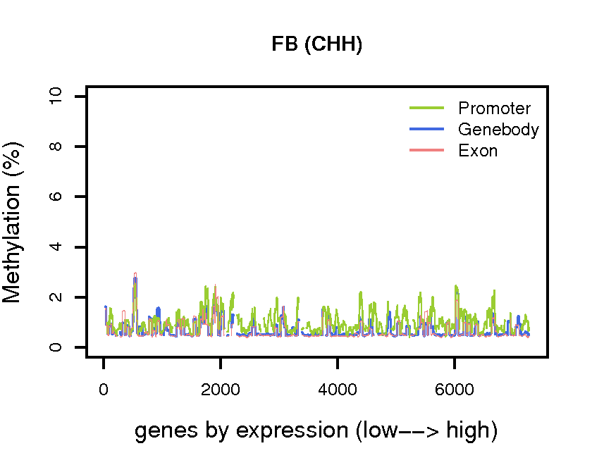
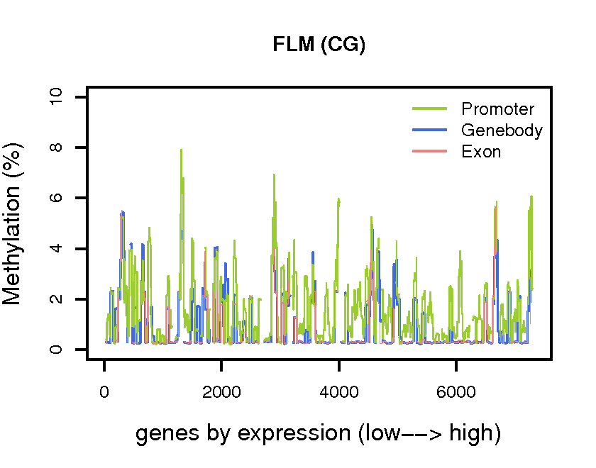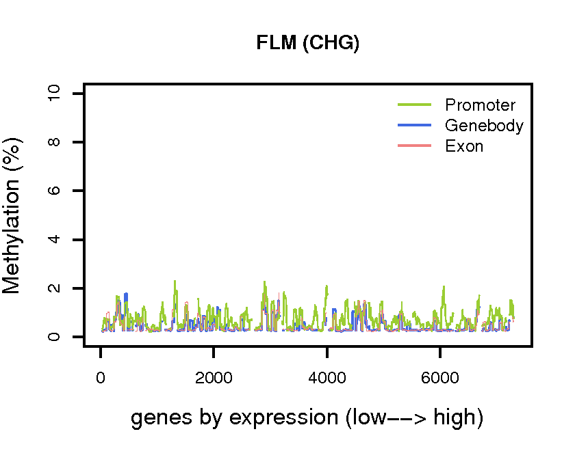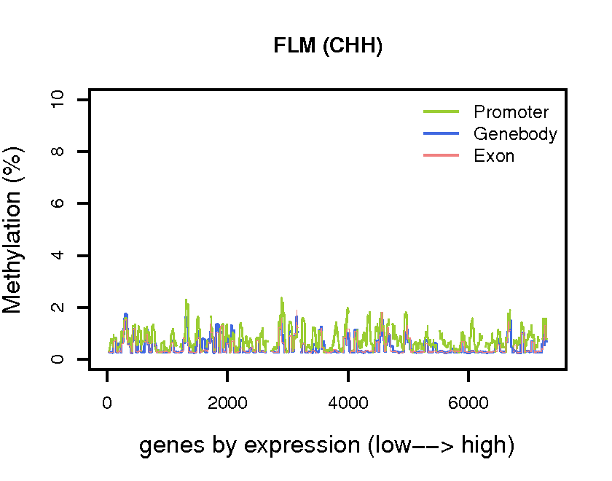

Figure S8. Promoter and gene-body methylation levels ranked according to gene expression levels (low to high); methylation levels are plotted as moving averages of 50 genes.

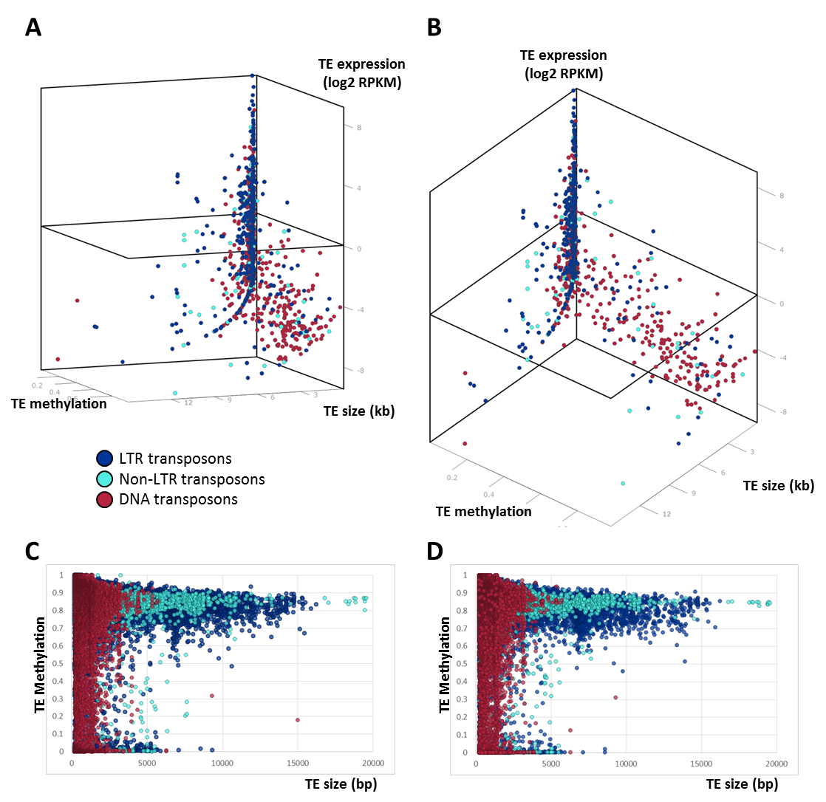

Figure S9. Transposon methylation and expression. CG methylation levels of individual TEs plotted against their size (kb) and expression levels (Log2 RPKM) in FLM (A-B) presented as two views of the same three-dimensional scatter plot. Only TEs with at least one mapped read (RPKM>0) are shown. The plane cut at log2 RPKM= 0 was set as a threshold for expressed TEs (corresponding to RPKM=1); see also Figure 2 (main text). CG methylation levels vs. size (bp) of TEs with RPKM=0 are presented as scatter plots for FB and FLM in panels (D) and (E). Retrotransposons are shown in blue (dark blue for LTR, light blue for non-LTR retrotransposons); DNA transposons are shown in red.

A.
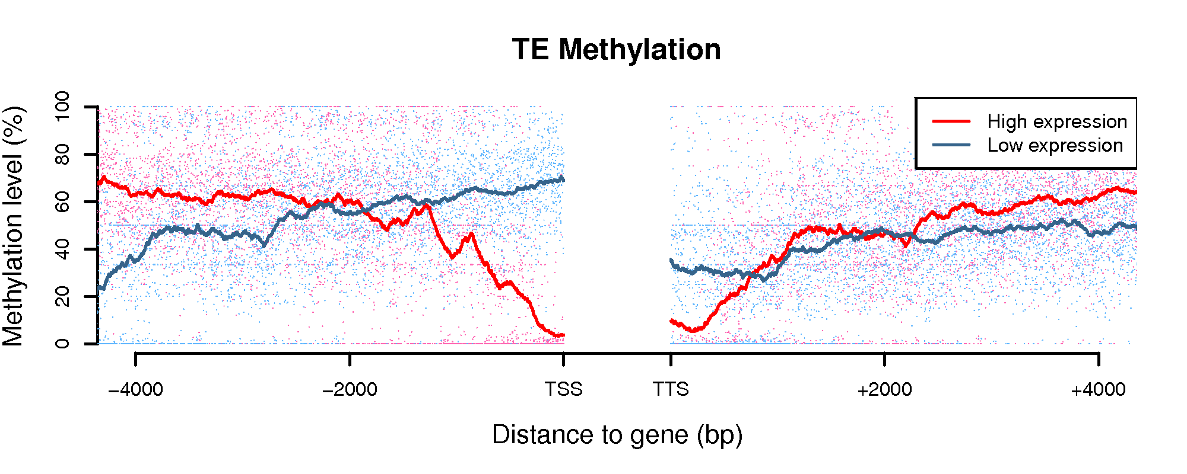
B.
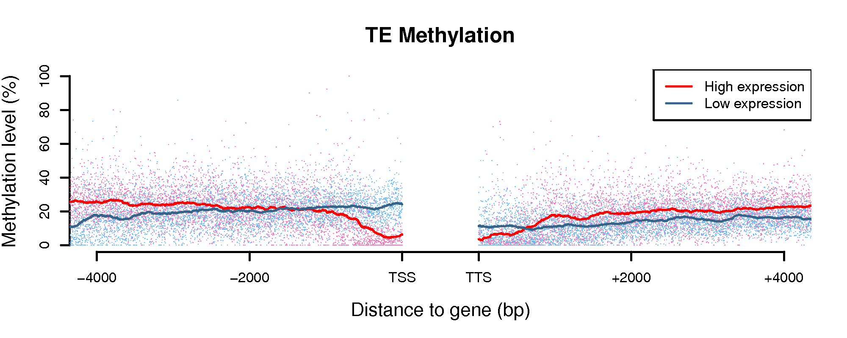
C.
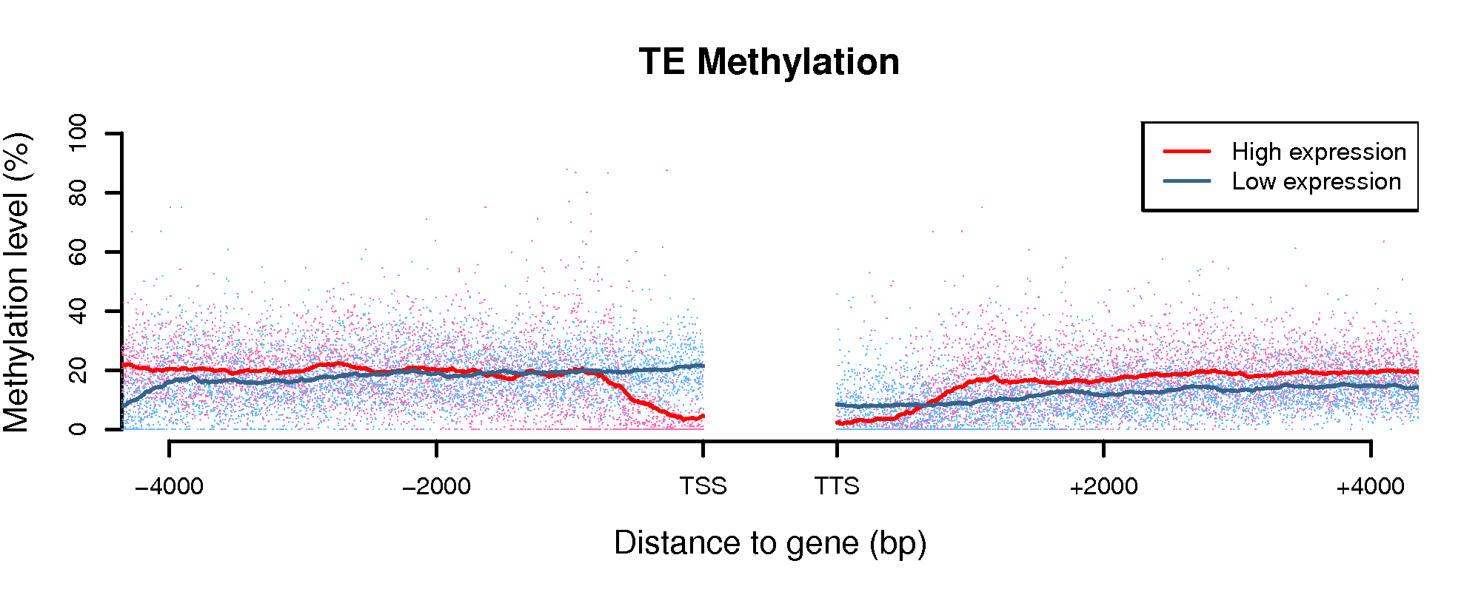
Figure S10. Transposon methylation and neighbor gene expression levels for FLM (CG sites), FB (CHG sites) and FLM (CHG sites) are shown in panels (A), (B) and (C), respectively. Methylation levels are referred to TEs located upstream or downstream to highly (top 25%) or lowly (bottom 25%) expressed genes. Red (highly expressed genes) and blue (lowly expressed genes) lines represent the moving average of methylation levels in 100 bp windows. t-test p-values of the differences in % TE methylation between highly and lowly expressed genes were 2.2∙10⁻¹⁶ for TE-gene distances ≤0.5kb and ≤10⁻⁴ for TE-gene distances comprised between 0.5 and 1 kb.

A.
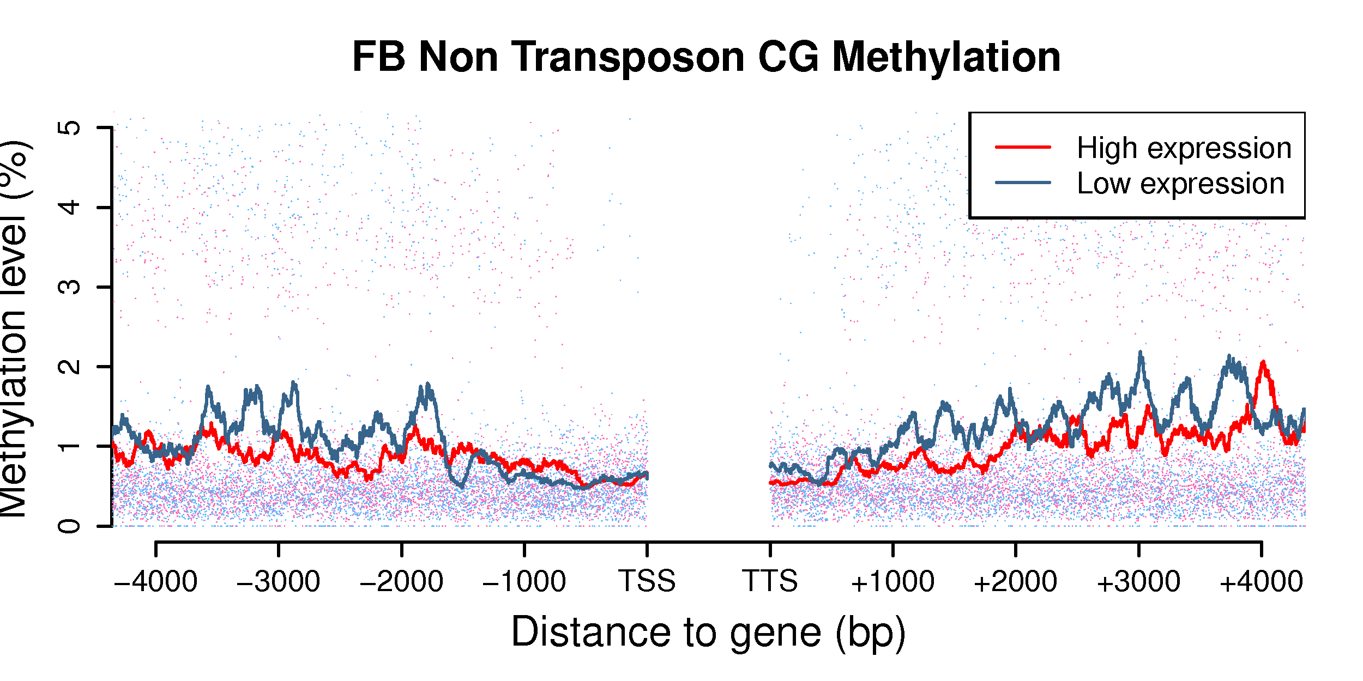
B.
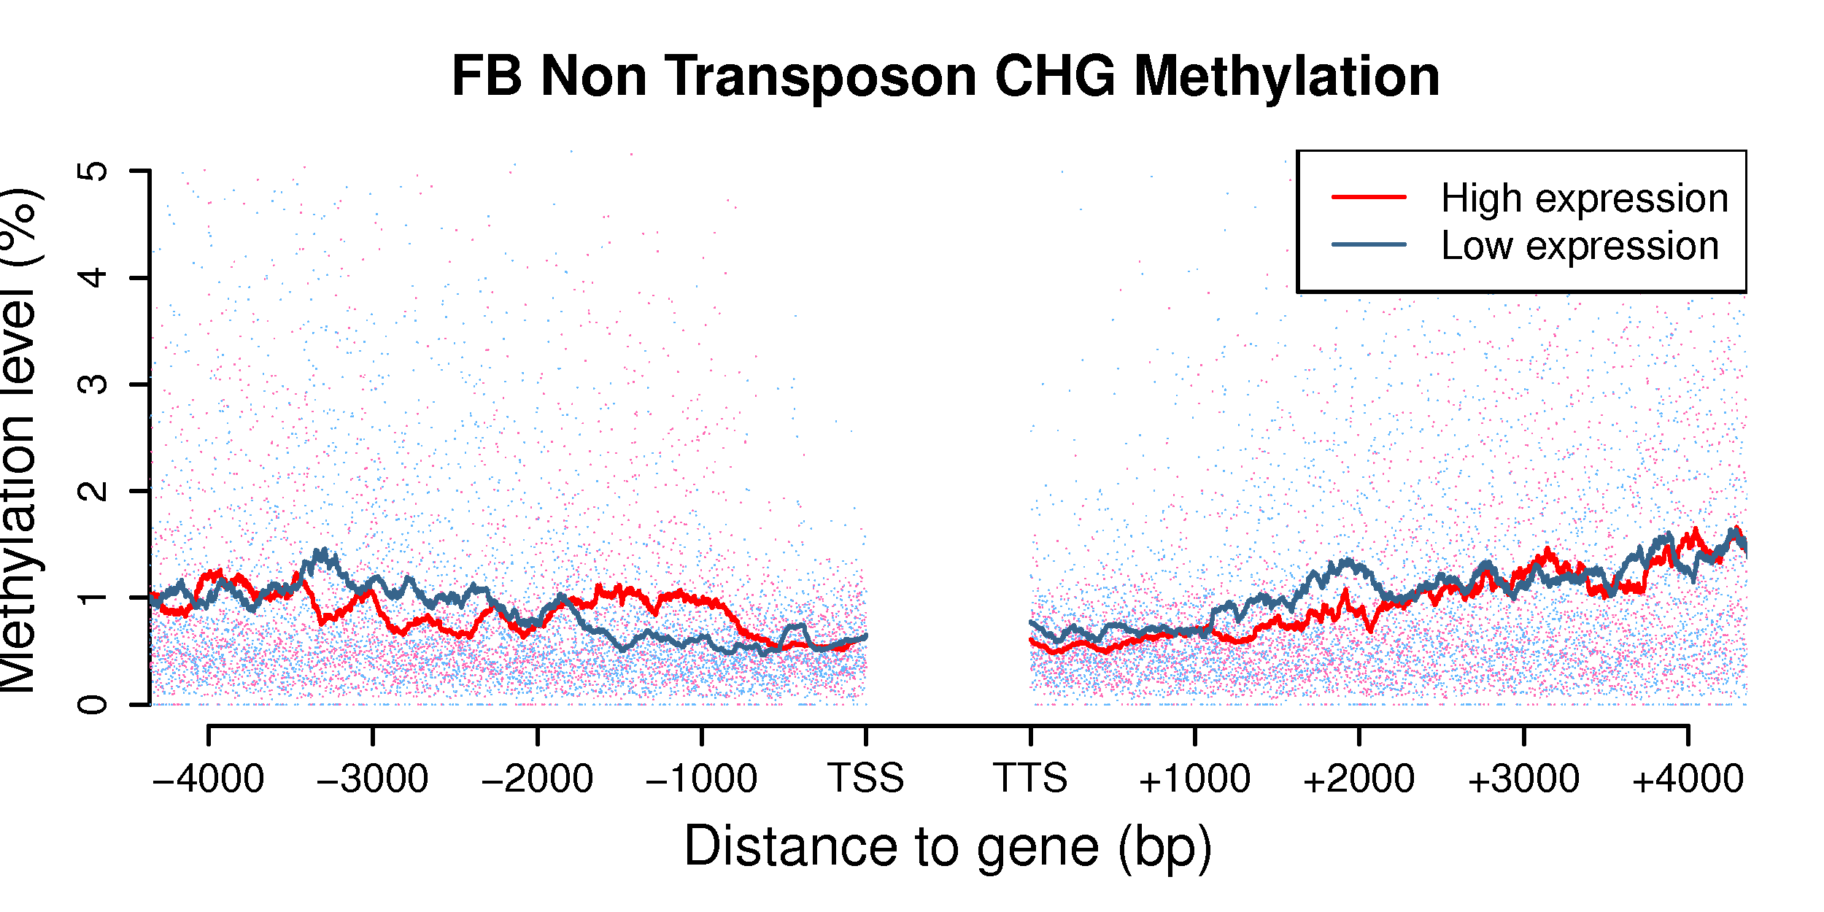
C.
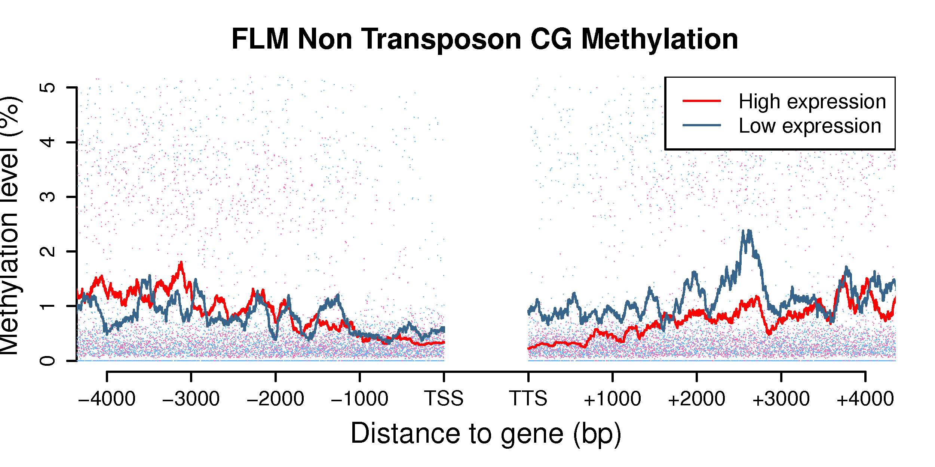
D.
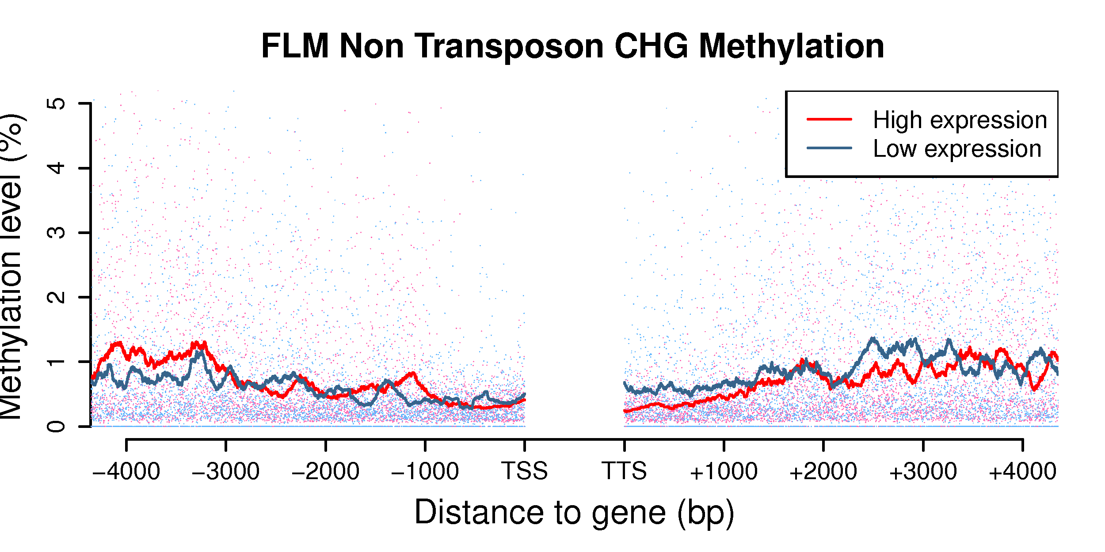

Figure S11. Non-transposon DNA methylation and neighbor gene expression levels for FB (CG sites), FB (CHG sites), FLM (CG sites), FLM (CHG sites) are shown in panels (A), (B), (C), and (D), respectively. Methylation levels are referred to non-TE DNA regions upstream or downstream to highly (top 25%) or lowly (bottom 25%) expressed genes as indicated. Red (highly expressed genes) and blue (lowly expressed genes) lines represent the moving average of methylation levels in 100 bp windows.

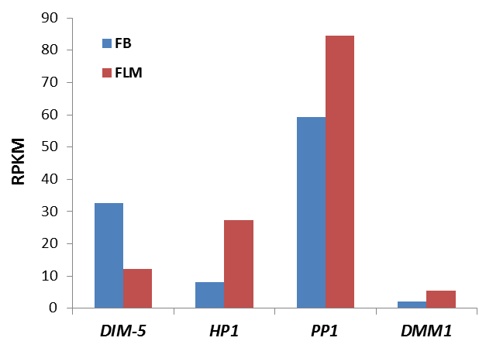

Figure S12. Expression levels of putative T. melanosporum DNA methylation accessory proteins in FB (blue bars) and FLM (red bars). Expression levels (RPKM) refer to the T. melanosporum homologs (gene IDs in brackets) of the following validated components of the N. crassa DNA methylation machinery: histone-lysine N-methyltransferase DIM-5 (GSTUMT00003241001); H3K9me3 histone binding protein, “heterochromatin protein 1” (GSTUMT00000912001); H3S10p phosphatase PP1 (GSTUMT00009673001); DNA methylation modifier DMM-1 (GSTUMT00000976001).
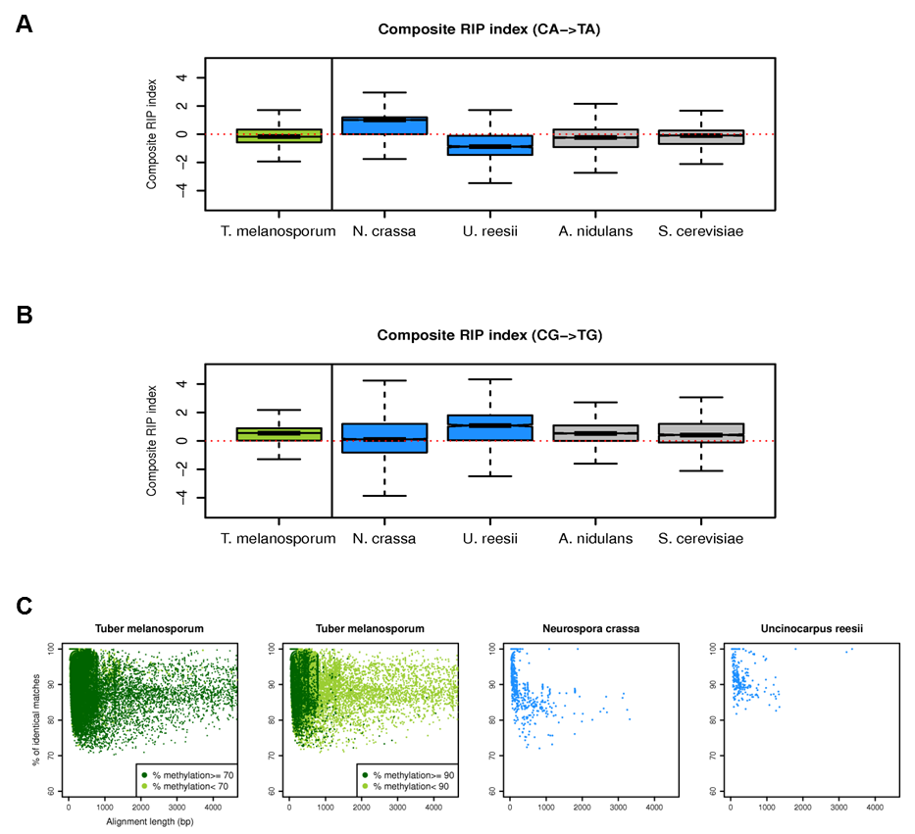

Figure S13. Cross-species genome comparisons between T. melanosporum and other fungi. (A) Box plots of the Composite RIP Index (CRI) for the truffle genome (left panels) and for the genomes of other fungi (right panels) based on CA to TA dinucleotide changes. (B) Same as (A) for CG to TG dinucleotide changes. Data were calculated as 50 kb genome-wide windows; deviation from baseline (CRI=0) increases with the likelihood of RIP occurrence. N. crassa served as a RIP positive control in panel (A); U. reesii was included in both analyses because of the exceptionally high CG->TG dinucleotide change frequency reported in a previous study [7]. (C) Scatter plots of sequence similarity versus alignment length in T. melanosporum are shown in the two left-side panels, where dark-green dots indicate methylation percentages ≥ 70% (first left panel) and ≥ 90% (second left panel) compared to N. crassa and U. reesii (third and fourth panel).

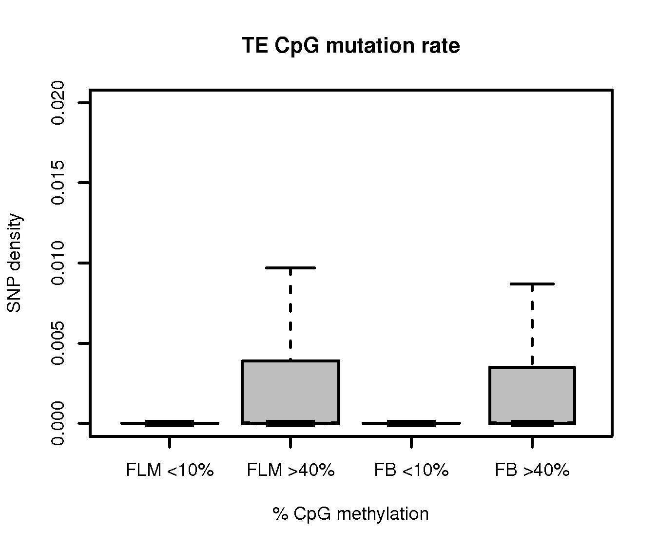
Low High Low High
FLM FB
CpG methylation

Figure S14. Transposon CpG mutation rate as a function of DNA methylation. Mutations (single nucleotide polymorphisms, SNPs) on CpG sites were called from BS-seq data. For each TE, SNP density (i.e., mutation rate) was calculated. The box plot shows SNP density for highly (>40%) and lowly (<40%) methylated TEs; a high mutation rate appears to be associated with high TE methylation levels.

