Supplementary Materials

- Supplementary Table 1. SNPs unique to each method characterized by the five most common splits found.
- Supplementary Figure 1. Runtime comparison for the whole-genome alignment methods on the simulated 32-genome E. coli W3110 dataset.
- Supplementary Figure 2. Timing performance from 32 to 10,000 S. pneumoniae genomes.

Supplementary Table 1. SNPs unique to each method characterized by the five most common splits represented. Combined, these five splits account for approximately half of the unique SNPs and ~70% of the unique SNP positions. Col Cnt: the number of alignment columns (i.e. SNP positions) supporting the split. Split: The identified split overlaid on the reference tree, with the highlighted genomes forming one half of the split. SNP count: the total number of SNPs that pertain to the split.
Method | Col Cnt | Split | SNP count
Parsnp | 28 (1%) | 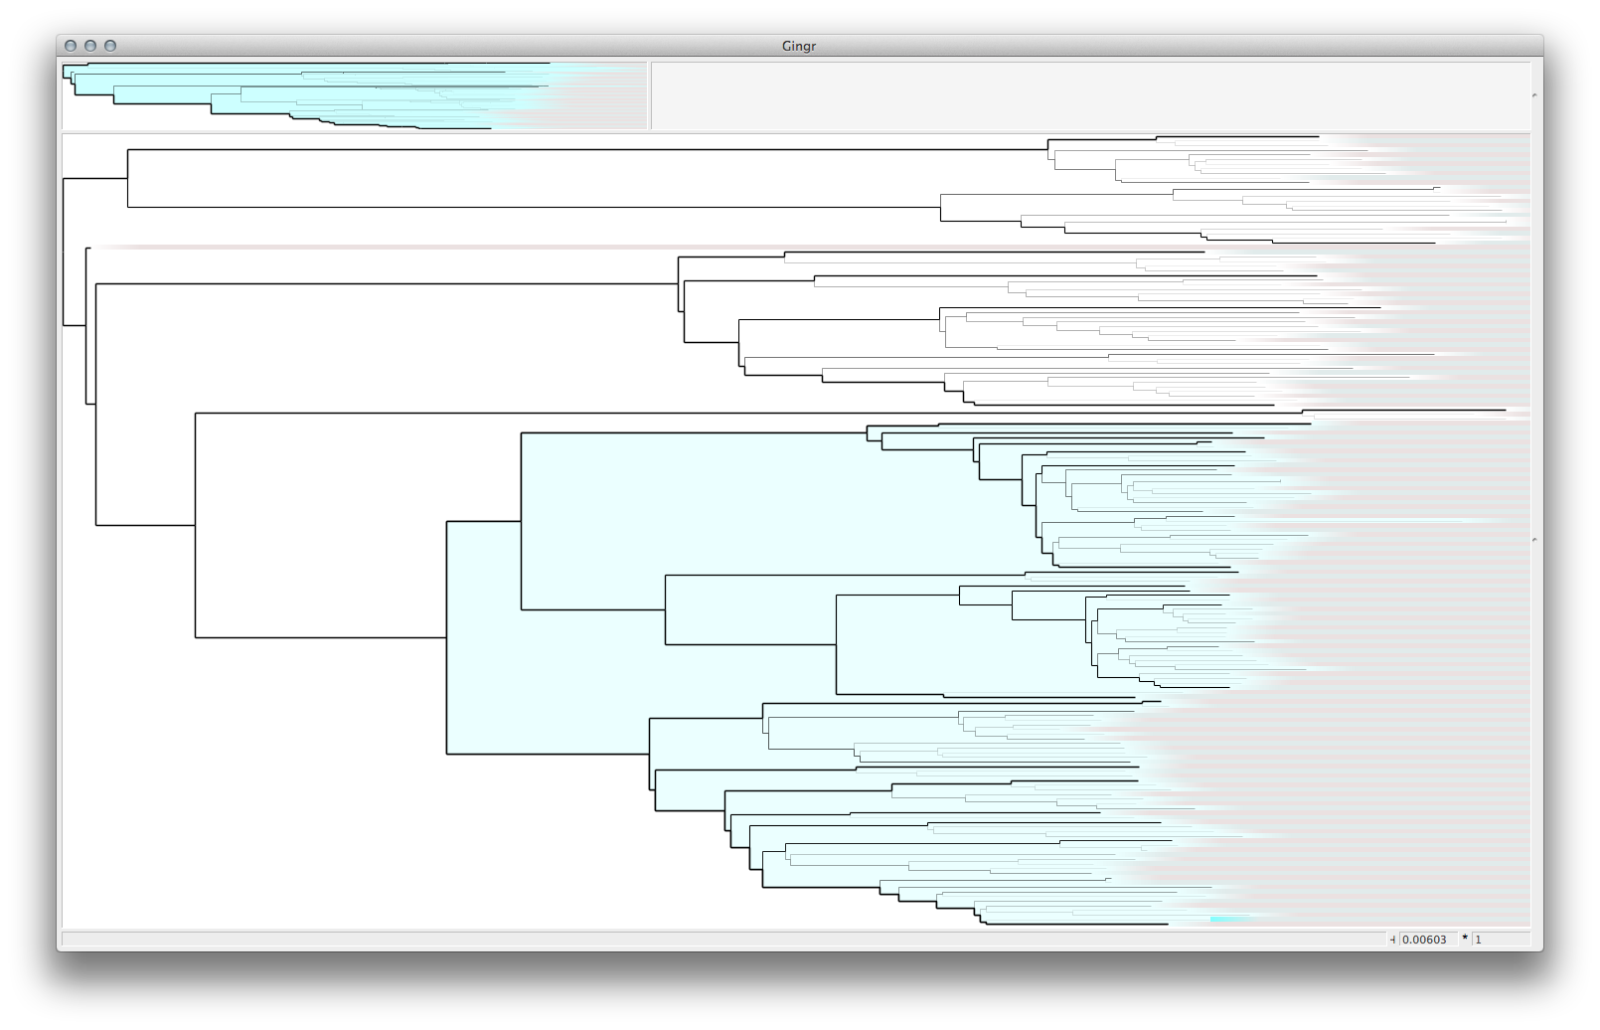 | 3052 (21%)
Parsnp | 129 (6%) | 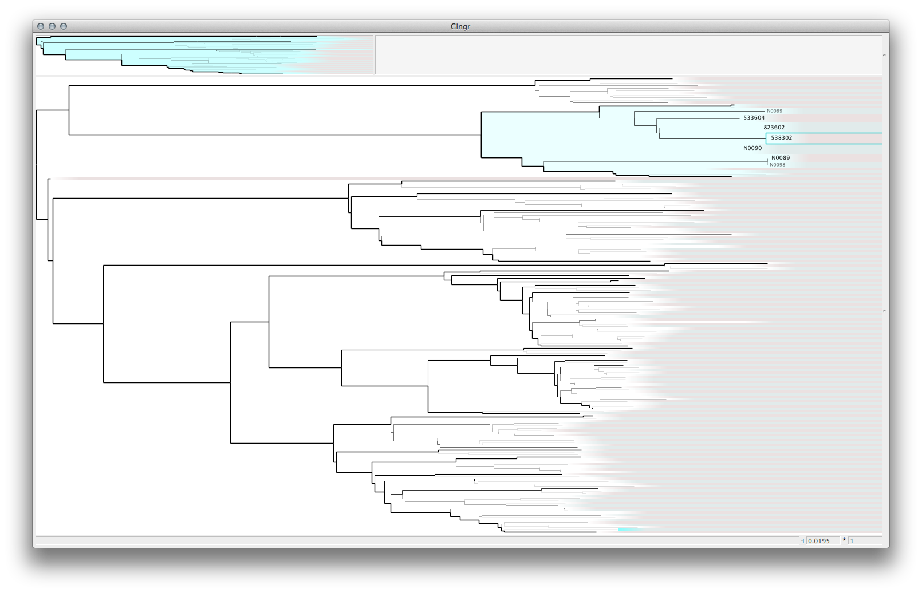 | 1677 (11%)
Parsnp | 1503 (66%) | Single genome splits | 1503 (10%)
Parsnp | 23 (1%) | 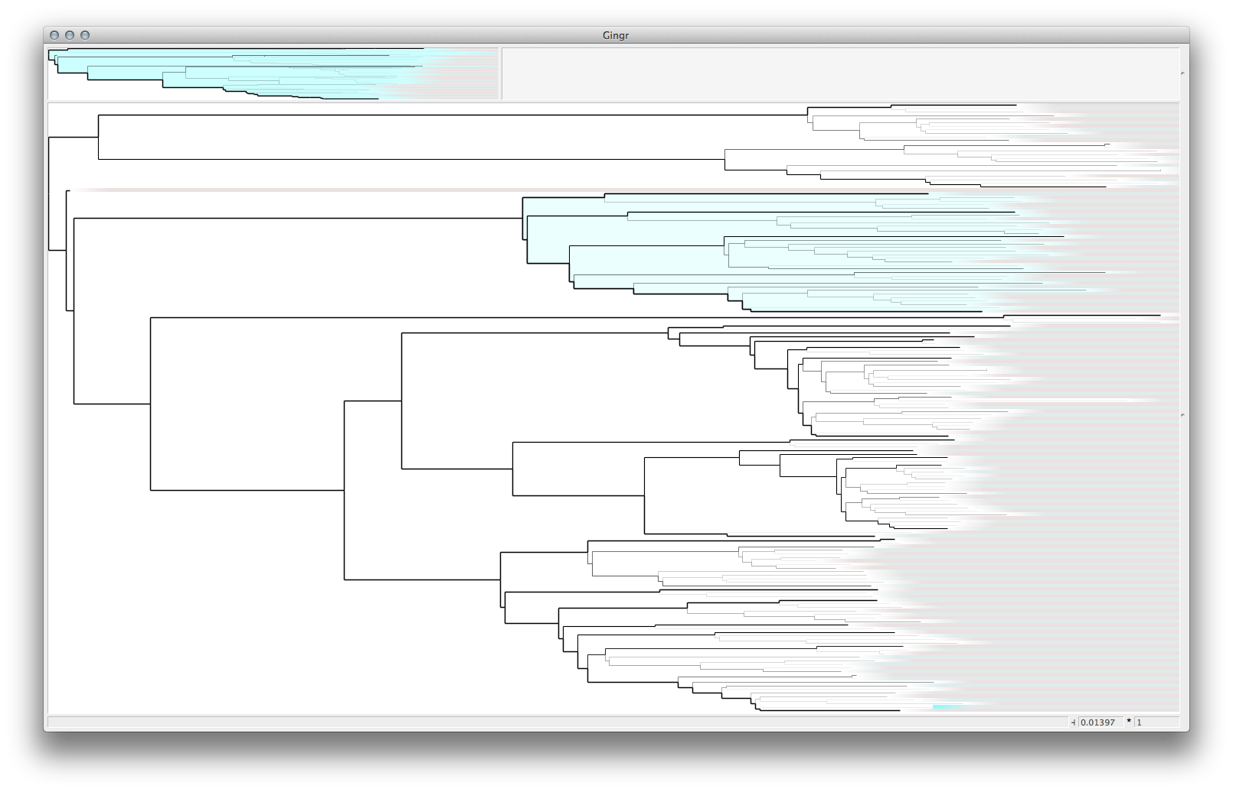 | 1127 (8%)
Parsnp | 8 (<1%) | 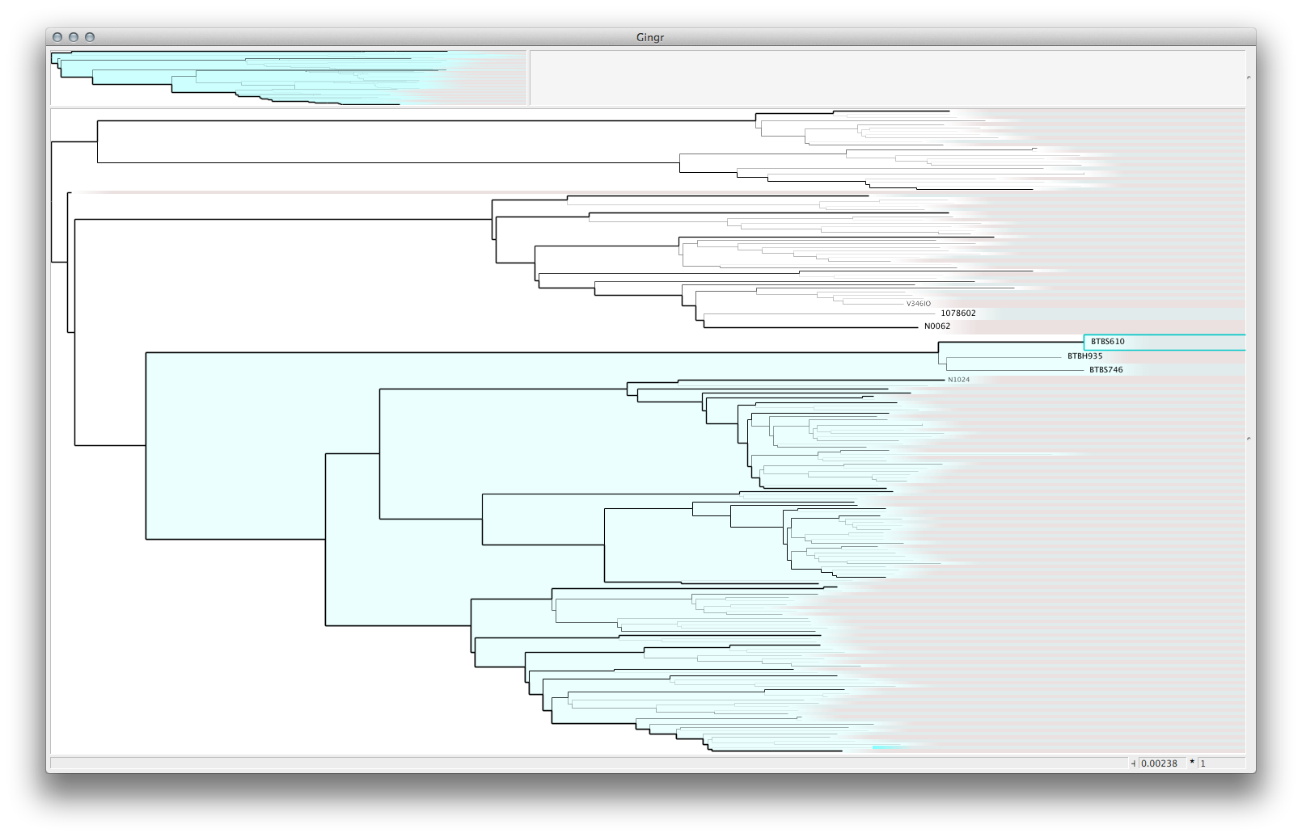 | 896 (6%)
Comas | 30 (1%) |  | 3270 (14%)
Comas | 3016 (63%) | Single genome splits | 3016 (13%)
Comas | 74 (2%) |  | 2516 (11%)
Comas | 109 (2%) | 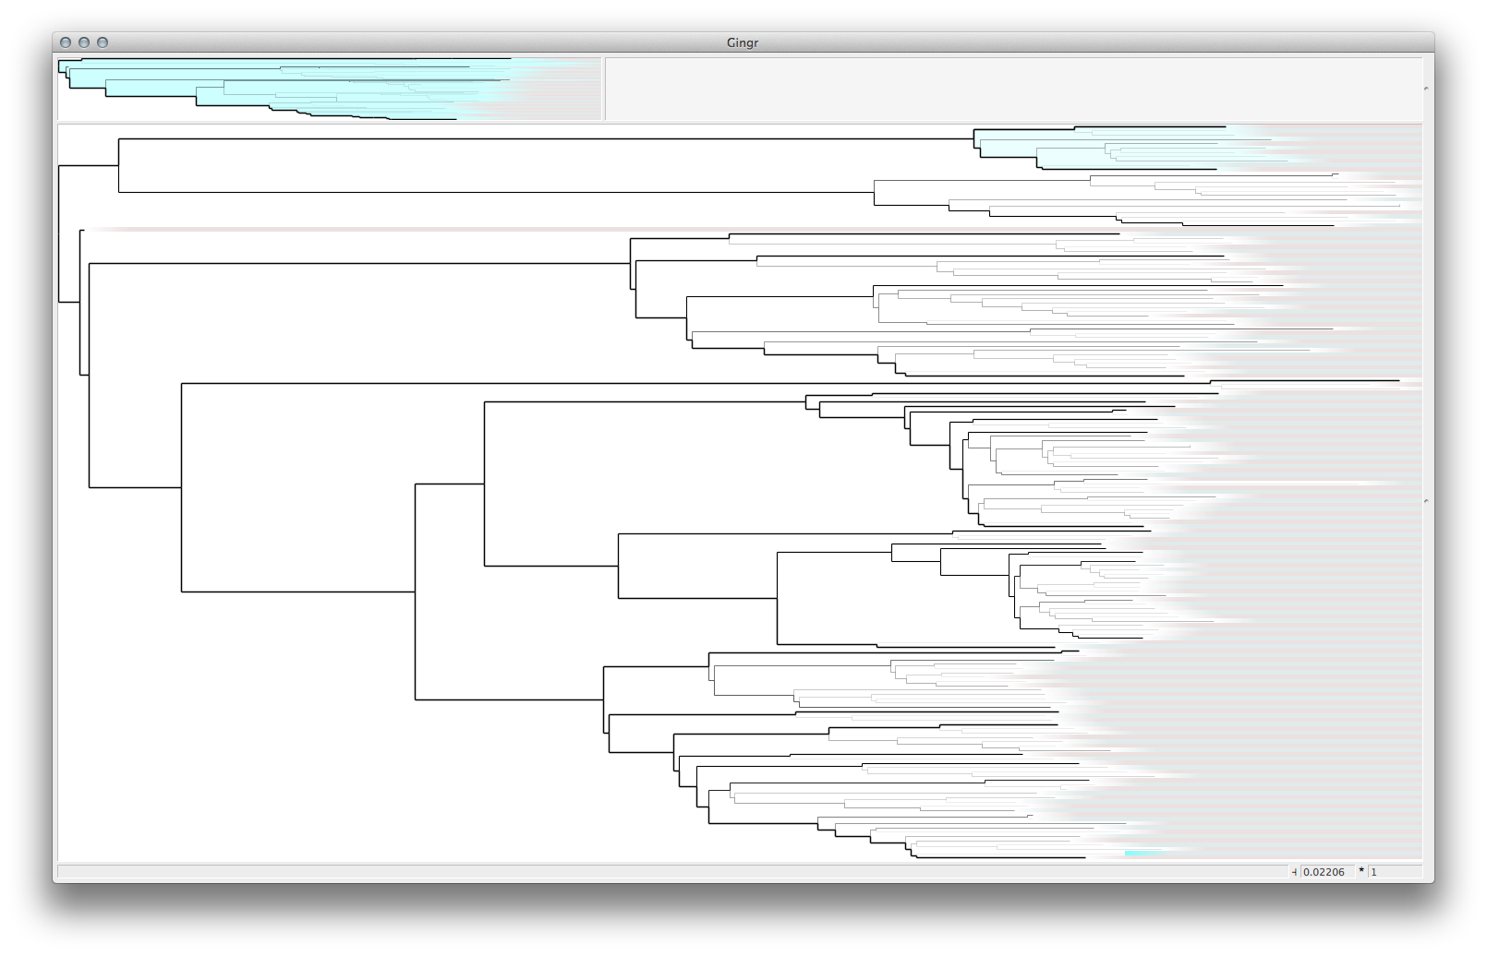 | 1199 (5%)
Comas et al | 32 (1%) | 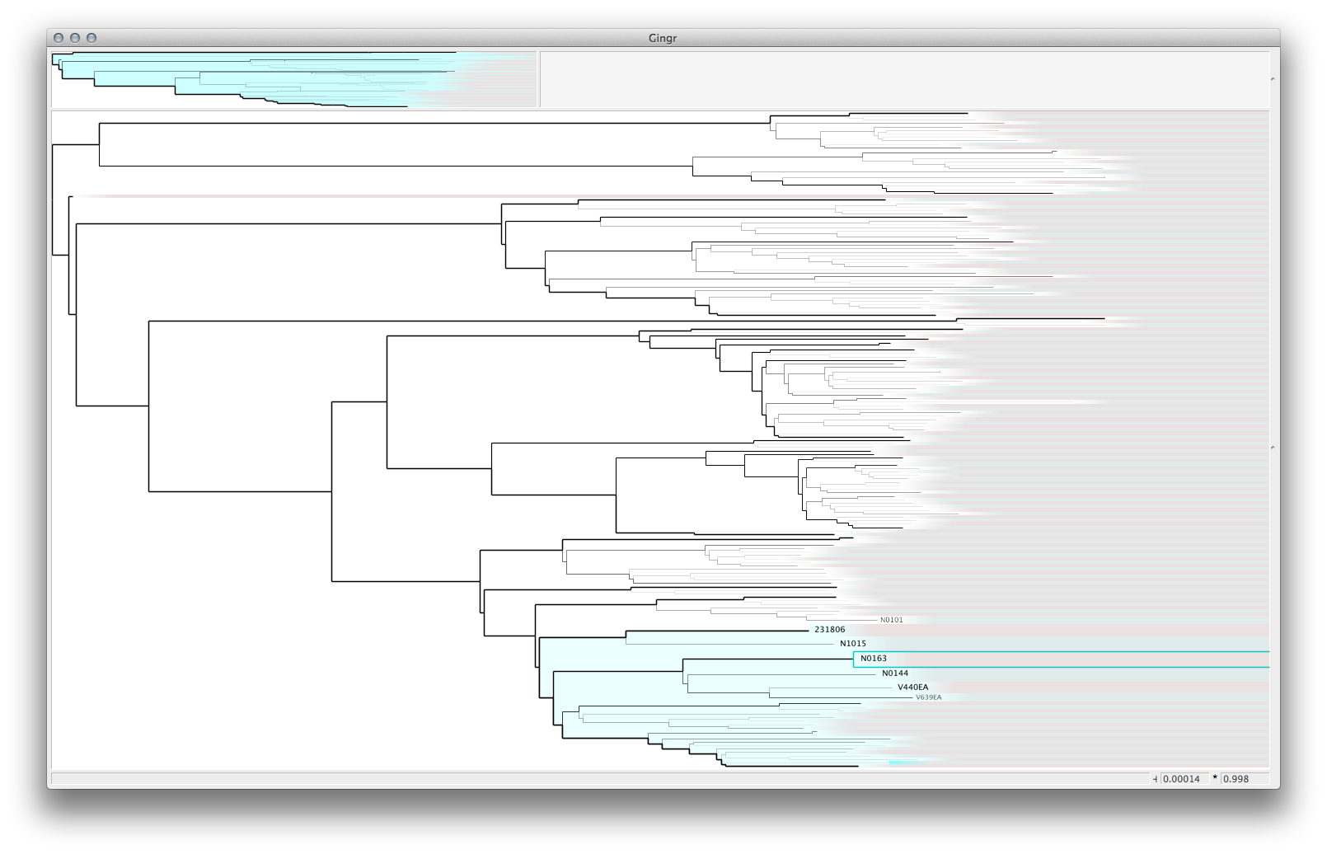 | 1127 (5%)

Supplementary Figure 1. Runtime comparison for the whole-genome alignment methods on the simulated 32-genome E. coli W3110 dataset. The y-axis is log scale. pMauve = progressiveMauve, and Mugsy(p) indicates Mugsy with a parallelized NUCmer search. All programs were allocated 32 cores on the hardware noted above. Note that Mugsy is not multithreaded.
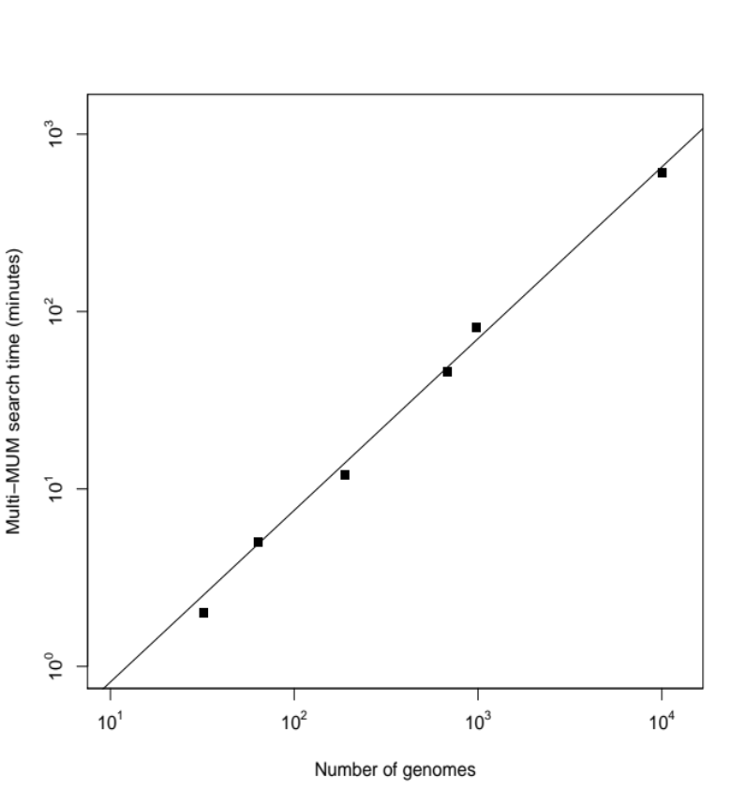

CPU runtime (minutes)

Number of genomes

Supplementary Figure 2. Timing performance from 32 to 10,000 S. pneumoniae genomes. The x-axis indicates the number of genomes and the y-axis the wall clock time for core-genome alignment. Alignments were performed on the hardware noted above. The gray line represents a linear time relationship between the number of genomes and search time.

