Supplemental Table 1. Overview of results from application of each algorithm to SVs in simulated whole genome data sets across different sequence coverage and SV type.
(see Additional File 1)

Supplemental Table 2. True positive and false positive deletion calls made by each algorithm on NA12878 and CHM1, based on previous reported calls as well as our custom PacBio validation approach.

 |  | Method | SV | TP | Ref  Calls | Total  Calls | FP | TPR | PPV | F1-Score
NA12878 | Simple Deletions compared to NIST | Svelter | DEL | 1624 | 2314 | 2623 | 999 | 0.7018 | 0.6191 | 0.6579
NA12878 | Simple Deletions compared to NIST | Delly | DEL | 1012 | 2314 | 1300 | 288 | 0.4373 | 0.7785 | 0.5600
NA12878 | Simple Deletions compared to NIST | Lumpy | DEL | 1706 | 2314 | 2569 | 863 | 0.7373 | 0.6641 | 0.6988
NA12878 | Simple Deletions compared to NIST | Pindel | DEL | 1591 | 2314 | 2046 | 455 | 0.6876 | 0.7776 | 0.7298
NA12878 | Simple Deletions compared to NIST | erds | DEL | 1409 | 2314 | 1806 | 397 | 0.6089 | 0.7802 | 0.6840
NA12878 | Simple Deletions compared to NIST set + Pacbio Validation Set | Svelter | DEL | 2218 | 3672 | 2623 | 405 | 0.6040 | 0.8456 | 0.7047
NA12878 |  | Delly | DEL | 1201 | 3672 | 1300 | 99 | 0.3271 | 0.9238 | 0.4831
NA12878 |  | Lumpy | DEL | 2268 | 3672 | 2569 | 301 | 0.6176 | 0.8828 | 0.7268
NA12878 |  | Pindel | DEL | 1994 | 3672 | 2046 | 52 | 0.5430 | 0.9746 | 0.6974
NA12878 |  | erds | DEL | 1735 | 3672 | 1806 | 71 | 0.4725 | 0.9607 | 0.6334
CHM1 | Simple Deletions compared to Chaisson et.al Set | Svelter | DEL | 1188 | 3588 | 1728 | 325 | 0.3311 | 0.6875 | 0.4470
CHM1 | Simple Deletions compared to Chaisson et.al Set | Delly | DEL | 243 | 3588 | 722 | 479 | 0.0677 | 0.3366 | 0.1128
CHM1 | Simple Deletions compared to Chaisson et.al Set | Lumpy | DEL | 844 | 3588 | 1524 | 680 | 0.2352 | 0.5538 | 0.3302
CHM1 | Simple Deletions compared to Chaisson et.al Set | Pindel | DEL | 765 | 3588 | 1106 | 341 | 0.2132 | 0.6917 | 0.3259
CHM1 | Simple Deletions compared to Chaisson et.al Set | erds | DEL | 447 | 3588 | 1089 | 642 | 0.1246 | 0.4105 | 0.1911
CHM1 | Simple Deletions compared to Chaisson et.al + Pacbio Validation Set | Svelter | DEL | 1617 | 3866 | 1728 | 34 | 0.4183 | 0.9358 | 0.5781
CHM1 |  | Delly | DEL | 612 | 3866 | 722 | 110 | 0.1583 | 0.8476 | 0.2668
CHM1 |  | Lumpy | DEL | 1418 | 3866 | 1524 | 106 | 0.3668 | 0.9304 | 0.5262
CHM1 |  | Pindel | DEL | 1068 | 3866 | 1106 | 38 | 0.2763 | 0.9656 | 0.4296
CHM1 |  | erds | DEL | 693 | 3866 | 1089 | 396 | 0.1793 | 0.6364 | 0.2797

Supplemental Table 3. Running time in hours of different algorithms using post-processed alignments from NA12878. Results were obtained using a single core for each chromosome on a Dell C6100 with 2.67 GHz Intel Xeon X5650 processor with a maximum memory of 8GB.
chromosome | svelter | delly | lumpy | pindel | erds#
chr1 | 7.7563 | 1.0311 | 2.0465 | * | 1.8402
chr2 | 7.0589 | 1.0261 | 2.1421 | 12.5220 | 1.8855
chr3 | 5.1461 | 0.8034 | 1.6076 | 6.1863 | 1.5029
chr4 | 4.5744 | 0.8908 | 1.5875 | 8.8362 | 1.4624
chr5 | 4.6423 | 0.7101 | 1.5012 | 5.4523 | 1.3818
chr6 | 4.4831 | 0.6068 | 1.4446 | 6.3549 | 1.3127
chr7 | 3.9558 | 0.5985 | 1.3626 | 6.4219 | 1.2253
chr8 | 3.9148 | 0.6163 | 1.1549 | 4.5544 | 1.1098
chr9 | 3.1073 | 0.4053 | 1.1400 | 6.4134 | 0.9711
chr10 | 3.3541 | 0.9472 | 1.3333 | * | 1.0850
chr11 | 3.4004 | 0.5190 | 1.1100 | 6.5348 | 1.0935
chr12 | 3.8711 | 0.5228 | 1.0619 | 4.5107 | 1.0104
chr13 | 2.1006 | 0.3366 | 0.7194 | 2.9312 | 0.7976
chr14 | 2.1463 | 0.3229 | 0.6918 | 4.5669 | 0.6919
chr15 | 1.9132 | 0.3394 | 0.6742 | 2.5471 | 0.6413
chr16 | 2.4926 | 1.1966 | 0.8031 | 6.8067 | 0.6750
chr17 | 2.7244 | 0.3684 | 0.7396 | 4.9526 | 0.5785
chr18 | 2.1359 | 0.2963 | 0.6178 | 4.8910 | 0.5896
chr19 | 2.2808 | 0.3236 | 0.5499 | 5.4751 | 0.4446
chr20 | 1.9088 | 0.1918 | 0.5021 | 2.6400 | 0.4748
chr21 | 0.9333 | 0.1707 | 0.3271 | 1.9323 | 0.3029
chr22 | 1.0984 | 0.1330 | 0.3045 | 1.4041 | 0.2847
chrX | 0.0177 | 0.5033 | 1.2475 | 5.0937 | 0.9118
chrY | 0.0147 | 0.1002 | 0.0693 | 0.9933 | 0.0000
chrM | 0.0127 | 0.0110 | 0.0753 | 0.3625 | 0.0001
*Did not produce results using the allocated resources
#Does not include runtime required for mandatory SNP genotyping data

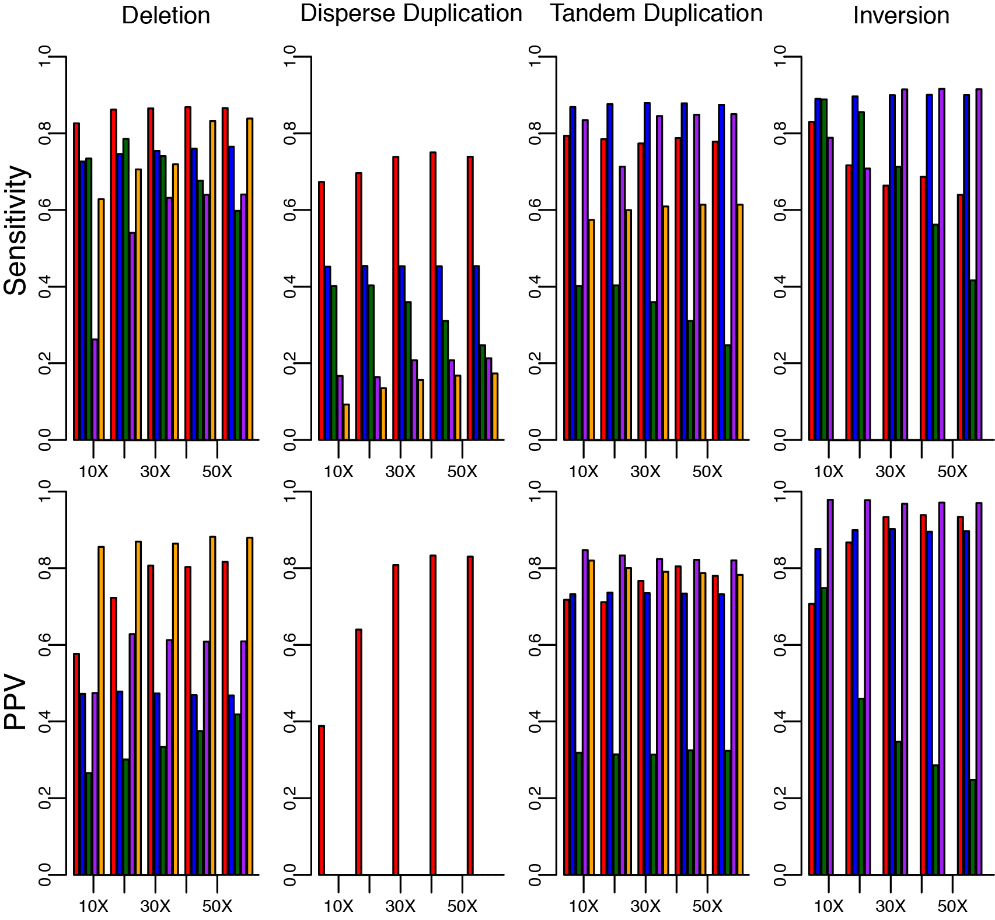Supplemental Figure 1. Assessment of accuracy on simulated simple events. Sensitivity and positive predictive values for SVelter (red), Delly (blue), Lumpy (green), Pindel (purple), and ERDS (yellow) across different simple SV types and sequence coverage on combined simulated homozygous and heterozygous events. For dispersed duplications, only SVelter was considered for positive predictive values and all predictions by other algorithms that did not overlap simulated results were considered only for the tandem duplication category.

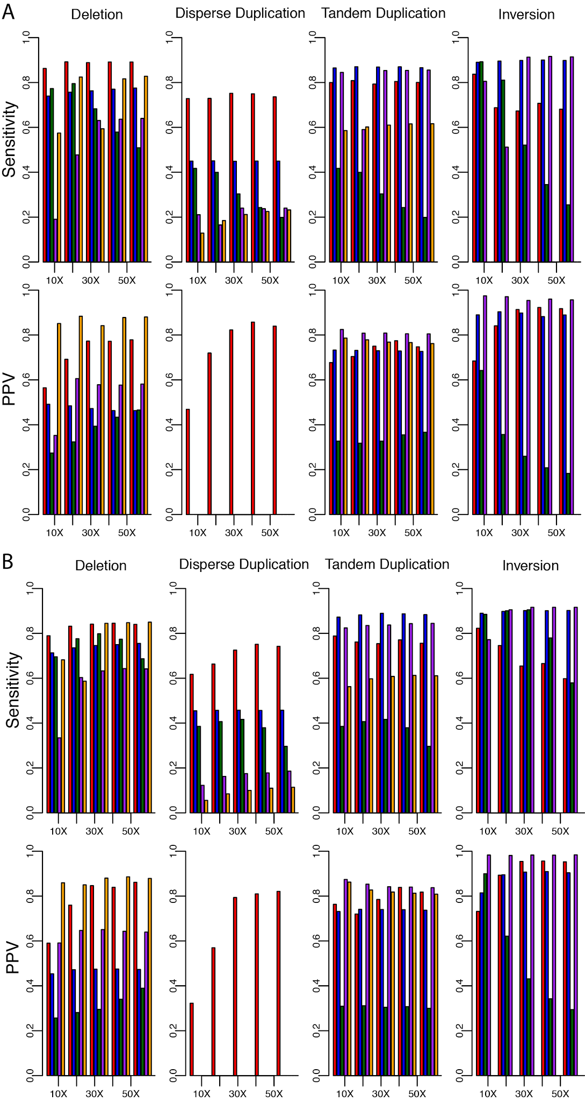
Supplemental Figure 2. Assessment of accuracy on simulated (A) homozygous and (B) heterozygous events. Sensitivity and positive predictive values for SVelter (red), Delly (blue), Lumpy (green), Pindel (purple), and ERDS (yellow) across different simple SV types and sequence coverage. For dispersed duplications, only SVelter was considered for positive predictive values and all predictions by other algorithms that did not overlap simulated results were considered only for the tandem duplication category.
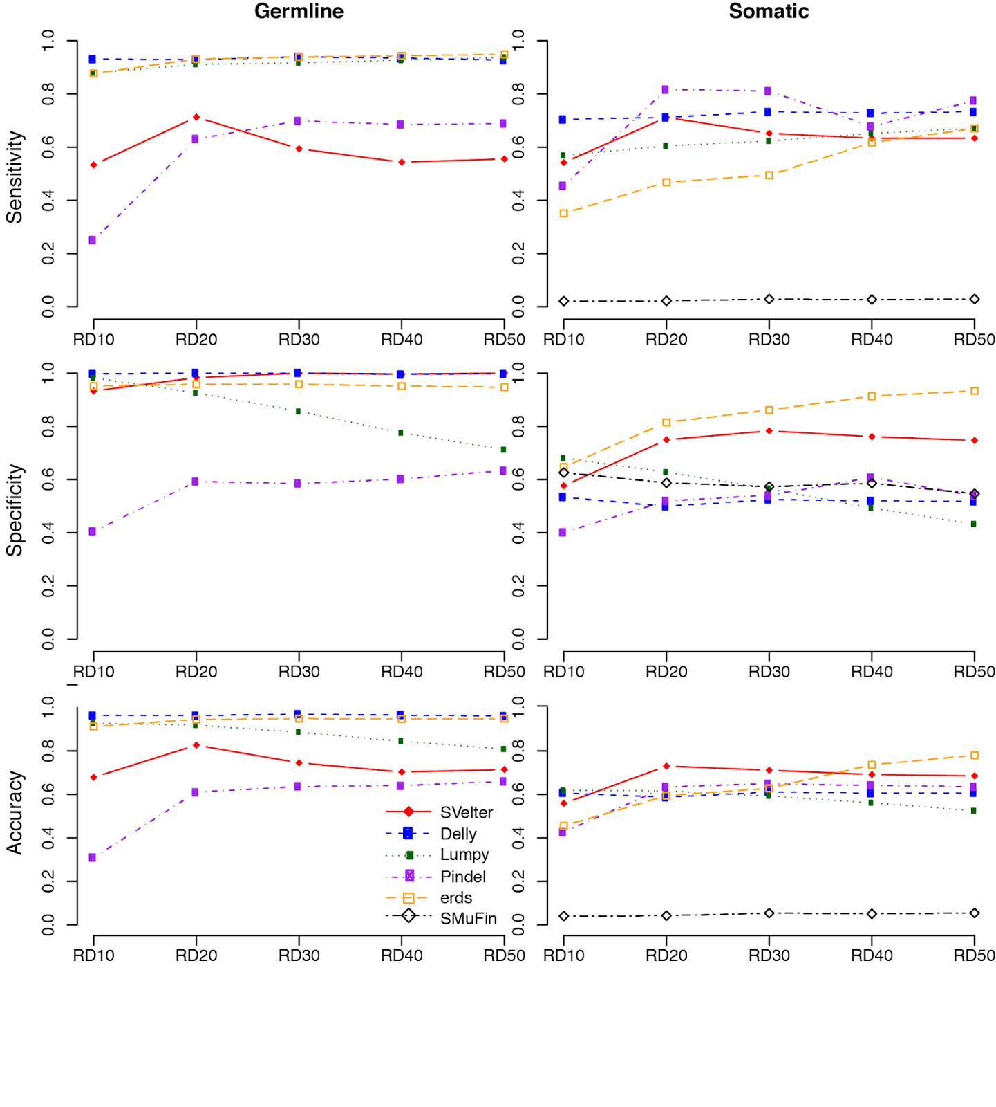
Supplemental Figure 3. Assessment of accuracy on simulated tumor and matched normal genomes. Sensitivity, specificity and combined accuracy (F-Score) of multiple algorithms at different coverage using simulated matched germline and somatic data generated locally using the Moncunill et al, 2014 set of variant calls and simulation strategy. SMuFin is absent in germline data as it only reports somatic events and is only reported for chromosomes 16-22.

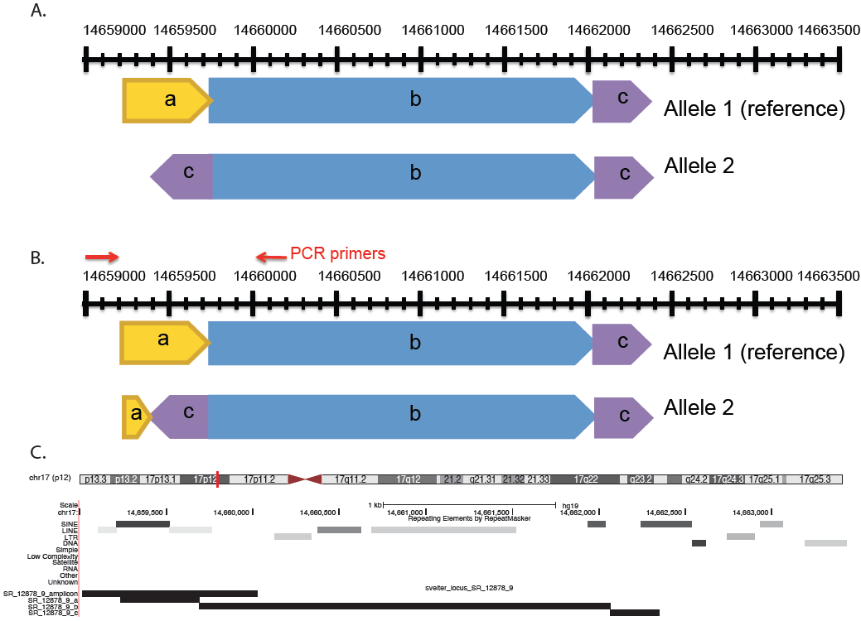
Supplementa Figure 4. Validation of inverted duplication (chr17_14659237_14662064_14662349_14662516_C) on at locus chr17:14659000-14663500. (A) Predicted structure of CSV. (B) PCR primer strategy and resulting observed structured. Primer sequences S91: GTGCACAGGATTGCTTCTGA, S92: TGTGTGGCTTTGACCACAAT. (C) Graphical representation of predicted structure and observed PCR product.

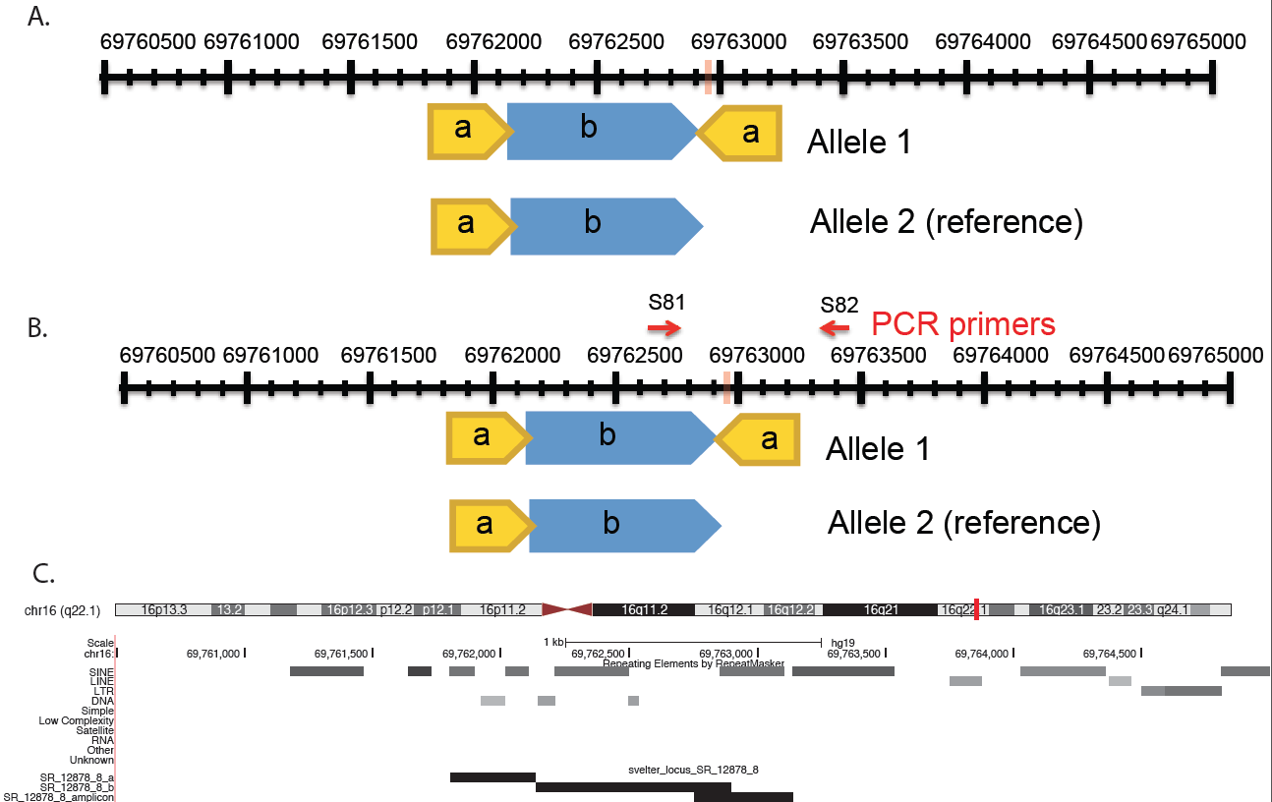
Supplemental Figure 5. Validation of inverted duplication (chr16_69761804_69762136_69762896_69766900_C) on at locus chr16:69760500-69765500. (A) Predicted structure of CSV. (B) PCR primer strategy and resulting observed structured. Primer sequences S81: CCCATCCCAAGTCATCTCAT, S82: AAATGTCTGTCTTTACCACTGTGTAG. (C) Graphical representation of predicted structure and observed PCR product.

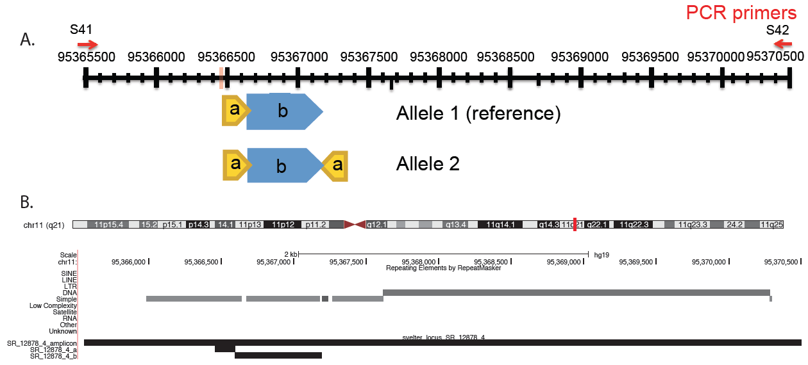
Supplemental Figure 6. Attempted validation of inverted duplication (chr11_95366462_95366593_95367193_C) at locus chr11:95365500-95375000. This region contained numerous repetitive elements making direct PCR validation difficult such that no distinct bands were produced resulting in an inconclusive validation status. (A) PCR primer strategy and predicted structured. Primer sequences S41: GCCAGGCAGTCAGAATTAGC, S42: TCCCTGAGGACAGGAACAAC. (B) Graphical representation of predicted structures.

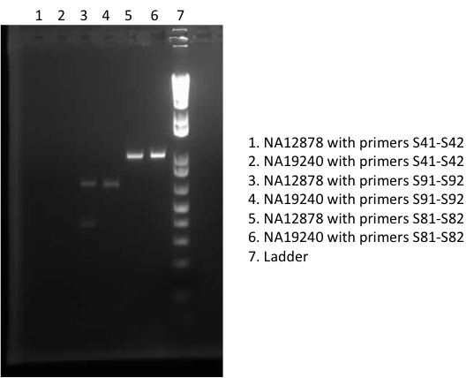
Supplemental Figure 7. Electrophoresis GEL image of PCR products for each primer pair in two different samples (NA12878, NA19240), as outlined in Supplemental Figures 1-3.

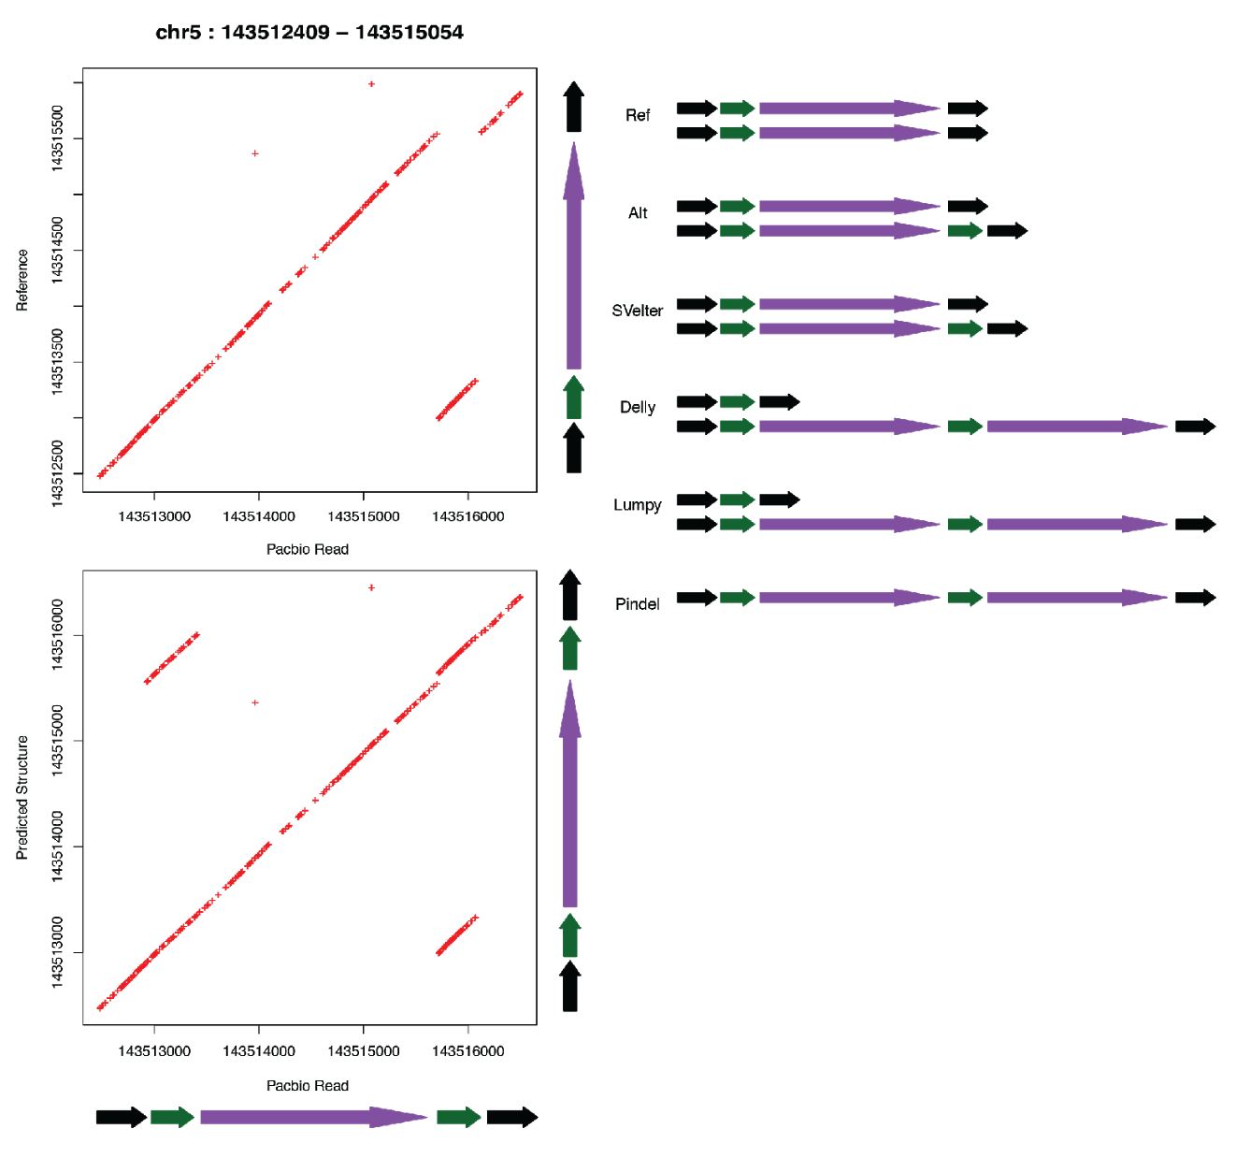

Supplemental Figure 8. Dot plot of a PacBio read (fa716c69_55756_0) from NA12878 against both unaltered reference sequence (chr5:143512409-143515054) and modified reference sequence containing the predicted rearrangement. Colored arrows on the right side indicate reference and alternative structures as diploid arrangements, as well as predictions from each individual algorithm. Ploidy for individual approaches is based on reported genotypes where available.
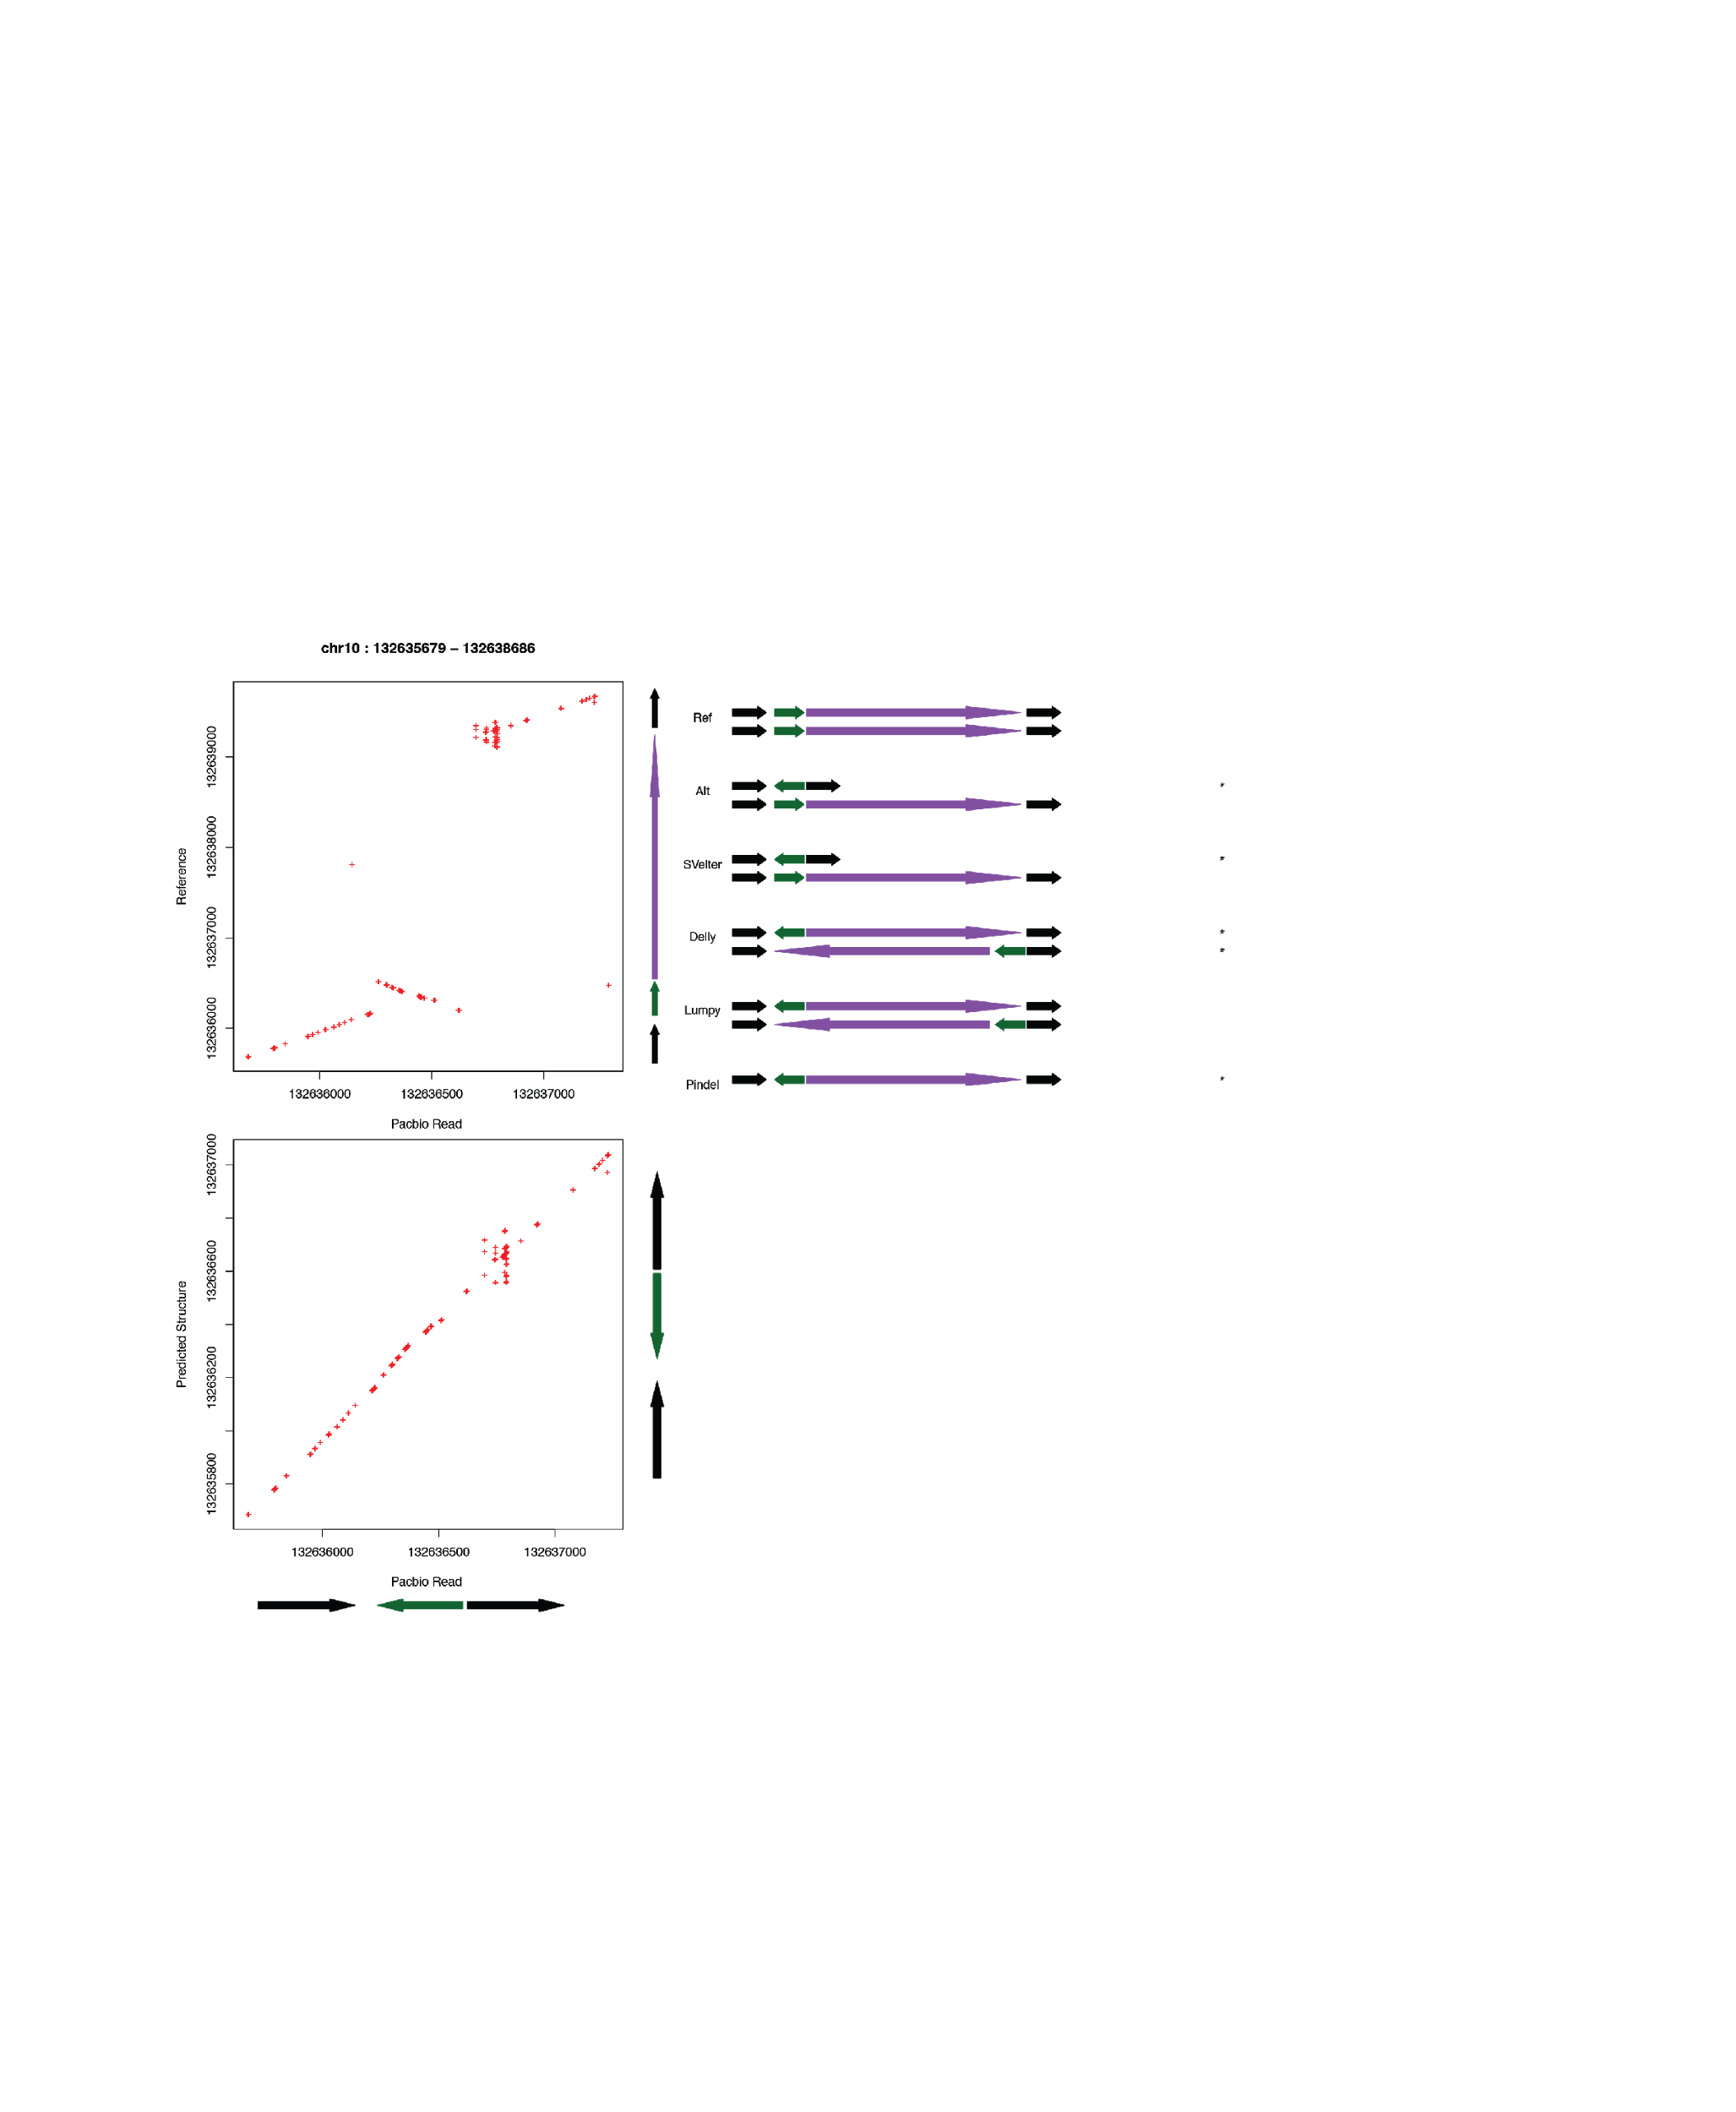
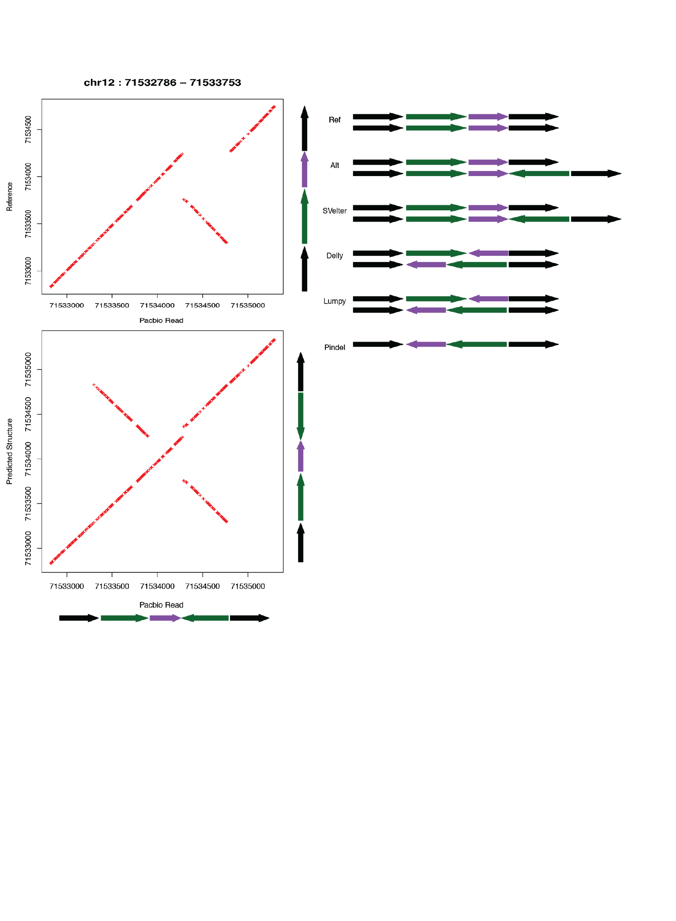
Supplemental Figure 9. Dot plot of a PacBio read (5308fbec_46356_10341) from NA12878 against both unaltered reference sequence (chr12:71532786-71533753) and modified reference sequence containing the predicted rearrangement. Colored arrows on the right side indicate reference and alternative structures as diploid arrangements, as well as predictions from each individual algorithm. Ploidy for individual approaches is based on reported genotypes where available.

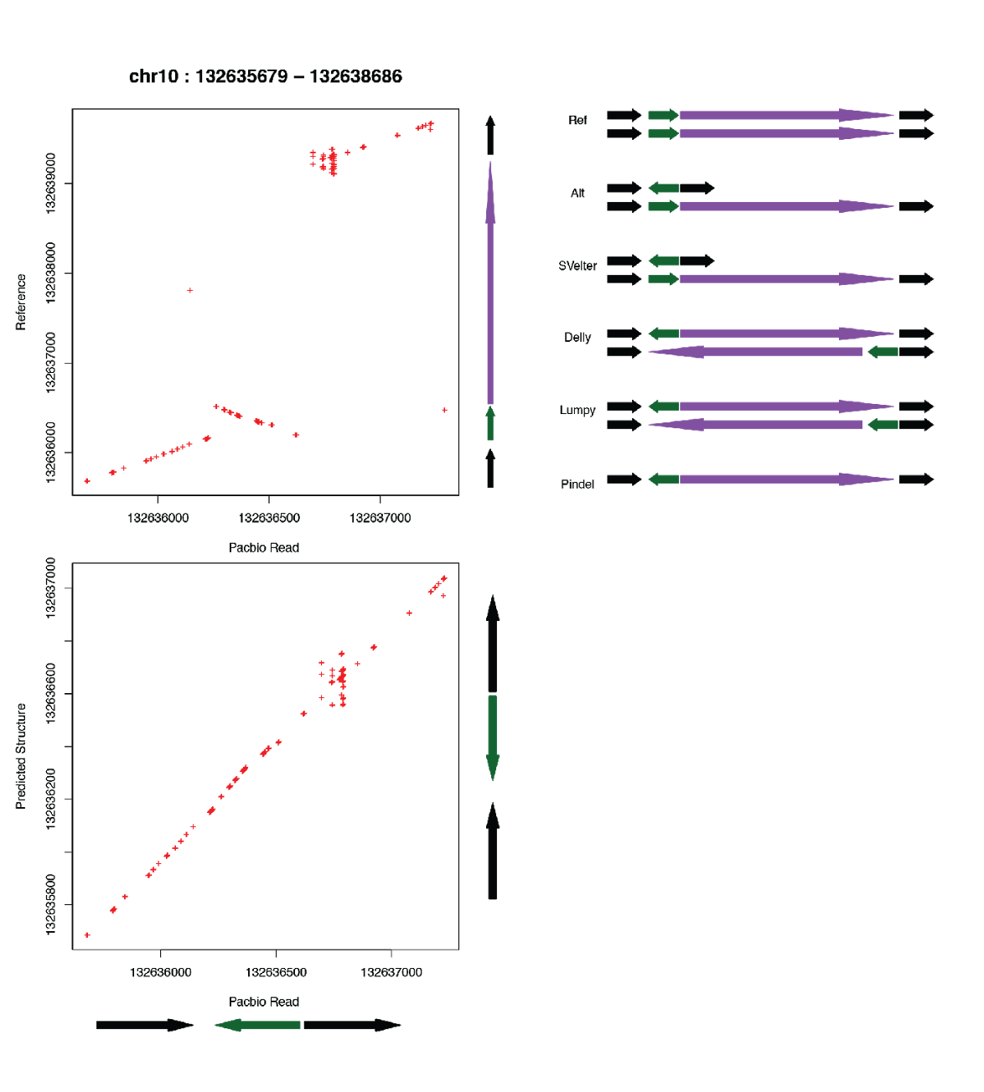
Supplemental Figure 10. Dot plot of a PacBio read (325320e3_146839_203) from NA12878 against both unaltered reference sequence (chr10:132635679-132638686) and modified reference sequence containing the predicted rearrangement. Colored arrows on the right side indicate reference and alternative structures as diploid arrangements, as well as predictions from each individual algorithm. Ploidy for individual approaches is based on reported genotypes where available.

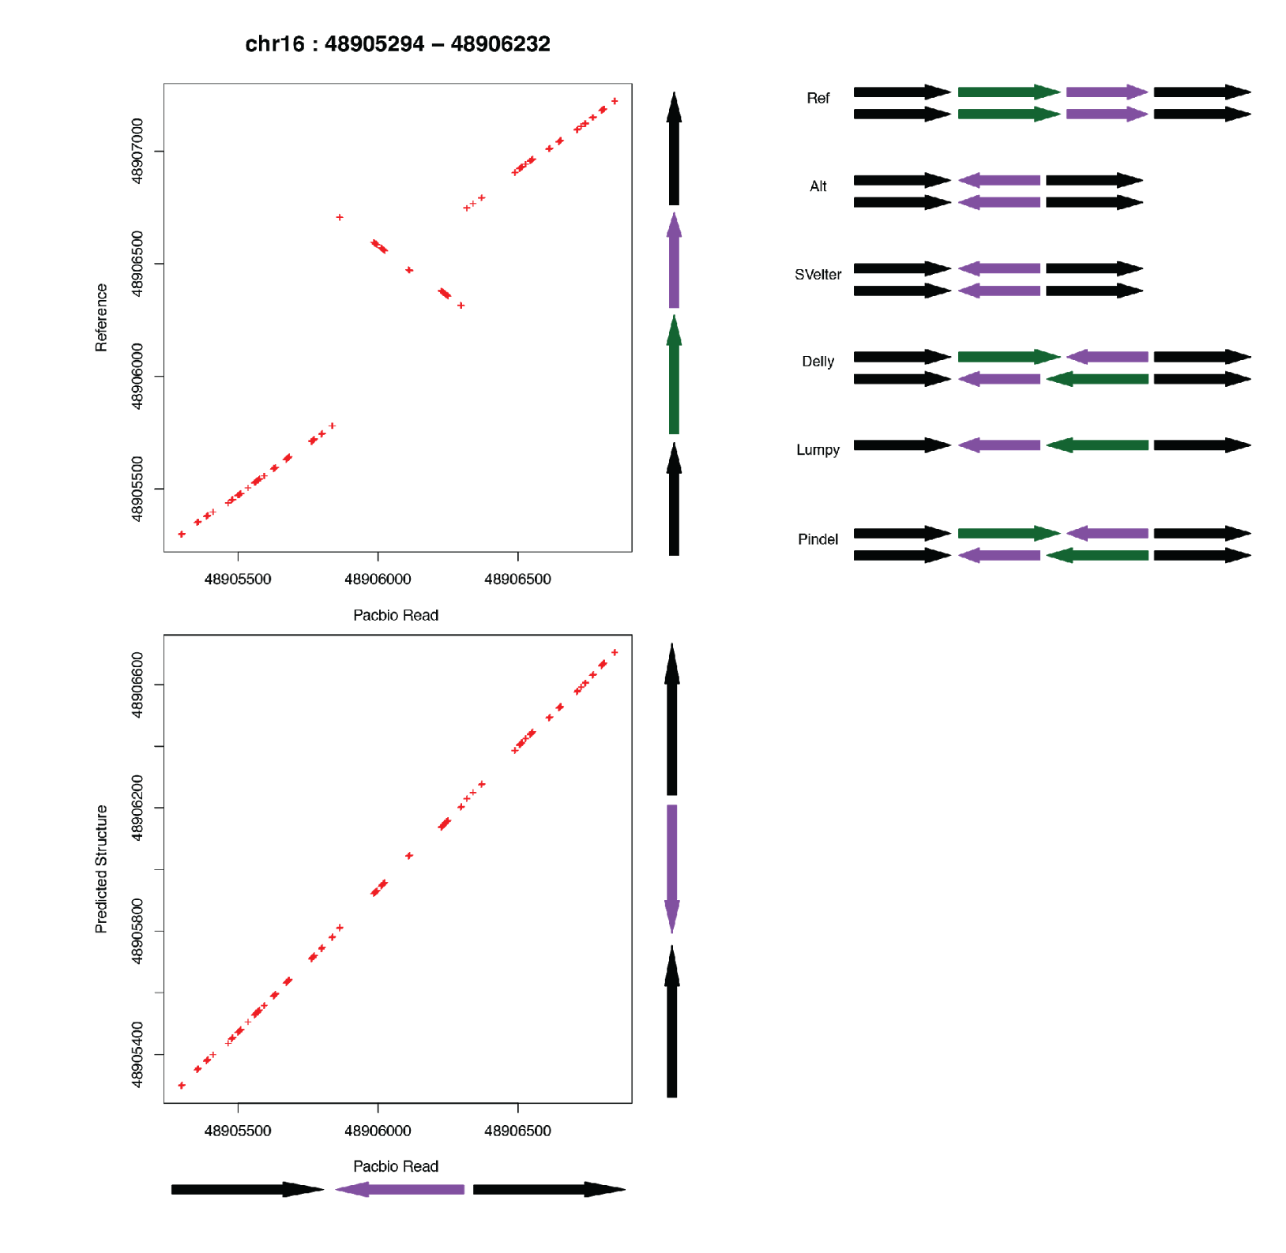
Supplemental Figure 11. Dot plot of a PacBio read (fffb5d0d_36049_18160) from NA12878 against both unaltered reference sequence (chr16:48905294-48906232) and modified reference sequence containing the predicted rearrangement. Colored arrows on the right side indicate reference and alternative structures as diploid arrangements, as well as predictions from each individual algorithm. Ploidy for individual approaches is based on reported genotypes where available.

