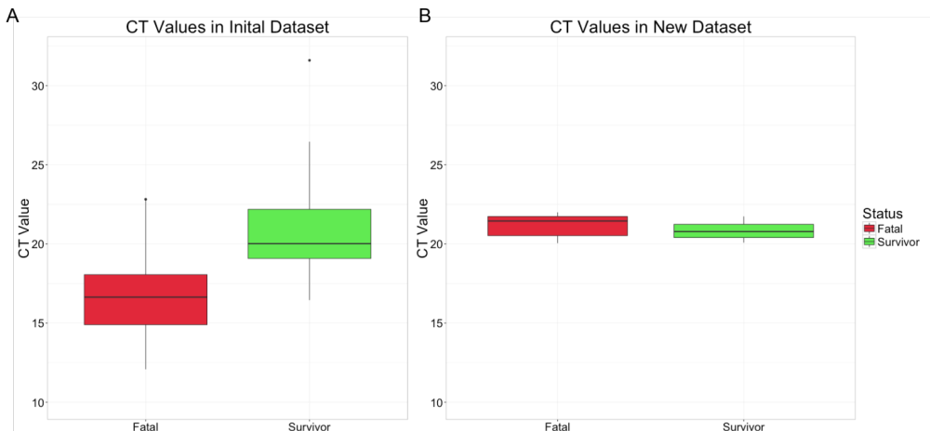

Comparison of CT values in the two datasets. A) CT distributions for the initial dataset of 112 patients during acute disease. In read is the box and whisker plot of the fatal samples CT value and in green is the survivors. B is a similar plot but for a validation set of 20 patients. B is showing that in the validation dataset, the CT values for the patients shows not significance difference.

