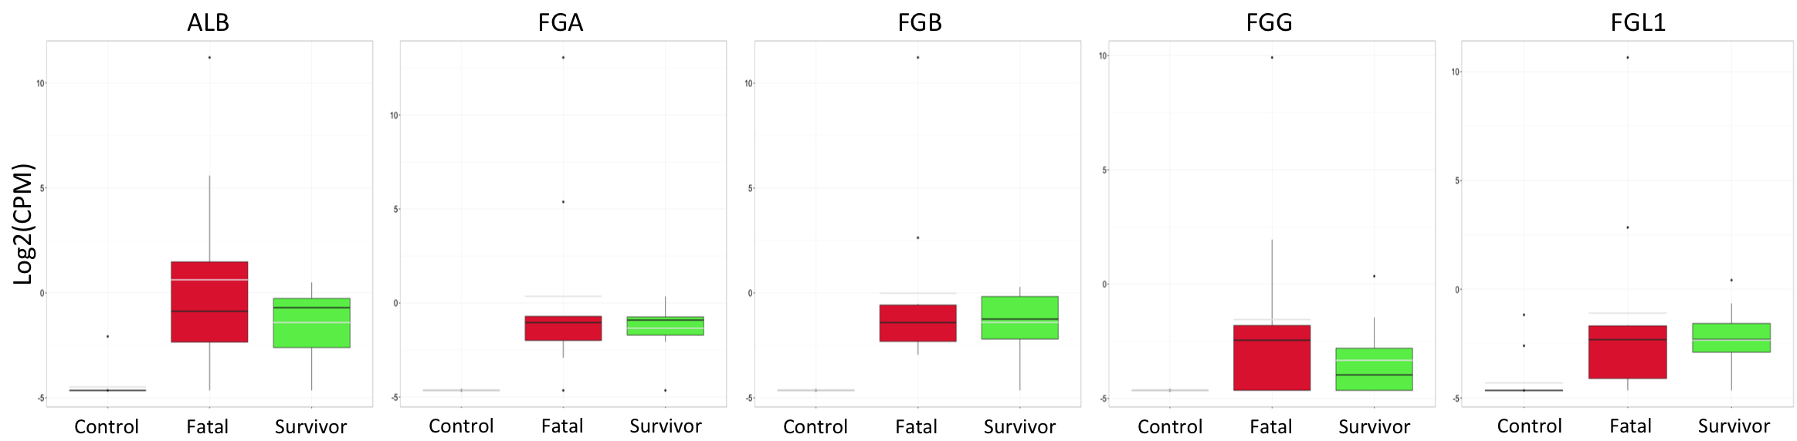

Box and whisker plot for the top differentially expressed genes in initial dataset in validation dataset with the acute fatal group shown in red, acute survivor in green, and convalescent survivors in blue. The black bar represents the median value. For all genes, there was significant increase in transcript abundance (log2(fold change) > 2 and FDR < 0.05) from convalescent survivors to acute disease (survivor or fatal). Also, in all genes except FFB there was a significant increase in transcript abundance in acute fatal compared to acute survivors.

