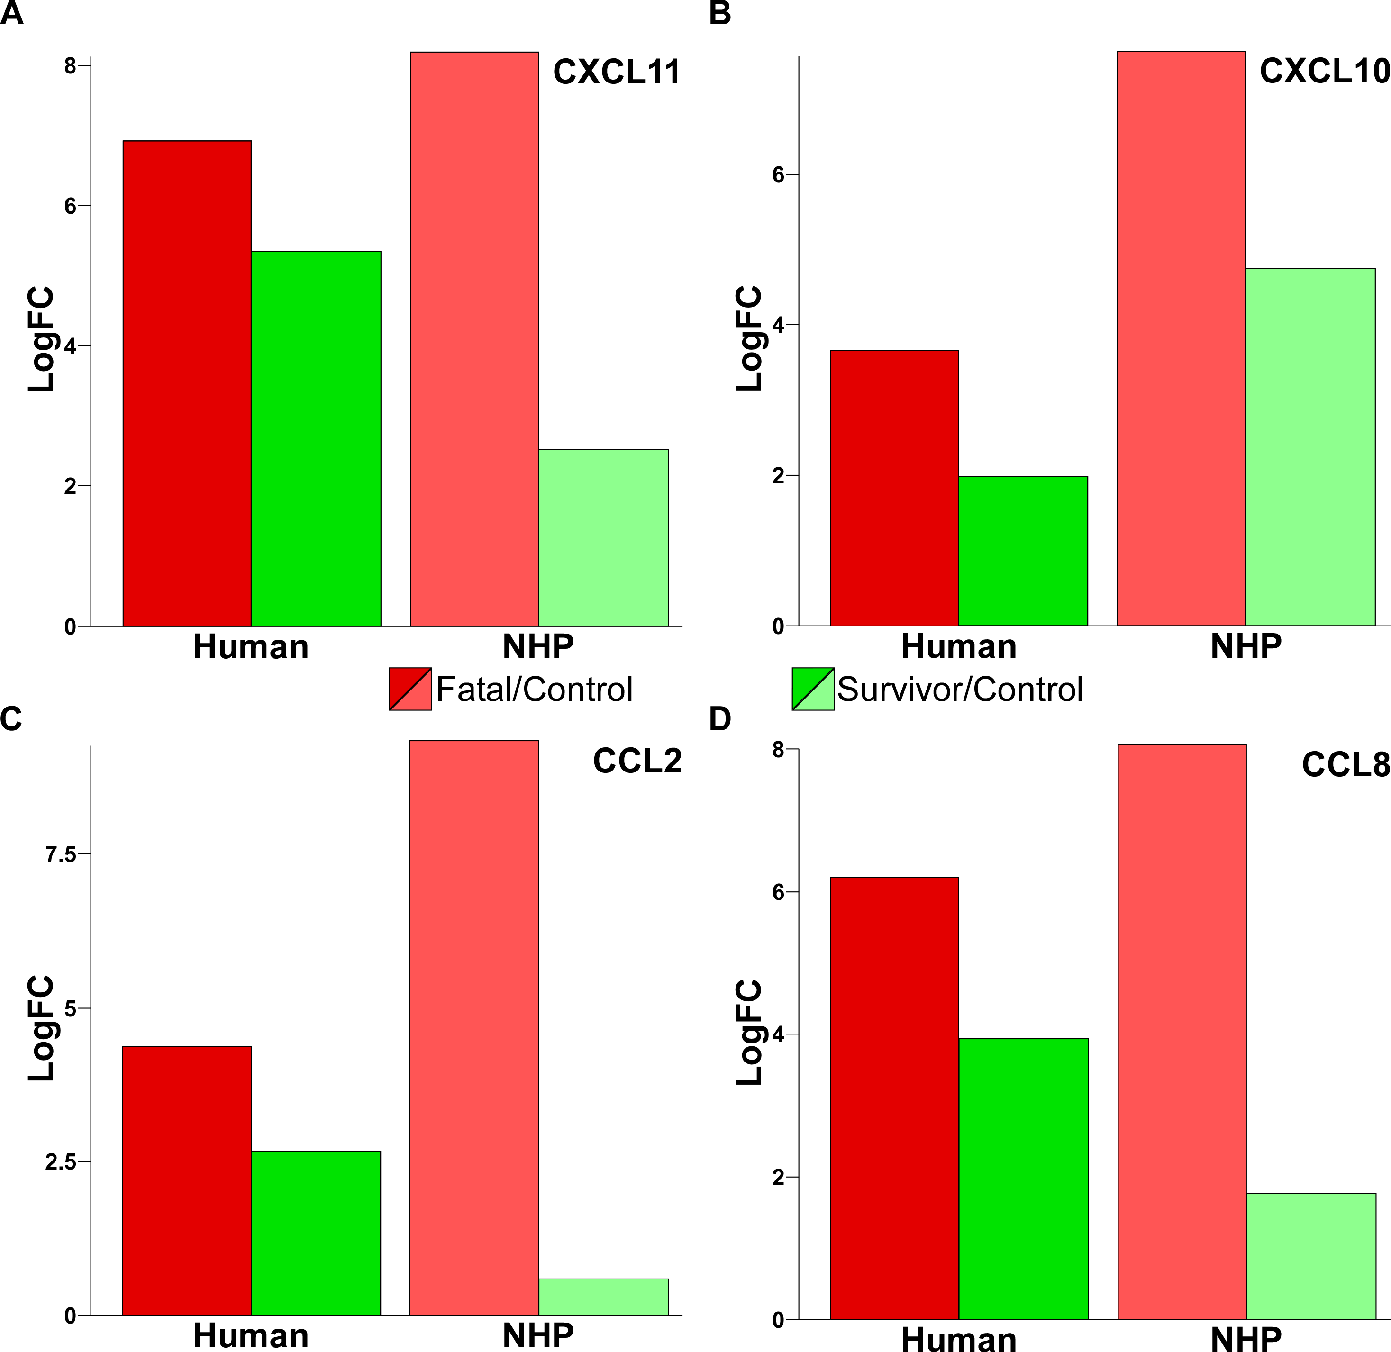

Differential accumulation of Cytokines during EBOV infection. A) bar plot illustrates the differential accumulation of CXCL11 mRNA in acute-fatal (dark red bar) and acute-survivor (green bar) human samples. For comparison, the differential accumulation of CXCL11 in non-human primates that succumb to EBOV infection is shown in the light red bar and the accumulation in individuals that survive EBOV infection is shown in the light green bar. Analogous data for CXCL10 is shown in B) for CCL2 in C) and for CCL8 in D). These plots indicate that mRNA changes seen in human infection are mimicked in primate models of lethal/non-lethal infection with EBOV.

