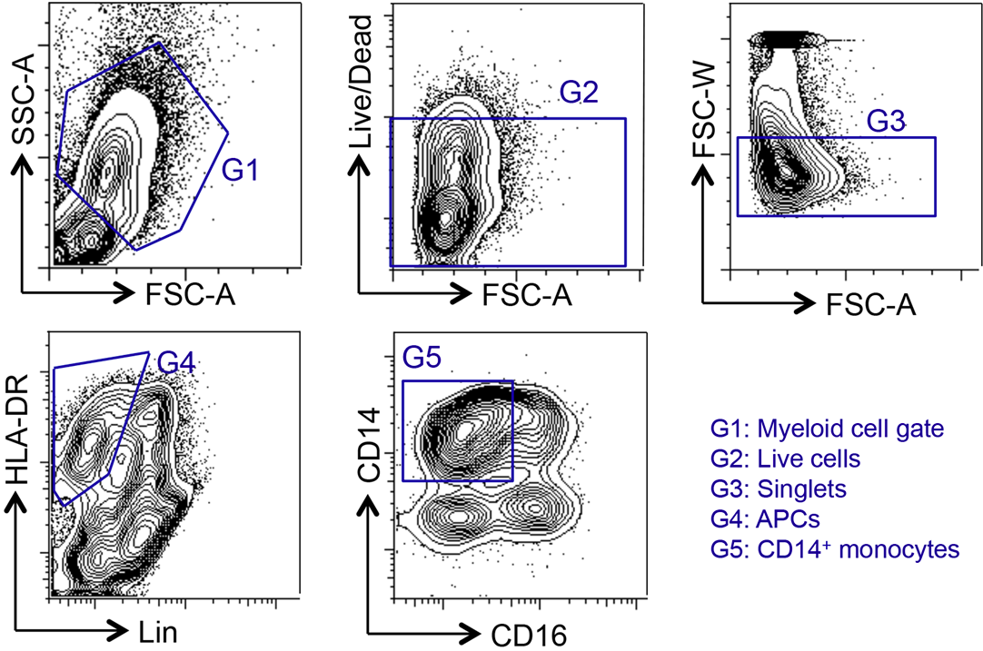

Flow cytometry gating strategy for discrimination of classic CD14+ peripheral blood monocytes.

