Additional File 19: Cathepsin B dsRNA alignment

Gene name | Gene ID | Score (bits) | E value | Reduced expression by dsCathB lines | Identities | Gaps
MpCathB4 | MYZPE13164_G006_v1.0_000104270 | 335 | 1.00E-91 | Yes | 241/242(99%)* | 0/242 (0%)*
MpCathB5 | MYZPE13164_G006_v1.0_000104270 | 335 | 1.00E-91 | Yes | 212/242(88%)* | 10/242 (4%)*
MpCathB3 | MYZPE13164_G006_v1.0_000141010 | 286 | 7.00E-77 | Yes | 208/242(86%) | 0/242 (0%)
MpCathB1 | MYZPE13164_G006_v1.0_000141000 | 286 | 7.00E-77 | Yes | 208/242(86%) | 0/242 (0%)
MpCathB2 | MYZPE13164_G006_v1.0_000049160 | 281 | 3.00E-75 | Yes | 207/242(86%) | 0/242 (0%)
MpCathB6 | MYZPE13164_G006_v1.0_000104300 | 250 | 6.00E-66 | Yes | 194/232(84%) | 0/232 (0%)
MpCathB7 | MYZPE13164_G006_v1.0_000104310 | 244 | 3.00E-64 | Yes | 193/232(83%) | 0/232 (0%)
MpCathB9 | MYZPE13164_G006_v1.0_000104280 | 177 | 5.00E-44 | Yes | 169/217(78%) | 0/217 (0%)
MpCathB10 | MYZPE13164_G006_v1.0_000195260 | 157 | 5.00E-38 | Yes | 134/174(77%)* | 0/174 (0%)*
MpCathB11 | MYZPE13164_G006_v1.0_000195260 | 157 | 5.00E-38 | Yes | 158/206(77%)* | 0/206 (0%)*
MpCathB8 | MYZPE13164_G006_v1.0_000104290 | 153 | 6.00E-37 | Yes | 143/182(79%) | 0/182 (0%)
MpCathB12 | MYZPE13164_G006_v1.0_000104320 | 137 | 5.00E-32 | No | 176/241(73%) | 3/241 (1%)
MpCathB13 | MYZPE13164_G006_v1.0_000104330 | 88.5 | 3.00E-17 | No | 108/148(73%) | 0/148 (0%)
MpCathB17 | MYZPE13164_G006_v1.0_000151060 | 44.9 | 4.00E-04 | No | 74/106 (69%) | 0/107 (0%)

Alignment of 242bp with target geens

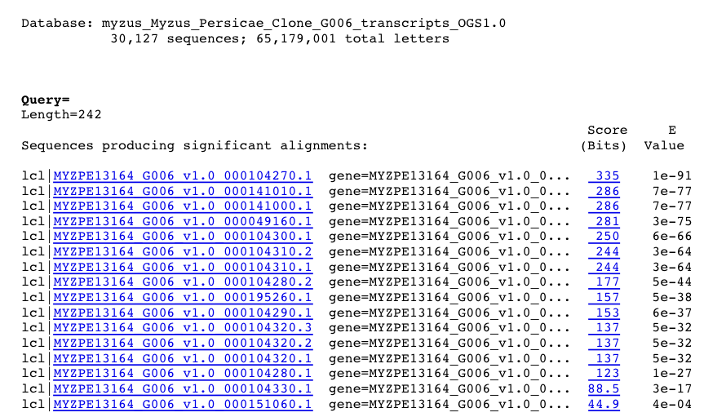

MpCathB4/MpCathB5 MYZPE13164_G006_v1.0_000104270
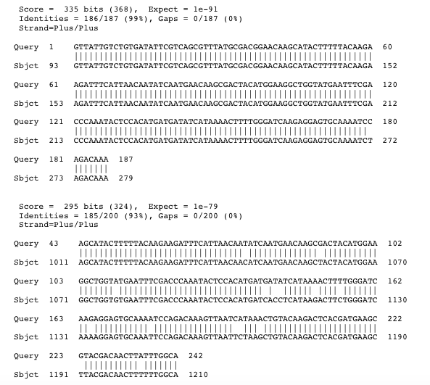
MpCathB4 MYZPE13164_G006_v1.0_000104270
Generated by NCBI blastn suite-2sequences
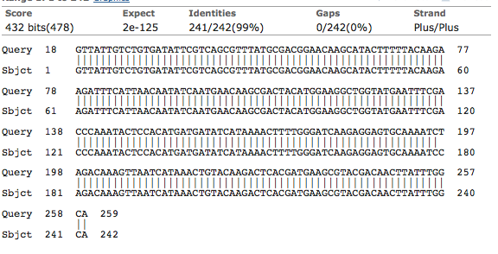
MpCathB5 MYZPE13164_G006_v1.0_000104270
Generated by NCBI blastn suite-2sequences
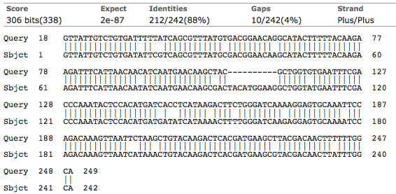
MpCathB3 MYZPE13164_G006_v1.0_000141010
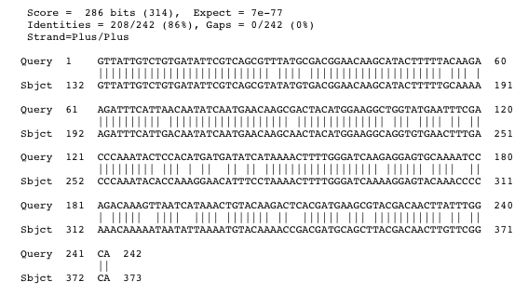
MpCathB1 MYZPE13164_G006_v1.0_000141000
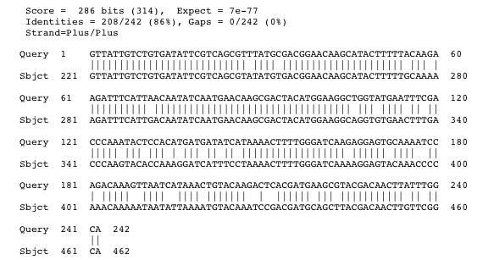
MpCathB2 MYZPE13164_G006_v1.0_000049160
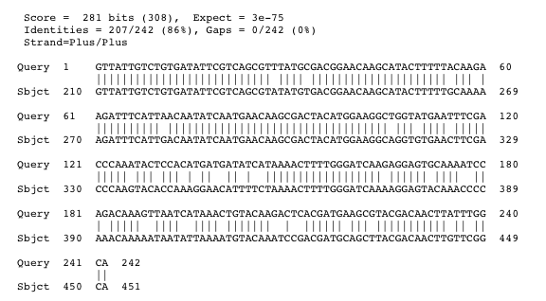
MpCathB6 MYZPE13164_G006_v1.0_000104300
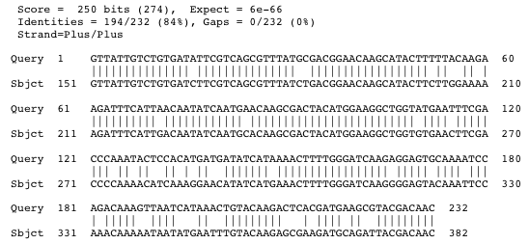

MpCathB7 MYZPE13164_G006_v1.0_000104310
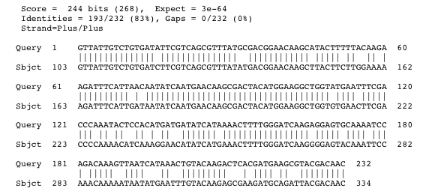
MpCathB9 MYZPE13164_G006_v1.0_000104280
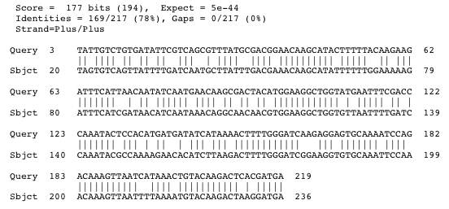

MpCathB10/MpCathB111 MYZPE13164_G006_v1.0_000195260
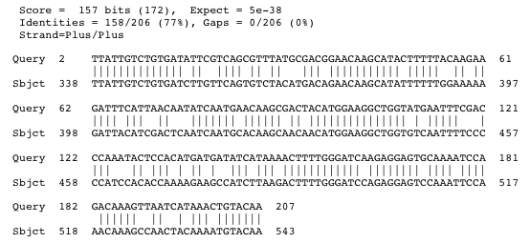

MpCathB10 MYZPE13164_G006_v1.0_000195260
Generated by NCBI blastn suite-2sequences
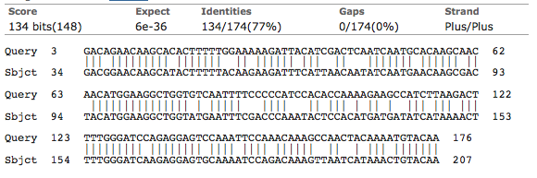
MpCathB11 MYZPE13164_G006_v1.0_000195260
Generated by NCBI blastn suite-2sequences
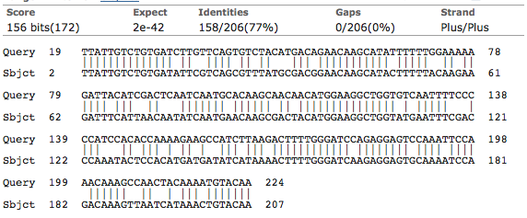
MpCathB8 MYZPE13164_G006_v1.0_000104290
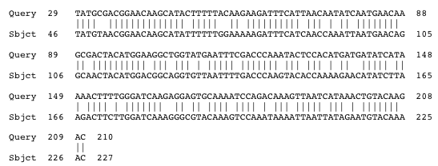

MpCathB12 MYZPE13164_G006_v1.0_000104320
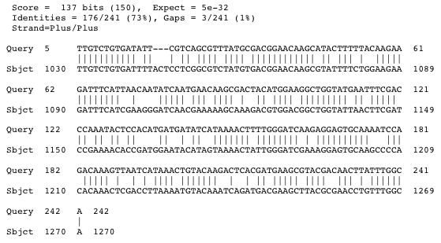
MpCathB13 MYZPE13164_G006_v1.0_000104330
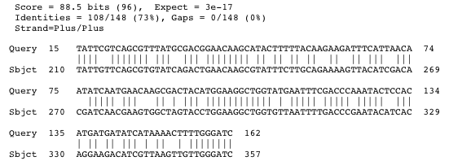
MpCathB17 MYZPE13164_G006_v1.0_000151060

