The genomic landscape of indigenous African cattle
Jaemin Kim*, Olivier Hanotte*, Okeyo Ally Mwai, Tadelle Dessie, Salim Bashir, Boubacar Diallo, Morris Agaba, Woori Kwak, Samsun Sung, Minseok Seo, Hyeonsoo Jeong, Taehyung Kwon, Kwondo Kim, Mengistie Terefe, Seoae Cho, Hyun-Jeong Lee, Duhak Yoon, Sung Jong Oh, Stephen Kemp, Hak-Kyo Lee*, Heebal Kim*

Additional file 1

- Additional file 1: Note………………………………………………………... 2
- Additional file 1: Tables
Table S1…………………………………………………….. 6
Table S2…………………………………………………….. 7
Table S3…………………………………………………….. 9
Table S4…………………………………………………….. 10
Table S5…………………………………………………….. 12
Table S6…………………………………………………….. 13
Table S7…………………………………………………….. 14

- Additional file 1: Figures
Figure S1…………………………………………………… 15
Figure S2…………………………………………………… 16
Figure S3…………………………………………………… 17
Figure S4…………………………………………………… 18
Figure S5…………………………………………………… 19
Figure S6…………………………………………………… 20
Figure S7…………………………………………………… 21
Figure S8…………………………………………………… 22
Figure S9…………………………………………………… 23
Figure S10………………………………………………….. 24
Figure S11………………………………………………….. 25
Figure S12………………………………………………….. 26

Note S1. Characteristics of the African cattle and commercial breeds.
The Ankole and its related strains (e.g. Watusi, Kigezi) are sanga type of cattle. They are ancient crossbreed Bos indicus and B. taurus cattle populations. They are found in Uganda, Rwanda, Burundi and Tanzania¹⁻⁵. These cattle have a medium body size with small birth weight, characteristic elegant gait, very long and symmetrical horns, a relatively short neck, weak legs, and solid brown color for their preferred coat color pattern¹. They are well adapted to hot climate being able to use and survive on poor quality feed and withstand severe droughts. The breed is tolerant against ticks and display resistance to theileriosis and helminthes⁵. We sequenced Ankole cattle from Uganda.
The N’Dama is a taurine cattle distributed in tsetse-infested regions of West and Central Africa. It is compact with short legs of fine bone and therefore small body size; neck is thick and deep. The coat color is predominantly red or black¹. It is known for its trypanosomosis resistance^{6,7} and it also shows superior resistance to several parasitic diseases and/or infections, including helminths¹. The animals studied were sampled in the Fouta Djallon area of Guinea, the geographic center of origin of the breed¹.
Boran cattle belong to the large East African Zebu breeds of cattle. The Boran cattle likely originate in Ethiopia and today they are found in this country as well as in Kenya (Kenyan Boran, Orma Boran) and Somalia^{1,4}. The Kenyan Boran is a meat type of breed. They are usually white or grey fawn, the hooves and muzzle are always black¹. Boran cattle have the reputation to be very versatile and to adapt well to various environments¹. They have the ability to thrive well in dry and low rainfall areas. The breed can walk long distances in hot climate in search of feed and water. The animal studied here are Kenya Boran from the ILRI Kapiti Ranch.
The Kenana breed is zebu cattle breed largely under the custody of semi-nomadic pastoralists in northern Sudan. They are medium to large in size. Coat color is white or steel grey with darker shading on the neck and shoulders and a black switch to the tail; blue-grey to white with black shadings on the head, neck hump, hindquarters and legs; horns are black. Calves are born ‘’red’’ in color turning white/grey when they get older. Horns are often loose; females have shorter horns than males^{1,4,8}. Kenana cows are considered as one of the best African zebu milk breed¹. Our animals were sampled in Sudan, and they were collected from different herds around the city of Rabak located approximately 260 kilometers south of Khartoum.

Ogaden cattle studied here originate from the Ogaden area in the southeastern portion of the Somali Regional State in eastern Ethiopia. Their coat color pattern is uniform plain white. However, some animals have shades of black around the face, hump and rump. They are similar to the Ethiopian Boran with well-developed hump and large dewlap; horns are short¹.
Holstein cattle have been intensively selected during recent centuries, especially in the last few decades after the implementation of progeny-test-based breeding programs in the 1960s^{9,10}. This breed has become highly specialized for milk production. Korean beef producers have selected Hanwoo for meat yield and quality¹¹. Hanwoo is reported to have originated from crossbreeding between taurine and zebu cattle and migrated to the Korean peninsula through North China; their history as a draft animal dates back at least 5,000 years¹². Angus cattle, (Aberdeen Angus) are beef breed, and they were developed from cattle native to the counties of Aberdeenshire and in Scotland¹³. Jersey cattle are small breed of dairy cattle, originally bred in the Channel Island of Jersey. This breed is popular for the better quality of milk¹⁴.

REFERENCE

1. DAGRIS. Domestic Animal Genetic Resources Information System (DAGRIS).
(eds S. Kemp, Y. Mamo, B. Asrat and T. Dessie). International Livestok
Research Institute, Addis Ababa, Ethiopia.
2. Mason, I.L. & Maule, J.P. The indigenous livestock of Eastern and Southern Africa. (1960).
3. Wurzinger, M. et al. Comparison of production systems and selection criteria of Ankole cattle by breeders in Burundi, Rwanda,Tanzania and Uganda. Tropical Animal Health and Production 38, 571-581 (2006).
4. Rege, J. The state of African cattle genetic resources I. Classification framework and identification of threatened and extinct breeds. Animal Genetic Resources Information 25, 1-25 (1999).
5. Ndumu, D. et al. Genetic and morphological characterisation of the Ankole Longhorn cattle in the African Great Lakes region. Genetics Selection Evolution 40, 467-490 (2008).
6. Murray, M. & Trail, J. Trypanotolerance: genetics, environmental influences and mechanisms. (1982).
7. Mattioli, R.C., Pandey, V.S., Murray, M. & Fitzpatrick, J.L. Immunogenetic influences on tick resistance in African cattle with particular reference to trypanotolerant N’Dama (Bos taurus) and trypanosusceptible Gobra zebu (Bos indicus) cattle. Acta Tropica 75, 263-277 (2000).
8. Yousif, I. & El-Moula, A. Characterisation of Kenana cattle breed and its production environment. Animal Genetic Resources Information 38, 47-56 (2006).
9. Rege, J. The state of African cattle genetic resources I. Classification framework and identification of threatened and extinct breeds. Animal Genetic Resources Information 25, 1-25 (1999).
10. Skjervold, H. & Langholz, H.J. Factors affecting the optimum structure of AI breeding in dairy cattle. Zeitschrift für Tierzüchtung und Züchtungsbiologie 80, 25-40 (1964).
11. Chung, E. & Kim, W. Association of SNP marker in IGF-I and MYF5 candidate genes with growth traits in Korean cattle. ASIAN AUSTRALASIAN JOURNAL OF ANIMAL SCIENCES 18, 1061 (2005).
12. Lee, C. & Pollak, E. Genetic antagonism between body weight and milk production in beef cattle. Journal of animal science 80, 316-321 (2002).
13. Britannica, E. & King, T. Encyclopaedia Britannica Almanac 2009, (Encyclopædia Britannica, 2009).
14. Consortium, B.H. Genome-wide survey of SNP variation uncovers the genetic structure of cattle breeds. Science 324, 528-532 (2009).

Table S1. Publically available whole genome sequencing data used for analyses.
Breed | Sample size | Bioproject ID
Holstein | 10 | PRJNA210521
Jersey | 10 | PRJNA318089
Angus | 10 | PRJNA318087
Hanwoo | 23 | PRJNA210523

Table S2. Summary of sequencing data.
Sample ID | DNA  Sequenced (bp) | Total Reads | Alignment  Rate (%) | Read Depth | Genome  Coverage (%) | SRA
Bo_672 | 30,638,401,106 | 303,350,506 | 98.77% | 5.97 | 97.78 | SRS1468768
Bo_2612 | 28,403,655,310 | 281,224,310 | 98.92% | 9.07 | 98.61 | SRS1335347
Bo_37506E | 28,301,084,356 | 280,208,756 | 98.64% | 9.09 | 98.56 | SRS1338703
Bo_392205G | 28,325,968,534 | 280,455,134 | 98.58% | 8.99 | 98.56 | SRS1429391
Bo_587 | 31,211,002,224 | 309,019,824 | 98.90% | 9.98 | 98.66 | SRS1727978
Bow_1304 | 30,304,683,976 | 300,046,376 | 98.77% | 9.51 | 98.61 | SRS1468771
Bo_439 | 28,267,720,016 | 279,878,416 | 98.76% | 8.87 | 98.53 | SRS1346805
Bow_1688 | 31,921,906,076 | 316,058,476 | 98.64% | 9.67 | 98.68 | SRS1468770
Bo_467 | 28,829,275,168 | 285,438,368 | 98.80% | 9.15 | 98.55 | SRS1429491
Bo_563005K | 32,477,775,534 | 321,562,134 | 96.16% | 9.85 | 98.73 | SRS1437860
BT200001 | 30,125,956,396 | 298,276,796 | 98.76% | 9.63 | 98.66 | SRS1338704
BT200015 | 26,850,027,254 | 265,841,854 | 98.91% | 8.81 | 98.60 | SRS1496254
BT200030 | 28,511,065,982 | 282,287,782 | 89.16% | 6.92 | 95.31 | SRS1496257
BT200050 | 31,302,879,904 | 309,929,504 | 98.99% | 9.91 | 98.67 | SRS1496259
BT200073 | 30,310,459,964 | 300,103,564 | 98.89% | 9.82 | 98.73 | SRS1496260
BT200109 | 30,781,515,884 | 304,767,484 | 98.85% | 10.04 | 98.61 | SRS1496261
BT200111 | 30,329,107,796 | 300,288,196 | 99.01% | 9.89 | 98.61 | SRS1496262
BT200122 | 29,454,188,226 | 291,625,626 | 98.96% | 9.47 | 98.64 | SRS1496264
BT200123 | 28,797,582,580 | 285,124,580 | 98.94% | 9.42 | 98.64 | SRS1496265
BT200135 | 29,320,591,284 | 290,302,884 | 98.96% | 9.43 | 98.65 | SRS1496266
KENANA_2 | 30,839,778,340 | 305,344,340 | 98.87% | 9.69 | 98.61 | SRS1439369
KENANA_4 | 31,233,638,748 | 309,243,948 | 98.80% | 9.80 | 98.63 | SRS1446906
KENANA_11 | 31,017,693,678 | 307,105,878 | 98.78% | 9.74 | 98.59 | SRS1437861
KENANA_13 | 30,171,253,078 | 298,725,278 | 98.78% | 9.45 | 98.60 | SRS1439366
KENANA_14 | 30,161,939,666 | 298,633,066 | 98.79% | 9.67 | 98.60 | SRS1439367
KENANA_16 | 29,802,497,432 | 295,074,232 | 98.84% | 9.52 | 98.61 | SRS1439368
KENANA_7 | 30,075,057,244 | 297,772,844 | 98.78% | 9.52 | 98.59 | SRS1446916
KENANA_18 | 30,979,082,186 | 306,723,586 | 98.74% | 9.63 | 98.74 | SRS1439001
KENANA_20 | 30,609,308,258 | 303,062,458 | 98.87% | 9.68 | 98.61 | SRS1439005
ND064 | 30,210,384,316 | 299,112,716 | 98.99% | 9.96 | 98.65 | SRS1512380
ND118 | 28,909,114,052 | 286,228,852 | 99.09% | 9.31 | 98.62 | SRS1512399
ND131 | 27,437,854,324 | 271,661,924 | 98.11% | 8.73 | 98.56 | SRS1512404
ND148 | 30,088,935,654 | 297,910,254 | 99.09% | 9.72 | 98.63 | SRS1512405
ND158 | 30,552,295,374 | 302,497,974 | 99.08% | 9.96 | 98.66 | SRS1512406
ND166 | 30,441,334,552 | 301,399,352 | 99.14% | 10.20 | 98.70 | SRS1512407
ND169 | 30,187,321,774 | 298,884,374 | 99.12% | 9.79 | 98.66 | SRS1512417
ND183 | 29,920,318,376 | 296,240,776 | 98.96% | 9.48 | 98.65 | SRS1512418
ND719 | 31,590,149,558 | 312,773,758 | 99.12% | 10.07 | 98.67 | SRS1512498
ND730 | 30,095,727,500 | 297,977,500 | 99.10% | 9.76 | 98.65 | SRS1512514
OgD5 | 29,246,322,550 | 289,567,550 | 98.60% | 8.92 | 98.54 | SRS1512521
OgD6 | 31,562,494,748 | 312,499,948 | 98.74% | 9.95 | 98.61 | SRS1512522
OgD7 | 29,799,017,376 | 295,039,776 | 98.72% | 9.40 | 98.57 | SRS1512523
OgD1 | 29,461,012,594 | 291,693,194 | 98.68% | 9.28 | 98.58 | SRS1512518
OgD2 | 30,480,606,584 | 301,788,184 | 98.71% | 9.63 | 98.61 | SRS1512519
OgD8 | 31,422,123,736 | 311,110,136 | 98.79% | 9.41 | 98.55 | SRS1512524
OgD4 | 29,744,012,574 | 294,495,174 | 98.54% | 9.14 | 98.54 | SRS1512520
OgS1 | 26,868,959,300 | 266,029,300 | 98.49% | 8.58 | 98.66 | SRS1512525
OgS2 | 31,218,873,356 | 309,097,756 | 98.62% | 9.67 | 98.69 | SRS1512526

Table S3. Chromosomal distribution and number of SNPs
Chromosome | Length (bp)* | Numbers of SNPs | Average distance between SNPs
1 | 158,337,067 | 2,307,435 | 68
2 | 137,060,424 | 1,917,262 | 71
3 | 121,430,405 | 1,662,248 | 73
4 | 120,829,699 | 1,762,569 | 68
5 | 121,191,424 | 1,665,070 | 72
6 | 119,458,736 | 1,740,133 | 68
7 | 112,638,659 | 1,533,299 | 73
8 | 113,384,836 | 1,579,856 | 71
9 | 105,708,250 | 1,492,154 | 70
10 | 104,305,016 | 1,476,536 | 70
11 | 107,310,763 | 1,506,893 | 71
12 | 91,163,125 | 1,423,996 | 64
13 | 84,240,350 | 1,158,798 | 72
14 | 84,648,390 | 1,187,482 | 71
15 | 85,296,676 | 1,291,360 | 66
16 | 81,724,687 | 1,167,512 | 69
17 | 75,158,596 | 1,110,369 | 67
18 | 66,004,023 | 907,819 | 72
19 | 64,057,457 | 875,206 | 73
20 | 72,042,655 | 1,068,977 | 67
21 | 71,599,096 | 1,031,652 | 69
22 | 61,435,874 | 863,499 | 71
23 | 52,530,062 | 864,636 | 60
24 | 62,714,930 | 948,245 | 66
25 | 42,904,170 | 627,563 | 68
26 | 51,681,464 | 767,090 | 67
27 | 45,407,902 | 719,364 | 63
28 | 46,312,546 | 742,945 | 62
29 | 51,505,224 | 819,853 | 62
MT | 16,338 | 319 | 51
X | 148,823,899 | 1,143,296 | 130
*Based on UMD3.1 genome of reference
Table S4. Genotype concordance rates of African cattle samples
Sample ID | Loci in  common | Concordant loci  by genotype | Genotype  concordance
Bo_2612 | 36,403 | 34,656 | 95.2%
Bo_37506E | 36,321 | 34,461 | 94.9%
Bo_392205G | 36,153 | 34,344 | 95.0%
Bo_439 | 30,075 | 28,268 | 94.0%
Bo_467 | 26,829 | 25,200 | 93.9%
Bo_672 | 33,544 | 31,553 | 94.1%
Bow_1304 | 30,109 | 28,597 | 95.0%
Bow_1688 | 35,556 | 33,858 | 95.2%
BT200001 | 34,091 | 31,413 | 92.1%
BT200015 | 36,590 | 34,834 | 95.2%
BT200030 | 36,802 | 32,869 | 89.3%
BT200050 | 36,215 | 34,600 | 95.5%
BT200073 | 33,673 | 29,075 | 86.3%
BT200109 | 30,323 | 28,911 | 95.3%
BT200111 | 36,084 | 34,508 | 95.6%
BT200122 | 36,899 | 35,252 | 95.5%
BT200123 | 36,647 | 34,229 | 93.4%
BT200135 | 35,651 | 32,120 | 90.1%
KENANA_11 | 40,392 | 38,872 | 96.2%
KENANA_13 | 40,001 | 38,463 | 96.2%
KENANA_14 | 35,577 | 34,148 | 96.0%
KENANA_16 | 35,154 | 33,746 | 96.0%
KENANA_18 | 33,527 | 31,940 | 95.3%
KENANA_2 | 34,716 | 33,289 | 95.9%
KENANA_20 | 37,535 | 35,941 | 95.8%
KENANA_4 | 39,093 | 37,601 | 96.2%
ND064 | 37,028 | 35,506 | 95.9%
ND118 | 36,904 | 35,210 | 95.4%
ND131 | 36,327 | 34,249 | 94.3%
ND148 | 32,033 | 30,241 | 94.4%
ND158 | 29,075 | 27,532 | 94.7%
ND166 | 39,324 | 37,798 | 96.1%
ND169 | 41,238 | 39,432 | 95.6%
ND183 | 40,885 | 39,209 | 95.9%
ND719 | 38,286 | 36,923 | 96.4%
ND730 | 38,164 | 36,812 | 96.5%
OgD1 | 39,454 | 37,828 | 95.9%
OgD2 | 40,108 | 38,557 | 96.1%
OgD4 | 36,741 | 35,075 | 95.5%
OgD5 | 34,983 | 33,428 | 95.6%
OgD6 | 35,423 | 33,944 | 95.8%
OgD7 | 38,686 | 37,104 | 95.9%
OgD8 | 39,525 | 37,982 | 96.1%
OgS1 | 39,689 | 38,051 | 95.9%
OgS2 | 36,827 | 35,420 | 96.2%

Table S5. Number of significant (Bonferroni adjusted P-value < 0.05) MISSENSE and NONSENSE (stop gained) variants specific to each breed

Breed | MISSENSE |  |  | NONSENSE |  |  | The others
Angus | 24 | 2 | 333 | 1 | 0 | 2 | 6,305 | 734 | 84,765
Ankole | 14 | 11 | 252 | 0 | 0 | 1 | 4,323 | 634 | 87,405
Boran | 6 | 2 | 351 | 0 | 0 | 0 | 3,148 | 713 | 173,985
Hanwoo | 348 | 45 | 537 | 1 | 0 | 1 | 119,495 | 18,056 | 175,435
Holstein | 62 | 21 | 592 | 0 | 0 | 1 | 17,827 | 8,389 | 167,574
Jersey | 175 | 130 | 1,103 | 1 | 0 | 3 | 47,758 | 31,394 | 316,721
Kenana | 0 | 0 | 177 | 0 | 0 | 1 | 304 | 41 | 97,544
N’Dama | 138 | 62 | 1,009 | 1 | 0 | 2 | 37,040 | 23,682 | 313,382
Ogaden | 0 | 0 | 114 | 0 | 0 | 1 | 110 | 29 | 60,362
Genetic model | DOM | REC | Geno | DOM | REC | Geno | DOM | REC | Geno

Table S6. F_{ST} estimates between groups of breeds used for comparative analyses.
 | African  vs  Commercial | N’Dama  vs  African | Ankole  vs  African | Boran  vs  African | Kenana  vs  African | Ogaden  vs  African | Indicus  vs  Commercial
F_{ST} | 0.200 | 0.172 | 0.044 | 0.053 | 0.039 | 0.039 | 0.292

Table S7. Summary of non-synonymous polymorphisms detected within HCRTR1 gene region on BTA2.
Variant Position | Base change | Amino acid change
122642051 | cGg/cAg | R405Q
122645430 | cGg/cAg | R260Q
122645433 | aAg/aGg | K259R
122647588 | Cgg/Tgg | R197W
122647614 | gTg/gCg | V188A
122647693 | Cgg/Tgg | R162W
122649547 | Gta/Ata | V59I

Figure S1. Principal Component Analysis of African cattle breeds (a), commercial breeds (b), and taurine breeds (c).
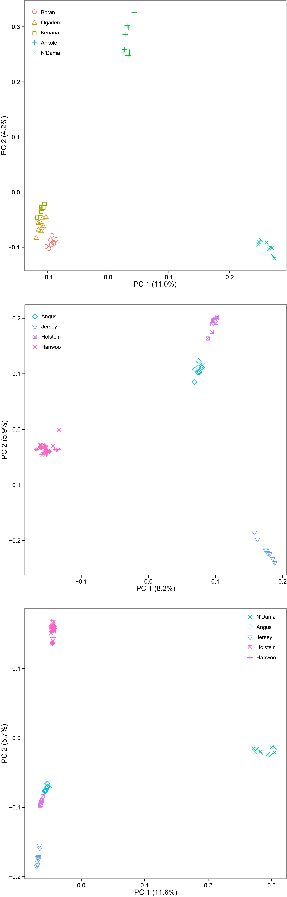
Figure S2. Proportion of ancestry for each individual assuming different numbers of ancestral population (K = 6 and 9). Colors in each vertical line represent the likelihood proportion of an animal genome assigned to a source population. Plot of delta (K) model scores using the Evanno method (bottom) indicating that K=2 has the highest delta K and therefore represents the best fit to the data.
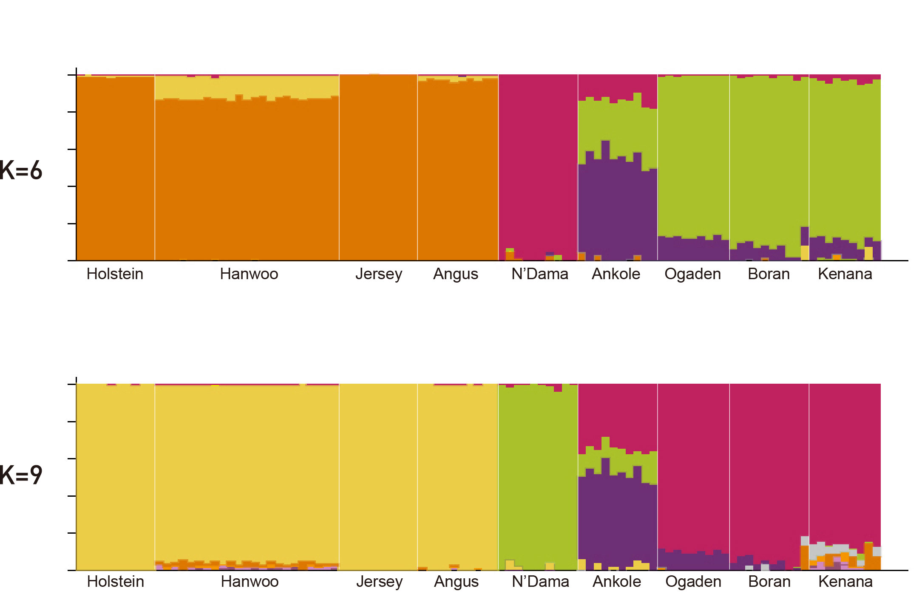

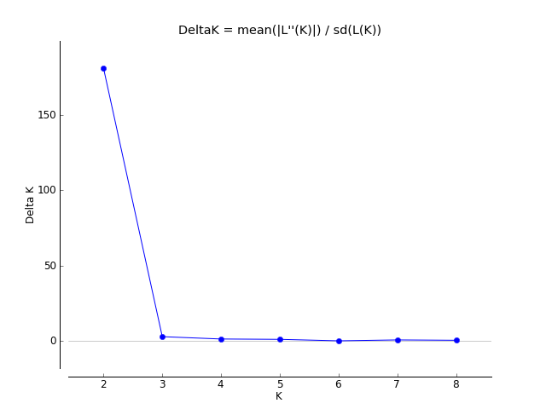

Figure S3. 90% credible intervals of estimated population size history in each cattle breed.

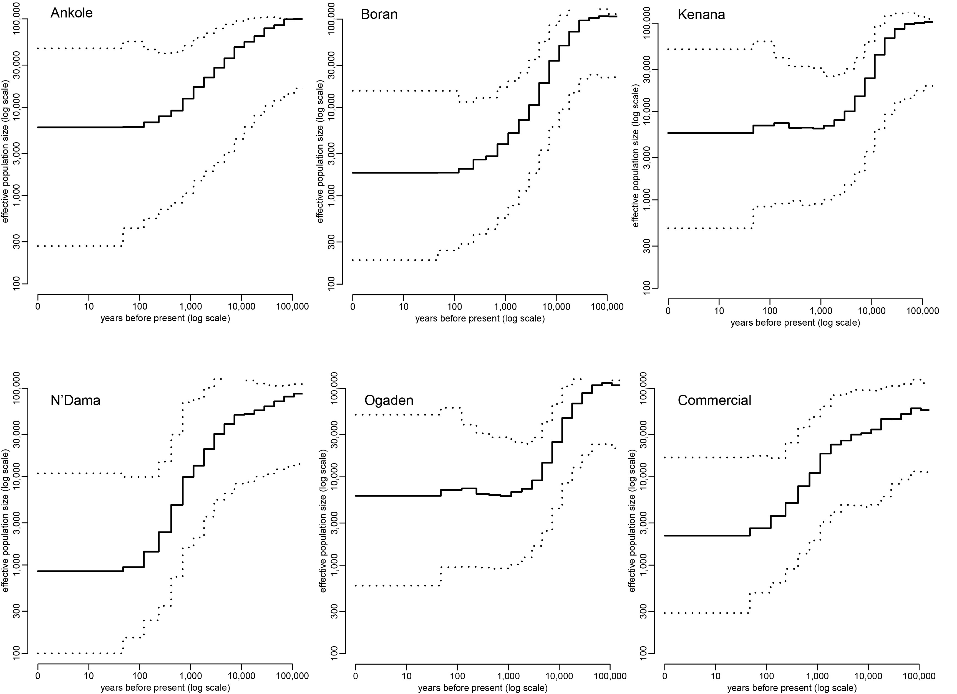

Figure S4. The maximum likelihood tree of the nine breeds and the residual matrix of the maximum likelihood tree assuming one and two migration events using TreeMix. The scale bar represents ten times the average standard error (s.e.) of the values in the covariance matrix. Positive residuals indicate pairs of breeds where the fit might be improved by adding additional edges.

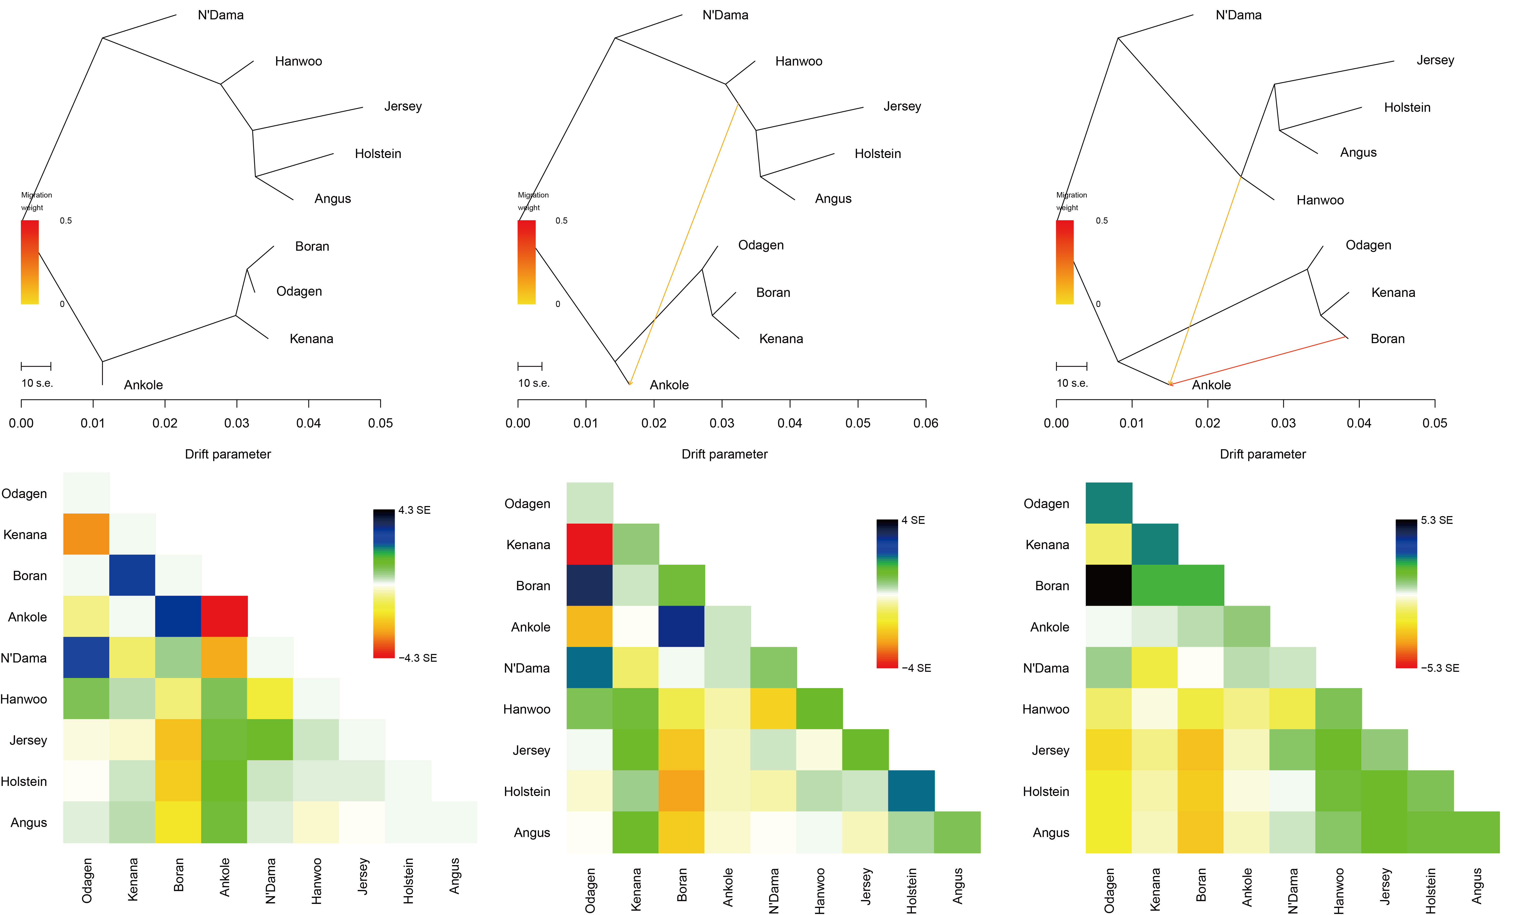

Figure S5. Distribution plots of XP-EHH raw score for each population comparison.
Figure S6. Histogram of SNP density in non-overlapping 50 kb window

Figure S7. Distribution plots of XP-CLR raw score for each population comparison.
Figure S8. Haplotype sharing plot at MC1R and KIT gene regions. Numbers at the bottom represent genome coordinates.
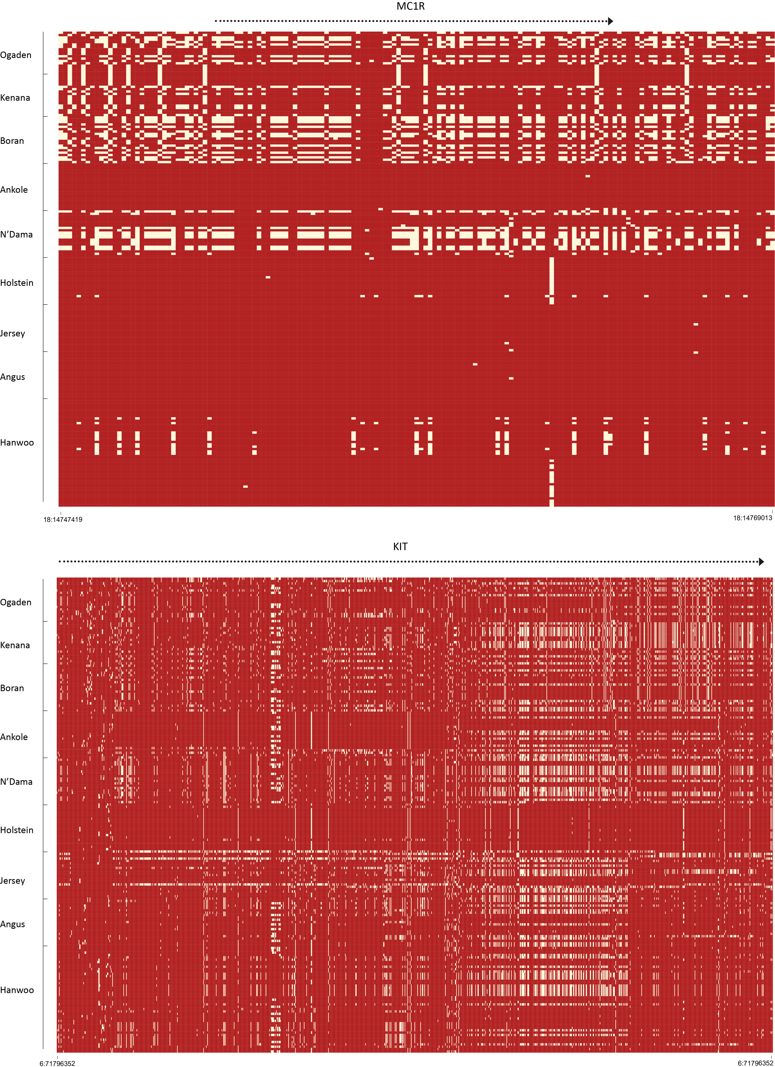
Figure S9. Haplotype blocks frequencies at the BoLA gene. *denotes non-synonymous SNPs.
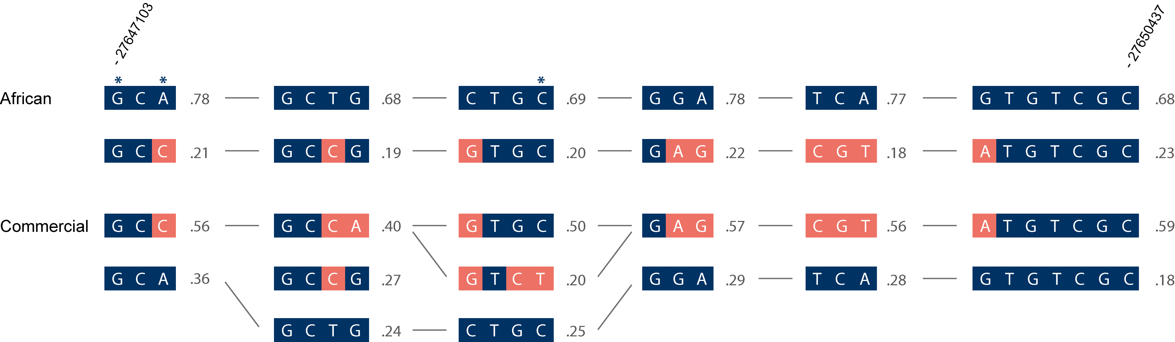

Figure S10. Pattern of haplotype sharing in random genomic region of 1Mb. The major allele in each Bos taurus and Bos indicus cattle is indicated in orange.

Figure S11. Haplotype sharing plot of HSPA4 gene region. Numbers at the bottom represent genome coordinates.

Figure S12. Structure of the PRLH gene with exons indicated by vertical bars. A non-synonymous SNP represents p.Arg76His and is highlighted in yellow. Haplotype frequencies are indicated by numbers next to each haplotype. In each haplotype, green and beige bars represent allele 1 and 2, respectively.

