Automatic detection of polyA+ vs Ribo- samples

Table S8: Genes used to detect polyA+ vs Ribo- samples

non-polyadenylated genes used to detect Ribo- VS polyA+ library preparation
SNORA80 | SNORA71D | GPR21 | HIST2H2AB | HIST1H2BI | SNORA40 | SNORA34 | HIST1H3F | HIST4H4
SNORA71C | AK311345 | SNORD97 | SNORA65 | WDR38 | HIST2H2AC | TVAS5 | HIST1H4D | SNORA74B
SCARNA5 | DCDC2B | HIST1H2AH | SCARNA21 | SNORA48 | SNORA81 | SNORD12C | DQ597482 | SNORD8
BC044606 | SCARNA12 | HIST1H2AM | SCARNA18 | SNORA76 | SCARNA6 | HIST1H3E | HIST1H2BL | HIST1H2AK
HIST1H2BM | SNORA62 | SNORD12B | HIST1H2BC | SCARNA1 | HTR2B | HIST1H3J | HIST1H1C | HIST1H4I
HIST1H2AL | SNORA5A | HIST1H2AJ | AK096592 | SNORA5C | SNORA37 | HIST1H2AG | SNORA8 | SNORA53
HIST1H1B | TAS2R19 | HIST2H2BF | SCARNA9 | ZNF124 | SCARNA16 | SNORA12 | SCARNA9L | SNORA54
HIST1H4E | HIST1H2BF | SNORD17 | BC079832 | SNORA72 | HIST1H2AB | SNORA57 | SCARNA7 | HIST1H3C
RPPH1 | SCARNA10 | SNORD60 | C12orf61 | CR605438 | SNORA27 | TMEM75 | hCG_1818547 | SCARNA2
SNORD18A | HIST1H4B | BC036695 | HIST1H4A | TERC | LOC100129716 | ZNF460 | BC069756 | HIST1H3B
CR590086 | HIST1H2AC | BC070113 | HIST2H2BE | SNORA23 | SNORA3 | SNORA63 | HIST1H1E | SNORA84
SNORD10 | SNORA18 | VTRNA1-1 | HIST1H3A | SNORA74A | HIST1H4C | ZNF678 | AX748175 | SNORA24
HIST1H2BG | SNORA68 | HIST1H2BK | SNORD15A | SNORD2 | HIST3H2A | HIST1H2BB | SNORD74 | AX746867
SNORD94 | SLC16A7 | NAG8 | SNORD46 | HIST1H2AD | CR624170 | SNORA52 | SCARNA13 | SCARNA4
SNORA67 | HIST1H2BN | HIST1H4J | HIST1H3H | SNORD9 | FLJ13224 | SNORA21 | C13orf25 v_1
RNU11 | HIST1H3D | SNORA26 | HIST1H2BO | SNORD55 | DM004349 | COL10A1 | C8orf39
HIST1H3G | HIST1H2BH | HIST3H2BB | HIST1H4H | SNORA6 | SNORA46 | HIST1H2BJ | SNORA32
HIST1H2AE | SNORA14B | VTRNA1-3 | BC021024 | SNORA71B | RMRP | SNORA49 | HIST1H2BD
SNORA13 | HIST2H3D | SNORA31 | SNORD15B | SCARNA20 | SNORA20 | SNORA28 | DQ582265

Table S9: Samples used to validate polyA+ vs Ribo- classification

PolyA+ | SRR357239
PolyA+ | SRR522063
PolyA+ | SRR522081
PolyA+ | SRR522091
PolyA+ | SRR522109
PolyA+ | SRR522121
PolyA+ | SRR900276
PolyA+ | SRR900283
PolyA+ | SRR900284
PolyA+ | SRR900285
PolyA+ | SRR900286
PolyA+ | SRR900287
PolyA+ | SRR900288
PolyA+ | SRR900289
PolyA+ | SRR900290
Ribo- | SRR1027171
Ribo- | SRR1027173
Ribo- | SRR1027174
Ribo- | SRR1027175
Ribo- | SRR1027176
Ribo- | SRR1027177
Ribo- | SRR1027178
Ribo- | SRR1027179
Ribo- | SRR1027180
Ribo- | SRR1027181
Ribo- | SRR1027182
Ribo- | SRR1027183
Ribo- | SRR1027184
Ribo- | SRR1027185
Ribo- | SRR1027186

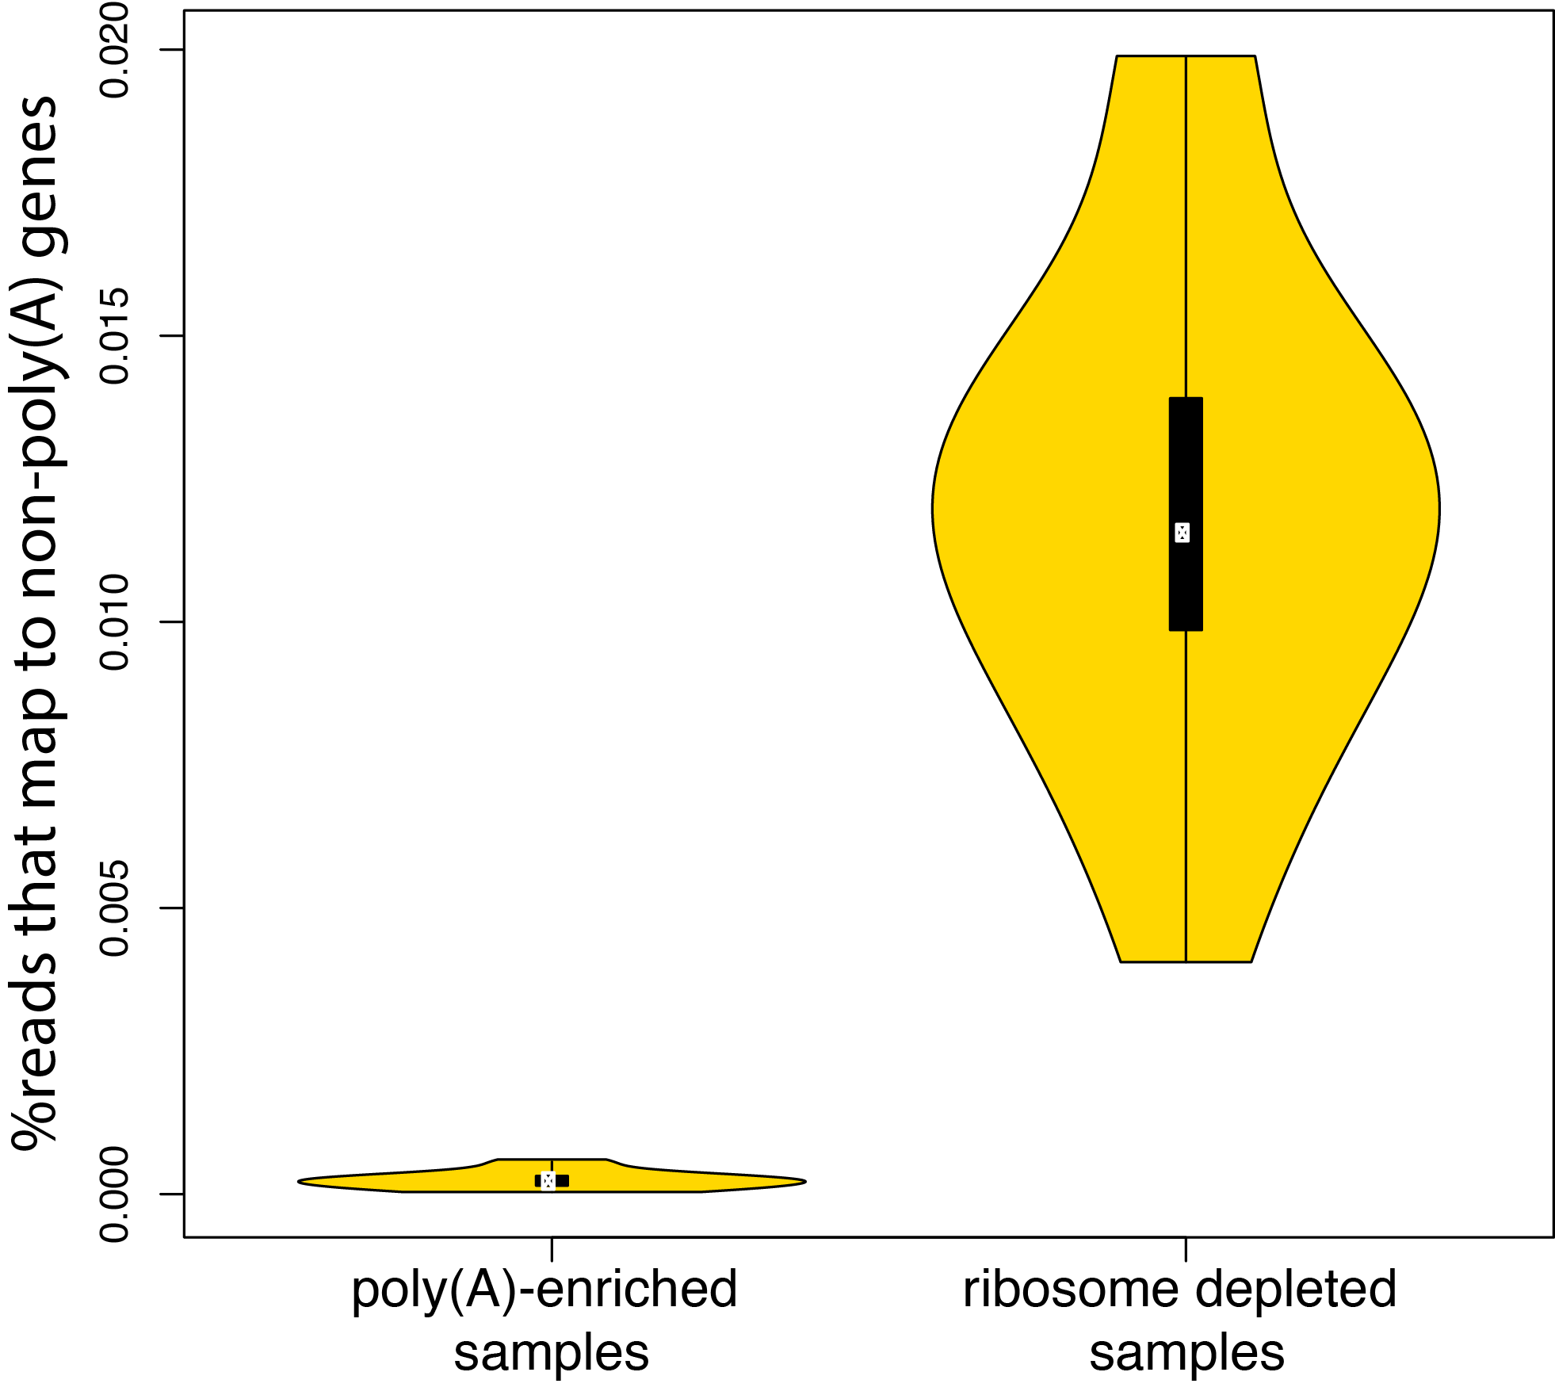

Figure S6: Number of reads that map to known non-poly(A) genes as a fraction of the total number of reads mapped to the main chromosomes (y-axis) for 15 libraries enriched for poly(A) (left) and 15 libraries that were only depleted of ribosomal RNA (right).

