Supplemental material
Negative selection in tumour genome evolution acts on essential cellular functions and the immunopeptidome
Luis Zapata, Oriol Pich, Luis Serrano, Fyodor A. Kondrashov, Stephan Ossowski & Martin H. Schaefer

Supplemental Figures

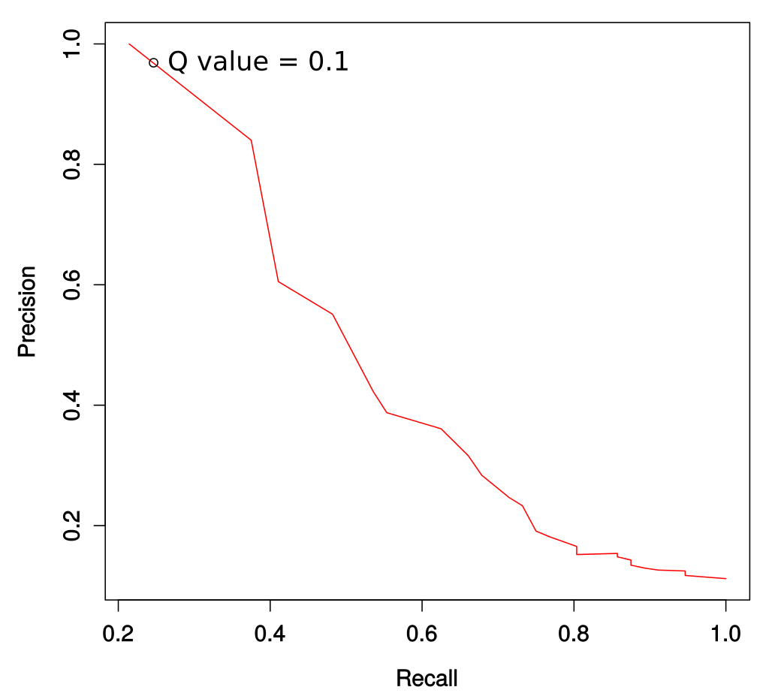

Figure S1. Performance in reproducing known cancer driver genes.
We retrieved a list of 260 previously identified genes under positive selection (Lawrence et al. 2012). For the 500 genes with the highest dN/dS ratio, we computed precision and recall for varying significance levels. The performance of the threshold used in this study (Q < 0.1) is indicated.
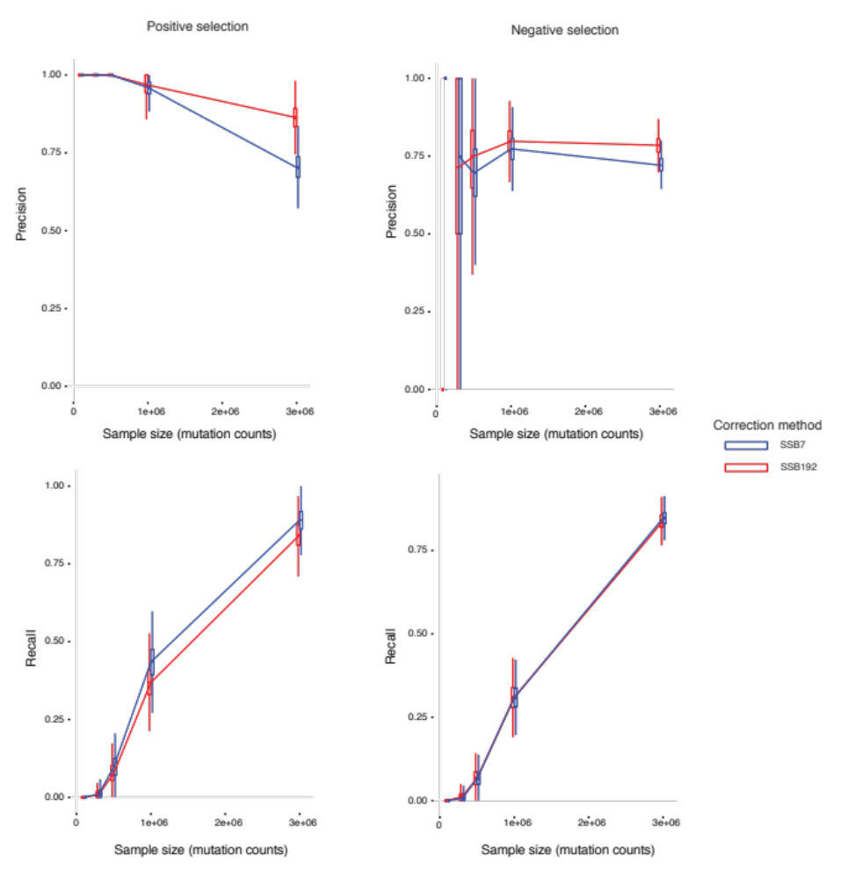

Figure S2. Simulation of positively and negatively selected genes. Precision and recall of SSB7 and SSB192 for positive and negatively selected genes using 100K, 300K, 500K, 1M, and 3M of simulated somatic mutations.
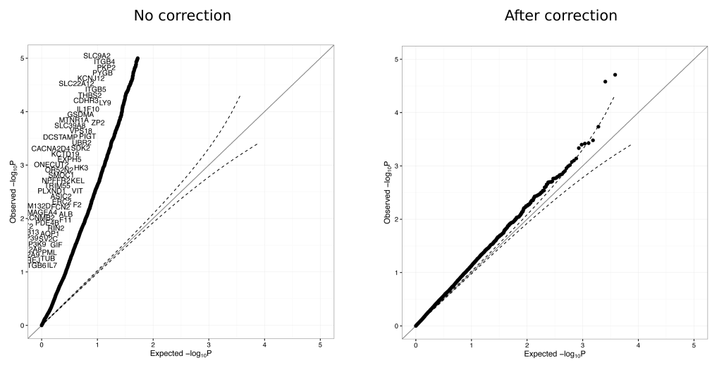
Figure S3. Effect of Somatic Substitution Bias correction on melanoma using 7 parameters (SBB7). QQ plot distribution for P-values before (left) and after (right) SBB7 correction on Skin Melanoma samples.

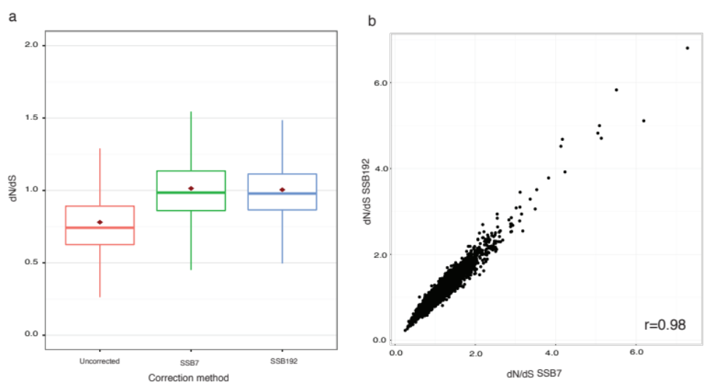
Figure S4. dN/dS comparison between the uncorrected, SSB7-corrected and SSB192-corrected datasets. A) dN/dS distribution for uncorrected, SSB7, and SSB192. The dot indicates the mean and the line the median. B) Correlation of dN/dS values for SSB7 versus SSB192 (each dot is one gene).
Figure S5. dN/dS comparison between the method published in Martincorena et al 2017 and SSB corrected dN/dS. Correlation plot between obtained dN/dS values in the pancancer dataset analyzed in this work and A) dnds_cv and B) dnds_loc, which are the two methods published in Martincorena et al 2017. C) (Vertical lines) Per gene - Median dNdS distribution (using the mean 95% CI after 100 iterations and sampling 500 genes at each iteration) plots for the three methods in the pancancer dataset and (Horizontal lines) global dN/dS estimates by looking at all mutations together. D) Same as C but using a simulated neutral set having 100K, 300K, 500K, and 1M somatic mutations. The numbers below the vertical lines show the number of significantly positive (+) or negative (+) selected genes for each method.

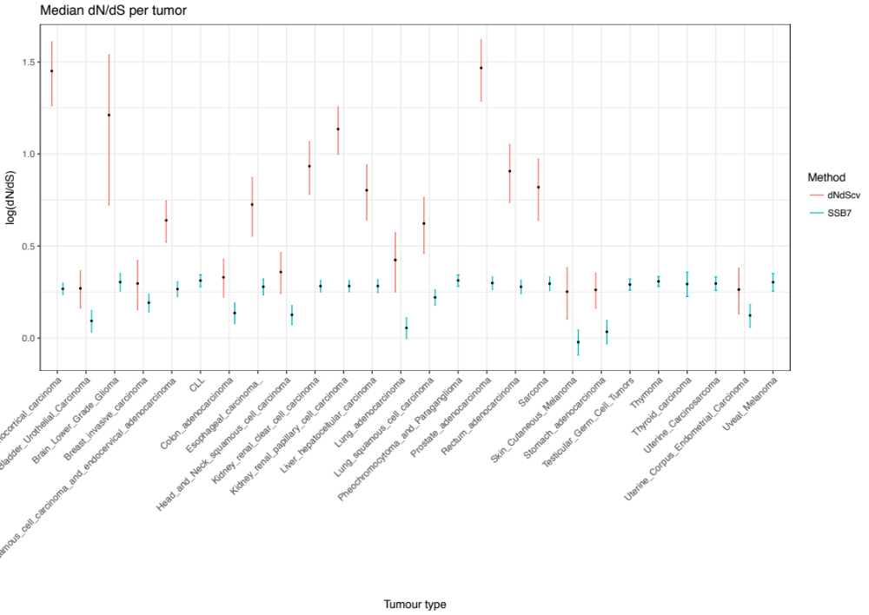
Figure S6. Log values of per gene dN/dS. The mean of the median and the 95% confidence intervals were calculated by bootstrapping 100 times the missense dN/dS of 500 genes each time. In red the median dN/dS obtained running dNdScv and in blue results from the SSB method. For simplicity, lines when the median dN/dS was above 5 were omitted.

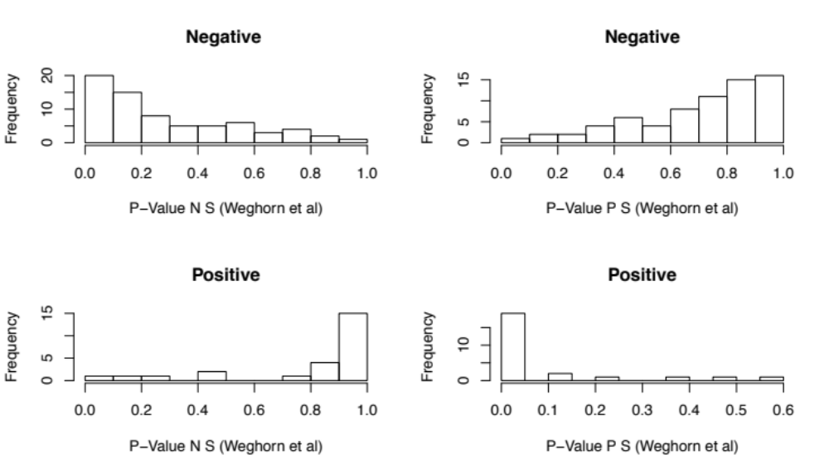
Figure S7. P-Values distribution of Weghorn et al 2017 for genes under negative and positive selection defined by dN/dS. Upper two plots show the distribution of the ‘N S’ and ‘P S’ P-values for a set of negatively selected genes. The same is shown for a set of positively selected genes in the bottom two plots. The P-values reported in Weghorn et al confirm the dN/dS predictions for a set of genes having q values less than 0.25.
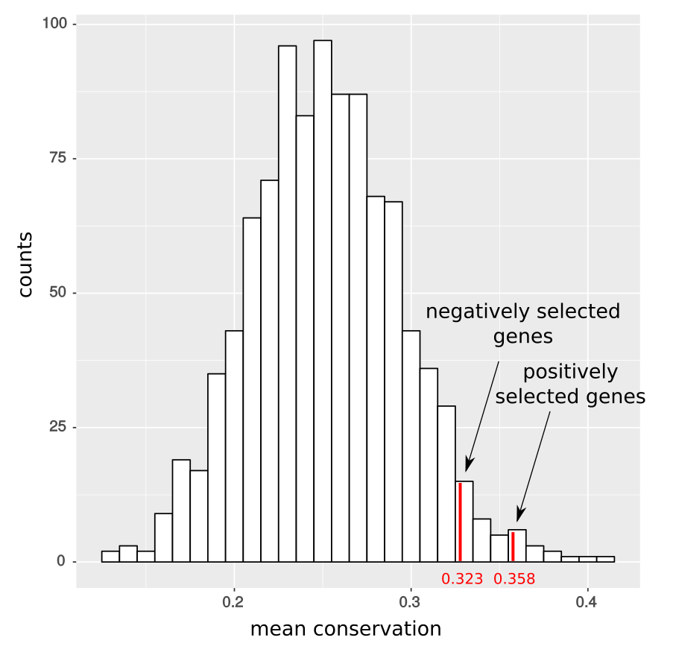

Figure S8. Phylogenetic conservation of negatively selected genes.
We randomly sampled sets of neutrally selected genes and computed their mean conservation. Negatively selected genes are more conserved than neutrally selected genes (P = 0.047; randomization test).

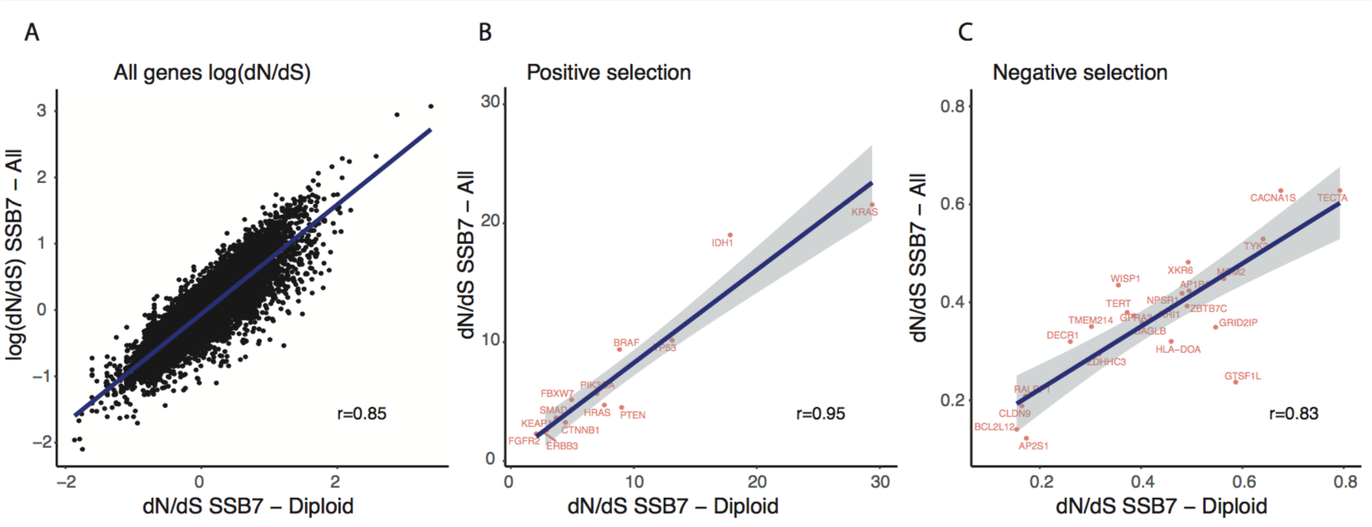

Figure S9. dN/dS values for diploid-only and all regions. Correlation plots for dN/dS values between diploid-only regions and all regions for A) all, B) positively selected, and C) negatively selected genes.

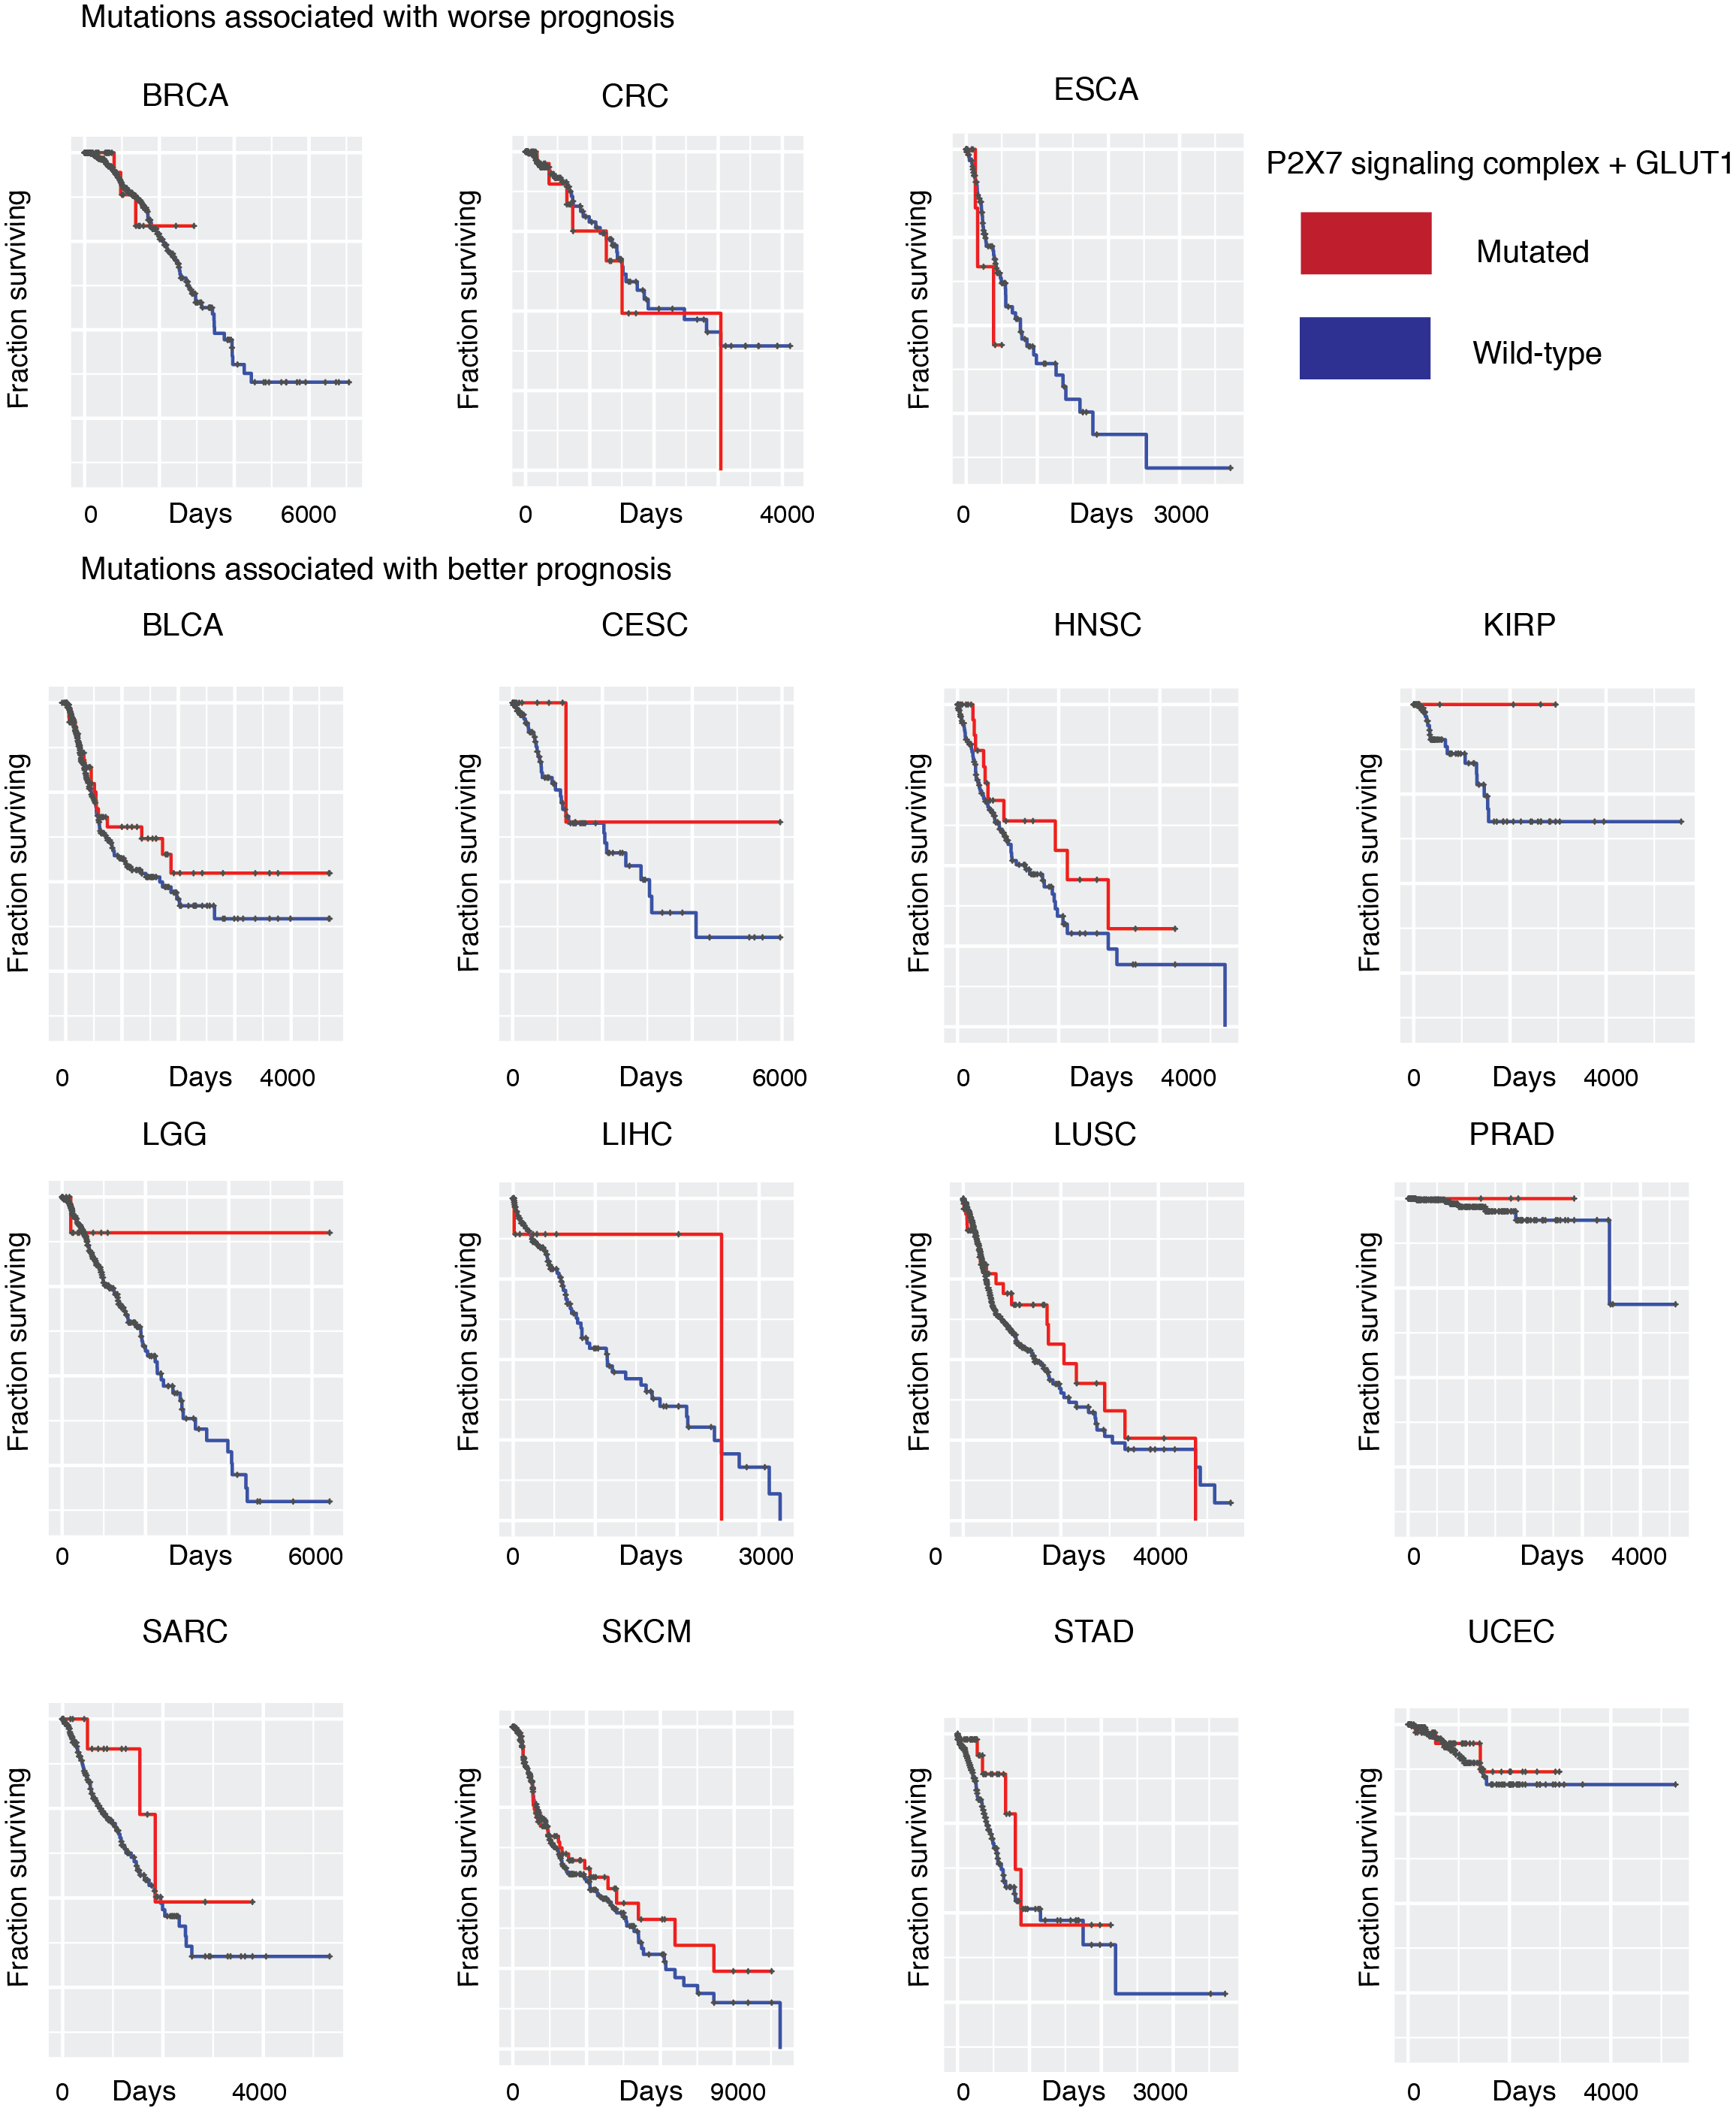
Figure S10. Kaplan-Meier curves for 15 tumour types with mutations in the P2X7 complex. Survival plots comparing patients having components of the P2X7 complex (or SLC2A1/GLUT1, which is regulated by P2X7) mutated versus non-mutated patients. 12 out of 15 tumour types show better prognosis when a member of the complex is mutated.

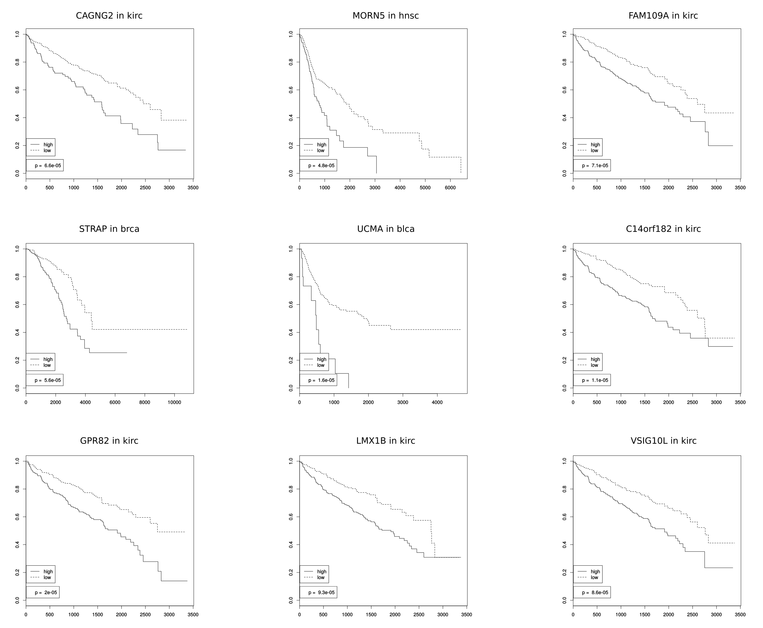

Figure S11. Kaplan-Meier curves for 9 negatively selected genes. Kaplan-Meier curves for nine genes found as negatively selected in cancer and showing a significant difference on survival based on the expression status.

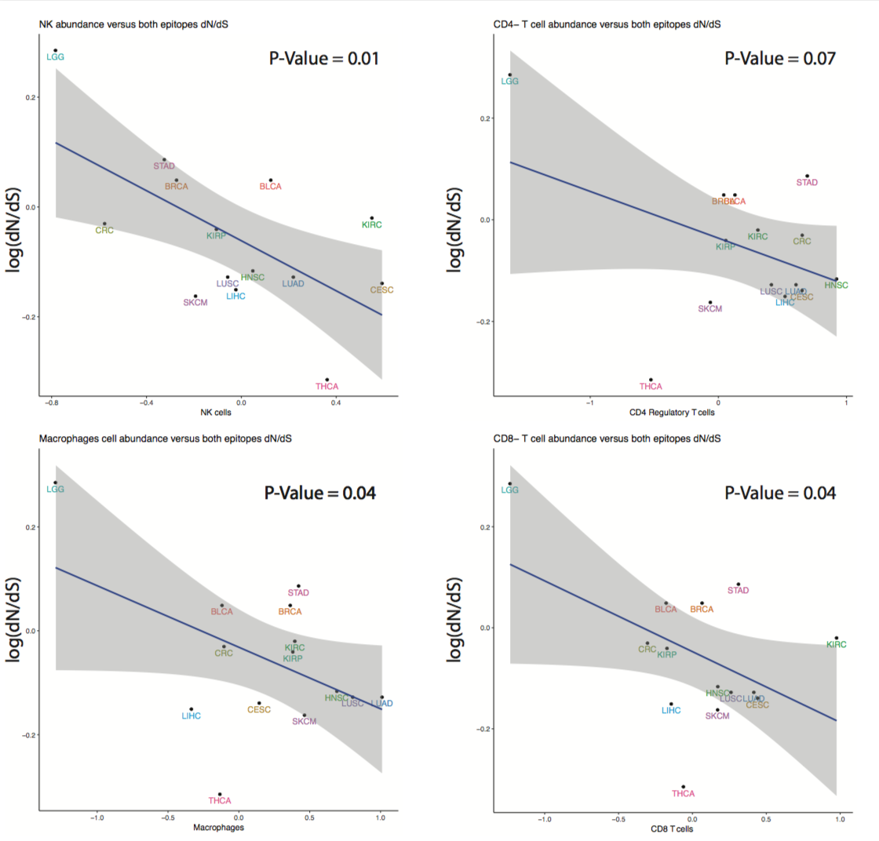

Figure S12. Tumour type specific cytolytic activity versus dN/dS values.
Relative abundance of different immune cell populations in different tumour types in relation to the tumour specific-dN/dS value of the MHC epitopes.

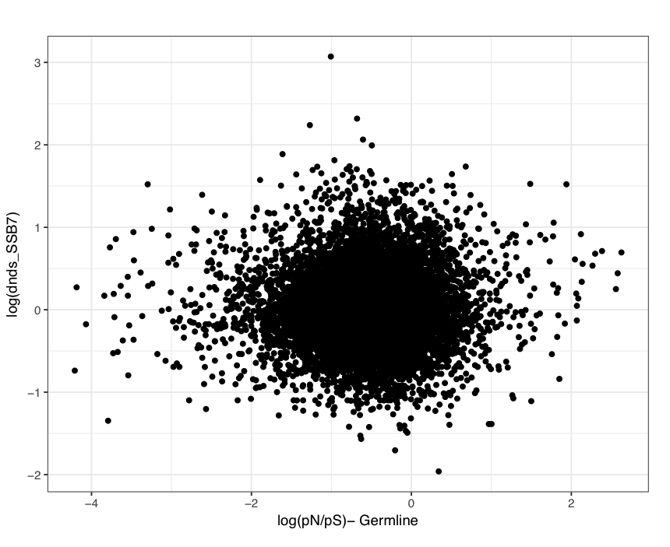

Figure S13. dN/dS values from cancer genomes and normal human populations.

Scatter plots of somatic dN/dS values (SSB7) and human germline dN/dS values.

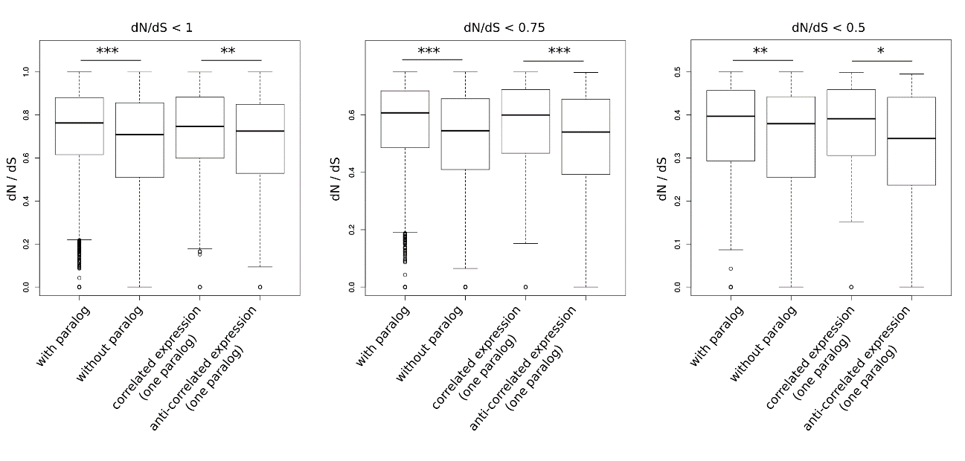

Figure S14. dN/dS distribution of different paralog classes.
Differences in dN/dS of genes with and without paralogs as well as of genes with one expression-correlated or one expression-anticorrelated gene are significant irrespective if genes with dN/dS < 1, dN/dS < 0.75 or dN/dS < 0.5 are considered. * = P < 0.05, ** = P < 0.01, *** = P < 0.001.
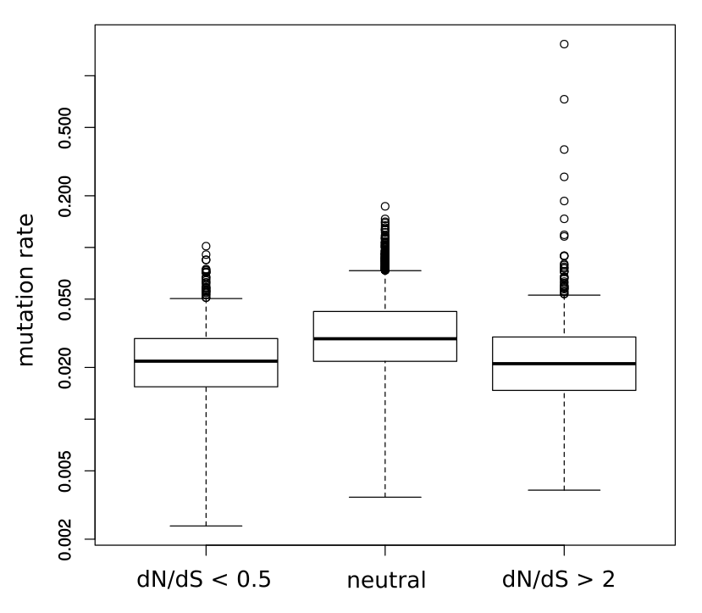

Figure S15. Mutation rates of genes in different selection classes.
The mutation rate [(synonymous + nonsynonymous mutations) / transcript length] is significantly lower for negatively selected (dN/dS < 0.5) or positively selected (dN/dS > 2) than for neutrally selected genes (0.9 < dN/dS < 1.1) (P < 0.05; Mann-Whitney U test). There is no significant difference between the mutation rates of negatively and positively selected genes.

Supplemental Tables

Table S1. Data details for the 26 tumour types used in this study.

Number of samples, mutations, and mutations after filtering are shown for each tumour type.

Table S2. Results of selection test for all genes across 26 tumour types.
Details for each gene after applying our statistical method. Top 39 genes are considered significant (FDR < 0.1).

Table S3. Analysis results for 26 tumour types separately.
Proportion of nonsilent and synonymous mutations separated for individual tumour types for significantly selected genes.

Table S4. Somatic substitution bias correction results.
dN/dS details for each tumour type before and after SSB7 correction.

Table S5. Significantly enriched terms among negatively selected genes. GO terms, Reactome pathways and CORUM complexes associated with negatively selected genes with a Q-value below 0.1 by GSEA are shown.

Table S6. Tumour specific dN/dS Immune epitopes and correlation to immune activity measures.
- Aggregated dN/dS for epitopes combined, non-epitopes combined, and MHC-specific values. Pvalues show the proportion of times that a random value was lower than the epitope dN/dS in 1000 iterations.
- Correlation coefficients for different measures of cytolityc activities versus dN/dS values.
- Pvalues for paired correlations.

Table S7. Significant genes predicted using unfiltered somatic variant lists.
List of genes under selection (positive or negative) when removing the ABB filter (affecting the number of somatic mutations) and the expression filter (affecting the number of genes).

