Fig. S1. K-mer plots of wild P. yedoensis (Pyn) and ‘Yoshino cherry’ (Pxy) accessions. The volumes of Illumina K-mer (K=17 mer, Y axes) are plotted against the frequency where they occur (X axes). Gray line, heterozygous peak; black line, homozygous peak. Taxon ID and sequence reads used in this analysis are presented in Additional file 11: Table S10.

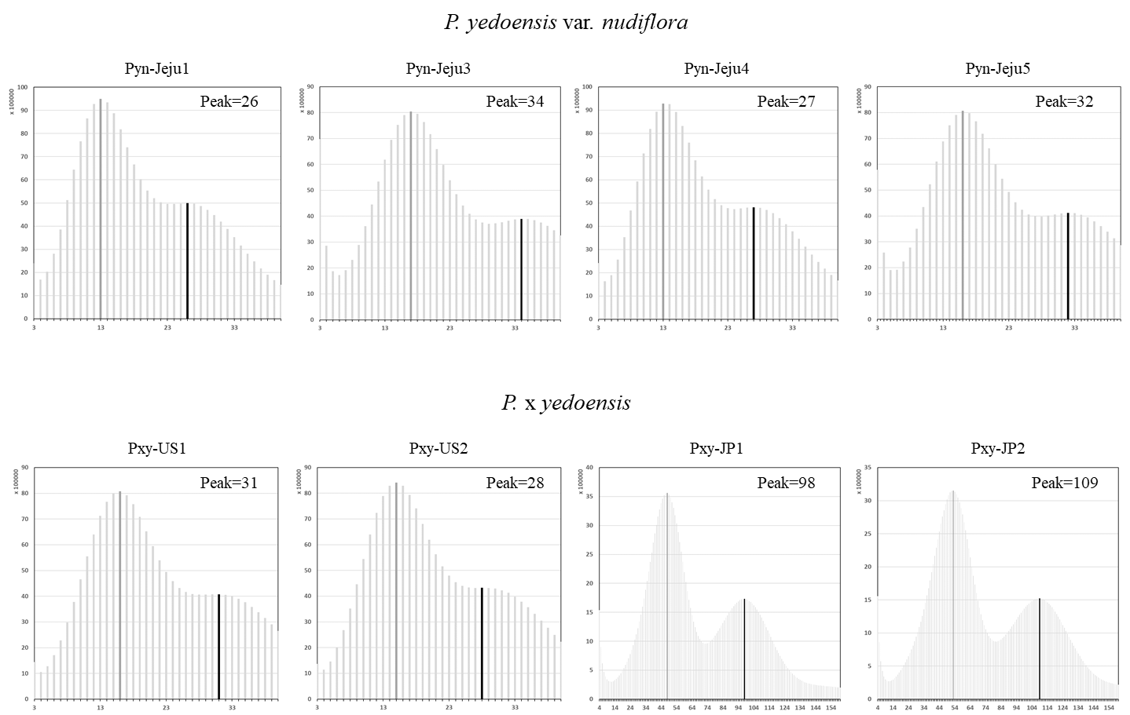

Fig. S2. A workflow of genome assembly and annotation. See Methods section for more details.

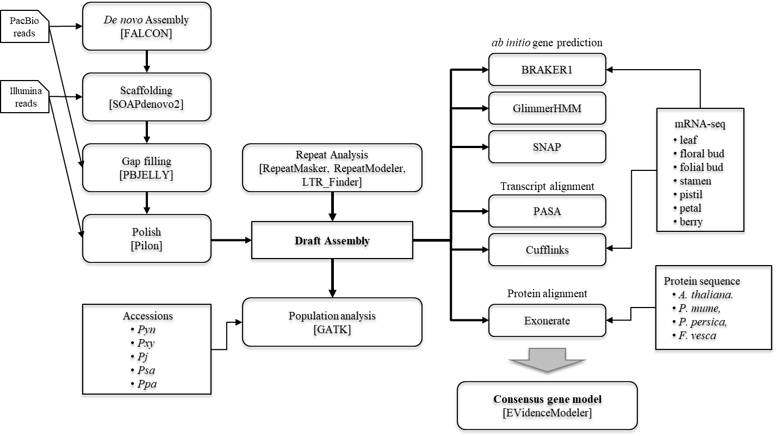

Fig. S3. Chromosomal comparison of the gene-phased genome assembly of wild P. yedoensis (Pyn) with the P. avium (Pa) and P. mume (Pm) genomes. Colored dots or lines represent maternal-phased genes (red), paternal-phased genes (blue), or common genes (gray).

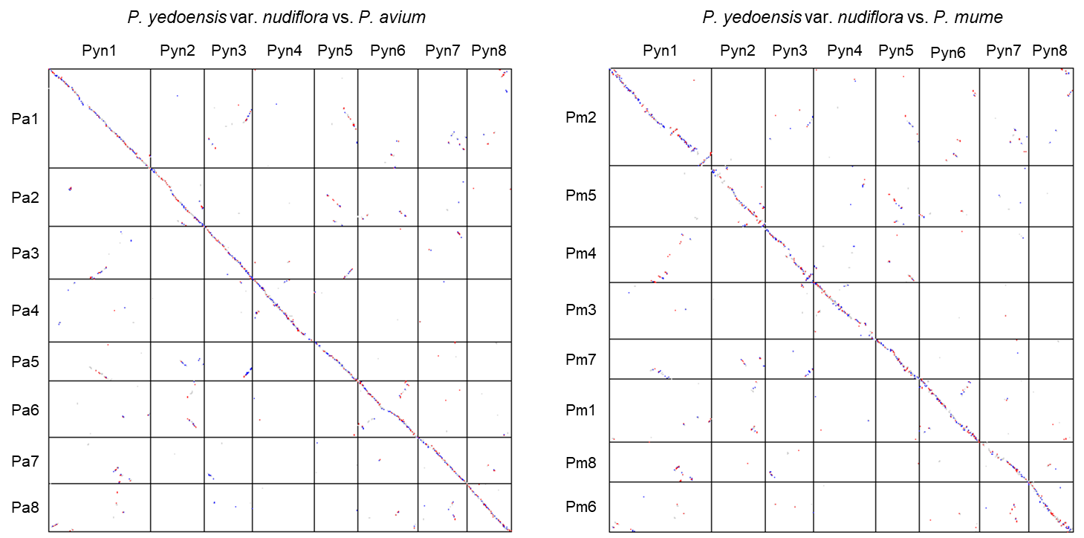

Fig. S4. A maximum likelihood tree of S-locus genes showing the phylogenetic relationship among the S-haplotypes. The coding sequences of S-RNase and SFB genes in S-locus regions of 12 Prunus accessions distributed in a sympatric natural habitat were aligned using MAFFT multiple alignment program. The trees were constructed using MEGA7 with bootstrap analysis with 1,000 replicates. Arabidopsis thaliana ribonuclease 3 (NP_564264, AtRNS3) and F-box protein (At3g16210) genes were used as outgroup.

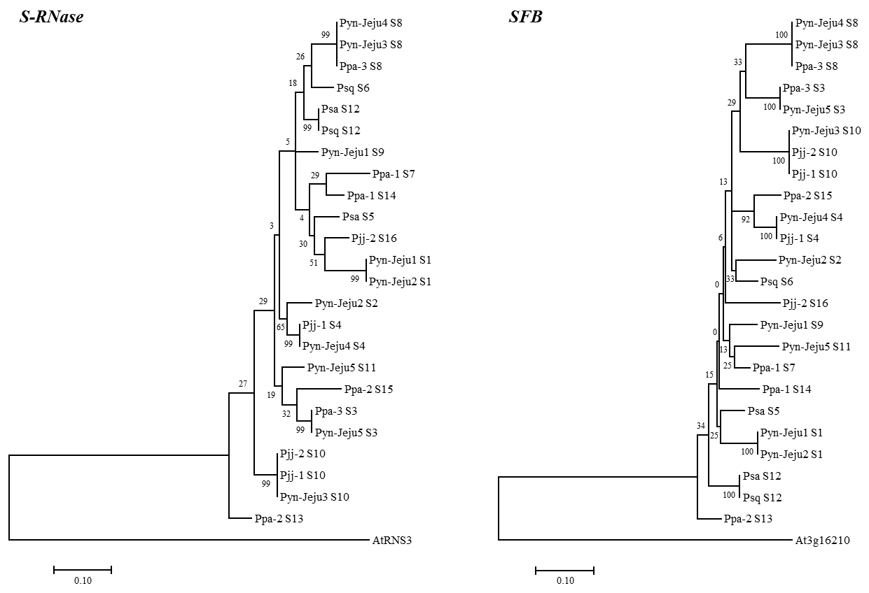
Pyn-Jeju4 S8
Pyn-Jeju3 S8
Ppa-3 S8
Ppa-3 S3
Pyn-Jeju5 S3
Pyn-Jeju3 S10
Pjj-2 S10
Pjj-1 S10
Ppa-2 S15
Pyn-Jeju4 S4
Pjj-1 S4
Pyn-Jeju2 S2
Psq S6
Pjj-2 S16
Pyn-Jeju1 S9
Pyn-Jeju5 S11
Ppa-1 S7
Ppa-1 S14
Psa S5
Pyn-Jeju1 S1
Pyn-Jeju2 S1
Psa S12
Psq S12
Ppa-2 S13
At3g16210
100
100
100
100
100
100
92
29
25
6
13
0
25
34
15
0
33
13
33
0.10
SFB

