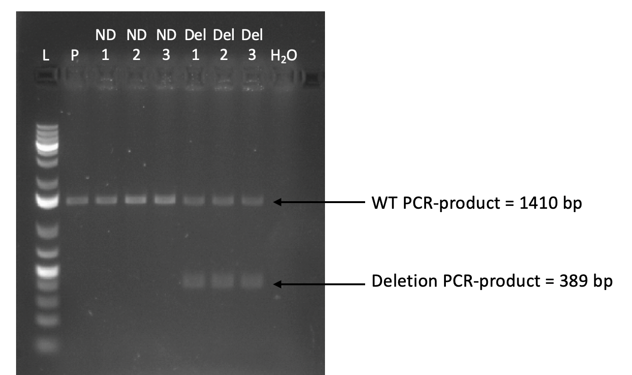

Additional file 14. Validation of the CRISPR/Cas9-induced deletion at the AIDA locus. Using PCR primers that map outside of the deletion, we amplified the locus in the parental teloHAEC cell line (P), in three independent control clones without a deletion (ND1-3), and in three clones that are heterozygous for the deletion (Del1-3). Cells without the deletion yield a single 1,410-bp PCR product, whereas heterozygous clones yield two bands: the normal (WT) allele at 1,410-bp and the deleted allele at 389-bp. L, 1 kb molecular ladder; H₂O, negative control without template DNA.

