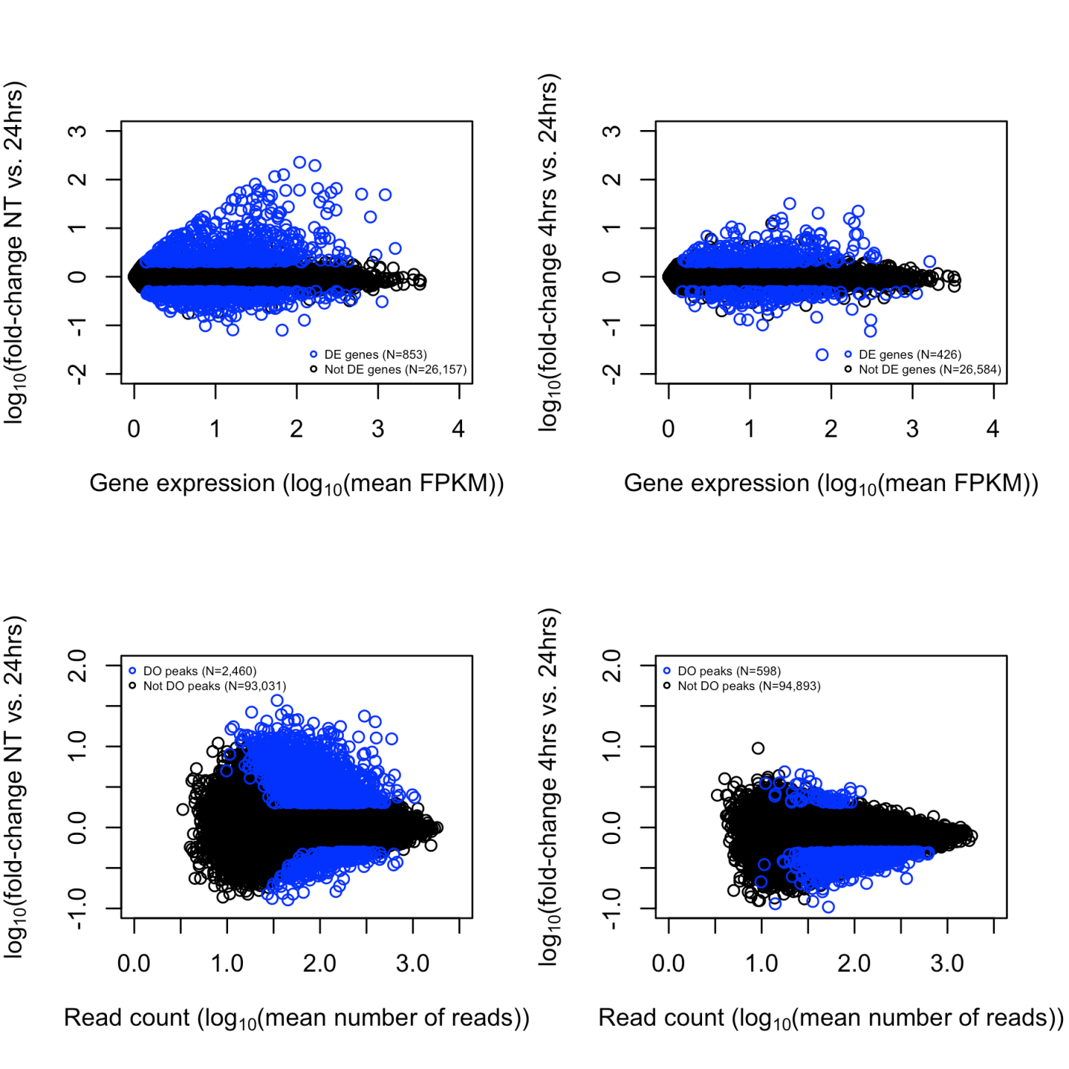
D
C
B
A

Additional file 1. Comparison of RNA-sequencing (A and B) and ATAC-sequencing (C and D) results in teloHAEC non-treated (NT) or treated with TNFα for 4 hours or 24 hours. (A) Log10-fold-change (LFC) in gene expression between NT and 24 hours-TNFα-treated teloHAEC. 853 genes have a false discovery rate (FDR) <0.1% and an absolute LFC >0.3 between these 2 timepoints. (B) LFC in gene expression between 4 hours- and 24 hours-TNFα-treated teloHAEC. 426 genes have a FDR <0.1% and an absolute LFC >0.3 between these 2 timepoints. (C) LFC in ATACseq peak read counts between NT and 24 hours-TNFα-treated teloHAEC. 2,460 peaks have a FDR <0.1% and an absolute LFC >0.3 between these 2 timepoints. (D) LFC in ATACseq peak read counts between 4 hours- and 24 hours-TNFα-treated teloHAEC. 598 peaks have a FDR <0.1% and an absolute LFC >0.3 between these 2 timepoints.

