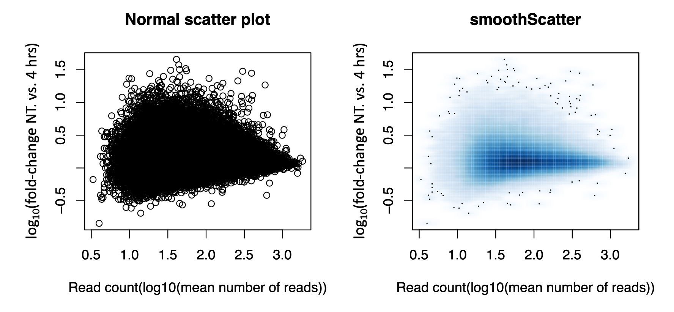
Additional file 5. Log10-fold-change (LFC) of ATAC-seq peaks comparing non-treated vs. 4 hours TNFα-treated teloHAEC. The smoothScatter plot shows the same data than on the right, but uses shades of blue to represent data density (darker blue means higher density). Most ATACseq peaks have a LFC that is centered at 0.

