Supplementary Figures

Fig. S1

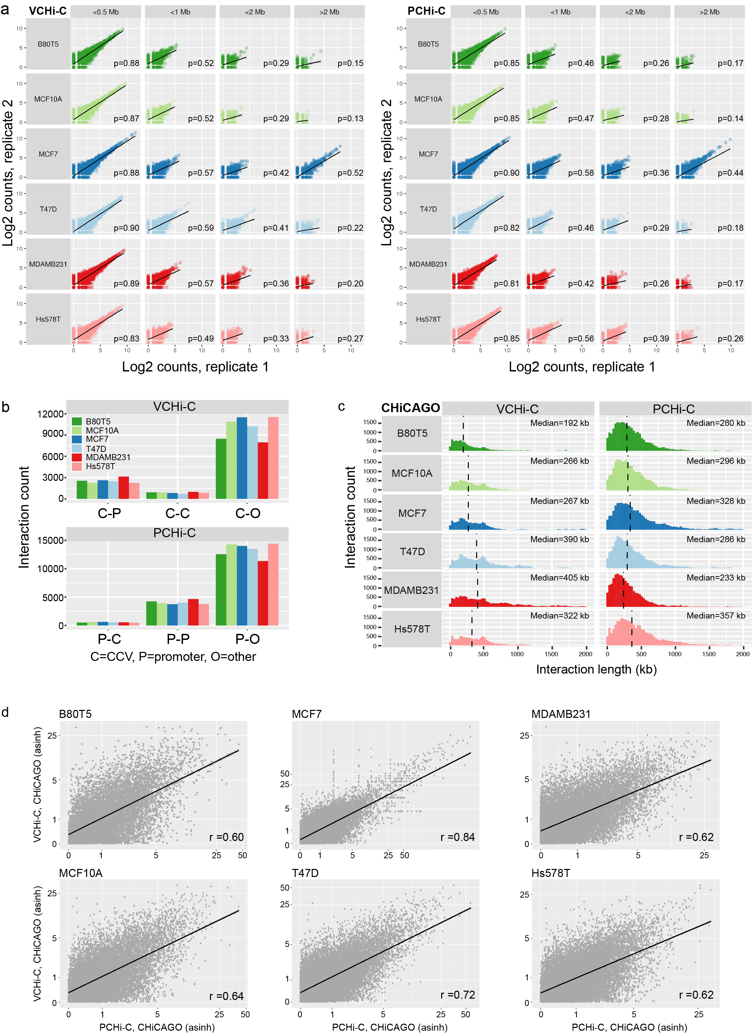
VCHi-C and PCHi-C CHiCAGO-identified interaction characteristics. a Scatter plots showing the correlation between duplicate VCHi-C or PCHi-C libraries based on the number of raw di-tags mapping to interaction fragment pairs. The analysis was stratified by cell line (rows) and distance between interacting fragments (columns). ρ is Spearman’s correlation; the black lines represent the linear regression fit. b The abundance of different classes of CHiCAGO-scored VCHi-C (upper panel) and PCHi-C (lower panel) interactions. c Distribution of CHiCAGO-scored interaction lengths in each breast cell line. Dashed black vertical lines denote the median interaction length. d Scatter plots showing the concordance of inverse hyperbolic sine (asinh)-transformed CHiCAGO-scored VCHi-C versus PCHi-C interactions in the respective breast cell lines. r is Pearson’s correlation; the black lines represent the linear regression fit.

Fig. S2

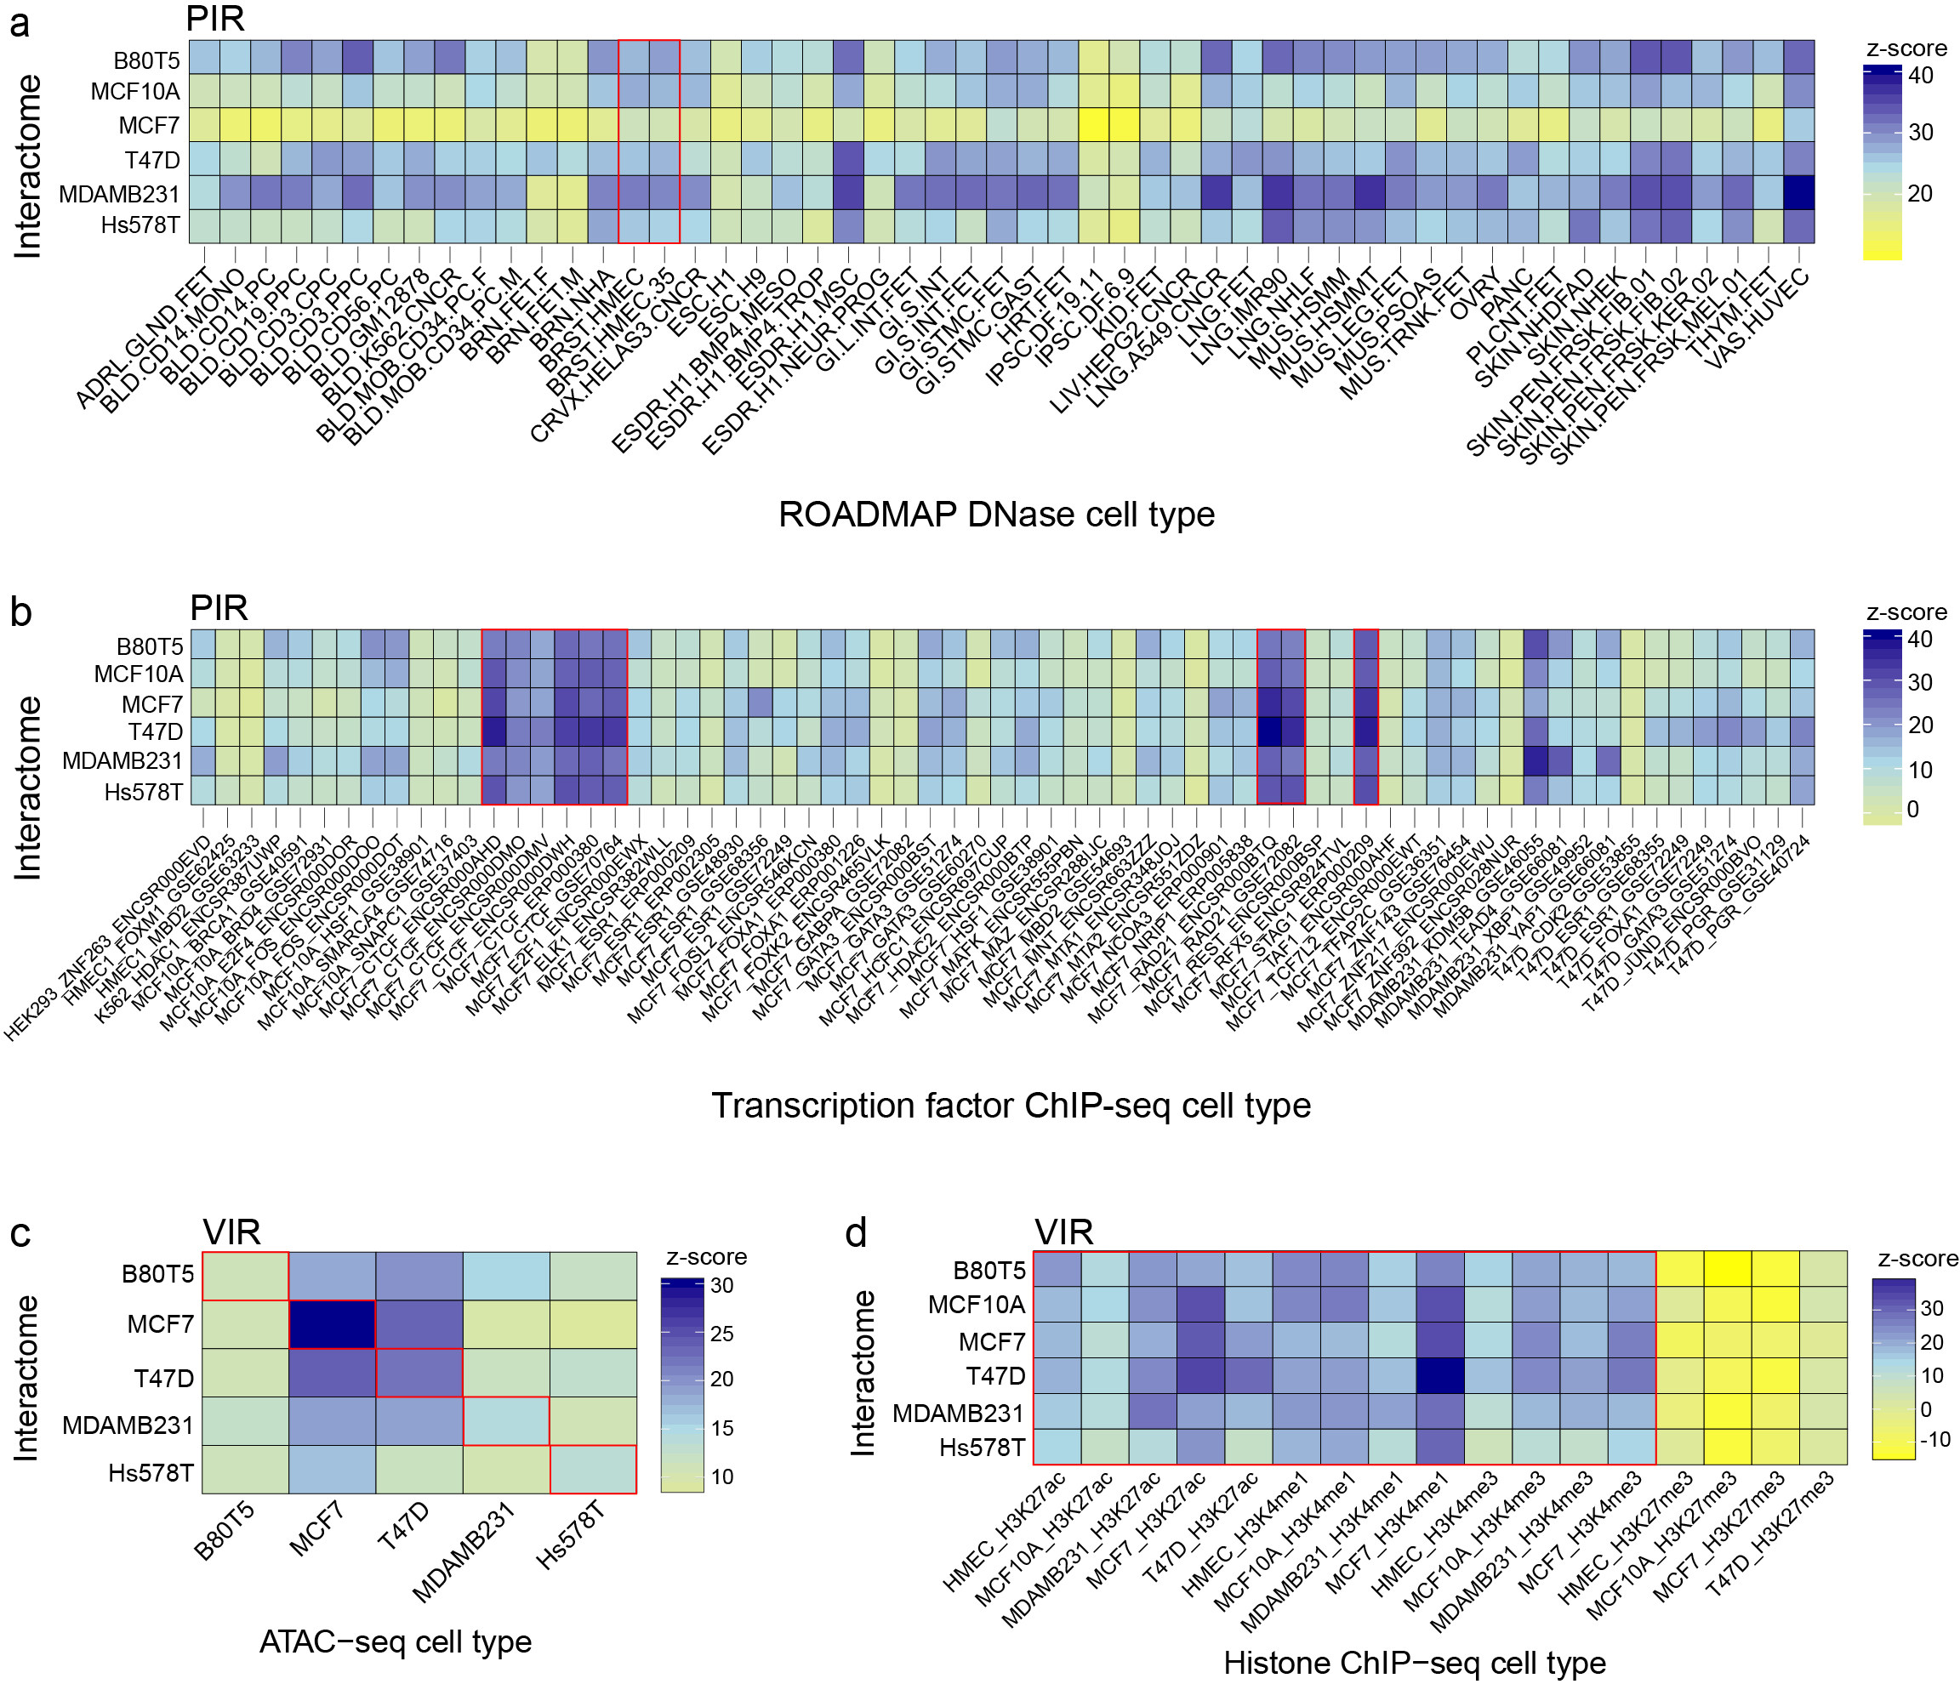

Promoter-interacting regions (PIRs) and variant-interacting regions (VIRs) are enriched for breast-specific regulatory features. Heatmaps showing PIR enrichment for a DNase I hypersensitivity sites in a ROADMAP cell types, b transcription factor binding in breast (additional datasets) and other cell types, expressed as z-scores. Heatmaps showing VIR enrichment for c ATAC-seq peaks in breast cell lines and d histone marks by ChIP-seq in available breast cell lines, expressed as z-scores. The red outlines highlight key enrichment signals.

Fig. S3

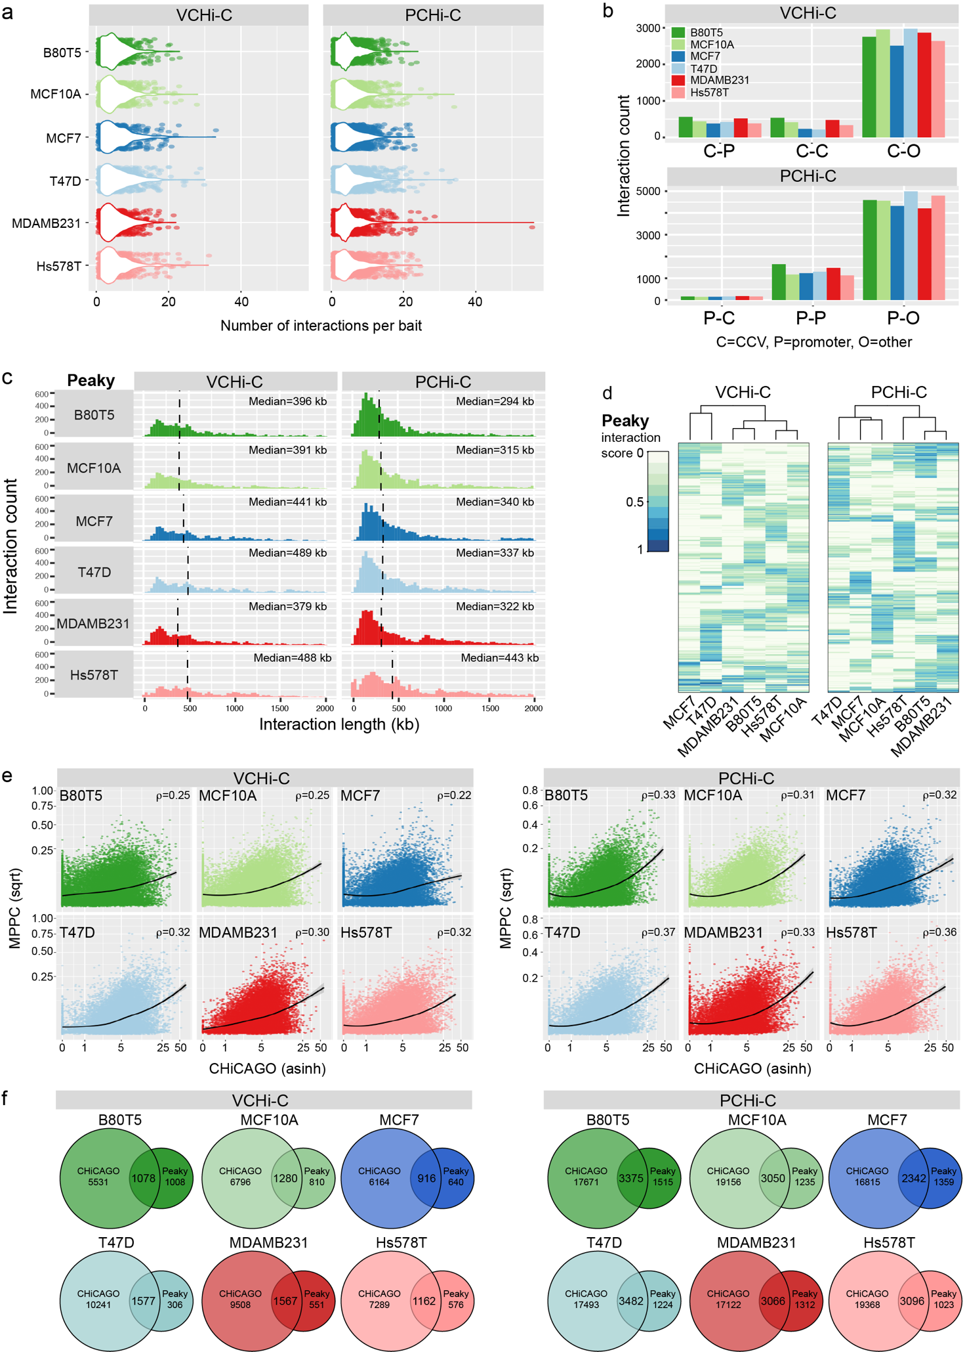

VCHi-C and PCHi-C Peaky-identified interaction characteristics. a Distribution of Peaky-scored interaction number per bait per cell line (combined biological replicates). b The abundance of different classes of Peaky-scored VCHi-C (upper panel) and PCHi-C (lower panel) interactions. c Distribution of Peaky-scored interaction lengths in each breast cell line. Dashed black vertical lines denote the median interaction length. d Agglomerative hierarchical clustering for the VCHi-C and PCHi-C. e Scatter plots showing the correlation between CHiCAGO (inverse hyperbolic sine-transformed) and Peaky (square root-transformed) interaction scores. ρ is Spearman’s correlation; the black lines represent the loess smoothed fit. f Venn diagrams illustrating the overlap in CHiCAGO- and Peaky-scored interactions in each capture per cell line.

Fig. S4

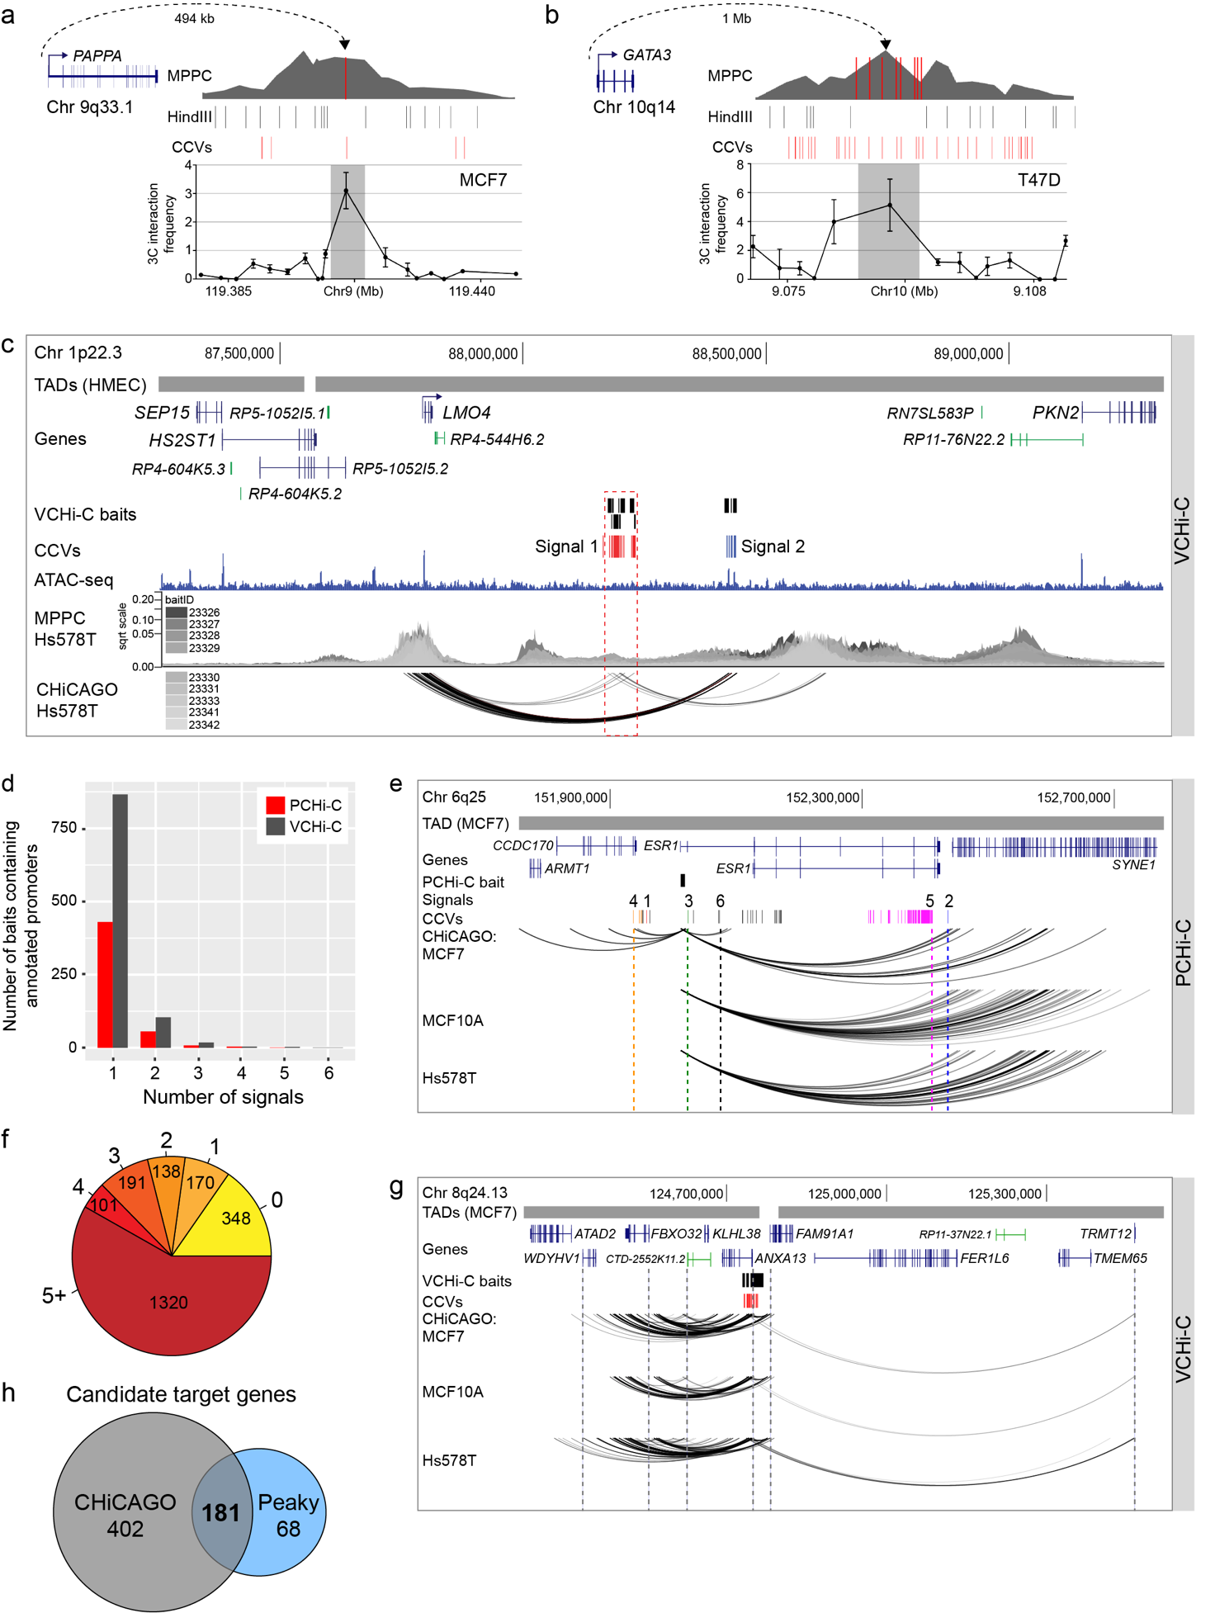

Candidate target gene properties. a 3C interaction profiles at 9q33.1 between the PAPPA promoter and CCVs in MCF7 cells. The anchor point is set at the PAPPA promoter. Error bars represent SD (n = 3). b 3C interaction profiles at 10q14 between the GATA3 promoter and CCVs in T47D cells. The anchor point is set at the GATA3 promoter. Error bars represent SD (n = 3). c Chromatin interactions at 1p22.3 in Hs578T cells. Topologically associating domains (TADs) are shown as horizontal gray bars above GENCODE annotated coding (blue) and non-coding (green) genes. The VCHi-C baits are depicted as black boxes. Risk signals 1 and 2 are numbered and the CCVs within each signal are shown as colored vertical lines. The ATAC-seq track is shown as a dark blue histogram. Peaky defined MPPC values (from nine specified BaitIDs) are plotted. CHiCAGO-scored interactions are shown as black arcs. The dashed red outline highlights the signal 1 CCVs. d Correlation between the number of candidate target genes and independent risk signals in the PCHi-C and VCHi-C datasets. e Chromatin interactions at 6q25 in MCF7, MCF10A and Hs578T breast cell lines. Topologically associating domains (TADs) are shown as horizontal gray bars above GENCODE annotated coding (blue) genes. The ESR1 PCHi-C bait (BaitID: 355261) is depicted as a black box. Risk signals 1-6 are numbered and the CCVs within each signal are shown as colored vertical lines. CHiCAGO-scored interactions are shown as black arcs. The dashed colored vertical lines highlight ESR1 promoter-signal interactions. f Enumeration of the number of transcription start sites skipped during chromatin looping for the 651 target gene promoter interactions. g Chromatin interactions at 8q24.13 in MCF7, MCF10A and Hs578T breast cell lines. Topologically associating domains (TADs) are shown as horizontal gray bars above GENCODE annotated coding (blue) and non-coding (green) genes. VCHi-C baits are depicted as black boxes and the signal 1 CCVs as red vertical lines. CHiCAGO-scored interactions are shown as black arcs. The dashed gray vertical lines highlight promoter-signal interactions to the candidate target genes. h Venn diagram illustrating the number of candidate target genes identified by CHiCAGO, Peaky and both algorithms.

Fig. S5

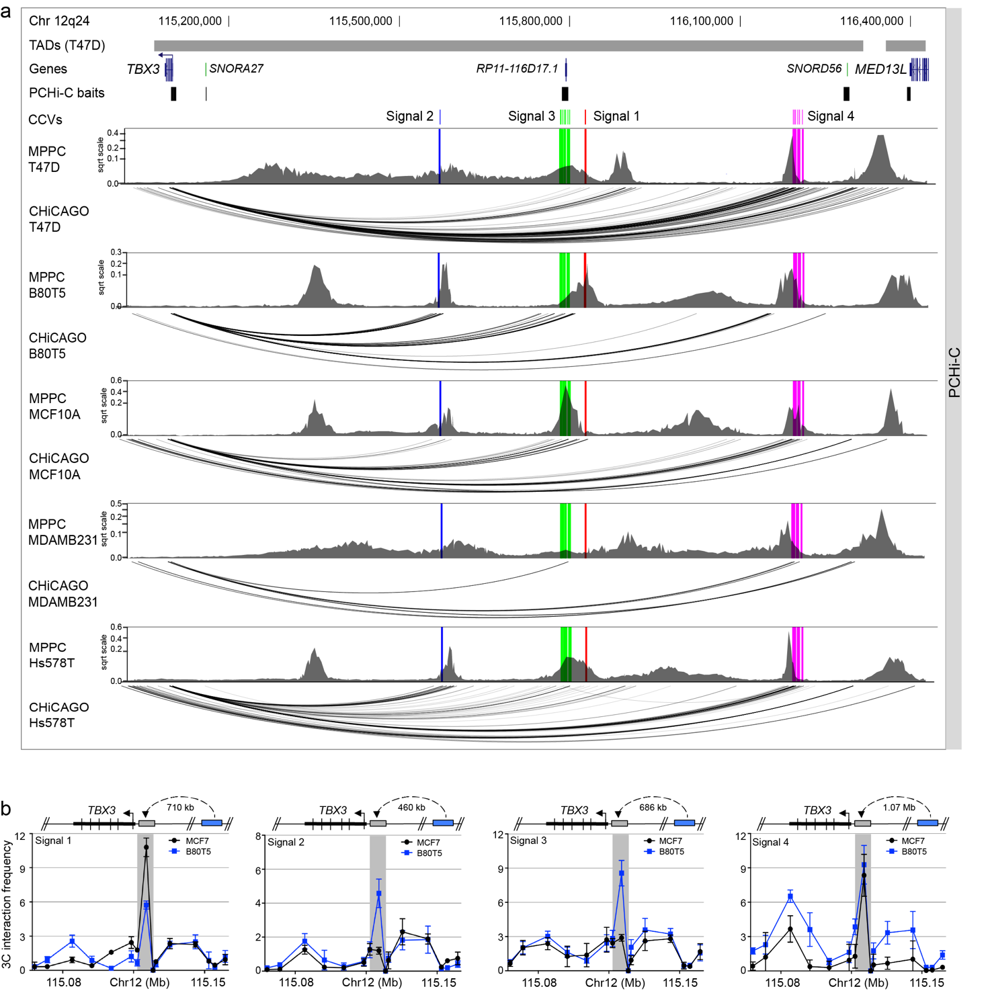

Chromatin interactions across 12q24. a Chromatin interactions at 12q24 in ER+ T47D, ER- MDAMB231 and Hs578T breast cancer cell lines, and non-tumorigenic B80T5 and MCF10A breast cells. Topologically associating domains (TADs) are shown as horizontal gray bars above GENCODE annotated coding (blue) and non-coding (green) genes. PCHi-C baits are depicted as black boxes. Risk signals 1-4 are numbered and the CCVs within each signal are shown as colored vertical lines. Peaky defined MPPC values (from PCHi-C baitID 596031) are plotted with the CCVs overlaid as colored vertical lines. CHiCAGO-scored interactions are shown as black arcs. b 3C interaction profiles between the risk signals 1-4 and the TBX3 promoter in MCF7 and B80T5 cell lines. Anchor points are set at signals 1-4. Error bars represent SD (n = 3).

Fig. S6

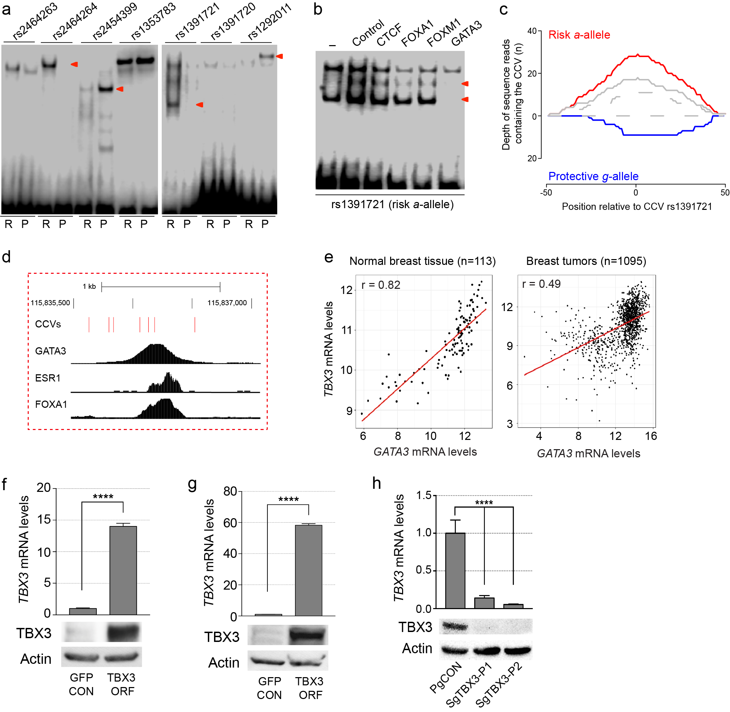

Additional in vitro and in vivo studies for 12q24. a EMSAs for signal 1 CCVs to detect allele-specific binding of nuclear proteins. Labeled oligonucleotide duplexes were incubated with BT474 nuclear extract. Red arrowheads show bands of different mobility detected between risk (R) and protective (P) alleles. b EMSAs for CCV rs1391721 to identify candidate nuclear proteins. Unlabeled competitor oligonucleotide duplexes for predicted transcription factors (100-fold molar excess) were incubated with labeled rs1391721-containing oligonucleotide duplex and MCF7 nuclear extract. Red arrowheads indicate bands that were competed for complex formation on the risk (a) allele. c Allele-specific GATA3 binding at CCV rs1391721 in heterozygous MCF7 cells. The depth of reads containing the risk (red) and protective (blue) alleles are shown. d Zoomed in view of Signal 1 CCVs at 12q24. CCVs are shown as red vertical lines. GATA3, ESR1 and FOXA1 binding are shown as black histograms. e Scatter plots of TBX3 versus GATA3 gene expression in TCGA normal breast tissue (n = 113, r is Pearson’s correlation) and breast tumors (n = 1095, r is Pearson’s correlation). f Top: TBX3 levels in HMLE-control (GFP CON) and HMLE-TBX3 overexpressing (TBX3 ORF) cells assessed by qPCR and normalized to GUSB. Error bars represent SEM (n=3). Bottom: Western blot analysis of TBX3 and Actin, serving as a loading control, in matched cell samples. g Top: TBX3 levels in MCF7-control (GFP CON) and MCF7-TBX3 overexpressing (TBX3 ORF) cells assessed by qPCR and normalized to GUSB. Error bars represent SEM (n = 3). Bottom: Western blot analysis of TBX3 and Actin in matched cell samples. h Top: TBX3 levels in MCF7-control (PgCON) and MCF7-TBX3-dCas9-KRAB repressed cells (SgTBX3-P1/P2) assessed by qPCR and normalized to GUSB. Error bars represent SEM (n = 3). Bottom: Western blot analysis of TBX3 and Actin in matched cell samples. f-h P-values were determined by a two-tailed t-test (****p < 0.0001).

