Additional file 1

Supplementary Tables

Table S1. Statistics of iterative Minia3 assemblies.

k-mer size | Assembled sequence in contigs >= 1 kb [bp] |  | N50 [bp]
 | Morex | Zavitan | Morex | Zavitan
100 | 1,747,458,428 | 3,259,112,517 | 177 | 199
200 | 3,606,526,319 | 8,697,490,960 | 1,884 | 2,395
300 | 4,023,350,988 | 9,739,809,801 | 14,342 | 12,135
350 | 4,076,423,599 | 9,925,057,490 | 22,806 | 16,904
400 | 4,100,916,814 | 10,037,407,369 | 27,210 | 18,934
450 | 4,101,704,421 | 10,044,831,808 | 30,782 | 19,637
500 | 4,101,704,422 | 10,044,905,812 | 32,715 | 21,666

Table S2: Comparison of SOAPDenovo2 and BESST scaffolding. The Morex contig assembly was scaffolded with MP9 reads. BESST was used with BAM files of MP9 reads mapped with Minimap2.

 | SOAPDenovo2 | BESST
Assembly size | 4.7 Gb | 4.6 Gb
Assembled sequence in scaffolds >= 1kb | 4.3 Gb | 4.2 Gb
Assembled sequence in scaffolds >= 1 Mb | 3.5 Gb | 2.4 Gb
N50 | 2.6 Mb | 1.1 Mb
N90 | 154 kb | 1.8 kb
Internal gaps | 221 Mb (4.76 %) | 136 Mb (3.0 %)

Table S3. Numbers of identified full-length retroelements in barley and wheat assemblies.

TE family | Genome assembly | Solo-LTRs | Full-length | with TSD
RLC_Angela | Chinese Spring DeNovoMagic | 6,935 | 21,948 | 19,379 (88%)
RLC_Angela | Chinese Spring TRITEX | 6,225 | 13746 | 12,177 (89%)
RLG_Sabrina | Chinese Spring DeNovoMagic | 656 | 604 | 492 (82%)
RLG_Sabrina | Chinese Spring TRITEX | 614 | 537 | 442 (83%)
RLC_BARE1 | Morex V1 | 3,464 | 3,469 | 2,797 (81%)
RLC_BARE1 | Morex V2 | 3,716 | 5,471 | 4,923 (90%)

Table S4: Classification of transposable elements in the Morex V1 and V2 assemblies.

 | Morex V1 | Morex V2
Mobile Element (TXX)¹ | 80.8 | 80.2
Class I: Retroelement (RXX) | 75.2 | 74.2
LTR Retrotransposon (RLX) | 75.0 | 74.0
Ty1/copia (RLC) | 16.0 | 15.8
Ty3/gypsy (RLG) | 21.3 | 21.3
unclassified LTR (RLX) | 37.7 | 36.9
non-LTR Retrotransposon (RXX) | 0.27 | 0.27
LINE (RIX) | 0.25 | 0.26
SINE (RSX) | 0.02 | 0.02
Class II: DNA Transposon (DXX) | 5.28 | 5.64
DNA Transposon Superfamily (DTX) | 5.03 | 5.39
CACTA superfamily (DTC) | 4.74 | 5.11
hAT superfamily (DTA) | 0.01 | 0.01
Mutator superfamily (DTM) | 0.15 | 0.15
Tc1/Mariner superfamily (DTT) | 0.02 | 0.02
PIF/Harbinger (DTH) | 0.08 | 0.08
unclassified (DTX) | 0.03 | 0.03
DNA Transposon Derivative (DXX) | 0.20 | 0.20
MITE (DXX) | 0.20 | 0.20
Helitron (DHH) | 0.03 | 0.03
unclassified DNA transposon (DXX) | 0.01 | 0.01
Unclassified Element (TXX) | 0.32 | 0.31
Retro-TE/DNA-TE ratio | 14.3 | 13.2
Gypsy/Copia ratio | 1.3 | 1.4
¹Except for the last two rows, numbers indicate the proportions (in percent) of the assembled genome sequence represented by the respective elements classes.

Table S5 Intact LTR retrotransposons in the Morex V1 and V2 assemblies.

 | Morex_V1 | Morex V2
Number of candidates | 143,957 | 150,570
Number of high-confidence (HC) elements | 31,643 (22.0 %) | 33,233 (22.1 %)
RLG/ RLC ratio | 0.87 | 0.91
Number of RLC elements | 11,606 | 12,313
Number of RLG elements | 10,116 | 11,210
Number of RLX elements | 9,921 | 9,710

Table S6: Numbers and sizes of sequence gaps in RLC_BARE1 elements in the Morex V1 and V2 assemblies.

 |  | Morex v1 |  | Morex V2
Size range | Copies | Gaps per copy | Average gap length¹ | Copies | Gaps per copy | Average gap length
8000-8100 | 7 | 0.57 | 28 | 12 | 1.08 | 130
8100-8200 | 14 | 0.42 | 33 | 20 | 0.6 | 121
8200-8300 | 12 | 0 | 0 | 24 | 1.45 | 207
8300-8400 | 17 | 0 | 0 | 20 | 0.7 | 169
8400-8500 | 26 | 0.3 | 26 | 47 | 0.97 | 239
8500-8600 | 387 | 0.01 | 0 | 342 | 0.08 | 12
8600-8700 | 725 | 0.03 | 1 | 753 | 0.05 | 3
8700-8800 | 317 | 0.04 | 4 | 347 | 0.2 | 45
8800-8900 | 470 | 0.03 | 0 | 552 | 0.18 | 21
8900-9000 | 1353 | 0.02 | 2 | 792 | 0.17 | 23
9000-9100 | 31 | 0.87 | 124 | 225 | 1.19 | 240
9100-9200 | 16 | 0.87 | 56 | 268 | 1.24 | 259
9200-9300 | 22 | 1 | 105 | 265 | 1.29 | 299
9300-9400 | 20 | 1.14 | 130 | 340 | 1.29 | 307
9400-9500 | 13 | 1.23 | 39 | 329 | 1.22 | 351
9500-9600 | 19 | 1.1 | 186 | 235 | 1.51 | 478
9600-9700 | 12 | 0.75 | 120 | 157 | 1.71 | 528
9700-9800 | 8 | 0.62 | 135 | 160 | 1.83 | 622
9800-9900 | 0 | 0 | 0 | 152 | 2.09 | 710
9900-10000 | 0 | 0 | 0 | 151 | 2.21 | 760
10000-10100 | 0 | 0 | 0 | 155 | 2.3 | 859
10100-10200 | 0 | 0 | 0 | 124 | 2.19 | 835
¹Average number of Ns per full-length copy in the respective size ranges

Supplementary Figures

Figure S1: Age distributions of full-length TEs in wheat and barley assemblies. The medians of the distributions are indicated by dotted lines.

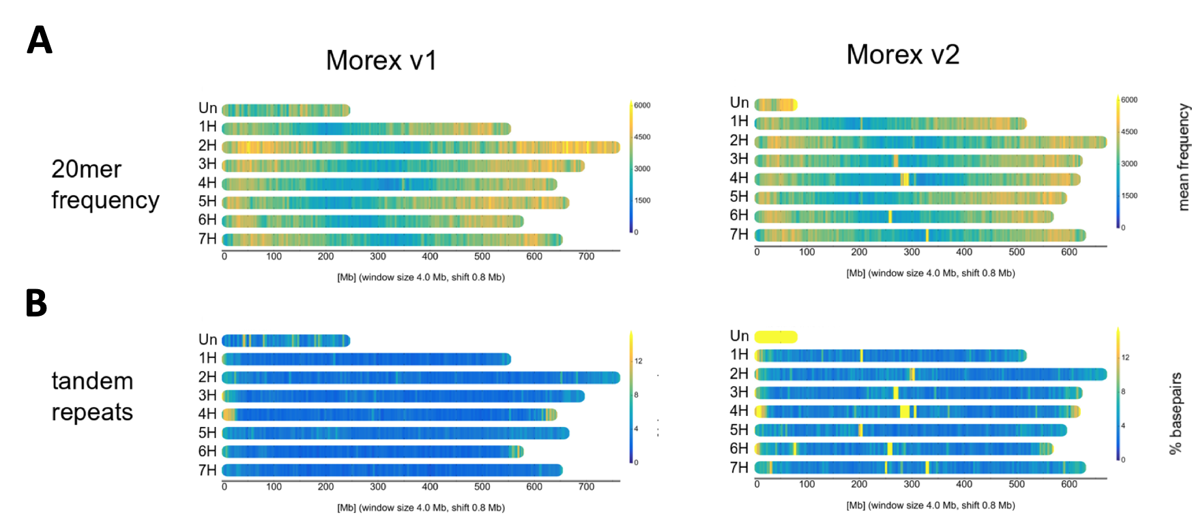

Figure S2: Chromosome distribution of repeats in the Morex V1 and V2 assemblies. (A) Frequencies 20-mer frequencies. (B) Locations of tandem repeats.

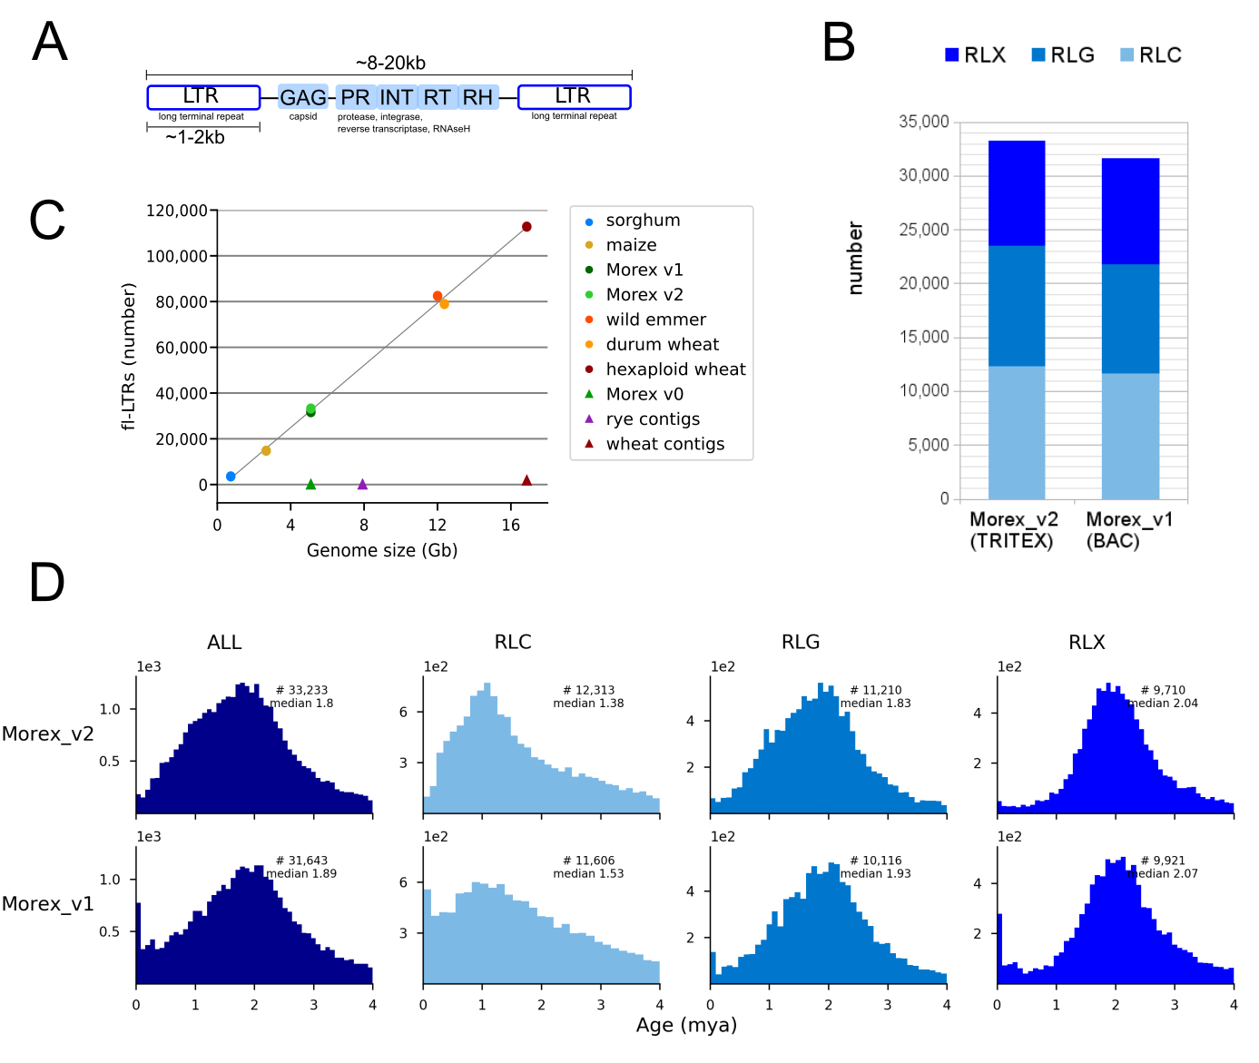
Figure S3: Characterization of intact LTR-retrotransposons in the Morex V1 and V2 assemblies. (A) Structure of LTR-retrotransposons. B) Numbers and superfamily distribution of quality filtered elements. RLC: Copia, RLG: Gypsy, RLX unassigned. (C) Linear relation between fl-LTR numbers and genome sized used as assembly quality metric. (D) Insertion age distribution of fl-LTRs: overall and per superfamily. The assemblies compared in panel C are the following: sorghum [1]; maize [2]; Morex v1, BAC-by-BAC assembly [3]; Morex v2 TRITEX assembly [this study]; wild emmer [4]; durum wheat [5]; hexaploid wheat, IWGSC RefSeqV1 [6]; Morex v0, fragmented WGS assembly [7]; rye contigs, WGS assembly [8]; wheat contigs, chromosome survey sequencing [9].

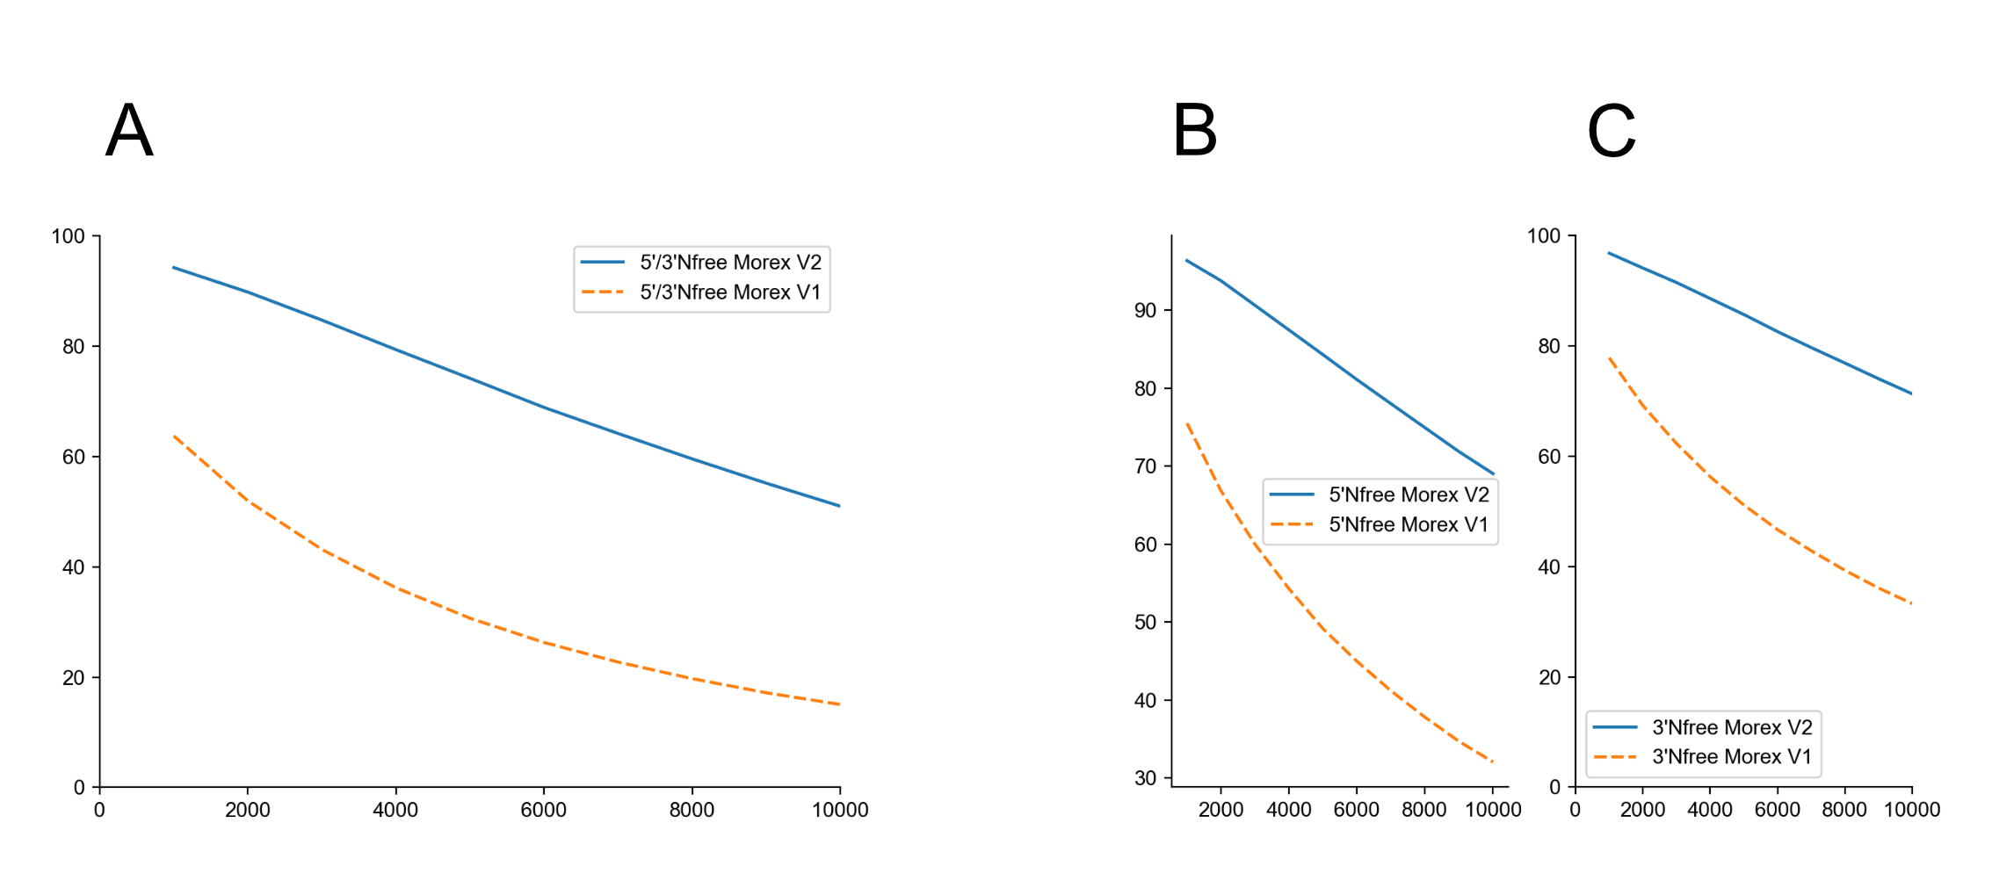

Figure S4: Sequence gaps around genes in Morex V1 and V2 assembly. The percentage of N-free flanking regions is plotted against the size of size of the flanking regions surrounding genes (A: combined 5’ and 3’ flanking regions; B:, 5’ flanking region; C: 3’ flanking region). The Morex V2 has longer N-free flanking regions than the Morex V1 assembly.

Supplementary References

1. Paterson AH, Bowers JE, Bruggmann R, Dubchak I, Grimwood J, Gundlach H, Haberer G, Hellsten U, Mitros T, Poliakov A, et al: The Sorghum bicolor genome and the diversification of grasses. Nature 2009, 457:551-556.
2. Jiao Y, Peluso P, Shi J, Liang T, Stitzer MC, Wang B, Campbell MS, Stein JC, Wei X, Chin CS, et al: Improved maize reference genome with single-molecule technologies. Nature 2017, 546:524-527.
3. Mascher M, Gundlach H, Himmelbach A, Beier S, Twardziok SO, Wicker T, Radchuk V, Dockter C, Hedley PE, Russell J, et al: A chromosome conformation capture ordered sequence of the barley genome. Nature 2017, 544:427-433.
4. Avni R, Nave M, Barad O, Baruch K, Twardziok SO, Gundlach H, Hale I, Mascher M, Spannagl M, Wiebe K: Wild emmer genome architecture and diversity elucidate wheat evolution and domestication. Science 2017, 357:93-97.
5. Maccaferri M, Harris NS, Twardziok SO, Pasam RK, Gundlach H, Spannagl M, Ormanbekova D, Lux T, Prade VM, Milner SG, et al: Durum wheat genome highlights past domestication signatures and future improvement targets. Nature Genetics 2019.
6. The International Wheat Genome Sequencing Consortium (IWGSC): Shifting the limits in wheat research and breeding using a fully annotated reference genome. Science 2018, 361:eaar7191.
7. International Barley Genome Sequencing Consortium: A physical, genetic and functional sequence assembly of the barley genome. Nature 2012, 491:711.
8. Bauer E, Schmutzer T, Barilar I, Mascher M, Gundlach H, Martis MM, Twardziok SO, Hackauf B, Gordillo A, Wilde P: Towards a whole‐genome sequence for rye (Secale cereale L.). The Plant Journal 2017, 89:853-869.
9. International Wheat Genome Sequencing C: A chromosome-based draft sequence of the hexaploid bread wheat (Triticum aestivum) genome. Science 2014, 345:1251788.

