Supplementary Figures

GRCh38 (yellow)

Ash1 (green) (b) (c) (a)

100bp gaps

Figure S1. Adding sequences from GRCh38 to the Ash1 genome assembly. In (a), GRCh38 closes a gap in Ash1. In (b), the GRCh38 contig extends into a gap in Ash1, but the sequence adjacent to the gap does not match. If the GRCh38 extended >1000bp into the gap, and if the alignment ended > 100bp from the end of the Ash1 contig, then the GRCh38 sequence indicated by (b) was inserted, separated from the Ash1 sequence by a gap set to 100 Ns. Case (c) shows an example where a separate GRCh38 contig falls completely within a gap in Ash1, in which case it would be inserted with gaps on both sides.

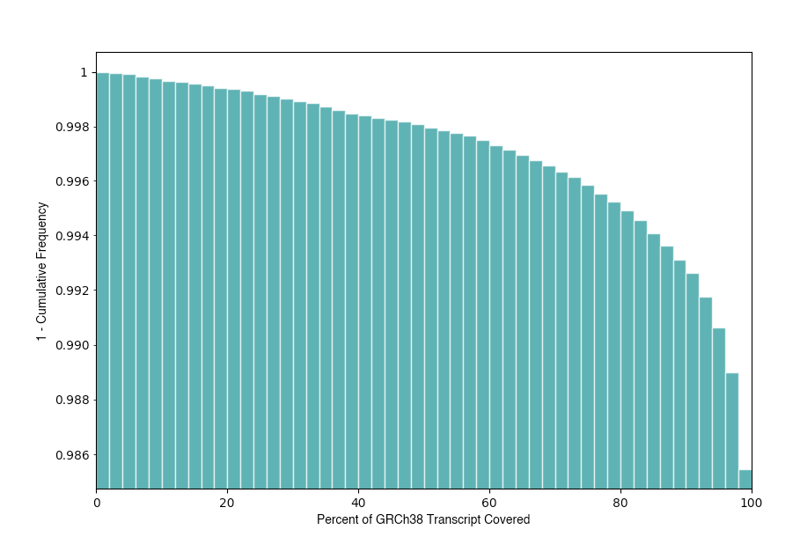
Figure S2. Cumulative distribution showing how much of the GRCh38 transcripts map onto Ash1. The Y axis shows the fraction of transcripts with percent coverage greater than or equal to coverage on the X axis; e.g., the next-to-last bar at 98% on the X axis shows that 98.9% of GRCh38 transcripts (Y axis) mapped for at least 98% of their length onto Ash1.

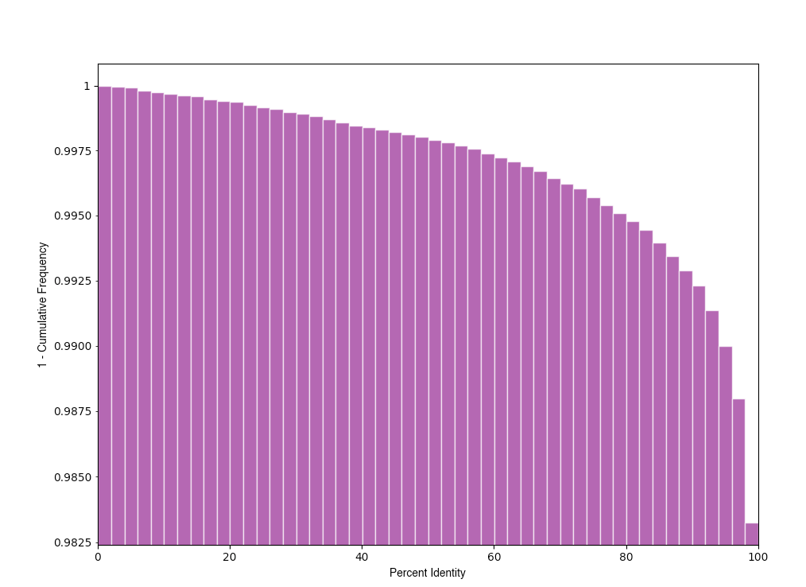
Figure S3. Cumulative distribution of the sequence identity of transcripts mapped onto Ash1. The Y axis shows the fraction of transcripts that aligned between GRCh38 and Ash1 with DNA sequence identity greater than or equal to the percent identity on the X axis. E.g., the next-to-last vertical bar at 98% on the X axis shows that 98.75% of the GRCh38 transcripts aligned at 98% or greater identity to Ash1.

