KAML: improving genomic prediction accuracy of complex traits using machine learning determined parameters
Supplementary Material

Lilin Yin^{1,2}, Haohao Zhang³, Xiang Zhou^{4,5}, Xiaohui Yuan³, Shuhong Zhao^{1,2}, Xinyun Li^{1,2,*}, and Xiaolei Liu^{1,2,*}
¹ Key Laboratory of Agricultural Animal Genetics, Breeding and Reproduction, Ministry of Education & College of Animal Science and Technology, Huazhong Agricultural University, Wuhan, Hubei, 430070, PR China;
² Key Laboratory of Swine Genetics and Breeding, Ministry of Agriculture, Huazhong Agricultural University, Wuhan 430070, Hubei, PR China;
³ School of Computer Science and Technology, Wuhan University of Technology, Wuhan 430070, China;
⁴ Department of Biostatistics, University of Michigan, Ann Arbor, MI, USA;

⁵ Center for Statistical Genetics, University of Michigan, Ann Arbor, MI, USA.

* Corresponding author. Email: xiaoleiliu@mail.hzau.edu.cn; xyli@mail.hzau.edu.cn

Table S1: Comparison of prediction performances of LMM and KAML in various simulated scenarios.
Methods | Scenario 1 |  |  | Scenario 2 |  |  | Scenario 3
Heritability | LMM | KAML |  | LMM | KAML |  | LMM | KAML
0.2 | 0.146 | 0.144 |  | 0.134 | 0.476 |  | 0.209 | 0.961
0.5 | 0.224 | 0.226 |  | 0.219 | 0.508 |  | 0.319 | 0.985
0.8 | 0.277 | 0.280 |  | 0.284 | 0.542 |  | 0.393 | 0.989
Average | 0.216 | 0.217 |  | 0.221 | 0.509 |  | 0.307 | 0.978
The values report the average prediction accuracy performances (correlation) of 100 replicates for each situation. Each situation represents a combination of model, scenario, and heritability.

Table S2: The counts of selected models in the model parameter optimization procedure of KAML in various simulated scenarios.
Models | Scenario 1 |  |  |  | Scenario 2 |  |  |  | Scenario 3
Heritability | pQ | pQ+K | K |  | pQ | pQ+K | K |  | pQ | pQ+K | K
0.2 | 0 | 11 | 89 |  | 15 | 85 | 0 |  | 98 | 2 | 0
0.5 | 0 | 31 | 69 |  | 0 | 100 | 0 |  | 96 | 4 | 0
0.8 | 0 | 33 | 67 |  | 0 | 100 | 0 |  | 89 | 11 | 0
In each situation, the value reports the number of selected models (“pQ”, “pQ+K”, “K”) for 100 replicates in the model parameter optimization procedure. Each situation represents a combination of model, scenario, and heritability. “pQ”: Linear Model with pseudo QTNs as covariates; “pQ+K”: LMM with pseudo QTNs as covariates and standard (or weighted) Kinship; “K”: LMM with standard (or weighted) Kinship.

Table S3: Comparison of the prediction performances of LMM, BSLMM, BayesR, and KAML methods on simulated traits using human dataset.
Heritability | Methods
Heritability | LMM | BSLMM | BayesR | KAML
0.2 | 0.4312 | 0.5632 | 0.5510 | 0.5680
0.5 | 0.5980 | 0.6815 | 0.6724 | 0.6814
0.8 | 0.7167 | 0.7722 | 0.7680 | 0.7728
Average | 0.5820 | 0.6723 | 0.6638 | 0.6741
Prediction accuracy was measured using Pearson correlation coefficients between the predicted values and the simulated additive genetic effect values. The average Pearson correlation coefficients of each scenario are shown on the basis of 20 replicates in the table.

Table S4: Prediction performances of KAML using different GWAS models and a variable number of cross validation folds in dataset of human diseases.
Traits  AUROC/Time(h) | KMAL
Traits  AUROC/Time(h) | GWAS | s1_c5 | s2_c5 | s4_c5
CAD | GLM | 0.596/0.12 | 0.599/0.17 | 0.600/0.3
CAD | MLM | 0.596/0.41 | 0.599/0.64 | 0.600/1.18
HT | GLM | 0.590/0.14 | 0.593/0.18 | 0.594/0.32
HT | MLM | 0.591/0.43 | 0.594/0.64 | 0.594/1.23
T2D | GLM | 0.614/0.13 | 0.617/0.18 | 0.618/0.32
T2D | MLM | 0.615/0.42 | 0.616/0.66 | 0.618/1.19
BD | GLM | 0.636/0.12 | 0.638/0.19 | 0.638/0.35
BD | MLM | 0.636/0.41 | 0.637/0.63 | 0.638/1.20
CD | GLM | 0.665/0.13 | 0.669/0.19 | 0.669/0.35
CD | MLM | 0.665/0.39 | 0.668/0.62 | 0.668/1.14
RA | GLM | 0.715/0.15 | 0.716/0.21 | 0.717/0.4
RA | MLM | 0.715/0.42 | 0.716/0.68 | 0.716/1.22
T1D | GLM | 0.861/0.15 | 0.861/0.22 | 0.862/0.4
T1D | MLM | 0.863/0.42 | 0.863/0.7 | 0.863/1.28
Prediction performance was measured by the AUROC method. For the prediction assessment of each trait, 20 replicates were carried out, and the dataset was randomly split into a reference subset that contained 80% of individuals and a validation subset that contained the remaining 20% in each replicate. The “GLM” and “MLM” represent a linear model and a mixed linear model, respectively. “s1_c5” means to repeat the 5-folds cross validation procedure 1 time, and so on.

Table S5: Comparison of the prediction performances of LMM, BSLMM, BayesR, and KAML methods in datasets of multiple species.
Species | Traits | Methods
Species | Traits | LMM | BSLMM | BayesR | KAML
Cattle | mfp | 0.8145 | 0.8704 | 0.8713 | 0.8645
Cattle | my | 0.7766 | 0.7921 | 0.7931 | 0.7916
Cattle | scs | 0.7372 | 0.7397 | 0.7393 | 0.7412
Horse | coat color | 0.2432 | 0.4971 | 0.4655 | 0.4919
Maize | ywk | 0.7667 | 0.7951 | 0.1321 | 0.8553
Maize | ssk | 0.9021 | 0.8638 | 0.0800 | 0.9058
Maize | gdd | 0.9012 | 0.9001 | 0.9019 | 0.9074
Prediction accuracy was measured using Pearson correlation coefficients between the predicted values and actual phenotypic records (Horse and Maize) or estimated breeding values (Cattle). For the prediction assessment of each trait, 20 replicates were carried out, and the dataset was randomly split into a reference subset that contained 80% of individuals and a validation subset that contained the remaining 20% in each replicate.

Table S6: Computing performance tests (h) of LMM, BSLMM, BayesR, and KAML methods using datasets of multiple species.
Species | Traits | Methods
Species | Traits | LMM | BSLMM | BayesR | KAML
Cattle | mfp | 0.0041 | 6.7118 | 9.0806 | 0.1177
Cattle | my | 0.0041 | 2.1986 | 9.3223 | 0.1124
Cattle | scs | 0.0041 | 102.2675 | 9.0467 | 0.1263
Horse | coat color | 0.0011 | 0.0407 | 0.7375 | 0.0057
Maize | ywk | 0.0066 | 6.3501 | 19.8108 | 0.0743
Maize | ssk | 0.0129 | 13.6788 | 29.1575 | 0.1416
Maize | gdd | 0.0098 | 8.4913 | 27.6100 | 0.1188
The values are reported in hours. The computing performance tests were conducted in a Red Hat Enterprise Linux server with 2.20 GHz Intel(R) Xeon(R) 132 CPUs E7-8880 v4 and 2 TB memory.

Table S7: Counts of selected models in the model parameter optimization procedure of KAML using datasets of multiple species.
Species | Traits | KAML
Species | Traits | pQ | pQ+Kw | pQ+Ks | Kw | Ks
Human | cad | 0 | 12 | 2 | 6 | 0
Human | ht | 0 | 0 | 0 | 13 | 7
Human | t2d | 0 | 13 | 0 | 7 | 0
Human | bd | 0 | 0 | 2 | 15 | 3
Human | cd | 0 | 20 | 0 | 0 | 0
Human | ra | 0 | 20 | 0 | 0 | 0
Human | t1d | 0 | 20 | 0 | 0 | 0
Cattle | mfp | 0 | 20 | 0 | 0 | 0
Cattle | my | 0 | 20 | 0 | 0 | 0
Cattle | scs | 0 | 20 | 0 | 0 | 0
Horse | coat colour | 18 | 1 | 1 | 0 | 0
Maize | ywk | 0 | 20 | 0 | 0 | 0
Maize | ssk | 0 | 9 | 0 | 11 | 0
Maize | gdd | 0 | 20 | 0 | 0 | 0
The pQ is the pseudo QTNs, Ks is the standard Kinship, and Kw is the SNP-weighted Kinship. The five models in KAML are (1) regular LMM (“Ks”), (2) LMM with SNP-weighted Kinship (“Kw”), (3) LMM with pseudo QTNs as covariates and standard Kinship (“pQ+Ks”), (4) LMM with pseudo QTNs as covariates and SNP-weighted Kinship (“pQ+Kw”), and (5) Linear Model with pseudo QTNs as covariates (“pQ”).
Table S8: Comparison of prediction performances of LMM and KAML with/without optimized parameters in various datasets.
Species | Traits |  | Methods
Species | Traits | LMM | Half | Adaptive
Human | cad | 0.5859 | 0.6008 | 0.6000
Human | ht | 0.5967 | 0.5965 | 0.5936
Human | t2d | 0.5997 | 0.6158 | 0.6176
Human | bd | 0.6411 | 0.6381 | 0.6378
Human | cd | 0.6275 | 0.6462 | 0.6686
Human | ra | 0.6142 | 0.7083 | 0.7165
Human | t1d | 0.6455 | 0.8620 | 0.8619
Cattle | mfp | 0.8145 | 0.8642 | 0.8645
Cattle | my | 0.7766 | 0.7924 | 0.7916
Cattle | scs | 0.7372 | 0.7421 | 0.7412
Horse | coat colour | 0.2432 | 0.5360 | 0.4919
Maize | ywk | 0.7667 | 0.8572 | 0.8553
Maize | ssk | 0.9021 | 0.9068 | 0.9058
Maize | gdd | 0.9012 | 0.9035 | 0.9074
The prediction performances were measured by the AUROC method and Pearson correlation coefficients between the predicted values and actual phenotypic records (or estimated breeding values) for datasets of humans and other species. Half represents the KAML model with only half of the total individuals selected randomly to optimize model parameters; Adaptive represents running KAML on the entire dataset, and the parameters were optimized for each replicate. In each replicate, Half and Adaptive shared the same individuals to be predicted.
Table S9: Computing performance tests (sec) of LMM and KAML with/without optimized parameters in various datasets.
Species | Traits |  | Methods
Species | Traits | LMM | Half | Adaptive
Human | cad | 52 | 104 | 1,139
Human | ht | 51 | 103 | 1,138
Human | t2d | 50 | 110 | 1,220
Human | bd | 50 | 103 | 1,487
Human | cd | 48 | 98 | 1,543
Human | ra | 51 | 110 | 1,779
Human | t1d | 50 | 113 | 1,499
Cattle | mfp | 15 | 85 | 424
Cattle | my | 15 | 82 | 405
Cattle | scs | 15 | 84 | 455
Horse | coat colour | 4 | 1 | 20
Maize | ywk | 24 | 73 | 267
Maize | ssk | 46 | 138 | 510
Maize | gdd | 35 | 119 | 428
The values are reported in seconds. The computing performance tests were conducted in a Red Hat Enterprise Linux sever with 2.20 GHz Intel(R) Xeon(R) 132 CPUs E7-8880 v4, and 2 TB memory.

Fig. S1. The Manhattan plots of GWAS results from human, cattle, horse, and maize datasets.

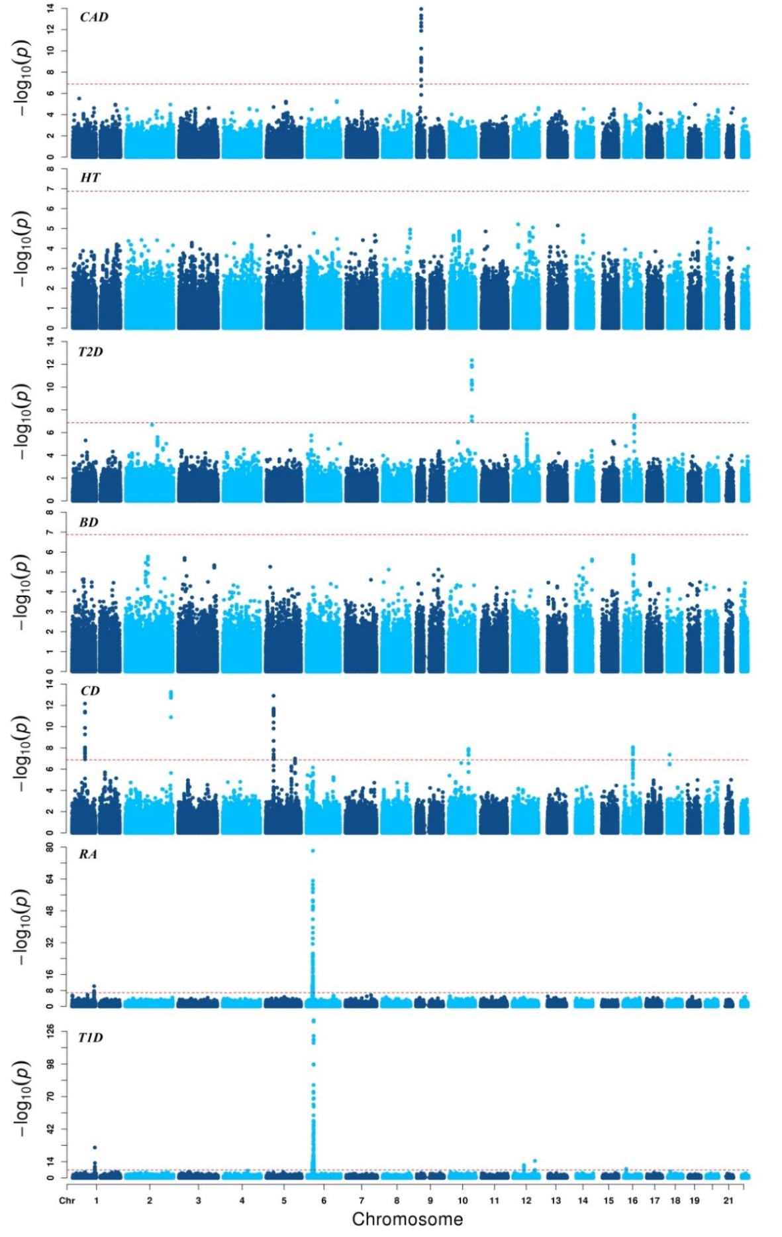
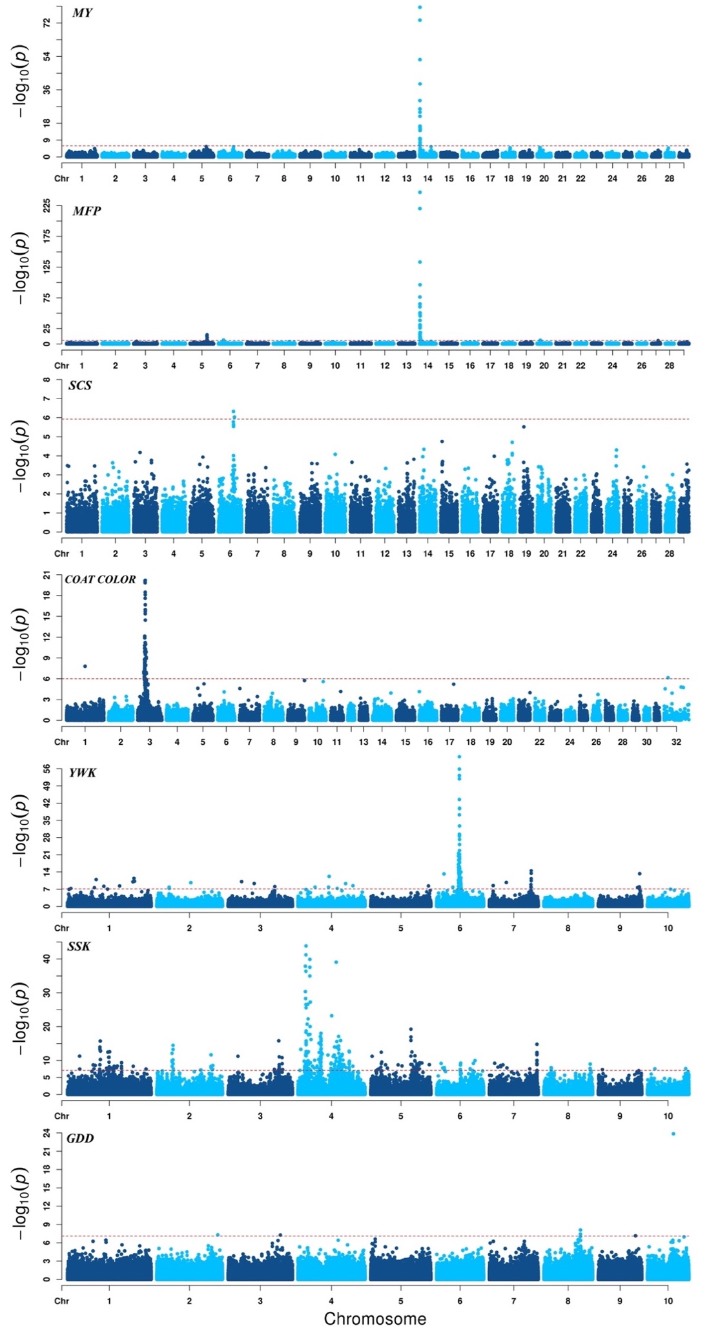
The trait name is marked on the top left of each figure.

Fig. S2. Prediction performances for LMM, BSLMM, BayesR, and KAML methods with different numbers of total MCMC iterations on three maize traits.
The average prediction accuracy value of 20 replicates is shown for each point. In each replicate, the dataset was randomly split into a reference subset that contained 80% of individuals and a validation subset that contained the remaining 20%. The number of burn-in iterations was set to 40% of the total number of iterations for both BSLMM and BayesR. The Y axis represents the prediction accuracy, and the X axis represents the total number of MCMC iterations.

Fig. S3. The calculating time (sec) of LMM, BSLMM, BayesR, and KAML methods with different numbers of total MCMC iterations on three maize traits.
The average calculating time of 20 replicates in log₁₀ is shown for each point. In each replicate, the dataset was randomly split into a reference subset that contained 80% of individuals, and a validation subset that contained the remaining 20%. The Y axis represents the calculating time, and the X axis represents the total number of MCMC iterations.

