Supplementary Figures

CB2 improves power of cell detection in droplet-based single-cell RNA sequencing data

Zijian Ni (zni25@wisc.edu)¹, Shuyang Chen (schen662@wisc.edu)¹, Jared Brown (brown46@wisc.edu)¹, Christina Kendziorski (c.kendziorski@gmail.com)^{2*}

¹Department of Statistics, University of Wisconsin-Madison, Madison, WI, USA
²Department of Biostatistics and Medical Informatics, University of Wisconsin-Madison, Madison, WI, USA
*Corresponding author

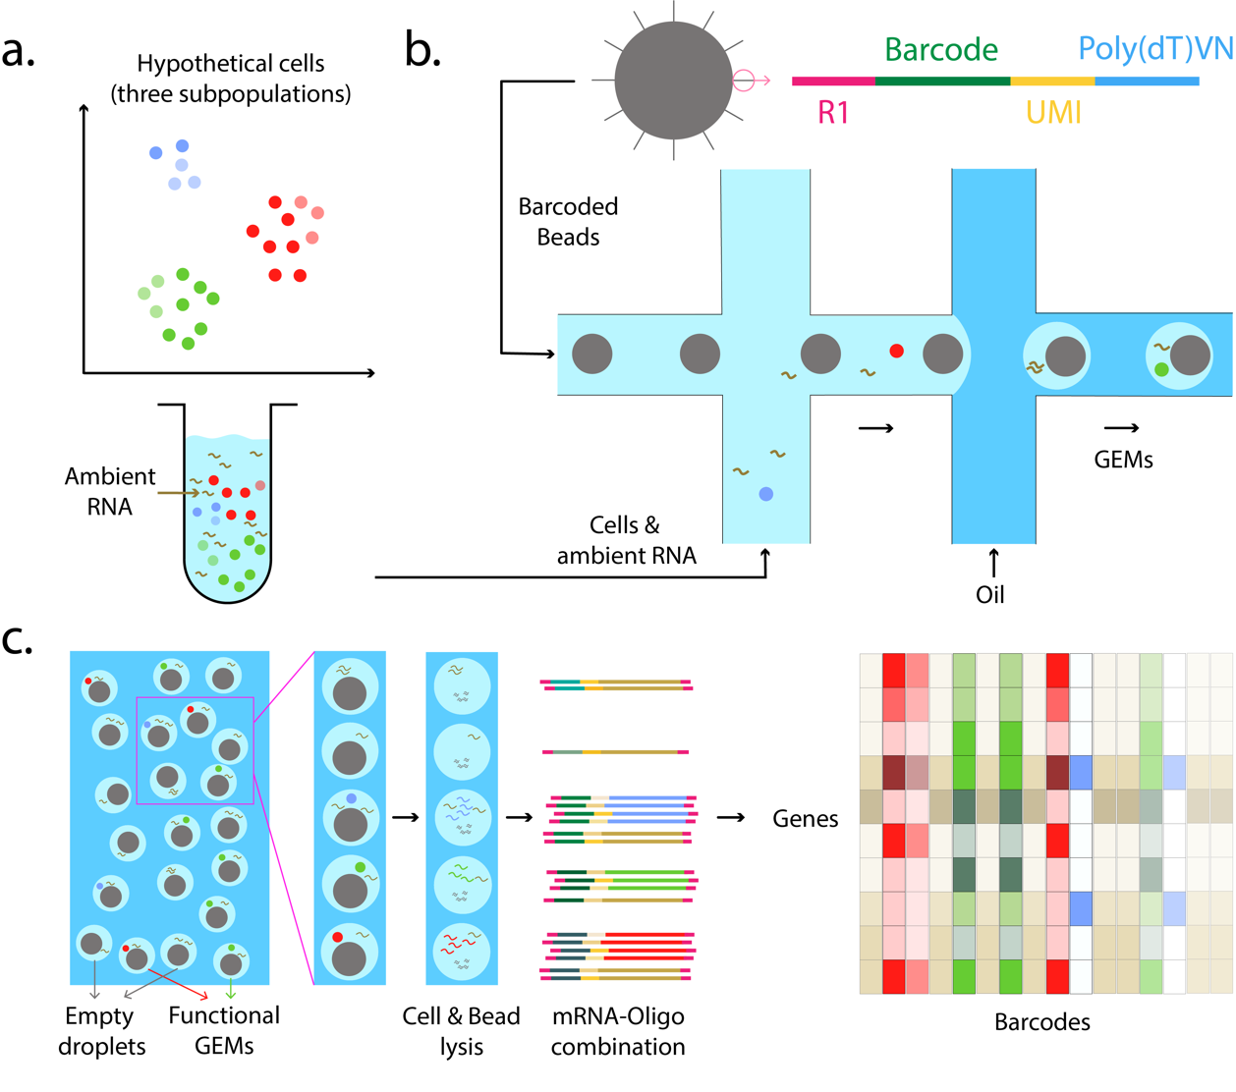
Fig. S1: (a) Projection of a hypothetical cell population containing three sub-populations (red, green and blue where intensity corresponds to read depth). (b) In the commercial droplet-based scRNA-seq protocol 10x Chromium[1], gel beads containing oligonucleotide indexes made up of bead-specific barcodes combined with UMIs and oligo-dT tags to prime polyadenylated RNA are combined with single cells in one channel of a microfluidic chip and oil in another to form gel-beads in emulsion, or GEMs. (c) GEMs that capture individual cells are referred to as functional GEMs; those that fail to capture cells are empty droplets. Gel beads dissolve and release their oligos for reverse transcription of polyadenylated RNAs. (d) Indexed cDNA is pooled for PCR amplification and sequencing to give a data matrix of UMI counts for each barcode, which is taken as input to CB2 (Fig. 1). By leveraging correlation among cell sub-populations, CB2 shows improved sensitivity and specificity for identifying cells in common as well as rare subpopulations.
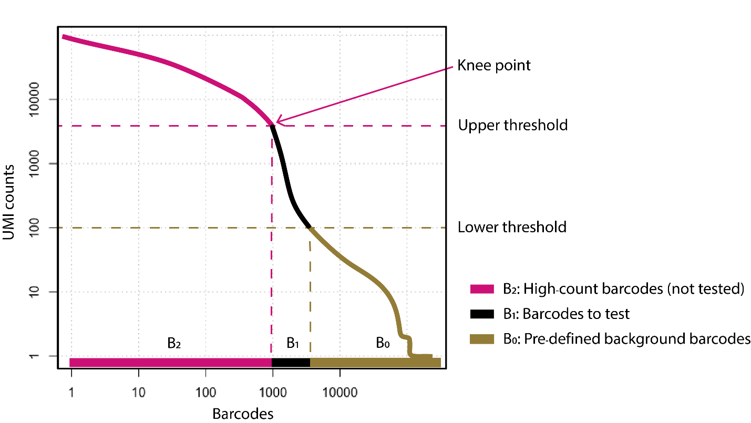
Fig. S2: UMI counts are plotted against barcodes that have been ordered by total count. Both CB2 and ED automatically call high count barcodes real cells (they are not tested); low count barcodes are considered background. The remaining barcodes are tested. By default, the high count (upper) threshold is defined by the knee point, where the counts vs. rank curve begins to drop rapidly; the low count threshold is set to 100. Either, or both, may be changed by a user.
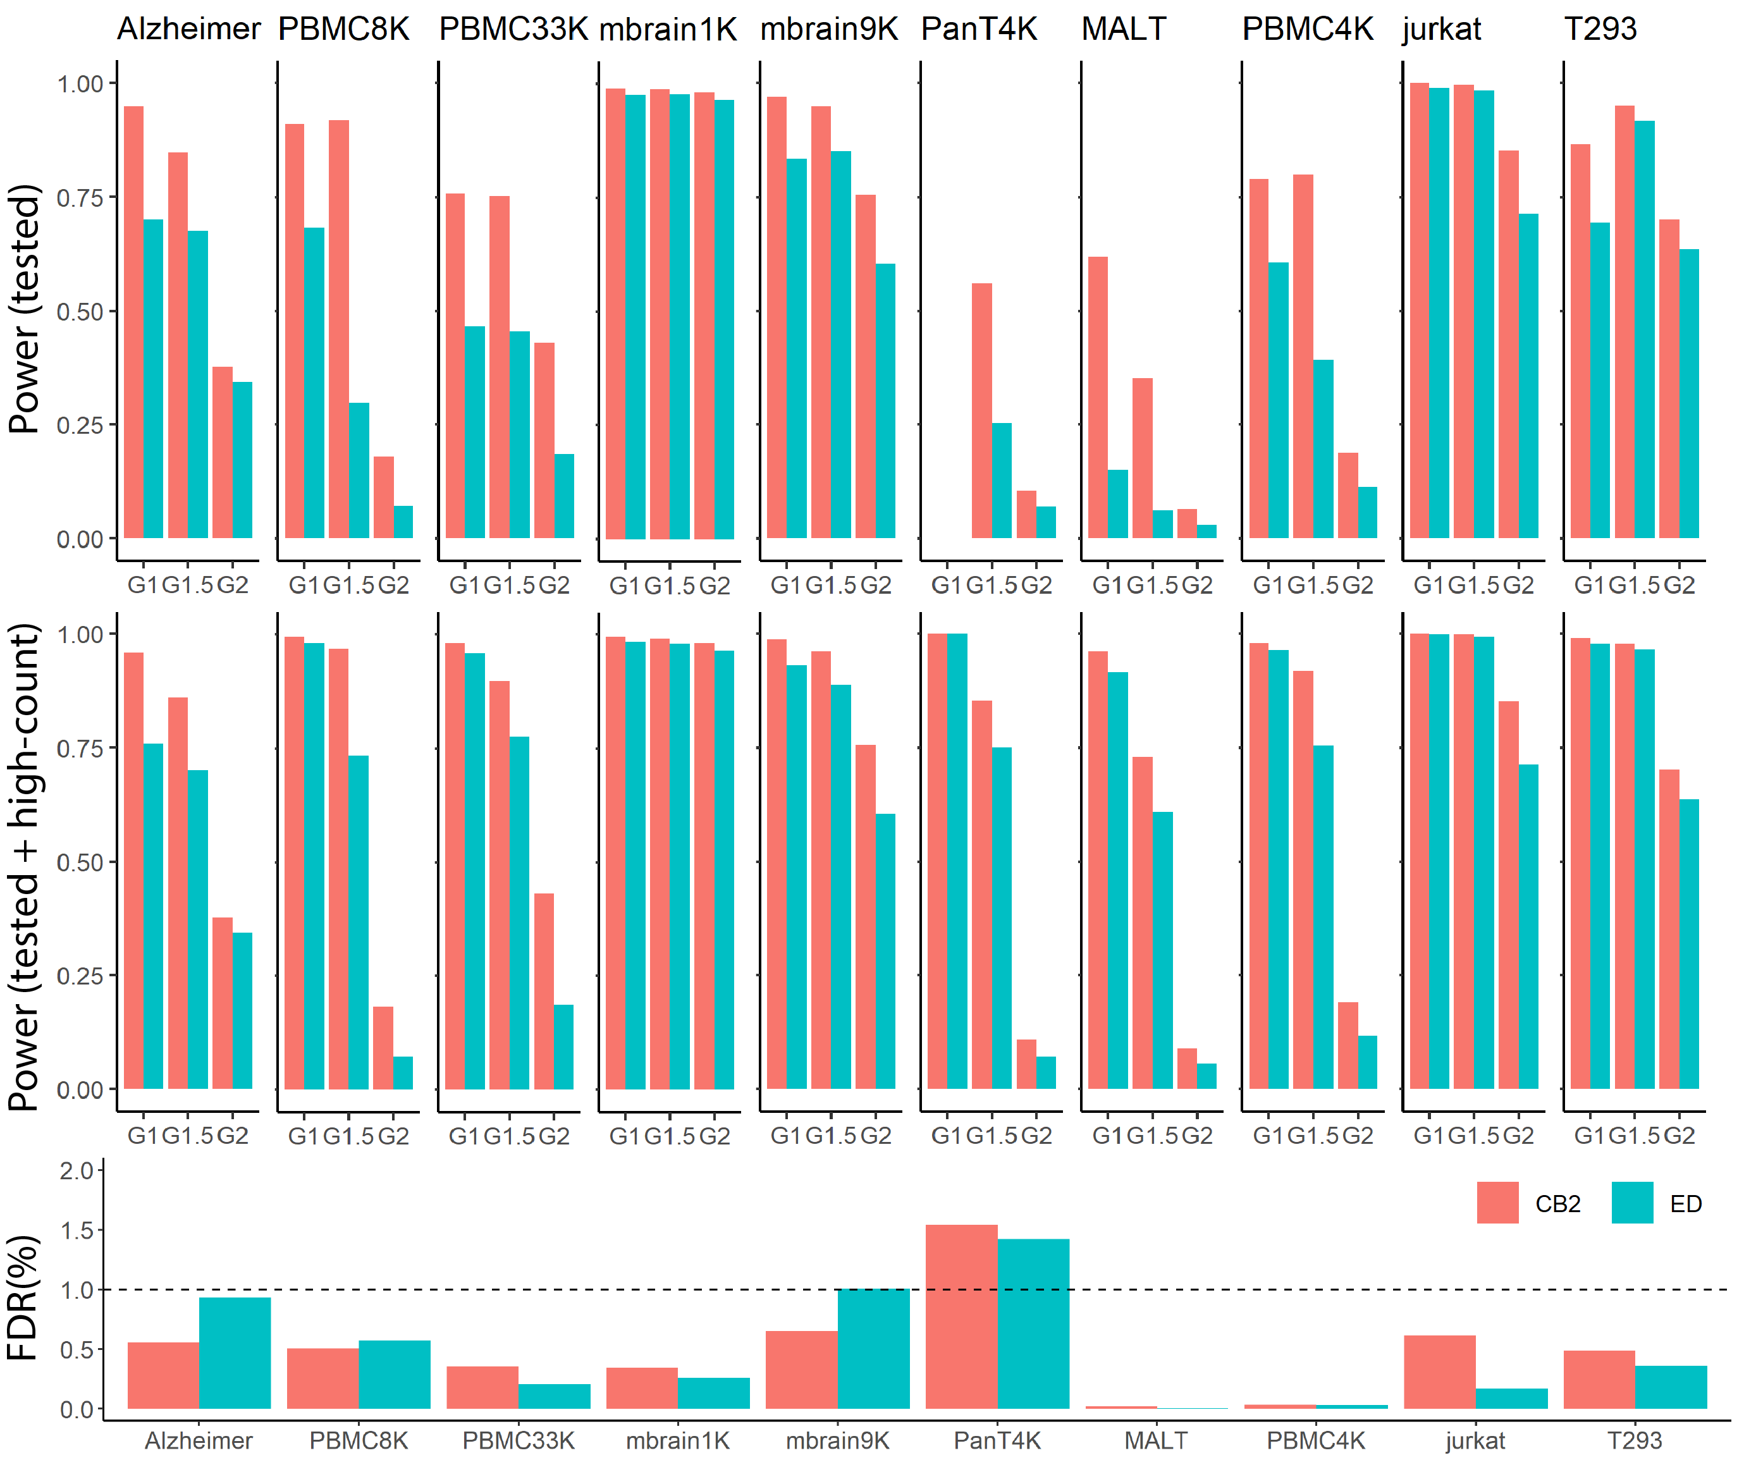
Fig. S3: The average power and average false discovery rate (FDR) of CB2 and ED for SIM IA data (average taken over 5 simulated datasets). Since both CB2 and ED automatically identify high count barcodes as real cells (they are not subject to statistical test; Fig. S2), we report results for all barcodes as well as those tested by CB2 and ED. The top panel shows the average power for tested barcodes; the middle panel for tested as well as high count barcodes. The bottom panel shows the average FDR. For the PanT4K dataset, all $G_{1}$ cells are above the upper threshold and so no barcodes were tested (as a result, power for tested barcodes is not defined).

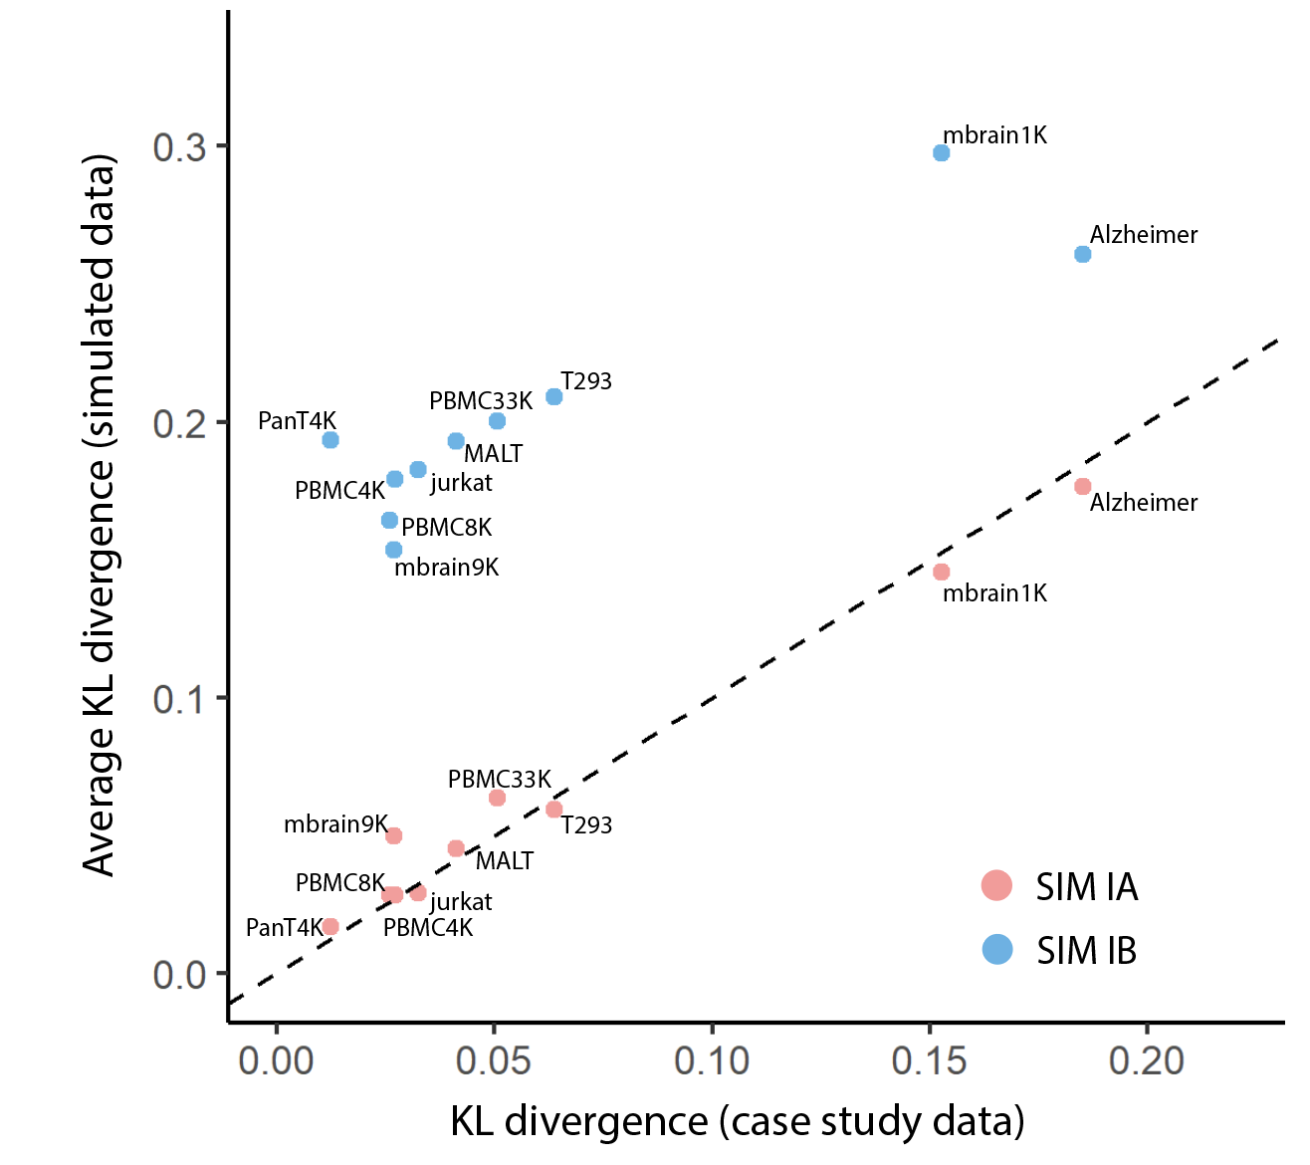
Fig. S4: To measure the similarity between each simulated dataset and the case study data from which it is derived, for each dataset we evaluate the extent to which the distribution of real cells differs from the background distribution. Specifically, for each case study dataset, we calculate the Kullback-Leibler (KL) divergence to measure the difference between the expression distribution of the high-count barcodes and the background distribution. For the simulated data, we calculate the KL divergence between the $G_{1}$ simulated cells and the background distribution. This is repeated to get a KL divergence for $G_{1.5}$ simulated cells vs. background and $G_{2}$ simulated cells vs. background. The average KL divergence (averaged over the three groups) for each simulation (SIM IA, SIM IB) is plotted against the KL divergence for each case study. The KL divergence in the SIM IA data is more similar to the case study data for each dataset considered. The increased KL divergence observed in the SIM IB data indicates that the SIM IB simulated barcodes differ from the background more than observed in the case study or SIM IA data, which makes differences easier to identify when applying CB2 or ED.
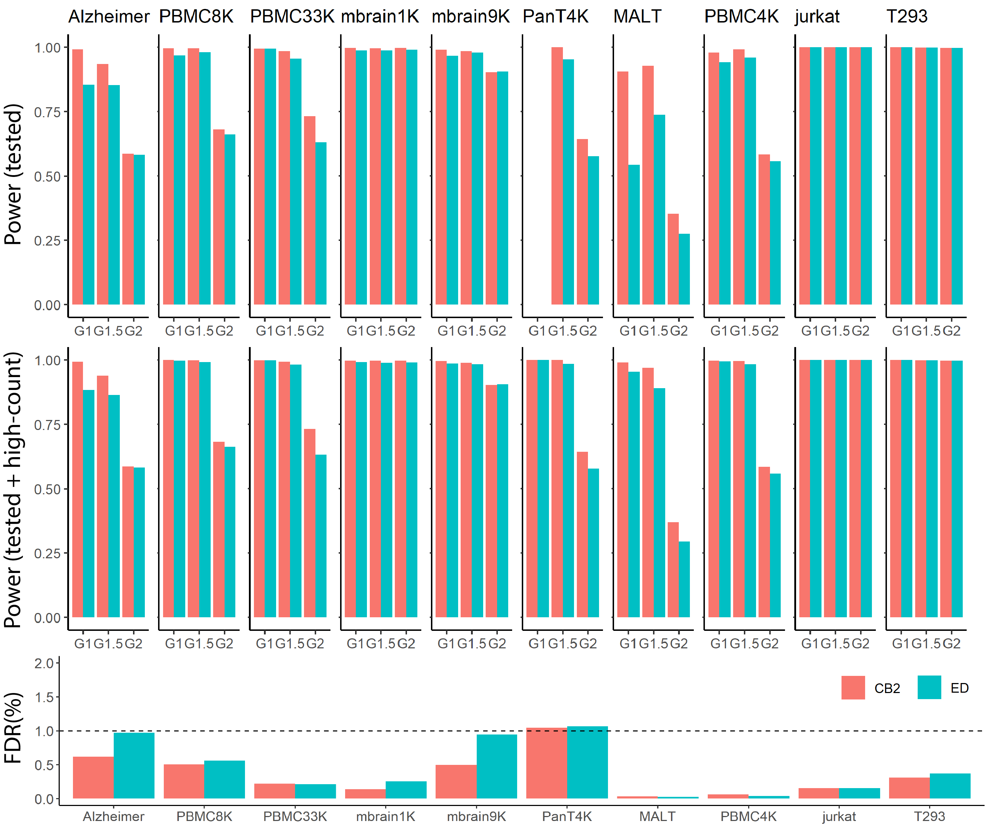
Fig. S5: The average power and average FDR of CB2 and ED for SIM IB data (average taken over 5 simulated datasets). SIM IB, also considered by Lun et al., 2019[2], is similar to SIM IA, but in SIM IB 10% of the genes in the real cells are shuffled making the real cells more different from the background and therefore easier to identify (Fig. S4). Since both CB2 and ED automatically identify high count barcodes as real cells (they are not subject to statistical test; Fig. S2), we report results for all barcodes as well as those tested by CB2 and ED. The top panel shows the average power for tested barcodes; the middle panel for tested as well as high count barcodes. The bottom panel shows the average FDR. For the PanT4K dataset, all $G_{1}$ cells are above the upper threshold and so no barcodes were tested (as a result, power for tested barcodes is not defined).
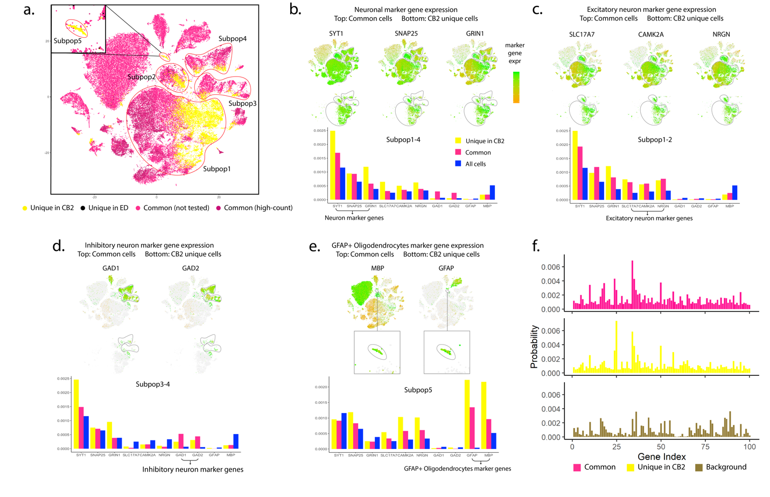
Fig. S6: Additional analysis of Alzheimer dataset. Mathys et al. 2019[3] considered marker genes to identify neurons (SYT1, SNAP25, GRIN1), excitatory neurons (SLC17A7, CAMK2A, NRGN), inhibitory neurons (GAD1, GAD2) and oligodendrocytes (MBP). (a) The same t-SNE plot as in Fig. 2. Panels (b)-(e) show that t-SNE plot colored by marker gene expression in all cells (upper) as well as those identified uniquely by CB2 (lower). Distribution plots of the 10 marker genes within the specified subpopulations are shown in the bottom panels for the common cells (pink) and those uniquely identified by CB2 (yellow). Expression levels of these markers calculated across all cells are shown in blue as a reference. Cells uniquely identified by CB2 have marker gene expression patterns similar to those observed in the cells identified in common between CB2 and ED, providing further support that they are real cells. As shown in panel (e), the novel subpopulation identified by CB2 is the only subpopulation showing high expression of both oligodendrocyte and astrocyte marker genes, suggesting that this group may be mixed phenotype glial cells[4] (GFAP+ oligodendrocytes). Panel (f) shows distribution plots of the 100 genes having highest average expression in Subpop5 for cells identified by both CB2 and ED (upper) and identified uniquely by CB2 (middle). The estimated background distribution is also shown (lower). Cells uniquely identified by CB2 in Subpop5 have a distribution similar to other Subpop5 cells and differ from the background.

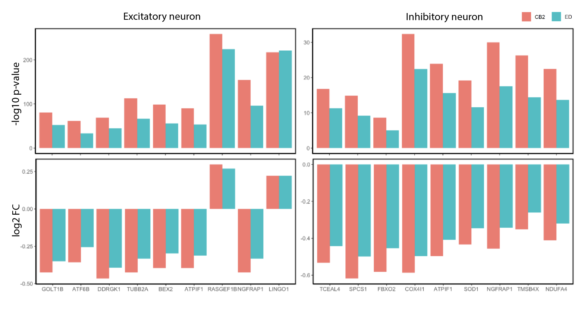
Fig. S7: Differential Expression analysis between Alzheimer’s disease (AD) cases and controls was conducted using cells identified by CB2 (salmon) and ED (turquoise). Shown in the upper panels are the -log10 p-values for 9 genes known to be differentially expressed between AD-pathology and control cells in excitatory neurons (left: GOLT1B, ATF6B, DDRGK1, TUBB2A, BEX2, ATPIF1, RASGEF1B, NGFRAP1, LINGO1) and 9 genes known to be differentially expressed in inhibitory neurons (right: TCEAL4, SPCS1, FBXO2, COX4I1, ATPIF1, SOD1, NGFRAP1, TMSB4X, NDUFA4)[3]. Log2 fold changes of the mean expression in AD-pathology vs. control cells are also shown (lower panels) for each gene in each cell type. Given that some of the unique CB2 identifications are expressing stronger cell-type-specific marker genes (Fig. S6(b)-(e)), fold changes in the CB2 identified cells are more extreme. CB2 improves downstream DE analysis by showing more significant p-values and stronger fold changes.

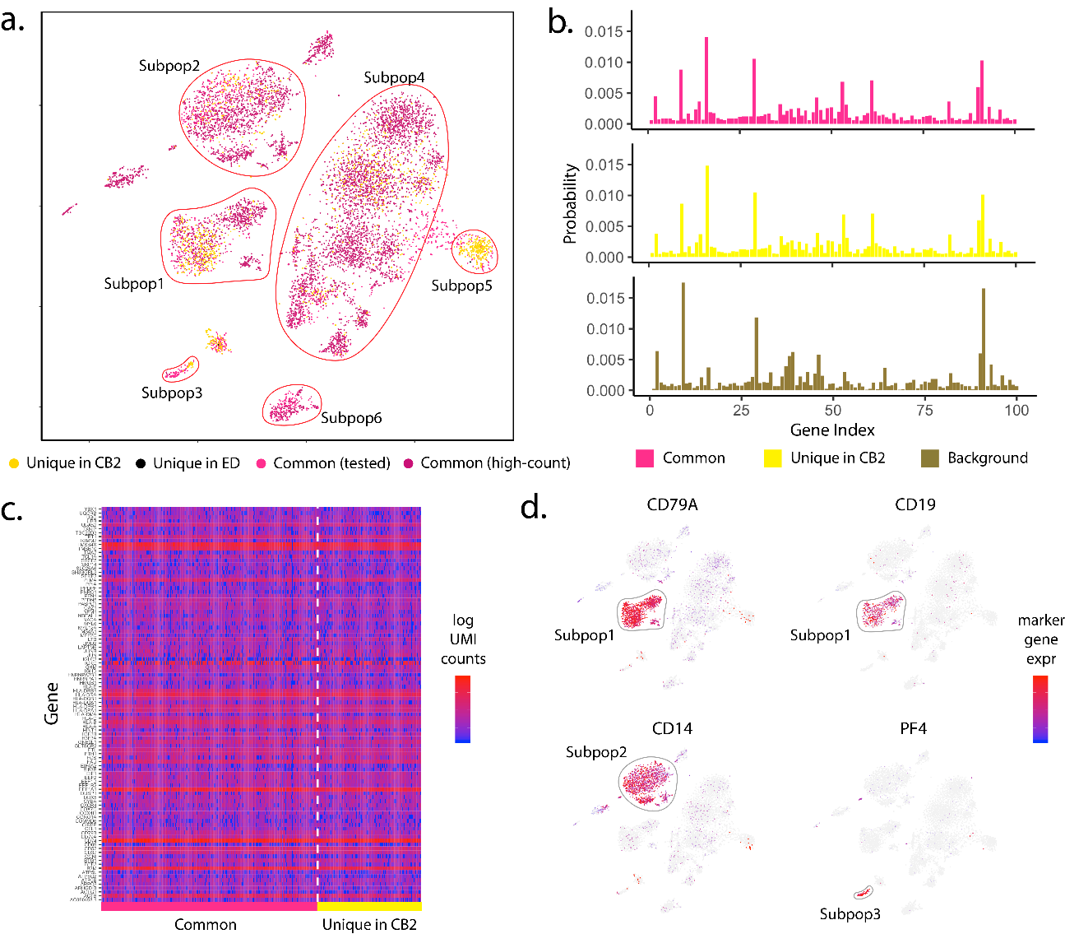
Fig. S8: Analysis of PBMC8K dataset. (a) t-SNE plot of cells identified by CB2 and ED. High-count barcodes exceeding an upper threshold are identified as real cells by both methods without a statistical test (dark pink); barcodes identified as cells by both methods following statistical test are shown in pink. Cells identified uniquely by CB2 (yellow) and ED (black) are also shown. (b) Distribution plots of the 100 genes having highest average expression in Subpop1 are shown for cells identified by both CB2 and ED (upper) and identified uniquely by CB2 (middle). The estimated background distribution is also shown (lower). Cells uniquely identified by CB2 in Subpop1 have a distribution similar to other Subpop1 cells and differ from the background. (c) Heatmap of log transformed raw UMI counts for the same 100 genes for barcodes identified by CB2 and ED (left) and barcodes uniquely identified by CB2 (right). (d) t-SNE plots of cells colored by known marker genes for B-cells (CD79A, CD19), CD14+ Monocytes (CD14), and ﻿Megakaryocytes (PF4)[1].

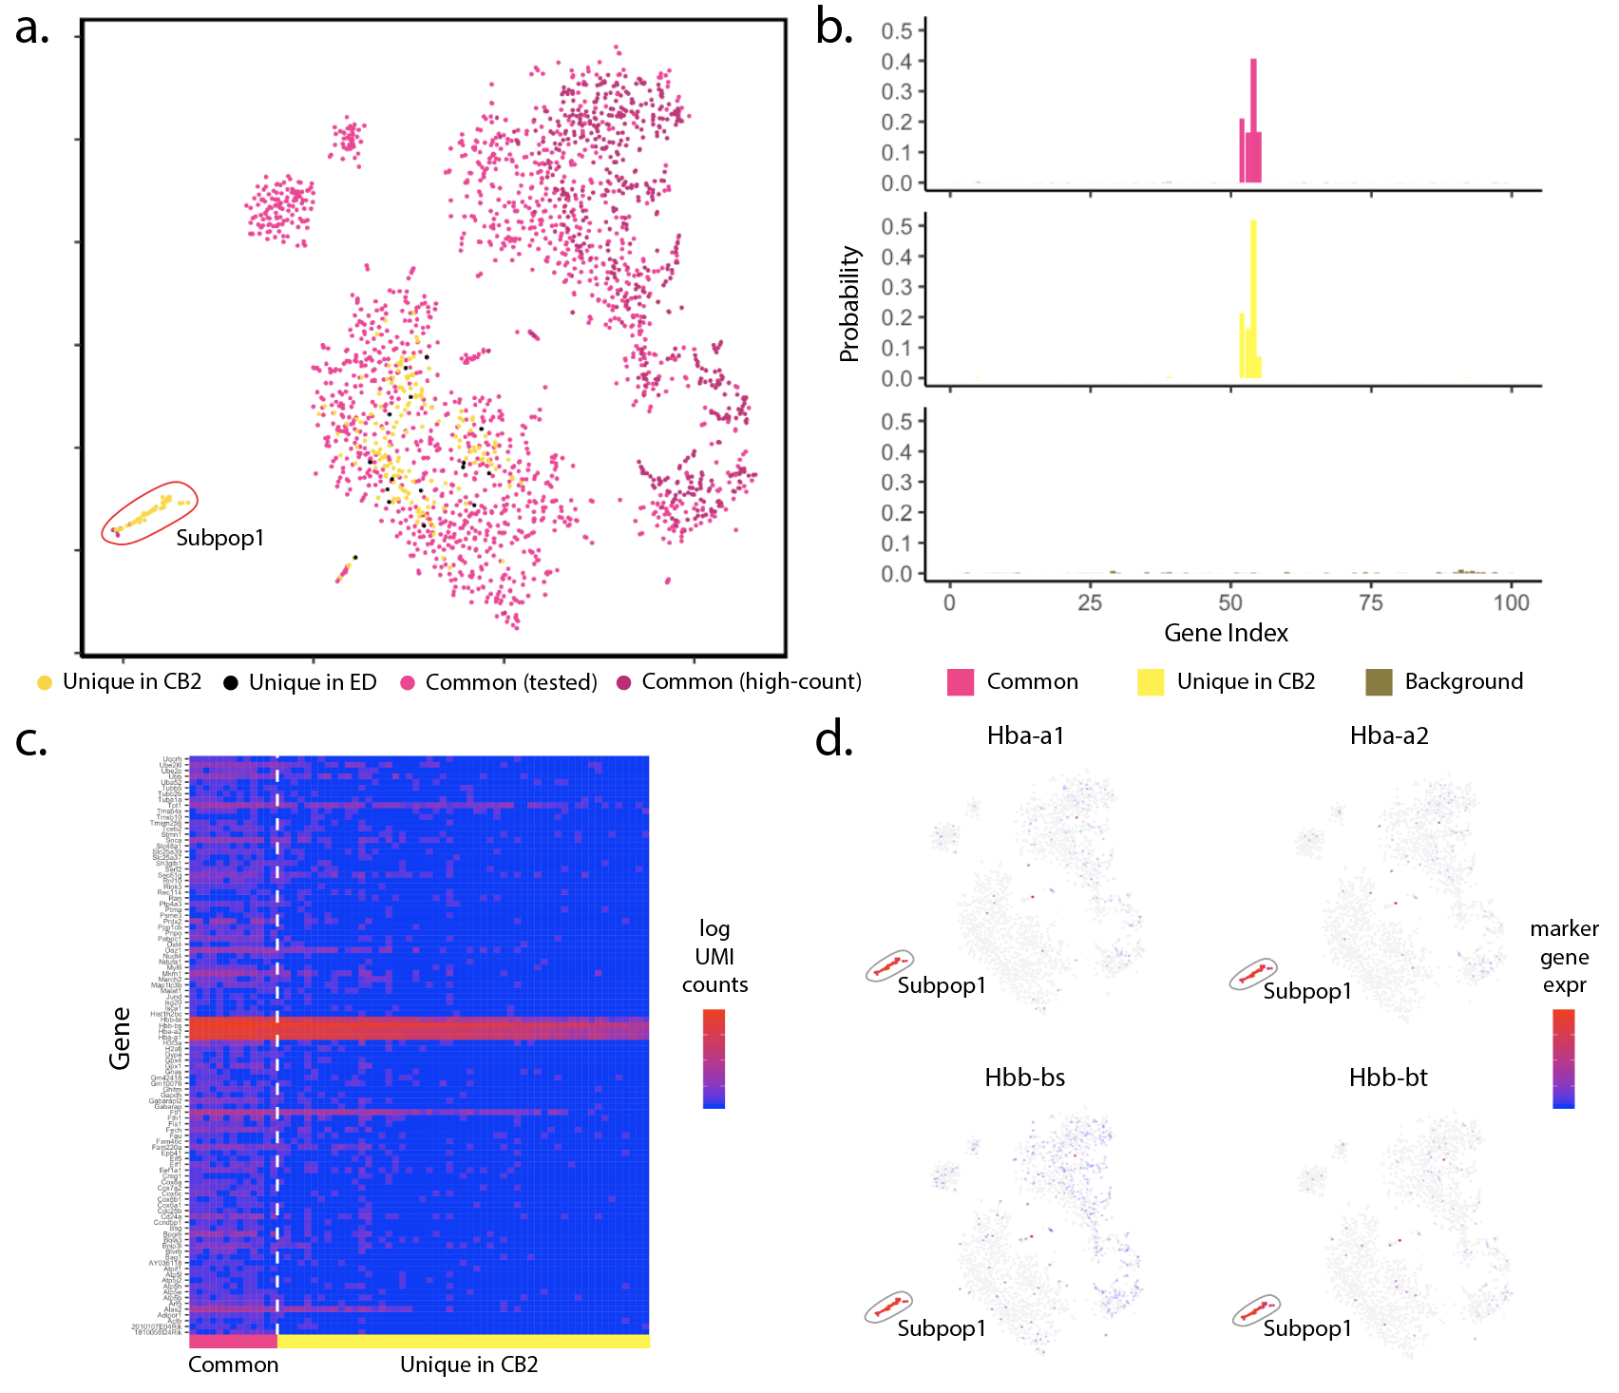
Fig. S9: Analysis of mbrain1K dataset. (a) t-SNE plot of cells identified by CB2 and ED. High-count barcodes exceeding an upper threshold are identified as real cells by both methods without a statistical test (dark pink); barcodes identified as cells by both methods following statistical test are shown in pink. Cells identified uniquely by CB2 (yellow) and ED (black) are also shown. (b) Distribution plots of the 100 genes having highest average expression in Subpop1 are shown for cells identified by both CB2 and ED (upper) and identified uniquely by CB2 (middle). The estimated background distribution is also shown (lower). Cells uniquely identified by CB2 in Subpop1 have a distribution similar to other Subpop1 cells and differ from the background. (c) Heatmap of log transformed raw UMI counts for the same 100 genes for barcodes identified by CB2 and ED (left) and barcodes uniquely identified by CB2 (right). (d) t-SNE plots of cells colored by expression of hemoglobin-related marker genes (Hba-a1, Hba-a2, Hbb-bs, Hbb-bt). (b)-(d) indicate that CB2 reveals a novel subpopulation of cells with expression patterns consistent with high stress and neurogenerative disorders in both human[5] and mouse[6] brain studies.
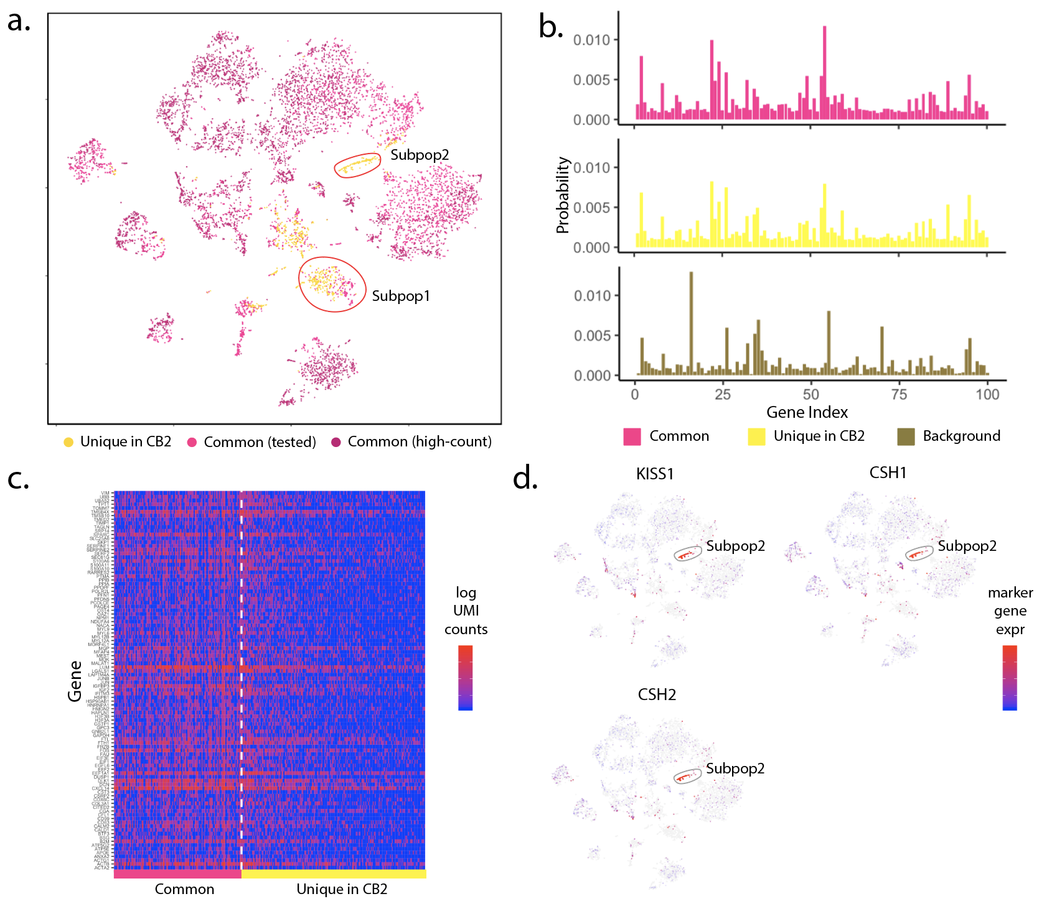
Fig. S10: Analysis of placenta dataset. (a) t-SNE plot of cells identified by CB2 and ED. High-count barcodes exceeding an upper threshold are identified as real cells by both methods without a statistical test (dark pink); barcodes identified as cells by both methods following statistical test are shown in pink. Cells identified uniquely by CB2 (yellow) and ED (black) are also shown. (b) Distribution plots of the 100 genes having highest average expression in Subpop1 are shown for cells identified by both CB2 and ED (upper) and identified uniquely by CB2 (middle). The estimated background distribution is also shown (lower). Cells uniquely identified by CB2 in Subpop1 have a distribution similar to other Subpop1 cells and differ from the background. (c) Heatmap of log transformed raw UMI counts for the same 100 genes for barcodes identified by CB2 and ED (left) and barcodes uniquely identified by CB2 (right). (d) t-SNE plots of cells colored by expression of a placenta-specific marker gene (KISS1) and marker genes related to placental lactogen secretion (CSH1, CSH2)[7]. Panels (a) and (d) indicate that CB2 reveals a novel subpopulation (Subpop2) that may be related to placental lactogen secretion.

References

1. Zheng GXY, Terry JM, Belgrader P, Ryvkin P, Bent ZW, Wilson R, et al. Massively parallel digital transcriptional profiling of single cells. Nat Commun. 2017;8:14049.
2. Lun ATL, Riesenfeld S, Andrews T, Dao TP, Gomes T, Marioni JC. EmptyDrops: distinguishing cells from empty droplets in droplet-based single-cell RNA sequencing data. Genome Biol. 2019;20:63.
3. Mathys H, Davila-Velderrain J, Peng Z, Gao F, Mohammadi S, Young JZ, et al. Single-cell transcriptomic analysis of Alzheimer’s disease. Nature. 2019;570:332–7.
4. Dyer CA, Kendler A, Jean-Guillaume D, Awatramani R, Lee A, Mason LM, et al. GFAP-positive and myelin marker-positive glia in normal and pathologic environments. J Neurosci Res. 2000;60:412–26.
5. Vanni S, Zattoni M, Moda F, Giaccone G, Tagliavini F, Haïk S, et al. Hemoglobin mRNA changes in the frontal cortex of patients with neurodegenerative diseases. Front Neurosci. 2018;12.
6. Stankiewicz AM, Goscik J, Swiergiel AH, Majewska A, Wieczorek M, Juszczak GR, et al. Social stress increases expression of hemoglobin genes in mouse prefrontal cortex. BMC Neurosci. 2014;15.
7. Männik J, Vaas P, Rull K, Teesalu P, Rebane T, Laan M. Differential expression profile of growth hormone/chorionic somatomammotropin genes in placenta of small- and large-for-gestational-age newborns. J Clin Endocrinol Metab. 2010;95:2433–42.

