Additional Materials

Supplementary Figures

- Figure S1 - K-mer distribution
- Figure S2 - Detailed sampling map of all sequenced individual
- Figure S3 - Treemix phylogeny and variance plot
- Figure S4 - Introgression segments into llama (f_{d})
- Figure S5 - PSMC plot for all four SAC species
- Figure S6 - MSMC plots for (a) guanaco; (b) llama; (c) vicuña; (d) alpaca
- Figure S7 - Manhattan plot of selection signatures detected in the comparison between vicuña and alpaca (XP-EHH upper, F_{ST} bottom)
- Figure S8 - Manhattan plot of selection signatures detected in the comparison between guanaco and llama (XP-EHH upper, F_{ST} bottom)
- Figure S9 - Comparison between region-wide F_{ST} and SNP distribution among wild ancestors and domestic relatives for the OR5 and OR2 olfactory receptor family
- Figure S10 - Comparison between region-wide F_{ST} and SNP distribution among wild ancestors and domestic relatives for the HoxD gene clusters and OLA1 gene related to morphology development
- Figure S11 - SNP distribution among wild ancestors and domestic relatives with evidence of introgression from llama to alpaca on Chr10
- Figure S12 - SNP distribution among wild ancestors and domestic relatives with evidence of introgression from alpaca to llama: CORIN, FGF21, GNAS, TAGLN
- Figure S13 - cDNA sequence, expression histogram, Western Blot and protein expression histogram for the alpaca skin FGF5 expression analysis
- Figure S14 - The phylogeny of South American camelids with segments of high guanaco ancestry removed from alpaca genomes

Supplementary Tables

- Table S1 - Statistics of the clean data for the de novo genomes
- Table S2a-c - Assembly statistics for each species
- Table S3 - Genome coverage assessed by transcriptome unigenes
- Table S4 - The BUSCO results of the three new assembled SAC genomes
- Table S5 - K-mer analysis
- Table S6 - Aligned sequence data for de novo genomes
Table S6a - Aligned sequence between the de novo genomes and related species: pairwise whole-genome alignment was performed using LASTZ
Table S6b - Synteny analysis for aligned de novo genomes
- Table S7a-c - the number of predicted genes for each species
- Table S8 - Sampling details
- Table S9 - Resequencing data summary
- Table S10 - ABBA-BABA statistics
- Table S11 - Introgressed segments from llama into alpaca using f_{d} and LAI
- Table S12 - Introgressed segments from alpaca into llama using f_{d} and LAI
- Table S13 - Introgressed segment and genes showing low and high LAI introgression on the inferred X-chromosome of alpaca
- Table S14 - Selection signatures detected in comparisons between vicuña and alpaca (XP-EHH)
- Table S15 - Selection signatures detected in comparisons between vicuña and alpaca (F_{ST})
- Table S16 - Selection signatures detected in comparisons between vicuña and alpaca (overlap between methods)
- Table S17 - Selection signatures detected in comparisons between guanaco and llama (XP-EHH)
- Table S18 - Selection signatures detected in comparisons between guanaco and llama (F_{ST})
- Table S19 - Selection signatures detected in comparisons between guanaco and llama (overlap between methods)
- Table S20 - Olfactory receptor gene numbers in South American camelids, compared to the cow
- Table S21 - PCR and qPCR primers
- Table S22 - Blood and skin tissue expression countsfor de novo sequenced SACs and Chinese alpaca, respectively

Supplementary Text

- S1 - De novo Genome Sequencing
a. Genome size estimation
b. De novo sequencing, assembly and annotation
- S2 - Introgression analysis
- S3 - Sample collection, DNA extraction and permits

Supplementary Figures

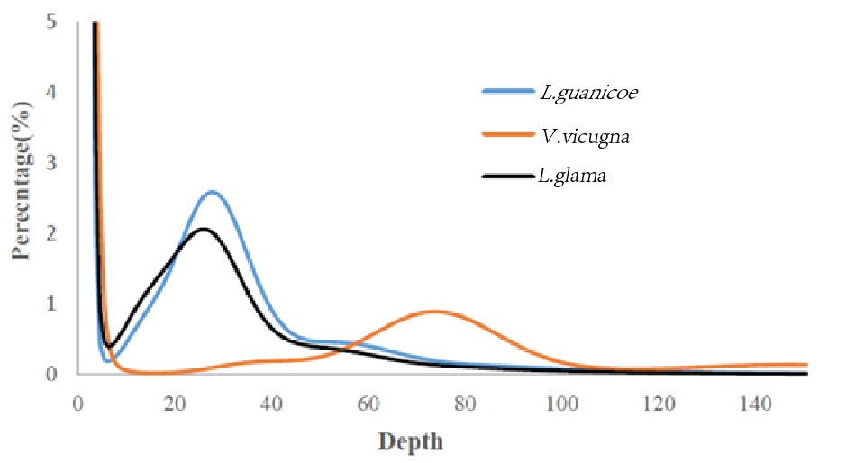

Figure S1. K-mer distribution. The X-axis represents the sequencing depth, the Y-axis represents the proportion of a K-mer count in total K-mer counts at a given sequencing depth. Estimated genome sizes for Lama guanicoe, Vicugna vicugna and Lama glama are 2.58 Gb, 2.60 Gb and 2.57 Gb, respectively.
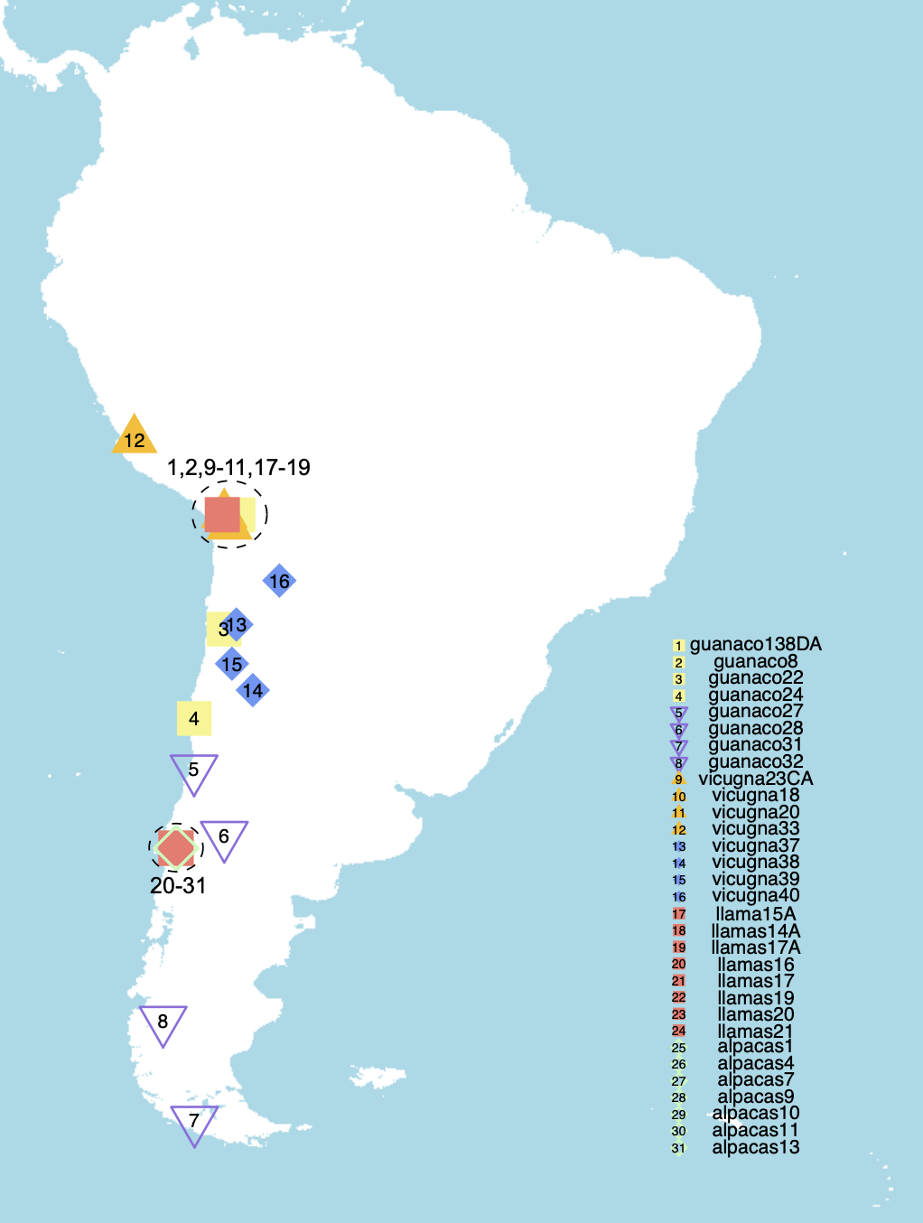

Figure S2. Detailed sampling map of all sequenced individuals (N = 31).

a
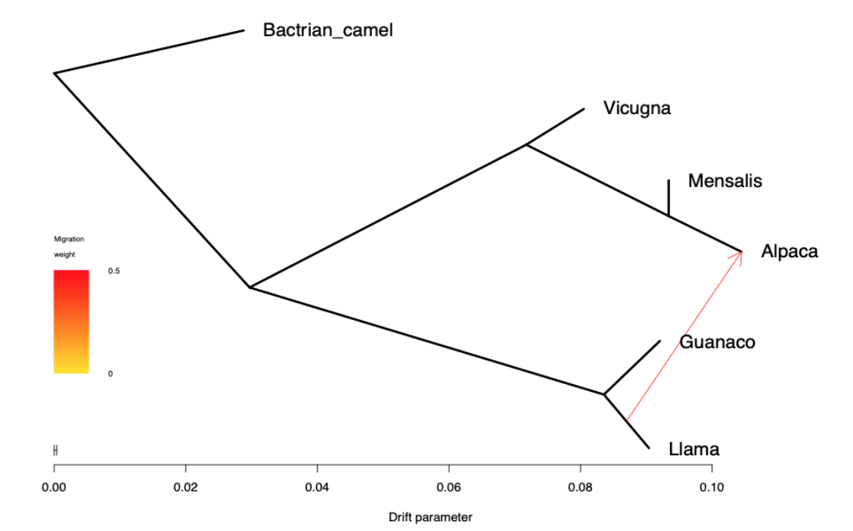

b
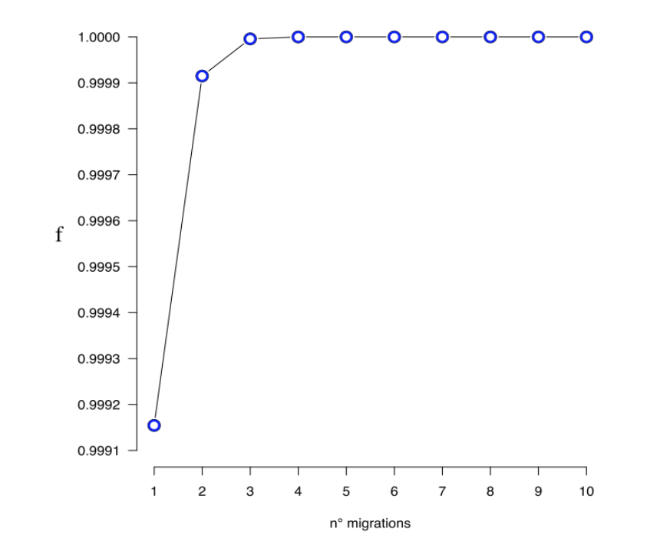
Figure S3. Treemix phylogeny and variance plot. a) Treemix phylogeny of South American Camelids showing unidirectional gene-flow from llama to alpaca and the relationship between alpaca and V. v. mensalis. b) f index representing the fraction of the variance, as a function of the number of modelled migration events.

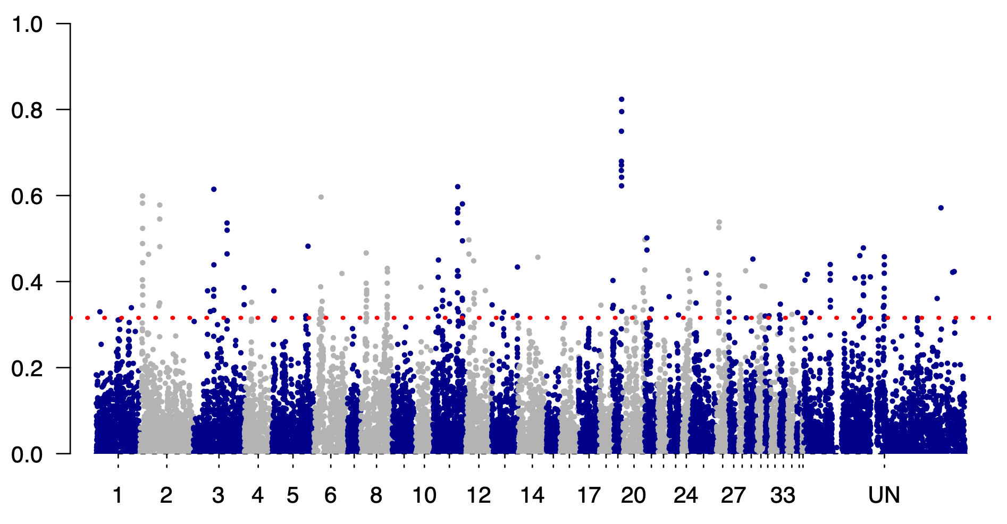
Figure S4. Manhattan Plot of introgression segments into llama (f_{d}). Middle line indicates mean introgression rate across the genome, red dotted line indicates the top 1% in terms of probability of llama ancestry. The X axis indicates the chromosome information and Y axis indicates the f_{d} statistics.

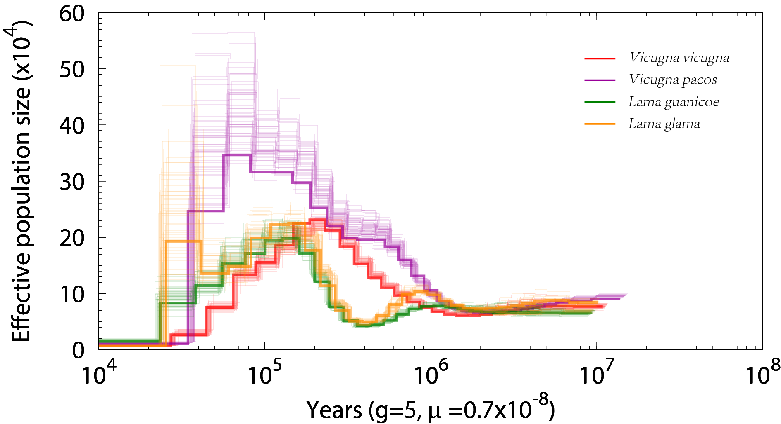

Figure S5. Pairwise Sequential Markovian Coalescent (PSMC) plot of historical changes in effective population size. The reference genome sequenced in Wu et al.’s (2014) camelid study¹ was refined in this study to remove regions of high llama ancestry (see main text methods).

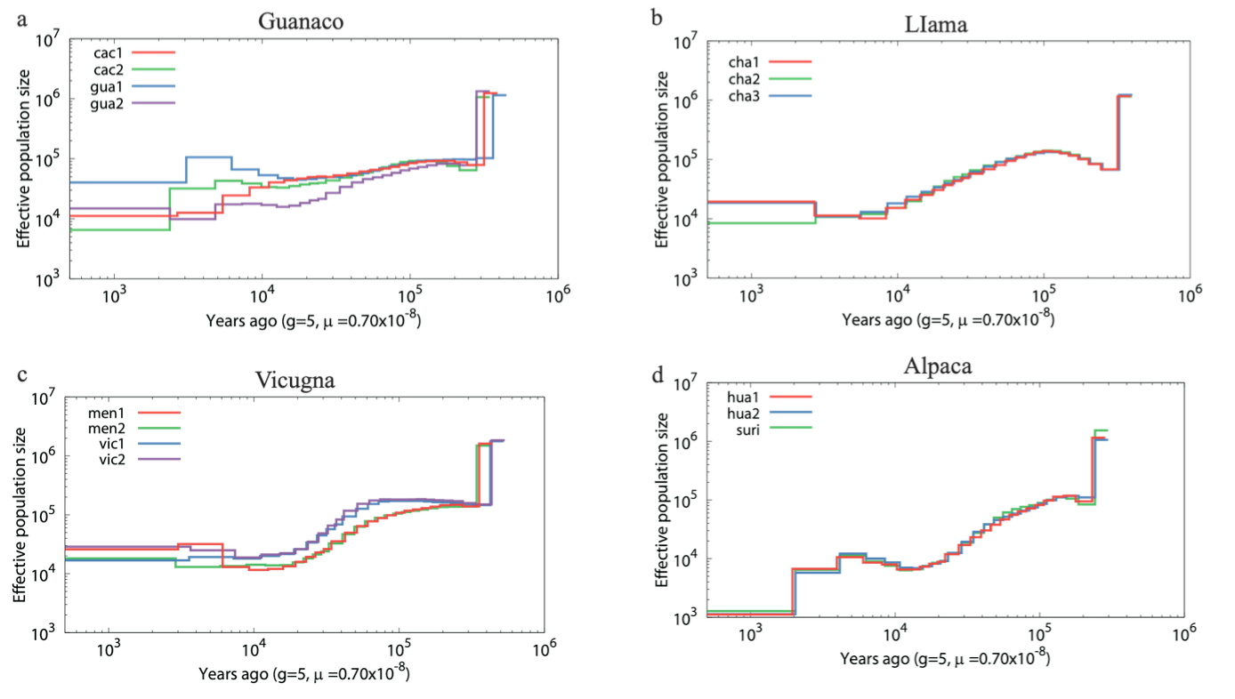
Figure S6. Multiple sequentially Markovian coalescent(MSMC) plots historical changes in effective population size for guanaco, llama, vicuña and alpaca. (a) guanaco (Individual guanaco138DA, 8,22, 24, 27, 28, 31, 32;see Table S8); (b) llama (llama16, 17,17A,19, 20, 21;see Table S8); (c) vicuña (vicugna23CA,18, 20, 33, 37, 38,39, 40: see Table S8); (d) alpaca (alpaca4,7, 9, 10,11, 13: see Table S8).

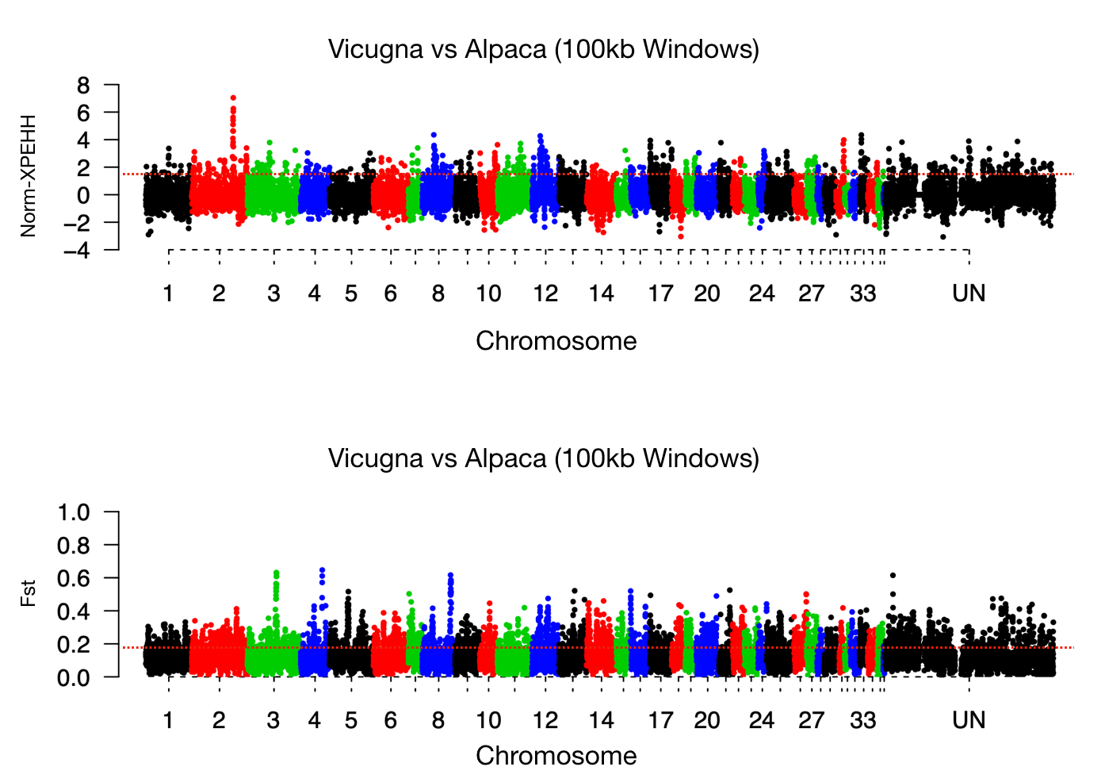

Figure S7. Manhattan plot of selection signatures detected in the comparison between vicuña and alpaca (XPEHH upper, F_{ST} bottom). The red dotted lines indicate the top 1% threshold.

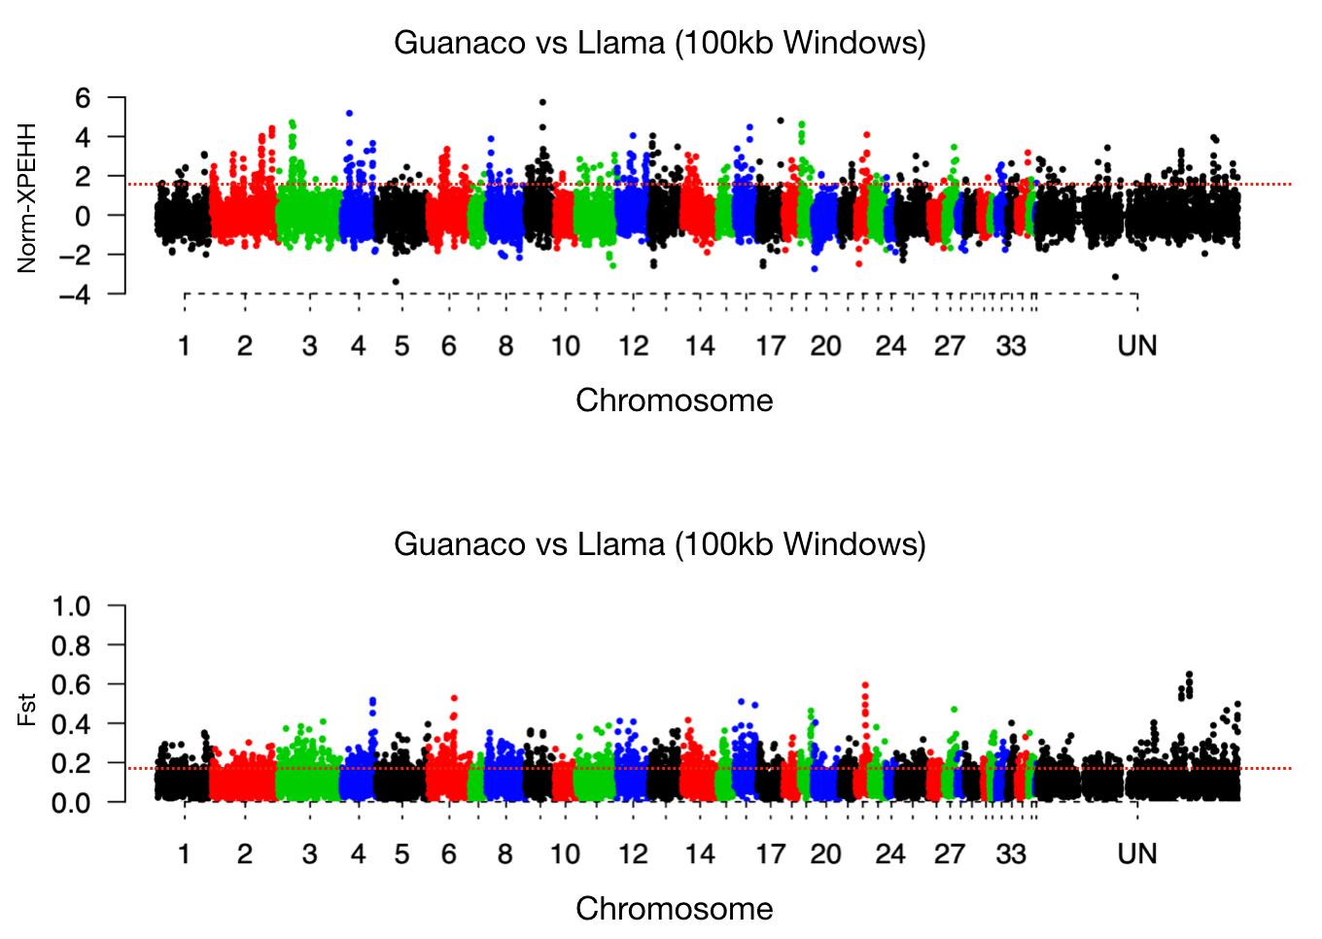

Figure S8. Manhattan plot of selection signatures detected in the comparison between guanaco and llama (XPEHH upper, F_{ST} bottom). The red dotted lines indicate the top 1% threshold.

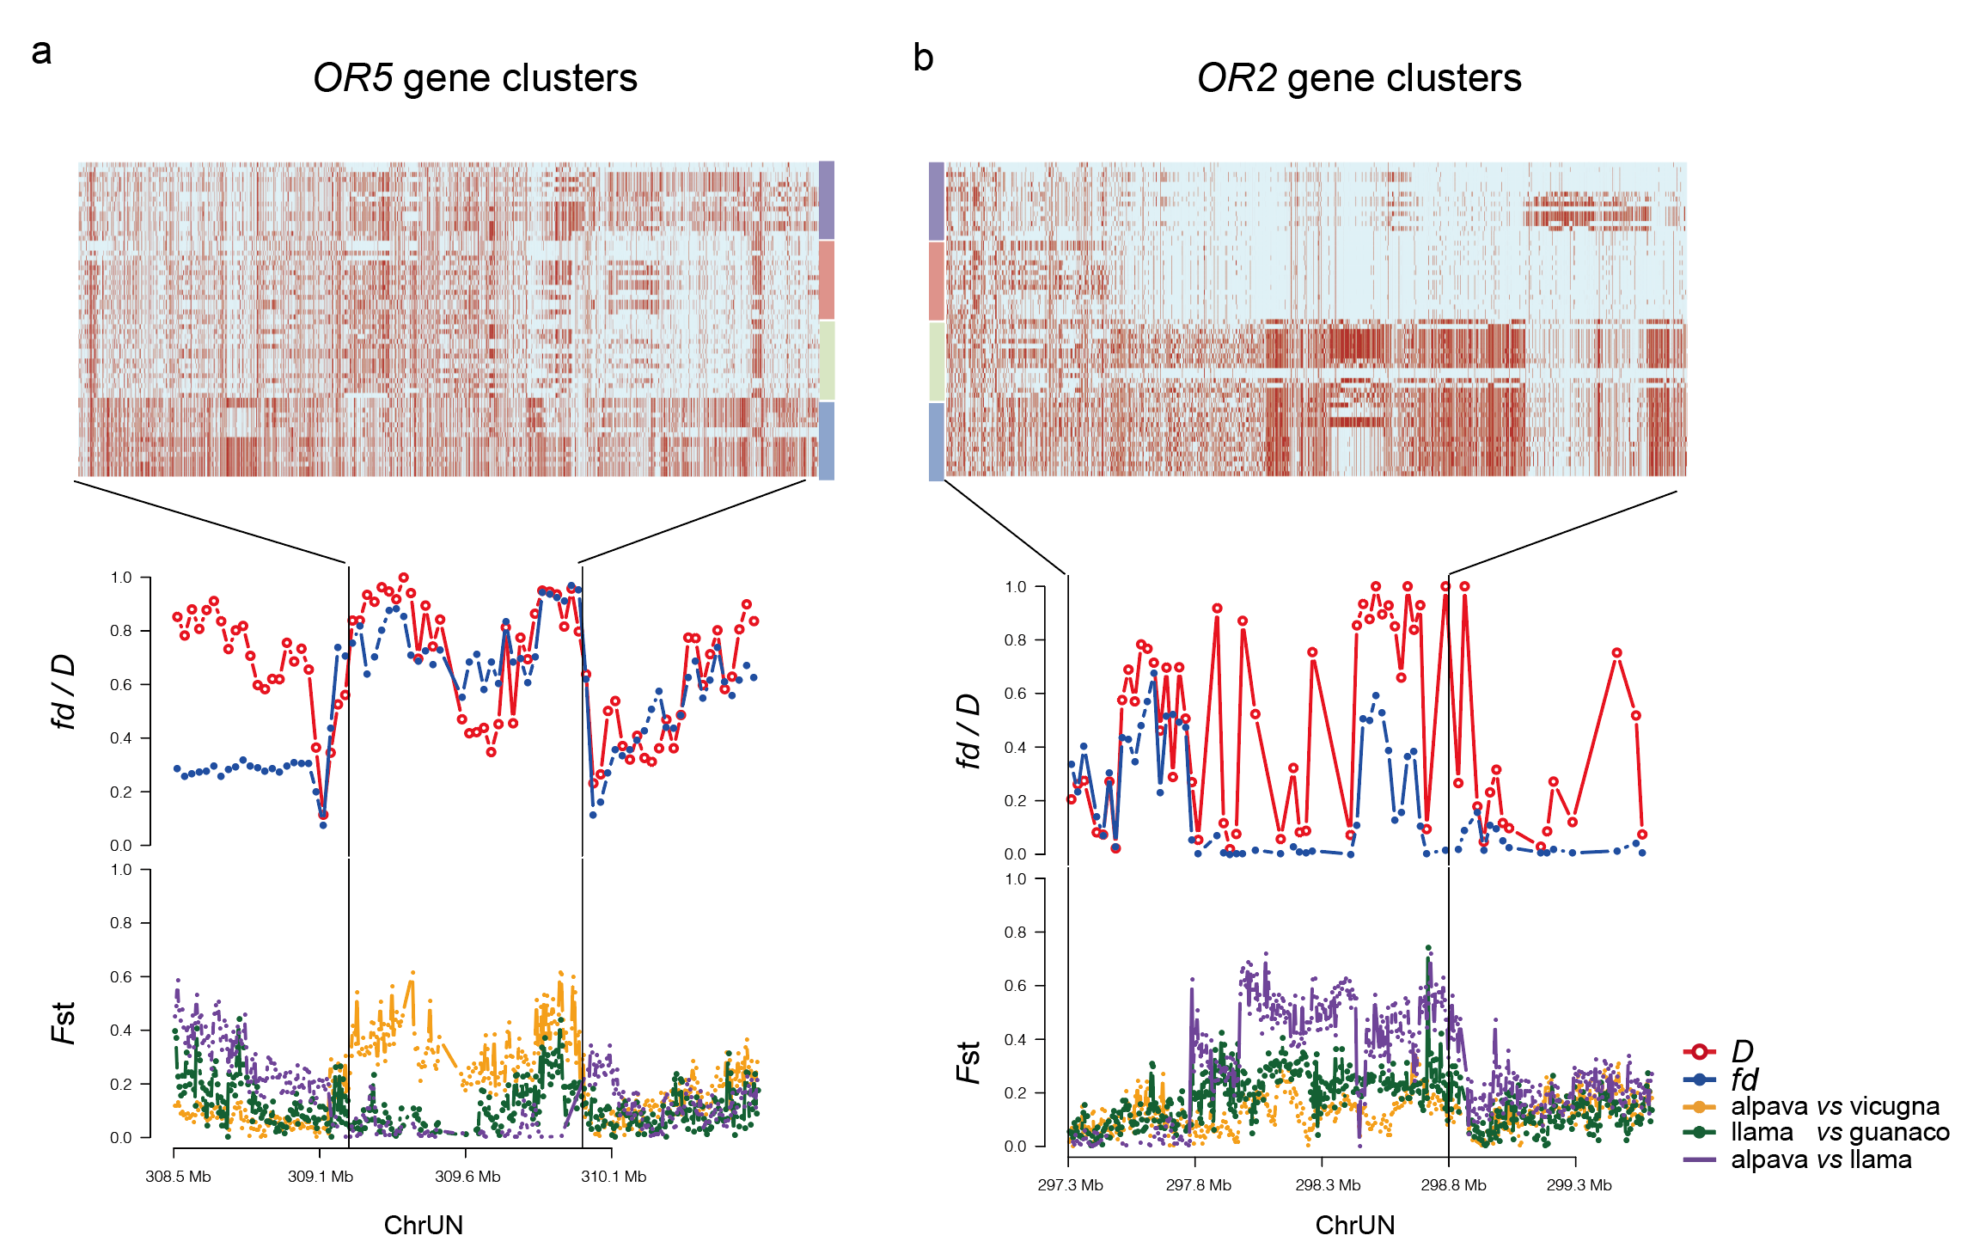
Figure S9. Comparison between region-wide F_{ST} and SNP distribution among wild ancestors and domestic relatives for the OR5 and OR2 olfactory receptor family. The haplotype heatmap among among camelid species for evidence of introgression from llama to alpaca (middle). The calculated D and f_{d} statistics for ((llama, guanaco), vicuña, Bactrian camel) and the respective F_{ST} values for alpaca versus vicuña, llama versus guanaco and alpaca versus llama (bottom). Rectangles indicate the same allele with reference, while light blue rectangles indicate the alternative allele.

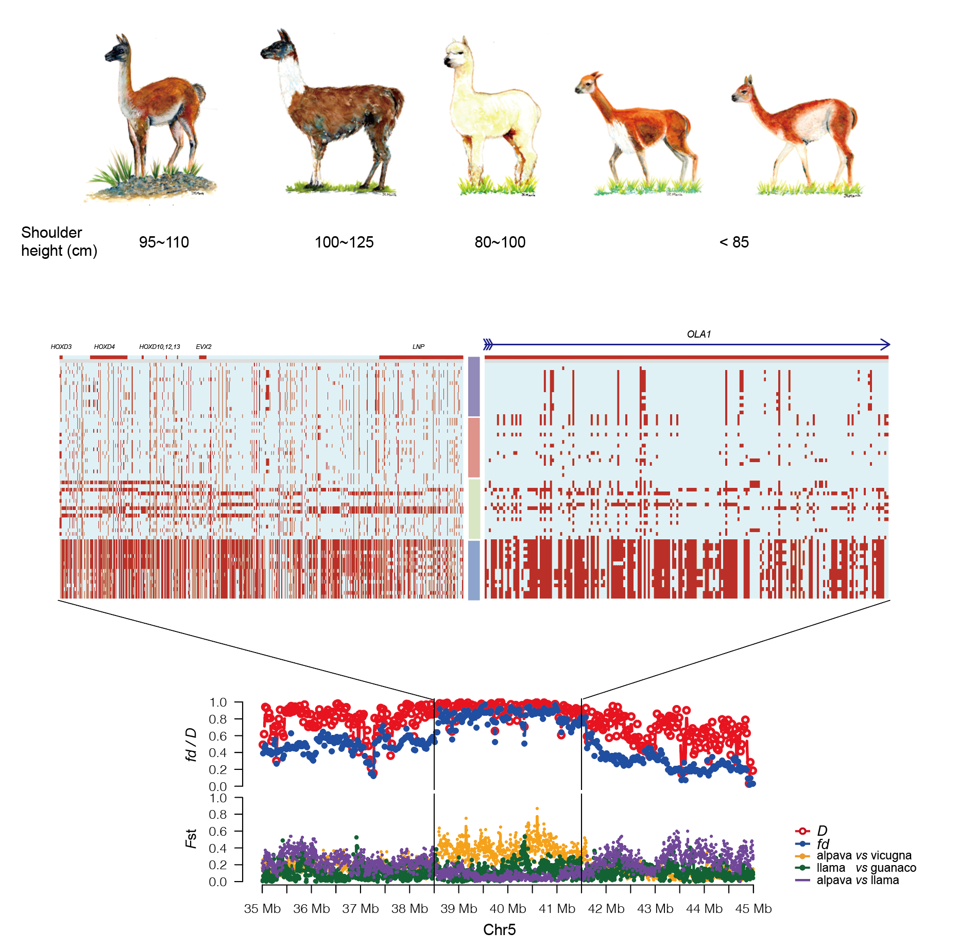
Figure S10. Comparison between region-wide F_{ST} and haplotype heatmap among wild and domestic camelids for the HOXD gene cluster and OLA1 gene related to morphology development. Morphological difference among SACs (top). Haplotype heatmap among among SACs for the evidence of introgression from llama to alpaca (middle). D and f_{d} statistics for ((llama, guanaco), vicuña, Bactrian camel) and respective F_{ST} values for alpaca versus vicuña, llama versus guanaco and alpaca versus llama (bottom). Red rectangles indicate the same allele with respect to the reference genome, while light blue rectangles indicate the alternative allele.

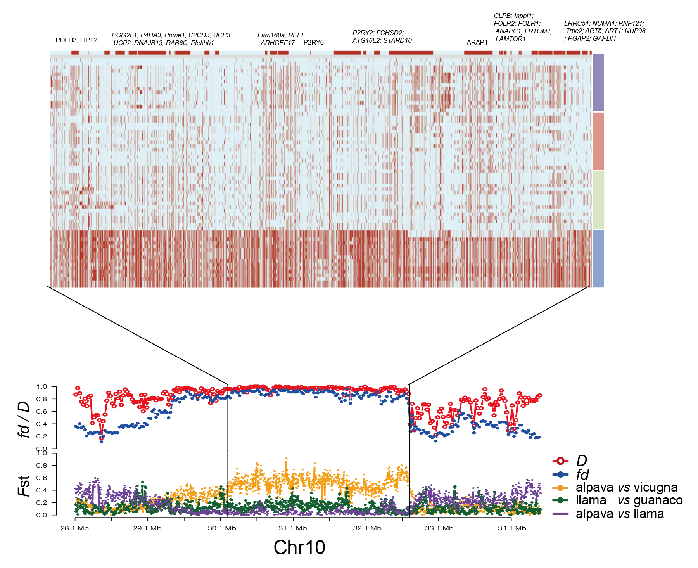
Figure S11. The introgression pattern of represent region (~1.5 Mb) in Chromosome 10. The haplotype heatmap among wild ancestors and domestic relatives for with evidence of introgression from llama to alpaca on Chr10 (top). The calculated D and f_{d} statistics for ((llama, guanaco), vicuña, Bactrian camel) and the respective F_{ST} values for alpaca versus vicuña, llama versus guanaco and alpaca versus llama (bottom). The rectangles with red color indicate the same allele with reference, while light blue rectangles indicate the alternative allele.

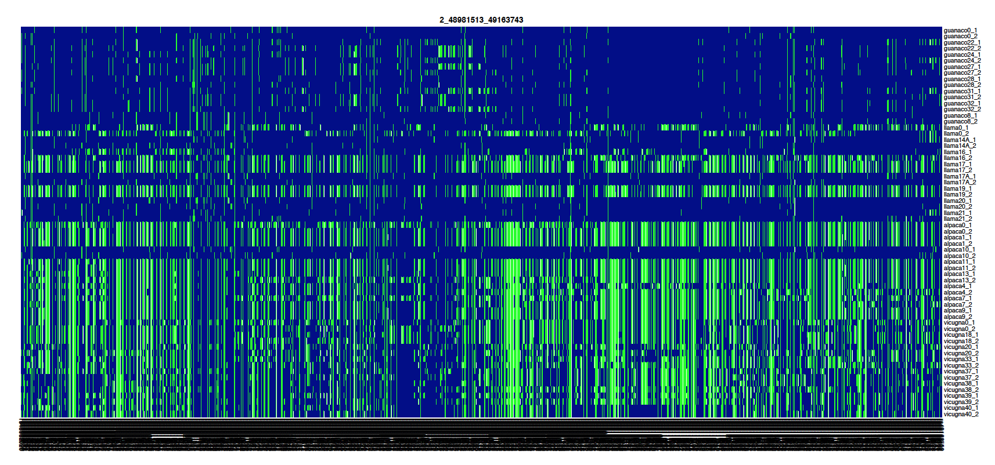
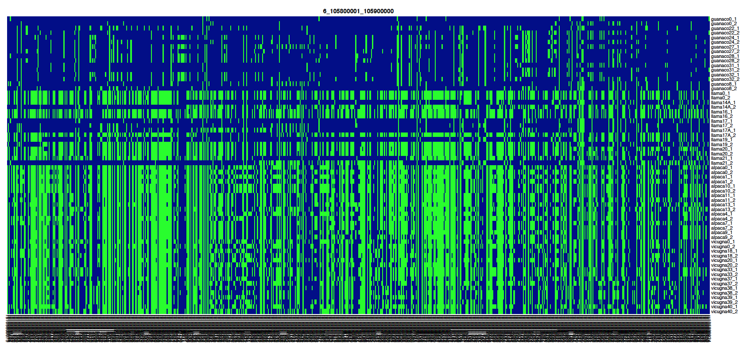
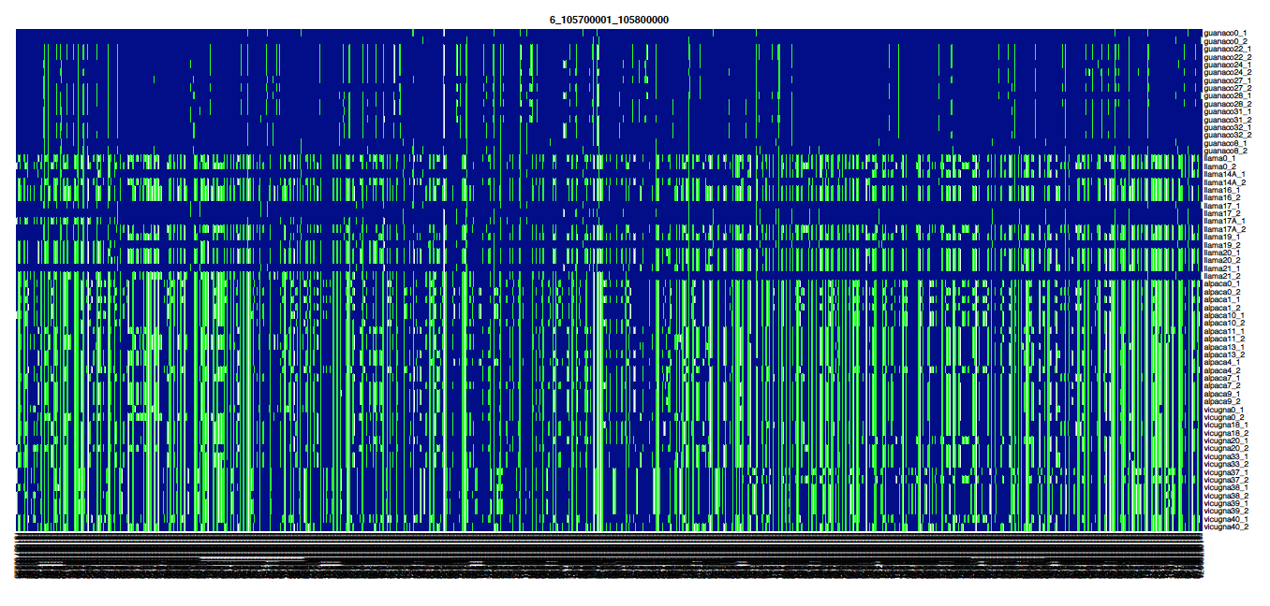
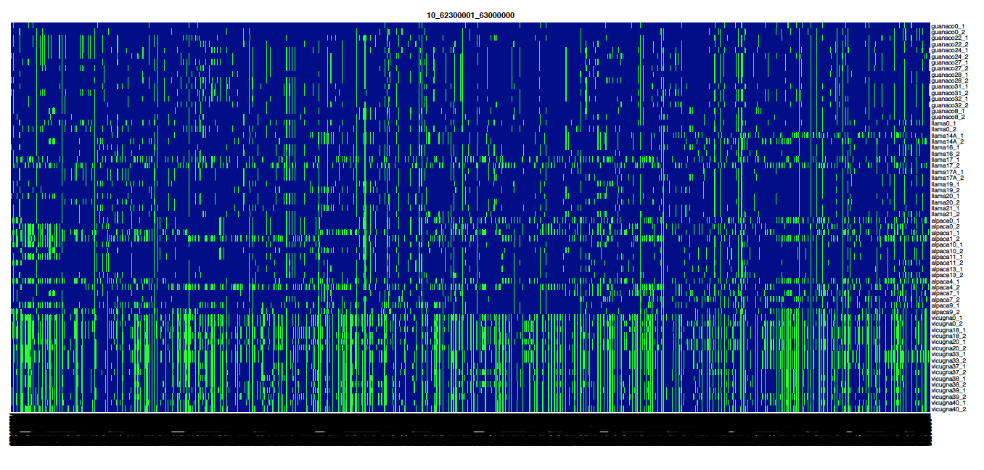

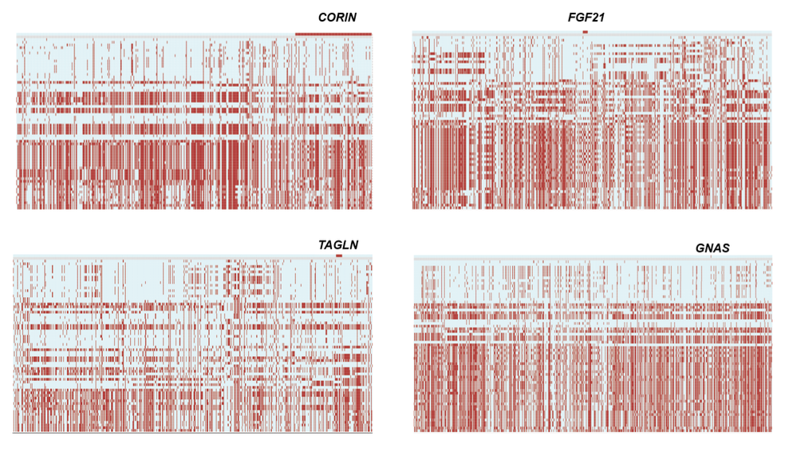
Figure S12. The haplotype heatmap among wild ancestors and domestic relatives for with evidence of introgression from alpaca to llama: CORIN, FGF21, TAGLN, GNAS. The rectangles with red color indicate the same allele with reference, while light blue rectangles indicate the alternative allele.

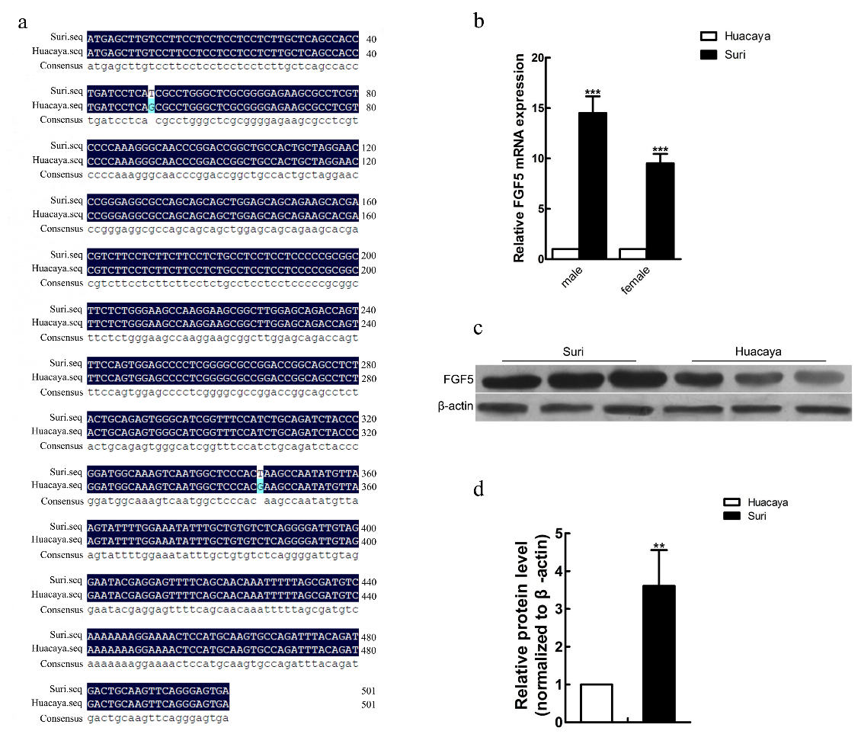
Figure S13. cDNA sequence, expression histogram, Western Blot and protein expression histogram for the alpaca skin FGF5 expression analysis . (a) CDS region sequences of FGF5 in Suri and Huacaya alpaca skins. (b) mRNA expression histogram of FGF5 in Suri and Huacaya alpaca skins by qPCR. (c) Protein expression histogram of FGF5 in Suri and Huacaya alpaca skins by Western Blot. (d) Protein expression level of FGF5 in Suri and Huacaya alpaca skins. All samples were run in triplicate and the relative mRNA and protein expression was normalized to the expression levels of 18s mRNA and β-actin (1:1000), respectively. The difference in abundance of FGF5 was determined by the variance analysis (SPSS 11.5 software, Chicago, IL).

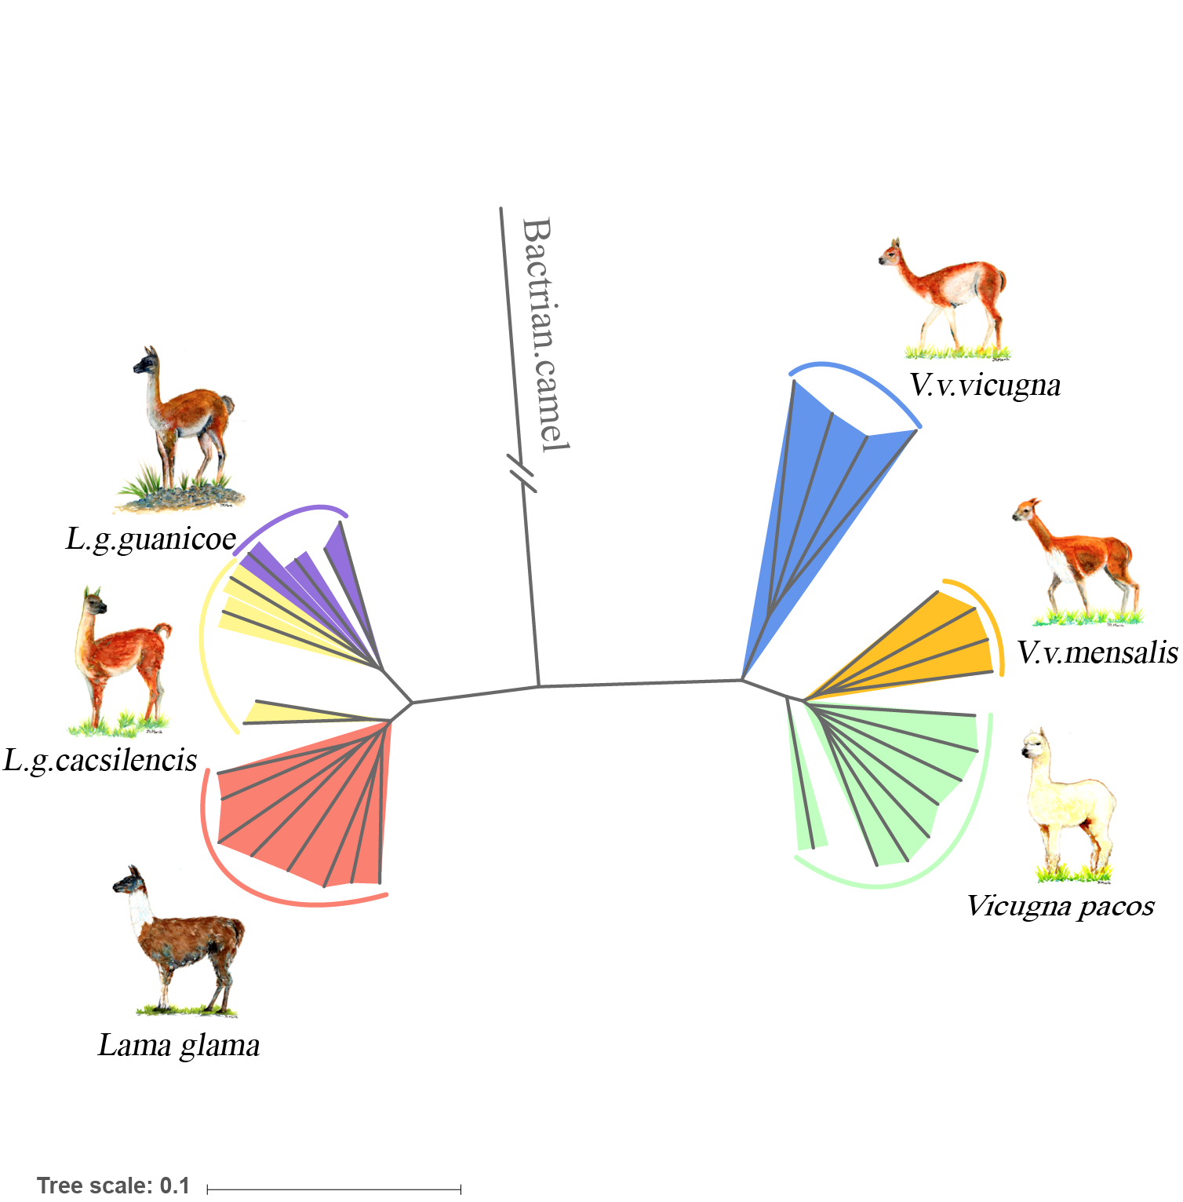

Figure S14. Phylogeny of South American camelids with segments of high probability guanaco ancestry removed from alpaca genomes(retaining 64% of the original sequence).
Table S1. Statistics of the clean data for the de novo genomes.Genomic DNA libraries with varied insert sizes were constructed.
Species | Platform | Insert Size | Read Length (bp) | Total Data (Gb) | Sequence Depth (x) | Physical Depth (x)
Lama guanicoe |  | 170bp | 125 | 109.55 | 42.14 | 28.66
Lama guanicoe | Hiseq 2000 | 500bp | 125 | 104.43 | 40.17 | 80.34
Lama guanicoe | Hiseq 2000 | 800bp | 125 | 46.65 | 17.94 | 57.47
Lama guanicoe | Hiseq 2000 | 2Kb | 49 | 26.65 | 10.25 | 209.18
Lama guanicoe | Hiseq 2000 | 5Kb | 49 | 20.61 | 7.93 | 404.59
Lama guanicoe | Hiseq 2000 | 10Kb | 49 | 11.1 | 4.27 | 435.71
Lama guanicoe | Hiseq 2000 | 20Kb | 49 | 9.5 | 3.65 | 744.9
Lama guanicoe | Hiseq 2000 | 40Kb | 49 | 7.18 | 2.76 | 1126.53
Lama guanicoe | Total |  |  | 335.67 | 129.1 | 3087.38
Vicugna vicugna | Hiseq 2000 | 170bp | 125 | 99.21 | 38.16 | 25.95
Vicugna vicugna | Hiseq 2000 | 500bp | 125 | 67.18 | 25.84 | 51.68
Vicugna vicugna | Hiseq 2000 | 800bp | 125 | 48.72 | 18.74 | 59.96
Vicugna vicugna | Hiseq 2000 | 2Kb | 49 | 25.87 | 9.95 | 203.06
Vicugna vicugna | Hiseq 2000 | 5Kb | 49 | 19.88 | 7.65 | 390.11
Vicugna vicugna | Hiseq 2000 | 10Kb | 49 | 7.79 | 3 | 305.73
Vicugna vicugna | Hiseq 2000 | 20Kb | 49 | 6.36 | 2.45 | 499.22
Vicugna vicugna | Hiseq 2000 | 40Kb | 49 | 7.18 | 2.76 | 1127.16
Vicugna vicugna | Total | ---- | ---- | 282.19 | 108.53 | 2662.86
Lama glama | Hiseq 2500 | 270bp | 150 | 84.33 | 32.44 | 29.2
Lama glama | Hiseq 2500 | 800bp | 125 | 108.57 | 41.76 | 133.63
Lama glama | Hiseq 2500 | 2kb | 48 | 28.91 | 11.12 | 231.67
Lama glama | Hiseq 2500 | 5kb | 48 | 29.84 | 11.48 | 597.92
Lama glama | Hiseq 2500 | 10kb | 48 | 13.48 | 5.19 | 540.63
Lama glama | Total | -- | -- | 265.13 | 101.97 | 1533.05

Table 2. Assembly statistics for each species

Table S2a. Assembly statistics for Lama guanicoe.
 | Contig  Size (bp) Number |  | Scaffold  Size (bp) Number
N90 | 17,946 | 24,934 | 1,583,091 | 192
N80 | 36,446 | 17,068 | 4,417,026 | 122
N70 | 53,649 | 12,414 | 7,082,961 | 85
N60 | 71,503 | 9,074 | 10,145,317 | 61
N50 | 91,651 | 6,507 | 14,639,450 | 44
Longest | 803,867 | ---- | 2,782,636 | ----
Total Size | 2,073,525,543 | ---- | 2,086,935,219 | ----
Total Number(≥100bp) | ---- | 382,544 | ---- | 324,321
Total Number(≥2kb) | ---- | 42,554 | ---- | 3,624

Table S2b. Assembly statistics for Vicugna vicugna
 | Contig  Size (bp) Number |  | Scaffold  Size (bp) Number
N90 | 22,394 | 23,079 | 912,915 | 393
N80 | 39,467 | 16,449 | 2,187,903 | 253
N70 | 55,400 | 12,170 | 3,396,254 | 178
N60 | 72,272 | 8,998 | 4,853,305 | 130
N50 | 91,189 | 6524 | 6,158,010 | 93
Longest | 627,215 | ---- | 40,737,153 | ----
Total Size | 2,012,487,251 | ---- | 2,026,893,968 | ----
Total Number(≥100bp) | ---- | 73,066 | ---- | 12,432
Total Number(≥2kb) | 22,394 | 23,079 | 912,915 | 393

Table S2c. Assembly statistics for Lama glama

 | Contig  Size (bp) Number |  | Scaffold  Size (bp) Number
N90 | 10,523 | 48,630 | 542,334 | 749
N80 | 19,047 | 34,546 | 1,203,272 | 501
N70 | 27,039 | 25,619 | 1,771,832 | 360
N60 | 35,214 | 19,027 | 2,414,184 | 261
N50 | 44,134 | 13,858 | 3,218,230 | 186
Longest | 333,241 | ---- | 16,767,056 | ----
Total Size | 2,036,633,356 | ---- | 2,060,869,063 | ----
Total Number(≥100bp) | ---- | 332,930 | ---- | 244,170
Total Number(≥2kb) | ---- | 73,110 | ---- | 5,034

Table S3. Genome coverage assessed by transcriptome unigenes

Species | Dataset | Number | Total length (bp) | Covered by assembly (%) | with >90% sequence in one scaffold |  | with >50% sequence in one scaffold
 |  |  |  |  | Number | Percent (%) | Number | Percent (%)
Lama guanicoe | >0bp | 123567 | 126875406 | 98.84 | 119715 | 96.88 | 123331 | 99.81
Lama guanicoe | >200bp | 93837 | 121779727 | 98.82 | 90863 | 96.83 | 93644 | 99.79
Lama guanicoe | >500bp | 50518 | 108800395 | 98.76 | 48491 | 95.99 | 50396 | 99.76
Lama guanicoe | >1000bp | 35556 | 98198733 | 98.71 | 33971 | 95.54 | 35464 | 99.74
Vicugna vicugna | >0bp | 204916 | 95306349 | 87.96 | 182908 | 89.26 | 187343 | 91.42
Vicugna vicugna | >200bp | 126658 | 81942149 | 87.15 | 111338 | 87.9 | 114332 | 90.27
Vicugna vicugna | >500bp | 36524 | 55861460 | 85.46 | 30680 | 84 | 31852 | 87.21
Vicugna vicugna | >1000bp | 17879 | 43060468 | 84.81 | 14687 | 82.15 | 15402 | 86.15
Lama glama | >0bp | 593,388 | 353,106,158 | 98.35 | 568,958 | 95.88 | 589,096 | 99.28
Lama glama | >200bp | 412,499 | 322,014,630 | 98.29 | 393,324 | 95.35 | 409,466 | 99.26
Lama glama | >500bp | 141,041 | 241,623,168 | 98.12 | 131,768 | 93.43 | 139,689 | 99.04
Lama glama | >1000bp | 74,673 | 195,906,489 | 98.04 | 69,183 | 92.65 | 73,879 | 98.94

Table S4. The BUSCO results of the three new assembled SAC species
Camels | Complete | Fragmented | Missing
Guanicoe | 94.70% | 3.30% | 2.00%
Glama | 93.70% | 3.90% | 2.40%
Vicugna | 95.80% | 2.00% | 2.20%

Table S5. K-mer analysis of the SAC genomes.
Species | K | K-mer  number | Peak  depth | Genome size | Bases used | Used reads | Coverage
Lama guanicoe | 17 | 67,200,000,000 | 26 | 2,584,615,384 | 80,000,000,000 | 800,000,000 | 31
Vicugna vicugna | 17 | 187,346,919,393 | 72 | 2,602,040,547 | 214,847,384,625 | 1,718,779,077 | 83
Lama glama | 17 | 64,244,213,848 | 25 | 2,569,768,553 | 78,134,854,680 | 868,165,052 | 30

Table S6. Aligned sequence data for de novo genomes

Table S6a. Aligned sequence between the de novo genomes and related species: pairwise whole-genome alignment was performed using LASTZ.
Query_species vs Target_species | Number of syntenic segments | Average length of syntenic segments
V. pacos vs C. bactrianus | 1,656,031 | 791.58
V. pacos vs C. dromedarius | 1,670,422 | 785.33
V. pacos vs H. sapiens | 2,215,344 | 457.90
V. pacos vs L. glama | 1,550,134 | 862.13
V. pacos vs L. guanicoe | 1,640,973 | 826.18
L. guanicoe vs C. bactrianus | 1,668,743 | 773.16
L. guanicoe vs C. dromedarius | 1,669,077 | 768.42
L. guanicoe vs H. sapiens | 2,133,358 | 458.73
V. vicugna vs C. bactrianus | 1,618,724 | 790.19
V. vicugna vs C. dromedarius | 1,650,899 | 777.75
V. vicugna vs H. sapiens | 2,175,076 | 459.02
V. vicugna vs L. guanicoe | 1,578,710 | 841.44
V. vicugna vs V. pacos | 1,516,416 | 871.186
L. glama vs C. bactrianus | 1,574,972 | 818.86
L. glama vs C. dromedarius | 1,610,460 | 823.37
L. glama vs H. sapiens | 2,236,162 | 456.48
L. glama vs L. guanicoe | 1,517,986 | 875.11
L. glama vs V. pacos | 1,550,134 | 862.13
L. glama vs V. vicugna | 1,521,136 | 859.16
V. pacos vs B. taurus | 2,386,058 | 437.028
V. pacos vs O. aries | 2,341,563 | 439.75
L. guanicoe vs B. taurus | 2,270,751 | 439.26
L. guanicoe vs O. aries | 2,238,269 | 441.098
V. vicugna vs B. taurus | 2,317,376 | 439.99
V. vicugna vs O. aries | 2,283,524 | 440.88
L. glama vs B. taurus | 2,409,718 | 438.91
L. glama vs O. aries | 2,363,906 | 440.18

Table S6b. Synteny between C. bactrianus, L. guanicoe and V.vicugna
Species | Total syntenic length (bp) | Number of Genes50 | Percentage | Number of Genes70 | Percentage
C. dromedarius | 1,227,054,638 | 17,907 | 88.45% | 12,480 | 61.62%
L. glama | 1,176,815,446 | 16,287 | 75.89% | 10,028 | 46.7%
L. guanicoe | 1,110,721,184 | 15,330 | 71.51% | 10,320 | 48.14%
V. vicugna | 1,161,319,807 | 16,120 | 74.09% | 10,316 | 47.41%
V. pacos | 1,171,568,387 | 15,823 | 75.83% | 10,147 | 48.63%

Number of Genes50 = the number of genes with 50% coverage overlapping with syntenic regions, Number of Genes70 = 70% coverage.

Table S7. The number of predicted genes for each species

Table S7a. The number of predicted genes for Lama guanicoe
Annotation methods |  | Gene  number | Average  gene  length | Average CDS length | Average  Exon number | Average  Exon length | Average intron length
de novo | AUGUSTUS | 27,424 | 21,142.33 | 1,230.13 | 6.59 | 186.59 | 3,560.37
de novo | GeneScan | 47,506 | 30,014.14 | 1,287.99 | 7.87 | 163.75 | 4,184.17
Homology | Bos taurus | 20,406 | 23,116.50 | 1,528.34 | 8.61 | 177.49 | 2,836.46
Homology | Camelus bactrianus | 21,117 | 24,638.85 | 1,529.95 | 8.78 | 174.21 | 2,969.38
Homology | Camelus dromedarius | 21,186 | 24,667.21 | 1,524.14 | 8.77 | 173.88 | 2,980.26
Homology | Equus caballus | 21,022 | 22,345.78 | 1,456.41 | 8.25 | 176.54 | 2,881.34
Homology | Homo sapiens | 20,056 | 25,174.09 | 1,569.24 | 8.82 | 177.98 | 3,019.73
Homology | Mus musculus | 20,088 | 24,528.51 | 1,544.12 | 8.62 | 179.03 | 3,014.35
Homology | Vicugna pacos | 20,508 | 25,369.62 | 1,538.45 | 8.9 | 172.86 | 3,016.66
RNA-seq |  | 119,824 | 16,944.57 | 1,079.37 | 3.72 | 290.24 | 5,835.14
Glean |  | 21,435 | 24,599.35 | 1,529.73 | 8.39 | 182.27 | 3,120.60

Table S7b. The number of predicted genes for Vicugna vicugna

Annotation methods |  | Gene  number |  | Average  gene  length | Average CDS length |  | Average  Exon number |  | Average  Exon length | Average intron length
de novo | AUGUSTUS |  | 28,971 | 19,445.25 | 1,180.75 | 6.22 |  | 189.84 |  | 3,499.03
de novo | GeneScan |  | 47,563 | 29,515.32 | 1,275.81 | 7.8 |  | 163.51 |  | 4,151.35
Homology | Bos taurus |  | 20,315 | 22,965.36 | 1,531.13 | 8.62 |  | 177.64 |  | 2,813.22
Homology | Camelus  bactrianus |  | 20,972 | 24,578.98 | 1,535.41 | 8.81 |  | 174.28 |  | 2,950.53
Homology | Camelus dromedarius |  | 20,885 | 24,597.36 | 1,527.29 | 8.79 |  | 173.72 |  | 2,960.79
Homology | Equus  caballus |  | 20,847 | 22,230.08 | 1,461.13 | 8.28 |  | 176.46 |  | 2,852.84
Homology | Homo sapiens |  | 20,131 | 24,997.41 | 1,565.92 | 8.81 |  | 177.71 |  | 2,999.64
Homology | Mus musculus |  | 20,006 | 24,439.34 | 1,547.05 | 8.64 |  | 179.02 |  | 2,995.74
Homology | Vicugna pacos |  | 20,296 | 25,250.08 | 1,541.50 | 8.92 |  | 172.77 |  | 2,992.73
RNA-seq |  | 119,824 |  | 179,097 | 6,302.52 |  | 480.33 |  | 247.78 | 6,203.52
Glean |  | 21,435 |  | 21,757 | 24,260.03 |  | 1,522.19 |  | 183.54 | 3,117.48

Table S7c. The number of predicted genes for Lama glama

Annotation methods |  | Gene  number | Average  gene  length | Average CDS length | Average  Exon number |  | Average  Exon length |  | Average intron length
de novo | AUGUSTUS | 28,555 | 17,220.50 | 1,186.09 | 6.4 | 185.24 |  | 2,967.68
de novo | GeneScan | 52,478 | 26,579.64 | 1,232.16 | 7.6 | 162.1 |  | 3,839.84
Homology | Bos taurus | 20,290 | 22,768.49 | 1,512.95 | 8.55 | 177.05 |  | 2,816.97
Homology | Camelus bactrianus | 21,002 | 24,277.54 | 1,516.61 | 8.71 | 174.22 |  | 2,954.04
Homology | Camelus dromedarius | 21,082 | 24,355.31 | 1,511.41 | 8.7 | 173.63 |  | 2,964.85
Homology | Equus caballus | 20,795 | 22,119.75 | 1,438.35 | 8.23 | 174.82 |  | 2,861.46
Homology | Homo sapiens | 20,034 | 24,905.10 | 1,557.88 | 8.79 | 177.33 |  | 2,998.86
Homology | Mus musculus | 20,042 | 24,077.58 | 1,526.39 | 8.55 | 178.46 |  | 2,985.67
Homology | Vicugna pacos | 20,483 | 24,998.88 | 1,524.88 | 8.82 | 172.82 |  | 3,000.37
RNA-seq |  | 119,824 | 539,292 | 5,354.51 | 618.18 |  | 278.84 |  | 3,891.91
Glean |  | 21,435 | 21,460 | 24,063.78 | 1,520.17 |  | 183.91 |  | 3,102.62

Table S8. Sampling details.
Sample name | Species | Subspecies/  variety | Genome | Fleece color | Sex* | Tissue | Location
 |  |  |  |  |  |  | Latitude | Longitude
Guanaco
138DA | Lama guanicoe | cacsilensis | de novo | wild type | male | Blood, muscle & biopsy tissue | -18.19 | -69.54
8 | Lama guanicoe | cacsilensis | Resequence | wild type | male | Blood | -18.21 | -69.56
22 | Lama guanicoe | cacsilencis | Resequence | wild type | female | Blood | -25.02 | -70.43
24 | Lama guanicoe | cacsilencis | Resequence | wild type | * | Blood | -30.36 | -72.37
27 | Lama guanicoe | guanicoe | Resequence | wild type | * | Muscle | -33.39 | -71.38
28 | Lama guanicoe | guanicoe | Resequence | wild type | female | Blood | -37.35 | -69.43
31 | Lama guanicoe | guanicoe | Resequence | wild type | * | Blood | -54.37 | -71.36
32 | Lama guanicoe | guanicoe | Resequence | wild type | male | Liver | -48.40 | -73.39
Vicuña
23CA | Vicugna vicugna | mensalis | de Novo | wild type | female | Blood, muscle & biopsy tissue | -18.17 | -69.43
18 | Vicugna vicugna | mensalis | Resequence | wild type | * | Blood | -18.17 | -69.43
20 | Vicugna vicugna | mensalis | Resequence | wild type | * | Blood | -18.87 | -69.09
33 | Vicugna vicugna | mensalis | Resequence | wild type | * | Blood | -13.70 | -75.25
37 | Vicugna vicugna | vicugna | Resequence | wild type | * | Blood | -24.75 | -68.65
38 | Vicugna vicugna | vicugna | Resequence | wild type | female | Blood | -28.67 | -67.58
39 | Vicugna vicugna | vicugna | Resequence | wild type | female | Muscle | -27.09 | -68.93
40 | Vicugna vicugna | vicugna | Resequence | wild type | male | Blood | -22.12 | -65.86
Llama
15A | Lama glama | chaku | de Novo | dark brown and white | male | skin | -18.19 | -69.56
14A | Lama glama | cara | Resequence | white | male | skin | -18.19 | -69.56
17A | Lama glama | chaku | Resequence | light brown | female | skin | -18.19 | -69.56
16 | Lama glama | chaku | Resequence | white | female | Blood | -38.1 | -72.55
17 | Lama glama | chaku | Resequence | beige | male | Blood | -38.1 | -72.55
19 | Lama glama | chaku | Resequence | brown | male | Blood | -38.1 | -72.55
20 | Lama glama | chaku | Resequence | light brown | male | Blood | -38.1 | -72.55
21 | Lama glama | chaku | Resequence | brown | male | Blood | -38.1 | -72.55
Alpaca
1 | Vicugna pacos | huacaya | Resequence | white | male | Blood | -38.1 | -72.55
4 | Vicugna pacos | suri | Resequence | white | male | Blood | -38.1 | -72.55
7 | Vicugna pacos | huacaya | Resequence | white | female | Blood | -38.1 | -72.55
9 | Vicugna pacos | huacaya | Resequence | light brown | female | Blood | -38.1 | -72.55
10 | Vicugna pacos | huacaya | Resequence | dark brown | male | Blood | -38.1 | -72.55
11 | Vicugna pacos | huacaya | Resequence | dark brown | female | Blood | -38.1 | -72.55
13 | Vicugna pacos | suri | Resequence | black | female | Blood | -38.1 | -72.55
17 Alpacas
1 | Vicugna pacos | huacaya | Resequence | Black | male | Skin | 37.73 | 112.73
2 | Vicugna pacos | huacaya | Resequence | Brown | male | Skin | 37.73 | 112.73
3 | Vicugna pacos | huacaya | Resequence | Black | female | Skin | 37.73 | 112.73
4 | Vicugna pacos | huacaya | Resequence | Brown | female | Skin | 37.73 | 112.73
5 | Vicugna pacos | huacaya | Resequence | Brown | female | Skin | 37.73 | 112.73
6 | Vicugna pacos | huacaya | Resequence | White | male | Skin | 37.73 | 112.73
7 | Vicugna pacos | huacaya | Resequence | White | female | Skin | 37.73 | 112.73
8 | Vicugna pacos | huacaya | Resequence | White | female | Skin | 37.73 | 112.73
9 | Vicugna pacos | huacaya | Resequence | Brown | male | Skin | 37.73 | 112.73
10 | Vicugna pacos | huacaya | Resequence | White | female | Skin | 37.73 | 112.73
11 | Vicugna pacos | huacaya | Resequence | White | female | Skin | 37.73 | 112.73
12 | Vicugna pacos | huacaya | Resequence | White | female | Skin | 37.73 | 112.73
13 | Vicugna pacos | Suri | Resequence | Brown | male | Skin | 37.73 | 112.73
14 | Vicugna pacos | Suri | Resequence | White | male | Skin | 37.73 | 112.73
15 | Vicugna pacos | Suri | Resequence | White | male | Skin | 37.73 | 112.73
16 | Vicugna pacos | Suri | Resequence | White | male | Skin | 37.73 | 112.73
17 | Vicugna pacos | Suri | Resequence | White | male | Skin | 37.73 | 112.73

* inferred from sequence data

Table S9. Resequencing data summary
Species | Sample ID | Reads (x10⁶) | Bases (Gb) | Q30 rate (%) | Depth
L. guanicoe | 31 | 284.59 | 42.7 | 95.4 | 20.43
L. guanicoe | 28 | 261.94 | 39.29 | 95.34 | 18.80
L. guanicoe | 8 | 237.62 | 35.65 | 93.89 | 17.06
L. guanicoe | 27 | 212.53 | 31.88 | 94.77 | 15.25
L. guanicoe | 24 | 256.07 | 38.41 | 95.32 | 18.38
L. guanicoe | 32 | 267.14 | 40.07 | 95.4 | 19.17
L. guanicoe | 22 | 250.77 | 37.62 | 95.41 | 18.00
V. pacos | 7 | 254.25 | 38.14 | 95.28 | 18.79
V. pacos | 9 | 254.2 | 38.13 | 95.19 | 18.78
V. pacos | 1 | 227.35 | 34.1 | 95.59 | 16.80
V. pacos | 13 | 255.43 | 38.32 | 95.36 | 18.88
V. pacos | 4 | 235.81 | 35.37 | 95.2 | 17.42
V. pacos | 10 | 275.35 | 41.3 | 95.3 | 20.34
V. pacos | 11 | 259.42 | 38.92 | 95.12 | 19.17
L. glama | 17 | 256.89 | 38.53 | 94.95 | 18.70
L. glama | 17A | 223.29 | 33.5 | 94.35 | 16.26
L. glama | 19 | 275.46 | 41.32 | 95.18 | 20.06
L. glama | 16 | 246.79 | 37.01 | 95.23 | 17.97
L. glama | 21 | 250.21 | 37.53 | 95.25 | 18.22
L. glama | 20 | 266.24 | 39.93 | 95.16 | 19.38
L. glama | 14A | 303.75 | 45.57 | 94.5 | 22.12
V. vicugna | 40 | 277.13 | 41.57 | 95.49 | 20.28
V. vicugna | 38 | 299.96 | 44.99 | 95.7 | 21.95
V. vicugna | 18 | 221.68 | 33.25 | 94.52 | 16.22
V. vicugna | 39 | 284.63 | 42.69 | 95.71 | 20.82
V. vicugna | 33 | 252.57 | 37.88 | 95.47 | 18.48
V. vicugna | 37 | 248.04 | 37.2 | 95.64 | 18.15
V. vicugna | 20 | 222.39 | 33.36 | 94.54 | 16.27

Q, is defined as Q = -10log₁₀(e), where e is the estimated probability of an incorrect base call. A quality score of 30 (Q30) represents an error rate of 1 in 1000, with a corresponding call accuracy of 99.9%.

Table S10. ABBA-BABA statistics.
P₁ | P₂ | P₃ | O | | f_{d} | | D_{statistics} | sd
Alpaca | Vicuña | Llama | Bactrian | 0.389 | 0.565 | 0.006
Alpaca | Vicuña | GL* | Bactrian | 0.324 | 0.55 | 0.007
Alpaca | Vicuña | Guanaco | Bactrian | 0.265 | 0.539 | 0.006
Guanaco | Llama | Alpaca | Bactrian | 0.133 | -0.265 | 0.004
Guanaco | Llama | VA* | Bactrian | 0.089 | -0.231 | 0.005
Guanaco | Llama | Vicuña | Bactrian | 0.045 | -0.185 | 0.006

Bactrian camel was used as the outgroup. *GL = Guanaco/Ilama lineage, *VA =Vicuña/Alpaca lineage

Table S11. Introgressed segments from llama into alpaca by using f_{d} and LAI (Top1%, 100kb windows)
Chromosome_start-end | Gene | f_{d} | LAI | Methods
3_60037430-60137429 | Cnot6l | 0.881 | 0.75 | Overlap
3_60237430-60337429 | MRPL1 | 0.837 | 0.75 | Overlap
3_61037430-61137429 | PAQR3 | 0.836 | 0.375 | f_{d}
3_61337430-61437429 | NAA11 | 0.651 | 0.89 | LAI
3_61437430-61537429 | GK2 | 0.766 | 1 | LAI
3_61437430-61537429 | Unknown | 0.766 | 1 | LAI
3_61837430-61937429 | ANTXR2 | 0.763 | 0.876 | LAI
3_61937430-62037429 | Unknown | 0.812 | 0.988 | LAI
3_62037430-62137429 | PRDM8 | 0.847 | 1 | Overlap
3_62037430-62137429 | FGF5 | 0.847 | 1 | Overlap
3_62137430-62237429 | NA | 0.916 | 1 | Overlap
3_62737430-62837429 | PRKG2 | 0.871 | 0.625 | f_{d}
11_43788735-43888734 | SKP2 | 0.752 | 0.709 | LAI
11_43788735-43888734 | NADK2 | 0.752 | 0.709 | LAI
11_43788735-43888734 | RANBP3L | 0.752 | 0.709 | LAI
11_44088735-44188734 | SLC1A3 | 0.871 | 0.733 | Overlap
chrUN_33181013-33281012 | Celsr1 | 0.863 | 0.5 | f_{d}
chrUN_33181013-33281012 | GRAMD4 | 0.863 | 0.5 | f_{d}
chrUN_33281013-33381012 | CERK | 0.903 | 0.5 | f_{d}
chrUN_33281013-33381012 | TBC1D22A | 0.903 | 0.5 | f_{d}
chrUN_41881013-41981012 | FZD3 | 0.84 | 0.701 | Overlap
chrUN_41881013-41981012 | Fbxo16 | 0.84 | 0.701 | Overlap
10_20917711-21017710 | IGFALS | 0.847 | 0.683 | Overlap
10_20917711-21017710 | NUS1 | 0.847 | 0.683 | Overlap
16_100001-200000 | FASN | 0.909 | 0.537 | f_{d}
16_200001-300000 | Dus1l | 0.894 | 0.625 | f_{d}
16_200001-300000 | Gps1 | 0.894 | 0.625 | f_{d}
16_200001-300000 | Rfng | 0.894 | 0.625 | f_{d}
16_200001-300000 | Cbr2 | 0.894 | 0.625 | f_{d}
16_200001-300000 | DCXR | 0.894 | 0.625 | f_{d}
16_200001-300000 | Rac3 | 0.894 | 0.625 | f_{d}
16_200001-300000 | LRRC45 | 0.894 | 0.625 | f_{d}
16_200001-300000 | CENPX | 0.894 | 0.625 | f_{d}
16_200001-300000 | Aspscr1 | 0.894 | 0.625 | f_{d}
16_200001-300000 | NOTUM | 0.894 | 0.625 | f_{d}
16_300001-400000 | MYADML2 | 0.861 | 0.625 | f_{d}
16_300001-400000 | PYCR1 | 0.861 | 0.625 | f_{d}
16_300001-400000 | Mafg | 0.861 | 0.625 | f_{d}
16_300001-400000 | SIRT7 | 0.861 | 0.625 | f_{d}
16_300001-400000 | PCYT2 | 0.861 | 0.625 | f_{d}
16_300001-400000 | NPB | 0.861 | 0.625 | f_{d}
16_300001-400000 | ALYREF | 0.861 | 0.625 | f_{d}
16_300001-400000 | ARHGDIA | 0.861 | 0.625 | f_{d}
16_300001-400000 | P4HB | 0.861 | 0.625 | f_{d}
16_300001-400000 | MCRIP1 | 0.861 | 0.625 | f_{d}
16_400001-500000 | GCGR | 0.889 | 0.625 | f_{d}
16_400001-500000 | SLC25A10 | 0.889 | 0.625 | f_{d}
16_400001-500000 | MRPL12 | 0.889 | 0.625 | f_{d}
16_400001-500000 | HGS | 0.889 | 0.625 | f_{d}
16_400001-500000 | HGS | 0.889 | 0.625 | f_{d}
16_400001-500000 | ARL16 | 0.889 | 0.625 | f_{d}
16_400001-500000 | CCDC137 | 0.889 | 0.625 | f_{d}
16_400001-500000 | OXLD1 | 0.889 | 0.625 | f_{d}
16_400001-500000 | PDE6G | 0.889 | 0.625 | f_{d}
16_400001-500000 | TSPAN10 | 0.889 | 0.625 | f_{d}
16_400001-500000 | NPLOC4 | 0.889 | 0.625 | f_{d}
16_500001-600000 | Unknown | 0.871 | 0.625 | f_{d}
16_500001-600000 | FAAP100 | 0.871 | 0.625 | f_{d}
16_500001-600000 | FSCN2 | 0.871 | 0.625 | f_{d}
16_500001-600000 | actg1 | 0.871 | 0.625 | f_{d}
16_600001-700000 | BAHCC1 | 0.9 | 0.625 | f_{d}
16_700001-800000 | SLC38A10 | 0.877 | 0.625 | f_{d}
16_700001-800000 | SLC38A10 | 0.877 | 0.625 | f_{d}
16_700001-800000 | Ndufaf8 | 0.877 | 0.625 | f_{d}
16_700001-800000 | Tepsin | 0.877 | 0.625 | f_{d}
16_700001-800000 | CEP131 | 0.877 | 0.625 | f_{d}
16_900001-1000000 | CHMP6 | 0.874 | 0.5 | f_{d}
16_900001-1000000 | Rptor | 0.874 | 0.5 | f_{d}
9_21852453-21952452 | AKNAD1 | 0.843 | 0.625 | f_{d}
9_21852453-21952452 | RPL9P9 | 0.843 | 0.625 | f_{d}
9_21852453-21952452 | GPSM2 | 0.843 | 0.625 | f_{d}
9_23052453-23152452 | RBM15 | 0.868 | 0.625 | f_{d}
9_23052453-23152452 | SLC16A4 | 0.868 | 0.625 | f_{d}
2_96476766-96576765 | C4orf33 | 0.875 | 0.5 | f_{d}
24_6013996-6113995 | TRAPPC8 | 0.853 | 0.401 | f_{d}
chrUN_94880520-94980519 | EXOC4 | 0.756 | 0.748 | LAI
chrUN_95380520-95480519 | EXOC4 | 0.844 | 0.625 | f_{d}
chrUN_95780520-95880519 | CHCHD3 | 0.846 | 0.625 | f_{d}
chrUN_101580520-101680519 | POT1 | 0.596 | 0.838 | LAI
chrUN_101680520-101780519 | GPR37 | 0.786 | 0.75 | LAI
28_7489923-7589922 | MRPS9 | 0.754 | 0.676 | LAI
28_7489923-7589922 | GPR45 | 0.754 | 0.676 | LAI
24_18338448-18438447 | Unknown | 0.899 | 0.625 | f_{d}
24_18338448-18438447 | PDGFA | 0.899 | 0.625 | f_{d}
24_18338448-18438447 | Unknown | 0.899 | 0.625 | f_{d}
24_18438448-18538447 | FAM210A | 0.959 | 0.625 | f_{d}
24_18438448-18538447 | MC5R | 0.959 | 0.625 | f_{d}
24_18538448-18634228 | MC2R | 0.938 | 0.405 | f_{d}
24_18538448-18634228 | Paip1 | 0.938 | 0.405 | f_{d}
24_18538448-18634228 | FRG1 | 0.938 | 0.405 | f_{d}
chrUN_114938671-115038670 | NTRK2 | 0.841 | 0.645 | f_{d}
6_60387980-60487979 | GBP4 | 1.84 | 0 | f_{d}
26_9427099-9527098 | TRIML2 | 0.838 | 0.786 | Overlap
26_9427099-9527098 | ZFP42 | 0.838 | 0.786 | Overlap
26_17093358-17193357 | IKBKB | 0.806 | 0.731 | LAI
11_62117369-62217368 | C1orf131 | 0.838 | 0.383 | f_{d}
11_62117369-62217368 | GNPAT | 0.838 | 0.383 | f_{d}
11_62117369-62217368 | EXOC8 | 0.838 | 0.383 | f_{d}
11_62117369-62217368 | SPRTN | 0.838 | 0.383 | f_{d}
11_62117369-62217368 | EGLN1 | 0.838 | 0.383 | f_{d}
7_28797379-28897378 | Unknown | 0.838 | 0.455 | f_{d}
7_28797379-28897378 | YAE1D1 | 0.838 | 0.455 | f_{d}
21_23015279-23115278 | MAP1LC3B | 0.906 | 0.5 | f_{d}
21_23015279-23115278 | ZCCHC14 | 0.906 | 0.5 | f_{d}
16_31831517-31931516 | SMG8 | 0.823 | 0.741 | LAI
16_31831517-31931516 | PRR11 | 0.823 | 0.741 | LAI
16_31831517-31931516 | TRIM37 | 0.823 | 0.741 | LAI
16_32031517-32131516 | PPM1E | 0.877 | 0.781 | Overlap
16_32131517-32231516 | PPM1E | 0.899 | 0.75 | Overlap
16_32131517-32231516 | RAD51C | 0.899 | 0.75 | Overlap
16_32231517-32331516 | TEX14 | 0.872 | 0.554 | f_{d}
chrUN_230937540-231037539 | RPL29 | 0.845 | 0.558 | f_{d}
chrUN_230937540-231037539 | EPCAM | 0.845 | 0.558 | f_{d}
chrUN_230937540-231037539 | MSH2 | 0.845 | 0.558 | f_{d}
30_14907467-14916093 | MSH6 | 0.811 | 0.71 | LAI
30_14907467-14916093 | Fbxo11 | 0.811 | 0.71 | LAI
26_22408004-22508003 | MCPH1 | 0.8 | 0.688 | LAI
26_22708004-22808003 | AGPAT5 | 0.736 | 0.748 | LAI
26_22708004-22808003 | XKR5 | 0.736 | 0.748 | LAI
23_28500866-28600865 | IKBKE | 0.811 | 0.823 | LAI
23_28600866-28700865 | Rassf5 | 0.802 | 0.875 | LAI
chrUN_249057006-249157005 | Unknown | 0.849 | 0.375 | f_{d}
chrUN_249057006-249157005 | RASA3 | 0.849 | 0.375 | f_{d}
chrUN_251230484-251330483 | APBA2 | 0.76 | 0.709 | LAI
chrUN_251230484-251330483 | FAM189A1 | 0.76 | 0.709 | LAI
chrUN_258330484-258430483 | Ints1 | 0.842 | 0.435 | f_{d}
chrUN_258330484-258430483 | MICALL2 | 0.842 | 0.435 | f_{d}
26_24876188-24976187 | Csmd1 | 0.742 | 0.75 | LAI
26_24876188-24976187 | Unknown | 0.742 | 0.75 | LAI
chrUN_287913310-288013309 | GABRB3 | 0.791 | 0.722 | LAI
chrUN_288013310-288113309 | GABRA5 | 0.832 | 0.838 | LAI
26_26058629-26104728 | ZNF596 | 0.84 | 0.375 | f_{d}
26_26104729-26204728 | TDRP | 0.898 | 0.75 | Overlap
26_26104729-26204728 | ERICH1 | 0.898 | 0.75 | Overlap
26_26204729-26304728 | Unknown | 0.908 | 0.75 | Overlap
26_26304729-26404728 | Unknown | 0.905 | 0.75 | Overlap
chrUN_309170225-309270224 | OR51B6 | 0.723 | 0.962 | LAI
chrUN_309170225-309270224 | OR51B5 | 0.723 | 0.962 | LAI
chrUN_309170225-309270224 | OR51B5 | 0.723 | 0.962 | LAI
chrUN_309170225-309270224 | OR51B2 | 0.723 | 0.962 | LAI
chrUN_309170225-309270224 | HBE1 | 0.723 | 0.962 | LAI
chrUN_309170225-309270224 | HBE1 | 0.723 | 0.962 | LAI
chrUN_309170225-309270224 | HBB | 0.723 | 0.962 | LAI
chrUN_309270225-309370224 | OR52Z1 | 0.859 | 1 | Overlap
chrUN_309270225-309370224 | OR52A1 | 0.859 | 1 | Overlap
chrUN_309270225-309370224 | OR52A5 | 0.859 | 1 | Overlap
chrUN_309270225-309370224 | OR52E2 | 0.859 | 1 | Overlap
chrUN_309270225-309370224 | OR51V1 | 0.859 | 1 | Overlap
chrUN_309270225-309370224 | OR52K2 | 0.859 | 1 | Overlap
chrUN_309270225-309370224 | OR52D1 | 0.859 | 1 | Overlap
chrUN_309270225-309370224 | OR51L1 | 0.859 | 1 | Overlap
chrUN_309370225-309470224 | OR51L1 | 0.698 | 1 | LAI
chrUN_309370225-309470224 | OR51F2 | 0.698 | 1 | LAI
chrUN_309370225-309470224 | OR52A1 | 0.698 | 1 | LAI
chrUN_309370225-309470224 | OR52D1 | 0.698 | 1 | LAI
chrUN_309370225-309470224 | OR52P1P | 0.698 | 1 | LAI
chrUN_309370225-309470224 | OR52A1 | 0.698 | 1 | LAI
chrUN_309370225-309470224 | OR52A1 | 0.698 | 1 | LAI
chrUN_309470225-309570224 | OR52A1 | 0.614 | 1 | LAI
chrUN_309470225-309570224 | OR52D1 | 0.614 | 1 | LAI
chrUN_309470225-309570224 | OR52E4 | 0.614 | 1 | LAI
chrUN_309470225-309570224 | OR52E1 | 0.614 | 1 | LAI
chrUN_309470225-309570224 | OR52J3 | 0.614 | 1 | LAI
chrUN_309470225-309570224 | OR52E2 | 0.614 | 1 | LAI
chrUN_309470225-309570224 | OR52D1 | 0.614 | 1 | LAI
chrUN_309470225-309570224 | OR52E1 | 0.614 | 1 | LAI
chrUN_309570225-309670224 | OR52E2 | 0.661 | 0.987 | LAI
chrUN_309570225-309670224 | OR52E2 | 0.661 | 0.987 | LAI
chrUN_309570225-309670224 | OR52J3 | 0.661 | 0.987 | LAI
chrUN_309570225-309670224 | OR52J3 | 0.661 | 0.987 | LAI
chrUN_309570225-309670224 | OR51A7 | 0.661 | 0.987 | LAI
chrUN_309570225-309670224 | OR51G2 | 0.661 | 0.987 | LAI
chrUN_309570225-309670224 | OR51L1 | 0.661 | 0.987 | LAI
chrUN_309570225-309670224 | MMP26 | 0.661 | 0.987 | LAI
chrUN_309670225-309770224 | OR51A4 | 0.724 | 0.859 | LAI
chrUN_309670225-309770224 | OR51G1 | 0.724 | 0.859 | LAI
chrUN_309670225-309770224 | OR51G2 | 0.724 | 0.859 | LAI
chrUN_309670225-309770224 | OR51A7 | 0.724 | 0.859 | LAI
chrUN_309670225-309770224 | OR51A7 | 0.724 | 0.859 | LAI
chrUN_309670225-309770224 | OR51T1 | 0.724 | 0.859 | LAI
chrUN_309670225-309770224 | OR51L1 | 0.724 | 0.859 | LAI
chrUN_309670225-309770224 | OR51H1 | 0.724 | 0.859 | LAI
chrUN_309670225-309770224 | OR51H1 | 0.724 | 0.859 | LAI
chrUN_309670225-309770224 | OR51S1 | 0.724 | 0.859 | LAI
chrUN_309770225-309870224 | OR51S1 | 0.809 | 1 | LAI
chrUN_309770225-309870224 | OR51F2 | 0.809 | 1 | LAI
chrUN_309770225-309870224 | OR52R1 | 0.809 | 1 | LAI
chrUN_309770225-309870224 | OR51F1 | 0.809 | 1 | LAI
chrUN_309770225-309870224 | OR51F1 | 0.809 | 1 | LAI
chrUN_309770225-309870224 | OR51F2 | 0.809 | 1 | LAI
chrUN_309770225-309870224 | OR51F2 | 0.809 | 1 | LAI
chrUN_309770225-309870224 | OR51F2 | 0.809 | 1 | LAI
chrUN_309870225-309970224 | OR51F2 | 0.941 | 1 | Overlap
chrUN_309870225-309970224 | Or51e2 | 0.941 | 1 | Overlap
chrUN_309870225-309970224 | OR51I2 | 0.941 | 1 | Overlap
chrUN_309870225-309970224 | OR51I2 | 0.941 | 1 | Overlap
chrUN_309870225-309970224 | OR51E1 | 0.941 | 1 | Overlap
chrUN_309870225-309970224 | OR51D1 | 0.941 | 1 | Overlap
chrUN_309870225-309970224 | TRIM68 | 0.941 | 1 | Overlap
chrUN_309870225-309970224 | OR52I2 | 0.941 | 1 | Overlap
chrUN_309870225-309970224 | SSU72 | 0.941 | 1 | Overlap
chrUN_309870225-309970224 | OR52B4 | 0.941 | 1 | Overlap
chrUN_316370225-316470224 | KPNA2 | 0.827 | 0.734 | LAI
chrUN_316370225-316470224 | BLMH | 0.827 | 0.734 | LAI
chrUN_316370225-316470224 | BLMH | 0.827 | 0.734 | LAI
chrUN_316370225-316470224 | HACD1 | 0.827 | 0.734 | LAI
chrUN_318277679-318370224 | PHKA1 | 0.851 | 0 | f_{d}
chrUN_339170225-339270224 | Unknown | 0.858 | 0.479 | f_{d}
5_39100001-39200000 | EVX2 | 0.869 | 0.612 | f_{d}
5_39100001-39200000 | LNPK | 0.869 | 0.612 | f_{d}
5_39700001-39800000 | Atp5mc3 | 0.755 | 0.75 | LAI
5_39800001-39900000 | ATF2 | 0.87 | 0.75 | Overlap
5_39900001-40000000 | CHN1 | 0.801 | 0.696 | LAI
5_40000001-40100000 | CHRNA1 | 0.932 | 0.625 | f_{d}
5_40200001-40300000 | Wipf1 | 0.856 | 0.636 | f_{d}
5_40300001-40400000 | GPR155 | 0.758 | 0.75 | LAI
5_40300001-40400000 | SCRN3 | 0.758 | 0.75 | LAI
5_40300001-40400000 | CIR1 | 0.758 | 0.75 | LAI
5_40400001-40500000 | SP9 | 0.904 | 0.75 | Overlap
5_40400001-40500000 | OLA1 | 0.904 | 0.75 | Overlap
5_40500001-40600000 | OLA1 | 0.873 | 0.75 | Overlap
5_40600001-40700000 | Unknown | 0.875 | 0.75 | Overlap
5_40700001-40800000 | Sp3 | 0.877 | 0.75 | Overlap
12_14315433-14415432 | Tmbim4 | 0.806 | 0.675 | LAI
12_34215433-34315432 | SLC6A15 | 0.782 | 0.714 | LAI
6_8472824-8572823 | BRMS1L | 0.874 | 0.125 | f_{d}
6_21972824-22072823 | CGRRF1 | 0.859 | 0.625 | f_{d}
25_503612-603611 | MTERF3 | 0.879 | 0.633 | f_{d}
25_503612-603611 | PTDSS1 | 0.879 | 0.633 | f_{d}
25_26603612-26703611 | PHF20L1 | 0.854 | 0.62 | f_{d}
25_26603612-26703611 | TG | 0.854 | 0.62 | f_{d}
25_28203612-28303611 | KHDRBS3 | 0.734 | 0.737 | LAI
25_28403612-28503611 | Unknown | 0.89 | 0.875 | Overlap
25_30603612-30703611 | KCNK9 | 0.837 | 0.5 | f_{d}
25_30603612-30703611 | TRAPPC9 | 0.837 | 0.5 | f_{d}
14_2744126-2844125 | TRIM13 | 0.84 | 0.625 | f_{d}
14_2744126-2844125 | KCNRG | 0.84 | 0.625 | f_{d}
14_4544126-4644125 | TPTE2 | 0.738 | 0.672 | LAI
14_4544126-4644125 | SLC25A15 | 0.738 | 0.672 | LAI
14_4644126-4744125 | MRPS31 | 0.819 | 0.727 | LAI
14_4644126-4744125 | FOXO1 | 0.819 | 0.727 | LAI
14_4744126-4844125 | FOXO1 | 0.819 | 0.75 | LAI
8_22100001-22200000 | PRKN | 0.858 | 0.537 | f_{d}
23_6211217-6311216 | Ptgs2 | 0.807 | 0.736 | LAI
23_23011217-23111216 | RGS1 | 0.775 | 0.875 | LAI
23_23011217-23111216 | RGS13 | 0.775 | 0.875 | LAI
23_23111217-23211216 | Rgs2 | 0.721 | 0.851 | LAI
20_18872385-18972384 | SUPT3H | 0.794 | 0.719 | LAI
20_23172385-23272384 | PKHD1 | 0.855 | 0.535 | f_{d}
7_1300001-1400000 | CBLL1 | 0.847 | 0.875 | Overlap
7_1300001-1400000 | SLC26A4 | 0.847 | 0.875 | Overlap
7_1400001-1500000 | DUS4L | 0.895 | 0.638 | f_{d}
7_1400001-1500000 | COG5 | 0.895 | 0.638 | f_{d}
7_5500001-5600000 | Unknown | 0.871 | 0.375 | f_{d}
7_5500001-5600000 | PHTF2 | 0.871 | 0.375 | f_{d}
7_5500001-5600000 | IFITM1 | 0.871 | 0.375 | f_{d}
7_5700001-5800000 | Magi2 | 0.875 | 0.375 | f_{d}
7_7700001-7800000 | CD36 | 0.877 | 0.497 | f_{d}
7_8600001-8700000 | HGF | 0.843 | 0.729 | Overlap
7_8800001-8900000 | CACNA2D1 | 0.734 | 0.737 | LAI
7_8900001-9000000 | SRP14 | 0.816 | 0.75 | LAI
2_41451425-41551424 | NFKB1 | 0.857 | 0.736 | Overlap
27_20953853-21053852 | Unknown | 0.867 | 0.538 | f_{d}
15_13059970-13159969 | Unknown | 0.844 | 0.589 | f_{d}
19_12125846-12225845 | NCOA3 | 0.853 | 0.402 | f_{d}
19_12125846-12225845 | SULF2 | 0.853 | 0.402 | f_{d}
13_30341542-30441541 | Casz1 | 0.866 | 0.583 | f_{d}
13_33741542-33841541 | RSC1A1 | 0.878 | 0.526 | f_{d}
13_33741542-33841541 | PLEKHM2 | 0.878 | 0.526 | f_{d}
13_33841542-33941541 | SLC25A34 | 0.913 | 0.583 | f_{d}
13_33841542-33941541 | TMEM82 | 0.913 | 0.583 | f_{d}
13_33841542-33941541 | FBLIM1 | 0.913 | 0.583 | f_{d}
13_33841542-33941541 | Unknown | 0.913 | 0.583 | f_{d}
13_33941542-34041541 | SPEN | 0.896 | 0.625 | f_{d}
13_33941542-34041541 | Zbtb17 | 0.896 | 0.625 | f_{d}
13_33941542-34041541 | SRARP | 0.896 | 0.625 | f_{d}
11_25833452-25933451 | BICC1 | 0.854 | 0.473 | f_{d}
11_25833452-25933451 | TFAM | 0.854 | 0.473 | f_{d}
20_35399569-35499568 | Gfod1 | 0.869 | 0.729 | Overlap
20_35499569-35599568 | TBC1D7 | 0.89 | 0.75 | Overlap
20_35499569-35599568 | PHACTR1 | 0.89 | 0.75 | Overlap
20_43099569-43199568 | Unknown | 0.878 | 0.807 | Overlap
20_43099569-43199568 | GMDS | 0.878 | 0.807 | Overlap
22_6990055-7090054 | FOXI1 | 0.721 | 0.667 | LAI
22_6990055-7090054 | DOCK2 | 0.721 | 0.667 | LAI
chrUN_8003618-8103617 | Unknown | 0.59 | 0.769 | LAI
chrUN_16803618-16903617 | FOXN2 | 0.929 | 0.75 | Overlap
chrUN_16903618-17003617 | PPP1R21 | 0.886 | 0.772 | Overlap
chrUN_17003618-17103617 | STON1 | 0.899 | 0.875 | Overlap
chrUN_17003618-17103617 | GTF2A1L | 0.899 | 0.875 | Overlap
chrUN_17103618-17203617 | LHCGR | 0.816 | 0.757 | LAI
18_9475754-9575753 | RABGEF1 | 0.805 | 0.725 | LAI
18_15775754-15875753 | FIS1 | 0.827 | 0.738 | LAI
18_15775754-15875753 | CLDN15 | 0.827 | 0.738 | LAI
18_15775754-15875753 | ZNHIT1 | 0.827 | 0.738 | LAI
18_15775754-15875753 | PLOD3 | 0.827 | 0.738 | LAI
18_15775754-15875753 | mogat2-b | 0.827 | 0.738 | LAI
18_15775754-15875753 | VGF | 0.827 | 0.738 | LAI
18_15775754-15875753 | SERPINE1 | 0.827 | 0.738 | LAI
5_70201271-70301270 | DARS | 0.6 | 0.804 | LAI
5_70201271-70301270 | MCM6 | 0.6 | 0.804 | LAI
5_70301271-70401270 | LCT | 0.744 | 0.875 | LAI
5_70301271-70401270 | UBXN4 | 0.744 | 0.875 | LAI
5_70401271-70501270 | R3HDM1 | 0.898 | 0.736 | Overlap
chrUN_60550937-60650936 | Ift81 | 0.839 | 0.598 | f_{d}
chrUN_60750937-60850936 | P2RX4 | 0.886 | 0.667 | Overlap
chrUN_60750937-60850936 | CAMKK2 | 0.886 | 0.667 | Overlap
chrUN_60850937-60950936 | ANAPC5 | 0.898 | 0.75 | Overlap
chrUN_60850937-60950936 | RNF34 | 0.898 | 0.75 | Overlap
chrUN_60850937-60950936 | KDM2B | 0.898 | 0.75 | Overlap
31_9197753-9297752 | SOSTDC1 | 0.672 | 0.68 | LAI
31_9197753-9297752 | ISPD | 0.672 | 0.68 | LAI
31_9197753-9297752 | Unknown | 0.672 | 0.68 | LAI
8_59789730-59889729 | GDPD5 | 0.885 | 0.625 | f_{d}
8_59789730-59889729 | KLHL35 | 0.885 | 0.625 | f_{d}
8_59789730-59889729 | RPS3 | 0.885 | 0.625 | f_{d}
8_59989730-60089729 | SLCO2B1 | 0.845 | 0.6 | f_{d}
8_59989730-60089729 | OR2AT4 | 0.845 | 0.6 | f_{d}
8_60389730-60489729 | POLD3 | 0.861 | 0.75 | Overlap
8_60489730-60589729 | LIPT2 | 0.899 | 0.769 | Overlap
8_60489730-60589729 | KCNE3 | 0.899 | 0.769 | Overlap
8_60589730-60689729 | PGM2L1 | 0.924 | 0.875 | Overlap
8_60589730-60689729 | P4HA3 | 0.924 | 0.875 | Overlap
8_60689730-60789729 | Ppme1 | 0.929 | 0.984 | Overlap
8_60689730-60789729 | C2CD3 | 0.929 | 0.984 | Overlap
8_60889730-60989729 | UCP3 | 0.874 | 1 | Overlap
8_60889730-60989729 | UCP2 | 0.874 | 1 | Overlap
8_60889730-60989729 | DNAJB13 | 0.874 | 1 | Overlap
8_60889730-60989729 | COA4 | 0.874 | 1 | Overlap
8_60989730-61089729 | RAB6C | 0.923 | 1 | Overlap
8_61089730-61189729 | Plekhb1 | 0.938 | 1 | Overlap
8_61289730-61389729 | Fam168a | 0.932 | 1 | Overlap
8_61289730-61389729 | RELT | 0.932 | 1 | Overlap
8_61289730-61389729 | ARHGEF17 | 0.932 | 1 | Overlap
8_61389730-61489729 | P2RY6 | 0.918 | 1 | Overlap
8_61389730-61489729 | P2RY2 | 0.918 | 1 | Overlap
8_61489730-61589729 | FCHSD2 | 0.928 | 1 | Overlap
8_61689730-61789729 | ATG16L2 | 0.933 | 1 | Overlap
8_61789730-61889729 | STARD10 | 0.9 | 1 | Overlap
8_61789730-61889729 | ARAP1 | 0.9 | 1 | Overlap
8_62089730-62189729 | CLPB | 0.883 | 1 | Overlap
8_62189730-62193908 | PHOX2A | 0.854 | 1 | Overlap
8_62189730-62193908 | Inppl1 | 0.854 | 1 | Overlap
8_62189730-62193908 | FOLR2 | 0.854 | 1 | Overlap
4_45844534-45944533 | FOLR1 | 0.876 | 1 | Overlap
4_45844534-45944533 | ANAPC15 | 0.876 | 1 | Overlap
4_45844534-45944533 | LRTOMT | 0.876 | 1 | Overlap
4_45844534-45944533 | LAMTOR1 | 0.876 | 1 | Overlap
4_45844534-45944533 | LRRC51 | 0.876 | 1 | Overlap
4_45944534-46044533 | Unknown | 0.882 | 1 | Overlap
4_45944534-46044533 | NUMA1 | 0.882 | 1 | Overlap
4_45944534-46044533 | IL18BP | 0.882 | 1 | Overlap
4_45944534-46044533 | RNF121 | 0.882 | 1 | Overlap
4_46044534-46144533 | Trpc2 | 0.775 | 1 | LAI
4_46044534-46144533 | ART5 | 0.775 | 1 | LAI
4_46044534-46144533 | ART1 | 0.775 | 1 | LAI
4_46044534-46144533 | NUP98 | 0.775 | 1 | LAI
4_46144534-46244533 | PGAP2 | 0.844 | 1 | Overlap
4_46144534-46244533 | Rhog | 0.844 | 1 | Overlap
4_46144534-46244533 | GAPDH | 0.844 | 1 | Overlap
4_46244534-46344533 | Stim1 | 0.825 | 1 | LAI
4_46344534-46444533 | RRM1 | 0.836 | 0.989 | LAI
4_53944534-54044533 | Unknown | 0.892 | 0.5 | f_{d}

Table S12. Introgressed segments from alpaca into llama by using f_{d} and LAI

Chromosome_start-end | Gene | f_{d} | LAI | Methods
11_40588735-40688734 | CDH6 | 0.464 | 0.375 | Overlap
11_40688735-40788734 | DROSHA | 0.519 | 0.375 | Overlap
11_40788735-40888734 | C5orf22 | 0.308 | 0.375 | LAI
32_7232501-7332500 | SHC4 | 0.403 | 0.031 | f_{d}
32_7332501-7432500 | EID1 | 0.44 | 0 | f_{d}
32_7432501-7532500 | SECISBP2L | 0.418 | 0 | f_{d}
32_7432501-7532500 | Cops2 | 0.418 | 0 | f_{d}
32_7532501-7632500 | GALK2 | 0.341 | 0 | f_{d}
chrUN_36581013-36681012 | Clcn3 | 0.32 | 0 | f_{d}
chrUN_36581013-36681012 | HPF1 | 0.32 | 0 | f_{d}
chrUN_45181013-45281012 | NKX2-6 | 0.321 | 0.25 | Overlap
chrUN_45281013-45381012 | NKX3-1 | 0.293 | 0.197 | LAI
chrUN_45281013-45381012 | Slc25a37 | 0.293 | 0.197 | LAI
10_28217711-28317710 | THEMIS | 0.346 | 0.077 | f_{d}
10_29317711-29417710 | Lama2 | 0.326 | 0 | f_{d}
6_39071995-39171994 | GALC | 0.181 | 0.125 | LAI
25_35498514-35598513 | LARGE2 | 0.42 | 0.246 | Overlap
25_35498514-35598513 | PEX16 | 0.42 | 0.246 | Overlap
25_35498514-35598513 | Mapk8ip1 | 0.42 | 0.246 | Overlap
25_35498514-35598513 | Cry2 | 0.42 | 0.246 | Overlap
25_35598514-35698513 | SLC35C1 | 0.231 | 0.245 | LAI
24_12538448-12638447 | SMCHD1 | 0.107 | 0.215 | LAI
24_13138448-13238447 | Dlgap1 | 0.426 | 0.08 | f_{d}
24_17138448-17238447 | Unknown | 0.377 | 0 | f_{d}
26_4104120-4204119 | PPP1R3B | 0.347 | 0.125 | Overlap
26_4304120-4404119 | TNKS | 0.239 | 0.195 | LAI
26_4504120-4604119 | Dusp4 | 0.237 | 0.25 | LAI
26_4904120-5004119 | SARAF | 0.525 | 0.25 | Overlap
26_5004120-5104119 | LEPROTL1 | 0.352 | 0.25 | Overlap
26_5004120-5104119 | MBOAT4 | 0.352 | 0.25 | Overlap
26_5004120-5104119 | DCTN6 | 0.352 | 0.25 | Overlap
26_5104120-5204119 | RBPMS | 0.415 | 0.25 | Overlap
26_5604120-5704119 | PURG | 0.327 | 0.125 | Overlap
26_5604120-5704119 | WRN | 0.327 | 0.125 | Overlap
26_5904120-6004119 | NRG2 | 0.539 | 0.125 | Overlap
chrUN_112305786-112338670 | CLEC1B | 0.16 | 0.164 | LAI
chrUN_112305786-112338670 | CLEC12B | 0.16 | 0.164 | LAI
chrUN_112305786-112338670 | CLEC12A | 0.16 | 0.164 | LAI
chrUN_114338671-114438670 | UBQLN1 | 0.408 | 0 | f_{d}
chrUN_114338671-114438670 | GKAP1 | 0.408 | 0 | f_{d}
chrUN_125127894-125227893 | PYGO1 | 0.333 | 0.184 | Overlap
chrUN_125127894-125227893 | DNAAF4 | 0.333 | 0.184 | Overlap
chrUN_125227894-125327893 | Unknown | 0.46 | 0.28 | Overlap
chrUN_125227894-125327893 | CCPG1 | 0.46 | 0.28 | Overlap
chrUN_133026188-133126187 | GBE1 | 0.369 | 0.124 | f_{d}
chrUN_133026188-133126187 | GBE1 | 0.369 | 0.124 | f_{d}
34_10785657-10885656 | TMTC1 | 0.324 | 0 | f_{d}
6_62653414-62753413 | NRXN3 | 0.419 | 0.125 | Overlap
11_55117369-55217368 | RAX2 | 0.337 | 0 | f_{d}
11_55117369-55217368 | SULT2A1 | 0.337 | 0 | f_{d}
11_55117369-55217368 | BSPH1 | 0.337 | 0 | f_{d}
11_55117369-55217368 | ELSPBP1 | 0.337 | 0 | f_{d}
11_55217369-55317368 | CABP5 | 0.413 | 0 | f_{d}
11_55217369-55317368 | LIG1 | 0.413 | 0 | f_{d}
11_55217369-55317368 | ZSWIM9 | 0.413 | 0 | f_{d}
11_55217369-55317368 | ZNF391 | 0.413 | 0 | f_{d}
11_55317369-55417368 | ZNF114 | 0.374 | 0.067 | f_{d}
11_55317369-55417368 | CCDC114 | 0.374 | 0.067 | f_{d}
11_55417369-55517368 | EMP3 | 0.537 | 0.25 | Overlap
11_55417369-55517368 | TMEM143 | 0.537 | 0.25 | Overlap
11_55417369-55517368 | SYNGR4 | 0.537 | 0.25 | Overlap
11_55417369-55517368 | Kdelr1 | 0.537 | 0.25 | Overlap
11_55417369-55517368 | Grin2d | 0.537 | 0.25 | Overlap
11_55417369-55517368 | GRWD1 | 0.537 | 0.25 | Overlap
11_55417369-55517368 | KCNJ14 | 0.537 | 0.25 | Overlap
11_55417369-55517368 | CYTH2 | 0.537 | 0.25 | Overlap
11_55517369-55617368 | LMTK3 | 0.425 | 0.25 | Overlap
11_55517369-55617368 | Unknown | 0.425 | 0.25 | Overlap
11_55517369-55617368 | Sult2b1 | 0.425 | 0.25 | Overlap
11_55617369-55717368 | Fam83e | 0.56 | 0.25 | Overlap
11_55617369-55717368 | SPACA4 | 0.56 | 0.25 | Overlap
11_55617369-55717368 | Fam83e | 0.56 | 0.25 | Overlap
11_55617369-55717368 | RPL18 | 0.56 | 0.25 | Overlap
11_55617369-55717368 | SPHK2 | 0.56 | 0.25 | Overlap
11_55617369-55717368 | DBP | 0.56 | 0.25 | Overlap
11_55617369-55717368 | CA11 | 0.56 | 0.25 | Overlap
11_55617369-55717368 | NTN5 | 0.56 | 0.25 | Overlap
11_55617369-55717368 | NTN5 | 0.56 | 0.25 | Overlap
11_55617369-55717368 | FUT2 | 0.56 | 0.25 | Overlap
11_55717369-55817368 | FUT2 | 0.621 | 0.25 | Overlap
11_55717369-55817368 | MAMSTR | 0.621 | 0.25 | Overlap
11_55717369-55817368 | RASIP1 | 0.621 | 0.25 | Overlap
11_55717369-55817368 | FUT1 | 0.621 | 0.25 | Overlap
11_55717369-55817368 | FGF21 | 0.621 | 0.25 | Overlap
11_55717369-55817368 | BCAT2 | 0.621 | 0.25 | Overlap
11_55717369-55817368 | HSD17B14 | 0.621 | 0.25 | Overlap
11_55817369-55917368 | PLEKHA4 | 0.569 | 0.177 | Overlap
11_55817369-55917368 | PPP1R15A | 0.569 | 0.177 | Overlap
11_55817369-55917368 | TULP2 | 0.569 | 0.177 | Overlap
11_55817369-55917368 | NUCB1 | 0.569 | 0.177 | Overlap
11_55817369-55917368 | DHDH | 0.569 | 0.177 | Overlap
11_55817369-55917368 | BAX | 0.569 | 0.177 | Overlap
11_55817369-55917368 | FTL | 0.569 | 0.177 | Overlap
11_55817369-55917368 | GYS1 | 0.569 | 0.177 | Overlap
11_55817369-55917368 | RUVBL2 | 0.569 | 0.177 | Overlap
11_57217369-57317368 | KLK9 | 0.33 | 0 | f_{d}
11_57217369-57317368 | KLK13 | 0.33 | 0 | f_{d}
11_57217369-57317368 | KLK14 | 0.33 | 0 | f_{d}
11_57217369-57317368 | CTU1 | 0.33 | 0 | f_{d}
11_57317369-57417368 | Ceacam18 | 0.413 | 0.117 | f_{d}
11_57317369-57417368 | CD33 | 0.413 | 0.117 | f_{d}
11_57317369-57417368 | Siglec5 | 0.413 | 0.117 | f_{d}
11_57317369-57417368 | SIGLECL1 | 0.413 | 0.117 | f_{d}
11_57317369-57417368 | Iglon5 | 0.413 | 0.117 | f_{d}
chrUN_177910337-178010336 | Rin2 | 0.341 | 0.125 | Overlap
chrUN_177910337-178010336 | RIN2 | 0.341 | 0.125 | Overlap
chrUN_178010337-178110336 | Naa20 | 0.222 | 0.216 | LAI
chrUN_178010337-178110336 | Crnkl1 | 0.222 | 0.216 | LAI
chrUN_178010337-178110336 | CFAP61 | 0.222 | 0.216 | LAI
chrUN_179310337-179410336 | Unknown | 0.345 | 0 | f_{d}
chrUN_179310337-179410336 | Unknown | 0.345 | 0 | f_{d}
chrUN_179310337-179410336 | Unknown | 0.345 | 0 | f_{d}
chrUN_179710337-179810336 | Unknown | 0.364 | 0.125 | Overlap
chrUN_179710337-179810336 | Foxa2 | 0.364 | 0.125 | Overlap
chrUN_179910337-180010336 | Unknown | 0.384 | 0.053 | f_{d}
chrUN_179910337-180010336 | THBD | 0.384 | 0.053 | f_{d}
chrUN_180010337-180110336 | CD93 | 0.419 | 0.125 | Overlap
chrUN_180010337-180110336 | Unknown | 0.419 | 0.125 | Overlap
chrUN_180110337-180210336 | NXT1 | 0.439 | 0.125 | Overlap
chrUN_180110337-180210336 | GZF1 | 0.439 | 0.125 | Overlap
chrUN_180110337-180210336 | Unknown | 0.439 | 0.125 | Overlap
chrUN_180110337-180210336 | Napb | 0.439 | 0.125 | Overlap
chrUN_180110337-180210336 | CSTL1 | 0.439 | 0.125 | Overlap
chrUN_180110337-180210336 | Cst11 | 0.439 | 0.125 | Overlap
chrUN_180110337-180210336 | NA | 0.439 | 0.125 | Overlap
chrUN_180110337-180210336 | Cst13 | 0.439 | 0.125 | Overlap
chrUN_180210337-180310336 | Cst13 | 0.458 | 0.125 | Overlap
chrUN_180210337-180310336 | CST9 | 0.458 | 0.125 | Overlap
chrUN_180210337-180310336 | CST3 | 0.458 | 0.125 | Overlap
35_2764578-2864577 | PRPF18 | 0.328 | 0 | f_{d}
35_2764578-2864577 | BEND7 | 0.328 | 0 | f_{d}
11_65986931-66086930 | ACP7 | 0.361 | 0.074 | f_{d}
11_65986931-66086930 | PAK4 | 0.361 | 0.074 | f_{d}
11_65986931-66086930 | FTL | 0.361 | 0.074 | f_{d}
11_65986931-66086930 | NCCRP1 | 0.361 | 0.074 | f_{d}
11_65986931-66086930 | SYCN | 0.361 | 0.074 | f_{d}
11_65986931-66086930 | IFNL3 | 0.361 | 0.074 | f_{d}
11_65986931-66086930 | IFNL4 | 0.361 | 0.074 | f_{d}
11_66186931-66286930 | PAF1 | 0.357 | 0 | f_{d}
11_66186931-66286930 | MED29 | 0.357 | 0 | f_{d}
11_66186931-66286930 | ZFP36 | 0.357 | 0 | f_{d}
11_66186931-66286930 | PLEKHG2 | 0.357 | 0 | f_{d}
11_66186931-66286930 | Rps16 | 0.357 | 0 | f_{d}
11_66186931-66286930 | Unknown | 0.357 | 0 | f_{d}
11_66186931-66286930 | SUPT5H | 0.357 | 0 | f_{d}
11_66186931-66286930 | TIMM50 | 0.357 | 0 | f_{d}
11_66186931-66286930 | DLL3 | 0.357 | 0 | f_{d}
11_66186931-66286930 | SELENOV | 0.357 | 0 | f_{d}
11_66286931-66386930 | EID2 | 0.581 | 0.194 | Overlap
11_66286931-66386930 | CLC | 0.581 | 0.194 | Overlap
11_66286931-66386930 | LEUTX | 0.581 | 0.194 | Overlap
11_66386931-66486930 | DYRK1B | 0.495 | 0.336 | Overlap
11_66386931-66486930 | Fbl | 0.495 | 0.336 | Overlap
11_66386931-66486930 | FCGBP | 0.495 | 0.336 | Overlap
11_66986931-67086930 | RAB4B | 0.32 | 0.125 | Overlap
11_66986931-67086930 | EGLN2 | 0.32 | 0.125 | Overlap
11_66986931-67086930 | CYP2F3 | 0.32 | 0.125 | Overlap
11_66986931-67086930 | CYP2A6 | 0.32 | 0.125 | Overlap
11_66986931-67086930 | CYP2G1 | 0.32 | 0.125 | Overlap
13_57304992-57404991 | Fubp1 | 0.321 | 0.119 | f_{d}
13_57304992-57404991 | NEXN | 0.321 | 0.119 | f_{d}
13_57304992-57404991 | MIGA1 | 0.321 | 0.119 | f_{d}
20_44649610-44749609 | ZNF76 | 0.386 | 0.125 | Overlap
20_44649610-44749609 | Unknown | 0.386 | 0.125 | Overlap
20_44649610-44749609 | SCUBE3 | 0.386 | 0.125 | Overlap
20_44749610-44849609 | TCP11 | 0.334 | 0.125 | Overlap
20_44749610-44849609 | ANKS1A | 0.334 | 0.125 | Overlap
20_45149610-45249609 | SPDEF | 0.374 | 0.125 | Overlap
chrUN_254930484-255030483 | SDCBP2 | 0.315 | 0.203 | LAI
chrUN_254930484-255030483 | FKBP1A | 0.315 | 0.203 | LAI
chrUN_254930484-255030483 | Unknown | 0.315 | 0.203 | LAI
chrUN_254930484-255030483 | NSFL1C | 0.315 | 0.203 | LAI
chrUN_255030484-255130483 | NSFL1C | 0.225 | 0.25 | LAI
chrUN_255030484-255130483 | SIRPB2 | 0.225 | 0.25 | LAI
chrUN_255030484-255130483 | SIRPB1 | 0.225 | 0.25 | LAI
chrUN_255030484-255130483 | SIRPA | 0.225 | 0.25 | LAI
chrUN_255130484-255230483 | Unknown | 0.283 | 0.199 | LAI
28_15410012-15510011 | MRPL19 | 0.425 | 0 | f_{d}
28_15410012-15510011 | EVA1A | 0.425 | 0 | f_{d}
20_46522732-46581870 | Patr-A | 0.058 | 0.15 | LAI
20_46522732-46581870 | Patr-A | 0.058 | 0.15 | LAI
20_46581871-46681870 | Patr-A | -0.189 | 0.212 | LAI
20_46581871-46681870 | NA | -0.189 | 0.212 | LAI
20_46581871-46681870 | Unknown | -0.189 | 0.212 | LAI
20_46581871-46681870 | TRIM39 | -0.189 | 0.212 | LAI
20_46581871-46681870 | PRR3 | -0.189 | 0.212 | LAI
20_46881871-46981870 | DDR1 | 0.195 | 0.199 | LAI
20_46881871-46981870 | GTF2H4 | 0.195 | 0.199 | LAI
20_46881871-46981870 | VARS2 | 0.195 | 0.199 | LAI
20_46881871-46981870 | Unknown | 0.195 | 0.199 | LAI
20_46981871-47081870 | Dpcr1 | 0.243 | 0.25 | LAI
20_46981871-47081870 | MUC21 | 0.243 | 0.25 | LAI
20_46981871-47081870 | HCG22 | 0.243 | 0.25 | LAI
20_46981871-47081870 | CDSN | 0.243 | 0.25 | LAI
20_46981871-47081870 | PSORS1C2 | 0.243 | 0.25 | LAI
20_46981871-47081870 | CCHCR1 | 0.243 | 0.25 | LAI
20_47081871-47181870 | TCF19 | 0.146 | 0.25 | LAI
20_47081871-47181870 | MICB | 0.146 | 0.25 | LAI
20_47081871-47181870 | Patr-A | 0.146 | 0.25 | LAI
20_47081871-47181870 | MCCD1 | 0.146 | 0.25 | LAI
20_47081871-47181870 | DDX39B | 0.146 | 0.25 | LAI
20_47081871-47181870 | ATP6V1G2 | 0.146 | 0.25 | LAI
20_47081871-47181870 | NFKBIL1 | 0.146 | 0.25 | LAI
20_47181871-47281870 | LTA | 0.227 | 0.25 | LAI
20_47181871-47281870 | TNF | 0.227 | 0.25 | LAI
20_47181871-47281870 | LTB | 0.227 | 0.25 | LAI
20_47181871-47281870 | LST1 | 0.227 | 0.25 | LAI
20_47181871-47281870 | AIF1 | 0.227 | 0.25 | LAI
20_47181871-47281870 | PRRC2A | 0.227 | 0.25 | LAI
20_47181871-47281870 | BAG6 | 0.227 | 0.25 | LAI
20_47181871-47281870 | APOM | 0.227 | 0.25 | LAI
20_47181871-47281870 | C6orf47 | 0.227 | 0.25 | LAI
20_47181871-47281870 | GPANK1 | 0.227 | 0.25 | LAI
20_47181871-47281870 | Csnk2b | 0.227 | 0.25 | LAI
20_47181871-47281870 | LY6G5B | 0.227 | 0.25 | LAI
20_47181871-47281870 | LY6G5C | 0.227 | 0.25 | LAI
20_47181871-47281870 | ABHD16A | 0.227 | 0.25 | LAI
20_47281871-47381870 | LY6G6F | 0.208 | 0.25 | LAI
20_47281871-47381870 | Unknown | 0.208 | 0.25 | LAI
20_47281871-47381870 | Ly6g6d | 0.208 | 0.25 | LAI
20_47281871-47381870 | Ly6g6c | 0.208 | 0.25 | LAI
20_47281871-47381870 | MPIG6B | 0.208 | 0.25 | LAI
20_47281871-47381870 | DDAH2 | 0.208 | 0.25 | LAI
20_47281871-47381870 | CLIC1 | 0.208 | 0.25 | LAI
20_47281871-47381870 | MSH5 | 0.208 | 0.25 | LAI
20_47281871-47381870 | SAPCD1 | 0.208 | 0.25 | LAI
20_47281871-47381870 | VWA7 | 0.208 | 0.25 | LAI
20_47281871-47381870 | VARS | 0.208 | 0.25 | LAI
20_47281871-47381870 | HSPA1L | 0.208 | 0.25 | LAI
20_47281871-47381870 | HSPA1B | 0.208 | 0.25 | LAI
20_47381871-47481870 | HSPA1B | 0.218 | 0.22 | LAI
20_47381871-47481870 | NEU1 | 0.218 | 0.22 | LAI
20_47381871-47481870 | SLC44A4 | 0.218 | 0.22 | LAI
20_47381871-47481870 | EHMT2 | 0.218 | 0.22 | LAI
20_47381871-47481870 | ZBTB12 | 0.218 | 0.22 | LAI
20_47381871-47481870 | C2 | 0.218 | 0.22 | LAI
20_47381871-47481870 | CFB | 0.218 | 0.22 | LAI
20_47381871-47481870 | NELFE | 0.218 | 0.22 | LAI
20_48090386-48190385 | GPX5 | 0.09 | 0.172 | LAI
20_48090386-48190385 | GPX6 | 0.09 | 0.172 | LAI
20_48090386-48190385 | GPX6 | 0.09 | 0.172 | LAI
20_48090386-48190385 | ZSCAN12 | 0.09 | 0.172 | LAI
20_48090386-48190385 | ZSCAN31 | 0.09 | 0.172 | LAI
20_48190386-48290385 | NKAPL | 0.354 | 0.25 | Overlap
20_48190386-48290385 | ZKSCAN4 | 0.354 | 0.25 | Overlap
20_48190386-48290385 | ZSCAN9 | 0.354 | 0.25 | Overlap
20_48190386-48290385 | ZNF850 | 0.354 | 0.25 | Overlap
20_48290386-48390385 | ZKSCAN8 | 0.197 | 0.25 | LAI
20_48290386-48390385 | OR1F12 | 0.197 | 0.25 | LAI
20_48290386-48390385 | OR2B8P | 0.197 | 0.25 | LAI
20_48390386-48490385 | OR2B8P | 0.141 | 0.25 | LAI
20_48390386-48490385 | OR2G6 | 0.141 | 0.25 | LAI
20_48390386-48490385 | OR2B8P | 0.141 | 0.25 | LAI
20_48390386-48490385 | OR2W6P | 0.141 | 0.25 | LAI
20_48390386-48490385 | OR2B6 | 0.141 | 0.25 | LAI
20_48390386-48490385 | OR2W6P | 0.141 | 0.25 | LAI
20_48390386-48490385 | OR2B2 | 0.141 | 0.25 | LAI
20_48490386-48590385 | OR2B2 | 0.427 | 0.25 | Overlap
20_48490386-48590385 | NA | 0.427 | 0.25 | Overlap
20_48490386-48590385 | HIST1H2AM | 0.427 | 0.25 | Overlap
20_48490386-48590385 | NA | 0.427 | 0.25 | Overlap
20_48490386-48590385 | TGas006m0 | 0.427 | 0.25 | Overlap
20_48490386-48590385 | NA | 0.427 | 0.25 | Overlap
20_48490386-48590385 | Hist1h1b | 0.427 | 0.25 | Overlap
20_48490386-48590385 | HIST1H2AM | 0.427 | 0.25 | Overlap
20_48490386-48590385 | NA | 0.427 | 0.25 | Overlap
20_48490386-48590385 | HIST1H2BN | 0.427 | 0.25 | Overlap
20_48490386-48590385 | HIST1H2AM | 0.427 | 0.25 | Overlap
20_48490386-48590385 | TGas006m0 | 0.427 | 0.25 | Overlap
20_48490386-48590385 | TGas006m0 | 0.427 | 0.25 | Overlap
20_48490386-48590385 | NA | 0.427 | 0.25 | Overlap
20_48490386-48590385 | NA | 0.427 | 0.25 | Overlap
20_48490386-48590385 | HIST1H2AH | 0.427 | 0.25 | Overlap
20_48490386-48590385 | NA | 0.427 | 0.25 | Overlap
20_48590386-48690385 | Unknown | 0.497 | 0.25 | Overlap
chrUN_297810177-297825252 | ZNF184 | 0.268 | 0.21 | LAI
chrUN_297810177-297825252 | ZNF391 | 0.268 | 0.21 | LAI
chrUN_297810177-297825252 | POM121L2 | 0.268 | 0.21 | LAI
chrUN_333270225-333370224 | ZMIZ2 | 0.422 | 0.065 | f_{d}
chrUN_336770225-336870224 | Spns3 | 0.423 | 0.515 | Overlap
chrUN_337691840-337770224 | TRIM26 | 0.103 | 0.325 | LAI
chrUN_337691840-337770224 | TRIM26 | 0.103 | 0.325 | LAI
chrUN_337691840-337770224 | TRIM15 | 0.103 | 0.325 | LAI
chrUN_337691840-337770224 | TRIM10 | 0.103 | 0.325 | LAI
chrUN_337770225-337870224 | TRIM40 | 0.307 | 0.39 | LAI
chrUN_337770225-337870224 | Trim31 | 0.307 | 0.39 | LAI
chrUN_337770225-337870224 | Trim31 | 0.307 | 0.39 | LAI
chrUN_337770225-337870224 | RNF39 | 0.307 | 0.39 | LAI
chrUN_337770225-337870224 | PPP1R11 | 0.307 | 0.39 | LAI
chrUN_337770225-337870224 | ZNRD1 | 0.307 | 0.39 | LAI
chrUN_337770225-337870224 | ZFP57 | 0.307 | 0.39 | LAI
chrUN_337870225-337970224 | GABBR1 | 0.207 | 0.258 | LAI
chrUN_337870225-337970224 | OR2H1 | 0.207 | 0.258 | LAI
chrUN_337870225-337970224 | OR2I1P | 0.207 | 0.258 | LAI
chrUN_337870225-337970224 | UBD | 0.207 | 0.258 | LAI
chrUN_337870225-337970224 | OR10C1 | 0.207 | 0.258 | LAI
chrUN_337870225-337970224 | OR11H2 | 0.207 | 0.258 | LAI
5_4100001-4200000 | PAX3 | 0.378 | 0.18 | Overlap
12_6615433-6715432 | Unknown | 0.335 | 0.066 | f_{d}
12_6615433-6715432 | SCAF11 | 0.335 | 0.066 | f_{d}
12_6715433-6815432 | ARID2 | 0.464 | 0.125 | Overlap
12_17415433-17515432 | RTCB | 0.36 | 0.225 | Overlap
12_17415433-17515432 | ASCL4 | 0.36 | 0.225 | Overlap
12_17415433-17515432 | PRDM4 | 0.36 | 0.225 | Overlap
12_17515433-17615432 | PWP1 | 0.448 | 0.245 | Overlap
12_17515433-17615432 | BTBD11 | 0.448 | 0.245 | Overlap
12_19215433-19315432 | NA | 0.374 | 0.125 | Overlap
12_43615433-43715432 | ZFC3H1 | 0.379 | 0.104 | f_{d}
12_43615433-43715432 | LGR5 | 0.379 | 0.104 | f_{d}
2_4935014-5035013 | FRYL | 0.29 | 0.202 | LAI
2_5035014-5135013 | ZAR1 | 0.286 | 0.25 | LAI
2_5035014-5135013 | Slc10a4 | 0.286 | 0.25 | LAI
2_5035014-5135013 | SLAIN2 | 0.286 | 0.25 | LAI
2_5235014-5335013 | Unknown | 0.582 | 0.495 | Overlap
2_5235014-5335013 | TEC | 0.582 | 0.495 | Overlap
2_5435014-5535013 | Unknown | 0.488 | 0.447 | Overlap
2_5435014-5535013 | NIPAL1 | 0.488 | 0.447 | Overlap
2_5435014-5535013 | CNGA3 | 0.488 | 0.447 | Overlap
2_5435014-5535013 | NFXL1 | 0.488 | 0.447 | Overlap
2_5535014-5635013 | CORIN | 0.524 | 0.337 | Overlap
2_5735014-5835013 | ATP10D | 0.369 | 0.299 | Overlap
2_5935014-6035013 | GABRB1 | 0.345 | 0.288 | Overlap
2_36235014-36242981 | NR3C1 | 0.022 | 0.17 | LAI
2_36235014-36242981 | ARHGAP26 | 0.022 | 0.17 | LAI
6_14972824-15072823 | Gm527 | 0.388 | 0.225 | Overlap
6_14972824-15072823 | RPL29 | 0.388 | 0.225 | Overlap
6_15072824-15172823 | Togaram1 | 0.305 | 0.272 | LAI
6_15072824-15172823 | PRPF39 | 0.305 | 0.272 | LAI
6_15172824-15272823 | FKBP3 | 0.305 | 0.25 | LAI
6_15172824-15272823 | FANCM | 0.305 | 0.25 | LAI
6_15172824-15272823 | MIS18BP1 | 0.305 | 0.25 | LAI
6_16072824-16172823 | RPL10L | 0.336 | 0.125 | Overlap
6_18272824-18372823 | LRR1 | 0.354 | 0 | f_{d}
6_18272824-18372823 | Rpl36a | 0.354 | 0 | f_{d}
6_18272824-18372823 | MGAT2 | 0.354 | 0 | f_{d}
6_18272824-18372823 | DNAAF2 | 0.354 | 0 | f_{d}
6_18272824-18372823 | POLE2 | 0.354 | 0 | f_{d}
6_19872824-19972823 | FRMD6 | 0.319 | 0.125 | Overlap
8_12800001-12900000 | Unknown | 0.315 | 0.232 | LAI
8_12800001-12900000 | GINM1 | 0.315 | 0.232 | LAI
8_12800001-12900000 | S100A11 | 0.315 | 0.232 | LAI
8_12800001-12900000 | KATNA1 | 0.315 | 0.232 | LAI
8_12800001-12900000 | LATS1 | 0.315 | 0.232 | LAI
8_12800001-12900000 | NUP43 | 0.315 | 0.232 | LAI
8_12900001-13000000 | NUP43 | 0.356 | 0.25 | Overlap
8_12900001-13000000 | PCMT1 | 0.356 | 0.25 | Overlap
8_12900001-13000000 | LRP11 | 0.356 | 0.25 | Overlap
8_12900001-13000000 | HNRNPA1 | 0.356 | 0.25 | Overlap
8_13000001-13100000 | FTH1 | 0.37 | 0.25 | Overlap
8_13100001-13200000 | Ppp1r14c | 0.375 | 0.25 | Overlap
8_13100001-13200000 | Unknown | 0.375 | 0.25 | Overlap
8_13100001-13200000 | Unknown | 0.375 | 0.25 | Overlap
8_13200001-13300000 | IYD | 0.38 | 0.25 | Overlap
23_11217-111216 | spen | 0.365 | 0 | f_{d}
23_11217-111216 | CD46 | 0.365 | 0 | f_{d}
20_25372385-25472384 | Unknown | 0.34 | 0.125 | Overlap
20_25572385-25672384 | BMP5 | 0.317 | 0.039 | f_{d}
4_16072817-16172816 | ECPAS | 0.352 | 0.125 | Overlap
29_1730046-1830045 | ST18 | 0.316 | 0.105 | f_{d}
29_16330046-16430045 | Unknown | 0.452 | 0.177 | Overlap
29_16330046-16430045 | Unknown | 0.452 | 0.177 | Overlap
2_43651425-43751424 | MTTP | 0.272 | 0.245 | LAI
2_43651425-43751424 | TRMT10A | 0.272 | 0.245 | LAI
2_43651425-43751424 | C4orf17 | 0.272 | 0.245 | LAI
2_43751425-43851424 | NA | 0.35 | 0.375 | Overlap
2_43851425-43951424 | ADH5 | 0.545 | 0.375 | Overlap
2_43951425-44051424 | METAP1 | 0.578 | 0.375 | Overlap
2_44051425-44151424 | Eif4e | 0.481 | 0.348 | Overlap
27_353853-453852 | Chsy1 | 0.362 | 0.125 | Overlap
19_25846-125845 | CSNK2A1 | 0.338 | 0.125 | Overlap
19_25846-125845 | TBC1D20 | 0.338 | 0.125 | Overlap
19_25846-125845 | RBCK1 | 0.338 | 0.125 | Overlap
19_925846-1025845 | TM9SF4 | 0.402 | 0 | f_{d}
19_925846-1025845 | TSPY26P | 0.402 | 0 | f_{d}
19_925846-1025845 | PLAGL2 | 0.402 | 0 | f_{d}
19_925846-1025845 | POFUT1 | 0.402 | 0 | f_{d}
19_1625846-1725845 | BPIFB1 | 0.345 | 0 | f_{d}
19_19825846-19925845 | Stx16 | 0.68 | 0.375 | Overlap
19_19825846-19925845 | NPEPL1 | 0.68 | 0.375 | Overlap
19_19825846-19925845 | Piezo2 | 0.68 | 0.375 | Overlap
19_19925846-20025845 | PIEZO2 | 0.749 | 0.375 | Overlap
19_19925846-20025845 | GNAS | 0.749 | 0.375 | Overlap
19_19925846-20025845 | Gnas | 0.749 | 0.375 | Overlap
19_20025846-20125845 | NELFCD | 0.671 | 0.375 | Overlap
19_20025846-20125845 | CTSZ | 0.671 | 0.375 | Overlap
19_20125846-20225845 | TUBB1 | 0.623 | 0.375 | Overlap
19_20125846-20225845 | ATP5F1E | 0.623 | 0.375 | Overlap
19_20125846-20225845 | PRELID3B | 0.623 | 0.375 | Overlap
19_20125846-20225845 | Unknown | 0.623 | 0.375 | Overlap
19_20225846-20325845 | ZNF831 | 0.642 | 0.383 | Overlap
19_20325846-20425845 | Rack1 | 0.824 | 0.605 | Overlap
19_20325846-20425845 | EDN3 | 0.824 | 0.605 | Overlap
13_26941542-27041541 | RPL22 | 0.329 | 0.125 | Overlap
13_26941542-27041541 | RNF207 | 0.329 | 0.125 | Overlap
13_26941542-27041541 | ICMT | 0.329 | 0.125 | Overlap
13_26941542-27041541 | HES3 | 0.329 | 0.125 | Overlap
13_26941542-27041541 | Gpr153 | 0.329 | 0.125 | Overlap
11_11900001-12000000 | SORCS1 | 0.41 | 0.125 | Overlap
3_45396183-45496182 | Set | 0.273 | 0.134 | LAI
10_11158754-11258753 | METTL15 | 0.387 | 0.164 | Overlap
11_21533452-21633451 | REEP3 | 0.342 | 0 | f_{d}
11_21933452-22033451 | NRBF2 | 0.356 | 0.038 | f_{d}
11_33333452-33433451 | IFIT3 | 0.17 | 0.146 | LAI
11_33333452-33433451 | IFIT1 | 0.17 | 0.146 | LAI
11_33333452-33433451 | IFIT5 | 0.17 | 0.146 | LAI
11_33333452-33433451 | SLC16A12 | 0.17 | 0.146 | LAI
11_33433452-33533451 | Unknown | 0.226 | 0.157 | LAI
11_37333452-37433451 | CYP2C42 | 0.348 | 0.17 | Overlap
chrUN_7703618-7803617 | TRMT10C | 0.417 | 0 | f_{d}
chrUN_7703618-7803617 | ZBTB11 | 0.417 | 0 | f_{d}
chrUN_15903618-16003617 | Unknown | 0.328 | 0.125 | Overlap
chrUN_15903618-16003617 | CD200 | 0.328 | 0.125 | Overlap
18_3175754-3275753 | UQCRC2 | 0.345 | 0.089 | f_{d}
18_3175754-3275753 | PDZD9 | 0.345 | 0.089 | f_{d}
18_3175754-3275753 | VWA3A | 0.345 | 0.089 | f_{d}
21_4453042-4553041 | Tdrd5 | 0.502 | 0.125 | Overlap
21_4553042-4653041 | Nphs2 | 0.473 | 0.125 | Overlap
21_14453042-14553041 | Uck2 | 0.336 | 0.005 | f_{d}
21_14453042-14553041 | Tmco1 | 0.336 | 0.005 | f_{d}
chrUN_72050937-72150936 | SERPINB11 | 0.318 | 0.237 | Overlap
chrUN_72050937-72150936 | SERPINB4 | 0.318 | 0.237 | Overlap
chrUN_72050937-72150936 | SERPINB4 | 0.318 | 0.237 | Overlap
chrUN_72050937-72150936 | SERPINB4 | 0.318 | 0.237 | Overlap
3_88066958-88166957 | DYNAP | 0.39 | 0.082 | f_{d}
3_88066958-88166957 | DYNAP | 0.39 | 0.082 | f_{d}
3_88066958-88166957 | Unknown | 0.39 | 0.082 | f_{d}
3_93466958-93566957 | SIK3 | 0.348 | 0.25 | Overlap
3_93466958-93566957 | PAFAH1B2 | 0.348 | 0.25 | Overlap
3_93466958-93566957 | SIDT2 | 0.348 | 0.25 | Overlap
3_93466958-93566957 | TAGLN | 0.348 | 0.25 | Overlap
3_93466958-93566957 | PCSK7 | 0.348 | 0.25 | Overlap
3_93566958-93666957 | RNF214 | 0.221 | 0.174 | LAI
3_93566958-93666957 | BACE1 | 0.221 | 0.174 | LAI
3_93566958-93666957 | CEP164 | 0.221 | 0.174 | LAI

Table S13. Introgressed segment and genes showing low and high LAI introgression on the inferred X-chromosome of alpaca

Region | Gene | Region | Gene
Low 1 | DACH2 | High 1 | rnf12-a
Low 1 | CHM | High 1 | DMD
Low 1 | ZNF711 | High 2 | GPR101
Low 1 | Cnksr2 | High 2 | ZIC3
Low 1 | POU3F4 | High 2 | FGF13
Low 1 | BRWD3 | High 2 | F9
Low 1 | TBX22 | High 3 | BCOR
Low 1 | MAGT1 | High 3 | ATP6AP2
Low 1 | ATRX | High 3 | USP9X
Low 2 | ARX | High 3 | DDX3X
Low 2 | POLA1 | High 3 | NYX
Low 2 | PDK3 | High 3 | CASK
Low 3 | OPHN1 | High 3 | CDKL5
Low 3 | EDA2R | High 3 | RS1
Low 4 | CNKSR2 | High 3 | Phka2
Low 4 | SMPX | High 3 | PDHA1
Low 4 | Mbtps2 | High 4 | OFD1
Low 4 | PHEX | High 4 | TLR8
Low 4 | PTCHD1 | High 4 | TLR7
Low 4 | PIH1D3 | High 4 | Prps2
Low 4 | Prps1 | High 4 | FRMPD4
Low 4 | Mid2 | High 4 | Amelx
Low 4 | COL4A6 | High 4 | MID1
Low 4 | ACSL4 | High 4 | CLCN4
Low 4 | Ammecr1 | High 4 | PLS3

Table S14. Selection signatures detected in comparisons between vicuña and alpaca (XP-EHH)
Chromosome start-end | Gene | F_{ST} | XP-EHH
3 61237430-62737429 | NAA11 | 0.287 | 4.42
3_61237430-62737429 | GK2 | 0.287 | 4.42
3_61237430-62737429 | Unknown | 0.287 | 4.42
3_61237430-62737429 | ANTXR2 | 0.287 | 4.42
3_61237430-62737429 | Unknown | 0.287 | 4.42
3_61237430-62737429 | PRDM8 | 0.287 | 4.42
3_61237430-62737429 | FGF5 | 0.287 | 4.42
3_61237430-62737429 | C4ORF22 | 0.287 | 4.42
3_94866958-95466957 | CCDC84 | 0.093 | 3.418
3_94866958-95466957 | RPS25 | 0.093 | 3.418
3_94866958-95466957 | TRAPPC4 | 0.093 | 3.418
3_94866958-95466957 | SLC37A4 | 0.093 | 3.418
3_94866958-95466957 | HYOU1 | 0.093 | 3.418
3_94866958-95466957 | VPS11 | 0.093 | 3.418
3_94866958-95466957 | HMBS | 0.093 | 3.418
3_94866958-95466957 | H2AFX | 0.093 | 3.418
3_94866958-95466957 | DPAGT1 | 0.093 | 3.418
3_94866958-95466957 | C2CD2L | 0.093 | 3.418
3_94866958-95466957 | ABCG4 | 0.093 | 3.418
3_94866958-95466957 | Nlrx1 | 0.093 | 3.418
3_94866958-95466957 | PDZD3 | 0.093 | 3.418
3_94866958-95466957 | CCDC153 | 0.093 | 3.418
3_94866958-95466957 | Cbl | 0.093 | 3.418
3_94866958-95466957 | MCAM | 0.093 | 3.418
3_94866958-95466957 | RNF26 | 0.093 | 3.418
3_94866958-95466957 | C1QTNF5 | 0.093 | 3.418
3_94866958-95466957 | MFRP | 0.093 | 3.418
3_94866958-95466957 | USP2 | 0.093 | 3.418
3_94866958-95466957 | THY1 | 0.093 | 3.418
3_94866958-95466957 | Unknown | 0.093 | 3.418
3_94866958-95466957 | Unknown | 0.093 | 3.418
3_94866958-95466957 | NECTIN1 | 0.093 | 3.418
3_102460109-102560108 | Rbm22 | 0.103 | 3.222
3_102460109-102560108 | DCTN4 | 0.103 | 3.222
3_102460109-102560108 | SMIM3 | 0.103 | 3.222
chrUN_47550937-48050936 | PRF1 | 0.11 | 3.094
chrUN_47550937-48050936 | PALD1 | 0.11 | 3.094
chrUN_47550937-48050936 | NODAL | 0.11 | 3.094
chrUN_47550937-48050936 | EIF4EBP2 | 0.11 | 3.094
chrUN_47550937-48050936 | Unknown | 0.11 | 3.094
chrUN_47550937-48050936 | Unknown | 0.11 | 3.094
chrUN_47550937-48050936 | NPFFR1 | 0.11 | 3.094
chrUN_47550937-48050936 | Unknown | 0.11 | 3.094
chrUN_47550937-48050936 | PPA1 | 0.11 | 3.094
chrUN_47550937-48050936 | TYSND1 | 0.11 | 3.094
chrUN_47550937-48050936 | AIFM2 | 0.11 | 3.094
chrUN_47550937-48050936 | H2AFY2 | 0.11 | 3.094
4_14772817-14872816 | HDHD3 | 0.163 | 3.034
4_14772817-14872816 | BSPRY | 0.163 | 3.034
4_14772817-14872816 | WDR31 | 0.163 | 3.034
4_14772817-14872816 | Rnf183 | 0.163 | 3.034
4_14772817-14872816 | PRPF4 | 0.163 | 3.034
4_14772817-14872816 | CDC26 | 0.163 | 3.034
4_14772817-14872816 | SLC31A1 | 0.163 | 3.034
31_1-197752 | CREB5 | 0.096 | 2.951
17_46187727-46885888 | KIF9 | 0.096 | 2.885
17_46187727-46885888 | KLHL18 | 0.096 | 2.885
17_46187727-46885888 | Ngp | 0.096 | 2.885
17_46187727-46885888 | Ptpn23 | 0.096 | 2.885
17_46187727-46885888 | SCAP | 0.096 | 2.885
17_46187727-46885888 | Elp6 | 0.096 | 2.885
17_46187727-46885888 | CSPG5 | 0.096 | 2.885
17_46187727-46885888 | SMARCC1 | 0.096 | 2.885
17_46187727-46885888 | DHX30 | 0.096 | 2.885
17_46187727-46885888 | MAP4 | 0.096 | 2.885
17_46187727-46885888 | CDC25A | 0.096 | 2.885
17_46187727-46885888 | NPG2 | 0.096 | 2.885
17_46187727-46885888 | PMAP37 | 0.096 | 2.885
chrUN_283454014-283854013 | RPAIN | 0.083 | 2.86
chrUN_283454014-283854013 | NUP88 | 0.083 | 2.86
chrUN_283454014-283854013 | RABEP1 | 0.083 | 2.86
chrUN_283454014-283854013 | ZNF594 | 0.083 | 2.86
chrUN_283454014-283854013 | ZFP3 | 0.083 | 2.86
chrUN_283454014-283854013 | Kif1c | 0.083 | 2.86
chrUN_283454014-283854013 | INCA1 | 0.083 | 2.86
chrUN_283454014-283854013 | CAMTA2 | 0.083 | 2.86
chrUN_283454014-283854013 | ENO3 | 0.083 | 2.86
chrUN_283454014-283854013 | PFN1 | 0.083 | 2.86
chrUN_283454014-283854013 | RNF167 | 0.083 | 2.86
chrUN_283454014-283854013 | SLC25A11 | 0.083 | 2.86
chrUN_283454014-283854013 | Gp1ba | 0.083 | 2.86
chrUN_283454014-283854013 | CHRNE | 0.083 | 2.86
chrUN_283454014-283854013 | MINK1 | 0.083 | 2.86
chrUN_283454014-283854013 | PLD2 | 0.083 | 2.86
21_3853042-4053041 | Lhx4 | 0.06 | 2.844
13_27000-126999 | HOOK1 | 0.115 | 2.749
chrUN_146456864-146556863 | PLCB4 | 0.101 | 2.726
chrUN_259315973-259615972 | Unknown | 0.147 | 2.682
chrUN_259315973-259615972 | Unknown | 0.147 | 2.682
chrUN_259315973-259615972 | Unknown | 0.147 | 2.682
20_5272385-5572384 | Unknown | 0.106 | 2.681
20_5272385-5572384 | FOXP2 | 0.106 | 2.681
chrUN_223137540-223437539 | Unknown | 0.046 | 2.647
chrUN_223137540-223437539 | Unknown | 0.046 | 2.647
chrUN_223137540-223437539 | HS3ST3A1 | 0.046 | 2.647
chrUN_223137540-223437539 | HS3ST3A1 | 0.046 | 2.647
3_64437430-64537429 | HELQ | 0.114 | 2.63
3_64437430-64537429 | ABRAXAS1 | 0.114 | 2.63
chrUN_149856864-149956863 | RASSF2 | 0.079 | 2.608
chrUN_149856864-149956863 | PRND | 0.079 | 2.608
chrUN_183710337-183810336 | TRIM24 | 0.048 | 2.594
12_20715433-21115432 | C12orf42 | 0.137 | 2.562
12_20715433-21115432 | ASCL1 | 0.137 | 2.562
12_20715433-21115432 | PAH | 0.137 | 2.562
33_16916594-17016593 | SIK2 | 0.115 | 2.56
33_16916594-17016593 | LAYN | 0.115 | 2.56
19_20225846-20325845 | ZNF831 | 0.11 | 2.554
6_32872824-32972823 | ZFP36L1 | 0.084 | 2.543
6_32872824-32972823 | ACTN1 | 0.084 | 2.543
5_93519328-93619327 | SAG | 0.088 | 2.533
5_93519328-93619327 | ATG16L1 | 0.088 | 2.533
5_93519328-93619327 | INPP5D | 0.088 | 2.533
8_30088785-30488784 | GJA10 | 0.098 | 2.529
8_30088785-30488784 | CASP8AP2 | 0.098 | 2.529
8_30088785-30488784 | BACH2 | 0.098 | 2.529
2_5535014-5935013 | CORIN | 0.074 | 2.507
2_5535014-5935013 | ATP10D | 0.074 | 2.507
2_60768624-60868623 | Unknown | 0.05 | 2.505
24_12538448-13138447 | SMCHD1 | 0.079 | 2.504
24_12538448-13138447 | EMILIN2 | 0.079 | 2.504
24_12538448-13138447 | LPIN2 | 0.079 | 2.504
24_12538448-13138447 | MYOM1 | 0.079 | 2.504
24_12538448-13138447 | MYL9 | 0.079 | 2.504
24_12538448-13138447 | Myl12b | 0.079 | 2.504
24_12538448-13138447 | TGIF1 | 0.079 | 2.504
6_33672824-33772823 | Unknown | 0.078 | 2.502

Table S15. Selection signatures detected in comparisons between vicuña and alpaca (F_{ST})
Chromosome start-end | Gene | F_{ST} | XP-EHH
chrUN_340870225-341070224 | SPIN4 | 0.299 | 1.651
8_59789730-62193908 | GDPD5 | 0.286 | 1.431
8_59789730-62193908 | KLHL35 | 0.286 | 1.431
8_59789730-62193908 | RPS3 | 0.286 | 1.431
8_59789730-62193908 | ARRB1 | 0.286 | 1.431
8_59789730-62193908 | TPBGL | 0.286 | 1.431
8_59789730-62193908 | SLCO2B1 | 0.286 | 1.431
8_59789730-62193908 | OR2AT4 | 0.286 | 1.431
8_59789730-62193908 | OR2AT4 | 0.286 | 1.431
8_59789730-62193908 | OR2AT4 | 0.286 | 1.431
8_59789730-62193908 | NEU3 | 0.286 | 1.431
8_59789730-62193908 | SPCS2 | 0.286 | 1.431
8_59789730-62193908 | XRRA1 | 0.286 | 1.431
8_59789730-62193908 | RNF169 | 0.286 | 1.431
8_59789730-62193908 | CHRDL2 | 0.286 | 1.431
8_59789730-62193908 | POLD3 | 0.286 | 1.431
8_59789730-62193908 | LIPT2 | 0.286 | 1.431
8_59789730-62193908 | KCNE3 | 0.286 | 1.431
8_59789730-62193908 | PGM2L1 | 0.286 | 1.431
8_59789730-62193908 | P4HA3 | 0.286 | 1.431
8_59789730-62193908 | Ppme1 | 0.286 | 1.431
8_59789730-62193908 | C2CD3 | 0.286 | 1.431
8_59789730-62193908 | UCP3 | 0.286 | 1.431
8_59789730-62193908 | UCP2 | 0.286 | 1.431
8_59789730-62193908 | DNAJB13 | 0.286 | 1.431
8_59789730-62193908 | COA4 | 0.286 | 1.431
8_59789730-62193908 | RAB6C | 0.286 | 1.431
8_59789730-62193908 | Plekhb1 | 0.286 | 1.431
8_59789730-62193908 | Fam168a | 0.286 | 1.431
8_59789730-62193908 | RELT | 0.286 | 1.431
8_59789730-62193908 | ARHGEF17 | 0.286 | 1.431
8_59789730-62193908 | P2RY6 | 0.286 | 1.431
8_59789730-62193908 | P2RY2 | 0.286 | 1.431
8_59789730-62193908 | FCHSD2 | 0.286 | 1.431
8_59789730-62193908 | ATG16L2 | 0.286 | 1.431
8_59789730-62193908 | STARD10 | 0.286 | 1.431
8_59789730-62193908 | ARAP1 | 0.286 | 1.431
8_59789730-62193908 | CLPB | 0.286 | 1.431
8_59789730-62193908 | PHOX2A | 0.286 | 1.431
8_59789730-62193908 | Inppl1 | 0.286 | 1.431
8_59789730-62193908 | FOLR2 | 0.286 | 1.431
8_59789730-62193908 | FOLR1 | 0.286 | 1.431
8_59789730-62193908 | ANAPC15 | 0.286 | 1.431
8_59789730-62193908 | LRTOMT | 0.286 | 1.431
8_59789730-62193908 | LAMTOR1 | 0.286 | 1.431
8_59789730-62193908 | LRRC51 | 0.286 | 1.431
8_59789730-62193908 | Unknown | 0.286 | 1.431
8_59789730-62193908 | NUMA1 | 0.286 | 1.431
8_59789730-62193908 | IL18BP | 0.286 | 1.431
8_59789730-62193908 | RNF121 | 0.286 | 1.431
8_59789730-62193908 | Trpc2 | 0.286 | 1.431
8_59789730-62193908 | ART5 | 0.286 | 1.431
8_59789730-62193908 | ART1 | 0.286 | 1.431
8_59789730-62193908 | NUP98 | 0.286 | 1.431
8_59789730-62193908 | PGAP2 | 0.286 | 1.431
8_59789730-62193908 | Rhog | 0.286 | 1.431
8_59789730-62193908 | GAPDH | 0.286 | 1.431
8_59789730-62193908 | Stim1 | 0.286 | 1.431
8_59789730-62193908 | RRM1 | 0.286 | 1.431
9_25536515-25736514 | ZFP1 | 0.27 | -0.945
9_25536515-25736514 | CTRB2 | 0.27 | -0.945
9_25536515-25736514 | CTRB1 | 0.27 | -0.945
9_25536515-25736514 | CTRB1 | 0.27 | -0.945
9_25536515-25736514 | BCAR1 | 0.27 | -0.945
9_25536515-25736514 | CFDP1 | 0.27 | -0.945
9_25536515-25736514 | CFDP1 | 0.27 | -0.945
chrUN_20903618-21003617 | CHAC2 | 0.264 | 0.379
chrUN_20903618-21003617 | Unknown | 0.264 | 0.379
chrUN_20903618-21003617 | Erlec1 | 0.264 | 0.379
chrUN_20903618-21003617 | GPR75 | 0.264 | 0.379
chrUN_20903618-21003617 | PSME4 | 0.264 | 0.379
23_28500866-28800865 | IKBKE | 0.259 | 0.133
23_28500866-28800865 | Rassf5 | 0.259 | 0.133
23_28500866-28800865 | EIF2D | 0.259 | 0.133
23_28500866-28800865 | DYRK3 | 0.259 | 0.133
23_28500866-28800865 | Mapkapk2 | 0.259 | 0.133
3_61137430-63237429 | NAA11 | 0.258 | 3.468
3_61137430-63237429 | GK2 | 0.258 | 3.468
3_61137430-63237429 | Unknown | 0.258 | 3.468
3_61137430-63237429 | ANTXR2 | 0.258 | 3.468
3_61137430-63237429 | Unknown | 0.258 | 3.468
3_61137430-63237429 | PRDM8 | 0.258 | 3.468
3_61137430-63237429 | FGF5 | 0.258 | 3.468
3_61137430-63237429 | C4ORF22 | 0.258 | 3.468
3_61137430-63237429 | PRKG2 | 0.258 | 3.468
3_61137430-63237429 | RASGEF1B | 0.258 | 3.468
21_22915279-24715278 | Unknown | 0.254 | 0.673
21_22915279-24715278 | Cd24 | 0.254 | 0.673
21_22915279-24715278 | Unknown | 0.254 | 0.673
21_22915279-24715278 | FBXO31 | 0.254 | 0.673
21_22915279-24715278 | MAP1LC3B | 0.254 | 0.673
21_22915279-24715278 | ZCCHC14 | 0.254 | 0.673
21_22915279-24715278 | Jph3 | 0.254 | 0.673
21_22915279-24715278 | Jph3 | 0.254 | 0.673
21_22915279-24715278 | Klhdc4 | 0.254 | 0.673
21_22915279-24715278 | SLC7A5 | 0.254 | 0.673
21_22915279-24715278 | CA5A | 0.254 | 0.673
21_22915279-24715278 | BANP | 0.254 | 0.673
21_22915279-24715278 | Unknown | 0.254 | 0.673
21_22915279-24715278 | Unknown | 0.254 | 0.673
21_22915279-24715278 | ZFPM1 | 0.254 | 0.673
21_22915279-24715278 | Trhr | 0.254 | 0.673
21_22915279-24715278 | Unknown | 0.254 | 0.673
21_22915279-24715278 | ZC3H18 | 0.254 | 0.673
21_22915279-24715278 | IL17C | 0.254 | 0.673
21_22915279-24715278 | CYBA | 0.254 | 0.673
21_22915279-24715278 | MVD | 0.254 | 0.673
21_22915279-24715278 | SNAI3 | 0.254 | 0.673
21_22915279-24715278 | RNF166 | 0.254 | 0.673
21_22915279-24715278 | CTU2 | 0.254 | 0.673
21_22915279-24715278 | PIEZO1 | 0.254 | 0.673
21_22915279-24715278 | CDT1 | 0.254 | 0.673
21_22915279-24715278 | APRT | 0.254 | 0.673
21_22915279-24715278 | GALNS | 0.254 | 0.673
21_22915279-24715278 | Trappc2l | 0.254 | 0.673
21_22915279-24715278 | CBFA2T3 | 0.254 | 0.673
21_22915279-24715278 | Unknown | 0.254 | 0.673
21_22915279-24715278 | Unknown | 0.254 | 0.673
21_22915279-24715278 | ACSF3 | 0.254 | 0.673
21_22915279-24715278 | Cdh15 | 0.254 | 0.673
21_22915279-24715278 | SLC22A31 | 0.254 | 0.673
21_22915279-24715278 | ANKRD11 | 0.254 | 0.673
21_22915279-24715278 | Unknown | 0.254 | 0.673
21_22915279-24715278 | SPG7 | 0.254 | 0.673
21_22915279-24715278 | Cpne7 | 0.254 | 0.673
21_22915279-24715278 | DPEP1 | 0.254 | 0.673
21_22915279-24715278 | CHMP1A | 0.254 | 0.673
21_22915279-24715278 | SPATA33 | 0.254 | 0.673
21_22915279-24715278 | CDK10 | 0.254 | 0.673
21_22915279-24715278 | SPATA2L | 0.254 | 0.673
21_22915279-24715278 | VPS9D1 | 0.254 | 0.673
21_22915279-24715278 | ZNF276 | 0.254 | 0.673
21_22915279-24715278 | FANCA | 0.254 | 0.673
21_22915279-24715278 | Spire2 | 0.254 | 0.673
21_22915279-24715278 | SPIRE2 | 0.254 | 0.673
21_22915279-24715278 | TCF25 | 0.254 | 0.673
21_22915279-24715278 | MC1R | 0.254 | 0.673
21_22915279-24715278 | TUBB3 | 0.254 | 0.673
21_22915279-24715278 | Afg3l1 | 0.254 | 0.673
21_22915279-24715278 | Afg3l1 | 0.254 | 0.673
21_22915279-24715278 | DBNDD1 | 0.254 | 0.673

Table S16. Selection signatures detected in comparisons between vicuña and alpaca (overlap between methods)

Chromosome start-end | Gene | F_{ST} | XP-EHH
3_61237430-62737429 | NAA11 | 0.287 | 4.42
3_61237430-62737429 | GK2 | 0.287 | 4.42
3_61237430-62737429 | Unknown | 0.287 | 4.42
3_61237430-62737429 | ANTXR2 | 0.287 | 4.42
3_61237430-62737429 | Unknown | 0.287 | 4.42
3_61237430-62737429 | PRDM8 | 0.287 | 4.42
3_61237430-62737429 | FGF5 | 0.287 | 4.42
3_61237430-62737429 | C4ORF22 | 0.287 | 4.42
chrUN_95380520-95480519 | EXOC4 | 0.22 | 2.173
chrUN_17103618-17203617 | LHCGR | 0.206 | 1.906
4_45748813-46444533 | ATG16L2 | 0.298 | 2.424
4_45748813-46444533 | STARD10 | 0.298 | 2.424
4_45748813-46444533 | ARAP1 | 0.298 | 2.424
4_45748813-46444533 | CLPB | 0.298 | 2.424
4_45748813-46444533 | PHOX2A | 0.298 | 2.424
4_45748813-46444533 | Inppl1 | 0.298 | 2.424
4_45748813-46444533 | FOLR2 | 0.298 | 2.424
4_45748813-46444533 | FOLR1 | 0.298 | 2.424
4_45748813-46444533 | ANAPC15 | 0.298 | 2.424
4_45748813-46444533 | LRTOMT | 0.298 | 2.424
4_45748813-46444533 | LAMTOR1 | 0.298 | 2.424
4_45748813-46444533 | LRRC51 | 0.298 | 2.424
4_45748813-46444533 | Unknown | 0.298 | 2.424
4_45748813-46444533 | NUMA1 | 0.298 | 2.424
4_45748813-46444533 | IL18BP | 0.298 | 2.424
4_45748813-46444533 | RNF121 | 0.298 | 2.424
4_45748813-46444533 | Trpc2 | 0.298 | 2.424
4_45748813-46444533 | ART5 | 0.298 | 2.424
4_45748813-46444533 | ART1 | 0.298 | 2.424
4_45748813-46444533 | NUP98 | 0.298 | 2.424
4_45748813-46444533 | PGAP2 | 0.298 | 2.424
4_45748813-46444533 | Rhog | 0.298 | 2.424
4_45748813-46444533 | GAPDH | 0.298 | 2.424
4_45748813-46444533 | Stim1 | 0.298 | 2.424
4_45748813-46444533 | RRM1 | 0.298 | 2.424

Table S17. Selection signatures detected in comparisons between guanaco and llama (XP-EHH)
Chromosome start-end | Gene | F_{ST} | XP-EHH
16_27064595-27364594 | Neurod2 | 0.129 | 3.414
16_27064595-27364594 | PPP1R1B | 0.129 | 3.414
16_27064595-27364594 | Stard3 | 0.129 | 3.414
16_27064595-27364594 | TCAP | 0.129 | 3.414
16_27064595-27364594 | PNMT | 0.129 | 3.414
16_27064595-27364594 | PGAP3 | 0.129 | 3.414
16_27064595-27364594 | ERBB2 | 0.129 | 3.414
16_27064595-27364594 | MIEN1 | 0.129 | 3.414
16_27064595-27364594 | GRB7 | 0.129 | 3.414
16_27064595-27364594 | Unknown | 0.129 | 3.414
16_27064595-27364594 | IKZF3 | 0.129 | 3.414
16_27064595-27364594 | ZPBP2 | 0.129 | 3.414
16_27064595-27364594 | GSDMB | 0.129 | 3.414
16_27064595-27364594 | ORMDL3 | 0.129 | 3.414
16_27064595-27364594 | LRRC3C | 0.129 | 3.414
2_107277008-108177007 | ARSJ | 0.107 | 2.858
2_107277008-108177007 | CAMK2D | 0.107 | 2.858
13_5627000-6026999 | PODN | 0.068 | 2.857
13_5627000-6026999 | SCP2 | 0.068 | 2.857
13_5627000-6026999 | ECHDC2 | 0.068 | 2.857
13_5627000-6026999 | ZYG11A | 0.068 | 2.857
13_5627000-6026999 | SERF2 | 0.068 | 2.857
13_5627000-6026999 | ZYG11B | 0.068 | 2.857
13_5627000-6026999 | Coa7 | 0.068 | 2.857
13_5627000-6026999 | SHISAL2A | 0.068 | 2.857
13_4727000-5126999 | MRPL37 | 0.076 | 2.837
13_4727000-5126999 | CYB5RL | 0.076 | 2.837
13_4727000-5126999 | CDCP2 | 0.076 | 2.837
13_4727000-5126999 | TCEANC2 | 0.076 | 2.837
13_4727000-5126999 | TMEM59 | 0.076 | 2.837
13_4727000-5126999 | LDLRAD1 | 0.076 | 2.837
13_4727000-5126999 | LRRC42 | 0.076 | 2.837
13_4727000-5126999 | RPS2 | 0.076 | 2.837
13_4727000-5126999 | HSPB11 | 0.076 | 2.837
13_4727000-5126999 | DIO1 | 0.076 | 2.837
13_4727000-5126999 | YIPF1 | 0.076 | 2.837
13_4727000-5126999 | NDC1 | 0.076 | 2.837
13_4727000-5126999 | Glis1 | 0.076 | 2.837
chrUN_322050946-322070224 | TRIM11 | 0.123 | 2.837
chrUN_322050946-322070224 | TRIM17 | 0.123 | 2.837
chrUN_322050946-322070224 | Unknown | 0.123 | 2.837
chrUN_322050946-322070224 | Hist3h2bb | 0.123 | 2.837
chrUN_322050946-322070224 | RNF187 | 0.123 | 2.837
chrUN_322050946-322070224 | Olfr56 | 0.123 | 2.837
chrUN_322050946-322070224 | OR2L13 | 0.123 | 2.837
chrUN_322050946-322070224 | Olfr56 | 0.123 | 2.837
chrUN_322050946-322070224 | OR2T27 | 0.123 | 2.837
14_13744126-13844125 | USP12 | 0.164 | 2.749
19_10525846-10625845 | MATN4 | 0.102 | 2.671
19_10525846-10625845 | RBPJL | 0.102 | 2.671
19_10525846-10625845 | SDC4 | 0.102 | 2.671
19_10525846-10625845 | SYS1 | 0.102 | 2.671
19_10525846-10625845 | TP53TG5 | 0.102 | 2.671
19_10525846-10625845 | DBNDD2 | 0.102 | 2.671
19_10525846-10625845 | PIGT | 0.102 | 2.671
3_61137430-63237429 | NAA11 | 0.106 | 2.629
3_61137430-63237429 | GK2 | 0.106 | 2.629
3_61137430-63237429 | Unknown | 0.106 | 2.629
3_61137430-63237429 | ANTXR2 | 0.106 | 2.629
3_61137430-63237429 | Unknown | 0.106 | 2.629
3_61137430-63237429 | PRDM8 | 0.106 | 2.629
3_61137430-63237429 | FGF5 | 0.106 | 2.629
3_61137430-63237429 | C4ORF22 | 0.106 | 2.629
3_61137430-63237429 | PRKG2 | 0.106 | 2.629
3_61137430-63237429 | RASGEF1B | 0.106 | 2.629
27_17653853-17953852 | Sin3a | 0.097 | 2.624
27_17653853-17953852 | MAN2C1 | 0.097 | 2.624
27_17653853-17953852 | NEIL1 | 0.097 | 2.624
27_17653853-17953852 | COMMD4 | 0.097 | 2.624
27_17653853-17953852 | Trcg1 | 0.097 | 2.624
27_17653853-17953852 | Unknown | 0.097 | 2.624
27_17653853-17953852 | PPCDC | 0.097 | 2.624
27_17653853-17953852 | SCAMP5 | 0.097 | 2.624
27_17653853-17953852 | Rpp25 | 0.097 | 2.624
25_52386813-52486812 | SCGB1A1 | 0.057 | 2.601
13_15227000-15426999 | RLF | 0.113 | 2.574
13_15227000-15426999 | PPT1 | 0.113 | 2.574
13_15227000-15426999 | CAP1 | 0.113 | 2.574
18_14075754-14275753 | Mlxipl | 0.09 | 2.564
18_14075754-14275753 | TBL2 | 0.09 | 2.564
18_14075754-14275753 | BCL7B | 0.09 | 2.564
18_14075754-14275753 | BAZ1B | 0.09 | 2.564
18_14075754-14275753 | Fzd9 | 0.09 | 2.564
18_14075754-14275753 | FKBP6 | 0.09 | 2.564
18_14075754-14275753 | TRIM50 | 0.09 | 2.564
18_14075754-14275753 | NSUN5 | 0.09 | 2.564
4_8772817-8972816 | PHF19 | 0.084 | 2.557
4_8772817-8972816 | cuta | 0.084 | 2.557
4_8772817-8972816 | PSMD5 | 0.084 | 2.557
4_8772817-8972816 | UnKnown | 0.084 | 2.557
4_8772817-8972816 | FBXW2 | 0.084 | 2.557
4_8772817-8972816 | Unknown | 0.084 | 2.557
4_8772817-8972816 | MEGF9 | 0.084 | 2.557
3_23891933-25591932 | Unknown | 0.067 | 2.51
3_23891933-25591932 | STARD4 | 0.067 | 2.51
3_23891933-25591932 | CAMK4 | 0.067 | 2.51
3_23891933-25591932 | CAMK4 | 0.067 | 2.51
3_23891933-25591932 | WDR36 | 0.067 | 2.51
3_23891933-25591932 | SLC25A46 | 0.067 | 2.51
3_23891933-25591932 | TMEM232 | 0.067 | 2.51
3_23891933-25591932 | TMEM232 | 0.067 | 2.51
3_23891933-25591932 | MAN2A1 | 0.067 | 2.51

Table S18. Selection signatures detected in comparisons between guanaco and llama (F_{ST})

Chromosome _start-end | Gene | F_{ST} | XP-EHH
chrUN_259315973-259615972 | Unknown | 0.358 | 0.326
chrUN_259315973-259615972 | Unknown | 0.358 | 0.326
chrUN_259315973-259615972 | Unknown | 0.358 | 0.326
27_18253853-18353852 | UBL7 | 0.249 | 1.473
27_18253853-18353852 | UBL7 | 0.249 | 1.473
27_18253853-18353852 | SEMA7A | 0.249 | 1.473
22_16944450-17844449 | C2cd4cC2C | 0.234 | 0.8
22_16944450-17844449 | Shc2 | 0.234 | 0.8
22_16944450-17844449 | Unknown | 0.234 | 0.8
22_16944450-17844449 | Madcam1 | 0.234 | 0.8
22_16944450-17844449 | TPGS1 | 0.234 | 0.8
22_16944450-17844449 | CDC34 | 0.234 | 0.8
22_16944450-17844449 | GZMM | 0.234 | 0.8
22_16944450-17844449 | BSG | 0.234 | 0.8
22_16944450-17844449 | Hcn2 | 0.234 | 0.8
22_16944450-17844449 | POLRMT | 0.234 | 0.8
22_16944450-17844449 | Fgf22 | 0.234 | 0.8
22_16944450-17844449 | RNF126 | 0.234 | 0.8
22_16944450-17844449 | FSTL3 | 0.234 | 0.8
22_16944450-17844449 | PRSS57 | 0.234 | 0.8
22_16944450-17844449 | PALM | 0.234 | 0.8
22_16944450-17844449 | MISP | 0.234 | 0.8
22_16944450-17844449 | PTBP1 | 0.234 | 0.8
22_16944450-17844449 | Plppr3 | 0.234 | 0.8
22_16944450-17844449 | AZU1 | 0.234 | 0.8
22_16944450-17844449 | Unknown | 0.234 | 0.8
22_16944450-17844449 | Elane | 0.234 | 0.8
22_16944450-17844449 | CFD | 0.234 | 0.8
22_16944450-17844449 | MED16 | 0.234 | 0.8
22_16944450-17844449 | R3HDM4 | 0.234 | 0.8
22_16944450-17844449 | KISS1R | 0.234 | 0.8
22_16944450-17844449 | ARID3A | 0.234 | 0.8
22_16944450-17844449 | WDR18 | 0.234 | 0.8
22_16944450-17844449 | GRIN3B | 0.234 | 0.8
22_16944450-17844449 | TMEM259 | 0.234 | 0.8
22_16944450-17844449 | CNN2 | 0.234 | 0.8
22_16944450-17844449 | ABCA7 | 0.234 | 0.8
22_16944450-17844449 | ARHGAP45 | 0.234 | 0.8
22_16944450-17844449 | POLR2E | 0.234 | 0.8
22_16944450-17844449 | GPX4 | 0.234 | 0.8
22_16944450-17844449 | SBNO2 | 0.234 | 0.8
22_16944450-17844449 | SBNO2 | 0.234 | 0.8
22_16944450-17844449 | STK11 | 0.234 | 0.8
22_16944450-17844449 | Cbarp | 0.234 | 0.8
22_16944450-17844449 | ATP5F1D | 0.234 | 0.8
22_16944450-17844449 | Midn | 0.234 | 0.8
22_16944450-17844449 | CIRBP | 0.234 | 0.8
22_16944450-17844449 | C19orf24 | 0.234 | 0.8
22_16944450-17844449 | Efna2 | 0.234 | 0.8
22_16944450-17844449 | MUM1 | 0.234 | 0.8
22_16944450-17844449 | NDUFS7 | 0.234 | 0.8
22_16944450-17844449 | GAMT | 0.234 | 0.8
22_16944450-17844449 | Dazap1 | 0.234 | 0.8
22_16944450-17844449 | Rps15 | 0.234 | 0.8
22_16944450-17844449 | APC2 | 0.234 | 0.8
22_16944450-17844449 | Unknown | 0.234 | 0.8
22_16944450-17844449 | PCSK4 | 0.234 | 0.8
22_16944450-17844449 | REEP6 | 0.234 | 0.8
22_16944450-17844449 | ADAMTSL5 | 0.234 | 0.8
22_16944450-17844449 | Plk5 | 0.234 | 0.8
22_16944450-17844449 | MEX3D | 0.234 | 0.8
22_16944450-17844449 | Uqcr11 | 0.234 | 0.8
22_16944450-17844449 | TCF3 | 0.234 | 0.8
19_19725846-20525845 | Stx16 | 0.231 | -0.694
19_19725846-20525845 | NPEPL1 | 0.231 | -0.694
19_19725846-20525845 | Piezo2 | 0.231 | -0.694
19_19725846-20525845 | PIEZO2 | 0.231 | -0.694
19_19725846-20525845 | GNAS | 0.231 | -0.694
19_19725846-20525845 | NELFCD | 0.231 | -0.694
19_19725846-20525845 | CTSZ | 0.231 | -0.694
19_19725846-20525845 | TUBB1 | 0.231 | -0.694
19_19725846-20525845 | ATP5F1E | 0.231 | -0.694
19_19725846-20525845 | PRELID3B | 0.231 | -0.694
19_19725846-20525845 | Unknown | 0.231 | -0.694
19_19725846-20525845 | ZNF831 | 0.231 | -0.694
19_19725846-20525845 | Rack1 | 0.231 | -0.694
19_19725846-20525845 | EDN3 | 0.231 | -0.694
5_93319328-93519327 | USP40 | 0.227 | 0.45
5_93319328-93519327 | DGKD | 0.227 | 0.45
33_8239455-8339454 | TMPRSS6 | 0.223 | 0.001
33_8239455-8339454 | IL2RB | 0.223 | 0.001
33_8239455-8339454 | C1qtnf6 | 0.223 | 0.001
3_80327083-80527082 | DUSP13 | 0.223 | 0.227
3_80327083-80527082 | DUPD1 | 0.223 | 0.227
5_40300001-40400000 | GPR155 | 0.217 | 1.222
5_40300001-40400000 | SCRN3 | 0.217 | 1.222
5_40300001-40400000 | CIR1 | 0.217 | 1.222
chrUN_340870225-341070224 | SPIN4 | 0.21 | 0.664
35_2764578-2864577 | PRPF18 | 0.209 | 0.788
35_2764578-2864577 | BEND7 | 0.209 | 0.788
6_46228104-46528103 | AMN | 0.204 | 0.546
6_46228104-46528103 | Traf3 | 0.204 | 0.546
6_46228104-46528103 | RCOR1 | 0.204 | 0.546
32_18922638-18926042 | brk1 | 0.203 | 0.395
32_18922638-18926042 | PPP1R3F | 0.203 | 0.395
32_18922638-18926042 | FOXP3 | 0.203 | 0.395
32_18922638-18926042 | CCDC22 | 0.203 | 0.395
32_18922638-18926042 | CACNA1F | 0.203 | 0.395
32_18922638-18926042 | SYP | 0.203 | 0.395
32_18922638-18926042 | PRICKLE3 | 0.203 | 0.395
32_18922638-18926042 | PLP2 | 0.203 | 0.395
32_18922638-18926042 | MAGIX | 0.203 | 0.395
32_18922638-18926042 | GPKOW | 0.203 | 0.395
32_18922638-18926042 | WDR45 | 0.203 | 0.395
32_18922638-18926042 | PRAF2 | 0.203 | 0.395
32_18922638-18926042 | CCDC120 | 0.203 | 0.395
32_18922638-18926042 | TFE3 | 0.203 | 0.395
32_18922638-18926042 | GRIPAP1 | 0.203 | 0.395
32_18922638-18926042 | KCND1 | 0.203 | 0.395
32_18922638-18926042 | Otud5 | 0.203 | 0.395
32_18922638-18926042 | PIM2 | 0.203 | 0.395
32_18922638-18926042 | SLC35A2 | 0.203 | 0.395
32_18922638-18926042 | PQBP1 | 0.203 | 0.395
32_18922638-18926042 | TIMM17B | 0.203 | 0.395
32_18922638-18926042 | Syt5 | 0.203 | 0.395
32_18922638-18926042 | Unknown | 0.203 | 0.395
32_18922638-18926042 | PCSK1N | 0.203 | 0.395
32_18922638-18926042 | ERAS | 0.203 | 0.395
32_18922638-18926042 | HDAC6 | 0.203 | 0.395
32_18922638-18926042 | GATA1 | 0.203 | 0.395
32_18922638-18926042 | GLOD5 | 0.203 | 0.395
32_18922638-18926042 | SUV39H1 | 0.203 | 0.395
32_18922638-18926042 | WAS | 0.203 | 0.395
32_18922638-18926042 | Unknown | 0.203 | 0.395
15_12459970-12559969 | SLC30A6 | 0.2 | 0.605
15_12459970-12559969 | NLRC4 | 0.2 | 0.605

Table S19. Selection signatures detected in comparisons between guanaco and llama (overlap between methods)

Chromosome start-end | Gene | F_{ST} | XP-EHH
3_55937430-56037429 | GC | 0.147 | 1.89
33_11239455-11339454 | RANGAP1 | 0.182 | 1.754
33_11239455-11339454 | ZC3H7B | 0.182 | 1.754
22_18844450-18944449 | GNA11 | 0.151 | 2.196
22_18844450-18944449 | GNA15 | 0.151 | 2.196
22_18844450-18944449 | S1PR4 | 0.151 | 2.196
22_18844450-18944449 | NCLN | 0.151 | 2.196
22_18844450-18944449 | MAP2K2 | 0.15 | 3.104
22_18844450-18944449 | CREB3L3 | 0.15 | 3.104
22_18844450-18944449 | SIRT6 | 0.15 | 3.104
22_18844450-18944449 | ANKRD24 | 0.15 | 3.104
22_18844450-18944449 | YJU2 | 0.15 | 3.104
33_16816594-16916593 | PPP2R1B | 0.162 | 1.82
chrUN_248757006-248857005 | GRTP1 | 0.16 | 1.828
chrUN_248757006-248857005 | ADPRHL1 | 0.16 | 1.828
chrUN_248757006-248857005 | Unknown | 0.16 | 1.828
chrUN_248757006-248857005 | Tmco3 | 0.16 | 1.828
chrUN_258530484-259030483 | Uncx | 0.15 | 2.802
chrUN_258530484-259030483 | ZFAND2A | 0.15 | 2.802
chrUN_258530484-259030483 | GPER1 | 0.15 | 2.802
chrUN_258530484-259030483 | Unknown | 0.15 | 2.802
chrUN_258530484-259030483 | Unknown | 0.15 | 2.802
chrUN_258530484-259030483 | Gpr146 | 0.15 | 2.802
chrUN_258530484-259030483 | C7orf50 | 0.15 | 2.802
chrUN_258530484-259030483 | CYP2W1 | 0.15 | 2.802
chrUN_258530484-259030483 | COX19 | 0.15 | 2.802
chrUN_258530484-259030483 | ADAP1 | 0.15 | 2.802
chrUN_258530484-259030483 | GET4 | 0.15 | 2.802
chrUN_258530484-259030483 | Sun1 | 0.15 | 2.802
chrUN_258530484-259030483 | Unknown | 0.15 | 2.802
chrUN_258530484-259030483 | Dnaaf5 | 0.15 | 2.802
chrUN_258530484-259030483 | PRKAR1B | 0.15 | 2.802
chrUN_258530484-259030483 | PDGFA | 0.15 | 2.802
chrUN_298125253-298325252 | Glud1 | 0.184 | 1.807
chrUN_298125253-298325252 | GLUD2 | 0.184 | 1.807
chrUN_298125253-298325252 | Unknown | 0.184 | 1.807
chrUN_316870225-317370224 | GLS2 | 0.15 | 2.298
chrUN_316870225-317370224 | SPRYD4 | 0.15 | 2.298
chrUN_316870225-317370224 | MIP | 0.15 | 2.298
chrUN_316870225-317370224 | TIMELESS | 0.15 | 2.298
chrUN_316870225-317370224 | APOF | 0.15 | 2.298
chrUN_316870225-317370224 | STAT2 | 0.15 | 2.298
chrUN_316870225-317370224 | IL23A | 0.15 | 2.298
chrUN_316870225-317370224 | PAN2 | 0.15 | 2.298
chrUN_316870225-317370224 | CS | 0.15 | 2.298
chrUN_316870225-317370224 | COQ10A | 0.15 | 2.298
chrUN_316870225-317370224 | Ankrd52 | 0.15 | 2.298
chrUN_316870225-317370224 | Slc39a5 | 0.15 | 2.298
chrUN_316870225-317370224 | RNF41 | 0.15 | 2.298
chrUN_316870225-317370224 | SMARCC2 | 0.15 | 2.298
chrUN_316870225-317370224 | MYL6B | 0.15 | 2.298
chrUN_316870225-317370224 | ESYT1 | 0.15 | 2.298
chrUN_316870225-317370224 | Zc3h10 | 0.15 | 2.298
chrUN_316870225-317370224 | ERBB3 | 0.15 | 2.298
chrUN_316870225-317370224 | IKZF4 | 0.15 | 2.298
chrUN_316870225-317370224 | SUOX | 0.15 | 2.298
chrUN_316870225-317370224 | RAB5B | 0.15 | 2.298
chrUN_316870225-317370224 | Cdk2 | 0.15 | 2.298
chrUN_316870225-317370224 | PMEL | 0.15 | 2.298
chrUN_316870225-317370224 | DGKA | 0.15 | 2.298
chrUN_316870225-317370224 | PYM1 | 0.15 | 2.298
chrUN_316870225-317370224 | MMP19 | 0.15 | 2.298
chrUN_321870225-321970224 | TRIM11 | 0.141 | 3.805
chrUN_321870225-321970224 | TRIM17 | 0.141 | 3.805
chrUN_321870225-321970224 | Unknown | 0.141 | 3.805
chrUN_321870225-321970224 | Hist3h2bb | 0.141 | 3.805
chrUN_336770225-336870224 | Spns3 | 0.194 | 1.909
6_32872824-33372823 | ZFP36L1 | 0.149 | 2.322
6_32872824-33372823 | ACTN1 | 0.149 | 2.322
6_32872824-33372823 | DCAF5 | 0.149 | 2.322
6_32872824-33372823 | EXD2 | 0.149 | 2.322
6_32872824-33372823 | Galnt16 | 0.149 | 2.322
14_10144126-10244125 | N4BP2L2 | 0.148 | 2.39
14_10144126-10244125 | N4BP2L1 | 0.148 | 2.39
14_13744126-13844125 | USP12 | 0.164 | 2.749
8_8600001-8700000 | SF3B5 | 0.161 | 1.726
8_8600001-8700000 | STX11 | 0.161 | 1.726

Table S20. Olfactory receptor gene numbers in South American camelids, compared to the cow
Species | Functional gene number | Pseudogene number
Alpaca | 591 | 259
Vicuña | 586 | 271
Guanaco | 602 | 248
llama | 566 | 263
Cow* | 1227 | 1057

* Niimura et al (2014)²

Table S21. PCR and qPCR primers

Gene | Sequence 5’-3’ | Application
FGF5 | F:TCCTCTTGCTCAGCCACC  R:CCATTGACTTTGCCATCC | qPCR
FGF5 | F:GCGAGCTATGAGCTTGTCCTTCCTCCTCCTCCT  R:GCCTCGAGTCACTCCCTGAACTTGCAGTCATCTG | PCR
SOX6 | F:GGCTCGGAAGATGCGAGAAC  R:CTCAAAGCGTGTTCTTTCCTTCT | qPCR
HIF1α | F:ACCTTCATCGGAAACTCCAAAG  R:ACTGTTAGGCTCAGGTGAACT | qPCR
18s rRNA | F:GAAGGGCACCACCAGGAGT  R:CAGACAAATCACTCCACCAA | qPCR

Table S22. Blood and skin tissue expression counts for de novo sequenced SACs and Chinese alpaca, respectively

Gene | Vicugna pacos  (skin, N=17) | Lama glama (blood, N=1) | Lama guanicoe (blood, N=1) | Vicugna vicugna (blood, N=1)
ANTXR2 | 16.815 | 77.86 | 2.48 | 12.41
CORIN | 0.396 | 1.1 | 0.42 | 0.96
EDN3 | 0.552 | 23.8 | 0.21 | 0
FGF21 | 48.333 | 0.85 | 0.21 | 0
ASIP | 110.89 | 0 | 1.54 | 1.17
TAGLN | 788.9 | 779.25 | 16.35 | 4.5
GNAS | 94.18 | 1.81 | 0.18 | 0.62
CTSZ | 124.97 | 58.35 | 71.51 | 117.2
GPER1 | 0.849 | 7.99 | 0.36 | 2.9
CS | 48.166 | 0 | 103.56 | 0
PMEL | 86.788 | 2.67 | 3.43 | 0.51
AGRP | 0 | 0.99 | 0 | 0
FGF22 | 36.346 | 0 | 0 | 0
TAPBPL | 6.996 | 42.12 | 14.8 | 18.5
LHCGR | 0.018 | 0.71 | 0 | 0
HYOU1 | 33.435 | 45.02 | 37.75 | 93.44
MYOM1 | 2.154 | 10.14 | 1.68 | 4.6
MC5R | 1.012 | 0.76 | 2.15 | 3.03
MC2R | 0.049 | 0 | 0.14 | 0
MC1R | 0 | 1.63 | 3.66 | 4.64
FGF5 | 33.05 | 0.64 | 0 | 0

Supplementary Text

S1a. Genome size estimation
To estimate the genome size of L. guanicoe, V. vicugna and L. glama, we first performed k-mer analysis on the Illumina short reads. An oligonucleotide with k bp refers to a k-mer. The k-mer frequencies derived from the sequencing reads follow a Poisson distribution in a given data set. Given a certain k-mer, genome size can be inferred from the total number of k-mers (referred to as k_num) divided by the k-mer depth (referred to as peak_depth), G=k_num/peak_depth. A total of 80 Gb, 214 Gb and 78 Gb clean data from short-insert size libraries were using for k-mer analysis, for each species, respectively. When the k-mer size was set at 17 (Figure S1), a total number of 67,200,000,000; 187,346,919,393 and 64,244,213, k-mers were generated, and the peak_depth was 26, 72 and 25, respectively. From these statistics, we estimated the three genome sizes were approximately 2.58GB, 2.60GB and 2.57Gb for L. guanicoe, V. vicugna and L. glama respectively, which was consistent with that from flow cytometric analysis (Table S5).
S1b. de novo sequencing, assembly and annotation
The paired-end libraries were constructed using paired-end kits (Illumina, USA) with average insert sizes of 170 bp, 500 bp and 800 bp. Mate-pair libraries were prepared using mate-pair kits (Illumina, USA) with average insert sizes of 2 kb, 5 kb, 10 kb, 20 kb and 40 kb. Using standard Illumina protocols, library preparation, sequencing and base calling were performed on Illumina Hiseq platforms. In total, we generated 335 Gb, 285 Gb and 262 Gb of high-quality clean data. Data filtering comprised: (1) removing reads from short insert-size libraries (<1 kb) where N constituted more than 2% of bases, and from long insert-size libraries (≥2 kb) where more than 5% of bases were poly(A); (2) removing low-quality reads from short insert-size libraries (<1 kb) when 40% or more of bases had a quality score ≤7, and from long insert-size libraries (≥2 kb) at 30%; (3) removing reads with more than 10 bp aligned to the adapter sequence (allowing ≤ 3 bp mismatch); (4) removing reads from short insert-size libraries when two reads overlapped by 10+ bp allowing for a 10% mismatch; (5) removing PCR duplicate reads; (6) removing possible contaminant reads of known bacterial and viral origin (Table S1).
Prior to assembly, we compiled a 17-mer frequency table for the short-insert size data (<1kb) and removed the reads with frequency lower than 10. For the data from libraries of 170 bp and 250 bp, we connected the paired-end reads into linked reads by overlapping sequences. Then SOAPdenovo (v2.04)^{3,4} was used to construct contigs and scaffolds for the three genomes with the same parameters (-K 41 -d 1 –M 2). Krskgf and Gapclose⁵ were used to fill gaps to improve the quality of genomes. The assembled genome sizes for these three individuals were 2.58, 2.6 and 2.6 Gb, respectively. Contig N50 and scaffold N50 lengths were 91.6 kb and 14.6Mb for L. guanicoe, 91.1 kb and 6.15Mb for V. vicugna, and 44.1 kb and 3.2Mb for L. glama (Table S2a-c). To investigate the quality of the genome assembly, the assembled transcriptome unigenes were mapped to the genome sequences using BLASTN⁶ (E-value < 1e-5; Table S3). Results showed that over 84% of the unigenes could be covered by the genome indicated its completeness. BUSCO results also indicated that >93.7% of the mammal’s orthologs could be found in the SAC genomes, also reflecting its high quality (Table S4). This also means that although all the SAC genomes were assembled based on NGS data, we can still assembly most of the conserved genes.
To identify transposable elements (TEs) in the assembly, we integrated de novo methods and homology based methods. The de novo prediction programs RepeatModeler⁷ (http://www.repeatmasker.org/RepeatModeler.html) and LTR-FINDER⁸ were first used to search for repetitive sequences in the assembled scaffolds, and then the repeat sequences obtained were used to construct a non-redundant repeat sequence library, with which repetitive sequences in the genome were identified using Repeatmasker (http://www.repeatmasker.org). Homology based prediction was conducted by comparing the assembly to the Repbase-18.04 using RepeatMasker and RepeatProteinMask⁹ (version 3.3.0). TEs identified by these two methods were further analysed to remove redundant elements. Overall, 32.61% 32.23% and 26.00% of the SAC genomes contained by TEs (L. guanicoe, V. vicugna, L. glama, respectively). Gene prediction was carried out as described in the Main Text. Table S6a-c show the results for each species.

S2 Introgression analysis
For the ABBA/BABA approach, we calculated both Patterson’s D¹⁰ and, because domesticated SACs have undergone several documented demographic bottlenecks since domestication, (f_{d})¹¹, which better accounts for genetic drift, to quantify genomic introgression. We used the frequency of the derived allele at each locus for each species instead of binary counts of fixed ABBA and BABA. The formula is as follows:
$$D\left(P_{1},P_{2},P_{3},O\right)=\frac{\sum_{i=1}^{n}{\left[\left(1-{\overset{^}{P}}_{i1}\right){\overset{^}{P}}_{i2}{\overset{^}{P}}_{i3}\left(1-{\overset{^}{O}}_{i}\right)-{\overset{^}{P}}_{i1}\left(1-{\overset{^}{P}}_{i2}\right){\overset{^}{P}}_{i3}\left(1-{\overset{^}{O}}_{i}\right)\right]}}{\sum_{i=1}^{n}{\left[\left(1-{\overset{^}{P}}_{i1}\right){\overset{^}{P}}_{i2}{\overset{^}{P}}_{i3}\left(1-{\overset{^}{O}}_{i}\right)+{\overset{^}{P}}_{i1}\left(1-{\overset{^}{P}}_{i2}\right){\overset{^}{P}}_{i3}\left(1-{\overset{^}{O}}_{i}\right)\right]}}$$
where P₁ , P₂ , P₃ and O are the four compared taxa and ${\overset{^}{P}}_{ij}$ is the observed frequency a SNP i in population j, ${\overset{^}{O}}_{i}$ is the observed frequency of SNP i in the outgroup population. Under the null hypothesis of zero gene flow and random mating in the ancestral population, D ((P₁, P₂), P₃), O) will approach zero, regardless of differences in effective population size. Hence, a significantly positive D is indicative of a significant excess of shared derived alleles between P₁ and P₃, while a significantly negative value indicates gene flow between P₂ and P₃. A block size of 30 Mb was selected to calculate standard errors of D by bootstrapping. fd was calculated as:
$${\overset{^}{f}}_{d}=\frac{S\left(P_{1},P_{2},P_{3},O\right)}{S\left(P_{1},P_{D},P_{D},O\right)}$$
where P₁ , P₂ , P₃ and O are the four taxa compared and P_{D} can be either P₁ or P₂, which has the higher frequency of the derived allele.
S3. Sample collection, DNA extraction and permits
Guanaco DNA was extracted from blood samples taken from six wild-caught adults following chemical immobilization. Animals were darted while in a herd group with 10 mg Medetomidine, 300 mg Ketamine, and reversed with Atipamezole per animal¹². DNA was extracted from skin samples from one carcass of animals form El Rosin, Chile and opportunistically from liver sample of one adult male guanaco slaughtered in Valle Chacabuco (Valchac Ltd.), Chile, under a sustainable use program authorized by the Chilean government. Blood samples were collected from five free-ranging vicuñas from Lauca, Surire and Nevado Tres Cruces Nationals Parks using 18 mg Medetomidine, 500 mg Ketamine, and reversed with Atipamezole per animal¹², and 500 mg Tiletamine-Zolazepam with one adult vicuña form Llullaillaco National Park¹³. Blood samples from two adult vicuñas were obtain during captures undertaken for obtaining wool in “chaku” in Huancavelica, Perú and Cieneguillas, Argentina. Samples collected from San Guillermo, Argentina were obtained from animals reared in captivity. All samples of domestic animals were obtained from the Llamas de Sur farm, Chile. Samples were collected following guidelines of the American Society of Mammalogists¹⁴. Specific permits were required for the Servicio Agrícola y Ganadero, SAG (Resolution Nº 5663, 2013), the Corporación Nacional Forestal, CONAF (Authorization Nº 018/2014), for granting other collection permits and helping in collecting samples (Table S8) , and from Peru to Chile by CITES Permit number 4222, granted July 15, 2003 by INRENA, Peru. All experimental protocols were approved by the Institutional Animal Care and Use Committee of Universidad del Bío-Bío. The methods were carried out in accordance with the approved guidelines. Samples were transported under CITES authorization number 6793.

Supplementary references
1. Wu H, Guang X, Al-Fageeh MB, Cao J, Pan S, Zhou H, et al. Camelid genomes reveal evolution and adaptation to desert environments. Nat Commun. 2014;5:5188.
2. Niimura Y, Matsui A, Touhara K. Extreme expansion of the olfactory receptor gene repertoire in African elephants and evolutionary dynamics of orthologous gene groups in 13 placental mammals. Genome Res. 2014;24:1485-96.
3. Li R, Li Y, Kristiansen K, Wang J. SOAP: short oligonucleotide alignment program. Bioinformatics. 2008;24:713-4.
4. Luo R, Liu B, Xie Y, Li Z, Huang W, Yuan J, et al. SOAPdenovo2: an empirically improved memory-efficient short-readde novoassembler. Gigascience. 2012;1:18.
5. Li R, Fan W, Tian G, Zhu H, He L, Cai J, et al. The sequence and de novo assembly of the giant panda genome. Nature. 2010;463:311-7.
6. Altschul SF, Madden TL, Schäffer AA, Zhang J, Zhang Z, Miller W, Lipman DJ.Gapped BLAST and PSI-BLAST: a new generation of protein database search programs. Nucleic Acids Res. 1997;25:3389-402
7. Smit A, Hubley R, Green P. RepeatModeler Open-1.0. 2008-2010.
8. Xu Z, Wang H. LTR_FINDER: an efficient tool for the prediction of full-length LTR retrotransposons. Nucleic Acids Res. 2007;35:W265-8.
9. Smit A, Hubley R, Green P. RepeatMasker Open-3.0. 1996-2010.
10. Durand EY, Nick P, David R, Montgomery S. Testing for ancient admixture between closely related populations. Mol Biol Evol. 2011;28:2239-52.
11. Martin SH, Davey JW, Jiggins CD. Evaluating the Use of ABBA-BABA Statistics to Locate Introgressed Loci. Mol Biol Evol. 2015;32:244-57.
12. Georoff TA, James SB, Kalk P, Calle PP, Martin-Flores M. Evaluation of Medetomidine–Ketamine–Butorphanol anesthesia with Atipamezole–Naltrexone antagonism in captive male guanacos (Lama guanicoe). J Zoo Wildlife Med. 2010;41:255-62.
13. Sarno RJ, Hunter RL, Franklin WL. Immobilization of guanacos by use of tiletamine/zolazepam. J AM Vet Med A. 1996;208:408-9.
14. Gannon WL, Sikes RS, The Animal Care and Use Committee of the American Society of Mammalogists. Guidelines of the American Society of Mammalogists for the Use of Wild Mammals in Research. J Mammal. 2007;88:809-23.

