Supplementary Information

DISC: a highly scalable and accurate inference of gene expression and structure for single-cell transcriptomes using semi-supervised deep learning
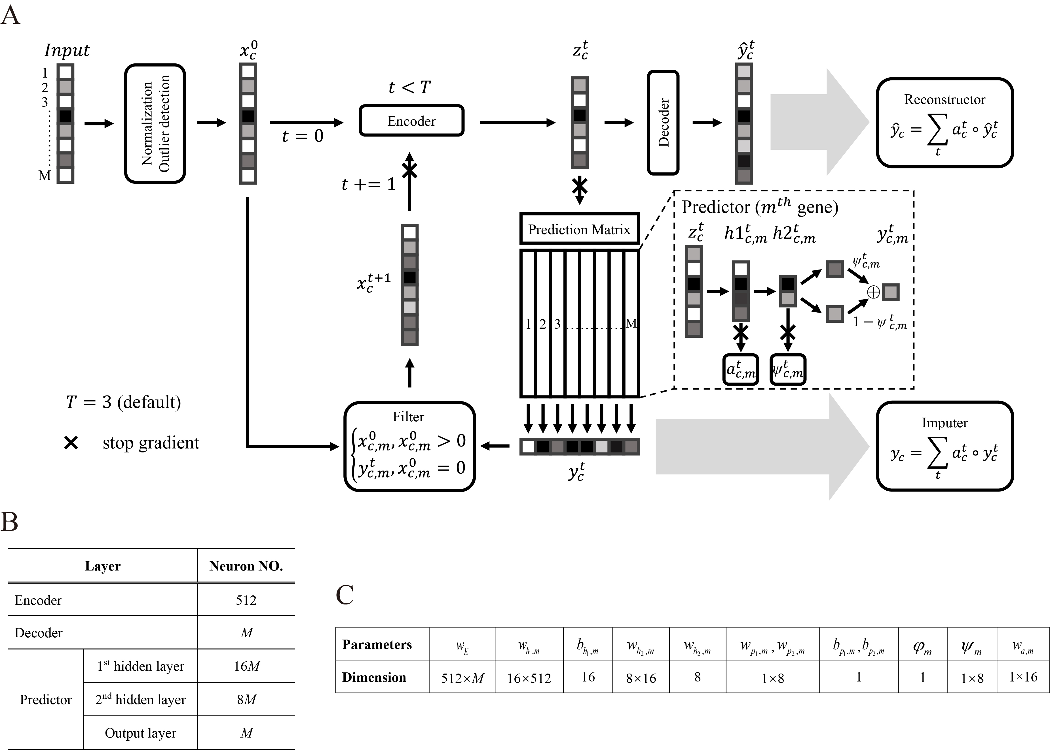
Fig. S1 (A) Model structure of DISC. (B) DISC architecture parameters. (C) Dimension of learnable parameters
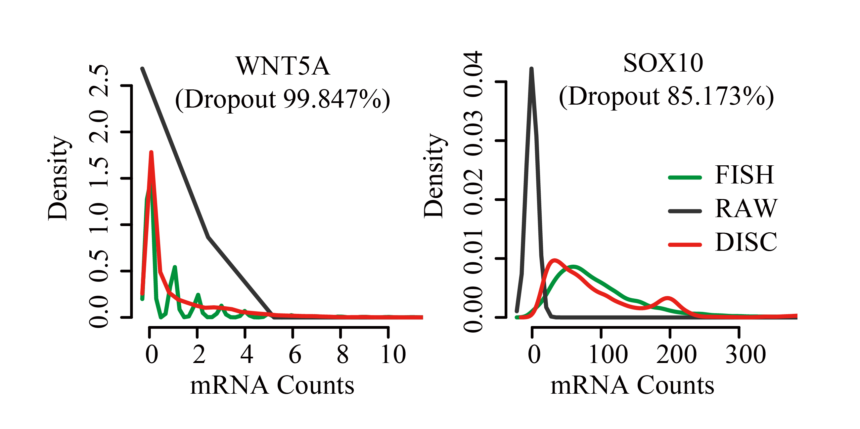
Fig. S2 Gene distribution of WNT5A (left) and SOX10 (right) genes among FISH, the raw scRNA-seq (RAW) and DISC. The dropout levels of two genes are shown in the title.

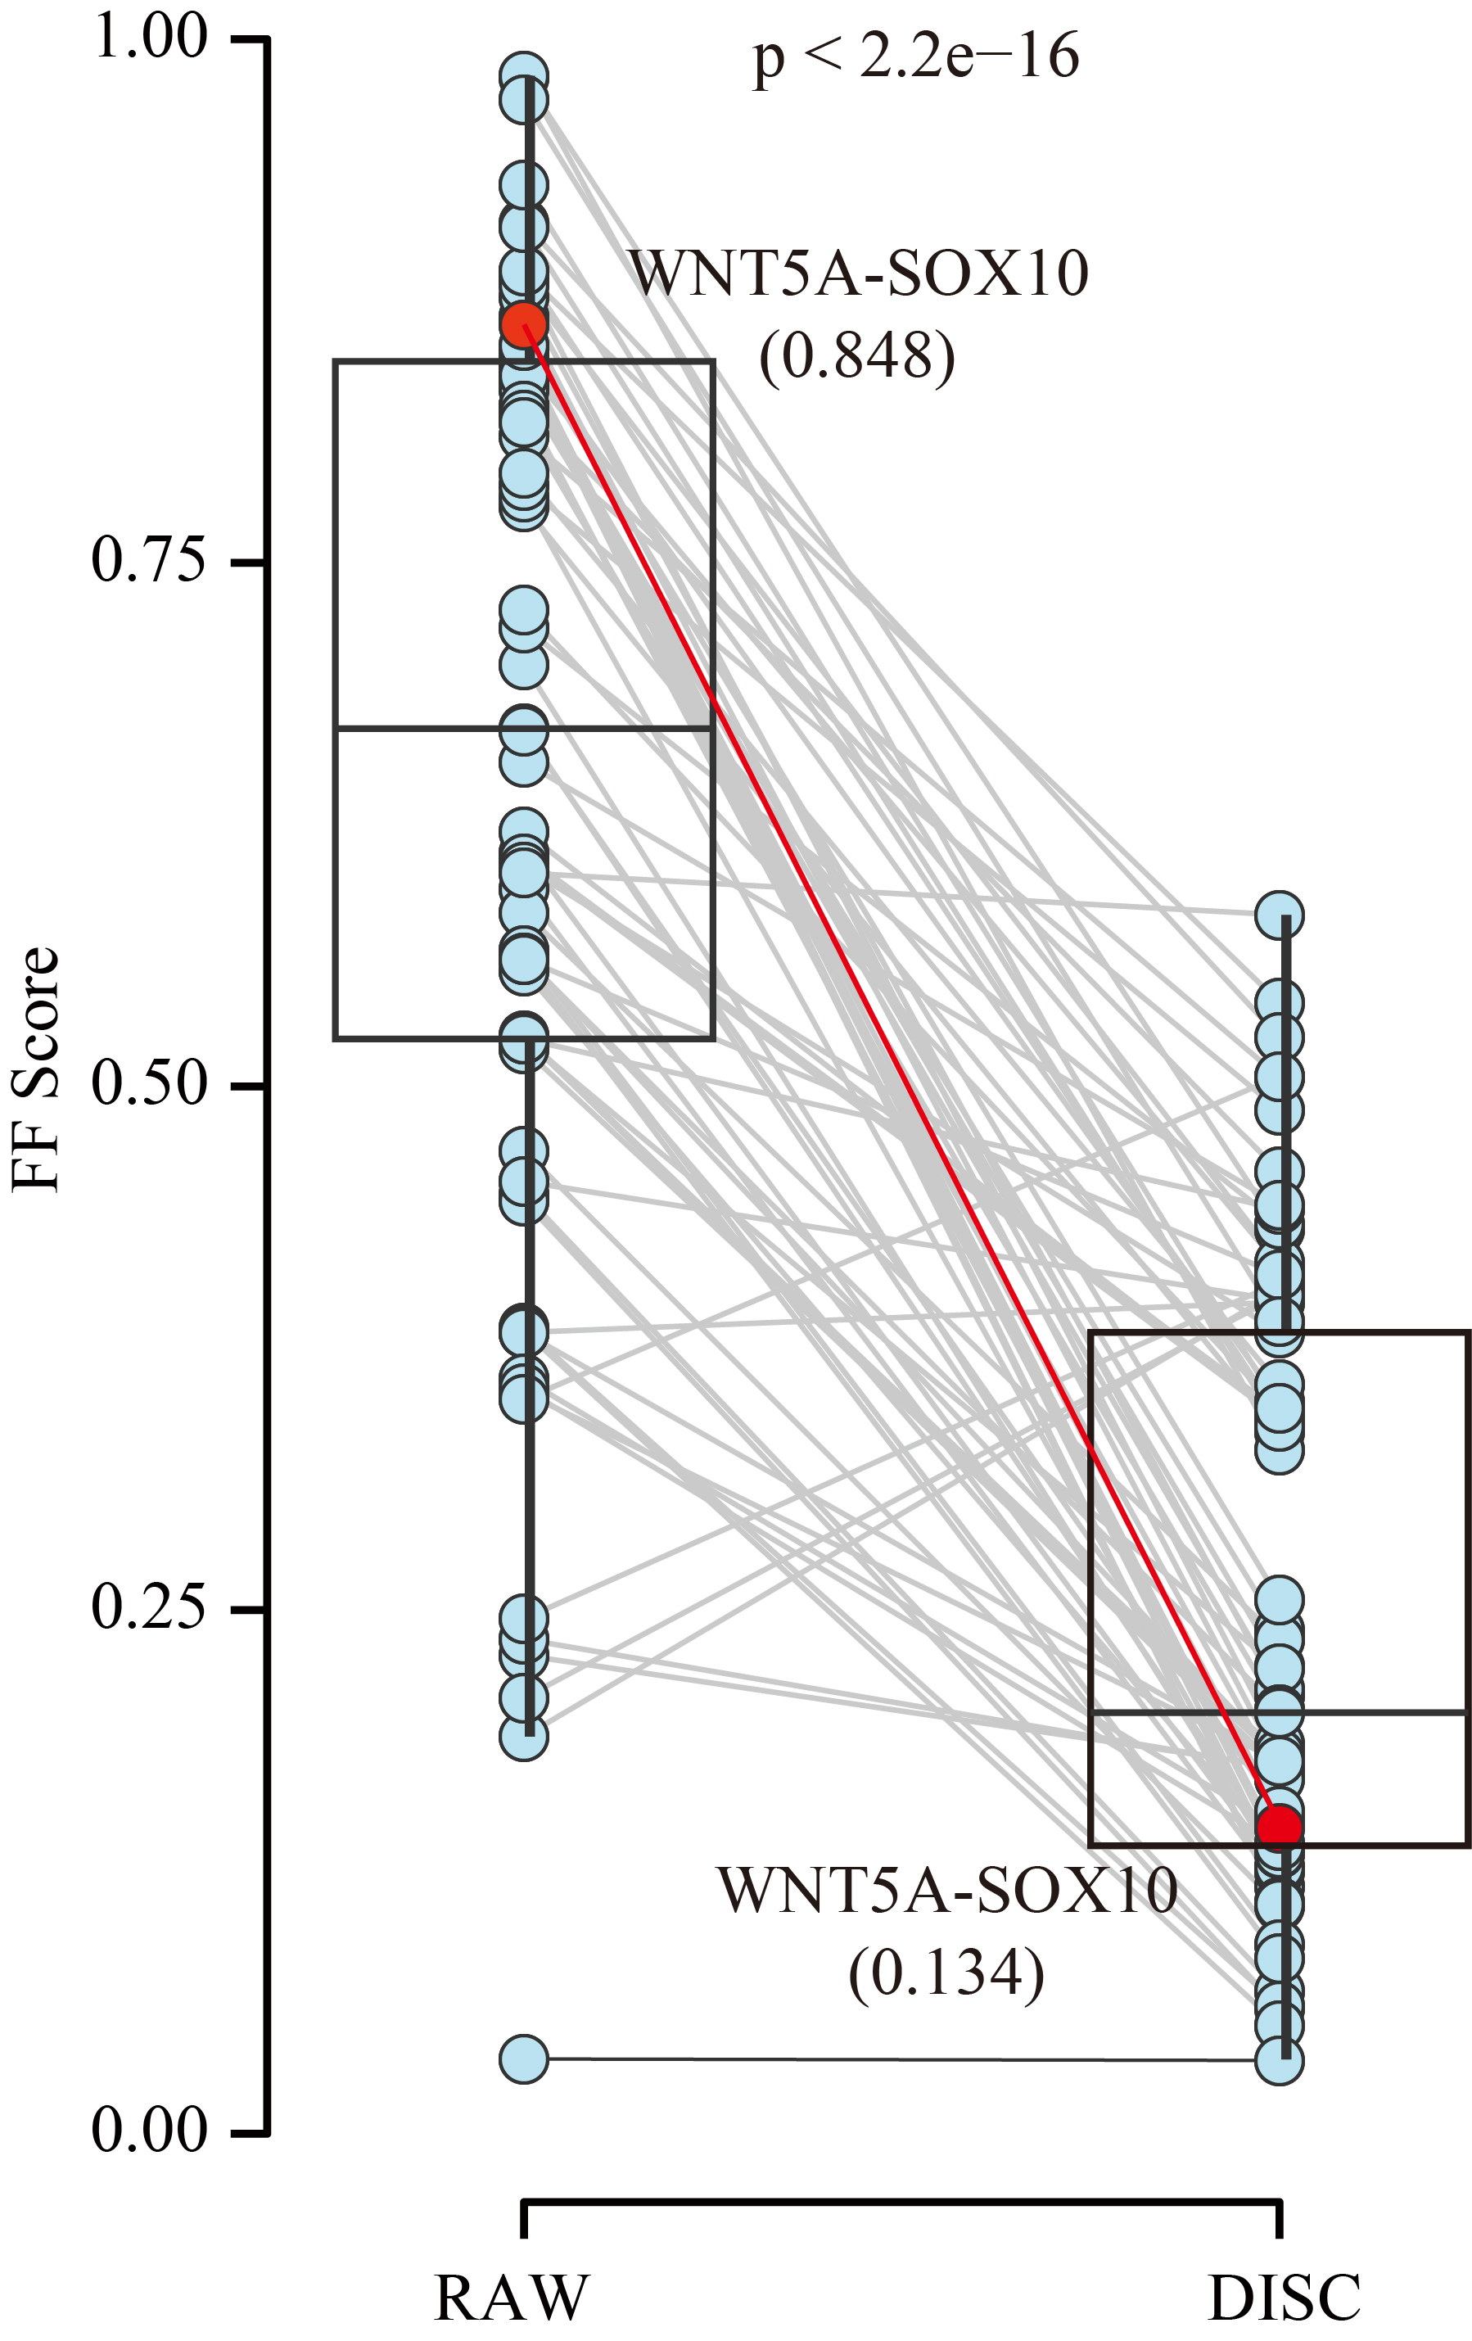
Fig. S3 FF score distribution for 81 gene-pairs between the RAW and DISC against FISH.
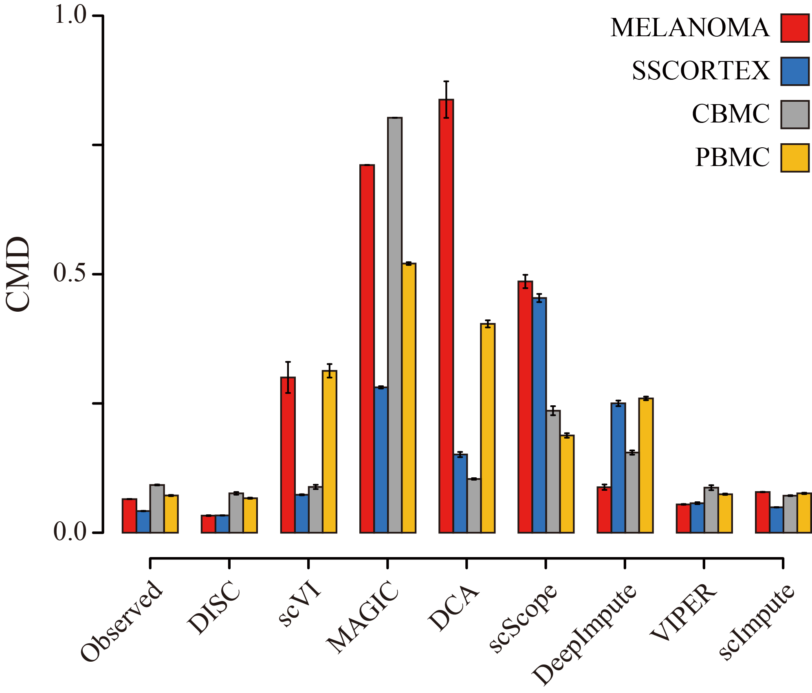
Fig. S4 CMD of gene co-expression between the reference and the observed/the imputation.
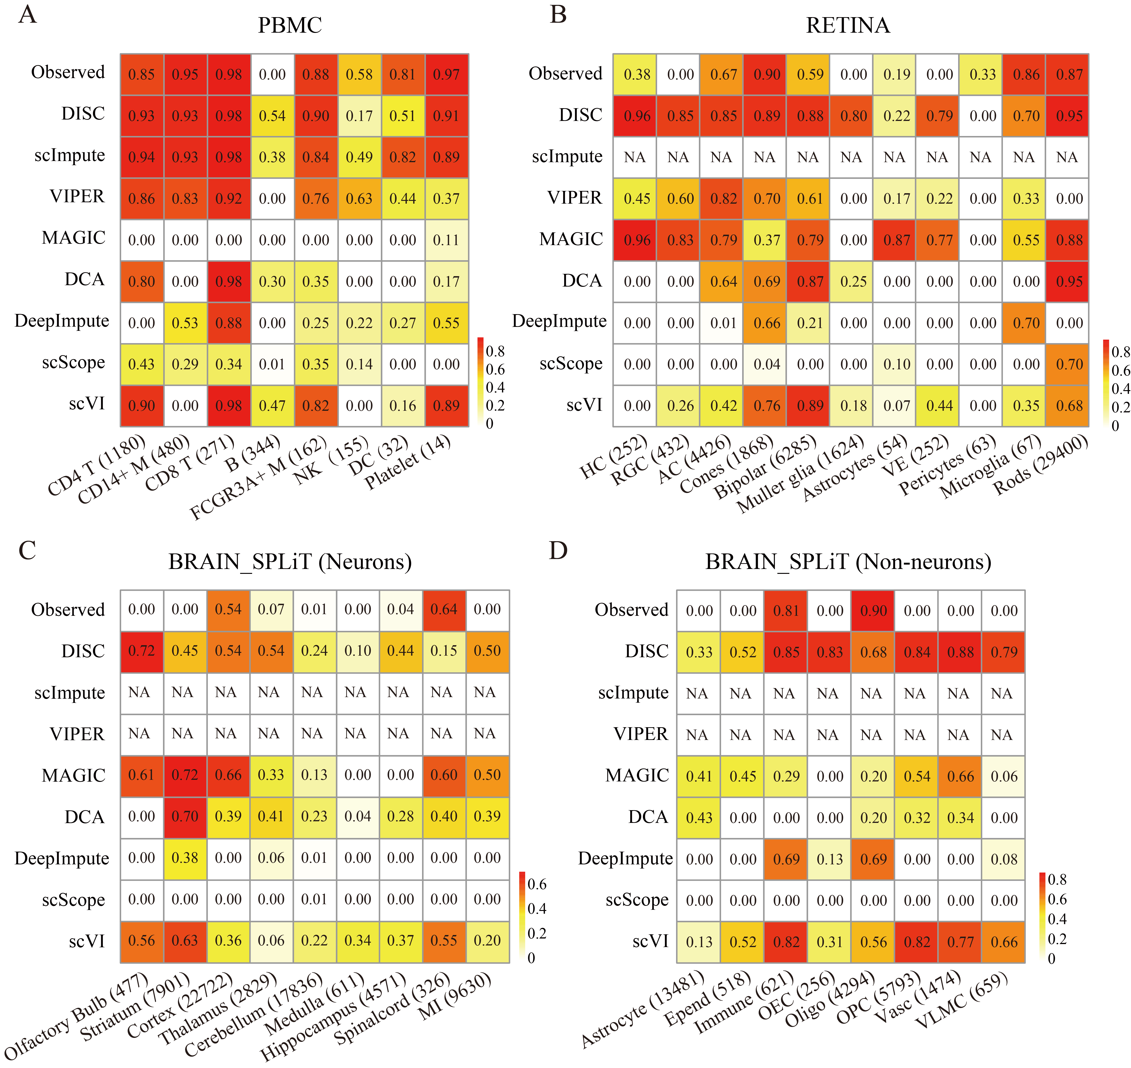
Fig. S5 Jaccard index of each cell type for down-sampling to 30% of the reference. Names and numbers of cell types are given in the label of x-axis. NA: failed to impute. (A) PBMC dataset; (B) RETINA dataset. (C) neurons of BRAIN_SPLiT and (D) non-neurons of BRAIN_SPLiT.

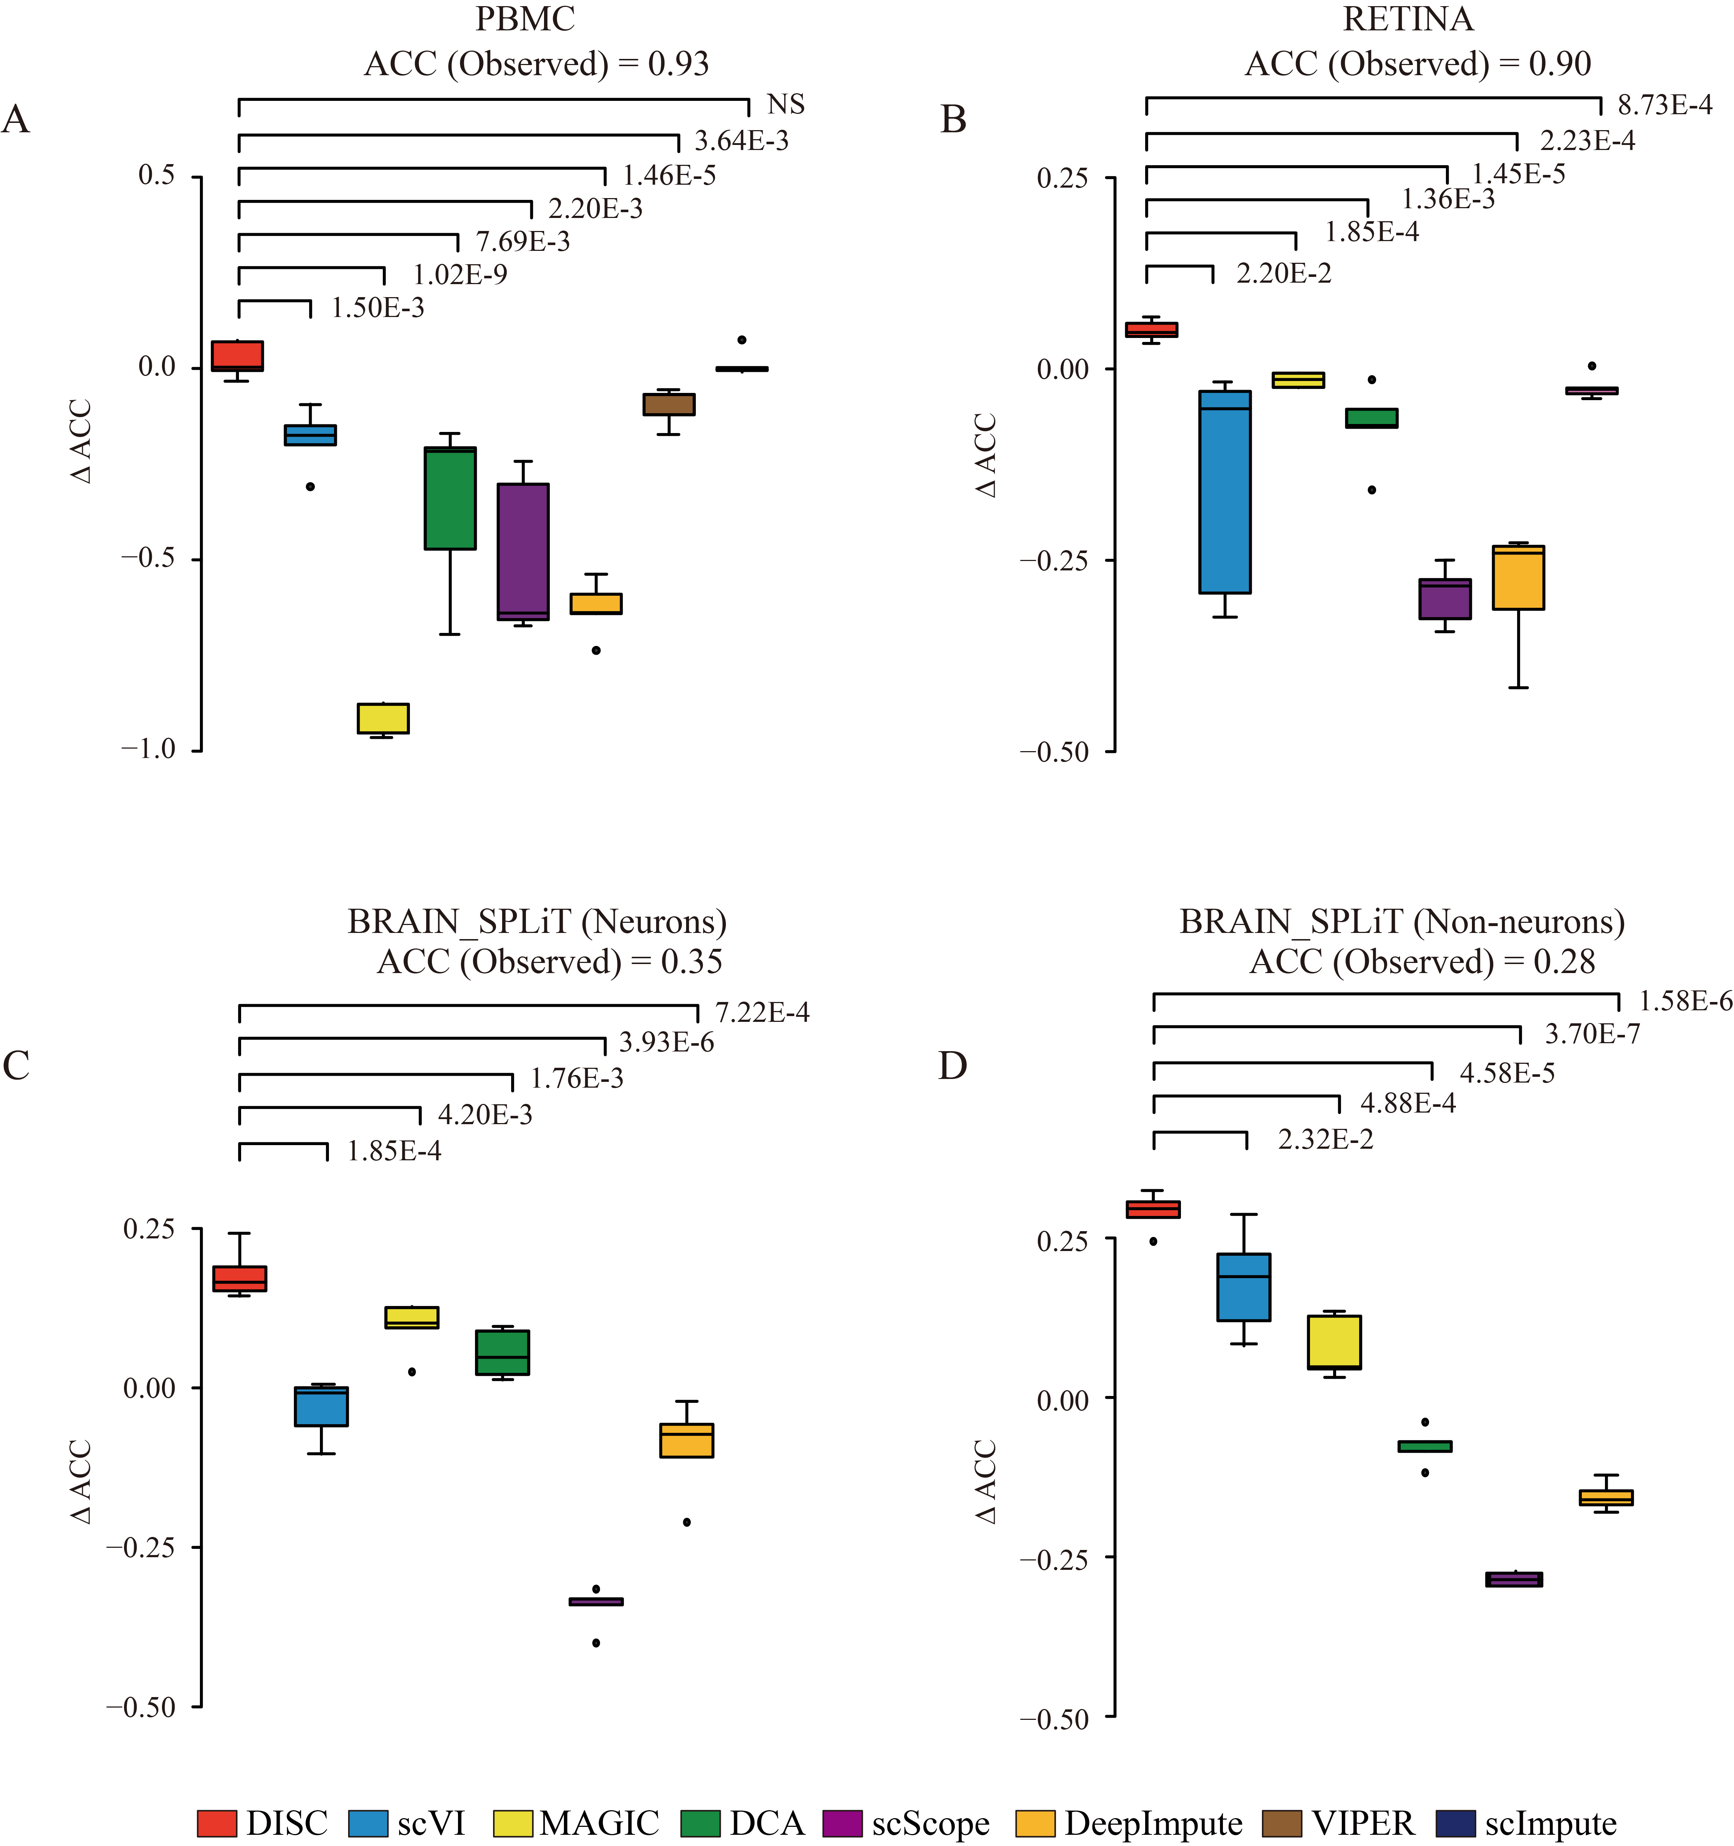
Fig. S6 Evaluation of cell type identification after down-sampling to 50% of the reference. ACC was used to measure accuracy of cell type identification. Y-axis showed the difference of ACC between the imputed and the observed datasets. ACCs of each observed dataset are shown. P values were calculated using one tailed paired t test. (A) PBMC dataset; (B) RETINA dataset. (C) neurons of BRAIN_SPLiT and (D) non-neurons of BRAIN_SPLiT. The following approaches failed due to ‘out-of-memory” error: scImpute on RETINA, VIPER and scImpute on BRAIN_SPLiT.

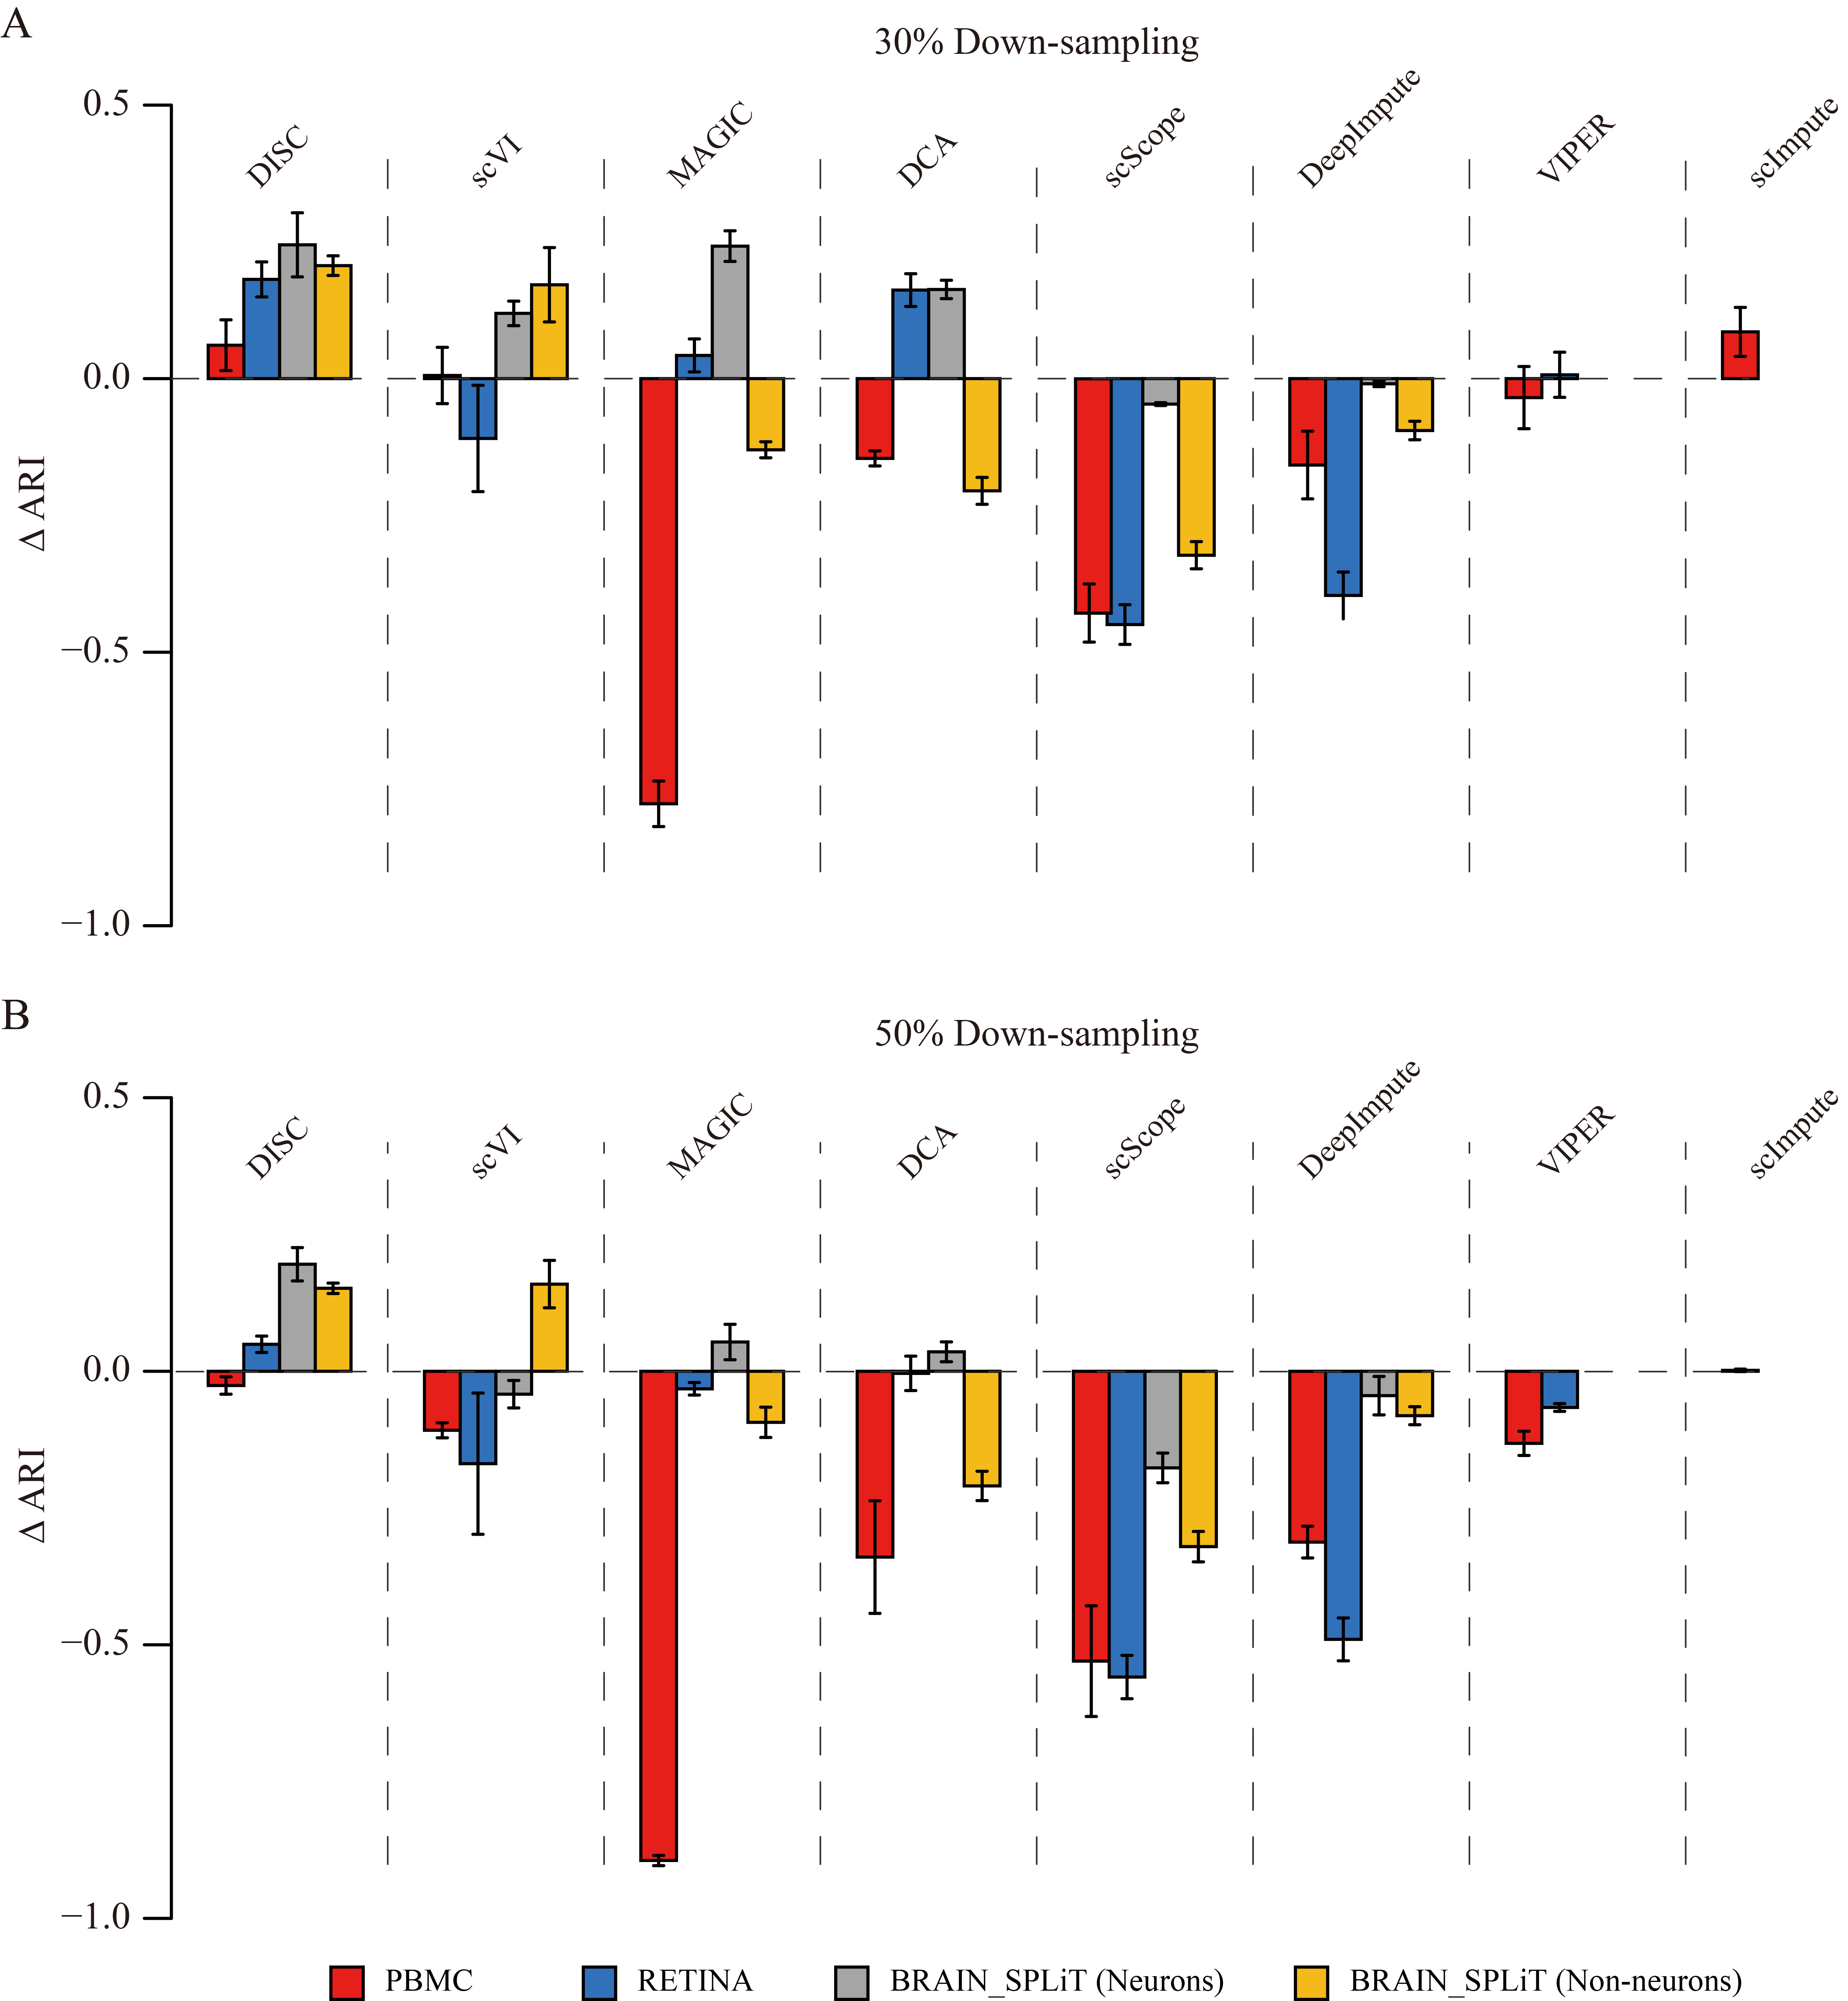
Fig. S7 Evaluation of cell type identification by ARI after down-sampling to 30% and 50%. Y-axis showed the difference of ARI between the imputed and the observed datasets. (A) Down-sampling to 30% of the reference, where the ARI of the observed are 0.81, 0.72, 0.05 and 0.31 for the PBMC, RETINA, Neurons and Non-neurons datasets, respectively. (B) Down-sampling to 50% of the reference, where the ARI of the observed are 0.92, 0.85, 0.18 and 0.30 for the PBMC, RETINA, Neurons and Non-neurons datasets, respectively.

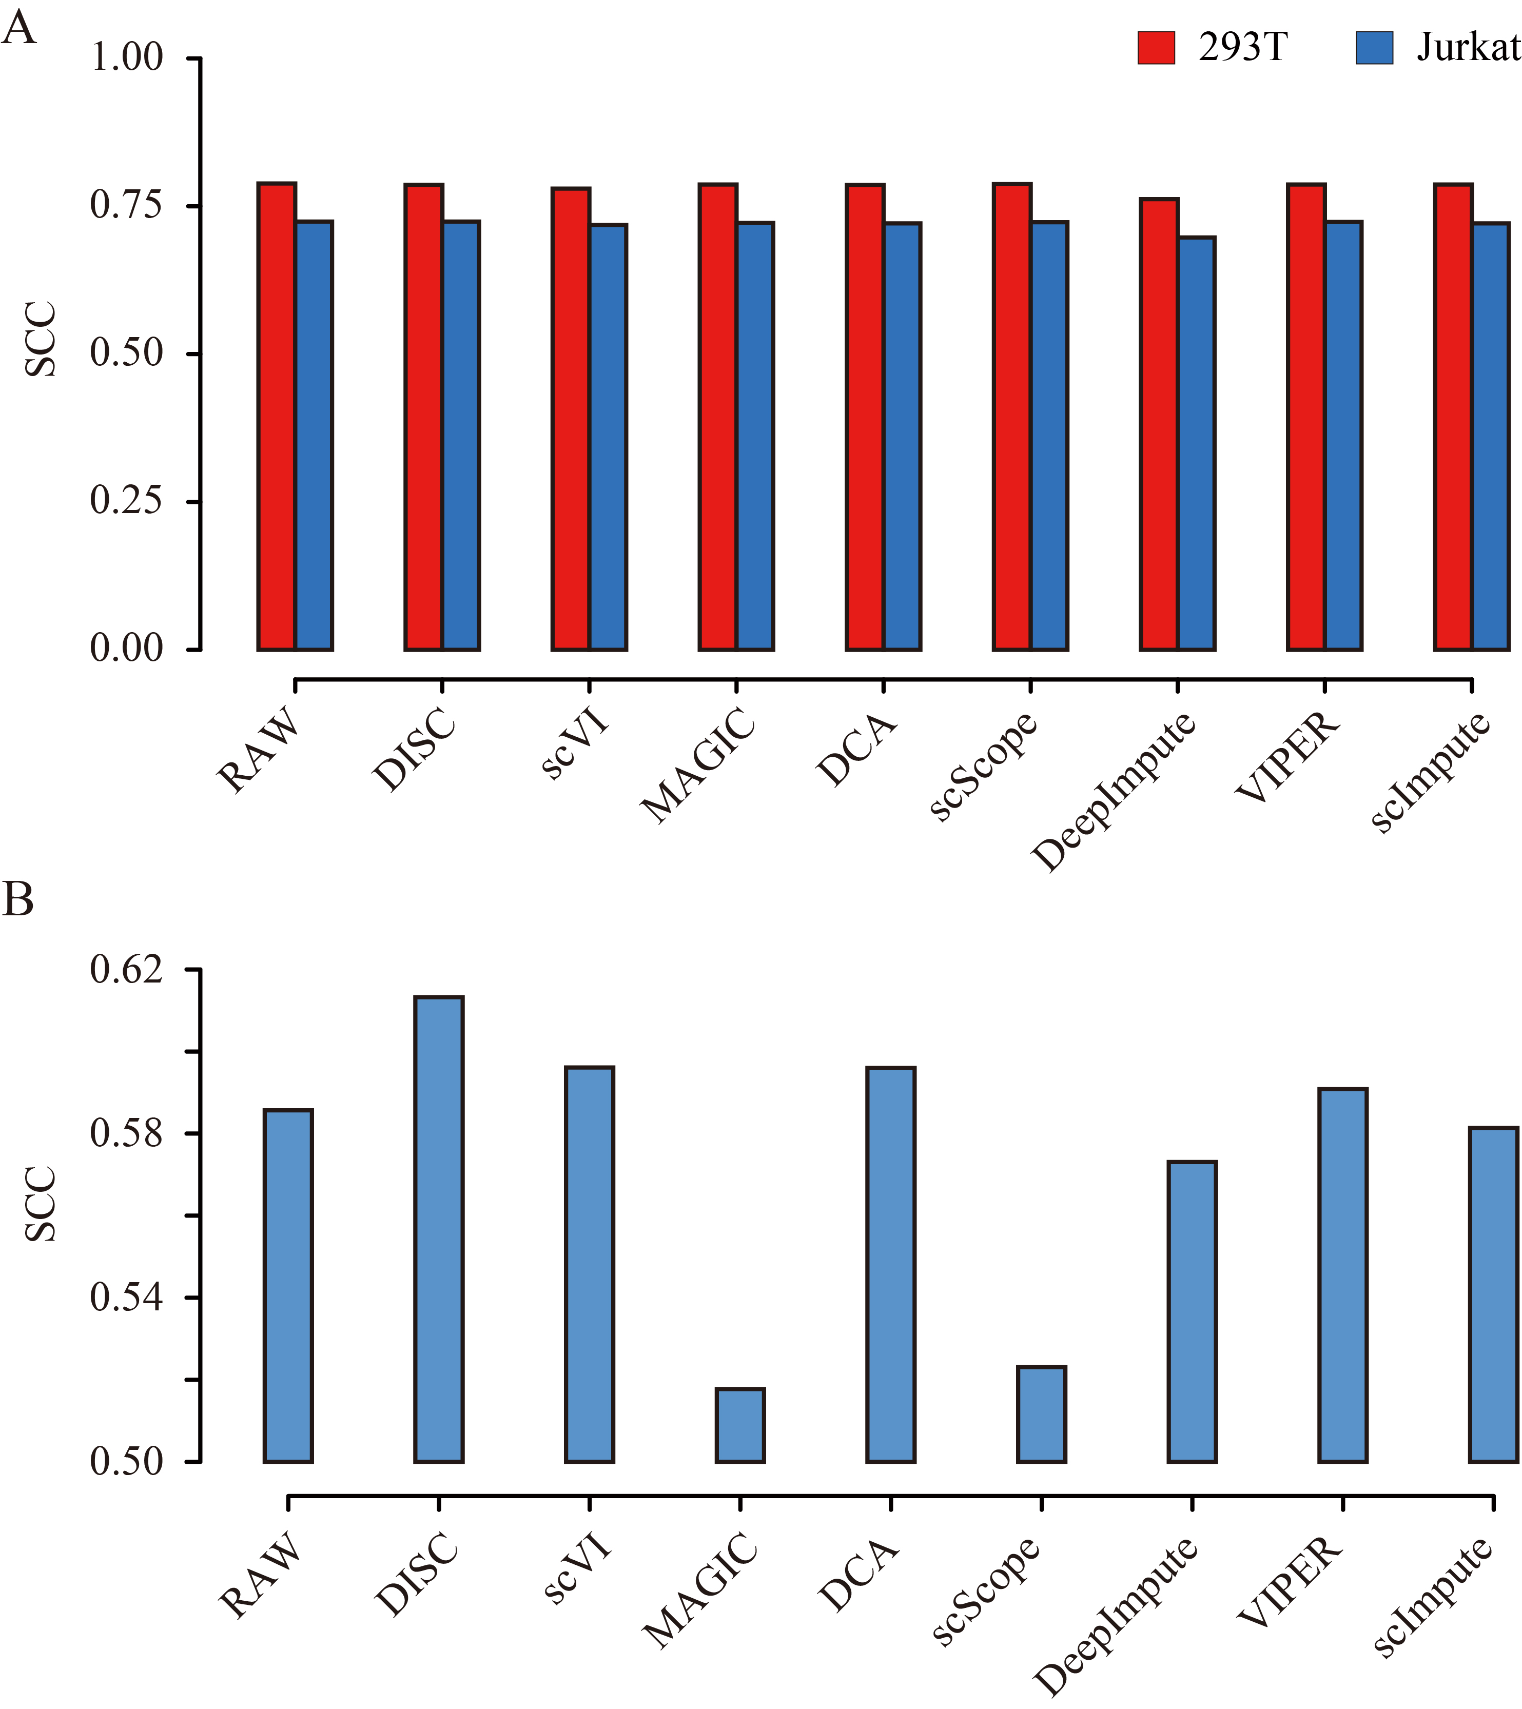
Fig. S8 Spearman correlation coefﬁcient (SCC) between the imputed scRNA-seq profiles and the bulk RNA-seq profiles (A) for Jurkat and 293T cell lines and (B) for expression difference between the Jurkat and 293T cell lines.

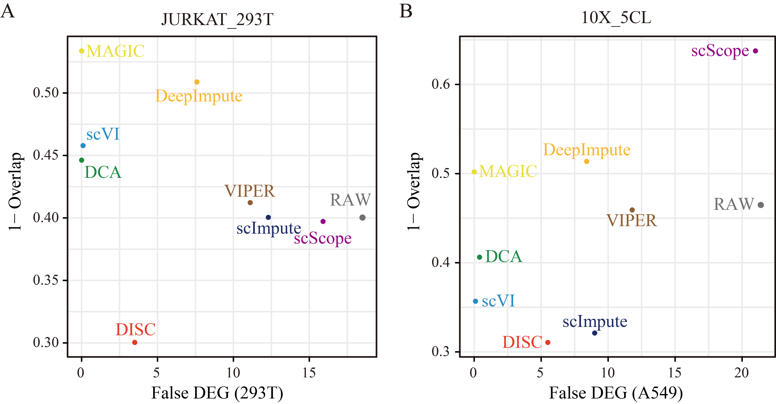
Fig. S9 DEG identified using Wilcoxon method for (A) the JURKAT_293T dataset and (B) the 10X_5CL dataset, where x-axis shows the false number of DEGs identified from a homogeneous population (293T and A549 cell lines were used, respectively) and y-axis shows the averaged overlaps of DEGs identified by scRNA-seq data to that of bulk RNA-seq for all the combination of cell lines in the dataset.

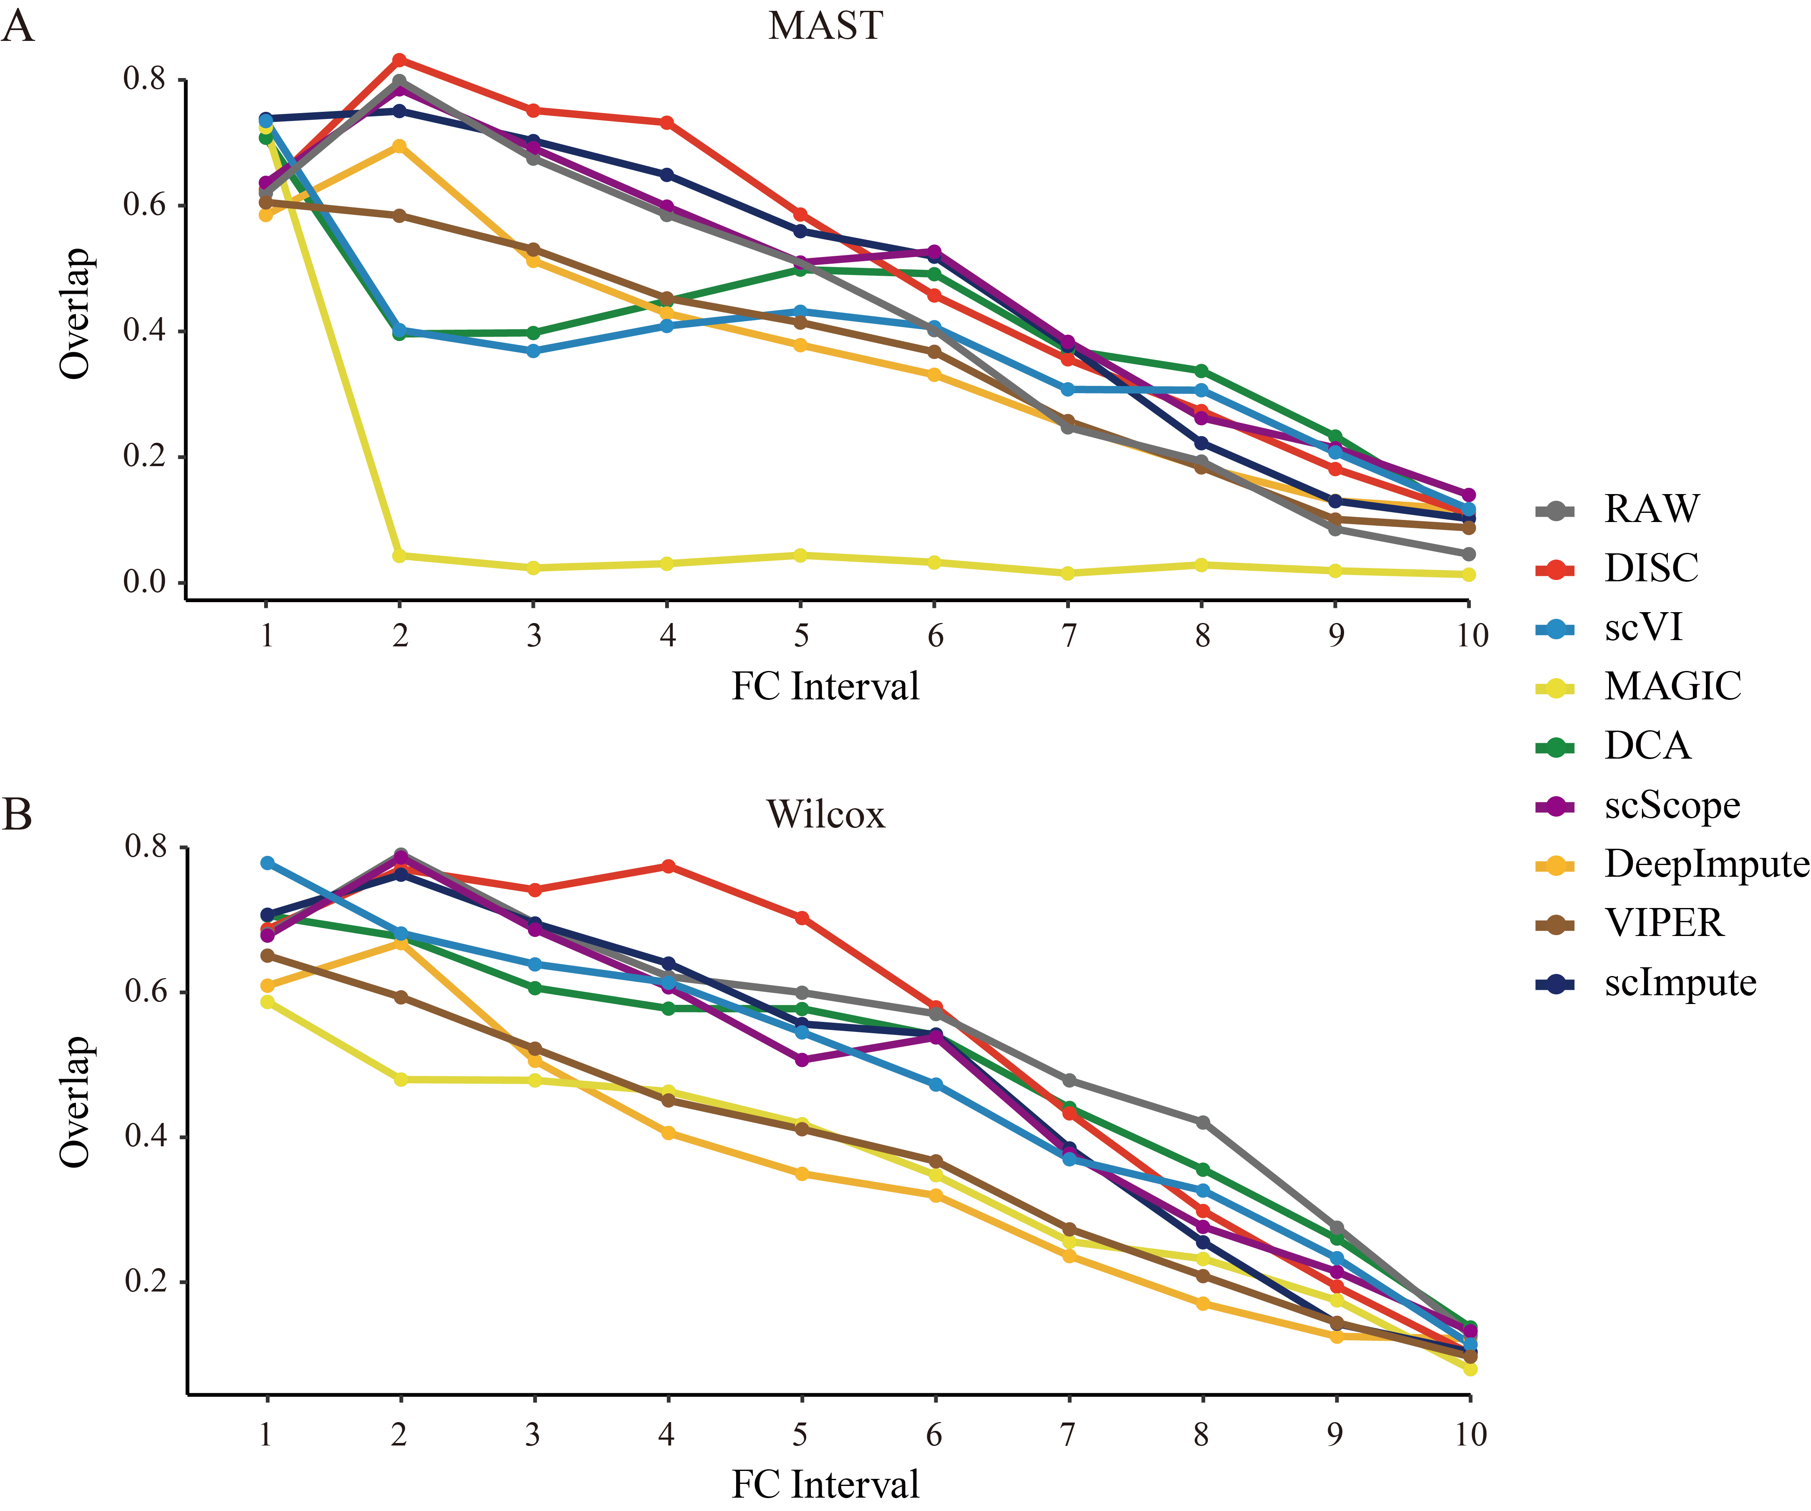
Fig. S10 For a pair of cell lines in the 10X_5CL dataset, genes were grouped into 10 intervals ranked by the FC values. The overlap between bulk and single-cell DEGs identified using (A) MAST and (B) Wilcoxon methods were calculated for 10 combinations of 5 cell lines in the 10X_5CL dataset for each interval.

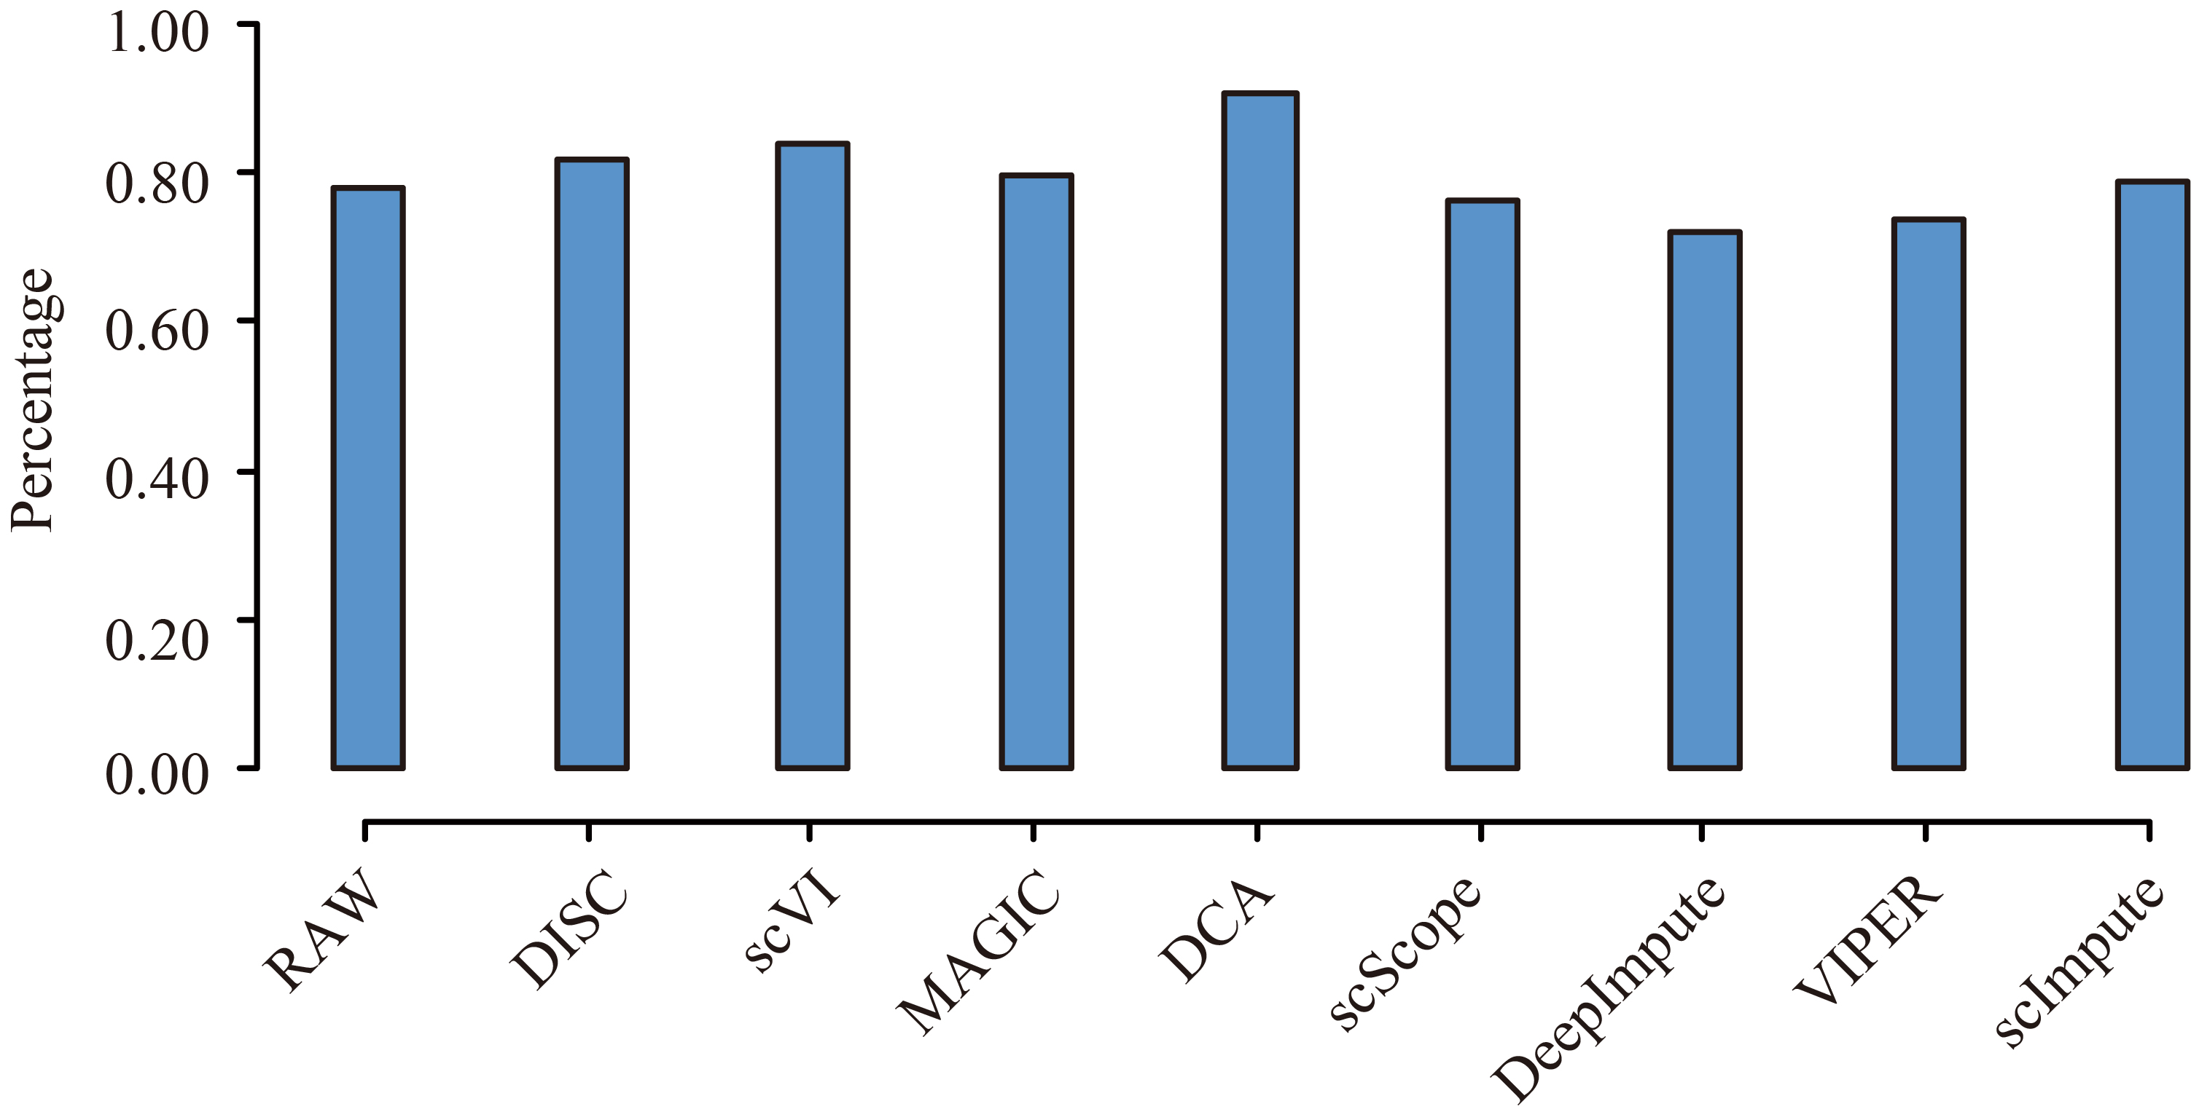
Fig. S11 Inference of the pseudo-temporal order for cells in the BONE_MARROW dataset by Monocle2 and comparison with the known cell differentiation order. The known differentiation levels (HSC: level 1; MPP: level 2; LMPP and CMP: level 3; CLP, GMP, and MEP: level 4; B cell, CD4 T cell, CD8 T cell, NK cell, Monocyte, and Erythroid: level 5) served as the reference. Y-axis shows the percentage of correctly ordered cell-pairs.

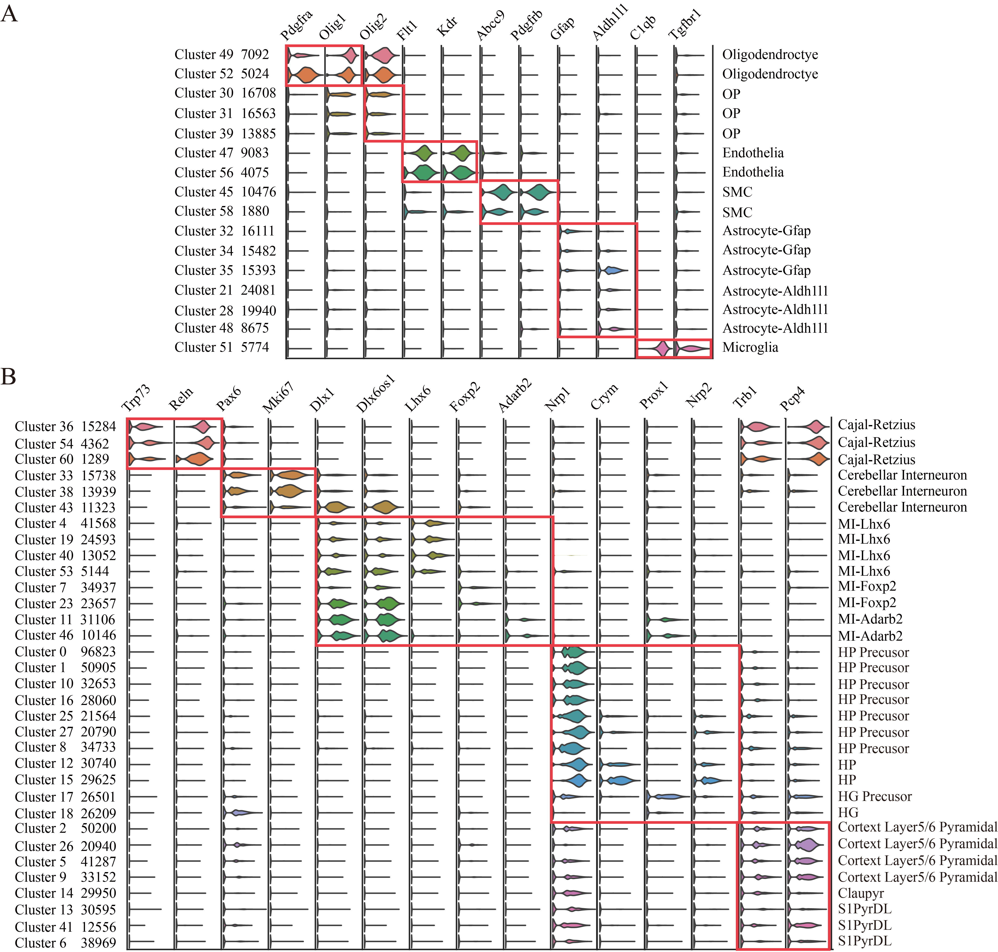
Fig. S12 Expression distribution of marker genes in BRAIN_1.3M dataset. The cluster ID and the number of cells in each cluster are shown on the left; the annotated cell type for each cluster is shown on the right. Red box represents the same cell type. (A) clusters for the non-neuronal cells. (B) clusters for the neuronal cells.
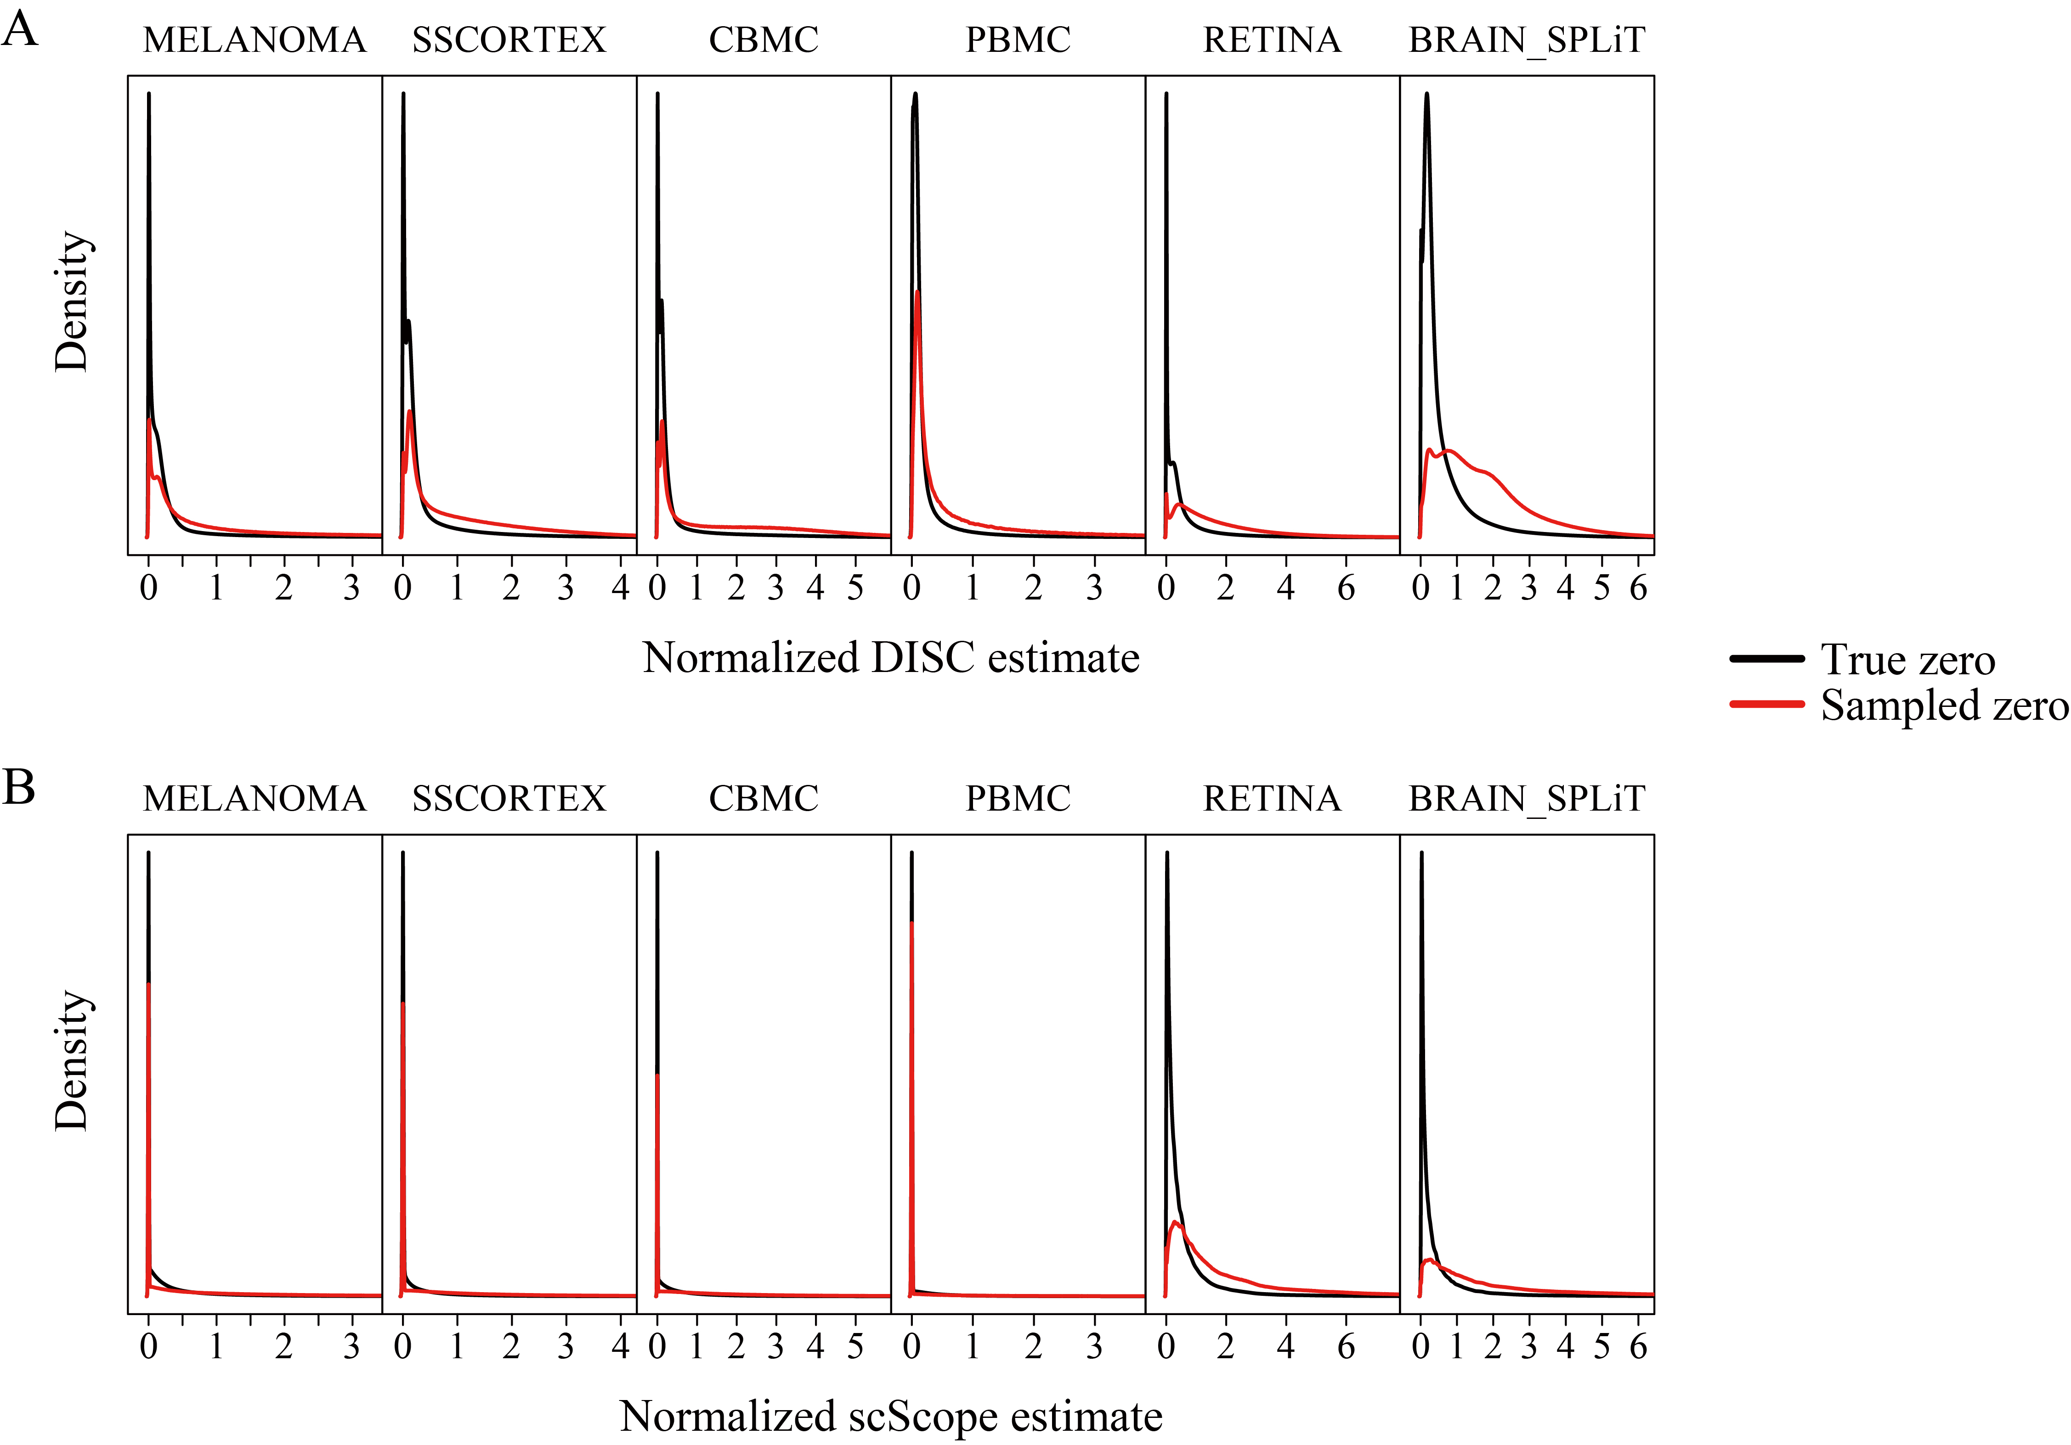
Fig. S13 Density plots of imputed gene expression of true zeros (zero-count genes in RAW) and sampled zeros (positive-count genes in RAW becomes zero-count genes after sampling in down-sampled data) for all the genes in 6 datasets. (A) DISC and (B) scScope.

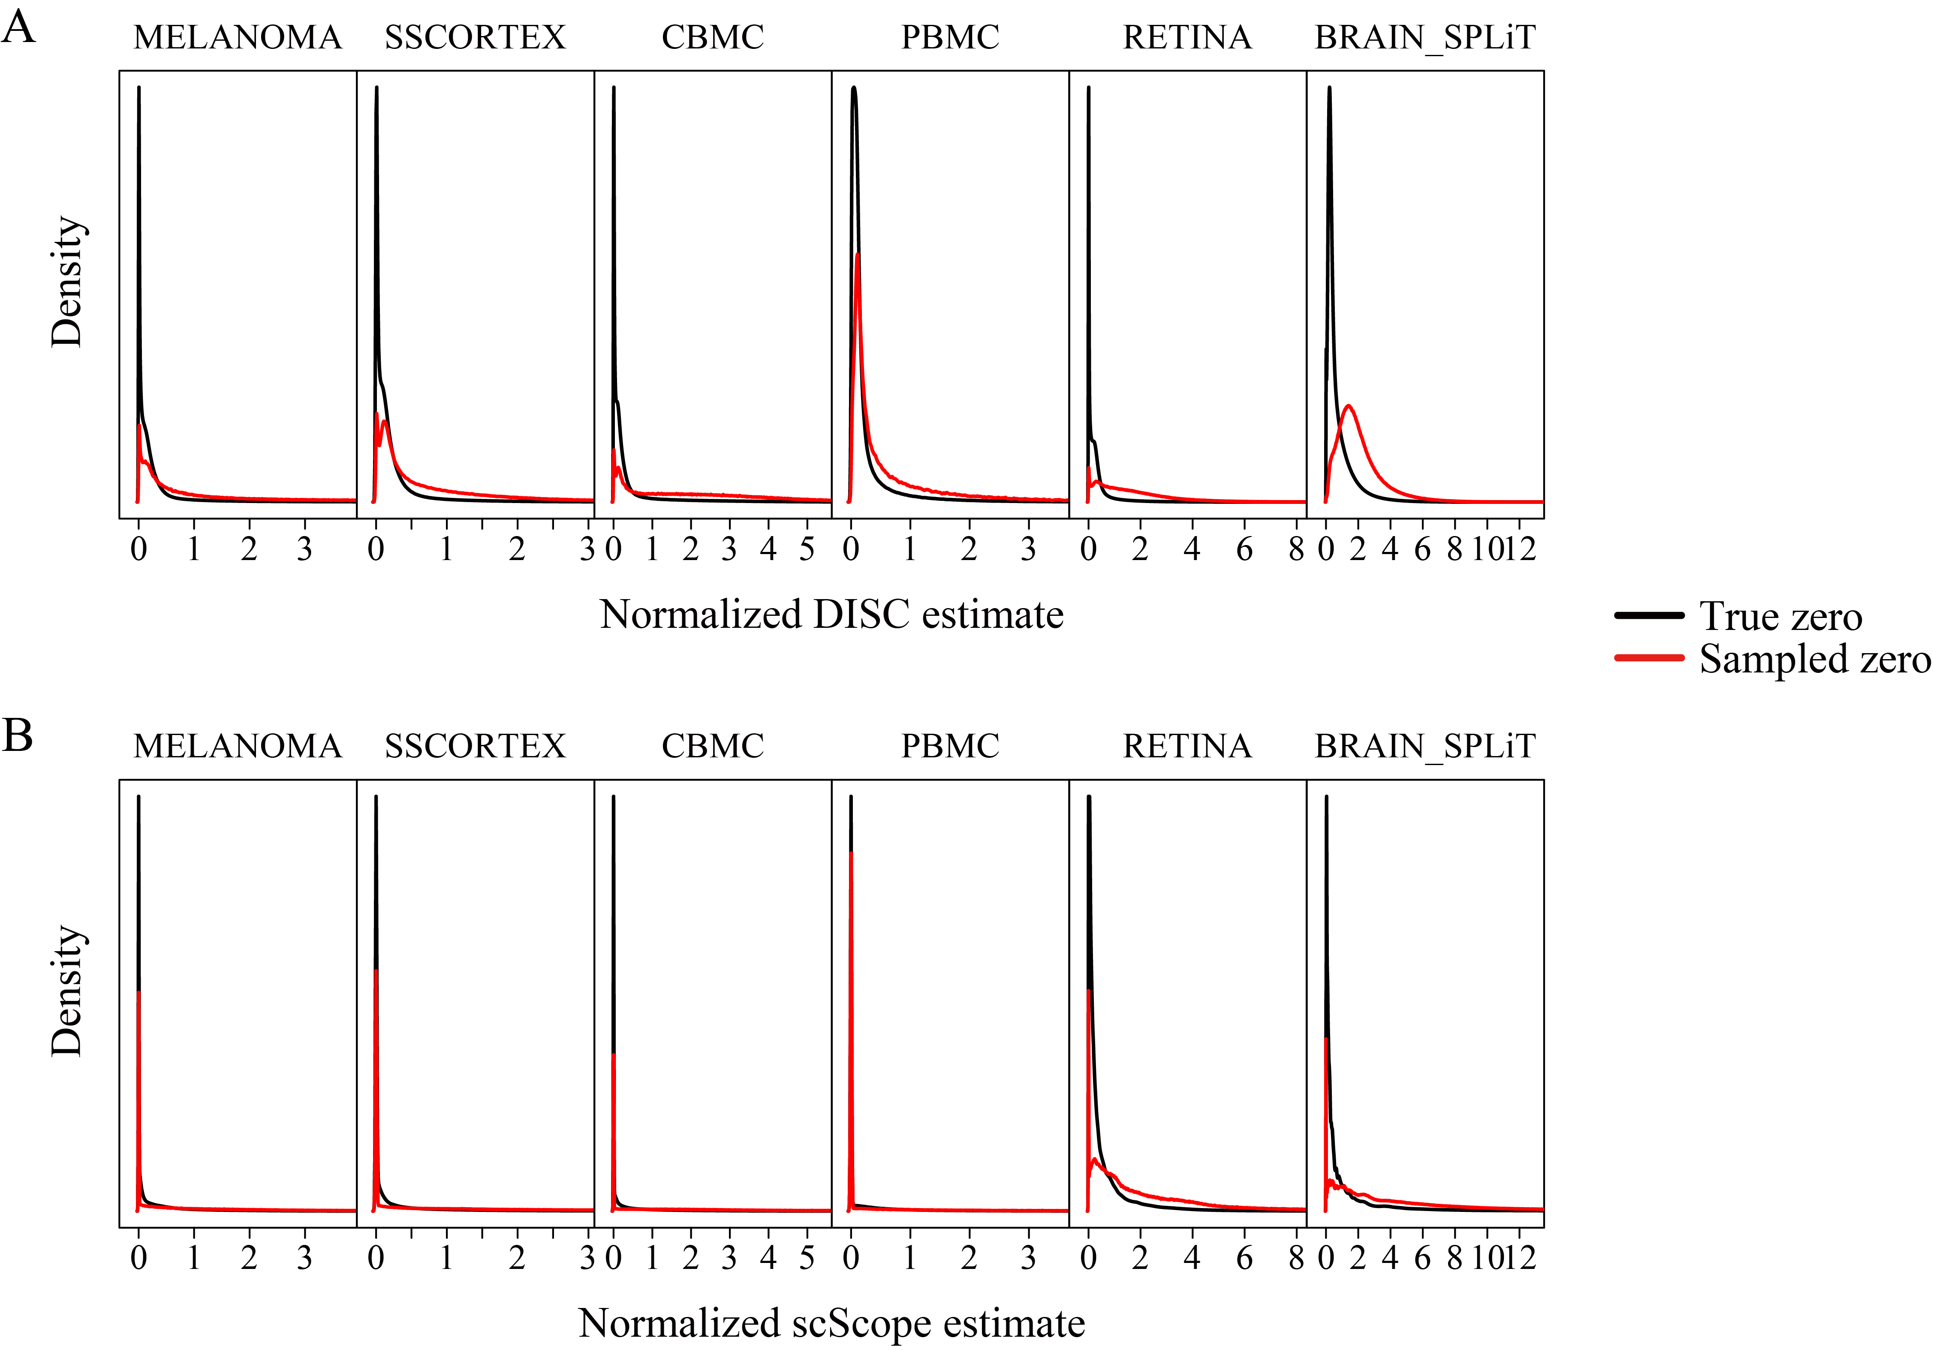
Fig. S14 Density plots of imputed gene expression of true zeros (zero-count genes in RAW) and sampled zeros (positive-count genes in RAW becomes zero-count genes after sampling in down-sampled data) for the top 1000 highly variable genes in 6 datasets. (A) DISC and (B) scScope.

Table S1：Mean library size of raw and down-sampling of the datasets.
Datasets |  | MELANOMA | SSCORTEX | CBMC | PBMC | RETINA | BRAIN_SPLiT
Platforms |  | Drop-seq | 10X | Cite-seq | 10X | Drop-seq | SPLiT-seq
Library Size (Mean) | Raw | 2213.30 | 3444.34 | 2327.77 | 2372.58 | 1287.41 | 1329.02
Library Size (Mean) | DS 0.5 | 1106.64 | 1722.18 | 1163.88 | 1186.30 | 643.71 | 664.51
Library Size (Mean) | DS 0.3 |  |  |  | 711.77 | 386.22 | 398.71
DS 0.5: down-sampling to 50% of the reference; DS 0.3: down-sampling to 30% of the reference.

Table S2：Gene markers used to annotate cell types for the RETINA dataset.
Cell Type | Marker Genes | Cells | Reference
Horizontal cells | Lhx1 & Pax6 | 252 | [1, 2]
Retinal ganglion cells | Slc17A6 & Pax6 | 432 | [1, 2]
Amacrine cells | (Pax6 & Gad1) ∩ (Pax6 & Slc6a9) | 4,426 | [1, 2]
Cones | Opn1mw | 1,868 | [1, 2]
Bipolar cells | Vsx2 | 6,285 | [1, 2]
Muller glia | Pax6 & Vsx2 & Rlbp1 | 1,624 | [1, 2]
Astrocytes | Rlbp1 & Gfap | 54 | [1, 2]
Fibroblasts | Pax6 & Slc6a9 & Vsx2 | 85 | [1, 2]
Vascular endothelium | Pecam1 & Kcnj8 | 252 | [1, 2]
Pericytes | Kcnj8 | 63 | [1, 2]
Microglia | Cx3cr1 | 67 | [1, 2]
Rods | no these marker genes | 29,400 | [1, 2]

Table S3：Gene markers used to annotate cell types for the PBMC dataset.
Cell Type | Marker Genes | Cells | Reference
CD4 T | IL7R & ^CD8A | 1,180 | https://satijalab.org/seurat/v3.1/pbmc3k_tutorial.html
CD14+ Mono | CD14& LYZ | 480 | https://satijalab.org/seurat/v3.1/pbmc3k_tutorial.html
B | MS4A1 | 344 | https://satijalab.org/seurat/v3.1/pbmc3k_tutorial.html
CD8 T | CD8A | 271 | https://satijalab.org/seurat/v3.1/pbmc3k_tutorial.html
FCGR3A+ Mono | FCGR3A & MS4A7 | 162 | https://satijalab.org/seurat/v3.1/pbmc3k_tutorial.html
NK | GNLY & NKG7 & ^CD8A | 155 | https://satijalab.org/seurat/v3.1/pbmc3k_tutorial.html
DC | FCER1A & CST3 | 344 | https://satijalab.org/seurat/v3.1/pbmc3k_tutorial.html
Platelet | PPBP | 271 | https://satijalab.org/seurat/v3.1/pbmc3k_tutorial.html

Table S4：Gene markers used to annotate cell types for the BRAIN_SPLiT dataset.

Class | Cell Type | Marker Genes | Cells | Reference
Neuron | Olfactory bulb | Deptor | 477 | [3]
Neuron | Striatum | Rarb | 7,901 | [3]
Neuron | Cartex | Satb2 | 22,722 | [3]
Neuron | Rostral Midbrain | Tfap2d | 736 | [3]
Neuron | Thalamus | Fign | 2,829 | [3]
Neuron | Cerebellum | Arap1 || Pax3 || Ntn1 | 17,836 | [3]
Neuron | Medulia | Pax2 & ^Ntn1 | 611 | [3]
Neuron | Basal Ganglia | Ntn1 & Slc6a3 | 47 | [3]
Neuron | Hippocampus | Fn1 || Tspan18 | 4,571 | [3]
Neuron | SpinalCord | Pdella | 326 | [3]
Neuron | Mirgrating Interneuron | Dlx6os1 | 9,630 | [3]
Non-neuron | Oligo | Mbp | 4,294 | [3]
Non-neuron | OPC | Pdgfra | 5,793 | [3]
Non-neuron | Immune | Dock2 | 621 | [3]
Non-neuron | VLMC | Rgs5 | 256 | [3]
Non-neuron | Vasc. | Col1a2 | 1,474 | [3]
Non-neuron | Astrocyte | Aldh1l1 | 13,481 | [3]
Non-neuron | Epend. | Dnah11 | 518 | [3]
Non-neuron | OEC | Mybpc1 | 256 | [3]

Table S5：Number of clusters and cells included in three major cell groups of BRAIN_1.3M dataset. Gene markers and criteria from the Allen Brain Atlas (http://brainmap.org) were used to annotate three major cell groups [1].

Cell Type | Clusters | Cells | % | Criteria
Glutamatergic neurons | 0,1,2,3,5,6,8,9,10,12,13,14,15,16,17,18,22,24,25,26,27,29,36,37,41,42,54,60 | 816,062 | 63.63% | max(Slc17a6, Slc17a7) > max(Gad1, Gad2, Olig1, Gja1, Xdh, Ctss, Myl9, Slc32a1)
GABAergic neurons | 4,7,11,19,23,33,  38,40,43,46,53,57 | 229,148 | 17.87% | max(Gad1, Gad2, Slc32a1) > max(Slc17a7, Slc17a6, Olig1, Gja1, Xdh, Ctss, Myl9)
Non-neurons | 20,21,28,30,31,32,34,35,39,44,45,47,48,49,50,51,52,55,56,58,59 | 237,384 | 18.51% | Other cell types

Table S6：Identification of cell types based on the clusters discovered by DISC on the BRAIN_1.3M dataset.
Clusters | Class | Cell Type | Gene Markers | Reference
36,54,60 | Neuron | Cajal-Retzius | Trp73 & Reln | [4]
33,38,43 | Neuron | Cerebellar Interneuron Progenitor | Mki67 | [5]
4,19,40,53,7,23,11,46 | Neuron | Migrating Interneuron | (Dlx1,2,5,6,6os1) & Lhx6 & Foxp2 & Adarb2 | [6]
0,1,8,10,16,25,27 | Neuron | Hippocampal Pyramidal Precursor | Nrp1 | [7, 8]
12,15 | Neuron | Hippocampal Pyramidal - Crym | Crym | [9]
17 | Neuron | Hippocampal Granule Precursor | Prox1 & Nrp2 | [10]
18 | Neuron | Hippocampal Granule | Prox1 | [10]
2,5,9,26 | Neuron | Cortext Layer5 /layer6 Pyramidal | Tbr1 & Pcp4 | [11]
14 | Neuron | Claupyr | Tbr1 & ^Pcp4 | [11]
6,13,41 | Neuron | S1PyrDL | Pcp4 & ^Tbr1 | [11]
49,52 | Non-neuron | Oligodendroctye | Pdgfra | [12]
30,31,39 | Non-neuron | Oligodendroctye Precursor Cells | Olig1 & Olig2 | [13]
47,56 | Non-neuron | Endothelia | Flt1 & Kdr | [14]
45,58 | Non-neuron | Smooth Muscle Cells | Abcc9 & Pdgfrb | [15]
32,34,35,21,28,48 | Non-neuron | Astrocyte | Gfap & Aldh1l1 | [16, 17]
51 | Non-neuron | Microglia | C1qb & Tgfbr1 | [18]
Table S7：The number of DEGs identified in bulk RNA-seq as the reference for the 10X_5CL and JURKAT_293T datasets.
Dataset | Cell Lines | DEGs number
10X_5CL | A549_H1975 | 4,167
10X_5CL | H2228_A549 | 4,526
10X_5CL | H2228_H1975 | 4,090
10X_5CL | H2228_H838 | 5,629
10X_5CL | H838_A549 | 4,277
10X_5CL | H838_H1975 | 4,709
10X_5CL | HCC827_A549 | 4,310
10X_5CL | HCC827_H1975 | 3,299
10X_5CL | HCC827_H2228 | 4,344
10X_5CL | HCC827_H838 | 4,953
JURKAT_293T | 293T_JURKAT | 5,901

References
1. Deng Y, Bao F, Dai Q, Wu LF, Altschuler SJ: Scalable analysis of cell-type composition from single-cell transcriptomics using deep recurrent learning. Nat Methods 2019, 16:311-314.
2. Macosko EZ, Basu A, Satija R, Nemesh J, Shekhar K, Goldman M, Tirosh I, Bialas AR, Kamitaki N, Martersteck EM, et al: Highly Parallel Genome-wide Expression Profiling of Individual Cells Using Nanoliter Droplets. Cell 2015, 161:1202-1214.
3. Rosenberg AB, Roco CM, Muscat RA, Kuchina A, Sample P, Yao Z, Graybuck LT, Peeler DJ, Mukherjee S, Chen W: Single-cell profiling of the developing mouse brain and spinal cord with split-pool barcoding. Science 2018, 360:176-182.
4. Abraham H, Perez-Garcia CG, Meyer G: p73 and Reelin in Cajal-Retzius cells of the developing human hippocampal formation. Cereb Cortex 2004, 14:484-495.
5. Doyle JP, Dougherty JD, Heiman M, Schmidt EF, Stevens TR, Ma G, Bupp S, Shrestha P, Shah RD, Doughty ML, et al: Application of a translational profiling approach for the comparative analysis of CNS cell types. Cell 2008, 135:749-762.
6. Alifragis P, Liapi A, Parnavelas JG: Lhx6 regulates the migration of cortical interneurons from the ventral telencephalon but does not specify their GABA phenotype. J Neurosci 2004, 24:5643-5648.
7. Thompson CL, Ng L, Menon V, Martinez S, Lee CK, Glattfelder K, Sunkin SM, Henry A, Lau C, Dang C, et al: A high-resolution spatiotemporal atlas of gene expression of the developing mouse brain. Neuron 2014, 83:309-323.
8. Xie Z, Ma X, Ji W, Zhou G, Lu Y, Xiang Z, Wang YX, Zhang L, Hu Y, Ding YQ, Zhang WJ: Zbtb20 is essential for the specification of CA1 field identity in the developing hippocampus. Proc Natl Acad Sci U S A 2010, 107:6510-6515.
9. Cembrowski MS, Wang L, Sugino K, Shields BC, Spruston N: Hipposeq: a comprehensive RNA-seq database of gene expression in hippocampal principal neurons. Elife 2016, 5:e14997.
10. Iwano T, Masuda A, Kiyonari H, Enomoto H, Matsuzaki F: Prox1 postmitotically defines dentate gyrus cells by specifying granule cell identity over CA3 pyramidal cell fate in the hippocampus. Development 2012, 139:3051-3062.
11. Zeisel A, Munoz-Manchado AB, Codeluppi S, Lonnerberg P, La Manno G, Jureus A, Marques S, Munguba H, He L, Betsholtz C, et al: Brain structure. Cell types in the mouse cortex and hippocampus revealed by single-cell RNA-seq. Science 2015, 347:1138-1142.
12. Marques S, Zeisel A, Codeluppi S, van Bruggen D, Mendanha Falcao A, Xiao L, Li H, Haring M, Hochgerner H, Romanov RA, et al: Oligodendrocyte heterogeneity in the mouse juvenile and adult central nervous system. Science 2016, 352:1326-1329.
13. Dai J, Bercury KK, Jin W, Macklin WB: Olig1 Acetylation and Nuclear Export Mediate Oligodendrocyte Development. J Neurosci 2015, 35:15875-15893.
14. Tasic B, Menon V, Nguyen TN, Kim TK, Jarsky T, Yao Z, Levi B, Gray LT, Sorensen SA, Dolbeare T, et al: Adult mouse cortical cell taxonomy revealed by single cell transcriptomics. Nat Neurosci 2016, 19:335-346.
15. He L, Vanlandewijck M, Raschperger E, Andaloussi Mae M, Jung B, Lebouvier T, Ando K, Hofmann J, Keller A, Betsholtz C: Analysis of the brain mural cell transcriptome. Sci Rep 2016, 6:35108.
16. Murthy M, Bocking S, Verginelli F, Stifani S: Transcription factor Runx1 inhibits proliferation and promotes developmental maturation in a selected population of inner olfactory nerve layer olfactory ensheathing cells. Gene 2014, 540:191-200.
17. Afsari ZH, Renno WM, Abd-El-Basset E: Alteration of glial fibrillary acidic proteins immunoreactivity in astrocytes of the spinal cord diabetic rats. Anat Rec (Hoboken) 2008, 291:390-399.
18. Butovsky O, Jedrychowski MP, Moore CS, Cialic R, Lanser AJ, Gabriely G, Koeglsperger T, Dake B, Wu PM, Doykan CE, et al: Identification of a unique TGF-beta-dependent molecular and functional signature in microglia. Nat Neurosci 2014, 17:131-143.

