Additional file 1: Supplementary Figures

A) B)
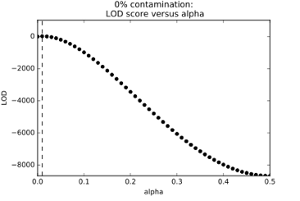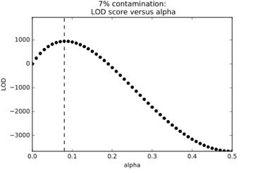
C)
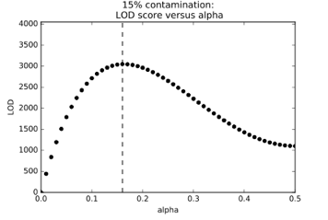
Fig. S1. Distribution of LOD scores in simulated data. The distribution of LOD scores is depicted for samples with A) 0%, B) 7%, and C) 15% simulated contamination. These data were generated as part of tests using 1000 Genomes CEU individuals as the sample and contaminant DNA and for the haplotype panel.
Fig. S2. ContamLD estimates when the individual, contaminant, and haplotype panel are all from CEU. ContamLD was run with no correction. The black dotted line is y=x, which would correspond to a perfect estimation of the contamination. Error bars are 1.96*standard error (95% confidence interval).

Fig. S3. ContamLD estimates for Upper Paleolithic European individual after damage restricted correction (option 1). Kostenki14 (2.81x coverage) was contaminated with CEU and analyzed using a CEU panel with ContamLD using damage correction and ANGSD [16] (Method 1). The black dotted line is y=x, which would correspond to a perfect estimation of the contamination. Error shading is 1.96*standard error (95% confidence interval).

B
A
C
E
D
F
H
G

Fig. S4. ContamLD estimates where the sample, contaminant, and haplotype panels have varying ancestries. ContamLD was run with damage restricted correction (option 1). An ancient Iberian of 1.02x coverage (I3756) was analyzed after contamination with A) CHB or B) YRI. An ancient East Asian of 1.10x coverage (DA362.SG) is analyzed after contamination with C) CEU, D) CHB, or E) YRI. An ancient South African of 1.21x coverage (I9028.SG) is analyzed after contamination with F) CEU, G) CHB, or H) YRI. The black dotted line is y=x, which would correspond to a perfect estimation of the contamination.

A) B)
Fig. S5. ContamLD estimates with CEU as the sample and multiple CEU individuals as contaminants. ContamLD was run with CEU haplotype panels and damage restricted correction (option 1). A CEU individual of 1.02x coverage (from the sequence distribution of the ancient Iberian above) is contaminated with A) two CEU individuals or B) three CEU individuals. The black dotted line is y=x, which would correspond to a perfect estimation of the contamination. Error bars are 1.96*standard error (95% confidence interval).

Fig. S6. ContamLD estimates with an ASW (African-American) individual and YRI panel. ContamLD was run with the 1240K SNP set and damage restricted correction (option 1). The black dotted line is y=x, which would correspond to a perfect estimate of the contamination. Error bars are 1.96*standard error (95% confidence interval).
Fig. S7. Contamination estimate standard errors of shotgun sequenced ancient individuals comparing the 1240K and shotgun panels. Ancient shotgun sequenced individuals of 0.1-0.5x coverage from Allentoft et al., 2015 [31], Damgaard et al., Nature 2018 [37], and Damgaard et al., Science 2018 [21] were analyzed with ContamLD damage restricted correction (option 1) using the 1240K SNP set and a shotgun panel created using all variants above 10% frequency in the 1000 Genomes dataset. This test shows that analyses with the shotgun panel generally have smaller error bars relative to those done with the 1240K panel, though it is unclear why there are two outliers with high standard errors on the shotgun panel and low standard errors on the 1240K panel. All estimates are in Table S1.

Fig. S8. ContamLD standard errors from an ancient individual contaminated with another individual at different damage rates. The target individual was a 0.5x coverage ancient West Eurasian-related individual (DA57.SG), and the contaminating individual was an ancient Iberian (I10895). ContamLD was run with the 1240K SNP set with the CEU panel. The damaged sequences were simulated as 0.005, 0.01, 0.02, 0.03, 0.04, 0.05, and 0.075.
Fig. S9. ContamLD estimates with an ancient individual contaminated with another ancient individual including its damaged sequences. The target individual was an ancient Iberian (I3756) and the contaminating individual was another ancient Iberian (I10895). ContamLD was run with the IBS panel and 1240K SNP set using damage restricted correction (option 1). The damaged sequences were simulated as a 5% down-sampling of each respective contaminated BAM file. IBS are 1000 Genomes Project present-day Iberians from Spain. The black dotted line is y=x, which would correspond to a perfect estimation of the contamination. Error bars are 1.96*standard error (95% confidence interval). Points in red are those flagged with “Very_High_Contamination” by the software. See Table S4 for all values.

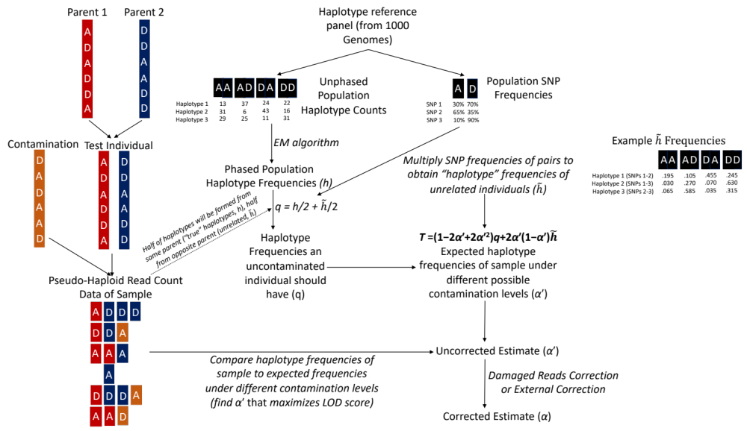Fig. S10. Schematic of ContamLD algorithm (see text for additional details).

