Additional File 1

Fig. S1: The ratio of average frequency of transversions to average frequency of transitions along the EBOV genome in windows slide of 200 nts.

Fig. S2: Correlation between frequency difference and P-value of each protein site.

Fig. S3. The percentage of top three codons.

Fig. S4. Uncropped western blots assessing the EBOV mini-genome system relative activity at different ratios between EBOV L and LSTOP.

Fig. S5. Uncropped western blots assessing the EBOV mini-genome system relative activity at equal EBOV L but different LSTOP amounts.

Fig. S6. Uncropped western blots assessing the functionality in an EBOV mini-genome system assay of the L3mut protein at different ratios with EBOV L.

Fig. S7. Uncropped western blots of the co-immunoprecipitation (coIP) assay fractions to examine the interaction between EBOV VP35 with EBOV LSTOP.

Table S1: General statistics of PCR cycle, average coverage, variation coefficient, number of SNPs, average frequency of SNPs and viral load (1/Ct) for each sample.

Table S2: Coefficients generated by glms.

Table S3: Count of transition (Ts) and transversion (Tv) in all samples.

Table S4: Summary of the goodness of fit measures.

Fig. S1. The ratio of average frequency of transversions to average frequency of transitions along the EBOV genome in windows slide of 200 nts. Ratio > 1 suggests the transversion is more frequent than transition at this region.

(a)
(b)

Fig. S2. Correlation between frequency difference and P-value of each protein site. (a) Absolute value of average frequency difference of non-synonymous change between hospitalised survivors and hospitalised fatalities plotting against P-values, calculated by with a one-sided Wilcoxon rank sum test to test if the non-synonymous nucleotide substitution frequencies of survivors was greater than fatalities at each protein site. (b) Absolute value of average frequency difference of non-synonymous change between hospitalised survivors and hospitalised fatalities plotting against P-values calculated by with a one-sided Wilcoxon rank sum test to test if the non-synonymous nucleotide substitution frequencies of survivors was less than fatalities at each protein site. L protein at positions 572, 986 and 2061 were labeled in both (a) and (b).

Fig. S3. The percentage of top three codons in 96 hospitalised fatal and 38 hospitalised survivor cases at positions 527, 986 and 2061 in the L protein and position 28 in the VP24.

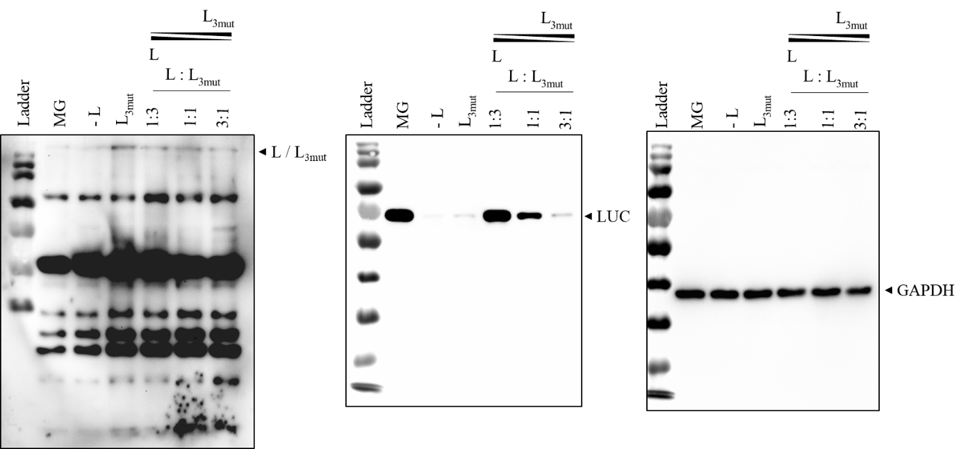
Fig. S4. Uncropped western blots assessing the EBOV mini-genome system relative activity at different ratios between EBOV L and L_{STOP}.

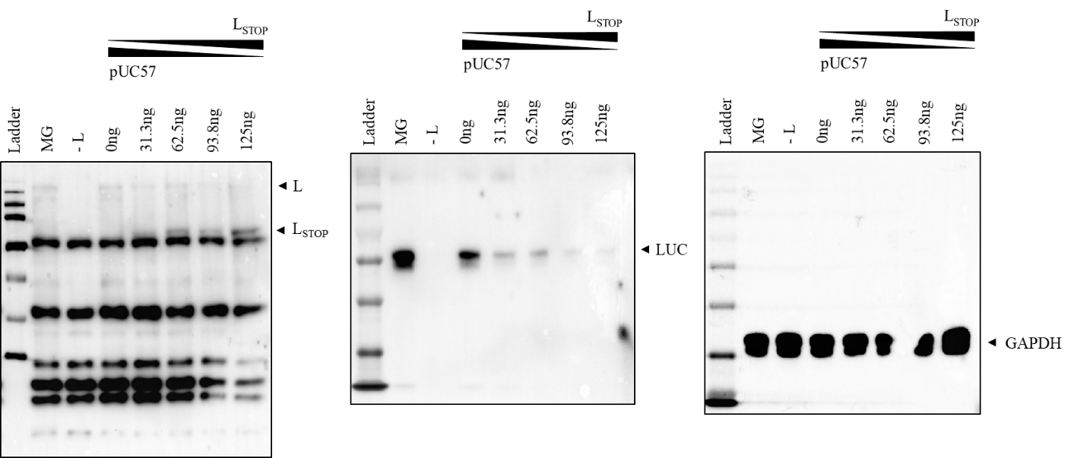
Fig. S5. Uncropped western blots assessing the EBOV mini-genome system relative activity at equal EBOV L but different L_{STOP} amounts.

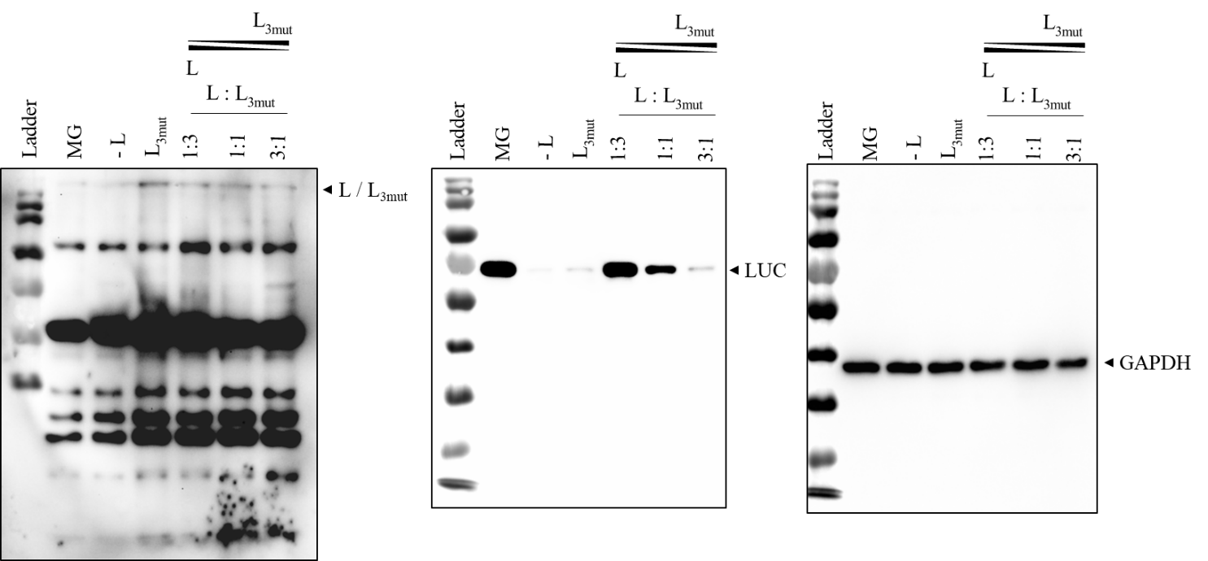
Fig. S6. Uncropped western blots assessing the functionality in an EBOV mini-genome system assay of the L_{3mut} protein at different ratios with EBOV L.

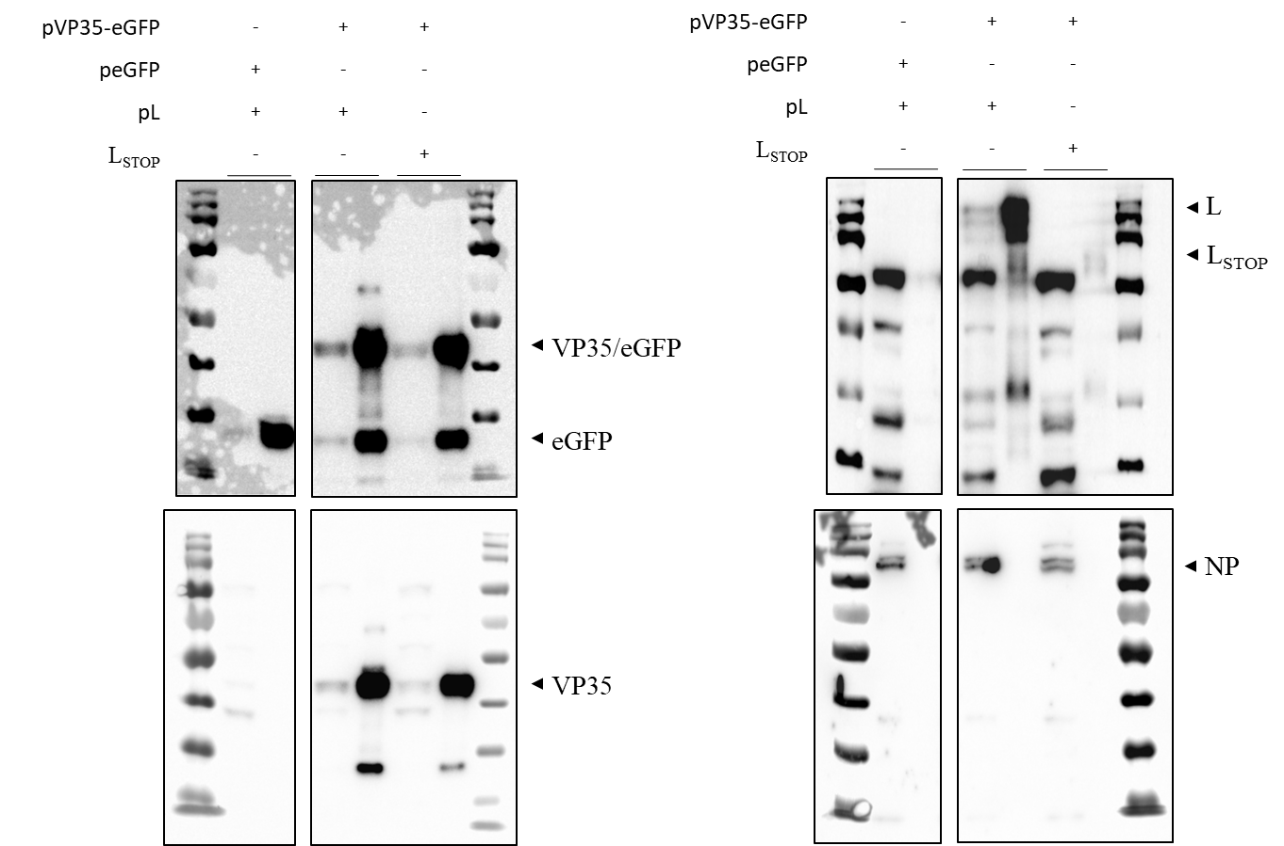

Fig. S7. Uncropped western blots of the co-immunoprecipitation (coIP) assay fractions to examine the interaction between EBOV VP35 with EBOV L_{STOP}.

Table S1: General statistics of PCR cycle, average coverage, variation coefficient, number of SNPs, average frequency of SNPs and viral load (1/Ct) for each sample. The mean and standard deviation of these factors were also calculated for both fatalities and survivors.

Sample ID | PCR cycle | Average coverage | Variation coefficient | Number of SNPs | Average frequency of SNPs | Viral load (1/Ct)
Fatality-1 | 15 | 654.57 | 0.45 | 24287 | 1.96E-03 | 5.80E-02
Fatality-2 | 15 | 3656.46 | 0.35 | 160103 | 2.31E-03 | 7.16E-02
Fatality-3 | 15 | 75.05 | 0.78 | 4302 | 3.03E-03 | 4.39E-02
Fatality-4 | 15 | 6079.84 | 0.30 | 275486 | 2.39E-03 | 6.84E-02
Fatality-5 | 15 | 1427.53 | 0.43 | 62578 | 2.31E-03 | 5.86E-02
Fatality-6 | 15 | 413.63 | 0.62 | 23375 | 2.98E-03 | 5.63E-02
Fatality-7 | 15 | 438.13 | 0.43 | 16858 | 2.03E-03 | 6.31E-02
Fatality-8 | 15 | 640.08 | 0.37 | 23869 | 1.97E-03 | 6.51E-02
Fatality-9 | 15 | 566.73 | 0.45 | 24772 | 2.31E-03 | 6.64E-02
Fatality-10 | 15 | 1568.12 | 0.39 | 59808 | 2.01E-03 | 6.25E-02
Fatality-11 | 15 | 79.61 | 0.55 | 3754 | 2.50E-03 | 5.33E-02
Fatality-12 | 15 | 169.37 | 0.53 | 7232 | 2.26E-03 | 5.39E-02
Fatality-13 | 15 | 39.98 | 0.64 | 5913 | 7.83E-03 | 6.33E-02
Fatality-14 | 15 | 371.38 | 0.47 | 15800 | 2.25E-03 | 5.14E-02
Fatality-15 | 15 | 4306.12 | 0.30 | 175077 | 2.14E-03 | 7.14E-02
Fatality-16 | 15 | 3492.66 | 0.35 | 145661 | 2.20E-03 | 6.98E-02
Fatality-17 | 15 | 10351.52 | 0.26 | 444520 | 2.27E-03 | 7.34E-02
Fatality-18 | 15 | 2025.2 | 0.43 | 80581 | 2.10E-03 | 6.84E-02
Fatality-19 | 15 | 1261.04 | 0.41 | 57948 | 2.42E-03 | 5.40E-02
Fatality-20 | 15 | 944.01 | 0.41 | 40090 | 2.24E-03 | 5.79E-02
Fatality-21 | 15 | 7825.25 | 0.28 | 287549 | 1.94E-03 | 7.95E-02
Fatality-22 | 15 | 816.98 | 0.43 | 97979 | 6.33E-03 | 5.24E-02
Fatality-23 | 15 | 3262.9 | 0.35 | 139813 | 2.26E-03 | 6.21E-02
Fatality-24 | 15 | 2880.43 | 0.33 | 122159 | 2.24E-03 | 6.39E-02
Fatality-25 | 15 | 3874.44 | 0.32 | 147584 | 2.01E-03 | 7.22E-02
Fatality-26 | 15 | 1670.33 | 0.37 | 67290 | 2.12E-03 | 5.63E-02
Fatality-27 | 15 | 9950.13 | 0.28 | 359825 | 1.91E-03 | 7.35E-02
Fatality-28 | 15 | 1559.77 | 0.38 | 61504 | 2.08E-03 | 5.95E-02
Fatality-29 | 15 | 1350.52 | 0.38 | 55736 | 2.18E-03 | 5.71E-02
Fatality-30 | 15 | 648.9 | 0.41 | 29936 | 2.44E-03 | 5.42E-02
Fatality-31 | 15 | 1454.27 | 0.44 | 60962 | 2.21E-03 | 6.20E-02
Fatality-32 | 15 | 2936.81 | 0.36 | 195692 | 3.51E-03 | 6.71E-02
Fatality-33 | 15 | 1443.69 | 0.41 | 61540 | 2.25E-03 | 5.23E-02
Fatality-34 | 15 | 938.24 | 0.49 | 45831 | 2.58E-03 | 5.45E-02
Fatality-35 | 15 | 3258.84 | 0.38 | 139726 | 2.26E-03 | 7.11E-02
Fatality-36 | 15 | 1546.01 | 0.37 | 56948 | 1.94E-03 | 6.43E-02
Fatality-37 | 15 | 748.51 | 0.46 | 29324 | 2.07E-03 | 5.54E-02
Fatality-38 | 15 | 1075.11 | 0.42 | 44042 | 2.16E-03 | 5.75E-02
Fatality-39 | 15 | 323.65 | 0.46 | 12602 | 2.05E-03 | 5.89E-02
Fatality-40 | 15 | 1607.18 | 0.39 | 59090 | 1.94E-03 | 6.55E-02
Fatality-41 | 15 | 595.84 | 0.46 | 31873 | 2.82E-03 | 5.70E-02
Fatality-42 | 15 | 656.29 | 0.44 | 35591 | 2.86E-03 | 5.90E-02
Fatality-43 | 15 | 1310.29 | 0.38 | 49538 | 1.99E-03 | 6.32E-02
Fatality-44 | 15 | 382.11 | 0.43 | 21071 | 2.91E-03 | 5.27E-02
Fatality-45 | 15 | 207.61 | 0.49 | 11921 | 3.03E-03 | 5.34E-02
Fatality-46 | 15 | 122.05 | 0.72 | 7166 | 3.10E-03 | 5.00E-02
Fatality-47 | 15 | 606.82 | 0.44 | 24288 | 2.11E-03 | 6.19E-02
Fatality-48 | 15 | 220.33 | 0.54 | 9790 | 2.34E-03 | 5.87E-02
Fatality-49 | 15 | 69.67 | 0.54 | 3318 | 2.52E-03 | 5.10E-02
Fatality-50 | 15 | 460.3 | 0.45 | 29349 | 3.36E-03 | 5.29E-02
Fatality-51 | 15 | 16.16 | 0.84 | 856 | 2.80E-03 | 3.90E-02
Fatality-52 | 15 | 238.36 | 0.47 | 10349 | 2.29E-03 | 4.87E-02
Fatality-53 | 15 | 717.49 | 0.41 | 33096 | 2.44E-03 | 5.84E-02
Fatality-54 | 15 | 1856.85 | 0.37 | 71788 | 2.04E-03 | 7.09E-02
Fatality-55 | 15 | 260.7 | 0.54 | 11304 | 2.29E-03 | 5.44E-02
Fatality-56 | 15 | 99.07 | 0.74 | 4937 | 2.64E-03 | 4.69E-02
Fatality-57 | 15 | 1083.26 | 0.39 | 48203 | 2.35E-03 | 5.76E-02
Fatality-58 | 15 | 410.21 | 0.64 | 16407 | 2.11E-03 | 6.12E-02
Fatality-59 | 15 | 606.7 | 0.46 | 33171 | 2.89E-03 | 5.64E-02
Fatality-60 | 15 | 234.8 | 0.47 | 11003 | 2.47E-03 | 4.69E-02
Fatality-61 | 15 | 947.96 | 0.40 | 41410 | 2.31E-03 | 5.78E-02
Fatality-62 | 15 | 208.33 | 0.72 | 9151 | 2.32E-03 | 5.70E-02
Fatality-63 | 15 | 325.31 | 0.46 | 14969 | 2.43E-03 | 4.80E-02
Fatality-64 | 15 | 854.78 | 0.46 | 33962 | 2.10E-03 | 7.21E-02
Fatality-65 | 15 | 2348.65 | 0.34 | 90787 | 2.04E-03 | 7.22E-02
Fatality-66 | 15 | 332.04 | 1.24 | 14658 | 2.33E-03 | 6.21E-02
Fatality-67 | 15 | 1953.61 | 0.36 | 105431 | 2.85E-03 | 6.13E-02
Fatality-68 | 15 | 130.26 | 0.55 | 5381 | 2.18E-03 | 5.52E-02
Fatality-69 | 15 | 318.94 | 0.51 | 14044 | 2.32E-03 | 4.90E-02
Fatality-70 | 15 | 88.31 | 1.27 | 4274 | 2.56E-03 | 5.56E-02
Fatality-71 | 15 | 362.58 | 0.86 | 16732 | 2.44E-03 | 5.98E-02
Fatality-72 | 15 | 4085.07 | 0.35 | 156742 | 2.02E-03 | 8.21E-02
Fatality-73 | 15 | 656.62 | 0.46 | 29004 | 2.33E-03 | 5.60E-02
Fatality-74 | 15 | 90.9 | 0.55 | 3495 | 2.03E-03 | 5.72E-02
Fatality-75 | 15 | 495.76 | 0.59 | 17483 | 1.86E-03 | 6.38E-02
Fatality-76 | 15 | 2783.9 | 0.35 | 104962 | 1.99E-03 | 6.85E-02
Fatality-77 | 15 | 413.76 | 0.46 | 16423 | 2.10E-03 | 6.06E-02
Fatality-78 | 15 | 1049.88 | 0.39 | 38869 | 1.95E-03 | 7.38E-02
Fatality-79 | 15 | 36.34 | 0.59 | 1487 | 2.16E-03 | 4.38E-02
Fatality-80 | 15 | 1579.16 | 0.37 | 63657 | 2.13E-03 | 6.04E-02
Fatality-81 | 15 | 137.89 | 0.71 | 5778 | 2.22E-03 | 5.42E-02
Fatality-82 | 15 | 427.77 | 0.59 | 18199 | 2.24E-03 | 6.41E-02
Fatality-83 | 15 | 614.38 | 0.45 | 23336 | 2.01E-03 | 6.73E-02
Fatality-84 | 12 | 663.67 | 0.49 | 38357 | 3.05E-03 | 5.51E-02
Fatality-85 | 12 | 132.94 | 0.50 | 6773 | 2.69E-03 | 4.16E-02
Fatality-86 | 12 | 1341.63 | 0.42 | 56471 | 2.22E-03 | 5.75E-02
Fatality-87 | 12 | 36.4 | 0.78 | 1942 | 2.82E-03 | 4.01E-02
Fatality-88 | 12 | 36.01 | 0.55 | 1753 | 2.58E-03 | 4.66E-02
Fatality-89 | 12 | 57.98 | 0.55 | 2604 | 2.37E-03 | 4.89E-02
Fatality-90 | 12 | 116.18 | 0.70 | 5317 | 2.42E-03 | 4.83E-02
Fatality-91 | 12 | 48.03 | 1.06 | 2328 | 2.58E-03 | 4.60E-02
Fatality-92 | 12 | 82.8 | 0.56 | 4110 | 2.62E-03 | 4.57E-02
Fatality-93 | 12 | 434.72 | 0.45 | 20365 | 2.47E-03 | 4.93E-02
Fatality-94 | 12 | 122.33 | 0.50 | 5855 | 2.53E-03 | 4.99E-02
Fatality-95 | 12 | 77.48 | 0.56 | 3858 | 2.64E-03 | 4.62E-02
Fatality-96 | 12 | 112.07 | 0.56 | 5509 | 2.60E-03 | 4.66E-02
Survivor-1 | 15 | 59.68 | 0.57 | 2600 | 2.30E-03 | 5.26E-02
Survivor-2 | 15 | 94.35 | 0.71 | 3952 | 2.21E-03 | 5.23E-02
Survivor-3 | 15 | 607.95 | 0.43 | 26571 | 2.31E-03 | 5.15E-02
Survivor-4 | 15 | 356.22 | 0.52 | 17468 | 2.59E-03 | 5.06E-02
Survivor-5 | 15 | 101 | 0.49 | 4806 | 2.51E-03 | 4.52E-02
Survivor-6 | 15 | 1846.14 | 0.37 | 81529 | 2.33E-03 | 5.46E-02
Survivor-7 | 15 | 96.92 | 0.60 | 4626 | 2.52E-03 | 4.51E-02
Survivor-8 | 15 | 350.38 | 0.51 | 14552 | 2.19E-03 | 5.09E-02
Survivor-9 | 15 | 42.7 | 0.93 | 3138 | 3.88E-03 | 4.54E-02
Survivor-10 | 15 | 116.72 | 0.59 | 9498 | 4.30E-03 | 4.68E-02
Survivor-11 | 15 | 63.61 | 0.62 | 4509 | 3.75E-03 | 4.67E-02
Survivor-12 | 15 | 26.49 | 0.60 | 1207 | 2.41E-03 | 4.73E-02
Survivor-13 | 15 | 172.37 | 0.56 | 8101 | 2.48E-03 | 5.03E-02
Survivor-14 | 15 | 64.62 | 0.56 | 2984 | 2.44E-03 | 4.55E-02
Survivor-15 | 15 | 127.42 | 0.49 | 7616 | 3.16E-03 | 5.19E-02
Survivor-16 | 15 | 159.21 | 0.51 | 9256 | 3.07E-03 | 4.32E-02
Survivor-17 | 15 | 54.12 | 0.63 | 3182 | 3.11E-03 | 3.78E-02
Survivor-18 | 15 | 257.21 | 0.48 | 9888 | 2.03E-03 | 5.79E-02
Survivor-19 | 15 | 69.04 | 0.63 | 3094 | 2.37E-03 | 4.55E-02
Survivor-20 | 15 | 20.76 | 0.79 | 1084 | 2.76E-03 | 4.40E-02
Survivor-21 | 11 | 163.58 | 0.57 | 8127 | 2.62E-03 | NA
Survivor-22 | 11 | 49.64 | 0.90 | 2145 | 2.29E-03 | 4.84E-02
Survivor-23 | 11 | 320.75 | 0.46 | 13045 | 2.15E-03 | 5.09E-02
Survivor-24 | 11 | 61.96 | 0.56 | 3039 | 2.60E-03 | 4.34E-02
Survivor-25 | 12 | 286.1 | 0.64 | 16974 | 3.13E-03 | 5.75E-02
Survivor-26 | 12 | 26.18 | 0.69 | 1311 | 2.66E-03 | 4.14E-02
Survivor-27 | 12 | 59.6 | 0.62 | 3026 | 2.68E-03 | 4.57E-02
Survivor-28 | 12 | 136.49 | 0.52 | 11119 | 4.30E-03 | NA
Survivor-29 | 12 | 114.41 | 0.57 | 5492 | 2.54E-03 | 3.17E-02
Survivor-30 | 12 | 87.82 | 0.59 | 4904 | 2.95E-03 | 4.30E-02
Survivor-31 | 12 | 73.89 | 0.52 | 3495 | 2.50E-03 | 4.83E-02
Survivor-32 | 12 | 70.19 | 0.53 | 3494 | 2.64E-03 | 4.79E-02
Survivor-33 | 12 | 130.99 | 0.50 | 6286 | 2.53E-03 | 4.91E-02
Survivor-34 | 12 | 101.4 | 0.60 | 4701 | 2.45E-03 | 4.60E-02
Survivor-35 | 12 | 100.26 | 0.53 | 4495 | 2.37E-03 | 4.90E-02
Survivor-36 | 12 | 49.63 | 0.54 | 2431 | 2.59E-03 | 4.90E-02
Survivor-37 | 12 | 118 | 0.54 | 5770 | 2.59E-03 | 4.72E-02
Survivor-38 | 12 | 198.74 | 0.48 | 9002 | 2.39E-03 | 4.98E-02
Mean of fatalities | - | 1264.50 | 0.50 | 53933.76 | 2.46E-03 | 5.83E-02
Standard deviation of fatalities | - | 1873.98 | 0.18 | 76115.43 | 7.65E-04 | 8.92E-03
Mean of survivors | - | 956.93 | 0.52 | 41090.73 | 2.53E-03 | 5.54E-02
Standard deviation of survivors | - | 301.56 | 0.11 | 13263.18 | 5.47E-04 | 5.00E-03

Table S2: Coefficients generated by glms. In each model, the term of “(Intercept)” is the intercept of regression for fatalities and the term of “1/Ct” is the slope of regression for fatalities; The term of “Survivors” indicates the difference of intercept in the regression of hospitalised survivors to hospitalised fatal cases and the term of “1/Ct:Survivors” indicates the difference of slope in the regression of hospitalised survivors to hospitalised fatal cases.
 | Term | Estimate | Std.error | Statistic | P-value
Deviation (fig. 1e) | (Intercept) | 230.965686 | 77.3391353 | 2.98640119 | 3.38E-03 | **
Deviation (fig. 1e) | 1/Ct | 3146.1085 | 1339.09337 | 2.34943177 | 2.03E-02 | *
Deviation (fig. 1e) | Survivors | 1.88587439 | 183.898241 | 0.01025499 | 9.92E-01
Deviation (fig. 1e) | 1/Ct:Survivors | 67.2037623 | 3763.07157 | 0.01785875 | 9.86E-01
Ts (fig. 1e) | (Intercept) | 440.0658323 | 55.1872552 | 7.97404818 | 7.43E-13 | ***
Ts (fig. 1e) | 1/Ct | 4405.309702 | 952.291535 | 4.62600952 | 9.00E-06 | ***
Ts (fig. 1e) | Survivors | -15.75466511 | 132.374611 | -0.1190158 | 9.05E-01
Ts (fig. 1e) | 1/Ct:Survivors | 426.3647915 | 2706.62585 | 0.15752631 | 8.75E-01
Tv (fig. 1e) | (Intercept) | 459.5975569 | 370.122283 | 1.24174517 | 2.17E-01
Tv (fig. 1e) | 1/Ct | 9657.982575 | 6440.6345 | 1.49953899 | 1.36E-01
Tv (fig. 1e) | Survivors | 47.9646623 | 869.275996 | 0.05517771 | 9.56E-01
Tv (fig. 1e) | 1/Ct:Survivors | -567.8873235 | 17808.5584 | -0.0318884 | 9.75E-01
L572 (fig. 2c) | (Intercept) | -6.236575332 | 1.19098349 | -5.2364919 | 6.53E-07 | ***
L572 (fig. 2c) | 1/Ct | 232.4688404 | 22.3129256 | 10.4185728 | 8.78E-19 | ***
L572 (fig. 2c) | Survivors | 7.068757752 | 2.34627066 | 3.01276314 | 3.12E-03 | **
L572 (fig. 2c) | 1/Ct:Survivors | -151.1440822 | 48.5028195 | -3.1161917 | 2.26E-03 | **
L986. (fig. 2d) | (Intercept) | -4.338988089 | 0.97153305 | -4.4661251 | 1.73E-05 | ***
L986. (fig. 2d) | 1/Ct | 166.2863538 | 18.1421132 | 9.1657654 | 1.04E-15 | ***
L986. (fig. 2d) | Survivors | 6.433032596 | 1.97841566 | 3.25160821 | 1.47E-03 | **
L986. (fig. 2d) | 1/Ct:Survivors | -139.1093669 | 40.594168 | -3.4268313 | 8.22E-04 | ***
L2061. (fig. 2e) | (Intercept) | -4.891539849 | 1.21786462 | -4.016489 | 1.00E-04 | ***
L2061. (fig. 2e) | 1/Ct | 216.2778233 | 22.4580962 | 9.63028306 | 7.66E-17 | ***
L2061. (fig. 2e) | Survivors | 7.355973457 | 2.47208468 | 2.97561549 | 3.50E-03 | **
L2061. (fig. 2e) | 1/Ct:Survivors | -159.3288384 | 50.7223188 | -3.1411978 | 2.09E-03 | **
Stop codon (fig. 3d) | (Intercept) | -75.4304652 | 33.5054089 | -2.2512922 | 2.64E-02 | *
Stop codon (fig. 3d) | 1/Ct | 2355.347737 | 611.246093 | 3.85335426 | 2.01E-04 | ***
Stop codon (fig. 3d) | Survivors | 120.6005535 | 57.9106187 | 2.08252918 | 3.97E-02 | *
Stop codon (fig. 3d) | 1/Ct:Survivors | -2576.836602 | 1150.31965 | -2.2401048 | 2.72E-02 | *
Signif. codes: 0 ‘***’ 0.001 ‘**’ 0.01 ‘*’ 0.05 ‘.’ 0.1 ‘ ’ 1

Table S3: Count of transition (Ts) and transversion (Tv) in all samples.
Mutation type | Interchanges | Survivors |  | Fatalities |  | All samples
Mutation type | Interchanges | Number | % mutates | Number | % mutates | Number | % mutates
Ts | A to G | 81765 | 24.85% | 1388631 | 26.79% | 1470396 | 26.67%
Ts | G to A | 22788 | 6.92% | 355847 | 6.87% | 378635 | 6.87%
Ts | C to T | 31722 | 9.64% | 512255 | 9.88% | 543977 | 9.87%
Ts | T to C | 57330 | 17.42% | 910139 | 17.56% | 967469 | 17.55%
Ts | Total | 193605 | 58.83% | 3166872 | 61.10% | 3360477 | 60.96%
TV | A to C | 24187 | 7.35% | 390291 | 7.53% | 414478 | 7.52%
TV | C to A | 19972 | 6.07% | 279580 | 5.39% | 299552 | 5.43%
TV | G to T | 15755 | 4.79% | 227470 | 4.39% | 243225 | 4.41%
TV | T to G | 18278 | 5.55% | 258838 | 4.99% | 277116 | 5.03%
TV | A to T | 23785 | 7.23% | 388049 | 7.49% | 411834 | 7.47%
TV | T to A | 17137 | 5.21% | 247559 | 4.78% | 264696 | 4.80%
TV | G to C | 6854 | 2.08% | 94216 | 1.82% | 101070 | 1.83%
TV | C to G | 8944 | 2.72% | 124766 | 2.41% | 133710 | 2.43%
TV | Total | 134912 | 41.00% | 2010769 | 38.79% | 2145681 | 38.92%

Table S4: ﻿Summary of the goodness of fit measures.
 | Null.deviance | Df.null | logLik | AIC | BIC | Deviance | Df.residual
Variation (Fig. 1e) | 6.344815225 | 131 | 814.886574 | -1619.7731 | -1605.3591 | 5.72458024 | 128
Ts (Fig. 1e) | 1.987165018 | 131 | 968.83851 | -1927.677 | -1913.263 | 1.53906307 | 128
Tv (Fig. 1e) | 16.54170919 | 131 | 871.423319 | -1732.8466 | -1718.4326 | 15.6183954 | 128
L572 (Fig. 2c) | 24.10337753 | 131 | 223.078869 | -436.15774 | -421.74373 | 11.118054 | 128
L986 (Fig. 2d) | 26.63419932 | 131 | 167.179241 | -324.35848 | -309.94447 | 14.1034737 | 128
L2061. (Fig. 2e) | 18.71989888 | 131 | 247.065374 | -484.13075 | -469.71674 | 8.81765706 | 128
Stop codon (Fig. 5d) | 58.90485951 | 108 | 348.06082 | -686.12164 | -672.6649 | 43.6055559 | 105

