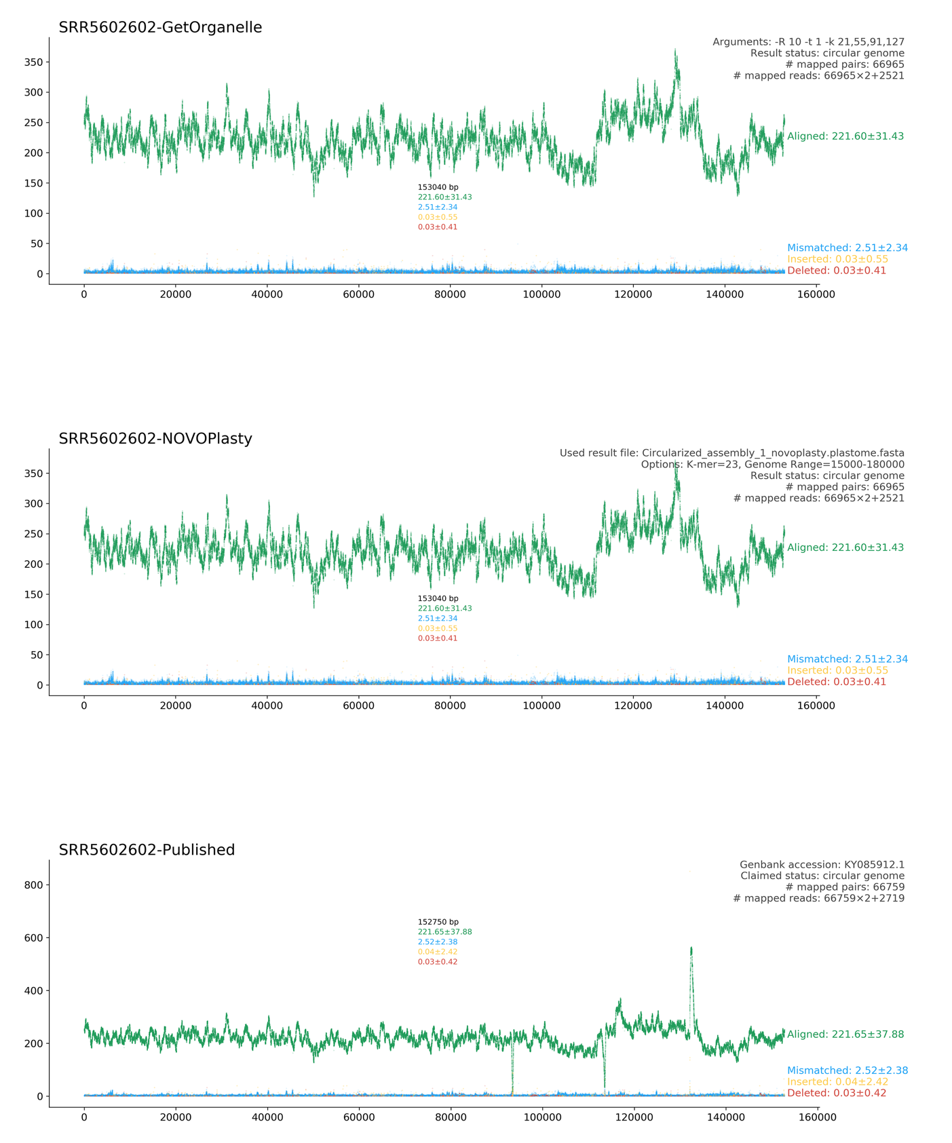
Additional file 1: Figure S1. Reads mapping comparisons among the plastomes reassembled using GetOrganelle and NOVOPlasty, and the plastome from GenBank (KY085912) based on the same raw data SRR5602602 (Laurus nobilis L.)

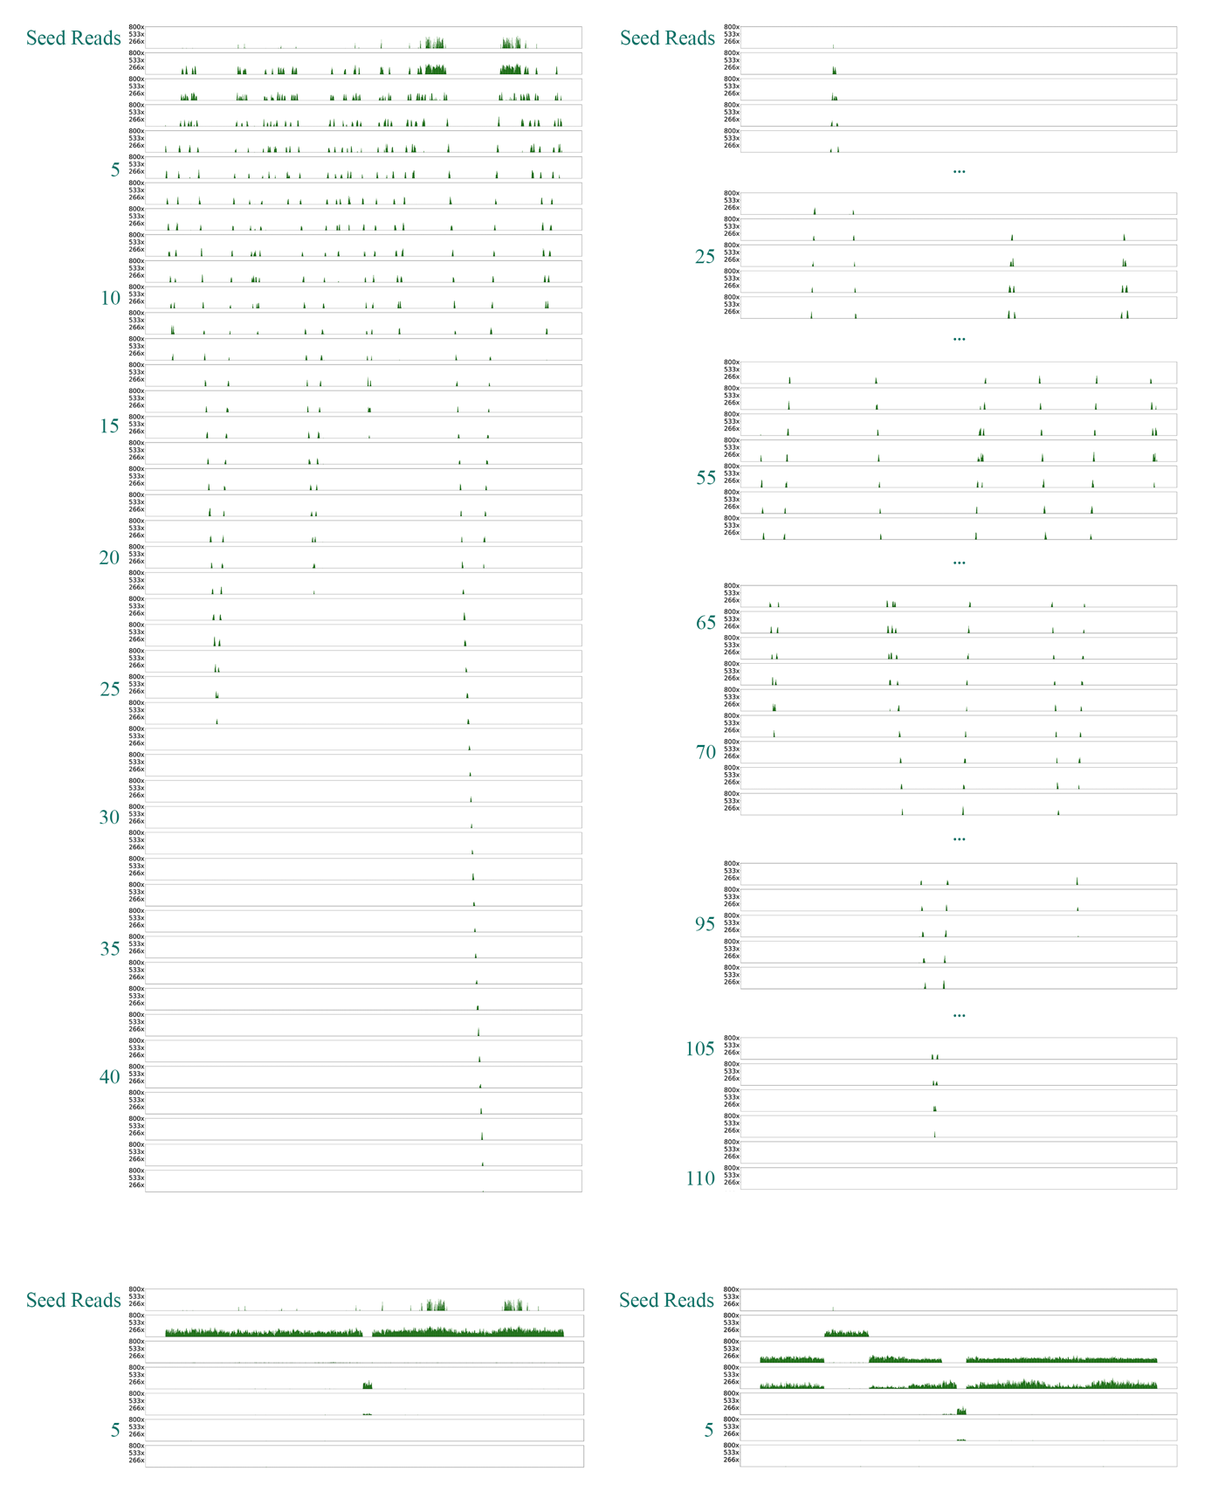Additional file 1: Figure S2. The covering positions and corresponding coverages at the plastome of newly captured reads during each round using GetOrganelle, with different arguments. A whole plastome and an rbcL region (right) from a gymnosperm species Gnetum parvifolium (Warb.) W.C.Cheng (GenBank nucleotide accession number: NC_011942.1) as the seed to assemble the plastome of an angiosperm species Haberlea rhodopensis from an online WGS dataset (GenBank SRA accession number: SRR4428742).
word size: 0.75, pre-grouping: 200,000

word size: 0.75, pre-grouping disabled

