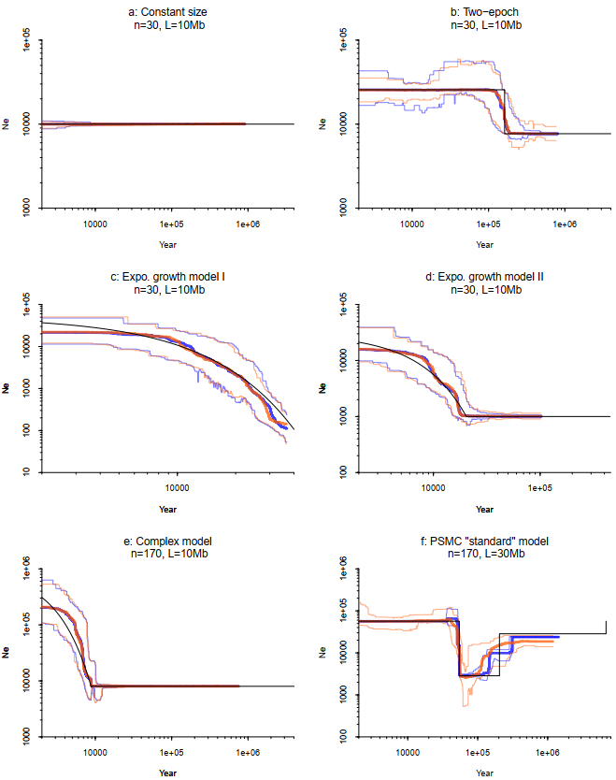
Fig. S1: Demographic inference comparison of Stairway Plot 2 with folded or unfolded SFS using the average SFS from 200 simulations. Each simulation simulated n sequences with L in length each. A total of 200 independent simulations were conducted.a: assuming the constant size model¹. b: assuming the two-epoch model¹. c: assuming an exponential growth model¹. d: assuming another exponential growth model¹. e: assuming a fast growth model¹. f: assuming the standard model used in the PSMC paper². Black line: true model. Thick orange line: median of 200 estimations with folded SFS. Thin orange lines: 5% and 95% of 200 estimations with folded SFS. Thick blue line: median of 200 estimations with unfolded SFS. Thin blue lines: 5% and 95% of 200 estimations with unfolded SFS.
A
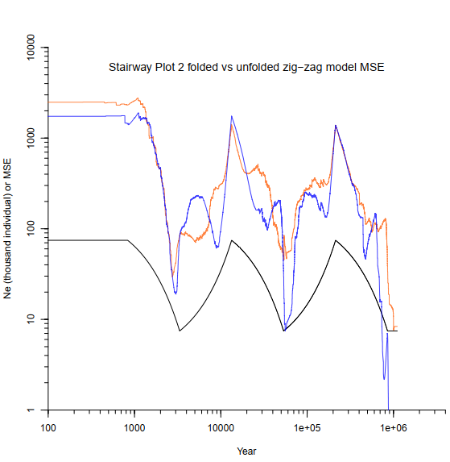

B
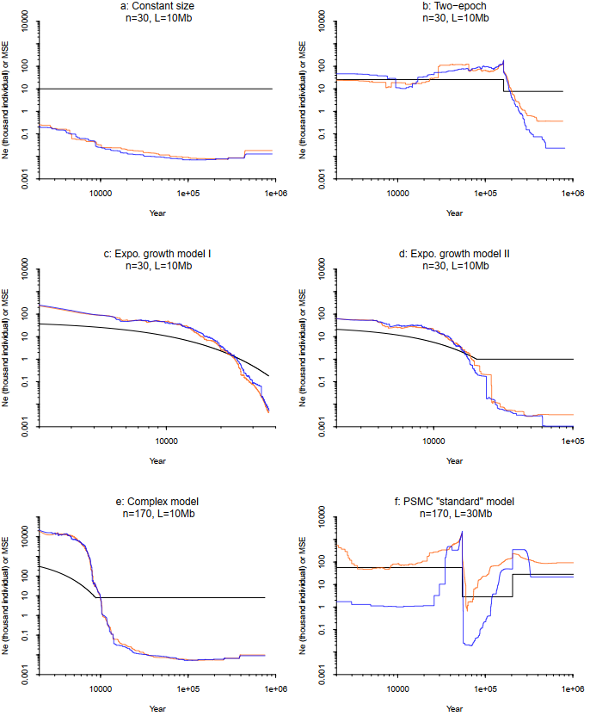
Fig. S2: Comparison of mean squared errors (MSEs) of 200 subsample estimations with either folded or unfolded SFSs calculated with Staiway Plot 2. A: The 200 subsample estmiations are the same ones used to produce the final estmiations and 95% CI estimations in Fig. 1A. B: The 200 subsample estmiations are the same ones used to produce the final estmiations and 95% CI estimations in Supplementary Fig. 1. Black line: true model. Orange line: MSE of the 200 subsample estimations with the folded SFS. Blue line: MSE of the 200 subsample estimations with the unfolded SFS.
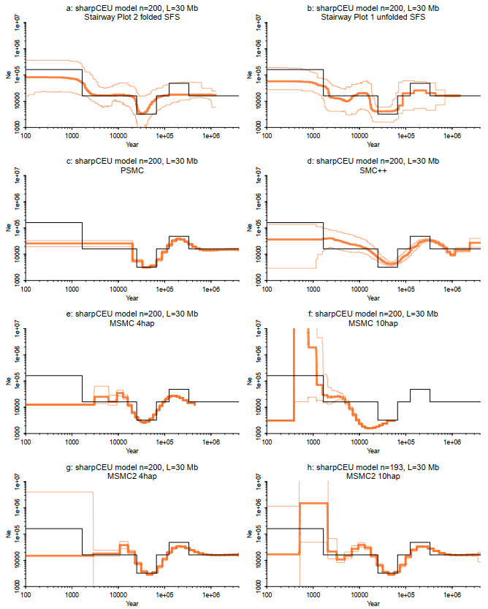
Fig. S3: Demographic inference comparison of Stairway Plot 2, Stairway Plot 1, PSMC, SMC++, MSMC and MSMC2 assuming the sharpCEU model³. Each simulation simulated n sequences with L in length each. A total of 200 independent simulations were conducted. Stairway Plot 2, Stairway Plot 1, PSMC, SMC++, MSMC and MSMC2 were applied to the same sample of 200 sequences for each simulation. MSMC and MSMC2 group samples with every 4 haplotypes (4hap) or every 10 haplotypes (10hap). n=193 in h because MSMC2 failed to obtain the final estimation for 7 samples. Black line: true model. Thick orange line: median of 200 estimations. Thin orange lines: 5% and 95% of 200 estimations.
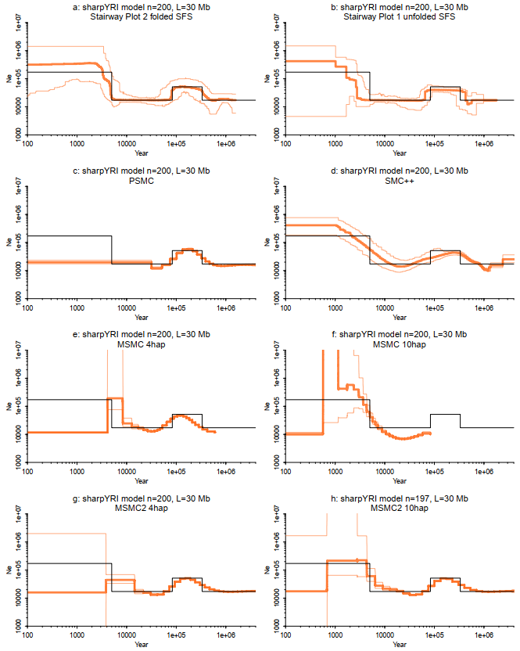
Fig. S4: Demographic inference comparison of Stairway Plot 2, Stairway Plot 1, PSMC, SMC++, MSMC and MSMC2assuming the sharpYRI model³. Each simulation simulated n sequences with L in length each. A total of 200 independent simulations were conducted. Stairway Plot 2, Stairway Plot 1, PSMC, SMC++, MSMC and MSMC2 were applied to the same sample of 200 sequences for each simulation. MSMC and MSMC2 group samples with every 4 haplotypes (4hap) or every 10 haplotypes (10hap). n=197 in h because MSMC2 failed to obtain the final estimation for 3 samples. Black line: true model. Thick orange line: median of 200 estimations. Thin orange lines: 5% and 95% of 200 estimations.
Reference
1. Liu, X. & Fu, Y.-X. Exploring population size changes using SNP frequency spectra. Nat. Genet. 47, 555–559 (2015).
2. Li, H. & Durbin, R. Inference of human population history from individual whole-genome sequences. Nature 475, 493–496 (2011).
3. Schiffels, S. & Durbin, R. Inferring human population size and separation history from multiple genome sequences. Nat. Genet. 46, 919–925 (2014).

