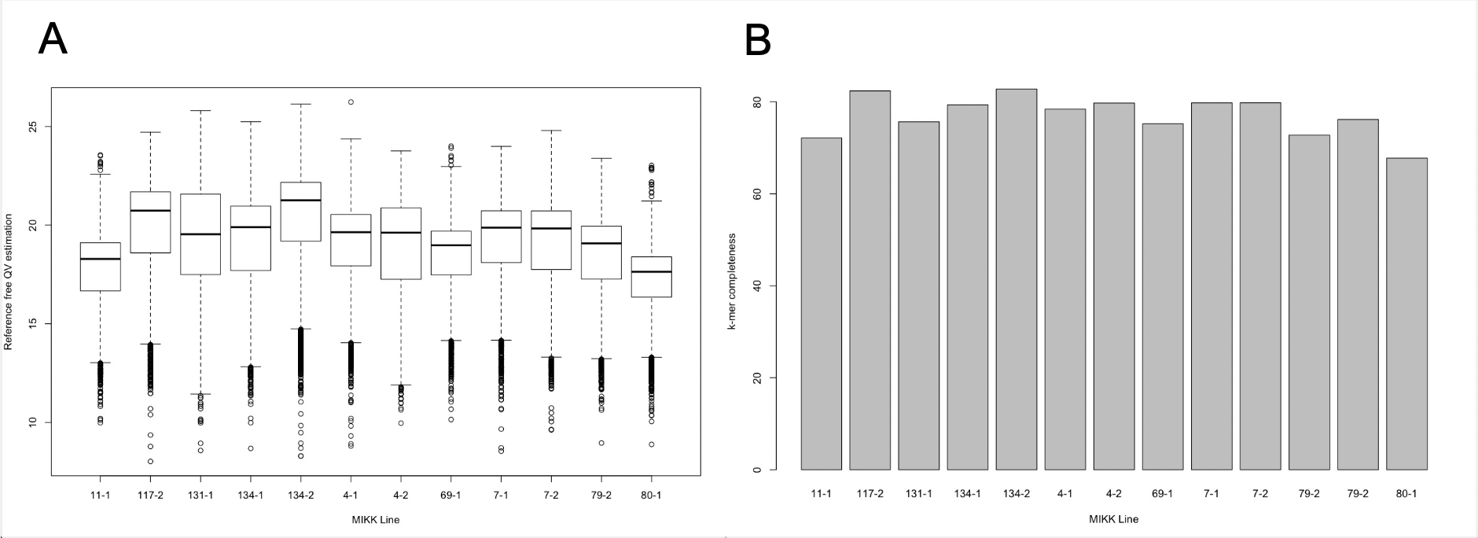

Figure S1: Reference free assembly quality assessment using Merqury. A: The QV estimation distribution of all contigs for the 12 MIKK panel assemblies. B: The k-mer completeness for the 12 MIKK panel assemblies.

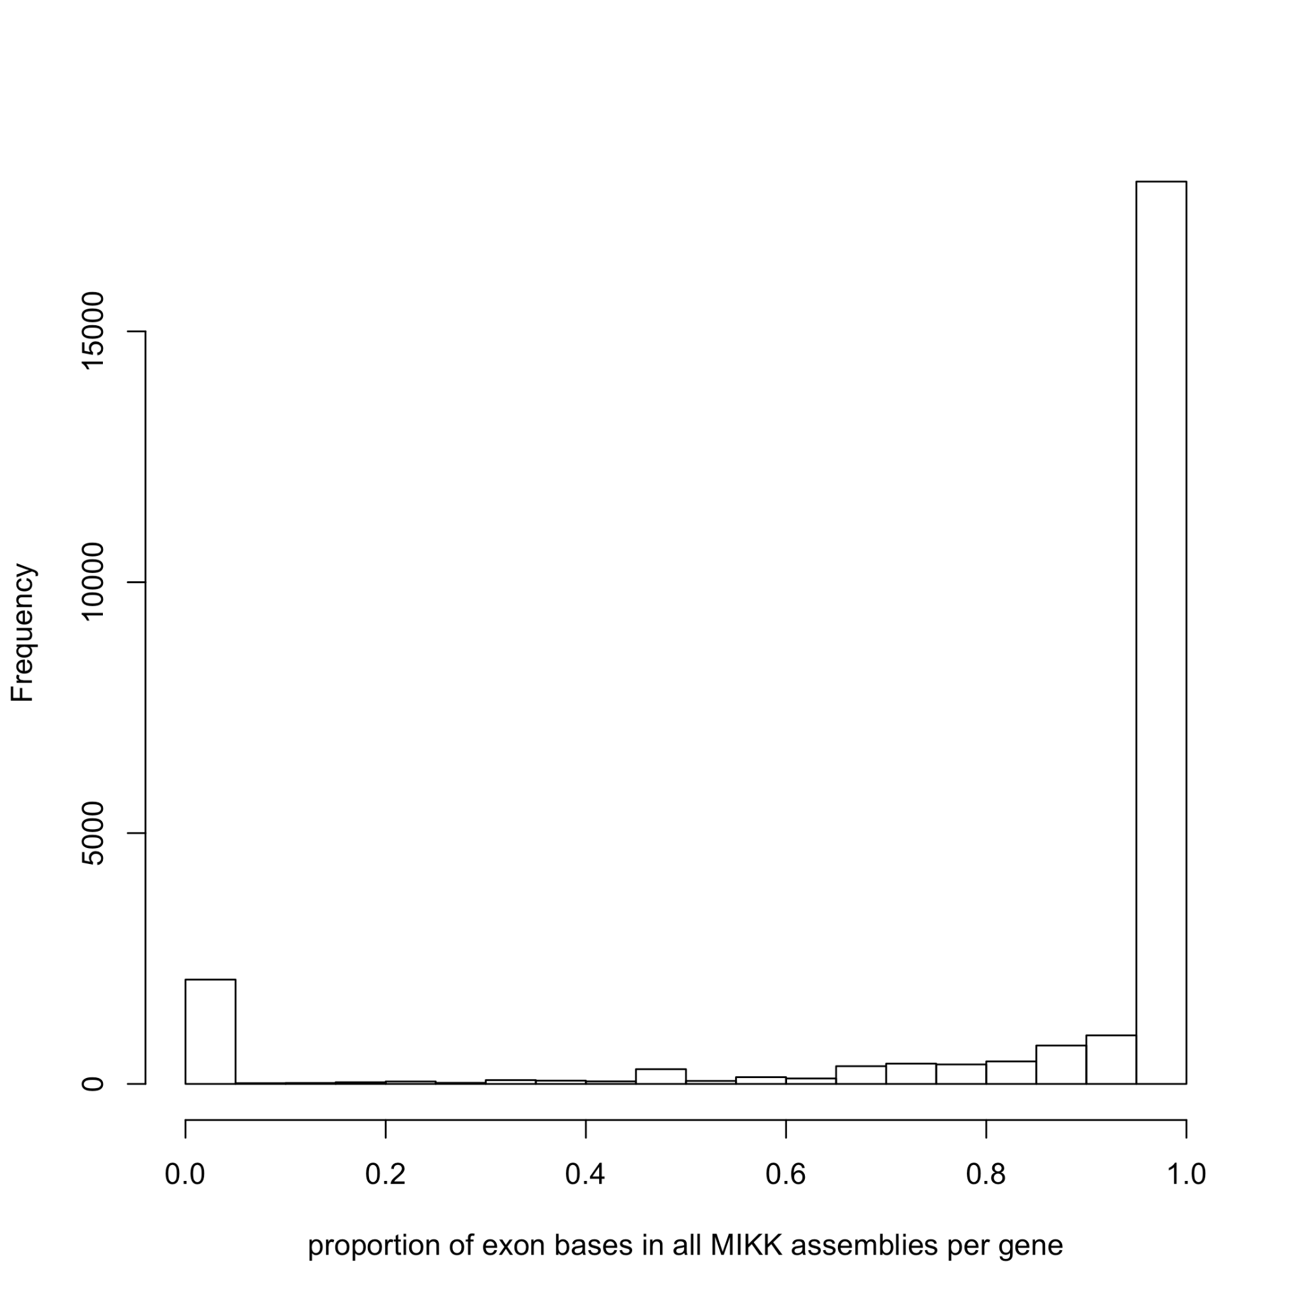
Figure S2: Histogram showing the proportion of exonic bases covered by all MIKK panel assembles for 24,328 annotated genes from the HdrR reference.

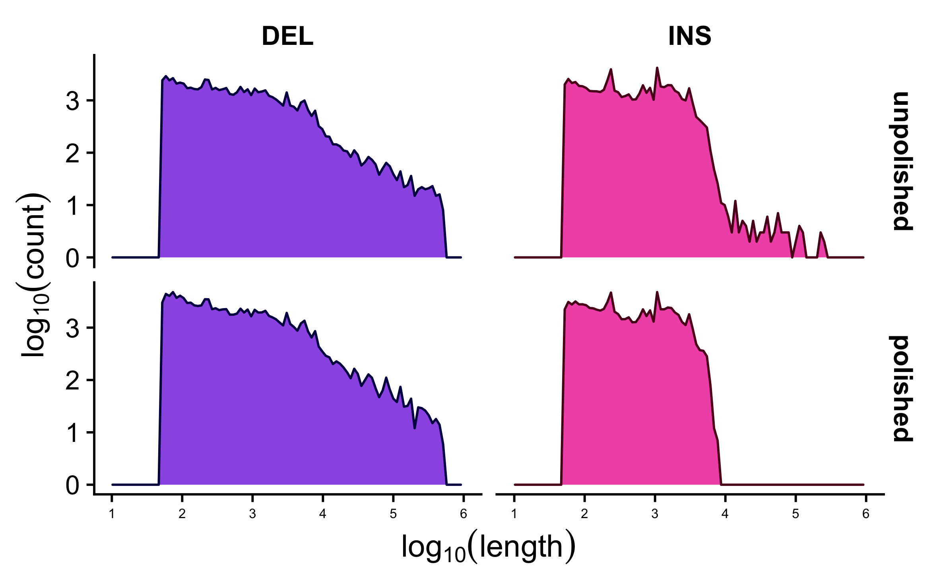

Figure S3: log₁₀ lengths and counts of deletion (DEL) and insertion (INS) structural variants before and after polishing with SViper.

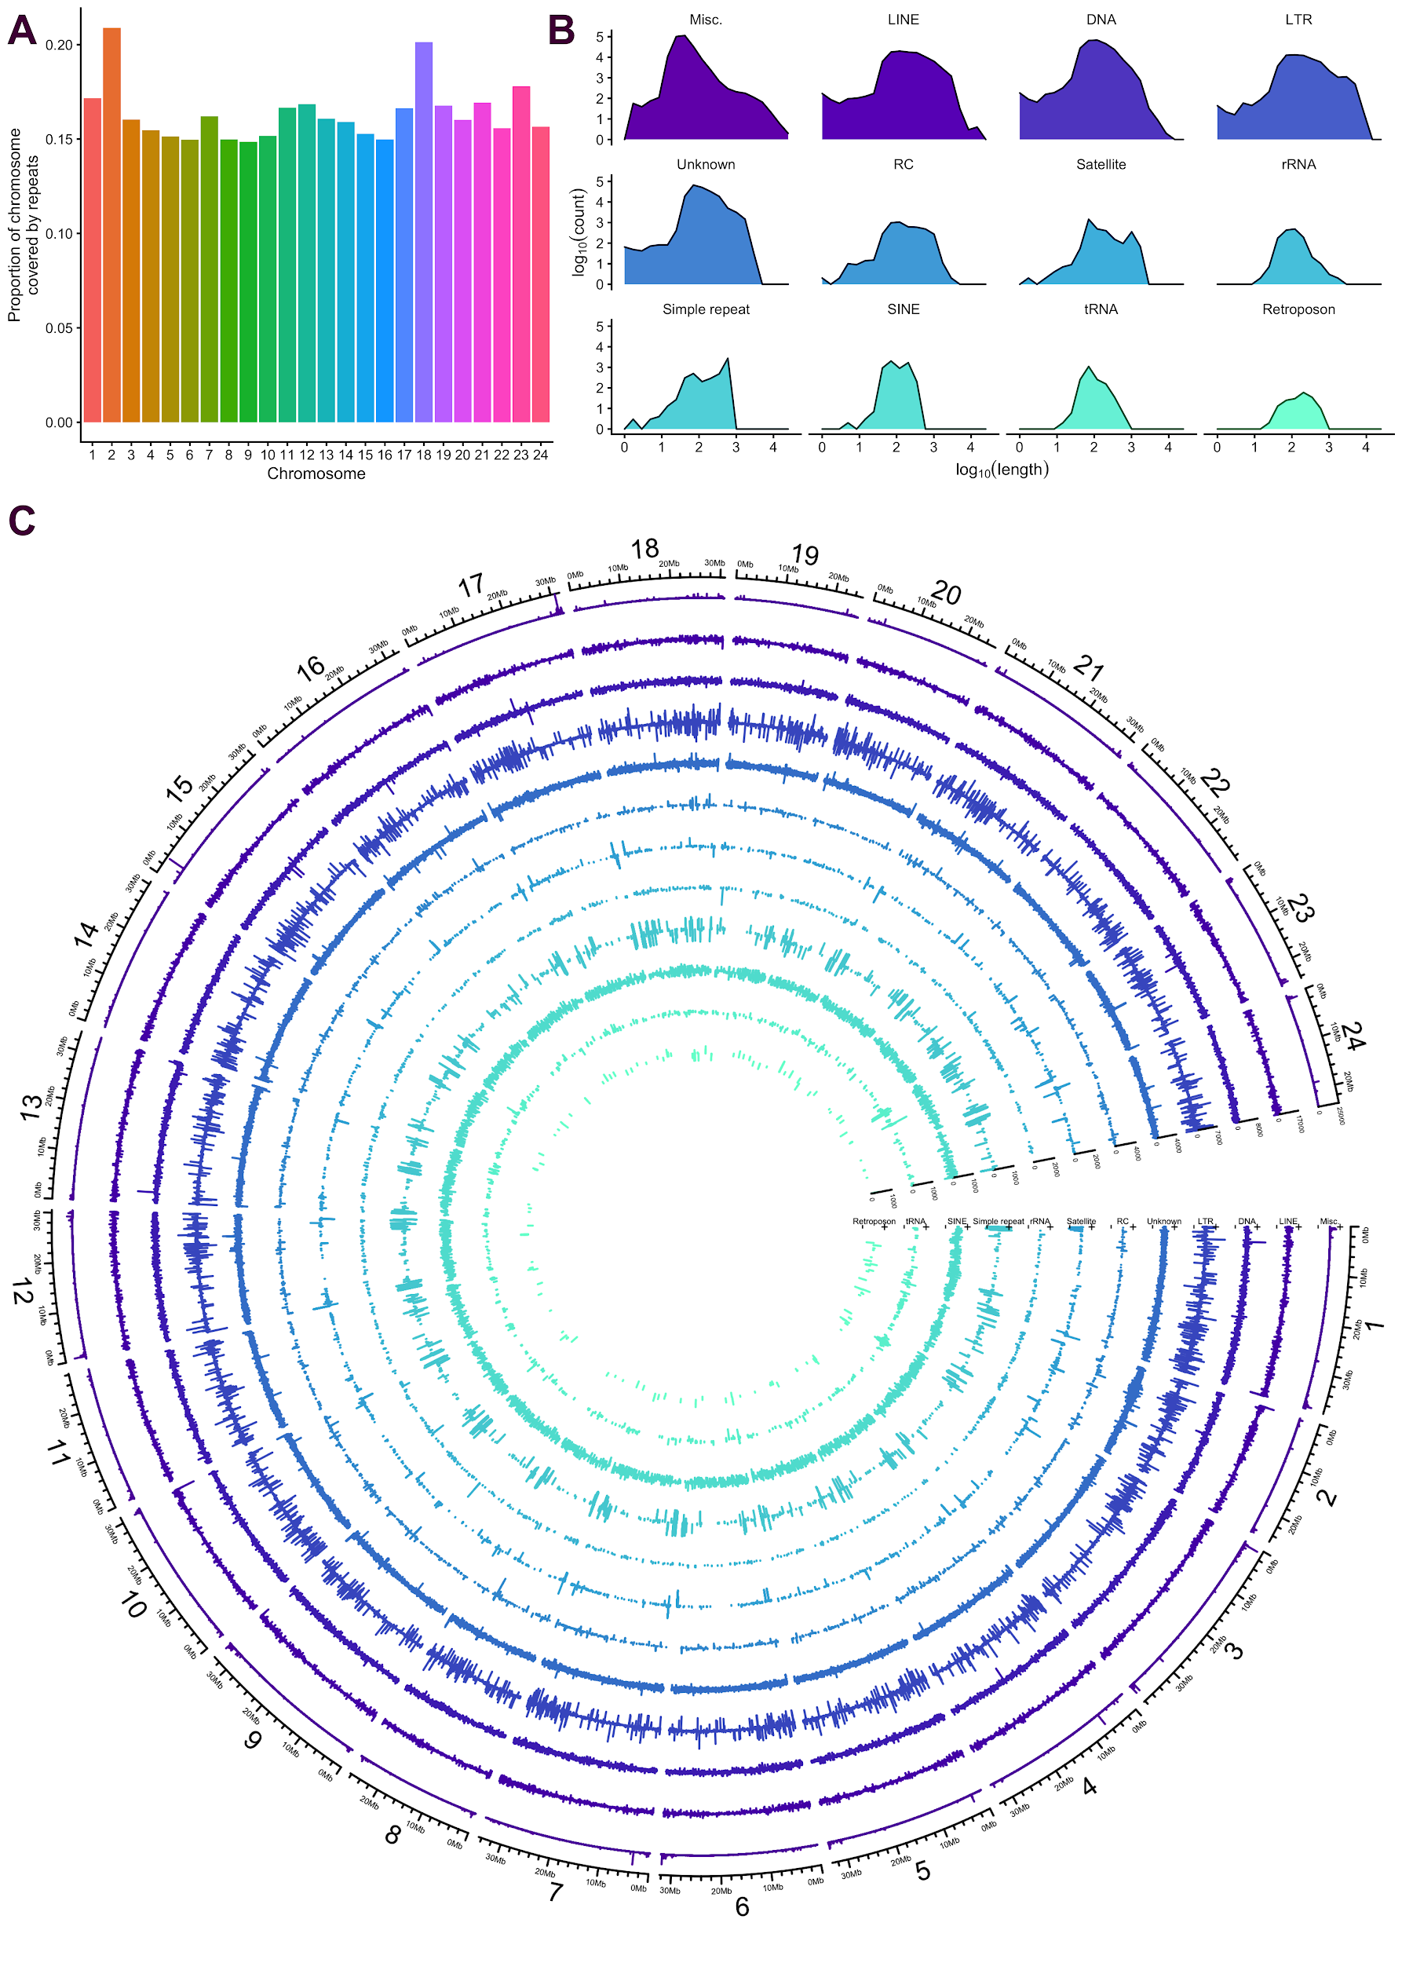

Figure S4: Repeat content in the HdrR genome based on RepeatMasker results (Methods). A. Proportion of repeat content per-chromosome. B. log₁₀ of repeat lengths and counts per repeat class. “Misc” includes all repeats assigned to their own specific class, for example “(GAG)n” or “(GATCCA)n”. C. Circos plot showing repeat length (radial axes) by locus (angular axis) and repeat class (track). The code and methods used to generate the figure are set out here: https://birneylab.github.io/MIKK_genome_main_paper/20210409_repeats.html

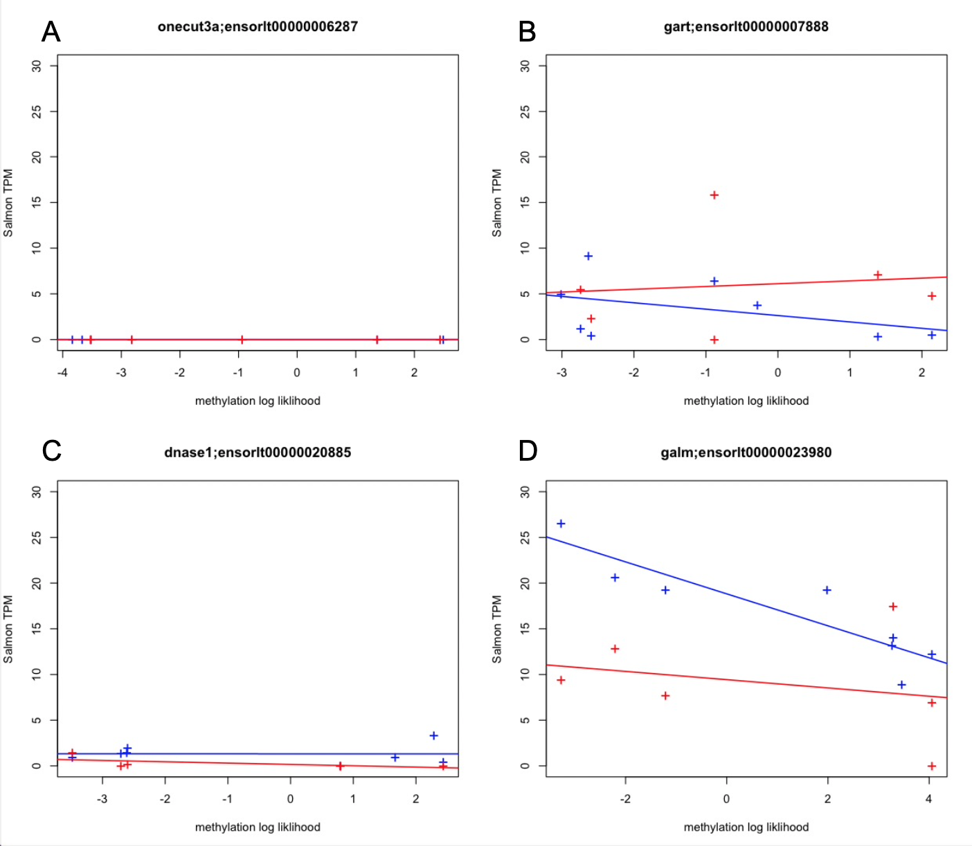

Figure S5: Median methylation log likelihood against Salmon transcripts per million for liver and heart at 4 of the top differentially methylated regions (DMRs). A: Methylation log likelihood against salmon TPM at the onecut3a gene (liver is shown in blue and heart is shown in red), B: Methylation log likelihood against salmon TPM at the gart gene (liver is shown in blue and heart is shown in red), C: Methylation log likelihood against salmon TPM at the dnase1 gene (liver is shown in blue and heart is shown in red), D: Methylation log likelihood against salmon TPM at the galm gene (liver is shown in blue and heart is shown in red).

