Additional file 1: Supplementary tables S1 and S2

The hazards of genotype imputation when mapping disease susceptibility variants

Winston Lau^{1†}, Aminah Ali^{1†}, Hannah Maude^{2†}, Toby Andrew², Dallas M. Swallow¹ and Nikolas Maniatis^{1*}

† Winston Lau, Aminah Ali and Hannah Maude contributed equally to this work.
__________________
¹University College London, Department of Genetics, Evolution and Environment,
UCL Genetics Institute, London, UK
²Imperial College London, Section of Genetics and Genomics, Department of Metabolism, Digestion and Reproduction, London, UK

*Correspondence: n.maniatis@ucl.ac.uk

Additional file 1: Table S1: Detailed output from the imputation for the three different experiments
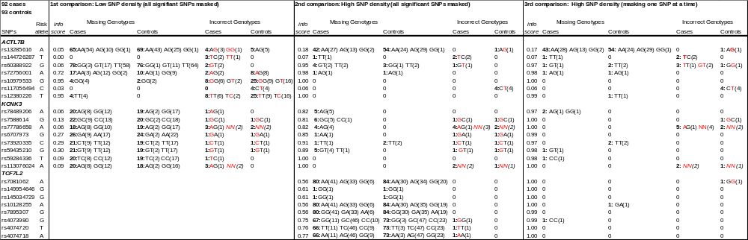

All imputed genotypes are based on the 1000 Genomes Project (1000GP) reference panel. Red alleles are the dataset's original but changed after imputation to the alternative alleles. For example, for the rs13285616, the cases AG(3), GG(1) indicate that 3 AG became AA and 1 GG became AA. The red NN is the original missing genotype that changed to homozygous for the major allele.

Additional file 1: Table S2: Comparison between reference panels
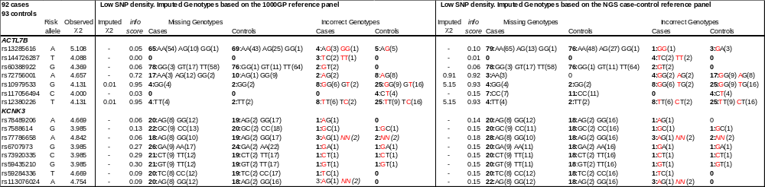

The T2D-association statistic (χ²) for the observed and imputed SNPs. Those with ‘-‘ were imputed as monomorphic. Red alleles are the dataset's original but changed after imputation to the alternative alleles. For example, for the rs13285616, the cases AG(3), GG(1) indicate that 3 AG became AA and 1 GG became AA. The red NN is the original missing genotype that changed to homozygous for the major allele.

