Review History
First round of review
Reviewer 1

Were you able to assess all statistics in the manuscript, including the appropriateness of statistical tests used?
Yes, and I have assessed the statistics in my report.

Comments to author:
In this manuscript, Mellis et al. have used computational analyses to examine the extent of nonsense-induced transcriptional adaptation, a form of compensation that mitigates propagation of perturbations through gene regulatory networks. While the mechanism(s) of transcriptional adaptation is not known, the phenomena has been observed in several systems prior to this work. Thus, Mellis et al set out to identify pairs of genes (generally paralogs or other related genes) that display compensatory expression. The manuscript succeeds on several points and claims. Specifically, the data show that nonsense-mediated transcriptional adaption is not limited to specific cellular contexts (e.g. genes exist that show transcriptional adaptation across cell lines and context) (Fig 1). They also show (albeit with some concerns about Fig 5E) how transcriptional activation may confound perturbative experiments, by weakening phenotypic changes (Fig 5). Fig 5 offers interesting implications for the effect of transcriptional adaptation in gene regulatory networks. This figure stands out for being nicely organized. However, the paper becomes very confused and confusing in the middle where analyses and modeling seem unclear. While the there was considerable text devoted to the development of the model, it remains unclear if it is appropriately parameterized as the space is large. The abstract states that regulon analysis "recapitulates important model predictions" but it is not clearly defined what those would be other than the expected priors of the model. In summary, while there are important ideas and pieces of work included, the manuscript overall lacks the cohesion and analyses needed to succeed in the objective of demonstrating the prevalence of and gene regulatory constraints on transcriptional adaptation in single cells.
Major concerns.
1. The connection between the data, model, and predictions feels disjointed. It is hard to suggest how to fix this as it may be due to the nature of many disparate data sets and differences between genes that show transcriptional adaptation.
2. Model predictions are unclear. Mainly, it seems that the manuscript presents a stochastic model of transcriptional adaptation. They show that under different parameter regimes this model gives qualitatively different expression distributions. What that means and if it's valid and important still seems buried.
3. The abstract states that regulon analysis "recapitulates important model predictions". What are those? The predictions that come out of the model should be defined clearly. For the final conclusions in Fig 5, it's not clear the model was needed. So the model feels like it's been added in to improve analysis but it's not apparent that it does.
4. Some of the metrics show correlations but it's not clear if that metric is important. For example Fig 1F that fraction of upregulated genes is a meaningful metrics for determining nonsense-induced transcriptional adaptation. If there were 3 paralogs instead of 2 paralogs upregulated in one condition, that would show poor correlation but if there are 10 paralogs and 2 always show increase that would be good. If the increased paralogs are always different (and we can't tell from the analysis), does this tell us that transcriptional adaptation is common? Are we just looking at noise? Or is the fraction upregulated higher than would just occur by chance? For many pairs, it looks like 1 gene shows upregulation. For these cases, is this always the same gene? Or is the point that there are many modes of transcriptional adaptation and no one paralog can account for the phenomena. In either case, this is not clear. The lack of clarity makes the importance of this metric dubious.
5. The authors claim that their work demonstrates that transcriptional adaptation is "widespread" in mammalian systems. "Widespread" does not seem like the right wording as the number of affected genes seems relatively small. Perhaps identifying how these affects might radiate to many important processes (via TFs) would support the claim that these effects can be substantial across cellular processes and states. The data better supports a more narrow claim that nonsense-mediated transcriptional adaption is not limited to specific cellular contexts. (e.g. genes exist that show transcriptional adaptation across cell lines and context.)
Minor concerns.
1. It is difficult to compare to datasets. We suggest splitting figure 1 into two figures. How many paralogs each of the genes in 1F have is a crucial piece of information needed to interpret the figure. E.g. if Smg7 only has one paralog or Myc only has three paralogs, then the dots in the upper right are less convincing (because they can only take on specific values). See main pt 4.
2. The authors do an important task in highlighting that nonsense transcriptional adaptation can confound perturbative screens (e.g. "the latter hypothesis implies that functional genetic screens for phenotypic outcomes will need to account for transcriptional adaptation." (pg 4, 28-30)). However, is there any way of accounting, controlling for this mechanism or should we not perform screens as we do now? I think there should be more in the discussion of where this work needs to direct us.
Minor comments and suggestions on figures.
- "Cells have a _remarkable_.......can remarkably trigger": repeated in intro and abstract. (pg 3).
- It would be helpful to expand on the description of citation 2 on page 4, line 4. Adding a sentence or two of the main discrepancy between knockouts/knockdowns would be helpful.
- In the intro, it would be helpful to add a discussion of the COMPASS complex / Upf genes, so that their first appearance is not in the results section.
Figure 1
- 1b: contrast on black/teal "identification/setup", "downstream analysis". Also it is low contrast on the gray/black.
- Consider plotting this as a volcano plot( p-value on x axis, fraction upregulated on y axis). The p-value is computed from the "expected fraction upregulated" (e.g. your bootstrapped null), so it is distracting to have both.
- Volcano plots also let you draw your p-value cutoff directly as a vertical line.
- Poor colormap choice.
- Overlapping labels
- 1e/1f: possibly split into its own separate (smaller) figure.
- "niave ESCs"
- 1f:How many paralogs do each gene have? E.g. if Smg7 only has one paralog then having 100% upregulated is less compelling.
Figure 2
- 2b: Can you add the gray dots to the right-hand panel of B to demonstrate that there is not a global increase in expression / that there is still a separation between gray and pink at the mean expression level.
- 2c: You can reduce the Venn diagram size.
- 2d: Why? This is not a strong addition to the figure.
- 2c/2d are distracting/don't add to the figure.
Figure 3
- 3B: Individual traces do show ergodicity, but probably can be moved to the supplemental information. If you want to keep one, then possibly keep the bimodal one, but annotate it (e.g. add vertical bands that separate the subpeaks of the bimodal peaks).
- 3F/3G: Showing the neighborhood in this way is a weak statement; showing that a small neighborhood around the trimodal parameter set is also trimodal is only helpful if you show that the neighborhood size is reasonable.
- Add a cartoon that explains the key three ratios that you are using.
Figure 4
- The decision tree splitting of the parameter space is confusing. This needs a cartoon description that you are splitting the high-dimensional space with planes at a minimum.
- This works better when combined and simplified with a Figure 3.
- Consider instead showing a decision tree for {unimodal, bimodal, trimodal, skewed, low expression} and sharply limiting the size of the tree, to enhance reader understanding. The full decision tree is too much information, especially for the trees in the SI.
- Ideally, it would be interesting to see the 3D diagram (or projection into 2D) of production ratio/activation ratio/NITC ratio where the regions are shown. This could be kmeans of each type to show generally where each of {unimodal, bimodal, trimodal, skewed, low expression} fall in the space. Then, the reader could see the spread across these three variables.
- This also answers how pervasive each of these types of distributions are! You could see that e.g. the trimodal space is a lot smaller than the unimodal space.
Figure 5
- 5a: misalignment of "mut" in the circles. What does "robustness" mean? Does the left mean "low robustness" and the right mean "high robustness"?
- 5c/d/e: What is "abundance"? Needs to be explained; is this single-cell UMIs, some size-factor-corrected value?
- 5c/d/e: Consider doing a log transform of the y axis.
- 5e: This needs some sort of quantification (KS test, Fisher exact).
- 5e: Which distributions match the claims "some downstream genes demonstrated fully robust, consistent gene expression distribution shapes, while others demonstrated partial expression robustness with possible new modes of gene expression, or lower expression overall"? This is unclear. Can you label the diagram and possibly back up this with a statistical test (or bootstrapping?) Fraction positive is a weak statistic.
- 5f/5g: this is the most interesting part of figure 5! It clearly shows the claim that the TFs that demonstrate adaptation have a lower standard deviation.

Reviewer 2

Were you able to assess all statistics in the manuscript, including the appropriateness of statistical tests used?
Yes, and I have assessed the statistics in my report.
Comments to author:
In Prevalence of and gene regulatory constraints on transcriptional adaptation in single cells, Mellis et al. analyze a swath of available genome-wide transcription data to discover a pervasiveness of nonsense-induced transcriptional compensation (NITC), whereby nonsense mutations of genes upregulate transcription of paralogs of those genes via an undiscovered mechanism. The results have important implications for how to interpret the results of popular gene-knockout approaches at least in humans and in mice. Furthermore, using a minimal mathematical model of transcription and nonsense-induced paralog transcription, the authors support the concept that transcriptional adaptation could provide a means for robustness in downstream effector variability. Lastly, they return to the datasets to find that NITC may indeed be responsible for buffering expression changes in downstream targets that are mutually targeted by paralog pairs.
The authors excel in setting proper controls in their analyses and maintaining stringent conditions for drawing conclusions, giving high confidence in their results. The work harnesses the power of the many existing RNAseq datasets and numerous CRISPR/Cas9 experiments performed to gather this data, revealing that there is much more information to learn from existing data, and demonstrating that NITC is widespread. Their model discovers interesting spaces of robust unimodal distributions, bimodal distributions, and even trimodal distributions of downstream effectors. Together, their computational framework should influence the design and analysis of genetic experiments from single-cell to bulk.
This work is appropriate for publication, with a few outstanding curiosities:
1. The authors do a good job eliminating factors such as sequence homology, shared signaling pathways, and correlated expression of adaptive components, but still there are other questions that could be tackled to help discover the mechanism behind this phenomenon. For instance, do identified paralog pairs have other shared non-coding genetic features (i.e., regulatory sequences like promoters, introns or shared enhancers)? Do identified compensatory paralogs share physical space (topologically associated domains as investigated in 10.1093/nar/gkw813)
a. Follow-up: If some of these other features (shared enhancer; shared TAD; etc) do predict non-sense induced transcriptional adaptation of paralogs, do these features also predict upregulation of non-paralogous genes that share the same feature?
2. If wild type paralog pairs have correlated co-expression, does this predict nonsense-induced transcriptional compensation in KO mutants?
3. Does the single-cell RNA-seq data eliminate the possibility that enrichment of paralogs is due to selection of cells that happened to have had increased paralog expression, and are therefore more fit? (i.e., selection from a random distribution rather than induced adaptation)

Authors Response
Point-by-point responses to the reviewers’ comments:
Reviewer #1: In this manuscript, Mellis et al. have used computational analyses to examine the extent of nonsense-induced transcriptional adaptation, a form of compensation that mitigates propagation of perturbations through gene regulatory networks. While the mechanism(s) of transcriptional adaptation is not known, the phenomena has been observed in several systems prior to this work. Thus, Mellis et al set out to identify pairs of genes (generally paralogs or other related genes) that display compensatory expression. The manuscript succeeds on several points and claims. Specifically, the data show that nonsense-mediated transcriptional adaption is not limited to specific cellular contexts (e.g. genes exist that show transcriptional adaptation across cell lines and context) (Fig 1). They also show (albeit with some concerns about Fig 5E) how transcriptional activation may confound perturbative experiments, by weakening phenotypic changes (Fig 5). Fig 5 offers interesting implications for the effect of transcriptional adaptation in gene regulatory networks. This figure stands out for being nicely organized. However, the paper becomes very confused and confusing in the middle where analyses and modeling seem unclear. While the there was considerable text devoted to the development of the model, it remains unclear if it is appropriately parameterized as the space is large. The abstract states that regulon analysis "recapitulates important model predictions" but it is not clearly defined what those would be other than the expected priors of the model. In summary, while there are important ideas and pieces of work included, the manuscript overall lacks the cohesion and analyses needed to succeed in the objective of demonstrating the prevalence of and gene regulatory constraints on transcriptional adaptation in single cells.

Reply: We thank the reviewer for their assessment that our study is interesting and that it provides important ideas. We also note that the reviewer raised several concerns about the study. We have taken all of their feedback seriously, and performed several new analyses and rewritten parts of the manuscript. We believe that our revised manuscript is significantly improved as a result. Major highlights of our revision include:

- Additional paralog expression change analyses: we performed several new analyses of paralog gene expression data.
  - Additional statistical analysis of Perturb-seq gene expression distribution changes after mutation, including Fisher’s Exact Tests for differences in percent-positive values and bimodality coefficients of distributions before and after mutation.
  - Additional analysis of repeatability of paralog upregulation on a per-paralog basis and a per-CRISPR-target basis, in a new standalone Figure 2.
- Additional analysis of model simulations: we further explored the associations between model parameters and downstream gene expression distributions. We conducted additional decision tree analyses to determine enrichment of different distribution shapes in parameter space, including:
  - Visualizations of parameter set decision rules that lead to high frequency of different distribution shapes.
  - Decision tree analysis of all classified distribution shapes and summary analysis of observed subspace sizes
  - Additional sets of simulations demonstrating enrichment for distribution shapes, taking into account observed subspace sizes
- Rewriting and reorganizing parts of the manuscript for clarity and enhanced precision of explanations: we clarified descriptions of statistical analyses, augmented the justification for the gene regulatory network model, and reoriented the connections between the two. We overhauled the text by augmenting Introduction, Results, and Discussion sections and by precisely describing the specific connections between the public data reanalysis and the modeling in response to the Reviewers’ comments. Furthermore, we made the simulation-based Results sections more concise and in harmony with the rest of the manuscript. We also created a new Supplementary Note document with technical notes on simulation results.

Major concerns.

1. The connection between the data, model, and predictions feels disjointed. It is hard to suggest how to fix this as it may be due to the nature of many disparate data sets and differences between genes that show transcriptional adaptation.

Reply: We agree with the reviewer that the connections between the model, its predictions, and the data needed to be clarified. Briefly, the purpose of the model is to explore in silico the range of possible consequences of transcriptional adaptation in the setting of a mutated transcription factor. We focused on this particular gene regulatory network model of transcriptional adaptation consequences, because 1) many developmental regulatory programs require transcription factor activity and transcriptional adaptation was originally described primarily in developmental contexts; and 2) some of the hits in our reanalysis of CRISPR/Cas9 RNA-seq datasets are transcription factors. The single-cell focus of the model emerges from consideration of the fact that unexpected deviations of single-cell phenotypes can be the underlying cause of variable penetrance and severity in disorders ranging from cancer to developmental abnormalities. However, we completely agree with the reviewer that the connection was (unintendedly) stated underwhelmingly in the original submission. We have extensively edited the text to bring our points across appropriately, including moving and condensing the sections and figures on modeling for clarity and flow.

Abstract

Cells and tissues have a remarkable ability to adapt to genetic perturbations via a variety of molecular mechanisms. Nonsense-induced transcriptional compensation, a form of transcriptional adaptation, has recently emerged as one such mechanism, in which nonsense mutations in a gene can trigger upregulation of related genes, possibly conferring robustness at cellular and organismal levels. However, beyond a handful of developmental contexts and curated sets of genes, to date, no comprehensive genome-wide investigation of this behavior has been undertaken for mammalian cell types and contexts. Moreover, how the regulatory-level effects of inherently stochastic compensatory gene networks contribute to phenotypic penetrance in single cells remains unclear. Here we present analyses of existing bulk and single-cell transcriptomic datasets to uncover the prevalence of transcriptional adaptation in mammalian systems across diverse contexts and cell types. We next performed regulon gene expression analyses of transcription factor target sets in both bulk and pooled single-cell genetic perturbation datasets. Our results revealed greater robustness in expression of regulons of transcription factors exhibiting transcriptional adaptation compared to those of transcription factors that do not. Stochastic mathematical modeling of minimal compensatory gene networks qualitatively recapitulated several aspects of transcriptional adaptation, including paralog upregulation and robustness to mutation. Combined with machine learning analysis of network features of interest, such as robustness, our framework offers potential explanations for which regulatory steps are most important for transcriptional adaptation. Our integrative approach identifies several putative hits—genes demonstrating possible transcriptional adaptation—to follow up on experimentally, and provides a formal quantitative framework to test and refine models of transcriptional adaptation.

Results

A generalizable framework for analyzing CRISPR-Cas9 knockouts paired with RNA-sequencing reveals upregulation of knockout-target paralogs

We wondered whether transcriptional adaptation to mutation—specifically nonsense-induced transcriptional compensation—is common in vertebrates, and if so, does it occur in specific genes belonging to specific signaling pathways or in broader gene sets across biological contexts.

…

Robustness of regulons at bulk and single-cell resolution for transcription factors exhibiting transcriptional adaptation

Previous studies have shown that paralog upregulation via transcriptional adaptation can enable the preservation or robustness of molecular and morphological phenotypes downstream of mutated regulators. Therefore, we wondered whether we would observe relative downstream buffering effects for targets exhibiting transcriptional adaptation versus those that do not.

…

Building a minimal network model of the effects of nonsense-induced transcriptional compensation

We demonstrated the existence of transcriptional adaptation in mice and humans across multiple contexts. Particularly, the results from Perturb-seq datasets suggest incomplete penetrance of transcriptional adaptation at a population level, with single-cell differences in the frequency and magnitude of related paralog upregulation (Figure 3) as well as downstream effector molecules (Figure 4). While such publicly-available datasets provide an important view of nonsense-induced transcriptional compensation, several questions related remain unanswered. For example, can simple gene regulatory networks recapitulate single-cell variability in compensating paralogs?

…

Therefore, it is important to identify the major control knobs that may confer robustness, or lack thereof, to 1. qualitatively recapitulate the computational findings from experimental datasets, and 2. obtain a plausible ensemble of single-cell variabilities and their sources in networks exhibiting transcriptional adaptation.

2. Model predictions are unclear. Mainly, it seems that the manuscript presents a stochastic model of transcriptional adaptation. They show that under different parameter regimes this model gives qualitatively different expression distributions. What that means and if it's valid and important still seems buried.

Reply: We thank the reviewer for pointing out a place where we can further clarify the model architecture and connections between the model, simulation results, and biology. We agree, and we have reorganized and extensively edited the manuscript to 1) focus on concisely covering how different model outputs recapitulate observed results from real transcriptomics data rather than serve as explicit predictions per se, and 2) comment on the scope of modeling and its role in theoretically characterizing potential network outputs in a minimal gene regulatory network with transcriptional adaptation.

Briefly, the model enables simulations of highly simplified gene regulatory networks that contain transcriptional adaptation-like regulatory interactions. As mentioned in the previous response, we assert that a gene regulatory network model in which a transcription factor displays transcriptional adaptation after mutation is a useful, albeit simplified, tool for exploring a range of possible downstream effects of transcriptional adaptation. Gillespie simulations of related gene regulatory network models, although without transcriptional adaptation, have been used extensively in the literature to study gene regulation, particularly in development and cancer. The model outputs here include both specific descriptions of downstream gene expression distribution shapes and higher-level statistics summarizing expression across a population of cells, such as mean, given sets of parameter values. We have revised the text to be more conservative in extrapolating any simulation results to unobserved contexts; rather, we highlight qualitative recapitulation by the model of results from real datasets described in earlier figures (now Figures 1-4). We also now emphasize that the validity of any predictions is dependent on the underlying model accurately representing the biology it aims to simulate. We have further clarified this point in the revised manuscript, which was particularly bolstered by the additional analysis presented in this revision. Some examples of relevant updated text include:

Introduction

Here we combine computational analysis of existing datasets with mathematical modeling of stochastic gene regulatory interactions to address the questions posed above. First, we argue that a systematic bioinformatic analysis of publicly available transcriptome-wide datasets that rely on CRISPR-Cas9-mediated mutagenesis can, in principle, suggest the presence of transcriptional adaptation, or lack thereof…We show that transcription factors that display potential transcriptional adaptation have more stable downstream regulatory targets after mutation. Lastly, we develop stochastic mathematical models of biallelic gene regulation and simulate over tens of millions of cells. We find that even a relatively parsimonious model of transcriptional adaptation can recapitulate paralog upregulation after mutation and diverse population-level gene expression distributions of downstream effectors qualitatively similar to those observed in real data. Our integrative framework is generalizable and lays the foundation for future work to test our findings experimentally and to refine models of transcriptional compensation.

Results

This parameter space is bounded by the three condensed decision rules: 1) ratio of r_{add}^{NITC} to r_{on,basal,A} <= 1.32 (up to moderate strength NITC), 2) ratio of r_{add} of A on B to r_{add} of A’ on B > 2.07 (relatively less frequent A’-directed bursting of B), and 3) ratio of r_{prod} of B in the A-directed on state to the r_{prod} of B in the A’-directed on state >0.37 (A’-directed B production rate can be either weaker or stronger than A-directed, but not by too much) (Figure 5E,F). When we further accounted for average expression of B as a measure of robustness, only 2 out of 5 terminal nodes (nodes 15 and 16) from shape robustness analysis remained (Figure 5G). New parameter sets resampled from within the node 15+16 parameter subspace were strongly enriched for robustness of shape and average expression level as compared to all parameters (Figure 5H,I). These results may aid in generating hypotheses for future experiments, for example, to test the constraints on differences between CRISPR target and paralog transcription factors’ differential affinity for binding to target regulatory regions (since these constraints could, in theory, map to activation or production ratio differences, for appropriately chosen networks).

Discussion

The mapping between simulation and wet-lab experiment can uncover plausible network and parameter constraints for individual compensating genes, and could provide evidence for particular compensating gene regulatory steps affected by transcriptional adaptation. For example, one study used single-molecule approaches to study the effect of nonsense-mediated decay in U2OS cells with and without nonsense immunoglobulin-µ genes. They showed that UPF1 depletion increased the speed of transcriptional elongation in the wild-type but not in the nonsense immunoglobulin-µ gene (de Turris et al., 2011). Furthermore, regulatory network mappings at a single-cell level could also help explain incomplete phenotypic penetrance reported in association with transcriptional adaptation.

3. The abstract states that regulon analysis "recapitulates important model predictions". What are those? The predictions that come out of the model should be defined clearly. For the final conclusions in Fig 5, it's not clear the model was needed. So the model feels like it's been added in to improve analysis but it's not apparent that it does.

Reply: We agree with the reviewer that it is essential to clarify the model predictions (if any) recapitulated by our analysis of public datasets and contextualize it better with regulon-related results in the previous Figure 5. In the revised manuscript, we reorganized how the results are communicated, including bringing the previous Figure 5 earlier, now as Figure 4, before simulation results. Relatedly, as described in the prior response, we have revised the text, figures, and analyses (see below) related to the stochastic model to concisely, conservatively, and accurately capture the role of modeling in this study. In particular, in the revised and reorganized manuscript, we have expanded on how a stochastic model can recapitulate or rationalize (rather than using the model explicitly as a predictor of) two observations from the Perturb-seq dataset: 1) observation of different distribution shape changes in different downstream genes, suggestive of different regulatory parameters from modeling; and 2) observation of more stable expression of downstream genes after upstream transcriptional-adaptation-displaying transcription factor mutation. Lastly, we describe a formalized approach to harnessing decision tree results to capture parameter regimes enriched for particular network outputs, such as distribution shapes and robustness.

Results

For gene product B, we found that while many simulations demonstrated shape class changes after mutation, a large number instead did not (Figure S4E), qualitatively similar to our analysis on published datasets (Figure 4). This robustness in distribution shape after mutation could translate into downstream phenotypic robustness...

We next asked whether we could identify model predictors of robustness to mutation, insofar as robustness could exist in our model (Figure 5D). Focusing on unimodal symmetric distributions in the wild-type state, we trained a classifier on whether or not a given parameter set resulted in gene B remaining unimodal symmetric in the heterozygous mutant-A genotype. We found a limited number of significant decision rules for unimodal symmetric robustness: a total of 11 decision rules, up to 5 layers deep, with 12 total groupings (terminal nodes) of parameter sets (Figure 5E)...

…3) ratio of r_{prod} of B in the A-directed on state to the r_{prod} of B in the A’-directed on state >0.37 (A’-directed B production rate can be either weaker or stronger than A-directed, but not by too much) (Figure 5E,F). When we further accounted for average expression of B as a measure of robustness, only 2 out of 5 terminal nodes (nodes 15 and 16) from shape robustness analysis remained (Figure 5G). New parameter sets resampled from within the node 15+16 parameter subspace were strongly enriched for robustness of shape and average expression level as compared to all parameters (Figure 5H,I).

4. Some of the metrics show correlations but it's not clear if that metric is important. For example Fig 1F that fraction of upregulated genes is a meaningful metrics for determining nonsense-induced transcriptional adaptation. If there were 3 paralogs instead of 2 paralogs upregulated in one condition, that would show poor correlation but if there are 10 paralogs and 2 always show increase that would be good. If the increased paralogs are always different (and we can't tell from the analysis), does this tell us that transcriptional adaptation is common? Are we just looking at noise? Or is the fraction upregulated higher than would just occur by chance? For many pairs, it looks like 1 gene shows upregulation. For these cases, is this always the same gene? Or is the point that there are many modes of transcriptional adaptation and no one paralog can account for the phenomena. In either case, this is not clear. The lack of clarity makes the importance of this metric dubious.

Reply: We agree with the reviewer that it is extremely important to clarify the meaning and utility of each statistic presented in the analyses. The reviewer is correct to conclude that this analysis, as presented in Figure 1F of the original manuscript, did not explicitly ask whether the same paralogs are upregulated after a gene is knocked out. We showed that similar fractions of paralogs are upregulated for a given knockout target in two different conditions. In Figure 1C, we show bootstrap p-values that test for whether such fractions could be considered “noise,” due to random chance of drawing random genes from the dataset, controlling for average sequencing coverage. We agree that such a per-paralog check is very important, as a more detailed version of this repeatability-across-conditions analysis. Therefore, we conducted a suite of new analyses of paralog upregulation across conditions, including showing paralog numbers per knockout target, calculating the fractions of upregulated paralogs in common across the two conditions, and assessing correlation between the change in expression levels for all paralogs, which we highlighted in a new main Figure 2. We found high correlation between paralog expression changes across the two conditions, in addition to the previously reported high correlation in per-target paralogs-upregulation-fraction correlation. We have edited the text accordingly.

Paralog upregulation degree and frequency are similar across conditions for the same genes

We wanted to check whether paralog upregulation frequencies and paralog fold-changes were consistent across conditions for the same CRISPR target genes. Therefore, we compared paralog upregulation frequency for all 27 knockout targets that met our inclusion criteria for analysis across two conditions in a dataset published in Lackner et al., 2021(Lackner et al., 2021) (see Methods). Lackner and colleagues performed RNA-sequencing on different knockout mouse embryonic stem cell lines, both under standard naive stem cell culture conditions and after a day of differentiation (Figure 2A). In our main analysis (Figure 1C,D), we considered the results from Lackner et al., 2021 under standard culture conditions to reduce potential confounding effects on expression changes associated with possible divergent differentiation outcomes in each knockout compared against differentiated non-template control lines. Nonetheless, we asked whether there is any agreement in paralog upregulation frequency across the standard undifferentiated and differentiated conditions. We found that for each knockout target, the fraction of paralogs upregulated in standard culture conditions was broadly correlated with the fraction of paralogs upregulated after a day of differentiation (Figure 2B; r = 0.832), as did the degree of upregulation of each paralog (Figure 2C,D, Spearman correlation coefficient = 0.677 for paralogs of all targets). Therefore, for the tested targets in mouse embryonic stem cells, paralog upregulation frequency is similar in two different conditions, further demonstrating the robustness of our approach.

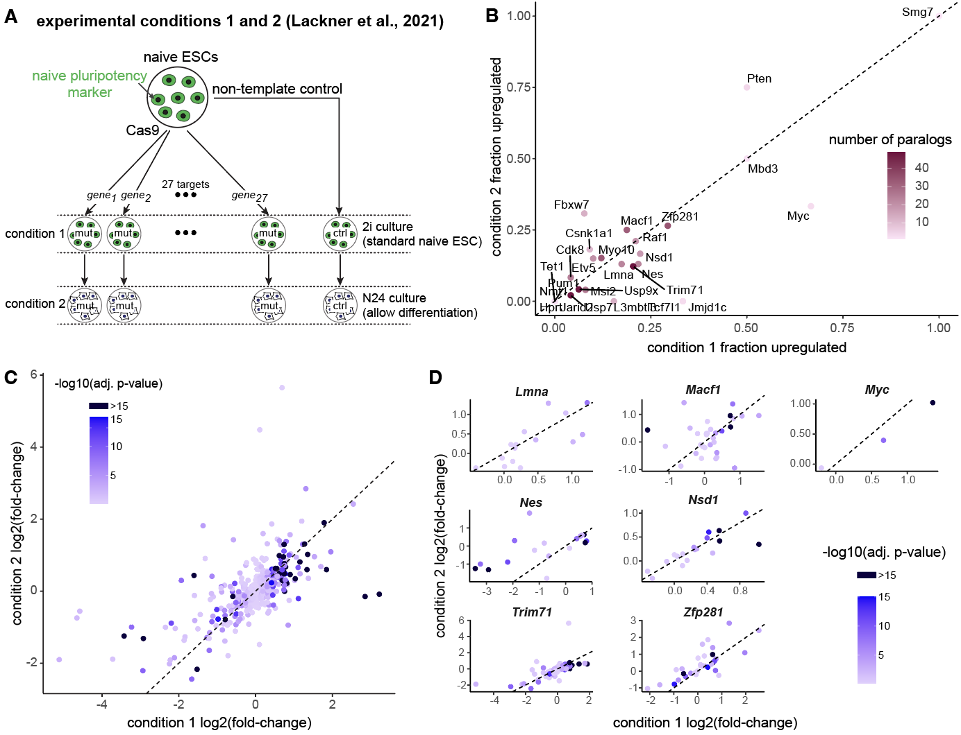
Figure 2: Repeatability of inferring prevalence of transcriptional adaptation across experimental conditions
- Schematic of experimental design for analysis of paralog upregulation frequency for 27 knockout targets in mouse naive embryonic stem cells (ESC), adapted from Lackner et al., 2021.
- Comparison of paralog upregulation frequency in 2i (standard naive ESC culture condition, condition 1, GSE145653-1) versus N24 (removal of 2i for 24 hours, allowing exit from naive pluripotency, condition 2, GSE145653-2) for 27 targets. Color indicates the number of paralogs per knockout target. Dotted line indicates y = x.
- Comparison of log₂ fold-change of paralog expression across experimental conditions. Each point corresponds to a gene-paralog pair. Color indicates the -log₁₀ adjusted p-value calculated from naive ESC dataset (condition 1), with any value greater than 15 being represented by the same dark blue. Dotted line indicates y = x.
- Comparison of log₂ fold-change of paralog expression across experimental conditions for individual knockout targets with bootstrap p-values < 0.1 (i.e., “hits”) as in panel C.

5. The authors claim that their work demonstrates that transcriptional adaptation is "widespread" in mammalian systems. "Widespread" does not seem like the right wording as the number of affected genes seems relatively small. Perhaps identifying how these affects might radiate to many important processes (via TFs) would support the claim that these effects can be substantial across cellular processes and states. The data better supports a more narrow claim that nonsense-mediated transcriptional adaption is not limited to specific cellular contexts. (e.g. genes exist that show transcriptional adaptation across cell lines and context.)

Reply: The reviewer makes an important point about the prevalence of transcriptional adaptation inferable from the results in this manuscript. In the original manuscript, we concluded that transcriptional adaptation may be “widespread”, because, even by the insensitive heuristic of paralog upregulation fraction after Cas9-based knockout, approximately 22% of all 74 tested genes displayed evidence of possible transcriptional adaptation in the bulk datasets (bootstrap p-value < 0.1). Furthermore, as the reviewer also notes, the affected genes span many cellular processes and pathways. However, we agree with the reviewer that it is better to more precisely qualify how confident we are of whether transcriptional adaptation is common, and we have modified the text accordingly. We are more cautious to avoid extrapolating widely in the new manuscript, and, specifically, we have removed “widespread” as a descriptor of the inferred prevalence of transcriptional adaptation. Rather, we emphasize that it is likely present in many genes, and does not appear to be limited to specific biological contexts. We also agree with the reviewer that characterizing network-level consequences of transcriptional adaptation is a useful way to highlight broad effects. Accordingly, we have emphasized the transcription factor regulon analysis in the revised manuscript by bringing the previous figure earlier, to the new Figure 4, and contextualizing it with other results. Lastly, we have added a paragraph to the discussion section to comment on another nuanced point related to our findings on the need for a unified adoption of the term “transcriptional adaptation” for related experiments.

Abstract

Here we present analyses of existing bulk and single-cell transcriptomic datasets to uncover the prevalence of transcriptional adaptation in mammalian systems across diverse contexts and cell types. We next performed regulon gene expression analyses of transcription factor target sets in both bulk and pooled single-cell genetic perturbation datasets. Our results revealed greater robustness in expression of regulons of transcription factors exhibiting transcriptional adaptation compared to those of transcription factors that do not.

Results

We next asked whether any specific annotated biological pathways, molecular functions, or cellular components were enriched for genes that display transcriptional adaptation by paralogs, either in bulk or in single-cell datasets. Therefore, we conducted gene set enrichment analysis, comparing human knockout targets with significantly upregulated paralogs in bulk data or any paralog in the top-100-increase sets of single-cell data against the full set of human knockout targets tested (see Methods) (Yu et al., 2012). No gene sets were overrepresented among the knockout targets with paralog upregulation. Therefore, transcriptional adaptation, at least for the targets tested, may not be limited to specific biological contexts, since we observed that it is not strongly correlated with functionally defined gene sets or particular signaling pathways…

Previous studies have shown that paralog upregulation via transcriptional adaptation can enable the preservation or robustness of molecular and morphological phenotypes downstream of mutated regulators. Therefore, we wondered whether we would observe relative downstream buffering effects for targets exhibiting transcriptional adaptation versus those that do not.

Discussion
During the process of mining published datasets from disparate studies, we found several cases where the phenomenology could reflect what the two landmark studies (El-Brolosy et al., 2019; Ma et al., 2019) term as “transcriptional adaptation,” but the results were not explicitly contextualized (nor definitively proven) as such. Localization of UPF proteins to compensating loci dependent on nonsense-mutated RNA in (de Turris et al., 2011), Tubulin family upregulation after Tubb4a mutation in (Fertuzinhos et al., 2022), and others, such as the knockdown-knockout discrepancies reviewed in (El-Brolosy & Stainier, 2017), could contribute to the field of transcriptional adaptation. Since our work and other recent studies point to the plausible presence of transcriptional adaptation across many contexts, e.g., even for coupling between maternal and zygotic gene regulation during early embryogenesis(Fishman et al., 2024), we propose a push towards consistent and universal usage of the term “transcriptional adaptation” to describe upregulation of compensating related genes after a mutation dependent on the mutated transcript. A common consensus may facilitate faster discovery and reconciliation of paradoxical findings across contexts moving forward.

Minor concerns.
1. It is difficult to compare to datasets. We suggest splitting figure 1 into two figures. How many paralogs each of the genes in 1F have is a crucial piece of information needed to interpret the figure. E.g. if Smg7 only has one paralog or Myc only has three paralogs, then the dots in the upper right are less convincing (because they can only take on specific values). See main pt 4.

Reply: We thank the reviewer for these suggestions. In the revised manuscript, we split Figure 1 into two figures and present additional analyses of paralog upregulation across two conditions in the new Figure 2. In the new Figure 2, we highlight the number of paralogs per knockout target in the two-condition comparison. Additionally, we updated Figure 1C to be a volcano-style plot, using the observed fraction of paralogs upregulated as the x-axis and the -log10(bootstrap p-value) as the y-axis.

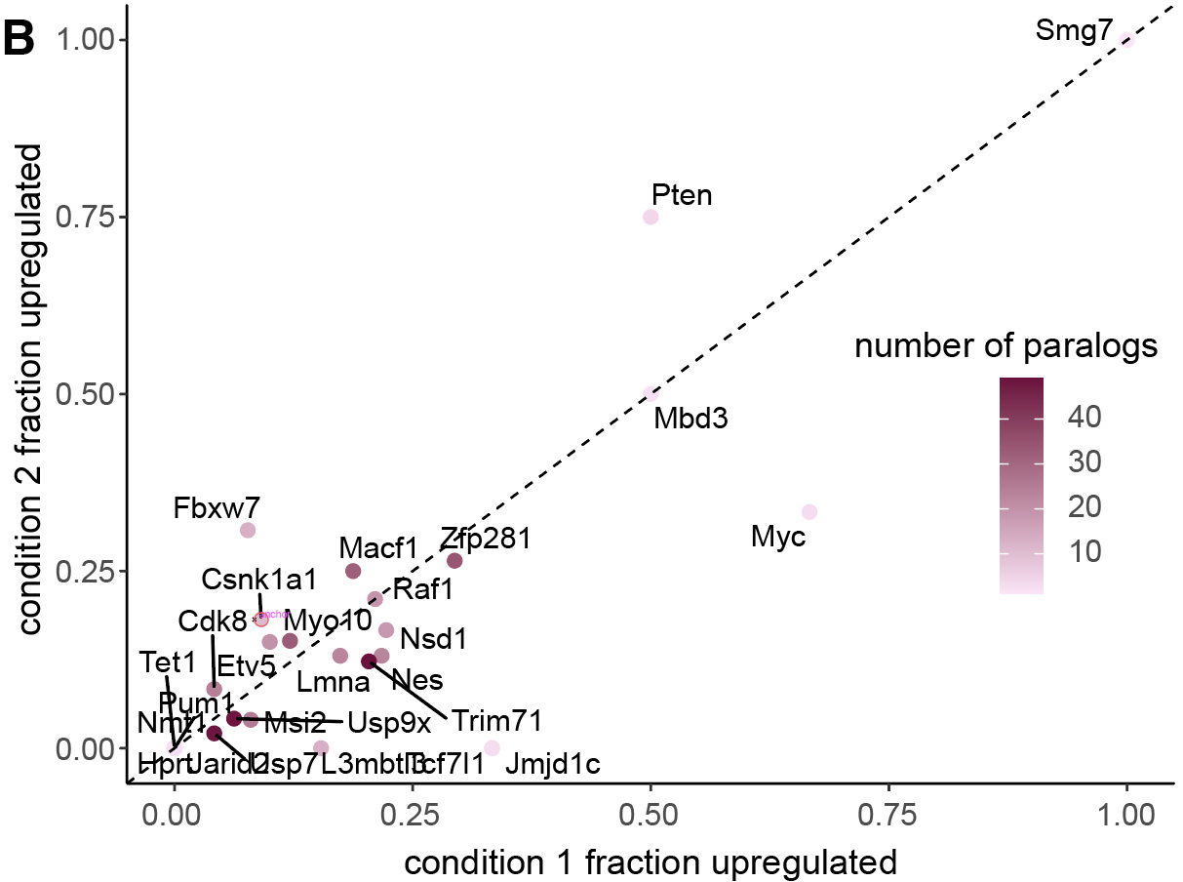
Figure 2: Repeatability of inferring prevalence of transcriptional adaptation across experimental conditions
- Comparison of paralog upregulation frequency in 2i (standard naive ESC culture condition, condition 1, GSE145653-1) versus N24 (removal of 2i for 24 hours, allowing exit from naive pluripotency, condition 2, GSE145653-2) for 27 targets. Color indicates the number of paralogs per knockout target. Dotted line indicates y = x.

2. The authors do an important task in highlighting that nonsense transcriptional adaptation can confound perturbative screens (e.g. "the latter hypothesis implies that functional genetic screens for phenotypic outcomes will need to account for transcriptional adaptation." (pg 4, 28-30)). However, is there any way of accounting, controlling for this mechanism or should we not perform screens as we do now? I think there should be more in the discussion of where this work needs to direct us.

Reply: We thank the reviewer for their positive assessment. We agree that this is an exceptionally important implication of these results, and we elaborate on this point in the discussion accordingly. The revised discussion text is provided below:

The fact that transcriptional adaptation occurred across a wide range of processes and for gene sets not necessarily belonging to a single regulatory module or signaling pathway highlights the need to consider their implications when screening for any phenotypic outcomes. One way to address this concern is to perform screens with perturbation methods that avoid nonsense mutations. Techniques such as CRISPRi, already being used in pooled screens (Replogle et al., 2020, 2022), or other methods of engineering knockdowns, could be helpful. Alternatively, if knockout is a requirement of the experimental design, engineering whole-gene deletion alleles could help decouple effects of transcriptional adaptation from that of specific gene knockouts. Another opportunity is presented by recently reported combinatorial CRISPR screens (e.g., (Ito et al., 2021; Replogle et al., 2020)), which include paired knockout of two or more genes in the same cells, which could identify gene sets for which transcriptional adaptation confounds the outcomes. For example, combined knockout of a reference gene and its paralogs could help to overcome the effects of transcriptional adaptation, while paired knockout of a reference gene and other interacting genes could help to disentangle reference- vs. paralog-specific functions. When such experimental designs are impractical or infeasible, the interpretation of nonsense-based knockout results could account for possible transcriptional adaptation by concurrent measurement of the expression of paralogs of the knockout target. In this way, caution must be taken in interpreting the phenotypic changes, or lack thereof, if a knockout target shows paralog upregulation.

Minor comments and suggestions on figures.

- "Cells have a _remarkable_.......can remarkably trigger": repeated in intro and abstract. (pg 3).

Reply: We thank the reviewer for their close reading of our manuscript text—we apologize for the oversight. We have now changed this (unintendedly) repeated part of a sentence in the main text:

Cells can sense changing conditions and exhibit robustness in response to perturbations.

- It would be helpful to expand on the description of citation 2 on page 4, line 4. Adding a sentence or two of the main discrepancy between knockouts/knockdowns would be helpful.

Reply: The reviewer has made an excellent suggestion. We have both modified the existing sentence and added additional text to expand on the discrepancy, pasted below from the main text:

Besides revealing a new kind of transcriptional regulation, this discovery proposed a resolution of the long-standing discrepancy in molecular and morphological phenotypes between many knockdowns and knockouts of the same gene across several animal model systems (De Souza et al., 2006; El-Brolosy & Stainier, 2017; Gao et al., 2015; Kok et al., 2015; Yamamoto et al., 2014). In particular, reducing the expression of a gene by using antisense oligos (including morpholinos) often resulted in more severe defects than for gene knockout, contrary to the expectation that complete removal of gene would, in principle, result in a stronger phenotype. Various existing explanations prior to these studies, including off-target effects associated with knockdowns(El-Brolosy & Stainier, 2017), could not fully account for the paradox.

- In the intro, it would be helpful to add a discussion of the COMPASS complex / Upf genes, so that their first appearance is not in the results section.

Reply: We agree with the reviewer that discussion of the COMPASS complex / Upf genes in the introduction will enhance the reader experience. We have now added the following text in the manuscript:

Mechanisms underlying nonsense-induced transcriptional compensation have been studied for a handful of curated genes in select developmental contexts, particularly in vertebrates and C. elegans (Buglo et al., 2020; Diofano et al., 2020; Ito et al., 2021; Konjikusic et al., 2021; Rossi et al., 2015; Serobyan et al., 2020; Welker et al., 2023; Zhu et al., 2017). Recent studies identified components of the COMPASS complex, a histone methylase, and regulators of nonsense-mediated decay, including Upf genes (El-Brolosy et al., 2019; Ma et al., 2019; Xie et al., 2023) as important mediators of nonsense-induced transcriptional compensation. For example…

Figure 1

Reply: The reviewer makes very good points about our figure design and data presentation. We addressed their points as described below.

- 1b: contrast on black/teal "identification/setup", "downstream analysis". Also it is low contrast on the gray/black.

Reply: We updated plot aesthetics with reader-friendly color schemes, as suggested.

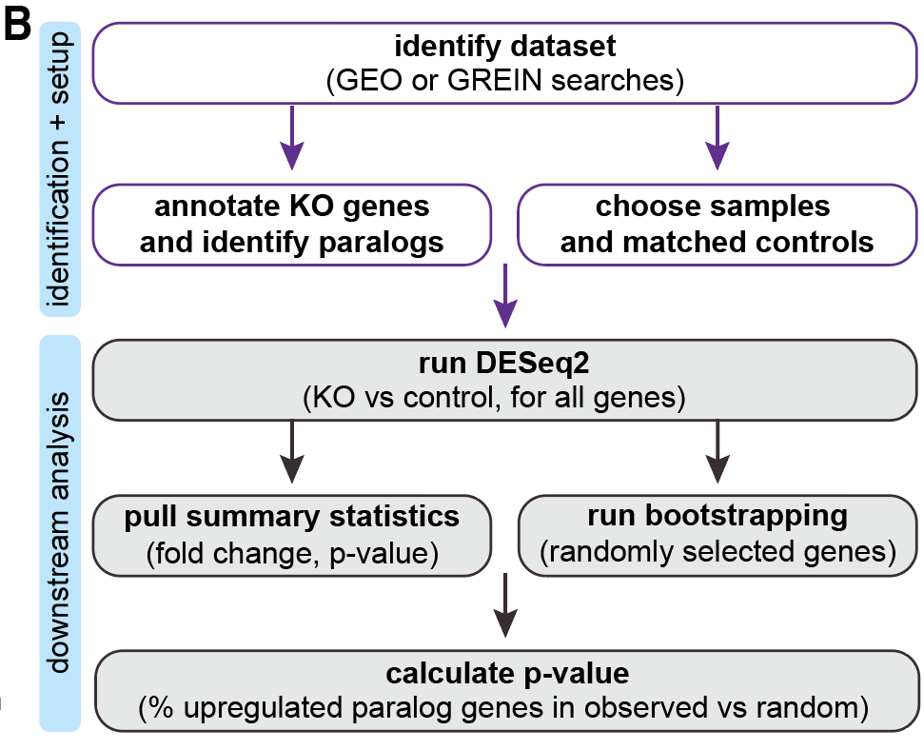
Figure 1: Inferring prevalence of transcriptional adaptation in transcriptomic datasets
- Schematic of analytical workflow. We mined publicly available RNA-seq datasets for differential expression of paralogs of CRISPR/Cas9 knockout targets after mutation. Randomly selected bootstrap sampled genes are chosen to have similar average expression levels as respective paralogs of interest.

- Consider plotting this as a volcano plot( p-value on x axis, fraction upregulated on y axis). The p-value is computed from the "expected fraction upregulated" (e.g. your bootstrapped null), so it is distracting to have both.

Reply: We agree and have now replaced Figure 1C with a volcano-style plot, using the observed fraction upregulated as the x-axis and the p-value as the y-axis. We moved the former plot to Supplementary Figure 1A.
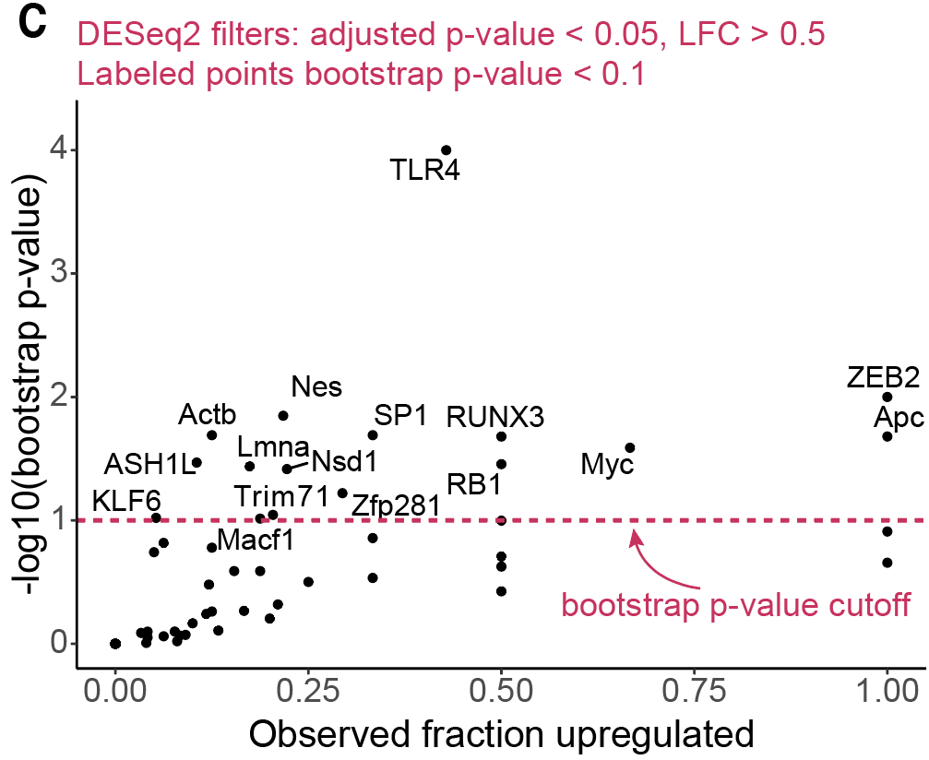
Figure 1: Inferring prevalence of transcriptional adaptation in transcriptomic datasets
- Per-knockout-target paralog differential expression results. The -log₁₀ bootstrap p-value compared to observed fraction of upregulated paralogs. Paralog differential expression counted if log2 fold-change > 0.5 and adjusted p-value < 0.05.

- Volcano plots also let you draw your p-value cutoff directly as a vertical line.

Reply: We included a line to represent the p-value cutoff in Figure 1C.

- Poor colormap choice.

Reply: We replaced the plot with a p-value colormap with a volcano-style plot, which helps significantly with visualization of bootstrap p-values without needing a colormap. The older plots, including bootstrap average upregulation frequencies and a p-value colormap, now only appear in the supplement.

- Overlapping labels

Reply: There are no overlapping labels in the revised figure, which has a volcano-style plot instead.

- 1e/1f: possibly split into its own separate (smaller) figure.

Reply: We agree with the reviewer. We moved panels E and F into a new, small Figure 2 with additional new analyses comparing paralog fold-change across conditions.
Figure 2: Repeatability of inferring prevalence of transcriptional adaptation across experimental conditions
- Schematic of experimental design for analysis of paralog upregulation frequency for 27 knockout targets in mouse naive embryonic stem cells (ESC), adapted from Lackner et al., 2021.
- Comparison of paralog upregulation frequency in 2i (standard naive ESC culture condition, condition 1, GSE145653-1) versus N24 (removal of 2i for 24 hours, allowing exit from naive pluripotency, condition 2, GSE145653-2) for 27 targets. Color indicates the number of paralogs per knockout target. Dotted line indicates y = x.
- Comparison of log₂ fold-change of paralog expression across experimental conditions. Each point corresponds to a gene-paralog pair. Color indicates the -log₁₀ adjusted p-value calculated from naive ESC dataset (condition 1), with any value greater than 15 being represented by the same dark blue. Dotted line indicates y = x.
- Comparison of log₂ fold-change of paralog expression across experimental conditions for individual knockout targets with bootstrap p-values < 0.1 (i.e., “hits”) as in panel C.

- "niave ESCs"

Reply: We apologize for the typo on what should be “naive ESCs,” which, along with other typos, we fixed in the revised manuscript.

- 1f:How many paralogs do each gene have? E.g. if Smg7 only has one paralog then having 100% upregulated is less compelling.

Reply: We re-colored points in former Figure 1F, updated to Figure 2B, according to the number of paralogs.

Figure 2: Repeatability of inferring prevalence of transcriptional adaptation across experimental conditions
- Comparison of paralog upregulation frequency in 2i (standard naive ESC culture condition, condition 1, GSE145653-1) versus N24 (removal of 2i for 24 hours, allowing exit from naive pluripotency, condition 2, GSE145653-2) for 27 targets. Color indicates the number of paralogs per knockout target. Dotted line indicates y = x.

Figure 2

Reply: We thank the reviewer for their suggestions. We updated former Figure 2 (now Figure 3) as suggested.

- 2b: Can you add the gray dots to the right-hand panel of B to demonstrate that there is not a global increase in expression / that there is still a separation between gray and pink at the mean expression level.

Reply: We have included the gray dots in updated Figure 3B as suggested, demonstrating that there is not a global increase in mean expression for paralogs with high percent-positivity in controls.

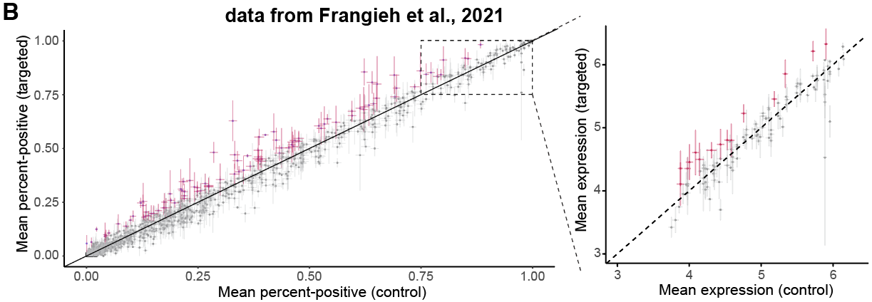
Figure 3: Inferring prevalence of transcriptional adaptation at single-cell resolution in Perturb-seq data
- Perturb-seq-based single-cell paralog expression change after reference gene knockout. Per paralog, percentage of cells positive for that paralog’s expression in non-template control guide-treated cells on x-axis, percentage of cells positive for that paralog’s expression in cells treated with guides targeting a reference CRISPR target for which the gene is a paralog. For paralog genes with percent-positive > 75% in non-template controls, mean expression plotted in inset at right. Paralogs ranked in the top-100 of absolute increases per quantification method marked in magenta. All paralogs of all knockouts shown meeting minimum cell count and UMI count in gray, inclusion criteria listed in Methods.

- 2c: You can reduce the Venn diagram size.

Reply: We have reduced the size of the Venn diagram in the revised manuscript (see below the following comment).

- 2d: Why? This is not a strong addition to the figure.
- 2c/2d are distracting/don't add to the figure.

Reply: We included Figure 2C (now part of Figure 3 in the revised manuscript) to show that many paralogs demonstrate high amounts of upregulation using different measures of upregulation in the single-cell RNA-seq results, highlighting the consistency of results across approaches. We updated the text to explain this further:

In general, the percent positives (and the means) in targeted cells and in controls were well correlated (Figure 3B). Nonetheless, there were many paralog genes in which expression levels may have differed. We rank-ordered the differences between targeted and control cells for all 1,792 paralog-target gene pairs and highlighted the paralogs with the 100 largest absolute increases in percent positive values after respective target knockout (or highest mean increases for those highly expressed at baseline). 85 of the largest differences detected were observed when considering either change in percent-positivity or change in mean abundance, suggesting that the identification of a target-paralog pair was not entirely dependent on the choice of paralog-upregulation measure (Figure 3C).

We included Figure 2D in the main figure of the original submission to highlight specific genes that demonstrate the most paralog upregulation in the Perturb-seq dataset. However, we do agree with the reviewer that Figure 2D was potentially distracting to the readers as a part of this figure—we have now removed 2D from the main figure and added it as a separate table instead (Table 1).

Revised Figure 3 is pasted below:

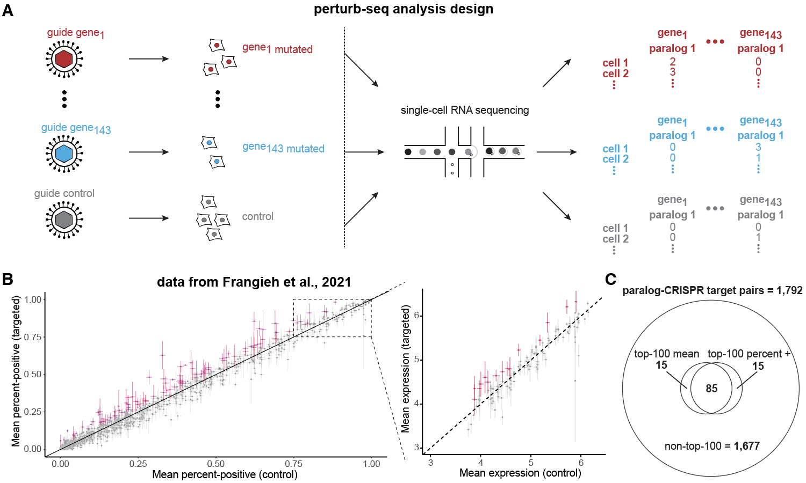
Figure 3: Inferring prevalence of transcriptional adaptation at single-cell resolution in Perturb-seq data
- Schematic of experimental design and paralog gene expression analysis, adapted from Frangieh et al., 2021. 143 gene targets, with a consistent batch of non-template control-treated cells, passing quality control filters (see Methods).
- Perturb-seq-based single-cell paralog expression change after reference gene knockout. Per paralog, percentage of cells positive for that paralog’s expression in non-template control guide-treated cells on x-axis, percentage of cells positive for that paralog’s expression in cells treated with guides targeting a reference CRISPR target for which the gene is a paralog. For paralog genes with percent-positive > 75% in non-template controls, mean expression plotted in inset at right. Paralogs ranked in the top-100 of absolute increases per quantification method marked in magenta. All paralogs of all knockouts shown meeting minimum cell count and UMI count in gray, inclusion criteria listed in Methods.
- Venn diagram summarizing the number of paralog-CRISPR target pairs with the top-100 largest increases in mean expression and/or percent-positive expression levels. 1,792 total paralog-target pairs, of which 1,677 are not in the top-100 largest increase lists. 85 paralog-target pairs in the top-100 largest difference list by both mean and percent-positive analysis.

Figure 3

Reply: We thank the reviewer for their helpful comments on the simulation results in Figure 3, which now appear as part of the updated Figure 5 and Supplementary Figure 6.

- 3B: Individual traces do show ergodicity, but probably can be moved to the supplemental information. If you want to keep one, then possibly keep the bimodal one, but annotate it (e.g. add vertical bands that separate the subpeaks of the bimodal peaks).

Reply: In agreement with the reviewer, we have significantly reduced the figure complexity by moving several traces and distributions to the Supplement (Figure S6A,B). We decided to keep two distributions and their traces to show differences between them: unimodal symmetric and bimodal examples (Figure 5B,C). Additionally, we added arrows to panels B and C to annotate modes.

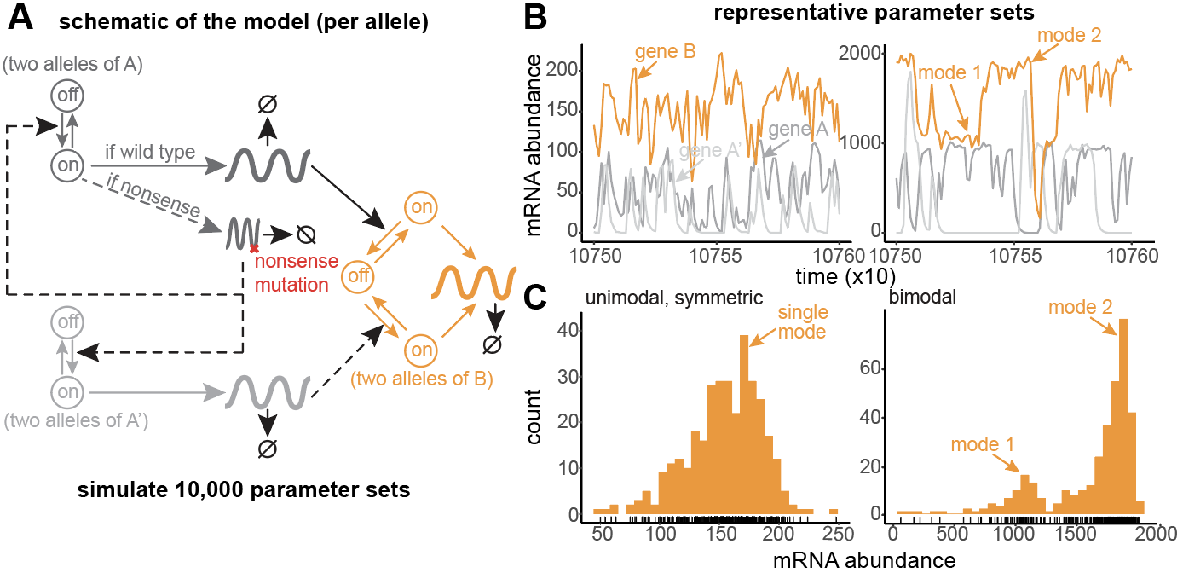
Figure 5: Outputs of simulated gene regulatory networks with transcriptional adaptation and robustness to mutation dependency on model parameters
- Schematic of a gene regulatory network with transcriptional adaptation to mutation. Two alleles of each gene, with bursty transcription of gene products at each allele. A mutated reference gene, A (dark gray), regulates downstream effector gene B (orange). When mutated, nonsense copies of A product upregulate a paralog of A, called A’ (light gray). A’ can also regulate B, albeit with different strengths. Hill functions are used in propensities for regulatory relationships between gene products and target alleles. See Methods for full model specification. Parameter descriptions in the table at right of the panel.
- Example simulation output and inference of single-cell expression distributions from pseudo-single-cells taken every 300 time-steps. See Methods.
- Example classification of gene expression distribution shapes. See Methods for classification algorithm.

- 3F/3G: Showing the neighborhood in this way is a weak statement; showing that a small neighborhood around the trimodal parameter set is also trimodal is only helpful if you show that the neighborhood size is reasonable.

Reply: The reviewer makes an excellent point, which inspired us to perform an extensive set of additional analyses to extract and summarize decision-tree-derived subspaces and their parameter ranges. We then used these results to pick more plausible subspaces to check for enrichment around the original trimodal parameter set (for each parameter, the 1) minimum, 2) 10th percentile, 3) 50th percentile of restricted subspace parameter range sizes). We include a schematic of this analysis and new simulation results and classifications in Figure S6. Furthermore, we added a description of how we conducted these analyses in the main Results section.

Results section

In further exploring the data, we identified an unexpected gene expression shape in one out of more than a hundred randomly inspected gene B expression distributions: trimodal with 3 non-zero modes (Figure S6C,D, and Supplementary Note). Examination of the gene expression traces suggested that the rate of B mRNA degradation was too slow to reach zero before an allele was activated by A or A’ (Figure S6C,D). To verify whether this distribution was associated with specific parameter combinations, we resampled parameter combinations from four progressively larger subspaces centered around the originally observed parameter set, ran new simulations, and inspected the output to check for trimodality (Figure S6E,F). Indeed, we found a strong enrichment of trimodal distributions (as high as 94% in the smallest subspace centered around the original parameter set) compared to the full original parameter space (<1%) (Figure S6G). As expected, the enrichment decreased monotonically with increasing size of the sampling hypercube (Figure S6G).

Methods

Decision tree subspace-based resampling analysis

We extracted the subspace bounds of decision tree terminal nodes (i.e., leaves in ctree objects) using partykit::.list.rules.party() in R, for all 5 decision trees constructed for identifying enrichment of different distribution shapes of gene B in the heterozygous genotype (see Supplementary Note) using the algorithm in the “Distribution shape classification” section. When a parameter was only bounded by one decision rule in a subspace, we used the full parameter subspace boundary as the corresponding upper or lower limit of the subspace. For each parameter, we measured the empirical distribution of sub-full-parameter-range subspace range sizes on a log₁₀ scale.

For trimodal shape resampling analysis (Fig. S6), we first specified the original parameter set in which we observed the trimodal distribution shape for gene B in the heterozygous genotype. We then picked subspaces in which each parameter range was centered on the original parameter set’s respective value, bounded by a range of size (custom-smaller than minimum, minimum of the empirical distribution, 10th percentile of the empirical distribution, or 50th percentile of the empirical distribution).

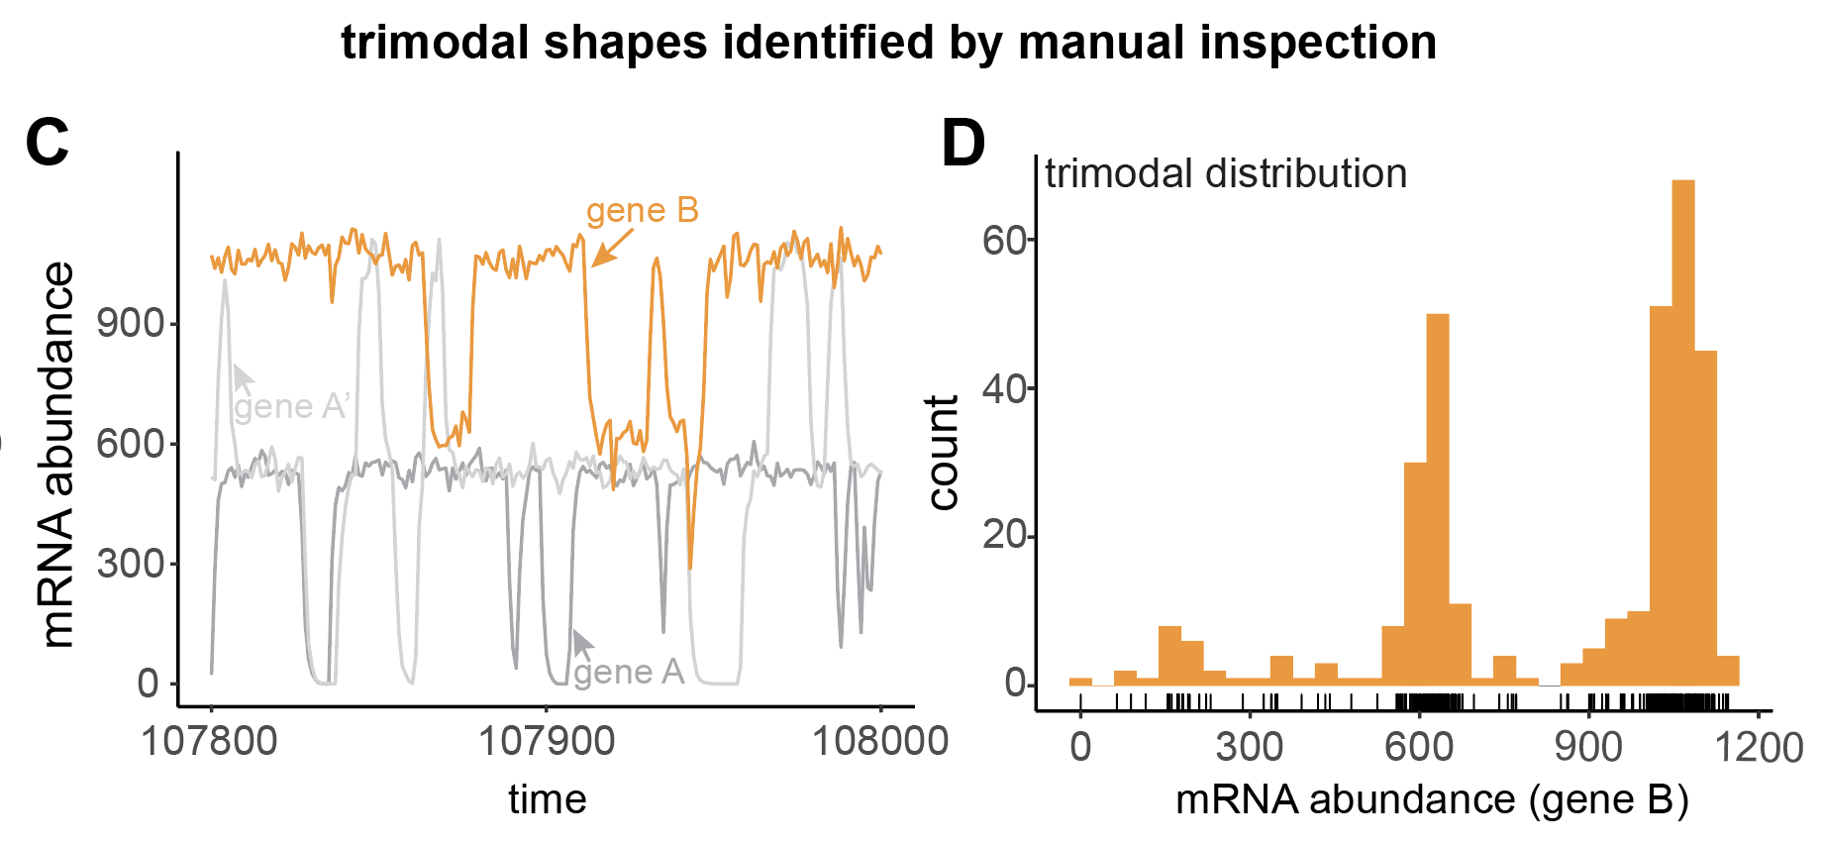

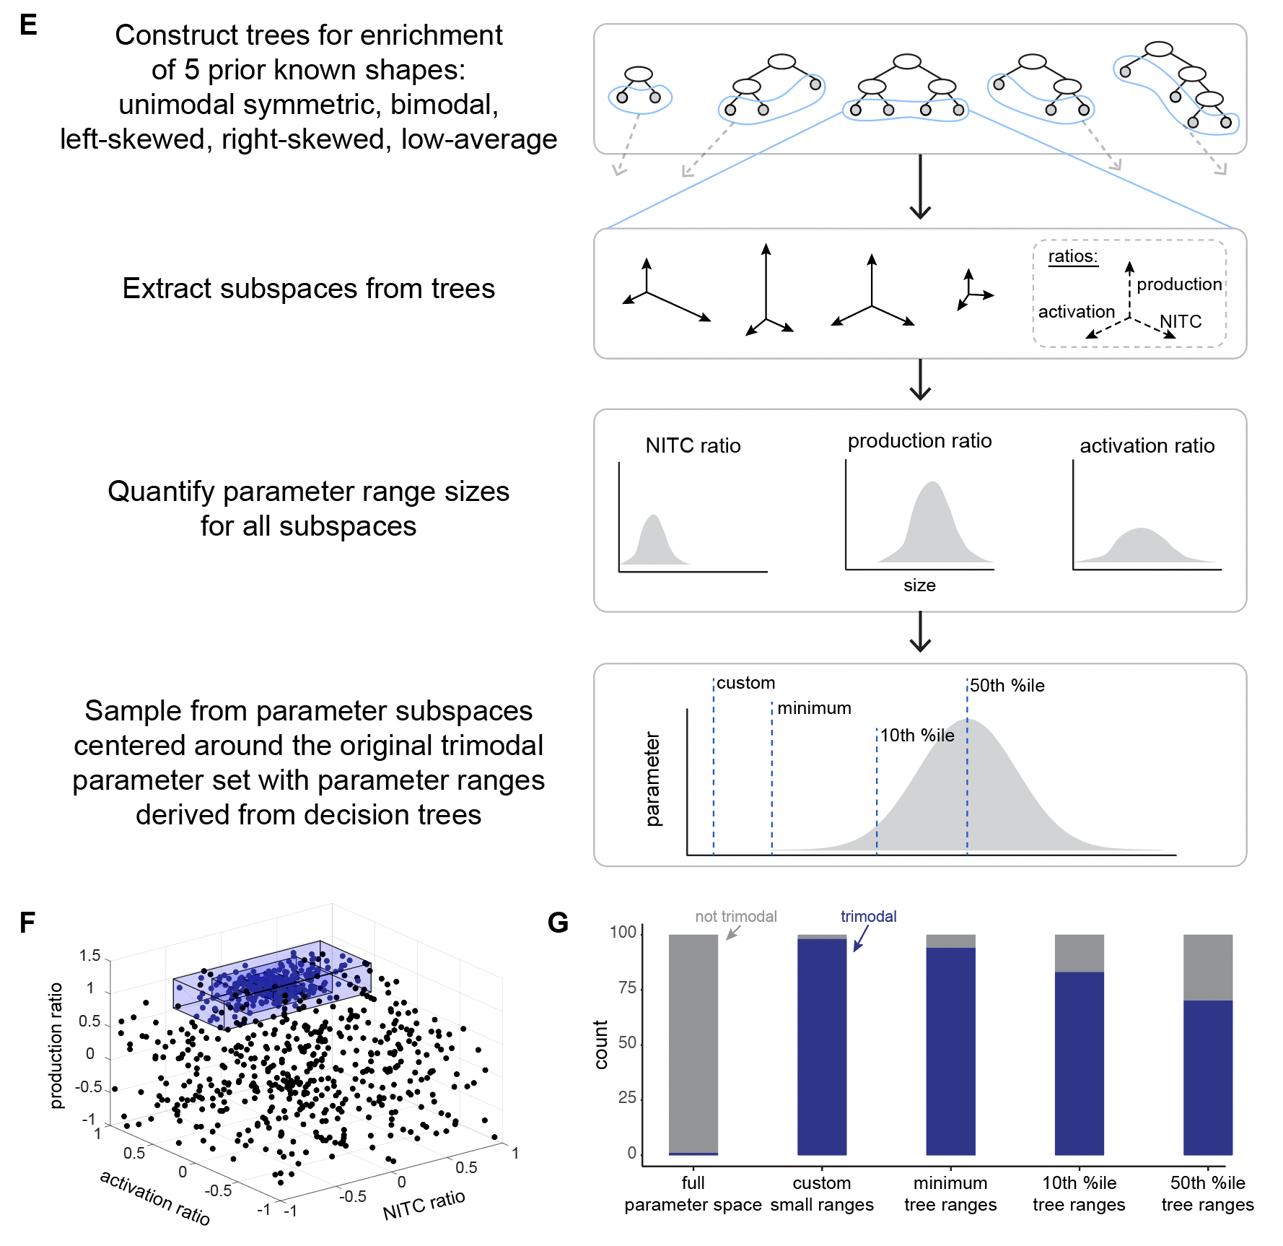
S6: Distribution shapes and resampling to identify enrichment of parameter subspaces enriched for trimodal distributions
- Example simulation output for a manually-identified trimodal distribution.
- Example expression distribution of a trimodal distribution. See Methods.
- Analysis schematic: How parameter subspace is constructed from decision trees.
- Parameter subspaces around the initially identified trimodal distribution’s parameter set.
- Enrichment of trimodal gene expression distribution shapes after sampling parameter sets from the subspaces vs. from the full parameter space.

Page 1 of the 19-page Supplementary Note: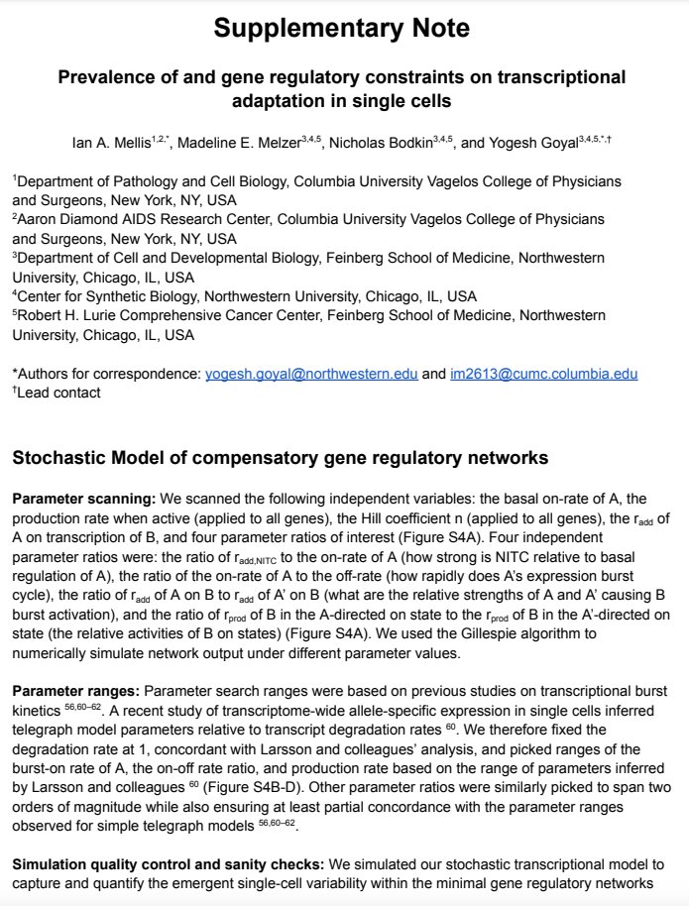

- Add a cartoon that explains the key three ratios that you are using.

Reply: We added exact definitions of the three key ratios to the panel describing model parameters (Figure S4A). We also highlight their descriptions in the methods section of the main text:

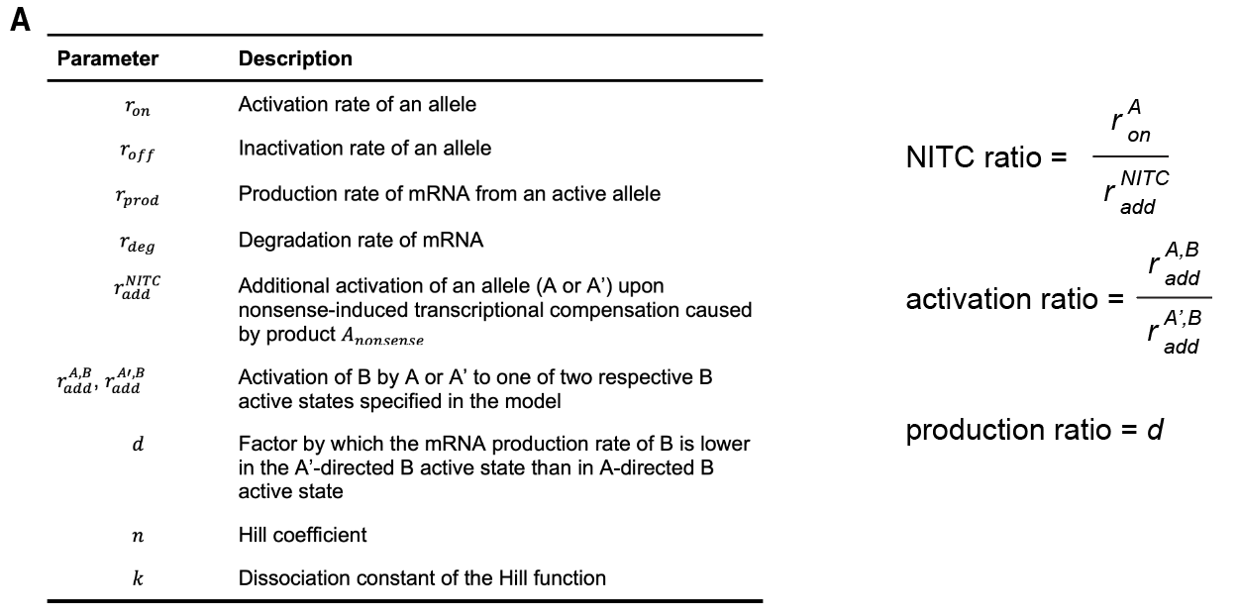
S4: Simulation transcriptional burst kinetics summary and resulting parameter set classifications, before and after mutation
- (left) Parameter descriptions and key parameter ratios for the model described in Figure 3A. (right) equations for key parameter ratios.

Methods

Parameter | Meaning
NITC ratio ($δ_{N}$) | $\frac{r_{on}^{(A)}}{r_{add}^{NITC}}$; the factor by which the NITC-mediated contribution to activation rate compares to the reference gene (A) activation rate
Activation ratio ($δ_{A}$) | $\frac{r_{add}^{A,B}}{r_{add}^{A',B}}$; the factor by which A is more effective at activating B alleles to A-directed active state than A’ to A’-directed active state
A/A’ production ratio ($δ_{P}$) | $d$; the factor by which the mRNA production rate of B is lower in the A’-directed B active state than in A-directed B active state

Figure 4

Reply: We thank the reviewer for their helpful comments on Figure 4, which now appears as most of the updated Figure 5.

- The decision tree splitting of the parameter space is confusing. This needs a cartoon description that you are splitting the high-dimensional space with planes at a minimum.

Reply: We agree with the reviewer and have now added additional schematics in multiple different contexts to highlight the connection between decision tree rules and parameter subspace boundaries (now Figure 5 and S6). We have also modified the main figure legend and figures (5F below, S6 above for a previous comment) to reflect this new addition:

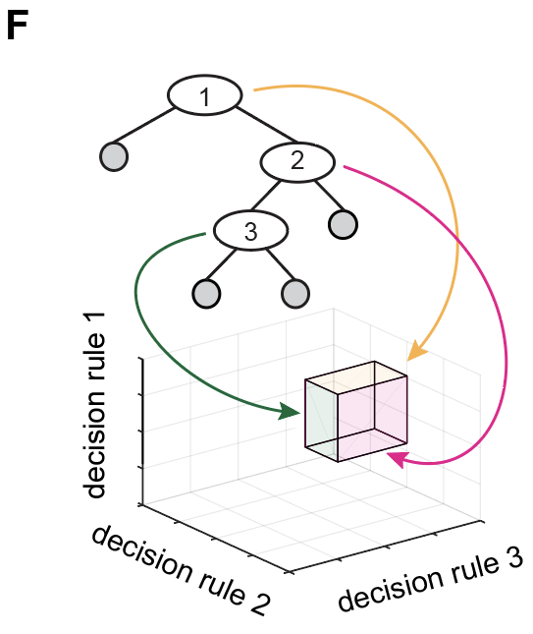
Figure 5: Outputs of simulated gene regulatory networks with transcriptional adaptation and robustness to mutation dependency on model parameters
…
- Analysis schematic: How parameter subspaces for terminal decision tree nodes relate to rules. Each rule limits the parameter subspace for the terminal node. Colored planes correspond to the decision rule-defined thresholds. When a subspace only encodes one decision rule for a given parameter, the subspace range is limited to the corresponding full parameter space boundary (e.g., if a decision rule sets only a new minimum parameter value, then the maximum parameter value for the subspace is the maximum parameter value of the full parameter space).

- This works better when combined and simplified with a Figure 3.

Reply: We agree with the reviewer’s comment, and combined with their other comments above, we have now overhauled the main text and the figures for better readability and flow. Briefly, we have now streamlined the text on model development and results, and accordingly also condensed Figures 3 and 4 into a revised Figure 5, which appears after Perturb-seq regulon analysis. We have added a Supplementary Note to the paper with exhaustive technical notes on the simulation results to complement the newly streamlined Results main text.

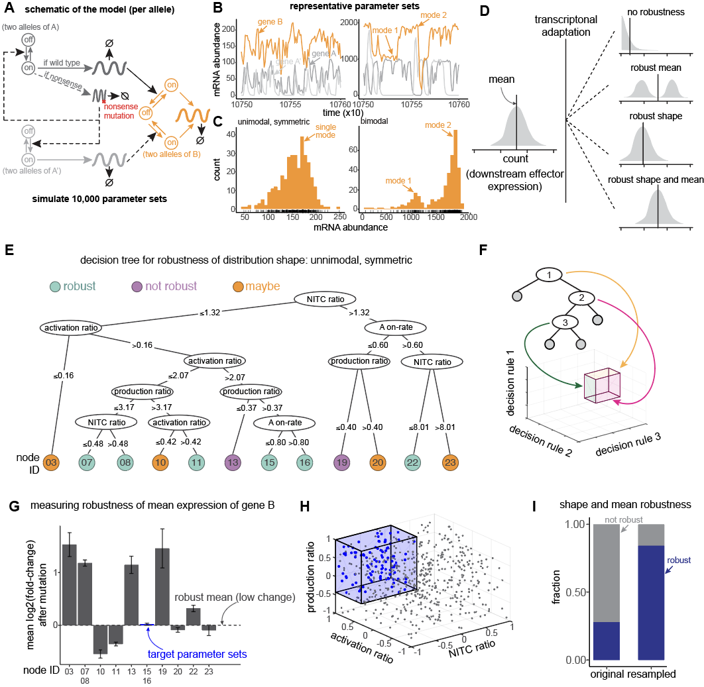
Figure 5: Outputs of simulated gene regulatory networks with transcriptional adaptation and robustness to mutation dependency on model parameters
- Schematic of a gene regulatory network with transcriptional adaptation to mutation. Two alleles of each gene, with bursty transcription of gene products at each allele. A mutated reference gene, A (dark gray), regulates downstream effector gene B (orange). When mutated, nonsense copies of A product upregulate a paralog of A, called A’ (light gray). A’ can also regulate B, albeit with different strengths. Hill functions are used in propensities for regulatory relationships between gene products and target alleles. See Methods for full model specification. Parameter descriptions in the table at right of the panel.
- Example simulation output and inference of single-cell expression distributions from pseudo-single-cells taken every 300 time-steps. See Methods.
- Example classification of gene expression distribution shapes. See Methods for classification algorithm.
- Analysis schematic: under what network conditions does the network output (i.e., distribution of B expression levels) remain unchanged, either in shape or in average expression level, after mutation of gene A?
- Decision tree trained on model parameters to classify parameter sets, restricted to those in which B is unimodal symmetric in the wildtype genotype, by whether B distribution remains unimodal symmetric or if it changes distribution shape class. Nodes marked “robust”: >70% of considered parameter sets robust, “maybe”: 30-70% robust, “not robust”: <30% robust.
- Analysis schematic: How parameter subspaces for terminal decision tree nodes relate to rules. Each rule limits the parameter subspace for the terminal node. Colored planes correspond to the decision rule-defined thresholds. When a subspace only encodes one decision rule for a given parameter, the subspace range is limited to the corresponding full parameter space boundary (e.g. if a decision rule sets only a new minimum parameter value, then the maximum parameter value for the subspace is the maximum parameter value of the full parameter space).
- Mean B expression changes after mutation in each decision tree leaf for unimodal symmetric robust parameter sets.
- Parameter subspace bounded by decision tree rules for nodes 15+16 in (E), resampled.
- Enrichment of robustness of both shape and mean for unimodal symmetric distributions of B after mutation, subsampled from the full parameter space and from the subspace marked in (D). Robustness of mean here defined as absolute log₂ fold-change after mutation < 0.35.

- Consider instead showing a decision tree for {unimodal, bimodal, trimodal, skewed, low expression} and sharply limiting the size of the tree, to enhance reader understanding. The full decision tree is too much information, especially for the trees in the SI.

Reply: We thank the reviewer for these excellent suggestions. In response, we have conducted several additional decision tree analyses along these lines. First, we constructed a 5-way-classifier decision tree that separates parameter subspaces with different proportions of each of the 5 distribution shapes {unimodal, bimodal, trimodal, skewed, low expression}. Since the full decision tree was very complicated, up to 8-rules-deep for some subspaces, to aid in visualizing results we limited the depth to 3. This appears as a new Supplementary Figure (S12), and text describing it features in the Results section covering the motivation behind our decision tree analyses. Second, to specifically identify subspaces enriched for individual distribution shapes, we constructed additional decision trees, one for each of all five shapes, and added them to the Supplementary Note. Please note that for the technical Supplementary Note and resampling analyses, we did not limit tree depth, since inclusion of significant decision rules took precedence over tree visualization for downstream resampling purposes. Indeed, by resampling new parameter subspaces resulted in clear enrichment of the respective distribution classes (unimodal symmetric shown in Figure S13). Our revised results are added to the main text and Figure S12.

Beyond associations between individual parameters and summary statistics, we wondered whether parameter combinations were more likely to give rise to particular distribution shape classes upon mutation. While we could visualize the (complicated) densities of different distribution shapes in two dimensions at a time (Fig. S11), we wanted to quantitatively assess the combined effects of all eight independent variables on the emergent network output. To address this question, we trained decision trees to classify all 5 distribution shapes at once, restricting the tree depth to varying degrees (see Methods, Fig. S12). We found that multiple parameter combinations could lead to enrichment or depletion of different distribution shapes.

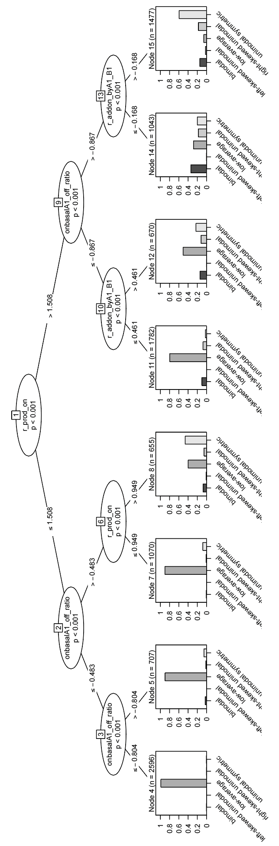
S12: Multi-class decision tree for five distribution shapes of gene B in the heterozygous genotype
- Decision tree trained on all parameter sets, on whether gene B is classified as one of {low-average, left-skewed, right-skewed, unimodal symmetric, bimodal} in the heterozygous genotype.

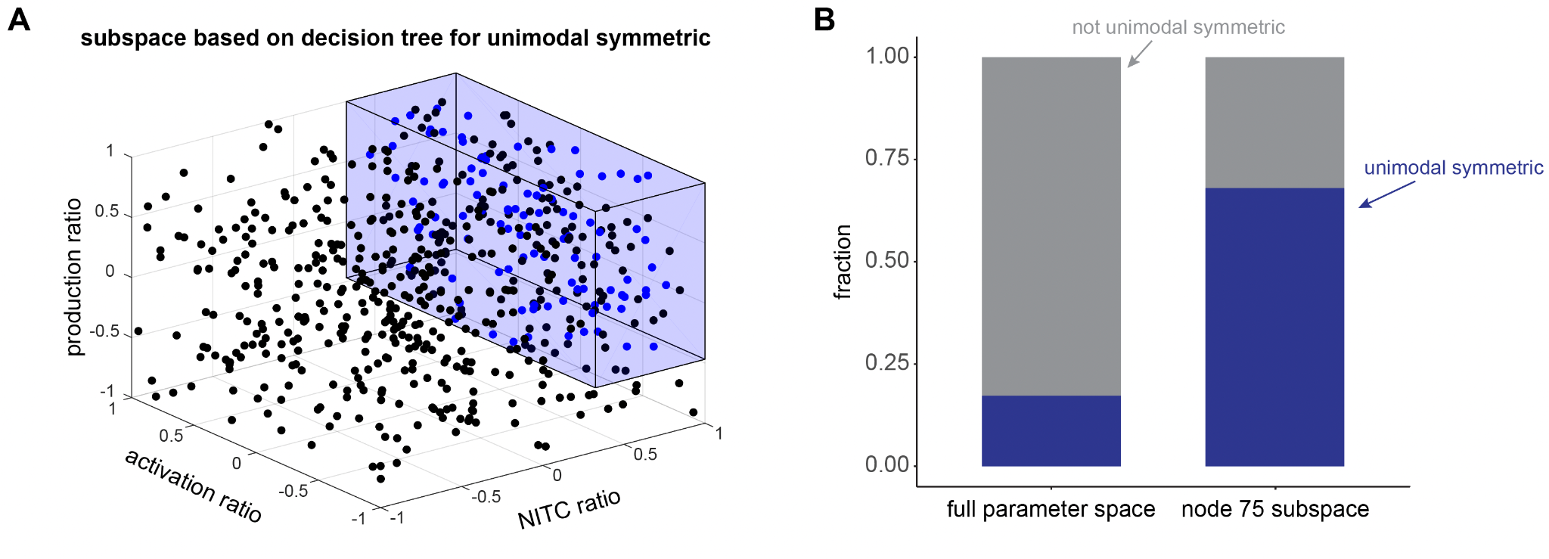
S13: Resampling to identify parameter subspaces enriched for unimodal symmetric distributions
- Parameter subspace corresponding to node 75 in the unimodal symmetric shape classifier tree in Supplementary Note, projected onto only the dimensions of NITC ratio, activation ratio, and production ratio..
- Enrichment of unimodal symmetric gene expression distribution shapes after sampling parameter sets from the subspace in (A) vs. from the full parameter space.

- Ideally, it would be interesting to see the 3D diagram (or projection into 2D) of production ratio/activation ratio/NITC ratio where the regions are shown. This could be kmeans of each type to show generally where each of {unimodal, bimodal, trimodal, skewed, low expression} fall in the space. Then, the reader could see the spread across these three variables.

Reply: We have generated visualizations of the densities of each distribution shape class projected onto two dimensions for the 3 pairs of production ratio, activation ratio, and NITC ratio (Figure S11). For some shapes, it was possible to see enrichment in two dimensional projections. However, for most shapes, it was challenging to interpret which combinations of parameters were associated or how strongly. Furthermore, it was not possible to visualize all eight dimensions at once, so we moved forward with decision tree analysis to describe subspaces considering all dimensions for each shape (Figure S12, Supplementary Note).

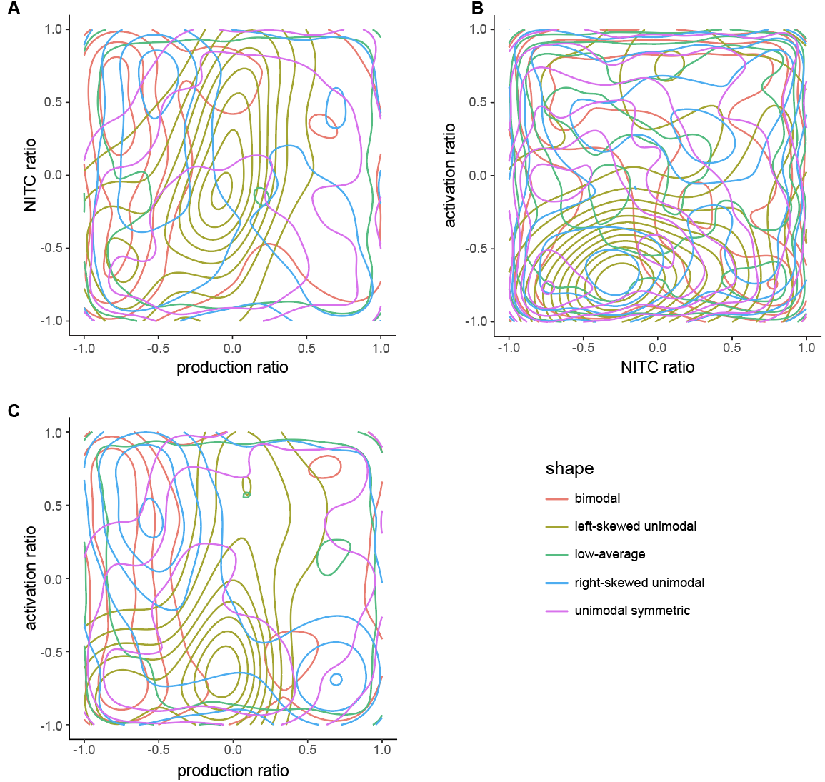
S11: 2-dimensional projections of distribution shapes onto parameter ratio coordinates
- Contour plot colored by distribution shape on NITC ratio vs. production ratio. Kernel density estimation using geom_density_2d() in R.
- Contour plot colored by distribution shape on activation ratio vs. NITC ratio. Kernel density estimation using geom_density_2d() in R.
- Contour plot colored by distribution shape on activation ratio vs. production ratio. Kernel density estimation using geom_density_2d() in R.

- This also answers how pervasive each of these types of distributions are! You could see that e.g. the trimodal space is a lot smaller than the unimodal space.

Reply: Per the response above, we have plotted 2-dimensional projections of shape densities, and we agree with the reviewer that they do show some parameter ranges with more enrichment for one shape over others, and that some shape-dense regions are larger than others! The reviewer is also correct in stating that the previous custom parameter subspace around the trimodal parameter set was smaller than even the minimum decision-tree-derived parameter ranges. Therefore, as described above, we repeated the trimodal subspace resampling analysis using parameter ranges more consistent in size with the decision-tree-based subspaces for other shapes.

Figure 5

Reply: We appreciate the insightful suggestions for changes to this figure. We have addressed each of the reviewer’s points below related to the updated Figure 4 (was Figure 5 in the original submission).
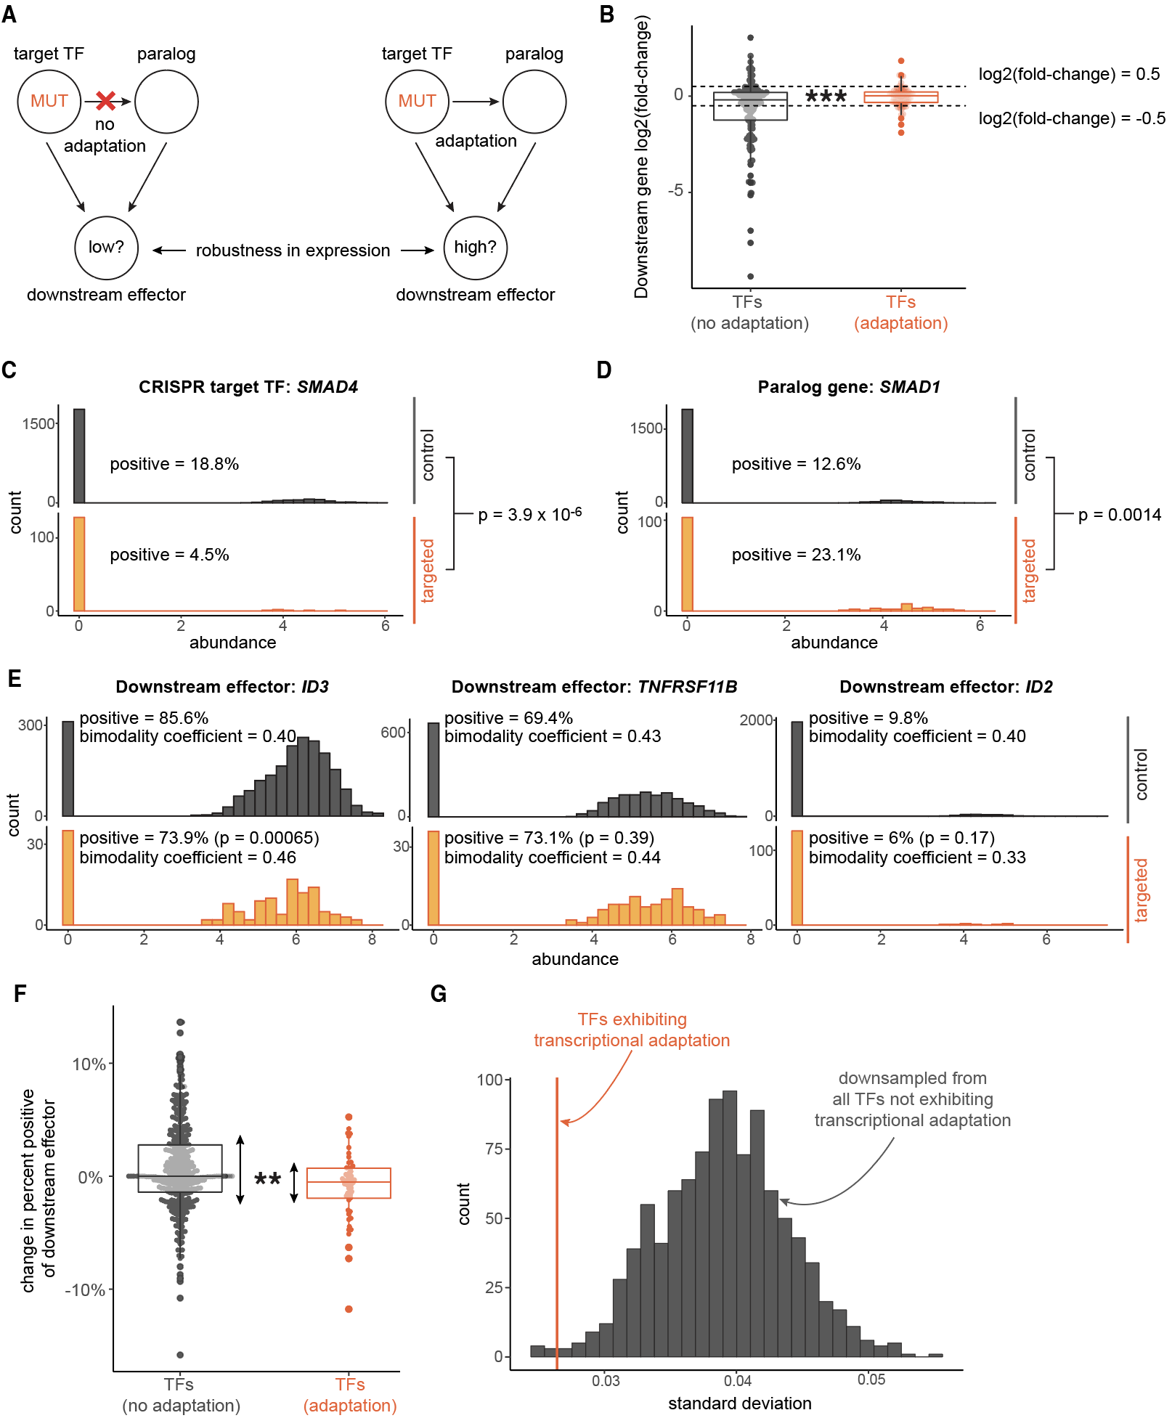
Figure 4: Robustness of regulon expression associated with transcription factor transcriptional adaptation
- Analysis schematic: is there different regulon gene expression robustness after mutation of upstream transcription factors, associated with whether the transcription factors demonstrate transcriptional adaptation by paralogs?
- Change in gene expression for each regulon gene after reference CRISPR transcription factor target mutation, compared against respective controls (log2(fold change) from DESeq2). Each point represents one downstream regulon member gene. Gray: regulon genes downstream of CRISPR target-paralog pairs not appearing to be involved in transcriptional adaptation. Red: regulon genes downstream of CRISPR target-paralog pairs with apparent transcriptional adaptation. Regulon genes called differentially expressed if DESeq2 adjusted p-value < 0.05 and abs(log2(fold change)) > 0.5. Fisher’s exact test for difference of odds of differential expression between the two groups of CRISPR target regulons, p = 1.82 x 10⁻⁴.
- Gene expression distributions of a representative transcription factor that demonstrates possible transcriptional adaptation: SMAD4, in non-template controls (“control”, gray) and in SMAD4-guide-treated cells (“targeted”, orange). Fisher’s exact test p-values for difference in odds of cells being positive in control vs. targeted populations. Abundance values log(TPM+1) reported by (Frangieh et al., 2021).
- Gene expression distributions of a representative top-100 paralog gene of a transcription factor that demonstrates possible transcriptional adaptation: SMAD1, a paralog of SMAD4, in non-template controls (gray) and in SMAD4-guide-treated cells (orange). Fisher’s exact test p-values for difference in odds of cells being positive in control vs. targeted populations. Abundance values log(TPM+1) reported by (Frangieh et al., 2021).
- Gene expression distributions of three representative regulon genes of a transcription factor that demonstrates possible transcriptional adaptation: ID3, TNFRSF11B, and ID2, regulon genes of both SMAD4 and SMAD1, in non-template controls (gray) and in SMAD4-guide-treated cells (orange). Fisher’s exact test p-values for difference in odds of cells being positive in control vs. targeted populations. Bimodality coefficient calculated for each non-zero subpopulation of each distribution. Abundance values log(TPM+1) reported by (Frangieh et al., 2021).
- Change in gene expression for each regulon gene after reference CRISPR transcription factor target mutation, compared against non-template controls (i.e., percent-positive in CRISPR targeted cells minus percent-positive in non-template control-treated cells, for genes 75% or less in non-template controls). Each point represents one downstream regulon member gene. Gray: regulon genes downstream of CRISPR target-paralog pairs not appearing to be involved in transcriptional adaptation. Red: regulon genes downstream of CRISPR target-paralog pairs with apparent transcriptional adaptation. Asymptotic test of difference in coefficient of variation for groups of unequal size, p = 0.0017.
- Empirical distribution of standard deviation of change in percent-positive for downsampled (n=49, same as transcriptional-adaptation group size) no-transcriptional-adaptation group regulon members without replacement, 1,000 downsamples, in gray. Observed standard deviation of change in percent-positive transcriptional-adaptation group standard deviation to this distribution, in orange.

- 5a: misalignment of "mut" in the circles. What does "robustness" mean? Does the left mean "low robustness" and the right mean "high robustness"?

Reply: We apologize for the schematic alignment and have fixed it in the updated figure. We have also more clearly explained that “low” and “high” refer to robustness of single-cell expression levels of downstream genes. In the main Results, we clarify:

Specifically, we wanted to know if there was robustness of expression distribution shape and average level for downstream targets of transcription factors—which can activate or repress downstream genes—that showed signs of transcriptional adaptation via paralog upregulation (Figure 4A).

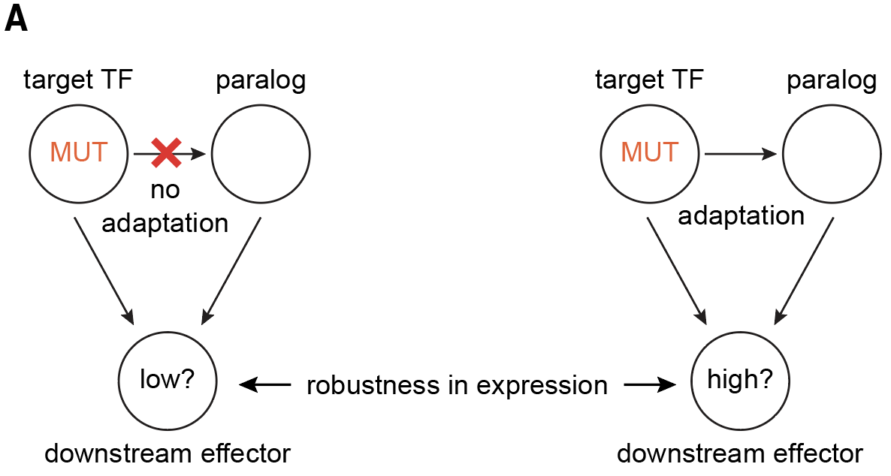
Figure 4: Robustness of regulon expression associated with transcription factor transcriptional adaptation
- Analysis schematic: is there different regulon gene expression robustness after mutation of upstream transcription factors, associated with whether the transcription factors demonstrate transcriptional adaptation by paralogs?

- 5c/d/e: What is "abundance"? Needs to be explained; is this single-cell UMIs, some size-factor-corrected value?

Reply: Abundance is log(TPM+1) values, derived from UMI-based counts, as originally processed and reported by Frangieh et al. in their 2021 paper. We have added this information to the figure legend.

Figure 4: Robustness of regulon expression associated with transcription factor transcriptional adaptation
- Gene expression distributions of a representative transcription factor that demonstrates possible transcriptional adaptation: SMAD4, in non-template controls (“control”, gray) and in SMAD4-guide-treated cells (“targeted”, orange). Fisher’s exact test p-values for difference in odds of cells being positive in control vs. targeted populations. Abundance values log(TPM+1) reported by (Frangieh et al., 2021).
- Gene expression distributions of a representative top-100 paralog gene of a transcription factor that demonstrates possible transcriptional adaptation: SMAD1, a paralog of SMAD4, in non-template controls (gray) and in SMAD4-guide-treated cells (orange). Fisher’s exact test p-values for difference in odds of cells being positive in control vs. targeted populations. Abundance values log(TPM+1) reported by (Frangieh et al., 2021).
- Gene expression distributions of three representative regulon genes of a transcription factor that demonstrates possible transcriptional adaptation: ID3, TNFRSF11B, and ID2, regulon genes of both SMAD4 and SMAD1, in non-template controls (gray) and in SMAD4-guide-treated cells (orange). Fisher’s exact test p-values for difference in odds of cells being positive in control vs. targeted populations. Bimodality coefficient calculated for non-zero subpopulation of each distribution. Abundance values log(TPM+1) reported by (Frangieh et al., 2021).

- 5c/d/e: Consider doing a log transform of the y axis.
- 5e: This needs some sort of quantification (KS test, Fisher exact).

Reply: To aid in interpreting differences in expression level and distribution shape, we have added Fisher’s exact test p-values for difference in odds of detected expression between control and targeted populations and bimodality coefficients, for downstream effectors, for descriptions of distribution shape. In panels C-E, we show histograms of the expression level distribution for each gene. Although log-transformation of the y-axis would highlight the shape of small peaks, it would also obscure the connection between histogram volume and the fraction of the population with a given abundance (Figure 4 [previously Figure 5] pasted above).

- 5e: Which distributions match the claims "some downstream genes demonstrated fully robust, consistent gene expression distribution shapes, while others demonstrated partial expression robustness with possible new modes of gene expression, or lower expression overall"? This is unclear. Can you label the diagram and possibly back up this with a statistical test (or bootstrapping?) Fraction positive is a weak statistic.

Reply: We thank the reviewer for pointing out a critical place for clarifying key results. For downstream effectors, we have added both Fisher’s exact test p-values and bimodality coefficients to the panels. Fully robust distributions would have a high p-value (>0.05) and low change in bimodality coefficient, like TNFRSF11B. Other targets, like ID2, are robust only in expression level but different in bimodality (with a high p-value but a change in bimodality coefficient). A third group of targets are robust in neither expression level nor shape, like ID3, with a low p-value and a change in bimodality coefficient. Overall, these results demonstrate the diverse outcomes possible for different downstream targets of mutated transcription factors. We have also modified our claims in the main text to accurately reflect our findings.

possible presence of bimodality or multimodality, with some gene expression distribution differences showing modest increases in bimodality coefficient (see Methods), or decreased average expression (Figure 4E).

- 5f/5g: this is the most interesting part of figure 5! It clearly shows the claim that the TFs that demonstrate adaptation have a lower standard deviation.

Reply: We are happy to hear that the reviewer found panels F and G to be so interesting! We similarly believe they are critical analyses. Accordingly, we changed the order of the figures to make this Figure 4 so that these results appear earlier in the manuscript. Furthermore, such reordering helped with explaining the connections between the expression data reanalysis and the gene regulatory network modeling.

Reviewer #2: In Prevalence of and gene regulatory constraints on transcriptional adaptation in single cells, Mellis et al. analyze a swath of available genome-wide transcription data to discover a pervasiveness of nonsense-induced transcriptional compensation (NITC), whereby nonsense mutations of genes upregulate transcription of paralogs of those genes via an undiscovered mechanism. The results have important implications for how to interpret the results of popular gene-knockout approaches at least in humans and in mice. Furthermore, using a minimal mathematical model of transcription and nonsense-induced paralog transcription, the authors support the concept that transcriptional adaptation could provide a means for robustness in downstream effector variability. Lastly, they return to the datasets to find that NITC may indeed be responsible for buffering expression changes in downstream targets that are mutually targeted by paralog pairs.

The authors excel in setting proper controls in their analyses and maintaining stringent conditions for drawing conclusions, giving high confidence in their results. The work harnesses the power of the many existing RNAseq datasets and numerous CRISPR/Cas9 experiments performed to gather this data, revealing that there is much more information to learn from existing data, and demonstrating that NITC is widespread. Their model discovers interesting spaces of robust unimodal distributions, bimodal distributions, and even trimodal distributions of downstream effectors. Together, their computational framework should influence the design and analysis of genetic experiments from single-cell to bulk.

This work is appropriate for publication, with a few outstanding curiosities:

Reply: We thank the reviewer for their positive assessment and thoughtful questions aimed at improving the manuscript. We believe that our additional analyses in the revised manuscript adequately address their remaining questions. Highlights of our revision in response to the reviewer’s comments include:

- Analyses of additional potential correlates of paralog upregulation: we comprehensively explored possible additional correlates of paralog upregulation, beyond gene length and sequence identity, which could aid future studies of transcriptional adaptation:
  - Shared enhancers, using the GeneHancer database.
  - 3D chromatin architecture, using the TADKB database.
  - Co-expression across tissues, using GTEx data.
- Rewriting and reorganizing parts of the manuscript for clarity and enhanced precision of explanations: we clarified descriptions of statistical analyses, augmented interpretation of observed paralog upregulation, and added discussion of potential future directions that could help resolve outstanding questions about paralog expression levels after reference gene mutation.

1. The authors do a good job eliminating factors such as sequence homology, shared signaling pathways, and correlated expression of adaptive components, but still there are other questions that could be tackled to help discover the mechanism behind this phenomenon. For instance, do identified paralog pairs have other shared non-coding genetic features (i.e., regulatory sequences like promoters, introns or shared enhancers)? Do identified compensatory paralogs share physical space (topologically associated domains as investigated in 10.1093/nar/gkw813)

Reply: We agree with the reviewer that non-coding features, including regulatory sequences and 3D chromatin architecture, would be interesting and important to explore as potential correlates of transcriptional adaptation. We addressed these points with two different approaches, and have added these analyses to the Results section.

First, we identified overlaps between enhancers annotated for knockout targets and their paralogs, and assess whether paralogs with shared enhancers are more often upregulated following target knockout. We used the GeneHancer database (Fishilevich et al., 2017). We found only a few paralogs that shared enhancers or promoters with their respective CRISPR target (2 out of 489 paralog-target pairs with both genes in the database). There was no difference in odds of paralog upregulation between the few paralogs with shared enhancers or promoters and those without (Fisher’s exact test p-value = 0.13). Second, we asked whether paralogs in the same topologically associated domain as their corresponding knockout target are more often upregulated after knockout. We used the TADKB database (Liu et al., 2019). Our overall analysis is conceptually similar in method to the citation the reviewer recommends but includes all annotated paralogs per reference gene rather than only one paralog. We found that only 4 out of 562 target-paralog pairs tested were co-located in the same topologically-associated domains. There was no difference in odds of paralog upregulation between the few paralogs with shared domains and those without (Fisher’s exact test p-value = 0.23). We modified the revised main text results and methods section to reflect these new analyses:

Results
Next, we asked whether sharing genomic regulatory elements, including enhancers and promoters, between a paralog and its respective CRISPR target was associated with paralog upregulation after knockout. First, we mined the GeneHancer database of human enhancers and promoters annotated with their regulated genes (Fishilevich et al., 2017). We found only a few paralogs that shared enhancers or promoters with their respective CRISPR target (only 2 out of 489 paralog-target pairs with both genes in the database). There was no difference in odds of paralog upregulation between the few paralogs with shared enhancers or promoters and those without (Fisher’s exact test p-value = 0.13, see Methods) ...

We also checked whether 3D genome architecture may be associated with paralog upregulation after target knockout. We mined the TADKB database(Liu et al., 2019) of human topologically-associated domains to check for knockout target-paralog pairs both located in shared annotated domains in any available human cell type (see Methods). We considered genes co-located in the same topologically-associated domain if any Ensembl-annotated transcription start sites for both genes occurred within the domain. We found that only 4 out of 562 target-paralog pairs tested were co-located in the same topologically-associated domains. There was no difference in odds of paralog upregulation between the few paralogs with shared domains and those without (Fisher’s exact test p-value = 0.23).

Methods
Checking for genomic regulatory feature association with paralog upregulation

We downloaded annotated associations between human enhancer or promoter elements and human genes from the GeneHancer v5.19 database (https://www.genecards.org/Guide/DatasetRequest, last accessed April 4, 2024). We converted gene identifiers to GeneCards IDs using gprofiler2 in R. We mined the GeneHancer database for associations between enhancers or promoters and genes. For assessment of paralogs only, we considered all knockout target-paralog pairs together. We checked for a difference in odds of paralog upregulation based on whether the paralog and CRISPR target shared any annotated enhancer or promoter using Fisher's exact test in R.

We downloaded annotated topologically-associated domains (TAD) coordinates in the hg19 human genome (http://dna.cs.miami.edu/TADKB/download/TAD_annotations.tar.gz, last accessed April 29, 2024). We considered annotated transcription start sites for any Ensembl transcript for each considered gene, identified using biomaRt, pulling from the February 2014 build of hg19. Consistent with the publicly accessible browser built by the authors of TADKB(Liu et al., 2019), we considered annotated TADs at 50kb resolution called using the directionality index method, in any of the human cell types in the database. For each CRISPR target, paralog, or any other gene, we searched for annotated TADs overlapping any of their annotated transcription start sites. For the paralog analysis, we combined all paralog-target pairs together and checked for a difference in odds of paralog upregulation based on co-location in any TAD shared with the knockout target using Fisher’s exact test in R.

a. Follow-up: If some of these other features (shared enhancer; shared TAD; etc) do predict non-sense induced transcriptional adaptation of paralogs, do these features also predict upregulation of non-paralogous genes that share the same feature?

Reply: The reviewer has raised an interesting follow-up analysis. We repeated the prior shared-enhancer-or-promoter and shared-TAD analyses to check for whether any genes sharing an enhancer or co-located in the same TAD as a knockout target demonstrate upregulation more often than others. We did not find significant associations with enhancers or promoters, or with TADs, and we have added these results to the main text:

In Caenorhabditis elegans, studies have shown for at least one pair of genes that transcriptional adaptation requires partial homology between a promoter and a subsequence of the mutated transcript (Welker et al., 2023). We hypothesized that even for genes not related to each other, sharing an upstream regulatory element with the CRISPR target may predispose another gene to upregulation. Our hypothesis, coupled with the fact the number of paralogs with shared regulatory elements was low, led us to further extend the check for association between sharing regulatory elements and upregulation after knockout to any genes in the database. Therefore, we repeated a check of shared regulatory elements for all genes in a given experiment in the GeneHancer database with the CRISPR target. Here again, we found no clear association between a gene being upregulated and whether it shared an enhancer or promoter with the CRISPR target (Fisher’s exact test p-value range (0.12, 1) across human CRISPR targets; see Methods)...

There is evidence that transcriptional adaptation may lead to the mutated gene’s own upregulation, such as at an unmutated allele in the case of heterozygosity or endogenous loci if mutated transcripts are injected into the cell (Jiang et al., 2022). Therefore, we hypothesized that if there were an association between 3D chromatin architecture and gene upregulation by transcriptional adaptation, it is possible that any neighboring gene with shared architectural regulatory features is more often upregulated. We repeated a check of shared domain co-location for CRISPR targets and any genes for which differential expression could be calculated. As with paralogs, we found minimal association between any gene sharing a topologically-associated domain with the CRISPR target and whether that gene was upregulated (Unadjusted Fisher’s exact test p-value range (0.039, 1); adjusted range (0.79, 1); see Methods). The only gene with an unadjusted p-value < 0.05 was SMARCA4 (p = 0.039), which was not a hit in the main analysis of paralog upregulation after SMARCA4 mutation and which with adjustment for multiple hypothesis testing did not meet a false-discovery rate threshold of < 0.05 (adjusted p-value = 0.79).

2. If wild type paralog pairs have correlated co-expression, does this predict nonsense-induced transcriptional compensation in KO mutants?

Reply: The reviewer poses an excellent conceptual question. In principle, we argue that correlated co-expression—specifically positively correlated expression—would not necessarily be predictive of nonsense-induced transcriptional compensation after knockout. Such co-expression could be suggestive of redundancy at baseline. At the same time, inspired by the reviewer comment, we checked for associations between co-expression at baseline and nonsense-induced transcriptional compensation. We accomplished this by asking whether paralogs with high average expression correlation across cell types to their respective knockout target were more often upregulated after mutation. We used GTEx data for human tissues (GTEx Consortium, 2020). We did not find a positive association between correlated expression levels and paralog expression change after mutation. In fact, we observed a slight anticorrelation between the two (Spearman’s rho = -0.11, p-val = 0.01). This anticorrelation raises interesting questions about whether it could be that transcriptional adaptation is only selected for in situations in which there is not already highly redundant paralog expression, and if so, why redundancy is not present. We have added these results to the main text.

In Results

We then wondered whether paralog expression similarity to knockout target expression across contexts is predictive of paralog upregulation after target mutation. Therefore, we performed an analysis at a functional level of genomic regulation, agnostic of specific regulatory features. Specifically, we calculated paralog expression level correlation with knockout target expression level across 54 human tissue types in the GTEx dataset (see Methods). We then compared the correlation coefficient for the expression of each gene-paralog pair against that pair’s paralog expression change after target mutation (Figure S1F). We found no positive association between gene expression correlation and paralog expression change after target knockout (instead, in fact, there was a slight anticorrelation (Spearman rho = -0.11, p-value = 0.01).) Of note, most paralogs have positive average expression correlation with the respective target genes across tissues, consistent with prior results (Ibn-Salem et al., 2017).

In Methods

Gene expression correlation analysis

For human genes, we downloaded GTEx Analysis V8 median expression levels (in TPM) in each tissue from the GTEx portal on April 15, 2024 (GTEx_Analysis_2017-06-05_v8_RNASeQCv1.1.9_gene_median_tpm.gct.gz). For each pair of genes: one knockout target and one paralog, we plotted the median expression in each tissue of the respective species and calculated a Spearman correlation coefficient on log(TPM+1). We then compared this correlation coefficient to the log2fold-change of the paralog as a check for association between cross-tissue average expression level correlation with the CRISPR target and whether a paralog displayed upregulation after CRISPR target knockout. We further calculated a Spearman correlation coefficient to check for association between the pairwise correlations and paralog log₂(fold changes).

3. Does the single-cell RNA-seq data eliminate the possibility that enrichment of paralogs is due to selection of cells that happened to have had increased paralog expression, and are therefore more fit? (i.e., selection from a random distribution rather than induced adaptation)

Reply: We thank the reviewer for bringing up this highly insightful alternative explanation for some results in the single-cell RNA-seq data. It is indeed possible that there is a selective advantage for cells expressing higher levels of compensating paralogs at baseline, in cases where loss of the CRISPR target’s activity reduces survival, which could lead to the appearance of upregulation after knockout. Available single-cell perturbation datasets from, e.g., Perturb-seq and CROP-seq are relatively sparse/noisy, and they are fixed snapshots in time, thus limiting their utility to answer such questions. Therefore, we do not have direct evidence to support or reject this specific hypothesis. At the same time, we added comments to the Discussion along these important line of questions for future studies to explore, as highlighted in purple here:

…quantitative resolution (Raj et al., 2008). Similarly, single-cell methods such as CROP-seq and Perturb-seq (Adamson et al., 2016; Datlinger et al., 2017; Jaitin et al., 2016) only offer fixed snapshots in time, limiting our ability to discriminate between two conceptually distinct scenarios possible: mutation-induced relative increases of paralog expression in surviving cells irrespective of initial expression levels vs. selection for pre-existing stably relatively higher paralog-expressing (rare) cells in the baseline population. Coupling single-cell RNA sequencing datasets with cellular lineage information, leveraging recently reported barcoding technologies (Goyal et al., 2023; Grody et al., 2023) that enable longitudinal tracking of individual cells before and after nonsense mutation for genes exhibiting transcriptional adaptation, can address such questions on the dynamics of transcriptional adaptation in single cells.

References:
Adamson, B., Norman, T. M., Jost, M., Cho, M. Y., Nuñez, J. K., Chen, Y., Villalta, J. E., Gilbert, L. A., Horlbeck, M. A., Hein, M. Y., Pak, R. A., Gray, A. N., Gross, C. A., Dixit, A., Parnas, O., Regev, A., & Weissman, J. S. (2016). A Multiplexed Single-Cell CRISPR Screening Platform Enables Systematic Dissection of the Unfolded Protein Response. Cell, 167(7), 1867–1882.e21.
Buglo, E., Sarmiento, E., Martuscelli, N. B., Sant, D. W., Danzi, M. C., Abrams, A. J., Dallman, J. E., & Züchner, S. (2020). Genetic compensation in a stable slc25a46 mutant zebrafish: A case for using F0 CRISPR mutagenesis to study phenotypes caused by inherited disease. PloS One, 15(3), e0230566.
Datlinger, P., Rendeiro, A. F., Schmidl, C., Krausgruber, T., Traxler, P., Klughammer, J., Schuster, L. C., Kuchler, A., Alpar, D., & Bock, C. (2017). Pooled CRISPR screening with single-cell transcriptome readout. Nature Methods, 14(3), 297–301.
De Souza, A. T., Dai, X., Spencer, A. G., Reppen, T., Menzie, A., Roesch, P. L., He, Y., Caguyong, M. J., Bloomer, S., Herweijer, H., Wolff, J. A., Hagstrom, J. E., Lewis, D. L., Linsley, P. S., & Ulrich, R. G. (2006). Transcriptional and phenotypic comparisons of Ppara knockout and siRNA knockdown mice. Nucleic Acids Research, 34(16), 4486–4494.
de Turris, V., Nicholson, P., Orozco, R. Z., Singer, R. H., & Mühlemann, O. (2011). Cotranscriptional effect of a premature termination codon revealed by live-cell imaging. RNA , 17(12), 2094–2107.
Diofano, F., Weinmann, K., Schneider, I., Thiessen, K. D., Rottbauer, W., & Just, S. (2020). Genetic compensation prevents myopathy and heart failure in an in vivo model of Bag3 deficiency. PLoS Genetics, 16(11), e1009088.
El-Brolosy, M. A., Kontarakis, Z., Rossi, A., Kuenne, C., Günther, S., Fukuda, N., Kikhi, K., Boezio, G. L. M., Takacs, C. M., Lai, S.-L., Fukuda, R., Gerri, C., Giraldez, A. J., & Stainier, D. Y. R. (2019). Genetic compensation triggered by mutant mRNA degradation. Nature, 1.
El-Brolosy, M. A., & Stainier, D. Y. R. (2017). Genetic compensation: A phenomenon in search of mechanisms. PLoS Genetics, 13(7), e1006780.
Fertuzinhos, S., Legué, E., Li, D., & Liem, K. F., Jr. (2022). A dominant tubulin mutation causes cerebellar neurodegeneration in a genetic model of tubulinopathy. Science Advances, 8(7), eabf7262.
Fishilevich, S., Nudel, R., Rappaport, N., Hadar, R., Plaschkes, I., Iny Stein, T., Rosen, N., Kohn, A., Twik, M., Safran, M., Lancet, D., & Cohen, D. (2017). GeneHancer: genome-wide integration of enhancers and target genes in GeneCards. Database: The Journal of Biological Databases and Curation, 2017. https://doi.org/10.1093/database/bax028
Fishman, L., Modak, A., Nechooshtan, G., Razin, T., Erhard, F., Regev, A., Farrell, J. A., & Rabani, M. (2024). Cell-type-specific mRNA transcription and degradation kinetics in zebrafish embryogenesis from metabolically labeled single-cell RNA-seq. Nature Communications, 15(1), 3104.
Frangieh, C. J., Melms, J. C., Thakore, P. I., Geiger-Schuller, K. R., Ho, P., Luoma, A. M., Cleary, B., Jerby-Arnon, L., Malu, S., Cuoco, M. S., Zhao, M., Ager, C. R., Rogava, M., Hovey, L., Rotem, A., Bernatchez, C., Wucherpfennig, K. W., Johnson, B. E., Rozenblatt-Rosen, O., … Izar, B. (2021). Multimodal pooled Perturb-CITE-seq screens in patient models define mechanisms of cancer immune evasion. Nature Genetics, 53(3), 332–341.
Gao, Y., Zhang, Y., Zhang, D., Dai, X., Estelle, M., & Zhao, Y. (2015). Auxin binding protein 1 (ABP1) is not required for either auxin signaling or Arabidopsis development. Proceedings of the National Academy of Sciences of the United States of America, 112(7), 2275–2280.
Goyal, Y., Busch, G. T., Pillai, M., Li, J., Boe, R. H., Grody, E. I., Chelvanambi, M., Dardani, I. P., Emert, B., Bodkin, N., Braun, J., Fingerman, D., Kaur, A., Jain, N., Ravindran, P. T., Mellis, I. A., Kiani, K., Alicea, G. M., Fane, M. E., … Raj, A. (2023). Diverse clonal fates emerge upon drug treatment of homogeneous cancer cells. Nature. https://doi.org/10.1038/s41586-023-06342-8
Grody, E. I., Abraham, A., Shukla, V., & Goyal, Y. (2023). Toward a systems-level probing of tumor clonality. iScience, 26(5), 106574.
GTEx Consortium. (2020). The GTEx Consortium atlas of genetic regulatory effects across human tissues. Science, 369(6509), 1318–1330.
Ibn-Salem, J., Muro, E. M., & Andrade-Navarro, M. A. (2017). Co-regulation of paralog genes in the three-dimensional chromatin architecture. Nucleic Acids Research, 45(1), 81–91.
Ito, T., Young, M. J., Li, R., Jain, S., Wernitznig, A., Krill-Burger, J. M., Lemke, C. T., Monducci, D., Rodriguez, D. J., Chang, L., Dutta, S., Pal, D., Paolella, B. R., Rothberg, M. V., Root, D. E., Johannessen, C. M., Parida, L., Getz, G., Vazquez, F., … Sellers, W. R. (2021). Paralog knockout profiling identifies DUSP4 and DUSP6 as a digenic dependence in MAPK pathway-driven cancers. Nature Genetics, 53(12), 1664–1672.
Jaitin, D. A., Weiner, A., Yofe, I., Lara-Astiaso, D., Keren-Shaul, H., David, E., Salame, T. M., Tanay, A., van Oudenaarden, A., & Amit, I. (2016). Dissecting Immune Circuits by Linking CRISPR-Pooled Screens with Single-Cell RNA-Seq. Cell, 167(7), 1883–1896.e15.
Jiang, Z., El-Brolosy, M. A., Serobyan, V., Welker, J. M., Retzer, N., Dooley, C. M., Jakutis, G., Juan, T., Fukuda, N., Maischein, H.-M., Balciunas, D., & Stainier, D. Y. R. (2022). Parental mutations influence wild-type offspring via transcriptional adaptation. Science Advances, 8(47), eabj2029.
Kok, F. O., Shin, M., Ni, C.-W., Gupta, A., Grosse, A. S., van Impel, A., Kirchmaier, B. C., Peterson-Maduro, J., Kourkoulis, G., Male, I., DeSantis, D. F., Sheppard-Tindell, S., Ebarasi, L., Betsholtz, C., Schulte-Merker, S., Wolfe, S. A., & Lawson, N. D. (2015). Reverse genetic screening reveals poor correlation between morpholino-induced and mutant phenotypes in zebrafish. Developmental Cell, 32(1), 97–108.
Konjikusic, M. J., Gray, R. S., & Wallingford, J. B. (2021). The developmental biology of kinesins. Developmental Biology, 469, 26–36.
Lackner, A., Sehlke, R., Garmhausen, M., Giuseppe Stirparo, G., Huth, M., Titz-Teixeira, F., van der Lelij, P., Ramesmayer, J., Thomas, H. F., Ralser, M., Santini, L., Galimberti, E., Sarov, M., Stewart, A. F., Smith, A., Beyer, A., & Leeb, M. (2021). Cooperative genetic networks drive embryonic stem cell transition from naïve to formative pluripotency. The EMBO Journal, 40(8), e105776.
Liu, T., Porter, J., Zhao, C., Zhu, H., Wang, N., Sun, Z., Mo, Y.-Y., & Wang, Z. (2019). TADKB: Family classification and a knowledge base of topologically associating domains. BMC Genomics, 20(1), 217.
Ma, Z., Zhu, P., Shi, H., Guo, L., Zhang, Q., Chen, Y., Chen, S., Zhang, Z., Peng, J., & Chen, J. (2019). PTC-bearing mRNA elicits a genetic compensation response via Upf3a and COMPASS components. Nature, 568(7751), 259–263.
Raj, A., van den Bogaard, P., Rifkin, S. A., van Oudenaarden, A., & Tyagi, S. (2008). Imaging individual mRNA molecules using multiple singly labeled probes. Nature Methods, 5(10), 877–879.
Replogle, J. M., Norman, T. M., Xu, A., Hussmann, J. A., Chen, J., Cogan, J. Z., Meer, E. J., Terry, J. M., Riordan, D. P., Srinivas, N., Fiddes, I. T., Arthur, J. G., Alvarado, L. J., Pfeiffer, K. A., Mikkelsen, T. S., Weissman, J. S., & Adamson, B. (2020). Combinatorial single-cell CRISPR screens by direct guide RNA capture and targeted sequencing. Nature Biotechnology, 38(8), 954–961.
Replogle, J. M., Saunders, R. A., Pogson, A. N., Hussmann, J. A., Lenail, A., Guna, A., Mascibroda, L., Wagner, E. J., Adelman, K., Lithwick-Yanai, G., Iremadze, N., Oberstrass, F., Lipson, D., Bonnar, J. L., Jost, M., Norman, T. M., & Weissman, J. S. (2022). Mapping information-rich genotype-phenotype landscapes with genome-scale Perturb-seq. Cell, 185(14), 2559–2575.e28.
Rossi, A., Kontarakis, Z., Gerri, C., Nolte, H., Hölper, S., Krüger, M., & Stainier, D. Y. R. (2015). Genetic compensation induced by deleterious mutations but not gene knockdowns. Nature, 524(7564), 230–233.
Serobyan, V., Kontarakis, Z., El-Brolosy, M. A., Welker, J. M., Tolstenkov, O., Saadeldein, A. M., Retzer, N., Gottschalk, A., Wehman, A. M., & Stainier, D. Y. (2020). Transcriptional adaptation in Caenorhabditis elegans. eLife, 9. https://doi.org/10.7554/eLife.50014
Welker, J. M., Serobyan, V., Zaker Esfahani, E., & Stainier, D. Y. R. (2023). Partial sequence identity in a 25-nucleotide long element is sufficient for transcriptional adaptation in the Caenorhabditis elegans act-5/act-3 model. PLoS Genetics, 19(6), e1010806.
Xie, A., Ma, Z., Wang, J., Zhang, Y., Chen, Y., Yang, C., Chen, J., & Peng, J. (2023). Upf3a but not Upf1 mediates the genetic compensation response induced by leg1 deleterious mutations in an H3K4me3-independent manner. Cell Discovery, 9(1), 63.
Yamamoto, S., Jaiswal, M., Charng, W.-L., Gambin, T., Karaca, E., Mirzaa, G., Wiszniewski, W., Sandoval, H., Haelterman, N. A., Xiong, B., Zhang, K., Bayat, V., David, G., Li, T., Chen, K., Gala, U., Harel, T., Pehlivan, D., Penney, S., … Bellen, H. J. (2014). A drosophila genetic resource of mutants to study mechanisms underlying human genetic diseases. Cell, 159(1), 200–214.
Yu, G., Wang, L.-G., Han, Y., & He, Q.-Y. (2012). clusterProfiler: an R package for comparing biological themes among gene clusters. Omics: A Journal of Integrative Biology, 16(5), 284–287.
Zhu, P., Ma, Z., Guo, L., Zhang, W., Zhang, Q., Zhao, T., Jiang, K., Peng, J., & Chen, J. (2017). Short body length phenotype is compensated by the upregulation of nidogen family members in a deleterious nid1a mutation of zebrafish. Journal of Genetics and Genomics = Yi Chuan Xue Bao, 44(11), 553–556.
Second round of review
Reviewer 1
The authors have invested significant effort to address concerns and issues identified in the original manuscript. While there may be lingering issues, they are small compared to the value of the work being broadly shared into the discussion of transcriptional adaptation and to better guide the design and interpretation of CRISPR screens.

