Supplementary Material

Figure S1: Bird’s-eye view of collapsed E-P-IN reveals highly modular, bipartite nature.
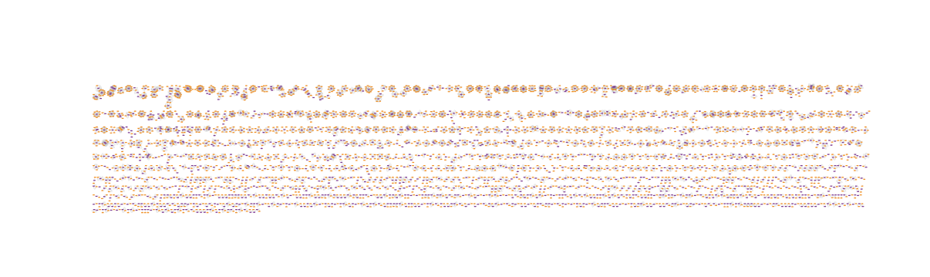

Figure S2: Distributions of enhancers, genes, and E-P-Is across relevant substructures.
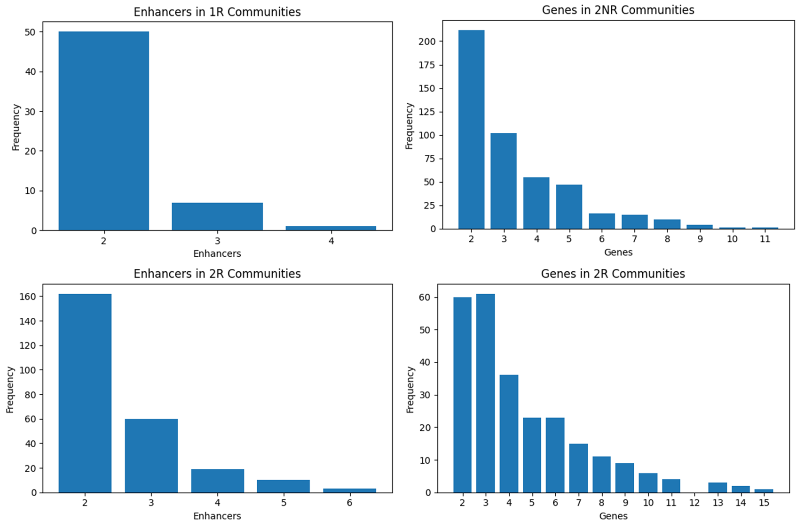
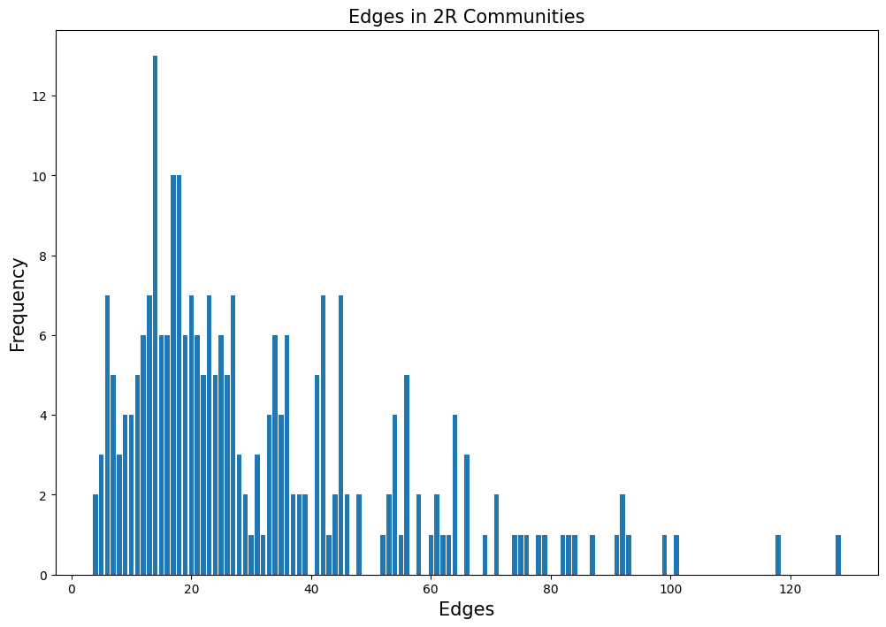
Figure S3: Jaccard similarities between ASD-associated gene sets in time-point-specific E-P-INs.
