Review History
First round of review
Reviewer 1

Were you able to assess all statistics in the manuscript, including the appropriateness of statistical tests used?
Yes, and I have assessed the statistics in my report.

Comments to author:
The manuscript by Zhang et al. investigates the molecular mechanisms underlying the effects of UV-B on the yield and quality of rice. A widely targeted metabolic profiling of leaves from diverse rice accessions under UV-B and normal-light conditions was conducted using a widely targeted metabolomics approach. Furthermore, transcriptome analysis and mGWAS were performed to elucidate the genetic basis of UV-B response.
Overall, the methods and results presented in the article are well-structured, but there are still some limitations:
Methods:
1. What are the principles for selecting 160 rice accessions from 533 rice varieties around the world?
2. While the article mentions the use of a widely targeted metabolomics approach, specific technical details. This may affect the reader's assessment of the reliability of the experiments.
3. What are the differences and distinctions between the linear mixed model (LMM) and the mixed linear model (MLM) in GWAS analysis? What are the respective advantages of each model?
4. The gene expression levels were measured using Fragments Per Kilobase of transcript per Million mapped reads (FPKM), but it is recommended to use TPM (Transcripts Per Million) values instead.
Results:
5. Please use different colors or traits to distinguish the indica and japonica subspecies in Figure 1a.
6. Please provide a detailed description of the differences referred to in the differentially accumulated metabolite analysis in Figure 1b, such as between treated and control samples, or between two different varieties.
7. Are the two conventional varieties, ZH11 and ZS97, UV-B resistant or UV-B susceptible? Additionally, what subspecies of indica and japonica are Lemon and Dular?
8. Group B comprised haplotypes H1 and H2, but only included 11 varieties of materials. Given that Group A has 500 materials in total, I personally believe that the number is too small to be statistically representative. Therefore, I suggest examining the haplotypes of OsUVR8 from a larger pool of 3000 rice sequencing materials.
Discussion:
9. Although the article reveals significant differences in metabolite accumulation between the two major rice subspecies, indica and japonica, under UV-B treatment, the biological significance and underlying mechanisms behind these differences are not fully discussed.
Additionally, I would encourage authors to also deposit their metabolomics data on the metabolomics workbench so other researchers can utilize it. https://www.metabolomicsworkbench.org
Reviewer 2

Were you able to assess all statistics in the manuscript, including the appropriateness of statistical tests used?
Yes, and I have assessed the statistics in my report.
Comments to author:
I found this to be an important and highly informative study which brought interesting conclusions. It was additionally well written. I wonder why the authors did not better discuss the findings of the following paper which they cite:
Peng M, Shahzad R, Gul A, Subthain H, Shen S, Lei L, et al. Differentially evolved glucosyltransferases determine natural variation of rice flavone accumulation and UV-tolerance. Nat Commun
since their findings are not entirely overlapping.
Secondly whilst the finding of the likely interaction between UVR8 and the TF mentioned in the discussion is intriuguing I would have expected to see at least a brief experimental follow up to this observation to see if this could be physiologically validated.
Otherwise I find this a very solid environmental genomics manuscript focussed on an important topic that is a good fit to the journal.

Authors Response
Point-by-point responses to the reviewers’ comments:
Reviewer #1: The manuscript by Zhang et al. investigates the molecular mechanisms underlying the effects of UV-B on the yield and quality of rice. A widely targeted metabolic profiling of leaves from diverse rice accessions under UV-B and normal-light conditions was conducted using a widely targeted metabolomics approach. Furthermore, transcriptome analysis and mGWAS were performed to elucidate the genetic basis of UV-B response.
Overall, the methods and results presented in the article are well-structured, but there are still some limitations:
Response: We greatly appreciate the reviewer’s positive comments and helpful suggestions.

Methods:
- What are the principles for selecting 160 rice accessions from 533 rice varieties around the world?
Response: Thank you very much for your comments. We randomly selected 160 rice accessions from 533 rice varieties around the world mainly based on the proportion of rice different subgroups in the 533 rice varieties. Finally, rice accessions including 76 Indica, 58 Japonica, 3 Admix, 17 Aus and 6 VI were used for UV-B treatment. We are very sorry that we have not describe the principles detailly in the Methods section of previous version. In this revision we added detailed descriptions of the selection principles (line 434-438).

2. While the article mentions the use of a widely targeted metabolomics approach, specific technical details. This may affect the reader's assessment of the reliability of the experiments.
Response: Thank you very much for your comments. In this revision, we added the technical details of the widely targeted metabolomics approach used in this study in the revised Methods section (line 457-477) as follows.
Samples were detected by both LC-ESI-QTOF-MS/MS (TripleTOF 5600+, Applied Biosystems, USA) and LC-ESI-QTRAP-MS/MS (4000 QTRAP, Applied Biosystems, USA) for the MS² spectral tag (MS2T) library construction. In the TOF MS mode, scanning mass range was from m/z 100 to m/z 1000 with an accumulation time of 0.10 sec. For IDA, the CEs were set at 30 V and 50 V, survey scans were acquired in 0.08 sec, and as many as 10 product ion scans were collected. Total cycle time was fixed to 0.79 sec. In the stepwise scan MIM–EPI mode, the Q1 (Q3) was set from 100.1 to 1000.1 Da, and the mass step was 1.0 Da, such as from 100.1/100.1, 101.1/101.1, 102.1/102.1, to 1000.1/1000.1. Each MIM transition was performed with a 5-ms Dwell time, and each MIM–EPI experiment with 60 MIM transitions monitored [35].
As described previously, a scheduled multiple reaction monitoring (MRM) method was used to carry out the quantiﬁcation of the metabolites [35]. An MRM detection window of 90 sec and a target scan time of 1.0 sec were used in the scheduled MRM algorithm. The data were processed with Analyst 1.6 software.

3. What are the differences and distinctions between the linear mixed model (LMM) and the mixed linear model (MLM) in GWAS analysis? What are the respective advantages of each model?
Response: Thank you very much for your comments. In the LMM model, each SNP and Q matrix is taken as fixed factors for regression analysis, kinship is taken as a random factor for SNP significance test. In fact, both the linear mixed model (LMM) and the mixed linear model (MLM) belong to mixed models, which model phenotypes using a mixture of fixed effects and random effects, and just written differently in different extended methods (Price et al., 2010; Xiao et al., 2017). In mixed model-based methods, population structure is fit as a fixed effect, and kinship is incorporated as the variance-covariance structure of the random effect for the individuals. Whereas, in the general linear model (GLM) model that early used for GWAS analysis, just simply regressed the marker variable against the phenotype and used background noise with covariates to control false associations. However, the individuals always share complex ancestral relatedness in a natural population. Mixed model approaches (MLM or LMM) have been demonstrated as an improved method to account for population structure and kinship among individuals. The difference between mixed models and GLM is the kinship, which were taken into account in mixed models (Zhang et al., 2010). Unfortunately, standard mixed models are computationally expensive and run slowly compared to simpler models, meaning not available to large datasets. In this study, we conducted our GWAS analysis used a factored spectrally transformed LMM (FaST-LMM) algorithm that dramatically increase analyzed datasets size and make current analyses much faster additionally (Lippert et al., 2011).
In this revision we detailly described the GWAS analysis using LMM model in the Methods section (line 500-503).

References:
Price AL, Zaitlen NA, Reich D, Patterson N. New approaches to population stratification in genome-wide association studies. Nat Rev Genet. 2010;11(7):459-63.
Xiao Y, Liu H, Wu L, Warburton M, Yan J. Genome-wide Association Studies in Maize: Praise and Stargaze. Mol Plant. 2017;10(3):359-74.
Zhang Z, Ersoz E, Lai CQ, Todhunter RJ, Tiwari HK, Gore MA, Bradbury PJ, Yu J, Arnett DK, Ordovas JM, Buckler ES. Mixed linear model approach adapted for genome-wide association studies. Nat Genet. 2010;42(4):355-60.
Lippert C, Listgarten J, Liu Y, Kadie CM, Davidson RI, Heckerman D. FaST linear mixed models for genome-wide association studies. Nat Methods. 2011;8(10):833-5.

4. The gene expression levels were measured using Fragments Per Kilobase of transcript per Million mapped reads (FPKM), but it is recommended to use TPM (Transcripts Per Million) values instead.
Response: Thank you very much for your comments.
Exactly, although both TPM and FPKM are homogenized based on gene length and sequencing depth, they are also obviously different. For FPKM homogenization, it is difficult to compare which gene has the highest total reads, because the number of total reads in each replicate is different. For TPM, the total TPM is the same for each repeat, making it easy to compare transcription levels of the same genes in different repeats.
Thanks again for your suggestions, which led us to discover an incorrect unit identification. When the gene expression levels were measured by TPM, we obtained the same results. After carefully checking the analysis process and transcriptome data, we found that our gene expression levels were measured using TPM, and the obvious evidence was that the sum of all gene expression levels in each sample was 1e⁶. Meanwhile, we conducted a quantitative analysis of the data again and also obtained the same results. In this revision, we revised the description about RNA sequencing and transcriptome analysis in the Methods section (line 591).

Results:
5. Please use different colors or traits to distinguish the indica and japonica subspecies in Figure 1a.
Response: Thank you very much for your helpful suggestion.
In this revised Fig. 1a, we use different colors to distinguish the indica subspecies, the japonica subspecies and the other rice accessions, namely green circles represent the japonica subspecies, red circles represent the indica subspecies and gray circles represent the others.

6. Please provide a detailed description of the differences referred to in the differentially accumulated metabolite analysis in Figure 1b, such as between treated and control samples, or between two different varieties.
Response: Thank you very much for your helpful suggestion.
We are very sorry to cause your trouble because we have not described it clearly. In this revision we described in detail the differences referred to in the differentially accumulated metabolite analysis were between treated and control samples in Figure 1b and the changes have been highlighted in red (line 147, 150). Moreover, we added a detailed description of the process of metabolite data analysis in the revised Methods section (line 480-493).

7. Are the two conventional varieties, ZH11 and ZS97, UV-B resistant or UV-B susceptible? Additionally, what subspecies of indica and japonica are Lemon and Dular?
Response: Thank you very much for your comments.
From our results, namely Additional file 1: Fig. S3, we found ZS97 is a UV-B medium resistant variety, since its slightly weaker resistance than Lemon, and ZH11 is a UV-B medium susceptible variety, since its slightly lower susceptibility compared to Dular. However, both the resistant variety Lemon and the susceptible variety Dular are Japonica. We have marked that ZH11 was UV-B medium susceptible and ZS97 were UV-B medium resistant in the revised version (line 165).

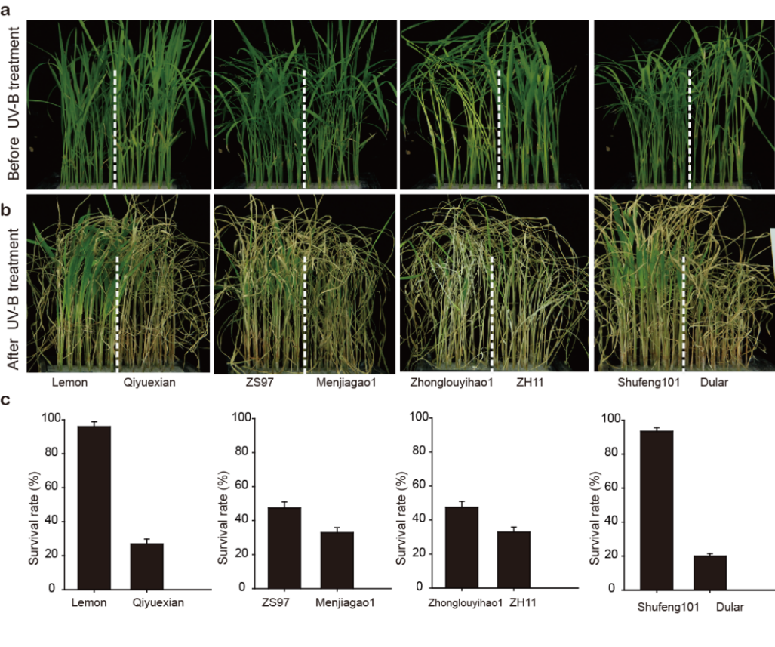
Additional file 1: Fig. S3 Tolerance of different rice varieties to UV-B stress.
a Phenotypes of 4-week-old rice seedling lines before UV-B treatment. b Phenotypes of 4-week-old rice seedling lines after 72h UV-B treatment for 10d recovery. c Survival rate of 4-week-old rice seedling lines after UV-B treatment for 10d recovery.

8. Group B comprised haplotypes H1 and H2, but only included 11 varieties of materials. Given that Group A has 500 materials in total, I personally believe that the number is too small to be statistically representative. Therefore, I suggest examining the haplotypes of OsUVR8 from a larger pool of 3000 rice sequencing materials.
Response: Thank you very much for your constructive suggestions.
In the revised manuscript, we examined the haplotypes of OsUVR8 both from rice materials sequenced by Huang et al. (2011) and by Wang et al. (2018). Since all these two rounds sequencing information were collected in RiceVarMap V2.0 (Zhao et al., 2021), we finally used 4275 rice materials based on information from RiceVarMap V2.0 (http://ricevarmap.ncpgr.cn/) for the analysis of OsUVR8 haplotype.
Consistent with previous results, twenty-five SNPs and insertion-deletions were categorized into two distinct groups, namely group A and group B, including 4067 and 208 rice varieties respectively. Group A consisted of haplotypes H3, H4, H5, H6, H7 and H10, and Group B consisted of haplotypes H1, H2, H8, H9, H11, H12 and H13. On the basis of the previous seven haplotypes, six new haplotypes were added, namely H8, H9, H10, H11, H12 and H13. In addition, we also updated geographical distribution analysis based on these sequencing materials with detailed geographical position. Consistent with previous results, approximately 6% of rice varieties with OsUVR8^{groupB} inhabit areas characterized by low UV-B intensity and 1% of rice varieties with OsUVR8^{groupB} inhabit areas characterized by high UV-B intensity, indicating rice varieties with OsUVR8^{groupB} are likely to have been artificially selected for their ability to withstand high UV-B intensity condition.
Based on these results, we have made corresponding alterations in the revision (line 318-330).

References:
Huang X, Zhao Y, Wei X, Li C, Wang A, Zhao Q, et al. Genome-wide association study of flowering time and grain yield traits in a worldwide collection of rice germplasm. Nat Genet. 2011;44(1):32-9.
Wang W, Mauleon R, Hu Z, Chebotarov D, Tai S, Wu Z, et al. Genomic variation in 3,010 diverse accessions of Asian cultivated rice. Nature. 2018;557(7703):43-49.
Zhao H, Li J, Yang L, Qin G, Xia C, Xu X, Su Y, Liu Y, Ming L, Chen L-L, Xiong L and Xie W. An inferred functional impact map of genetic variants in rice. Mol Plant. 2021;14(9):1584-99.

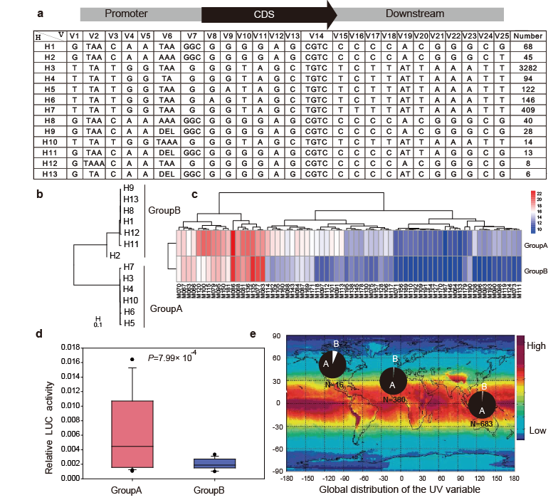
Fig. 6 Natural variation and geographical distribution of OsUVR8 in rice varieties.
a Haplotype analysis of OsUVR8 in 4275 rice varieties; thirteen haplotypes were detected, and the numbers of rice accessions with thirteen haplotypes were shown. b Phylogenetic tree of the thirteen haplotypes divided into group A (Hap3-Hap7 and Hap10), and group B (Hap1, Hap2, Hap8, Hap9, Hap11, Hap12, and Hap13). The scale bar indicates average number of substitutions per site for different haplotypes. c Hierarchical clustering showing flavonoid accumulation in rice variety leaves with the two Groups. Red represents high flavonoid content, and blue represents low flavonoid content. d Bar graphs showing the promoter activity of the OsUVR8 with different haplotypes in tobacco. LUC activity value was normalized to REN activity as an internal control; REN, renilla luciferase; LUC, firefly luciferase. e Geographic distribution among rice varieties with group A and group B in this study. Each pie chart size was proportional to the number of rice accessions with different groups in geographic location; red showing high UV-B intensity and blue showing low UV-B intensity.

Discussion:
9. Although the article reveals significant differences in metabolite accumulation between the two major rice subspecies, indica and japonica, under UV-B treatment, the biological significance and underlying mechanisms behind these differences are not fully discussed.
Response: Thank you very much for your constructive suggestion.
In this revision we fully discussed the biological significance and underlying mechanisms behind these differences in metabolite accumulation between indica and japonica, under UV-B treatment (line 346-354).
Namely, Interestingly, the difference of metabolite accumulation was more obvious between indica and japonica accessions under UV-B stress comparing with normal condition (Fig. 1a). Due to the differing geographic distributions of indica and japonica accession, these two subspecies encounter distinct environmental stresses. Flavonoids and amino acids have been reported to play roles in various abiotic stress response and resistance (Tohge et al., 2016; Zhang et al., 2021). Therefore, we hypothesize that the specific accumulation of these metabolites may be significant both biologically and evolutionarily in the differentiation of indica and japonica accessions, as well as their adaptation to environmental stresses.

References:
Tohge T, Wendenburg R, Ishihara H, Nakabayashi R, Watanabe M, Sulpice R, et al. Characterization of a recently evolved flavonol-phenylacyltransferase gene provides signatures of natural light selection in Brassicaceae. Nat Commun. 2016;7:12399.
Zhang F, Wu J, Sade N, Wu S, Egbaria A, Fernie AR, et al. Genomic basis underlying the metabolome-mediated drought adaptation of maize. Genome Biol. 2021;22(1):260.

Additionally, I would encourage authors to also deposit their metabolomics data on the metabolomics workbench so other researchers can utilize it. https://www.metabolomicsworkbench.org
Response: Thank you very much for your helpful suggestion.
Exactly, we also hope other researchers can utilize our metabolomics data and give us valuable advice. We have deposited our metabolomics data on the metabolomics workbench. The accession numbers ST003278 was provided in the revised Availability of Data and Materials section (line 626-627).

Reviewer #2: I found this to be an important and highly informative study which brought interesting conclusions. It was additionally well written. I wonder why the authors did not better discuss the findings of the following paper which they cite:

Peng M, Shahzad R, Gul A, Subthain H, Shen S, Lei L, et al. Differentially evolved glucosyltransferases determine natural variation of rice flavone accumulation and UV-tolerance. Nat Commun.
since their findings are not entirely overlapping.
Response: Thank you very much for your highly positive comments and constructive suggestions.
Exactly, our results about natural variation of rice flavonoid accumulation and UV-tolerance were consistent with the results reported by Peng et al. (2017), and we should well discuss them. In this revision we fully discussed these results (line 408-418).
Namely, A key discovery of our work was that OsUVR8 plays an active role in promoting flavonoid accumulation to enhance UV-B stress tolerance, with natural variants within the OsUVR8 locus, group A specifically, linked to heightened UV-B resistance in rice (Fig. 6), which were similar to natural variation of rice flavone accumulation and UV-tolerance reported previously (Peng et al., 2017). These results collectively revealed the fact that, natural variation of rice flavonoid accumulation is regulated not only by structural genes involved in flavonoid biosynthesis but also by certain upstream proteins, and exploring of the naturally occurring allelic variations can provide a better understanding of gene function from physiological, ecological and evolutionary perspectives. Collectively, these results provide new insights for further studies of rice response, tolerance, and adaptation to UV-B stress, and underscore the significance of OsUVR8 as a valuable molecular breeding target for improving rice resilience and productivity under UV-B stress to ultimately bolster crop tolerance to environmental stressors.

Secondly whilst the finding of the likely interaction between UVR8 and the TF mentioned in the discussion is intriuguing I would have expected to see at least a brief experimental follow up to this observation to see if this could be physiologically validated.
Response: Thank you very much for your comments.
We are very sorry for causing your misunderstanding by our reasons. In fact, in our results of previous version, we identified OsMYB110 as an interacting partner with OsUVR8 by a yeast two-hybrid screen (Fig. 5h). And bimolecular fluorescence complementation assays further confirmed the interaction between OsUVR8 and OsMYB110 in tobacco (Fig. 5i). Moreover, transient transcription analysis demonstrated that both OsUVR8 and OsMYB110 individually activated the activity of ProOsCHS:LUC, with a more pronounced effect observed when OsUVR8 was co-expressed with OsMYB110, particularly under the UV-B condition (revised Fig. 5k).
In the revised manuscript, we further conducted GST pull-down assays and confirmed the direct physiological interaction both of recombinant His-OsUVR8 with GST-OsMYB110 (revised Fig. 5j, line 288-289), and GST-OsUVR8 with His-OsMYB110 (see the figures below). These findings provide evidence that OsUVR8 interacts with OsMYB110 to regulate flavonoid accumulation and enhance UV-B tolerance in rice. The methods of GST pull-down assays were described in the revised Methods section (line 573-583).
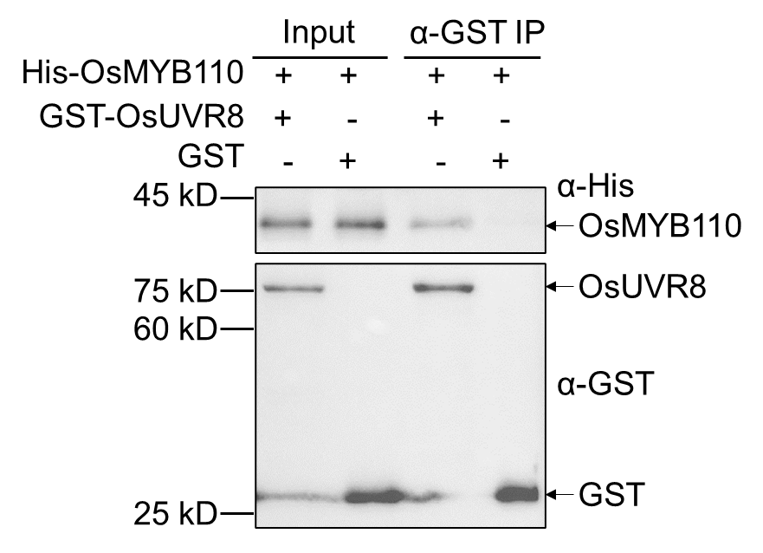
Fig. R1 The direct physical interaction between recombinant GST-OsUVR8 with His-OsMYB110 confirmed by in vitro GST pull-down assays.

Otherwise I find this a very solid environmental genomics manuscript focussed on an important topic that is a good fit to the journal
Response: Thank you very much again for your highly positive comments. Your valuable suggestions will be of great significance to the improvement of our article.

Meanwhile, we deposited our data to a relevant repository and the detail information were described in the revision as below (line 623-632).
Availability of data and materials
Transcriptome sequencing reads of the rice leaves of four rice varieties under UV-B and control conditions were deposited into the NCBI BioProject under the accession numbers PRJNA123160 [Zhang et al., 2024]. Metabolomics data in this paper have been deposited to the metabolomics workbench under the accession numbers ST003278 [Zhang et al., 2024]. The rice reference genome was accessed from the Rice Genome Annotation Project [Kawahara et al., 2013]. The rice genotyping information was accessed from Rice Variation Map v2.0 [Zhao et al., 2021]. The global distribution of the UV intensity was accessed from literature previously published [Andersen et al., 2016]. The rice accession information was accessed from literature previously published [Huang et al., 2011; Wang et al., 2018].

References:
Zhang F, Yang C, Guo H, Li Y, Shen S, Qianqian Zhou Q, et al. Dissecting the genetic basis of UV-B responsive metabolites in rice. PRJNA123160. Transcriptome sequencing of rice leaves. https://dataview.ncbi.nlm.nih.govobjects?linked_to_id=PRJNA1123160 (2024).
Zhang F, Yang C, Guo H, Li Y, Shen S, Qianqian Zhou Q, et al. Dissecting the genetic basis of UV-B responsive metabolites in rice. ST003278. Metabolomics data of rice leaves. https://www.metabolomicsworkbench.org/data/DRCCDataDeposit.php?Mode=SetupListDataUpload&UploadMode=ListDataUpload (2024).
Kawahara Y, Bastide M, Hamilton JP, Kanamori H, McCombie WR, Ouyang S, et al. Improvement of the Oryza sativa Nipponbare reference genome using next generation sequence and optical map data. Rice. 2013;6(1):4.
Zhao H, Li J, Yang L, Qin G, Xia C, Xu X, Su Y, Liu Y, Ming L, Chen L-L, Xiong L and Xie W. An inferred functional impact map of genetic variants in rice. Mol Plant. 2021, 14:1584-1599.
Andersen TB, Dalgaard CJ, Selaya P. Climate and the emergence of global income differences. Rev Econ Stud, 2016, 83: rdw006.
Huang X, Zhao Y, Wei X, Li C, Wang A, Zhao Q, et al. Genome-wide association study of flowering time and grain yield traits in a worldwide collection of rice germplasm. Nat Genet. 2011 4;44(1):32-9.
Wang W, Mauleon R, Hu Z, Chebotarov D, Tai S, Wu Z, et al. Genomic variation in 3,010 diverse accessions of Asian cultivated rice. Nature. 2018 ;557(7703):43-49.

Second round of review
Reviewer 1
I have no further comments/suggestions.

Reviewer 2
I am fully satisfied by the revised manuscript.

