1st round
Reviewer 1
This manuscript describes a new statistical approach for treating quantitative proteomic data. While it is clearly written and the approach seems to be rigorous, I feel that there are a few points that should be included to help readers understand:
1. There is no mention of the ratio compression and other technical problems associated with isobaric tags. This absolutely needs to be discussed, including its impact on the statistics used here. For example, from one run to the next, one could imagine that the variance of the measured data might change simple as a result of differences in ratio compression rather than any biological effect. How would this impact the algorithm?
2. As I was reading the manuscript I found myself wondering "why do we need this?". It is explained a bit further down, especially around Figure 2, but some statement earlier on would help guide the reader. But Fig. 2 then raises more questions that i did not find answered: Why do the more conventional approaches not find the same things, especially in the PCA analysis? The differences between zMAP and the Log2 intensity seem too starkly different, which makes me wonder whether the authors did all they could to optimize the log2 data? For example, what if it were normalized for some kind of block effect?
3. Another thing I found myself wondering as I read the manuscript was "Why should this be specific for isobaric tag data?" I think I know the answer but the authors should clearly state either why this applies only to isobaric tag data OR how it could be applied to other kinds of proteomic data

Reviewer 2
Gui et al. present two methods, zMAP and reverse-zMAP, for normalizing protein abundances from isobaric labeling-based mass spectrometry (ILMS) experiments. These methods replace the estimated variance of the regular z-transformation by an intensity-dependent expected variance. This ensures that proteins with high variance retain their high variance after z-transformation, while also accounting for the higher variability of low intensity proteins due to technical factors.
In a small erythropoiesis study, the authors demonstrate that zMAP identifies proteins of interest based on hypervariability, i.e. proteins with a higher than expected variance. The authors then use reverse-zMAP, a variant of zMAP suitable for multibatch TMT studies, to analyze a hepatocellular carcinoma CPTAC cohort study. By applying several downstream analysis techniques on hypervariable proteins, the authors show that interesting biology can be discovered. Although accounting for the mean-variance relationship in ILMS proteomics data is in itself sensible, the authors insufficiently demonstrate the general validity of hypervariability as a proxy for significance and the added value of their (reverse-)zMAP method compared to (simple) alternatives.
Major issues:
* The main premise of the zMAP method is that hypervariable proteins are of biologic interest. Unfortunately, the authors do not provide sufficient evidence or literature references that this is generally true. The authors use a study with just a few conditions and multiple replicates to demonstrate that hypervariable proteins identified by zMAP correspond to proteins of biological interest. Due to the nature of this study design, differential expression happens to coincide with high variability. However, such a relation is presumably not generally true for other study designs, e.g. when comparing many different patients without replicates in cohort studies.
* Based on the results of the small erythropoiesis study, the authors conclude that zMAP is a useful method. However, they then introduce a heavily modified version (reverse-zMAP) and apply this to the cohort study without ever comparing it to alternative methods. To demonstrate the utility of reverse-zMAP, the authors need to contrast their downstream analysis results to what would have been found with, e.g. the regular z-transformation.
* 2290 (erythropoiesis study) and 3097 (HCC study) significant hypervariable proteins is a very high proportion of the total number of proteins. This seems to indicate that the distribution of variances is not well-modeled.
* Using only W=30% of the proteins in a window for the quantile estimation is very low. Does this imply that we expect the vast majority of proteins are in fact differentially expressed, or is this a sign that a normal distribution is not the correct distribution to model the data with? How do the results change for different values of W? Related to this, I do not understand the meaning of the red colored "Proteins in sliding window used for linear fitting" and "Proteins used for model fitting" in Figure 4a. If there are really this few proteins used for the linear fit, I would be very worried about the stability of the estimate.
* The difference in the MVC relation of different samples in Fig. S7 is rather concerning. Especially the middle case where the variance is very low for all intensities and even goes up for high intensities does not inspire confidence in the reliability of the zMAP z-statistics. It suggests we could have outlier zMAP z-statistics in certain samples that were driven by technical artifacts rather than biological relevance. It would be good to see how much the MVCs are affected by batch-related effects, how much they reflect sample heterogeneity and to what degree the parameter W has an influence.
* It is unclear how much new biology was discovered using the zMAP method that would not have been found with conventional methods. For example, how do the 3 subgroups based on PC1 of hypervariable proteins from reverse-zMAP compare to the 3 subgroups in the original paper which were based on simple differential expression and also were associated with survival? Furthermore, the association of TSC2 mutation with survival was already noted in the original study. It is often easy to find differences between tumor and NAT tissues, both with differential expression and zMAP, because of the large differences between the two. Most of the differences tend to reflect general cancer biology (most of which is already known, e.g. TP53), whereas it is often hard to find cancer-type specific relevant proteins. It should be further discussed and clarified in which situations it is expected that zMAP works well and in which cases it would not.
Minor comments:
* Page 6, line 55: "Finally, differentially expressed proteins are identified as those proteins whose observed variances are significantly larger than the corresponding variances read from the MVC." This is not how differential expression is defined, i.e. a difference in (mean) abundance between two groups. The term "hypervariability", as used later on in the manuscript is more appropriate.
* The heatmaps for Chi-squared and p-values in the bottom right of Fig 1f are confusing because they look like scales.
* Page 10, line 19: "Finally, we ranked all proteins based on the standard deviations and selected the top 0.5% as differential ones, which included most of the hemoglobin proteins (Fig. 3b)." Why was 0.5% chosen? This seems completely arbitrary.
* It would be interesting to discuss/see how zMAP compares to the recently published msTrawler method which also accounts for lower reliability of certain protein quantifications.
* It is strange to put a new analysis (the co-expression network) in the discussion section. This should be a part of the results section.
* Having the variance estimate only depend on the reference intensity in reverse zMAP (Eq. 7) is conceptually not very satisfying, since the M-value and its variance will dependBy contrast, the samples were clustered by their biological labels when the z-statistics derived by zMAP were used on the intensity of both the reference and the actual sample.

Authors’ response
Reviewer #1
This manuscript describes a new statistical approach for treating quantitative proteomic data. While it is clearly written and the approach seems to be rigorous, I feel that there are a few points that should be included to help readers understand:

1. There is no mention of the ratio compression and other technical problems associated with isobaric tags. This absolutely needs to be discussed, including its impact on the statistics used here. For example, from one run to the next, one could imagine that the variance of the measured data might change simple as a result of differences in ratio compression rather than any biological effect. How would this impact the algorithm?
Reply: sincerely thanks for this valuable comment. As a general technical problem associated with isobaric tags, ratio compression indeed deserves a specific discussion in the manuscript. According to previous reports, this technical problem is believed to arise from contamination during precursor ion selection by co-eluting peptides^{1,2}. Since these peptides typically contribute a background value equally to each reporter ion signal, the contamination caused by them leads to increased intensity levels as well as shrunken fold changes of observed intensities across samples. For a specific protein, the influence of ratio compression can be different across MS runs, resulting in different degrees to which the observed variance of log₂-intensities is diminished.
To explore the influence of ratio compression on our method, we took the iTRAQ data set about human erythropoiesis and focused on the robustness of different statistics to the change of ratio compression across MS runs. We noticed that the observed variances of many proteins showed considerable fluctuations across MS runs and were strongly negatively correlated with the average log₂-intensities (Figure S3a, b in Additional file 1 provides two examples). Globally, the median PCC (for all proteins) between observed variances in different MS runs and the corresponding average log₂-intensities was -0.34, and 27.4% of the proteins were associated with a PCC less than -0.7 (Additional file 1: Fig. S3c). These results indicated that the difference in ratio compression across MS runs was considerable for many proteins, which significantly affected the reproducibility of their observed variances.
After we applied the zMAP module and scaled the observed variances based on fitted MVCs, the negative correlations were largely eliminated (Additional file 1: Fig. S3a, b). Specifically, the median PCC between the scaled variances and average log₂-intensities was 0.09, and only 8.6% of all proteins had a PCC less than -0.7 (Additional file 1: Fig. S3c). These results suggested that modeling mean-variance dependence could alleviate to some extent the influence of ratio compression.

2. As I was reading the manuscript I found myself wondering "why do we need this?". It is explained a bit further down, especially around Figure 2, but some statement earlier on would help guide the reader. But Fig. 2 then raises more questions that i did not find answered: Why do the more conventional approaches not find the same things, especially in the PCA analysis? The differences between zMAP and the Log2 intensity seem too starkly different, which makes me wonder whether the authors did all they could to optimize the log2 data? For example, what if it were normalized for some kind of block effect?
Reply: sincerely thanks for this comment. We agree that additional clarification should be made for readers to better understand our method. In the revised manuscript, we provide a fairly detailed description of the working principle of zMAP toolset at the end of Introduction section and the beginning of Results section (line 90-140, highlighted in blue). Specifically, we point out that the whole toolset, including both zMAP and reverse-zMAP modules, is based on a biologically identical reference sample in each MS run (only that the reference sample employed by zMAP module in each MS run is a pseudo one and is created by averaging the included samples). The key step of both modules is to calculate the M-values of each sample against the corresponding reference sample and scale the results by estimated signal variability, which is acquired by fitting smooth MVCs to model the mean-variance dependence of ILMS intensities. As for the sliding-window process, it’s simply a statistical technique designed for rendering the MVC fitting procedure resistant to underlying differential proteins across samples.
Once the main principle of zMAP toolset is made clear, it can be easily found that the only difference between the three approaches compared in Figure 2 is about the specific way in which the M-values against (pseudo) reference profiles are scaled: zMAP scales the M-values based on the variances read from MVCs; traditional z-scores are based on observed variances; centered log₂-intensities are exactly the M-values themselves without any scaling (or, equivalently, a scaling factor of 1 is used). We do agree that the hierarchical clustering result based on original (untransformed) log₂-intensities is starkly different from that based on the z-statistics of zMAP, since the latter is perfectly consistent with the biological labels of samples while the former is perfectly consistent with the MS run indexes (Additional file 1: Fig. S2a, b). We believe the primary reason accounting for this difference is that the MS runs are associated with severe block effects. To our best knowledge, the canonical approach to removing such block effects is calculating the M-values of each sample against the corresponding reference sample, which are exactly the centered log₂-intensities in this case. We therefore repeated the hierarchical clustering analysis by using the centered log₂-intensities. It was found that the samples were again perfectly clustered by their biological labels (Additional file 1: Fig. S2d). Besides, using the traditional z-scores to perform the analysis has led to a similar clustering result (Additional file 1: Fig. S2c). These observations indicated both of the two approaches could effectively remove the block effects of the MS runs.
As for the PCA plots shown in Figure 2b-d, it can be seen that, for all the three methods, the samples associated with different biological labels are separated to some extent from each other, only that the pattern generated from zMAP is more clear. As mentioned before, all the three transformations were based on the same M-values (i.e., the centered log₂-intensities). Only the scaling factors were different. We therefore deemed that additional adjustments to the centered log₂-intensities should be avoided, for a fair comparison of the three methods.

3. Another thing I found myself wondering as I read the manuscript was "Why should this be specific for isobaric tag data?" I think I know the answer but the authors should clearly state either why this applies only to isobaric tag data OR how it could be applied to other kinds of proteomic data.
Reply: sincerely thanks for this valuable comment. The zMAP toolset was initially developed for improving the comparability of ILMS intensities across MS runs. Therefore, we did not explore in the original manuscript the applicability of this toolset beyond the data type.
In the revised manuscript, we tried applying the toolset to a label-free proteomic data set that profiled the proteomes of 101 early-stage HCC tumor samples. Since label-free samples are much more comparable with each other than ILMS samples from different MS runs, we treated all the 101 label-free samples as from a single MS run when applying the toolset. We first noticed that the zMAP module was not applicable to this data set, because the distribution of missing values was not consistent across the label-free samples, which resulted in different numbers of degrees of freedom associated with the observed variances of different proteins. Using reverse-zMAP module to identify hypervariable proteins across the samples, however, required a reference profile that represented the “average” proteomic landscape of them. Such a reference sample had not been designed for this data set. Therefore, we created a pseudo reference profile by averaging the 101 samples, as it was achieved by the zMAP module for the iTRAQ data set about human erythropoiesis.
We next applied reverse-zMAP to transforming the M-values of each sample against the pseudo reference profile into z-statistics. Similar to iTRAQ intensities, the label-free intensities of this data set were also associated with clear mean-variance dependence, as suggested by large variability of M-values derived from low intensity levels (Additional file 1: Fig. S25a). This dependence was effectively alleviated by the z-transformation of reverse-zMAP (Additional file 1: Fig. S25b).
In total, reverse-zMAP identified 2567 significant hypervariable proteins for this data set (BH-adjusted p-value<0.05). We then picked out the ones with detected expression in all the 101 samples and used the z-statistics of these proteins to classify the samples, which produced 3 subgroups of samples with distinct protein expression signatures and significantly different survival outcomes (Fig. 7d, e). We also performed a hierarchical clustering for the significant hypervariable proteins, resulting in 3 protein clusters enriched in different biological pathways (Fig. 7d). The enriched pathways of the protein clusters, along with their differential expression patterns across the subgroups of samples, were consistent with the survival differences among the subgroups. For example, one of the protein clusters was enriched in metabolic pathways associated with normal liver function, including drug metabolism, metabolism of xenobiotics by cytochrome P450, and retinol metabolism³⁻⁵. This protein cluster had the highest and lowest overall expression in subgroup 2 and 1, respectively. Consistently, these two subgroups were associated with the best and worst survival curves respectively (Fig. 7e). Another protein cluster was enriched in the pathway of DNA replication and showed, consistently, the lowest overall expression in subgroup 2.
Based on the above observations, we conclude that, although the comparability of label-free proteomic samples generated from different experiments is much better than that of ILMS samples, the signal measurements of label-free samples are still associated with strong mean-variance dependence, which deserves a proper modeling. By using reverse-zMAP to diminish this dependence, hypervariable proteins across label-free samples can be reliably identified.

Reviewer #2: Gui et al. present two methods, zMAP and reverse-zMAP, for normalizing protein abundances from isobaric labeling-based mass spectrometry (ILMS) experiments. These methods replace the estimated variance of the regular z-transformation by an intensity-dependent expected variance. This ensures that proteins with high variance retain their high variance after z-transformation, while also accounting for the higher variability of low intensity proteins due to technical factors.

In a small erythropoiesis study, the authors demonstrate that zMAP identifies proteins of interest based on hypervariability, i.e. proteins with a higher than expected variance. The authors then use reverse-zMAP, a variant of zMAP suitable for multibatch TMT studies, to analyze a hepatocellular carcinoma CPTAC cohort study. By applying several downstream analysis techniques on hypervariable proteins, the authors show that interesting biology can be discovered. Although accounting for the mean-variance relationship in ILMS proteomics data is in itself sensible, the authors insufficiently demonstrate the general validity of hypervariability as a proxy for significance and the added value of their (reverse-)zMAP method compared to (simple) alternatives.

Major issues:
* The main premise of the zMAP method is that hypervariable proteins are of biologic interest. Unfortunately, the authors do not provide sufficient evidence or literature references that this is generally true. The authors use a study with just a few conditions and multiple replicates to demonstrate that hypervariable proteins identified by zMAP correspond to proteins of biological interest. Due to the nature of this study design, differential expression happens to coincide with high variability. However, such a relation is presumably not generally true for other study designs, e.g. when comparing many different patients without replicates in cohort studies.
Reply: sincerely thanks for this valuable comment, which makes us realize that we did not provide in the original manuscript sufficient clarification on the working principle of the zMAP toolset, which is tightly connected with the formal definition of hypervariable proteins and the application scopes of the zMAP and reverse-zMAP modules. In the revised manuscript, a fairly detailed explanation of these issues is given at the end of Introduction section and the beginning of Results section (line 90-140, highlighted in blue). Here, we put the explanation in the following three paragraphs.
The whole zMAP toolset, including both zMAP and reverse-zMAP modules, is based on a biologically identical reference sample in each MS run, either a real sample or a pseudo one created by averaging the associated samples. The z-transformation designed in the toolset is achieved by calculating the M-values of each sample against the corresponding reference sample and scaling the results based on estimated signal variability, which is obtained by modeling the mean-variance dependence of ILMS intensities and fitting smooth MVCs. The primary rationale behind this transformation is using relative protein abundance compared to a biological invariant to improve the comparability across MS runs, while accounting for the different reliability of M-values derived from different intensity levels.
Essentially, for each ILMS intensity, the transformed z-statistic assesses the statistical significance of the deviation of this measurement from that (of the same protein) in the corresponding reference sample (so this is actually an evaluation of DIFFERENTIAL expression, which is only possible because the assumption of mean-variance linkage along with the sliding-window process renders the variance estimation independent of replicates). For a certain protein, the final p-value is derived by integrating the associated statistical significances from all samples generated by all MS runs (achieved by summing the squares of all the associated z-statistics), and the corresponding null hypothesis is no differential expression between sample 1 and its corresponding reference sample AND no differential expression between sample 2 and its corresponding reference sample AND … For this p-value to make biological sense (and also for the z-statistics to be comparable across MS runs), all reference samples must be strictly biologically identical (that’s why we state this requirement is the basis of the whole toolset), and the null hypothesis becomes no differential expression between each involved condition and the biological state represented by the reference samples. Furthermore, if the reference samples represent the average of all involved conditions, the null hypothesis becomes no differential expression between each pair of the conditions. In this case, the p-value of each protein evaluates its overall expression variability around the center, and we refer to the significant proteins as hypervariable ones.
As for the two computational modules, they are designed for completely different scenarios: the only requirement for applying the reverse-zMAP module is a real reference sample in each MS run, while the zMAP module is specifically developed for handling ILMS data sets without real reference samples but whose MS runs are all associated with the same biological composition (i.e., the MS runs are biological replication of each other). The rationale behind this requirement of zMAP module is to guarantee that the pseudo reference profile associated with each MS run, which is created by averaging all samples generated from it, is strictly biologically identical.
Together, the above three paragraphs give the working principle of zMAP toolset, a rigorous definition of hypervariable proteins, and the applicability of the two computational modules. With this global picture, it becomes clear that the zMAP module is not applicable to data sets in large-cohort cancer studies, since different MS runs of such data sets typically handle different cancer patients. The pseudo reference profiles created for the MS runs represent the averages of their respective sets of patients and cannot be viewed as biologically identical, considering the typically huge proteomic heterogeneity across cancer patients. We sincerely apologize for the lack of clarification in the original manuscript. In the revised one, the application scope of zMAP module is explicitly pointed out as soon as it is introduced (the 2nd paragraph of the Results section).

* Based on the results of the small erythropoiesis study, the authors conclude that zMAP is a useful method. However, they then introduce a heavily modified version (reverse-zMAP) and apply this to the cohort study without ever comparing it to alternative methods. To demonstrate the utility of reverse-zMAP, the authors need to contrast their downstream analysis results to what would have been found with, e.g. the regular z-transformation.
Reply: sincerely thanks for this comment. This is a good point regarding the benchmarking of reverse-zMAP. As stated previously, zMAP and reverse-zMAP modules are designed for distinct scenarios. In the application scenario of zMAP module, different MS runs are biological replication of each other. This requirement makes the benchmarking of different transformation methods for achieving the comparability across MS runs easy to perform, by evaluating the consistency between samples with the same biological context but from different MS runs (this was exactly what we did in Figure 2e, f). For data sets in large-cohort cancer studies, such as the HCC TMT data set, this benchmarking strategy cannot be applied owing to the proteomic heterogeneity across cancer patients (in other words, there are no strict biological replicates from different MS runs).
On this account, we involved another ILMS data set that was comprised of replicate MS runs. This data set profiled the proteomes of many different ovarian carcinoma cell lines. It consisted of three MS runs performed on 11-plex TMT platform. The 11 samples generated from each MS run profiled the proteomes of 7 low-grade serous ovarian carcinoma (LGSOC) cell lines, a uniform mixture of protein extracts from these LGSOC cell lines, a uniform mixture of 5 high-grade serous ovarian carcinoma (HGSOC) cell lines, and a uniform mixture of all the 12 ovarian carcinoma cell lines (two replicates in each MS run for this mixture).
We then considered the LGSOC-mixed sample in each MS run as internal reference and accordingly applied the reverse-zMAP module. Similar to the benchmarking analysis performed in the erythropoiesis study, we also used M-values and traditional z-scores to integrate samples across MS runs. The former was derived by comparing each sample to the corresponding reference sample, and the latter was derived by applying z-score transformation to all the M-values (from all MS runs) associated with each protein. Finally, we calculated the PCC between each pair of samples with the same biological context, based on the different kinds of statistics for integrating MS runs. It was found that the PCC derived based on the z-statistics of reverse-zMAP was always higher than those from M-values and traditional z-scores (Fig. 4b, c).

* 2290 (erythropoiesis study) and 3097 (HCC study) significant hypervariable proteins is a very high proportion of the total number of proteins. This seems to indicate that the distribution of variances is not well-modeled.
Reply: sincerely thanks for this valuable comment. This is a reasonable concern regarding whether the variance modeling designed in the zMAP toolset is inappropriate and leads to overly increased statistical power.
We believe, however, that the vast majority of the significant hypervariable proteins (HVPs) are true positives. As previously explained, the final p-value of each protein is derived by integrating the associated z-statistics from all samples generated by all MS runs. Considering the statistical interpretation of the z-statistics, this integration gives rise to a rather strict null hypothesis for the expression of each protein. For the human erythropoiesis data set, the null hypothesis is no differential expression between each pair of the four conditions (A0, A5, F0, F5). Consistently, the vast majority of the 2290 significant HVPs showed a clear differential expression pattern among the four conditions, as indicated by the hierarchical clustering of the proteins (Fig. 3a). Besides, meaningful biological processes were enriched out for most of the protein clusters. For the HCC TMT data set, the null hypothesis amounts to no systematic differential expression between the tumor and NAT samples AND no differential expression caused by the underlying heterogeneity structure of the tumor/NAT samples. Again, most of the 3097 significant HVPs exhibited systematically increased/decreased expression in the tumor samples compared to the NAT samples (Additional file 1: Fig. S10). Consistently, the tumor and NAT samples were largely separated from each other by their PC1 scores, which were derived by using the z-statistics of the HVPs as features to perform a PCA (Fig. 5a). Furthermore, the variation of PC1 score across the tumor samples was biologically meaningful, since the classification of the HCC patients based on the PC1 scores of their tumor samples resulted in patient subgroups that were associated with significantly different clinical features and survival time (Fig. 5d, e). The PC1 variation across the NAT samples made biological sense too, as suggested by the analysis results for exploring the biological identity of the NAT samples with excessively large PC1 scores (these NATs could be in a state of severe inflammation; Fig. 5k; Additional file 1: Figs. S17-S19).
Together, the above observations suggested the large numbers of significant HVPs could result from the strict null hypotheses. To be rigorous, we explored in the revised manuscript whether the zMAP toolset always identifies a large number of significant HVPs, independent of the specific conditions being compared. Note S2 in Additional file 2 provides a complete discussion of related analysis results and figures. Briefly, for the human erythropoiesis data set, we selected two pairs of conditions that corresponded respectively to the most similar and most distinct condition pair among the total four conditions. Based on prior biological knowledge as well as observations on Figure 2b-d in the main text and Figure S2b-d in Additional file 1, we determined the most similar and most distinct condition pairs to be F0-A0 and F0-A5, respectively. For each condition pair, we retained only the corresponding two samples in each MS run and applied the zMAP module to identifying HVPs (or, equivalently, the differential proteins between the two conditions). To explore also the influence of sample size, we tried all possible combinations of the total five MS runs for each comparison scenario:
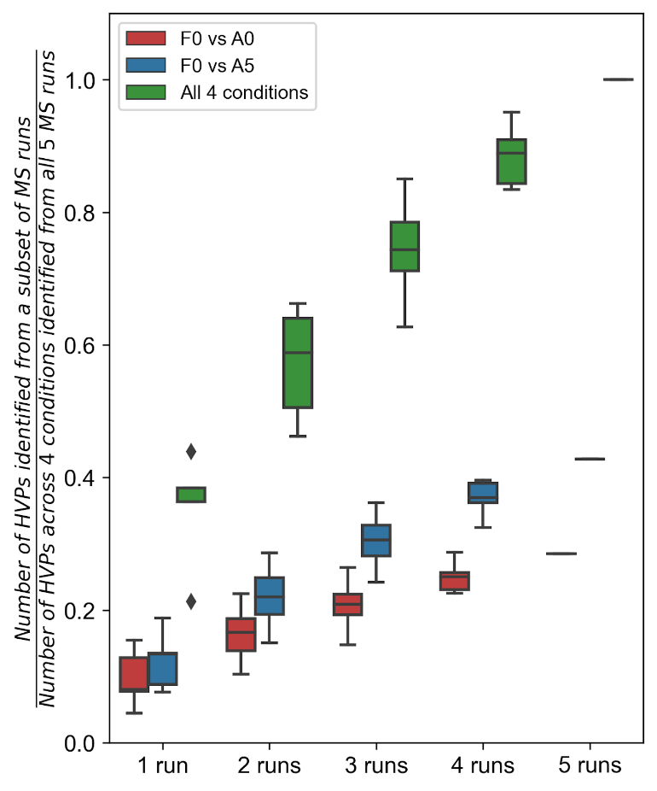

We found that, for all the above three comparisons, the number of significant HVPs exhibited a clear increasing trend as the sample size increased. Notably, for each combination of MS runs, the F0-A0 comparison always got the fewest HVPs, and the four-condition comparison always got many more HVPs than the other two comparisons. In particular, the number of HVPs identified for the F0-A0 comparison was only 653 even when all the five MS runs were used. By contrast, the four-condition comparison achieved a median number of 832 HVPs when only a single MS run was used (under the same circumstances, the median numbers of HVPs identified for the F0-A0 and F0-A5 comparisons were only 183 and 305, respectively). These results suggest that the number of significant HVPs identified by zMAP module is tightly linked with the specific conditions being compared and that zMAP module is not associated with an arbitrarily high statistical power.
For the HCC TMT data set, we performed a similar analysis in which the reverse-zMAP module was applied to subsets of the total 33 MS runs:
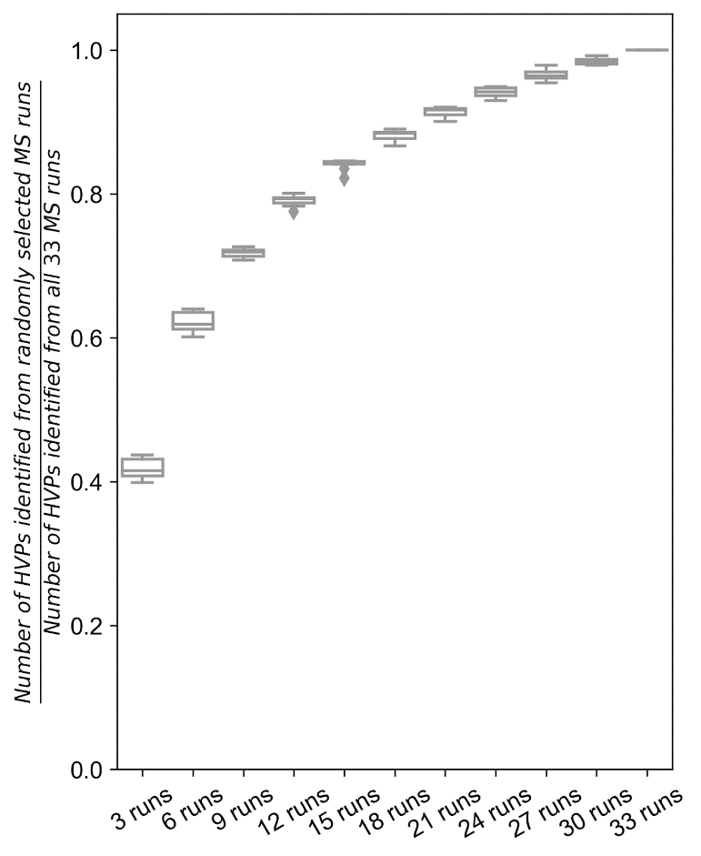
Technically, for each given number of MS runs, we constructed 10 subsets of randomly selected MS runs and applied reverse-zMAP to each of them. Considering the proteomic heterogeneity across the HCC patients and the underlying substructures of them, using only a subset of MS runs would give rise to a reduction in both sample size and the number of conditions. On the one hand, the number of significant HVPs showed a clear increasing trend as the number of MS runs increased. On the other hand, this trend gradually became mild as the MS run number increased, suggesting the involved conditions to be compared became stable. For reference, when 21 MS runs were used (including 99-105 patients), the median number of significant HVPs reached 2837 (91.6% of the 3097 HVPs identified from all the 33 MS runs). These results imply the number of significant HVPs identified by reverse-zMAP also depends strongly on the involved conditions.

* Using only W=30% of the proteins in a window for the quantile estimation is very low. Does this imply that we expect the vast majority of proteins are in fact differentially expressed, or is this a sign that a normal distribution is not the correct distribution to model the data with? How do the results change for different values of W? Related to this, I do not understand the meaning of the red colored "Proteins in sliding window used for linear fitting" and "Proteins used for model fitting" in Figure 4a. If there are really this few proteins used for the linear fit, I would be very worried about the stability of the estimate.
Reply: sincerely thanks for this valuable comment, which raises a reasonable concern regarding the stability of the variance estimates as well as their sensitivity to the setting of W.
We sincerely apologize for the confusions in Figure 4a in the original manuscript. In the revised one, we have unified the terms “linear fitting” and “model fitting” to “quantile regression”, for avoiding potential ambiguity. Besides, we realized the perceived amount of proteins used for quantile regression was severely compromised by the use of dot symbols with a black circle and a red interior. It seemed that the red interiors of such dots were largely covered by the black circles of nearby dots, leading to an illusion that only a few proteins were used for the quantile regression. In the revised manuscript, the black circles have been eliminated for all the related figures (Fig. 1a and Fig. 4a).
W=30% is indeed a low proportion of proteins used for quantile regression. The primary reason for which this proportion is adopted for the human erythropoiesis data set is that we expect the underlying hypervariable proteins associated with this data set are abundant, given the strict null hypothesis of no differential expression between any pair of conditions and the fact that there are four conditions in total. Indeed, a large number (2290) of significant hypervariable proteins were identified, and most of them showed clear differential expression among the four conditions (Fig. 3a). Besides, using W=30% does not mean that we expect the remaining 70% of proteins are all differentially expressed, only that we expect no differential proteins are distributed among the 30% of proteins used for quantile regression.
We agree that the relationship between the setting of W and the resulting variance estimate deserves specific attention. In the revised manuscript, we have systematically explored this relationship as well as how it is linked with the abundance of underlying differential proteins. Note S1 in Additional file 2 provides a complete discussion of related analysis results and figures. Briefly, with the human erythropoiesis data set, we first profiled the W-variance estimate relationship for the first MS run:
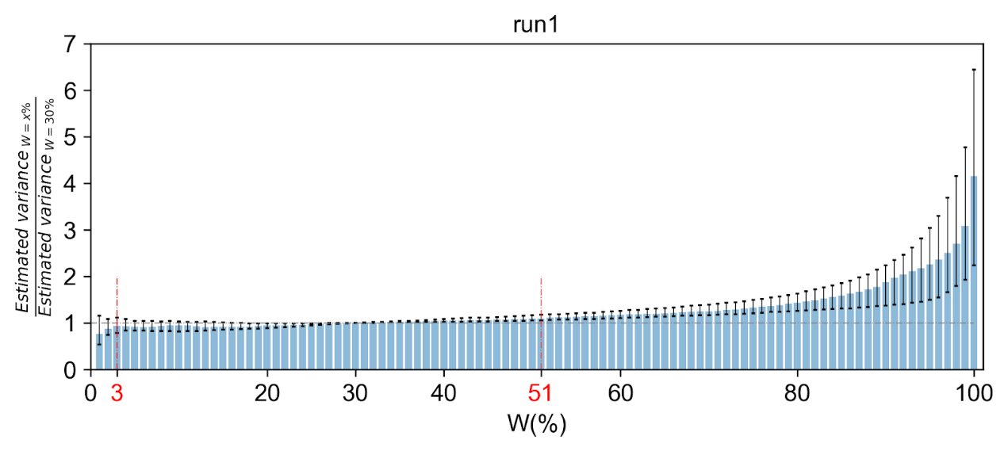
The above plot gives an overview of all windows. Technically, the variance estimates associated with each window, resulting from a sequence of different values of W, were scaled by the estimate from default setting (W=30%), for achieving a comparability across windows. Then, for each W, the corresponding (scaled) variance estimates from all windows were gathered, and the three quartiles of them were indicated in the plot (median values were indicated by the blue bars, and the other two quartiles were indicated by the black error bars).
Overall, the variance estimate showed an increasing trend as W increased. On the one hand, this trend implied a gradual involvement of more and more differential proteins in the quantile regression. On the other hand, the trend was mild when W was relatively small, suggesting differential proteins were mainly distributed among the proteins with large observed variances. Consequently, the variance estimate was stable along a considerable range of W, and rapidly increased after that range. To quantify this stability, we defined the “stable interval” of W as the set of those values that led to a variance estimate with a deviation from the default estimate less than 10% (based on the median profile of all windows). In this way, the stable interval of W was [3%, 51%] for the first MS run (between the two red lines in the plot), indicating the variance estimation result was stable even when W was close to half. Similar findings were also observed on the other four MS runs (Additional file 2: Note S1).
We next explored how the stable interval of W was affected by the abundance of underlying differential proteins. For this purpose, we again involved the two pairs of conditions that corresponded respectively to the most similar condition pair (F0-A0) among the total four conditions and the most distinct condition pair (F0-A5). For each condition pair, we retained only the corresponding two samples in each MS run and utilized the same sliding-window process to derive variance estimates, with different settings of W. Finally, the stable interval of W was deduced separately for each combination of conditions in each MS run:
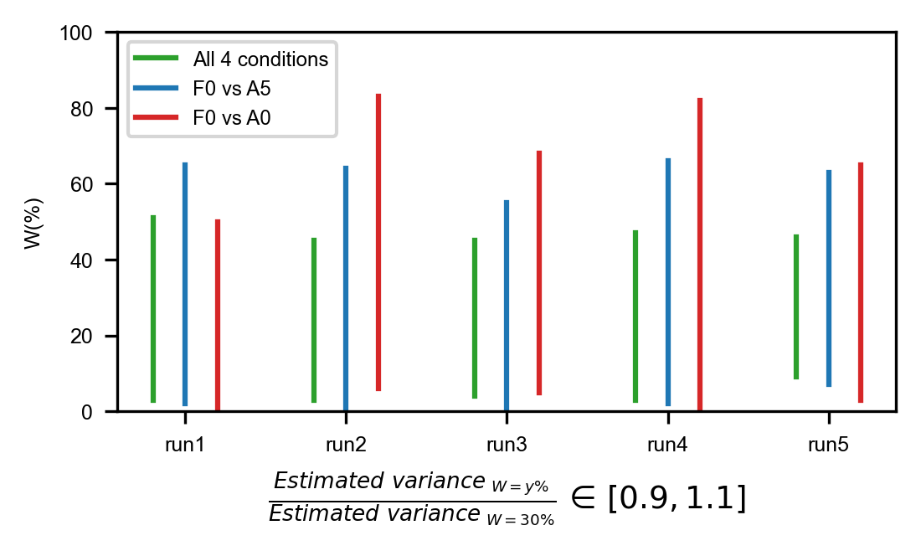
For the three scenarios in the above plot, the underlying differential proteins should be most abundant in the four-condition case and be least abundant in the F0-A0 case. Consistently, the four-condition and F0-A0 cases almost always got the narrowest and widest stable interval of W, respectively. The only exception was the first MS run, in which the F0-A5 case got the widest stable interval and the other two cases got very similar stable intervals.
In conclusion, choosing an appropriate W is indeed dependent on the specific conditions being compared. The main principle should be avoiding the influence of differential proteins as much as possible while retaining sufficient data for a reliable variance estimation. Considering the abundance of differential proteins associated with the (complete) human erythropoiesis data set as well as the default window size (400 proteins) used in the sliding-window process, we believe W=30% is an appropriate setting for this data set.

* The difference in the MVC relation of different samples in Fig. S7 is rather concerning. Especially the middle case where the variance is very low for all intensities and even goes up for high intensities does not inspire confidence in the reliability of the zMAP z-statistics. It suggests we could have outlier zMAP z-statistics in certain samples that were driven by technical artifacts rather than biological relevance. It would be good to see how much the MVCs are affected by batch-related effects, how much they reflect sample heterogeneity and to what degree the parameter W has an influence.
Reply: special thanks for this valuable comment. We agree that the influence factors, including both biological and technical ones, of the resulting MVC fit deserve an in-depth exploration, which are also tightly linked with the motivation for fitting sample-specific MVCs.
In the revised manuscript, we explored this issue for the HCC TMT data set, as well as the risk of outlier z-statistics and the influence of W on MVC fitting. A complete description of associated analysis results is provided in Note S3 in Additional file 2, which we also detail here.
We first performed a thorough search among all samples for the ones whose MVCs showed the concerning pattern (i.e., the variance is very low along the whole range of log₂-intensities). It turned out that almost all such samples were NAT samples. More specifically, there was a systematic difference in fitted MVC between tumor and NAT samples. The MVCs fitted for tumor samples showed a clear tendency to lie above those of NAT samples, suggesting higher signal variability of tumor samples:
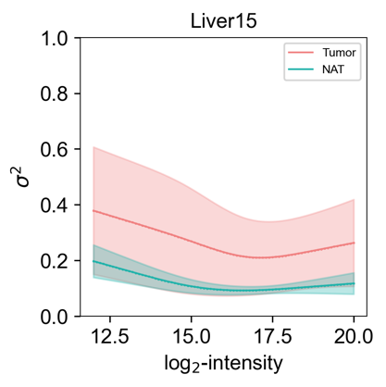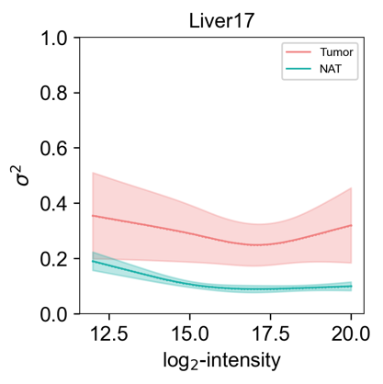
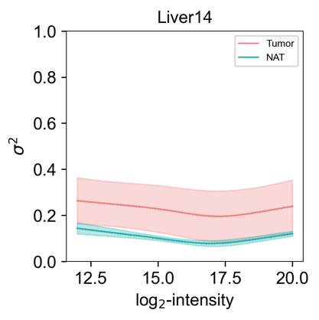
This figure profiles, for each of three example MS runs, the overall mean-variance trend associated with the included tumor/NAT samples. Technically, the MVCs fitted for the tumor/NAT samples were averaged at each level of log₂-intensity, and the standard deviation of the corresponding variances was used to visualize the variability across the MVCs at this log₂-intensity level. We can see that the variances read from tumor MVCs were considerably larger, on average, than those from NAT MVCs. Additionally, the variability across tumor MVCs was much higher than that of NAT MVCs. Similar results were also found when we pooled all tumor/NAT samples from the total 33 MS runs:
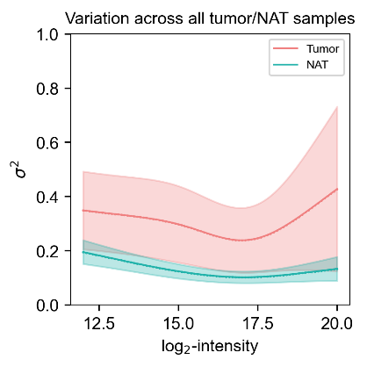
Together, these observations indicated a much stronger heterogeneity associated with the tumor samples than that of the NAT samples.
We next explored how much the fitted MVCs were affected by the specific MS run. We first pooled the average tumor/NAT MVCs of the three example MS runs in a single plot:
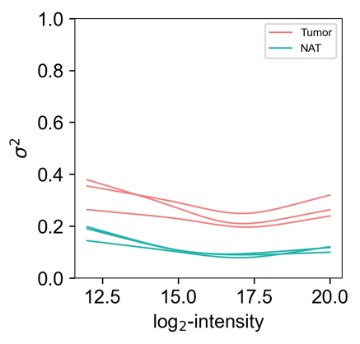
It can be seen that the variability of average tumor/NAT MVC was low across these MS runs, especially for the average NAT MVCs. We next pooled the average tumor/NAT MVCs of all the MS runs:
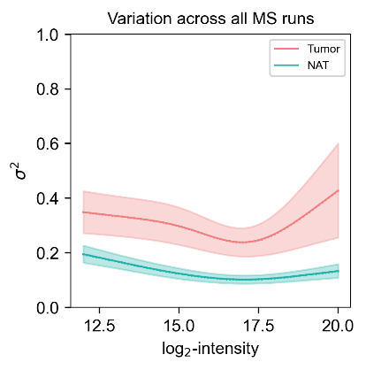
For the above plot, the average tumor/NAT MVCs from all MS runs were once again averaged, and the associated standard deviations were used to visualize the variability across the average MVCs. The pattern exhibited in this plot is similar to the previous plot showing the MVC variation across all individual tumor/NAT samples, only that the perceived MVC variability becomes lower due to the averaging operation within each MS run. Compared with the within-run MVC variability as illustrated by the three examples, the between-run variability did not exhibit a clear increase, for both tumor and NAT samples. Together, these observations suggested the influence of batch-related effects on MVC fitting was weak, at least not as strong as that of the biological contexts of samples.
We next evaluated the risk of producing outlier z-statistics in NAT samples, considering that the MVCs of such samples were very low and could lead to very small variances for scaling M-values. For this purpose, we compared the distribution of absolute z-statistics between tumor and NAT samples. More specifically, we calculated several key percentiles for the distribution associated with each sample:
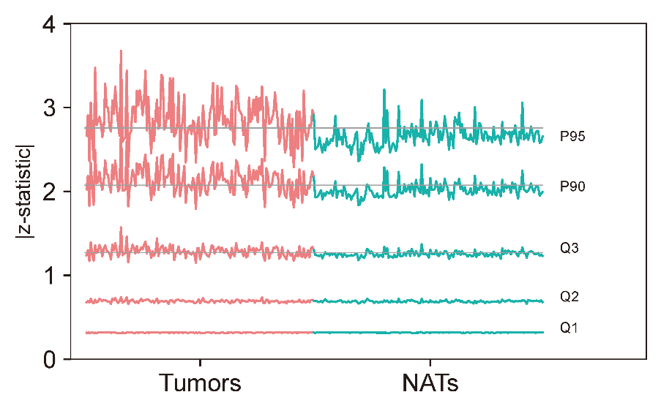
The order of tumor/NAT samples in the above plot is simply random. For each sample, the three quartiles as well as the 90th and 95th percentiles of the associated absolute z-statistics are shown. It can be clearly seen that the NAT samples did not show a tendency to generate larger absolute z-statistics than those of the tumor samples. In fact, the 90th and 95th percentiles observed from NAT samples were considerably smaller than those from tumor samples:
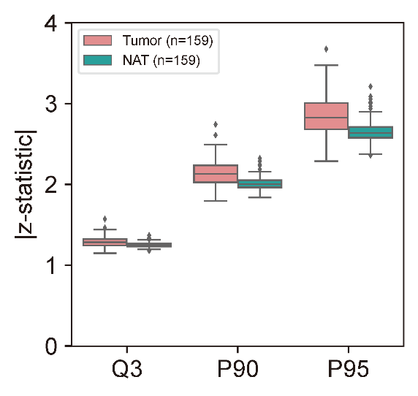
Additionally, the variability of each of the two percentiles across tumor samples was clearly higher than that across NAT samples, which was consistent with the stronger heterogeneity of the tumor samples. In summary, we deemed that the generally low MVCs of the NAT samples did not result from potential technical artifacts in the fitting process but were an inherent property of these samples. This property would not increase the risk of producing outlier z-statistics, because the magnitude of M-values of the NAT samples was small as well.
Finally, we explored the influence of W on variance estimation and MVC fitting. Similar to the previous analysis on the iTRAQ data set about human erythropoiesis, we examined, for each application of the sliding-window procedure, the scaled variance estimates (from all windows) corresponding to each of a sequence of W values:
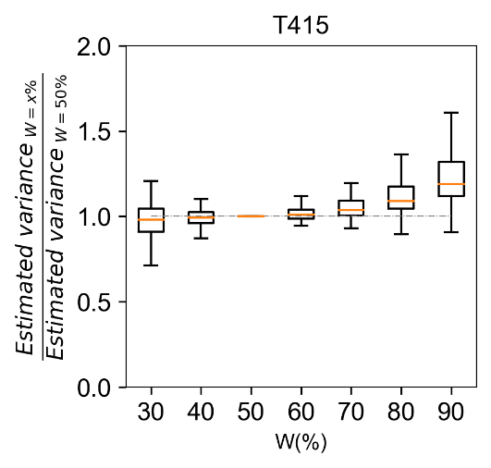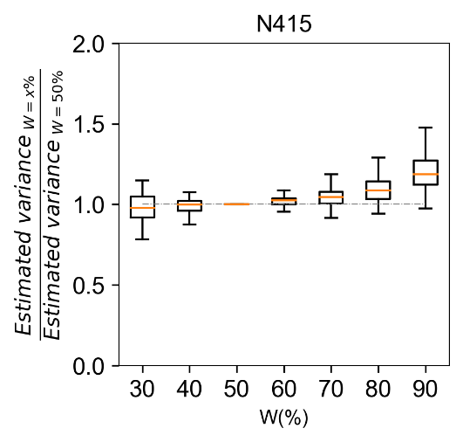
The above figure shows the results for an example pair of tumor and NAT samples. It can be seen that the variance estimation results were relatively stable for W values not greater than the default setting (50%). After this critical point, the variance estimates started to rapidly increase as W increased. We next inspected the resulting MVCs from the different settings of W:
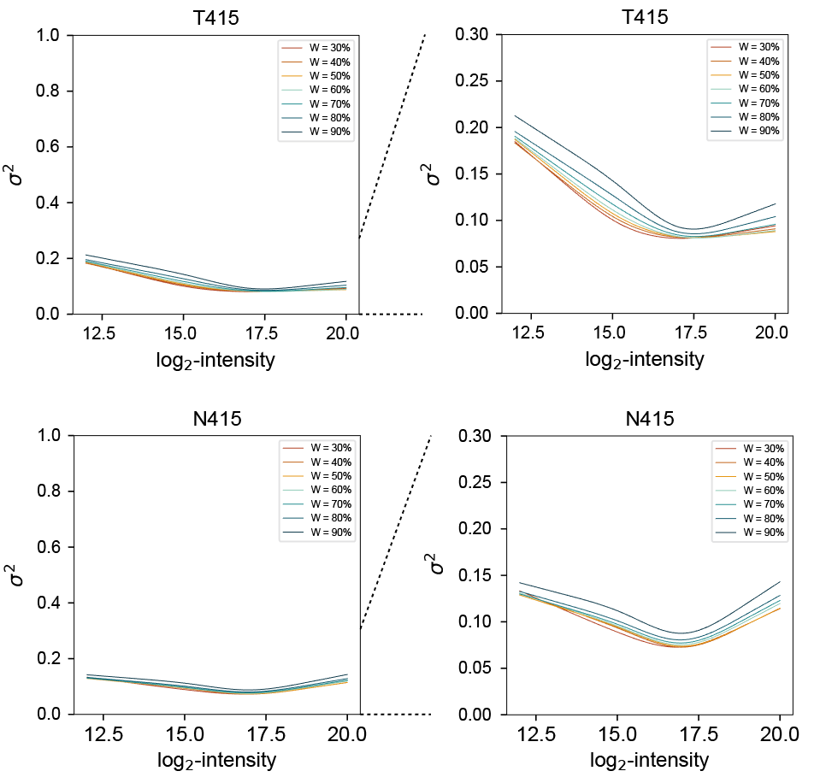
Consistently, the differences between those MVCs were trivial that were obtained by using the W values not greater than 50%. After that, the fitted MVC clearly rose up as W increased, especially after W reached 70%. Based on these observations, we deemed that the default setting of W was appropriate for this data set.

* It is unclear how much new biology was discovered using the zMAP method that would not have been found with conventional methods. For example, how do the 3 subgroups based on PC1 of hypervariable proteins from reverse-zMAP compare to the 3 subgroups in the original paper which were based on simple differential expression and also were associated with survival? Furthermore, the association of TSC2 mutation with survival was already noted in the original study. It is often easy to find differences between tumor and NAT tissues, both with differential expression and zMAP, because of the large differences between the two. Most of the differences tend to reflect general cancer biology (most of which is already known, e.g. TP53), whereas it is often hard to find cancer-type specific relevant proteins. It should be further discussed and clarified in which situations it is expected that zMAP works well and in which cases it would not.
Reply: sincerely thanks for this valuable comment. In the original study of the HCC TMT data set, 1274 differentially expressed proteins between tumor and NAT samples were identified, based on which a variety of downstream analyses were performed, including a classification of the HCC patients. Different from these differentia proteins, our hypervariable proteins were identified from an unsupervised comparison of all samples, in which the biological labels of samples were never used. A potential advantage of our unsupervised comparison was that, in addition to the differences between tumor and NAT samples, the identified hypervariable proteins may also capture the heterogeneity within each sample group. Consistently, the PC1 scores, which were derived based on the expression of the hypervariable proteins, reflected not only the huge difference between the two sample groups but also the heterogeneity within each group. As previously mentioned, the variation of PC1 score within the tumor sample group was biologically meaningful, since the PC1-based classification of tumor samples resulted in patient subgroups that had significantly different clinical features and survival (Fig. 5d, e); the PC1 variation within the NAT group made biological sense as well, as suggested by the GSVA results showing that the NAT samples with excessively large PC1 scores were associated with molecular characteristics of hepatitis (Fig. 5k; Additional file 1: Figs. S17 and S18).
In the original study, the authors found that the identified differential proteins were also associated with higher expression variability across tumor samples than the other proteins⁶. This was normal because hypervariable proteins across tumors are usually linked with their subtype structure and can easily show an overall increase/decrease in expression strength from NATs to tumors. As for the heterogeneity across the NAT samples in this data set, this might not be the case because the NAT samples with excessively large PC1 scores accounted only for a small proportion (7.5%) of all NAT samples. The protein signatures of the large-PC1 NATs might not necessarily show an overall expression difference between all NAT and tumor samples that was strong enough for the proteins to be identified as differential ones.
In the revised manuscript, we found 87.4% of the differential proteins identified in original study were covered by our hypervariable proteins (Additional file 1: Fig. S19a). We then clustered the proteins uniquely identified by us and found that two of the resulting clusters were associated with clear expression heterogeneity across the NAT samples (these two clusters were referred to as C4 and C5, which comprised 176 and 241 proteins, respectively). More specifically, both C4 and C5 showed elevated expression levels specifically in the NAT samples with excessively large PC1 scores and were also significantly enriched in biological pathways that suggest activated immune and inflammatory responses, which was consistent with the above speculation about hepatitis (Additional file 1: Fig. S19b). For example, the C4 proteins were enriched in the pathway of ECM-receptor interaction, and it has been suggested that the deposition and remodeling of ECM can enhance local immune response to chronic hepatitis tissue⁷; the C5 proteins were enriched in neutrophil extracellular trap formation and leukocyte transendothelial migration, which are crucial for innate immunity and inflammation response^{8,9}. For a more quantitative evaluation of the expression heterogeneity of the two protein clusters, we hierarchically clustered all NAT samples into two subgroups based on their PC1 scores, which successfully isolated the ones with excessively large PC1 scores (NAT II group, 12 samples) from the others (NAT I group, 147 samples). We then calculated for each sample the average z-statistic across C4/C5 proteins, as an overall expression evaluation for the protein cluster. It was found that the expression of both C4 and C5 was considerably higher in NAT II than in NAT I and the three subgroups of tumor samples, while the differences among NAT I and the tumor subgroups were not as distinct (Additional file 1: Fig. S19c, d). Since NAT II only accounted for a small proportion of all NAT samples, the overall expression difference between all NAT and tumor samples was also not distinct (Additional file 1: Fig. S19c, d). Especially for the C4 cluster, the p-value from the corresponding t-test for comparing all NAT and tumor samples was only 0.31 even with such a large sample size (159 vs. 159), which explained why the associated proteins had not been identified as differential ones in the original study. In summary, our hypervariable proteins revealed the proteomic heterogeneity across the NATs and suggested a state of severe inflammation for a part of them, which provided insights into the progression from HBV-infected liver tissue to HCC and was missed by the differential proteins in original study.
As for the identification of cancer-(sub)type specific proteins, we incorporated two additional proteomic data sets comprised purely of tumor samples in the revised manuscript. One of them was a TMT data set about pediatric brain cancer (PBC), which profiled the proteomes of 218 tumor tissue samples from 199 patients representing 7 different histological diagnoses of PBC (Fig. 7a). A reference TMT sample was generated in each MS run by using a uniform mixture of representative tumor samples. After applying reverse-zMAP to identifying significant hypervariable proteins for this data set (3130 proteins in total, with BH-adjusted p-value<0.05), we picked out the ones with detected expression in at least half of the 218 samples and used the z-statistics of these proteins to classify the samples, resulting in 7 subgroups associated with significantly different survival outcomes (Fig. 7b). We next performed a hierarchical clustering for the hypervariable proteins and found that the resulting protein clusters were associated with clear differential expression among the subgroups. As previously explained, our method could only compare the PBC samples in an unsupervised manner and could not be directly used to identify differential proteins between different histological labels. We indeed, however, observed a statistically significant consistency between this proteome-based classification and the histological labels (chi-square test p-value=8.4e-45). Besides, the majority (72.8%) of the hypervariable proteins were covered by differentially expressed proteins (identified by msTrawler in the original study) between any pair of histological types (Additional file 1: Fig. S24). Among all the subgroups, subgroup 7 had the worst survival curve, and all the PBC samples in this subgroup were histologically diagnosed as high-grade glioma (HGG), which is generally associated with rather bad prognosis¹⁰. On the other hand, PBC samples of the same histological type could still have distinct protein expression characteristics and be classified into different subgroups. For example, the samples diagnosed as ependymoma were primarily distributed in subgroup 3 and 4, between which there were several differentially expressed protein clusters, including a cluster that was significantly enriched in the biological pathways of DNA replication and cell cycle (Fig. 7a). The overall expression of this protein cluster was clearly higher in subgroup 4 than that in subgroup 3, which was consistent with the survival difference between the two subgroups (Fig. 7b). Intriguingly, this survival difference was still significant when we specifically picked out the ependymoma samples from the two subgroups (Fig. 7c), suggesting different molecular characteristics of PBC samples with the same histological diagnosis could be biologically meaningful.
The other proteomic data set was a label-free one (as required by reviewer #1) that profiled the proteomes of 101 early-stage HCC tumor samples. Since label-free samples are much more comparable with each other than ILMS samples from different MS runs, we treated all the 101 samples as from a single MS run when applying our toolset. We first noticed that the zMAP module was not applicable, because the distribution of missing values is not consistent across label-free samples, resulting in different numbers of degrees of freedom associated with the observed variances of different proteins. Applying reverse-zMAP, on the other hand, required a reference sample representing the “average” proteomic landscape of the HCC tumors, which was not available in this data set. Therefore, we created a pseudo reference profile by averaging the 101 label-free samples, as it was achieved by zMAP module for the iTRAQ data set (in theory, this should lead to a reduction in the number of degrees of freedom associated with the final chi-square statistic, but we expected the effect to be weak given the large sample size). When applying reverse-zMAP, we found that the label-free intensities were also associated with clear mean-variance dependence, as suggested by large variability of M-values derived from low intensity levels (Additional file 1: Fig. S25a). This dependence was effectively alleviated by the z-transformation of reverse-zMAP (Additional file 1: Fig. S25b).
In total, 2567 significant hypervariable proteins were identified for this data set (BH-adjusted p-value<0.05), based on which the 101 samples were classified into 3 subgroups with distinct protein expression signatures and significantly different survival outcomes (Fig. 7d, e). A hierarchical clustering of the hypervariable proteins resulted in 3 protein clusters enriched in different biological pathways (Fig. 7d). The enriched pathways of the protein clusters, along with their differential expression patterns among the subgroups of samples, were consistent with the survival differences among the sample subgroups. For example, one of the protein clusters was enriched in metabolic pathways associated with normal liver function, including drug metabolism, metabolism of xenobiotics by cytochrome P450, and retinol metabolism³⁻⁵. Consistently, this protein cluster exhibited the highest and lowest overall expression in the sample subgroups with the best (subgroup 2) and worst (subgroup 1) survival curves, respectively. Another protein cluster was enriched in the pathway of DNA replication and showed, consistently, the lowest overall expression in subgroup 2.
Based on the above observations, we conclude that our toolset can be used for a reliable identification of hypervariable proteins across tumor samples only.

Minor comments:
* Page 6, line 55: "Finally, differentially expressed proteins are identified as those proteins whose observed variances are significantly larger than the corresponding variances read from the MVC." This is not how differential expression is defined, i.e. a difference in (mean) abundance between two groups. The term "hypervariability", as used later on in the manuscript is more appropriate.
Reply: thanks for this comment. Now that a formal definition of hypervariable proteins has been given at the beginning of Results section in the revised manuscript, we have changed the terms “differentially expressed” and “differential” into “hypervariable” throughout the part of erythropoiesis study.

* The heatmaps for Chi-squared and p-values in the bottom right of Fig 1f are confusing because they look like scales.
Reply: sincerely thanks for this nice reminder. We believe the confusion results primarily from the fact that the involved proteins were sorted by their statistical significances in the original manuscript. In the revised manuscript, we have rearranged the order of the proteins based on their expression patterns (Fig. 1f and Fig. 2a).

* Page 10, line 19: "Finally, we ranked all proteins based on the standard deviations and selected the top 0.5% as differential ones, which included most of the hemoglobin proteins (Fig. 3b)." Why was 0.5% chosen? This seems completely arbitrary.
Reply: sincerely thanks for this comment. We apologize for our lack of clarification in the original manuscript. The selection criterion was determined based on the profile shown in Figure 3b. At the beginning, the standard deviation across conditions increases uniformly as the cumulative frequency of proteins increases. It then rapidly increases after some critical point of the cumulative frequency, suggesting an enrichment of true hypervariable proteins after that point. We therefore adopted a commonly used proportion that was surely after the critical point as the selection cutoff.
We admit that this selection criterion was somewhat subjective, since the critical point was roughly located by the eyes. In the revised manuscript, we have tried two additional selection criteria. The first one considered top 1% of the proteins as hypervariable ones. The second one used the hemoglobin protein with the smallest standard deviation across conditions as the cutoff (Additional file 1: Fig. S4a). For both of the two criteria, we observed similar results as presented in the original manuscript: (i) the vast majority of the selected proteins had elevated expression specifically in one or two conditions; (ii) the four protein markers (PNMT, CHI3L1, S100A9, and S100A8) that had been experimentally verified in the original manuscript still emerged when we clustered the selected proteins and focused on the erythroid differentiation process at fetal stage (Additional file 1: Fig. S4b, c).

* It would be interesting to discuss/see how zMAP compares to the recently published msTrawler method which also accounts for lower reliability of certain protein quantifications.
Reply: sincerely thanks for this suggestion. msTrawler is a fantastic method for identifying differentially expressed proteins. It considers the different signal-to-noise ratios of peptide-level measurements and integrates this consideration into the following statistical model to evaluate differential protein expression, while zMAP toolset starts directly with protein-level intensities, without devising a sophisticated method for integrating peptide-level intensities corresponding to the same protein.
We think the primary difference between msTrawler and zMAP is that the former performs supervised comparisons while the latter performs unsupervised ones. On the one hand, msTrawler is capable of identifying differential proteins between specified conditions and has a stronger statistical power than zMAP, as illustrated by the analysis of the PBC data set (Fig. 7a; Additional file 1: Fig. S24). On the other hand, zMAP cannot take advantage of prior labels of samples but is able to dissect the heterogeneity across samples with the same label, as exemplified by the different protein expression signatures and survival outcomes of the PBC samples diagnosed as ependymoma (Fig. 7a-c).
Another difference regards the primary motivation of the z-transformation of zMAP. As highlighted in the Introduction section, the transformation is designed for quantitatively integrating different MS runs and facilitating the application of various downstream analyses on all available samples, such as PCA and clustering analysis as demonstrated throughout the whole study. As far as we know, no such machinery coupled with the core models of msTrawler has been specifically designed.

* It is strange to put a new analysis (the co-expression network) in the discussion section. This should be a part of the results section.
Reply: sincerely thanks for this reminder. We have accordingly made a rearrangement in the revised manuscript. The network construction analysis has now been included in the Results subsection entitled “Applying various downstream analyses on the z-statistics of reverse-zMAP” (line 502-516).

* Having the variance estimate only depend on the reference intensity in reverse zMAP (Eq. 7) is conceptually not very satisfying, since the M-value and its variance will depend. By contrast, the samples were clustered by their biological labels when the z-statistics derived by zMAP were used on the intensity of both the reference and the actual sample.
Reply: sincerely thanks for this comment. In fact, the variance estimates of zMAP module are derived based on the reference intensities as well, only that the reference profile is a pseudo one created by averaging all the actual samples included in the MS run. Technically, for a specific protein, the variance estimate for scaling its centered log₂-intensities is derived by applying the fitted MVC to its average log₂-intensity across the samples, which is exactly the log₂-intensity measurement of this protein in the pseudo reference profile (Eq. 6). The primary rationale behind this design is for providing a “fair” scaling strength for all centered log₂-intensities associated with the same protein (i.e., all M-values of the protein against the pseudo reference profile), with the hope of avoiding potential biases.
As for the reverse-zMAP module, it follows the same design principle by which the variance estimates for scaling M-values (against a real reference sample) are derived solely based on the reference intensities, only that the scaling factors derived by zMAP module for a specific protein are exactly the same, while the scaling factors derived by reverse-zMAP can differ from each other because of the fitting of sample-specific MVCs. Another reason for which reverse-zMAP adopts this design is that the whole statistical framework of reverse-zMAP treats the reference intensities as constants in the probabilistic sense, just like a (non-stochastic) covariate in an ordinary regression. Therefore, having the variance estimates depend only on the reference intensities can avoid, in theory, the uncertainty of the estimates (provided the uncertainty associated with the fitted MVCs is disregarded), which reduces the approximations made for deriving the theoretical null distribution of the z-statistics.
References
1 Karp, N. A. et al. Addressing accuracy and precision issues in iTRAQ quantitation. Molecular & cellular proteomics : MCP 9, 1885-1897, doi:10.1074/mcp.M900628-MCP200 (2010).
2 Ow, S. Y., Salim, M., Noirel, J., Evans, C. & Wright, P. C. Minimising iTRAQ ratio compression through understanding LC-MS elution dependence and high-resolution HILIC fractionation. Proteomics 11, 2341-2346, doi:10.1002/pmic.201000752 (2011).
3 Anzenbacher, P. & Anzenbacherová, E. Cytochromes P450 and metabolism of xenobiotics. Cellular and molecular life sciences : CMLS 58, 737-747, doi:10.1007/pl00000897 (2001).
4 Almazroo, O. A., Miah, M. K. & Venkataramanan, R. Drug Metabolism in the Liver. Clinics in liver disease 21, 1-20, doi:10.1016/j.cld.2016.08.001 (2017).
5 Gudas, L. J. Retinoid metabolism: new insights. Journal of molecular endocrinology 69, T37-t49, doi:10.1530/jme-22-0082 (2022).
6 Gao, Q. et al. Integrated Proteogenomic Characterization of HBV-Related Hepatocellular Carcinoma. Cell 179, 561-577.e522, doi:10.1016/j.cell.2019.08.052 (2019).
7 McQuitty, C. E., Williams, R., Chokshi, S. & Urbani, L. Immunomodulatory Role of the Extracellular Matrix Within the Liver Disease Microenvironment. Frontiers in immunology 11, 574276, doi:10.3389/fimmu.2020.574276 (2020).
8 Delgado-Rizo, V. et al. Neutrophil Extracellular Traps and Its Implications in Inflammation: An Overview. Frontiers in immunology 8, 81, doi:10.3389/fimmu.2017.00081 (2017).
9 Schwartz, A. B. et al. Elucidating the Biomechanics of Leukocyte Transendothelial Migration by Quantitative Imaging. Frontiers in cell and developmental biology 9, 635263, doi:10.3389/fcell.2021.635263 (2021).
10 Hatoum, R. et al. Extent of Tumor Resection and Survival in Pediatric Patients With High-Grade Gliomas: A Systematic Review and Meta-analysis. JAMA network open 5, e2226551, doi:10.1001/jamanetworkopen.2022.26551 (2022).

2nd round
Reviewer 1
The authors have addressed my concerns

Reviewer 2
The detailed responses from the authors as well as the additional datasets and manuscript changes have convincingly addressed my previous concerns.
My only remaining concern is that there is insufficient information in the methods section and as supplementary material or on Zenodo to reproduce the results. For example, I could not find tables with z-statistics for the new analyses (ovarian carcinoma cell lines, PBC cohort, HCC LFQ cohort) as supplementary tables nor on Zenodo. A more detailed description is necessary of how the data was obtained from the original studies. Ideally, all the analysis and manuscript figures could easily be reproduced by readers using something like jupyter notebooks starting from data matrices available as supplementary tables or from Zenodo. Furthermore, a more detailed description is necessary in the methods section, e.g. for GO enrichment, consensus clustering and survival analysis.
Minor comments:
• The subgroups in the original paper of the PBC cohort look better aligned with the diagnosis compared to the subgroups in Figure 7. If this is indeed the case, this should be discussed.
• All the protein clusters in Figure 7a look surprisingly well aligned with the subgroups. Were there clusters that were omitted which had proteins that did not show a clear separation by the subgroups?
• In several plots PCC is plotted but not part of the axis labels, e.g. Figure 2e,f and 4b,c. Please add “PCC” to the axis labels.
• The authors frequently use sentences starting with the word "Technically" to describe implementation details. This is not a common use of this word and could easily be confused for its meaning as "strictly speaking". Please consider replacing this with a more appropriate formulation.

Authors’ response
Reviewer #2
The detailed responses from the authors as well as the additional datasets and manuscript changes have convincingly addressed my previous concerns.

My only remaining concern is that there is insufficient information in the methods section and as supplementary material or on Zenodo to reproduce the results. For example, I could not find tables with z-statistics for the new analyses (ovarian carcinoma cell lines, PBC cohort, HCC LFQ cohort) as supplementary tables nor on Zenodo. A more detailed description is necessary of how the data was obtained from the original studies. Ideally, all the analysis and manuscript figures could easily be reproduced by readers using something like jupyter notebooks starting from data matrices available as supplementary tables or from Zenodo. Furthermore, a more detailed description is necessary in the methods section, e.g. for GO enrichment, consensus clustering and survival analysis.
Reply: sincerely thanks for the valuable suggestions. We have accordingly updated the manuscript.
Firstly, the sources of all the data sets used in our study have been provided in the section of “Availability of data and materials”. For each data set, the database of origin along with the accession number or the URL where it was obtained has been specified. Secondly, the z-statistic matrices derived by zMAP toolset for all the data sets, including the newly added ones, have been provided in Tables S1-S5 in Additional file 3. These data, along with the code starting with them for reproducing the analysis results, have also been uploaded to Zenodo (https://doi.org/10.5281/zenodo.13337951). Finally, we have added two subsections at the end of Methods (pages 30-31) to provide the technical details of the downstream analyses, including the enrichment, clustering, and survival analyses.

Minor comments:
• The subgroups in the original paper of the PBC cohort look better aligned with the diagnosis compared to the subgroups in Figure 7. If this is indeed the case, this should be discussed.
Reply: sincerely thanks for this comment. We first examined the consistency of the subgrouping results from the original paper with the histological diagnoses:
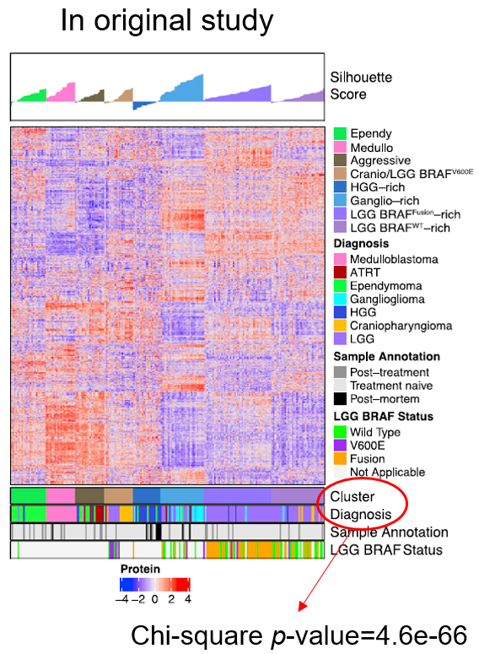
In the original study, the PBC samples within each subgroup were ordered by their silhouette scores, and the subgroup and diagnosis labels were indicated with different colors from ours. Since these factors may affect the perceived consistency, we re-plotted an alignment figure for our subgroups in a similar manner:

We did not use indexes like ARI to evaluate the subgroup-diagnosis consistencies, because the number of subgroups was different between the two studies. It seems that the difference in chi-square p-value is trivial, and the consistency observed from the original study is only slightly better than ours.
We further noticed that the diagnosis labels had been explicitly used by the computational procedure designed in the original study for preprocessing the data set. Specifically, two rounds of missing value imputation were performed in the original study. In each round, missing values of each given sample were imputed by selecting the most similar samples with the same diagnosis label. In contrast, our preprocessing and clustering workflow was fully blind to the diagnosis labels, which may partially explain the better subgroup-diagnosis consistency in the original study.

• All the protein clusters in Figure 7a look surprisingly well aligned with the subgroups. Were there clusters that were omitted which had proteins that did not show a clear separation by the subgroups?
Reply: thanks for this comment. We did not omit any protein clusters in Figure 7a. More specifically, all the proteins that were used for the consensus clustering of the PBC samples were hierarchically clustered, and all the resulting protein clusters were shown in Figure 7a. We have indeed applied a smoothing procedure to the z-statistic matrix corresponding to the heat map in Figure 7a, for a better visualization. As we can see, however, the separation pattern of each protein cluster is still clear even without the smoothing procedure:
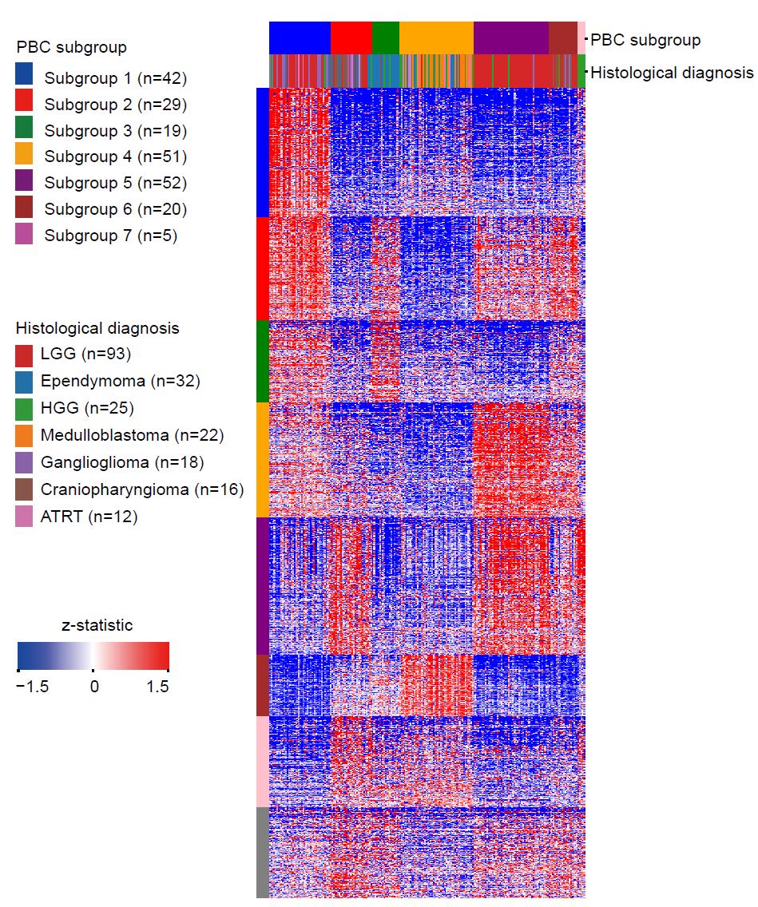
The smoothing procedure was applied by using the Python function scipy.ndimage.gaussian_filter (detailed in the Methods section, page 30), and the complete code for generating Figure 7a can be found in Zenodo (https://doi.org/10.5281/zenodo.13337951).

• In several plots PCC is plotted but not part of the axis labels, e.g. Figure 2e,f and 4b,c. Please add “PCC” to the axis labels.
Reply: sincerely thanks for this nice reminder. We have accordingly modified the axis labels.

• The authors frequently use sentences starting with the word "Technically" to describe implementation details. This is not a common use of this word and could easily be confused for its meaning as "strictly speaking". Please consider replacing this with a more appropriate formulation.
Reply: sincerely thanks for this suggestion. For each appearance of “Technically”, we have either omitted it or replaced it with “In detail” or “More specifically”.

