Review History
First round of review
Reviewer 1

Were you able to assess all statistics in the manuscript, including the appropriateness of statistical tests used?
Yes, and I have assessed the statistics in my report.

Comments to author:
In this study, Fengyang Jing et al. observed that DHX9 lactylation promoted OSCC development. The elucidation of these molecular regulatory mechanisms sheds light on the understanding of OSCC, might open avenues for potential targeted therapeutic strategies. This highlights the involvement of lactylation in the regulatory processes governing OSCC development. However, there are several issues as followed in the manuscript should be addressed:

1.Insufficiently standardized writing, the abbreviation that appears for the first time should be written in full，such as CAL27, NAT.
2.In evaluating the lactylation levels in OSCC and NAT tissues, logistic regression analysis should be used to exclude the influence of age and gender.
3.The result of extended data fig.4a should be repeated at least 3.
4.The authors elaborated that lactylation affects transcription process in their preliminary analyses, in their subsequent study, why they did not directly study the lactylation of transcription factors, but chose the auxiliary transcription factor RNA polymerase DHX9. Authors should add some descriptions about these in discussion.
5.In extended data fig.8b, the DHX9 protein level was also increased in OSCC (Fold changed, 1.93) according to proteomics data, whether the increased DHX9 level led to the DHX9 lactylation level increased, which could be verified by IB experiments after IP DHX9.
6.In discussion, author stated that ''we observed enrichment in classical pathways such as the HIF-1 signaling pathway, PI3K/AKT signaling pathway, and Hippo signaling pathway in OSCC ...... However, their influence on lactylation in OSCC has not been explored.'', author should add the association content between DHX9 lactylation and related pathways.

Reviewer 2

Were you able to assess all statistics in the manuscript, including the appropriateness of statistical tests used?

Yes, and I have assessed the statistics in my report.

Comments to author:
The manuscript report the important role of lactylation in OSCC and find the critical role of lactylation at the K146 site of dexh-box helicase 9 (DHX9) in promoting OSCC progression. Overall, the topic is scientifically sounding and the results may provide potential clinical contribution to the field. Some specific issues are indicated below:
Major issues:
1/ Clinical information about 109 samples enrolled in this study is lacking. A table showing the most significant information (age at diagnosis, gender, histological type and grade, tumor stage, primary vs metastatic, etc.) must be provided.
2/ In section "DHX9-146Kla Potentially Reverses the Inhibitory Impact of DHX9 on OSCC", authors should discuss whether there are some other critical auxiliary transcription factors playing important roles in OSCC. Their expression in OSCC and differences from DHX9 should be described. Why did authors choose DHX9 for further analysis？
3/ In Extended Data Fig.8b, the P value should be calculated to confirm the statistical significance. The Extended Data Fig.8c is insufficient to support the theory that patients with DHX9 high expression exhibit a relatively favorable prognosis. More reasonable evidence should be provided to validate the clinical significance of DHX9.
4/ All the western blot bands should be clear and aligned. Especially, deformation and inconsistency of β-actin is noted in Figure 4c. Besides, the molecular weight of western blot bands is suggested to be indicated in the figures.
5/ In Figure 4 and Figure5, scale bars should be described in figure legends.
6/ Though authors identified the inhibitory role of DHX9 in LEUK1 and CAL27 cell lines, the assays in vivo are lacking. Authors are strongly encouraged to conduct assays using animal models to validate the conclusion.
7/ It is suggested to add a schematic diagram to summarize the whole manuscript to enable readers better understanding.
8/ Discussion: DHX9 is an important factor in the processing, transcription and translation of RNA, more detailed introduction of DHX9 in the process of tumors should be included.
9/ Regarding cell viability assays, cell migration, and cell invasion assays, authors should indicate whether they have used image analysis and any software to support the calculations, for instance.
10/ While the manuscript's language is generally clear, attention to grammar errors, sentence structure, and paragraph organization is necessary. Ensure a logical flow that facilitates readers' comprehension and their ability to follow the research process.
Authors Response
Point-by-point responses to the reviewers’ comments:
Reviewer #1:
In this study, Fengyang Jing et al. observed that DHX9 lactylation promoted OSCC development. The elucidation of these molecular regulatory mechanisms sheds light on the understanding of OSCC, might open avenues for potential targeted therapeutic strategies. This highlights the involvement of lactylation in the regulatory processes governing OSCC development. However, there are several issues as followed in the manuscript should be addressed:
1.Insufficiently standardized writing, the abbreviation that appears for the first time should be written in full，such as CAL27, NAT.
Response: Thank you very much for your careful review and questions regarding our manuscript. We have meticulously proofread the manuscript and have annotated the full names for the abbreviations upon their first appearance. Additionally, we have standardized the use of abbreviations in the figure legends. Furthermore, we have polished the entire manuscript to enhance the writing quality.

2.In evaluating the lactylation levels in OSCC and NAT tissues, logistic regression analysis should be used to exclude the influence of age and gender.
Response: Thank you very much for your suggestion. We have conducted a logistic regression analysis to exclude the impact of age and gender on the histological grading in the data of the included patients. This serves as a supplemental explanation for Figure 1a, and the results have been placed in Supplemental Figure 2a (originally Supplemental Figure 1).

3.The result of extended data fig.4a should be repeated at least 3.
Response: Thank you very much for your rigorous review of our manuscript. We have repeated the detection of the results for Supplemental Figure 4a (now Supplemental Figure 5a) and observed consistent results. The detailed Western blot results are as follows, indicating that the addition of lactic acid can increase the level of lactylation within the cells. The results of Figure 1b also show that compared with the adjacent normal tissue, the level of lactylation in the tumor is elevated. We appreciate your meticulous pointing out of this issue once again.
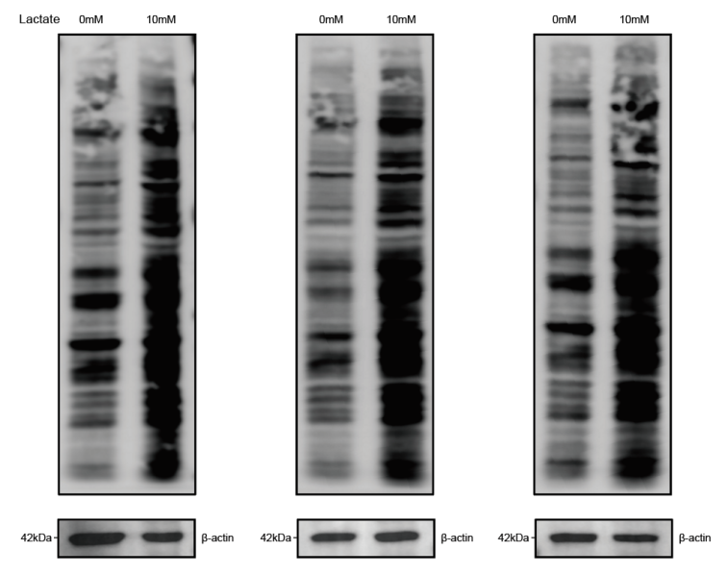

4.The authors elaborated that lactylation affects transcription process in their preliminary analyses, in their subsequent study, why they did not directly study the lactylation of transcription factors, but chose the auxiliary transcription factor RNA polymerase DHX9. Authors should add some descriptions about these in discussion.
Response: Thank you very much for raising this issue. In our original manuscript, we indeed did not fully elaborate on the scientific basis for selecting DHX9 for subsequent validation. In this study, we identified 217 potential oncogenes driven by lactylation that are upregulated during the development of oral cancer. The upregulation of these genes may be related to the openness of chromatin structure, suggesting that chromatin helicases may play a key role in the development of oral cancer. We speculate that during the development of oral cancer, some helicases may promote the opening of chromatin, thereby leading to the upregulation of a large number of gene expressions.
In our previous work, we constructed a diagnostic model for the development of oral cancer, in which DHX9 was identified as an important part of the model. Therefore, we focused our attention on DHX9. At the same time, through high-throughput sequencing data of lactylation, we found that the lactylation of DHX9 is significantly increased in tumor tissues. This suggests that the lactylation of DHX9 may be associated with the abnormal expression of these oncogenes in oral cancer.
Based on the above two findings, we selected the lactylation site of DHX9 for subsequent experimental validation. Firstly, as a helicase, the upregulation of DHX9 expression in oral cancer may have an important impact on chromatin opening and gene expression. Secondly, the significant increase in the lactylation of DHX9 in tumors suggests that it may have a promoting effect in oral cancer. To substantiate this hypothesis, we have supplemented related experiments in Supplemental Figure 9c, demonstrating that the expression of these genes is significantly enhanced after DHX9 undergoes lactylation. Once again, thank you for your careful review of our manuscript and for pointing out this issue. We have supplemented the above detailed explanation in the manuscript.

5.In extended data fig.8b, the DHX9 protein level was also increased in OSCC (Fold changed, 1.93) according to proteomics data, whether the increased DHX9 level led to the DHX9 lactylation level increased, which could be verified by IB experiments after IP DHX9.
Response: Thank you very much for your question. We took into account that the increase in DHX9 protein levels in oral squamous cell carcinoma (1.93 times) is much lower than that of its lactylation (4.97 times), and based on this, we explored the role of DHX9 lactylation. We fully accepted your suggestion to perform IP experiments using the DHX9 antibody in both adjacent normal and tumor tissues to detect the expression of DHX9 protein and its lactylation. The results are as follows: when the expression of DHX9 in adjacent tissues and tumor tissues is consistent, the level of DHX9 lactylation in tumor tissues is higher than in adjacent tissues. This indicates that the increased lactylation level of DHX9 in tumors does not depend on the expression of its own protein.
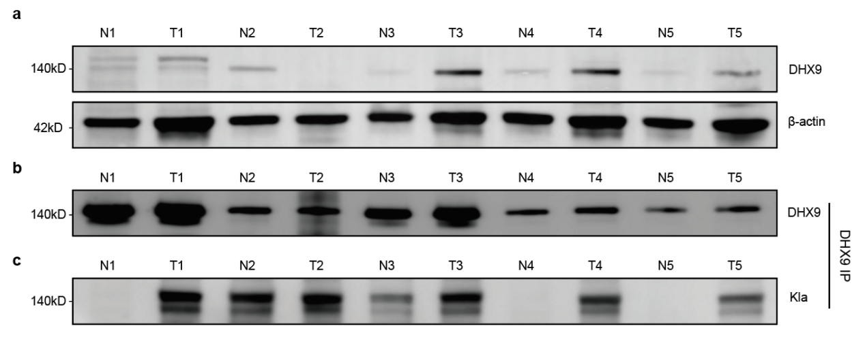
a. Expression of DHX9 in 5 pairs of matched oral cancer tissues and normal adjacent tissues.
b. After co-IP of DHX9, the content of DHX9 is consistent between oral cancer tissues and normal adjacent tissues.
c. When the co-IP samples demonstrate equivalent DHX9 content in both oral cancer tissues and normal adjacent tissues, the lactylation status of DHX9 is examined.

6.In discussion, author stated that ''we observed enrichment in classical pathways such as the HIF-1 signaling pathway, PI3K/AKT signaling pathway, and Hippo signaling pathway in OSCC ...... However, their influence on lactylation in OSCC has not been explored.'', author should add the association content between DHX9 lactylation and related pathways.
Response: Thank you very much for your suggestion. We have reviewed papers on the association of DHX9 with these pathways and have added it to the discussion. Your suggestion has made our manuscript more comprehensive and the discussion more in-depth. Thank you again for your advice.

Reviewer #2:
The manuscript report the important role of lactylation in OSCC and find the critical role of lactylation at the K146 site of dexh-box helicase 9 (DHX9) in promoting OSCC progression. Overall, the topic is scientifically sounding and the results may provide potential clinical contribution to the field. Some specific issues are indicated below:
Major issues:
1/ Clinical information about 109 samples enrolled in this study is lacking. A table showing the most significant information (age at diagnosis, gender, histological type and grade, tumor stage, primary vs metastatic, etc.) must be provided.
Response: Thank you very much for your feedback. We have added detailed clinical information about the relevant patients in the Supplemental Table 1.

2/ In section "DHX9-146Kla Potentially Reverses the Inhibitory Impact of DHX9 on OSCC", authors should discuss whether there are some other critical auxiliary transcription factors playing important roles in OSCC. Their expression in OSCC and differences from DHX9 should be described. Why did authors choose DHX9 for further analysis？
Response: Thank you very much for raising this issue. In our original manuscript, we indeed did not fully elaborate on the scientific basis for selecting DHX9 for subsequent validation. In this study, we identified 217 potential oncogenes driven by lactylation that are upregulated during the development of oral cancer. The upregulation of these genes may be related to the openness of chromatin structure, suggesting that chromatin helicases may play a key role in the development of oral cancer. We speculate that during the development of oral cancer, some helicases may promote the opening of chromatin, thereby leading to the upregulation of a large number of gene expressions.
In our previous work, we constructed a diagnostic model for the development of oral cancer, in which DHX9 was identified as an important part of the model. Therefore, we focused our attention on DHX9. At the same time, through high-throughput sequencing data of lactylation, we found that the lactylation of DHX9 is significantly increased in tumor tissues. This suggests that the lactylation of DHX9 may be associated with the abnormal expression of these oncogenes in oral cancer.
Based on the above two findings, we selected the lactylation site of DHX9 for subsequent experimental validation. Firstly, as a helicase, the upregulation of DHX9 expression in oral cancer may have an important impact on chromatin opening and gene expression. Secondly, the significant increase in the lactylation of DHX9 in tumors suggests that it may have a promoting effect in oral cancer. To substantiate this hypothesis, we have supplemented related experiments in Supplemental Figure 9c, demonstrating that the expression of these genes is significantly enhanced after DHX9 undergoes lactylation. Once again, thank you for your careful review of our manuscript and for pointing out this issue. We have supplemented the above detailed explanation in the manuscript.

3/ In Extended Data Fig.8b, the P value should be calculated to confirm the statistical significance. The Extended Data Fig.8c is insufficient to support the theory that patients with DHX9 high expression exhibit a relatively favorable prognosis. More reasonable evidence should be provided to validate the clinical significance of DHX9.
Response: We are very grateful for your suggestions. We have added the P-values to the Supplemental Figure 8b (now Supplemental Figure 9b). Since the CUT&TAG-seq and ATAC-seq were not replicated, no statistical analysis was performed. However, some of the screened results have been verified by ChIP-qPCR and RT-qPCR, indicating the credibility of the results.
There is no public data on the impact of DHX9 lactylation on patient prognosis, so we cannot perform the relevant analysis. The initial manuscript suggested that DHX9 lactylation might affect the prognosis of oral cancer patients, but this was merely our speculation. As we are currently unable to verify this, we have removed this part of the content in the revised version to avoid misleading readers.
As for the clinical significance of DHX9, as mentioned in the previous response, we selected DHX9 based on the carcinogenesis model, so this molecule may play an important role in the process of oral carcinogenesis and may serve as a potential therapeutic target in the process of carcinogenesis. Our current research is actively investigating the role of DHX9 lactylation in drug resistance, with a focus on identifying drugs that target this process. Due to the large amount of screening work, we have not yet obtained final results. Therefore, we plan to elaborate on this part in subsequent studies on the molecular mechanisms affected by DHX9 lactylation. Once again, we are grateful for your suggestions, which have made our manuscript more rigorous.

4/ All the western blot bands should be clear and aligned. Especially, deformation and inconsistency of β-actin is noted in Figure 4c. Besides, the molecular weight of western blot bands is suggested to be indicated in the figures.
Response: Thank you very much for your careful review. We have labeled the molecular weights of the relevant proteins in all the figures. We assure you that all the Western blot results in the manuscript are genuine, and we have also provided the full membrane images of the DHX9 (140kDa) and β-actin (42kDa) in Figure 4c for your further review.
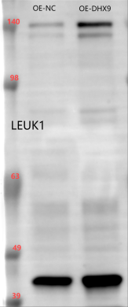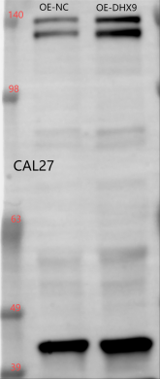

5/ In Figure 4 and Figure5, scale bars should be described in figure legends.
Response: Thank you very much for pointing out this issue meticulously. We have added descriptions of the scale in the figure legends.

6/ Though authors identified the inhibitory role of DHX9 in LEUK1 and CAL27 cell lines, the assays in vivo are lacking. Authors are strongly encouraged to conduct assays using animal models to validate the conclusion.
Response: We are very grateful for your suggestions and fully agree with your viewpoints. We have applied for animal ethics and are actively conducting related animal experiments. However, unfortunately, our previous animal model construction failed. Due to the long cycle of oral carcinogenesis animal models, the model construction work has not yet been completed. In addition, the focus of this study is to screen for potential oncogenes driven by lactylation in oral cancer and to preliminarily explore the mechanisms, with the verification of DHX9 serving as an auxiliary to this discovery. Once again, we are very grateful for your suggestions, and we will take your advice as an important reference for subsequent in-depth exploration of the impact of DHX9 lactylation on tumorigenesis and related mechanisms.

7/ It is suggested to add a schematic diagram to summarize the whole manuscript to enable readers better understanding.
Response: Thank you very much for your suggestion, and we completely agree with your point of view, and a summary schematic will help readers quickly grasp the process of our research. We have extracted key result figures from the entire study to draw a schematic diagram of the research process. Since all the images used are from the main text, we have placed this schematic diagram in the position of Supplemental Figure 1, and we have also made annotations in the introduction to facilitate readers' faster understanding of the thought process of our research.

8/ Discussion: DHX9 is an important factor in the processing, transcription and translation of RNA, more detailed introduction of DHX9 in the process of tumors should be included.
Response: Thank you very much for your suggestion. DHX9 is a multifunctional helicase that can regulate the occurrence and development of tumors through various aspects such as affecting DNA transcription, damage repair, and immune response. We have added the complex regulatory role of DHX9 in the process of tumor development in the discussion. Your suggestion has made our manuscript more complete and has broadened the inspiration for future in-depth research.

9/ Regarding cell viability assays, cell migration, and cell invasion assays, authors should indicate whether they have used image analysis and any software to support the calculations, for instance.
Response: Thank you very much for pointing out this issue. Perfecting these methodological descriptions makes our manuscript more detailed and complete. Specifically, cell viability assays were conducted using the CCK8 kit, followed by measurements with a Biotec brand microplate reader. Quantitative data results were statistically analyzed and visualized using R package software (version 4.0.2). The cell scratch assay was recorded and analyzed using the IncuCyte ZOOM system from Essen BioScience. The results of the colony formation assay and Transwell assay were analyzed using ImageJ software. After obtaining the quantitative data, statistical analysis and result visualization were performed using R package software (version 4.0.2). We have added the aforementioned content to the methods section of the manuscript. Thank you again for your suggestion.

10/ While the manuscript's language is generally clear, attention to grammar errors, sentence structure, and paragraph organization is necessary. Ensure a logical flow that facilitates readers' comprehension and their ability to follow the research process.
Response: Thank you very much for raising the issue. We have carefully reviewed the manuscript, thoroughly proofread and revised any grammatical and sentence structure issues, and optimized the language of the manuscript. This ensures that the language is smooth, the expressions are accurate, and readers can understand our research process and results.

Second round of review
Reviewer 1
The authors have addressed most of my concerns properly.

Reviewer 2
The authors have well-addressed my concerns.

