Additional file 2: Supplementary Figures and Notes

Figure S1. Trimester repartition of the proportion of females that died or were slaughtered before reaching six years of age by genotype group at the RFC5 substitution. 2
Figure S2. Analysing the origin of M6P72 haplotype and NOA1 frameshift variant. 3
Note S1. Neutrophils from NOA1 homozygous mutant calves are functional 4
Note S2. Simulations to define significant thresholds for HHED mapping. 9

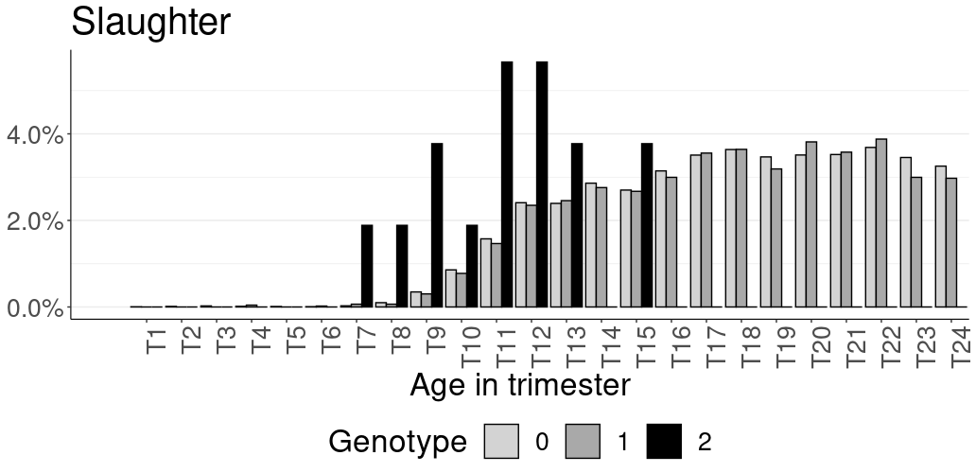
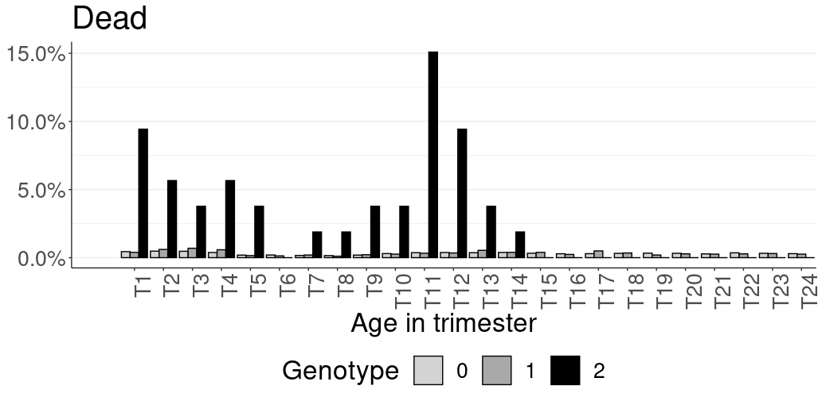
Figure S1. Trimester repartition of the proportion of females that died or were slaughtered before reaching six years of age by genotype group at the RFC5 substitution.
Supplementary Figure 1. Trimester repartition of the proportion of females that died or were slaughtered before reaching six years of age by genotype group at the RFC5 substitution. Source data are provided in Additional file 1: Table S31.

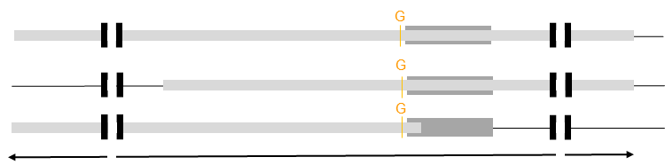
Figure S2. Analysing the origin of M6P72 haplotype and NOA1 frameshift variant.
DEBOUT
BOIS LEVIN
GARDIAN
NOA1 variant
M6P72
87,0-Mb IBD segment
DEBOUT, 2nd, 1972
BOIS-LEVIN, 1986
Mutation
REDON, 11th, 2000
LYSINE,1995
SIRENE, 1981
ACTIVE, 1985
GARDIAN, 8th, 1991
BRINK, 30th, 2006
PAPAYOU,1999
Recombination occurs
TELLA, 1982
a
b
Fig. S2. Analysing the origin of M6P72 haplotype and NOA1 frameshift variant. a) Schematic pedigree showing the dissemination of the haplotype and NOA1 variant following a founder effect and subsequent recombination events in the French Montbeliarde breed. The 2nd, 8th, 11th, and 30th largest contributors to the breed are highlighted (Supplementary Table 12). Several chromosomal segments carry the mutation but only one is detected by the haplotype test. b) Details of the IBD segments shared by the bulls DEBOUT, BOIS-LEVIN and GARDIAN showing the recombination in the middle of the M6P72 haplotype.

Note S1. Neutrophils from NOA1 homozygous mutant calves are functional
Results
Since Nitric Oxide-Associated Protein 1 (NOA1) has been shown to play a role in plant immunity (e.g. [109-110]) and nitric oxide (NO) synthesis is involved in the antibacterial immune response in animals (e.g., [111:113]) we examined the production of reactive oxygen species (ROS) by blood neutrophils and monocytes from calves homozygous for a NOA1 frameshift mutation and matched controls by flow cytometry (Supplementary Note S1 Fig. S1A). The ROS production by neutrophils (G1+) or monocytes (CD14+) was similar between cases and controls, both at basal level and upon stimulation with tert-butyl hydroperoxide (Supplementary Note S1 Fig. S1B). We also measured the specific levels of H₂O₂ and NO in neutrophils by spectrophotometry and again observed no obvious difference between cases and controls (Supplementary Note S1 Fig. S1C). We concluded that ROS production by monocytes and neutrophils was not affected by the NOA1 mutation.
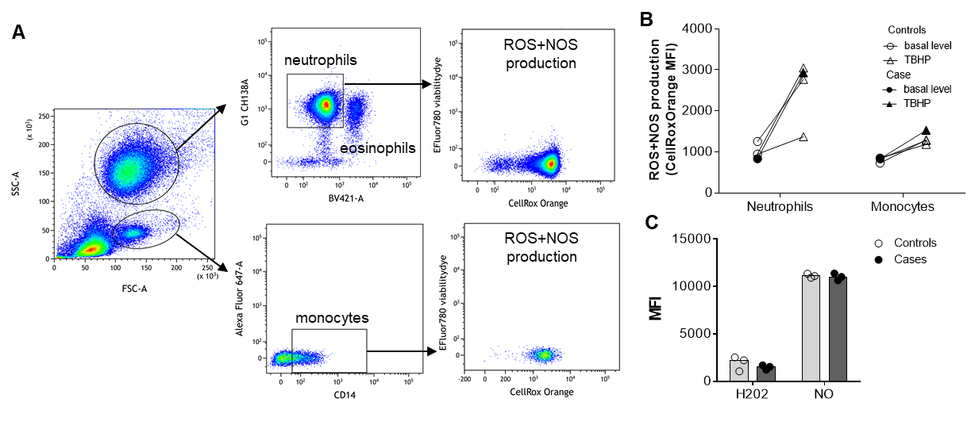
Supplementary Note S1 Fig. 1. Neutrophil oxidative stress levels are similar between cases and controls. A) Flow cytometry gating strategy used to identify blood neutrophils (granulocytes autofluoBV421- G1+) and monocytes (CD14+). ROS and RNS production were measured by flow cytometry using the cellRoxOrange dye. B) Mean Fluorescence Intensity (MFI) of the cellRoxOrange dye in the neutrophils or monocytes gates, measured with or without 1h ex vivo stimulation with tert-butyl hydroperoxide TBHP (circles and triangles, respectively). Results are shown for three controls (clear symbols) and one case calf (black symbols; representative of 2). C) MFI of the H2DCFDA and DAF2DA dyes (H2O2 and NO respectively) produced ex vivo by neutrophils (positive enrichment with G1 Ab and magnetic beads) measured with the TECAN SparkControl. Results are shown for three controls (clear symbols) and three cases (black symbols).

We then extracted RNA from case and control neutrophils, to evaluate the transcription of key neutrophil enzyme genes: myeloperoxidase, elastase, and cathepsin G, and the pro-inflammatory cytokine IL-1b. As shown in Supplementary Note S1 Fig. S2, gene expression was equivalent in the two groups, suggesting that neutrophils from cases are properly equipped to respond to infection.

Supplementary Note S1 Fig. 2. Gene expression in neutrophils. Neutrophils were enriched by positive magnetic bead sorting (G1 Ab) and RNA was extracted. The expression of 4 neutrophil-related genes, myeloperoxidase (MPO), elastase (ELANE), IL-1b (IL1B) and cathepsin G (CTSG) was measured by qRT-PCR, and normalized to the expression of 3 housekeeping genes (PPIA, ACTB, and GAPDH) and then to the control group (ddCT). Individual data of 2 case and 3 control animals are presented.

In conclusion, the comprehensive analysis performed did not reveal any discernible differences between the two groups in the parameters evaluated. Therefore, no inherent defects in neutrophil function could be demonstrated in this study.

Methods
Preparation and labeling of neutrophils
Blood samples were collected by veterinarians and sent to INRAE Nouzilly. Upon receipt 18-24 hours after sampling, Vacutainer K2 EDTA tubes (10 ml) were centrifuged at 1,000g for 15 min at 20°C. Plasma and buffy coat were discarded, then ACK (Gibco) (5 vol/1 vol blood cells) was added for 5 min at room temperature to lyse red blood cells. Cells were washed twice in D-PBS (without calcium and magnesium) with 2mM EDTA, resuspended in D-PBS (without Ca/Mg) containing 10% of horse normal serum (Gibco) and 2mM EDTA, and labeled for 30 min at 4°C with primary antibodies: mouse anti-bovine granulocytes G1 (CH138A). After washes in D-PBS with 2mM EDTA and 10% of horse normal serum (400g, 10 min, 4°C), cells were labeled with the appropriate fluorescent-conjugated secondary antibodies (goat anti-mouse IgM A647, goat anti-mouse IgG1 A488, and the eFluor780 Fixable Viability Dye) for 30 min at 4°C. Cells were washed and i) plated for ROS/NOS assay or ii) analyzed by flow cytometry by direct acquisition using an LSR Fortessa™ X-20 flow cytometer (Becton Dickinson) or iii) purified as described below.

Neutrophil purification
Cell concentrations were adjusted to 10⁷cells/mL and sorted with a MoFlo AstriosEQ high-speed cell sorter (Beckman Coulter) or with anti-G1 Ab and anti-IgM magnetic beads according to our previously published protocol [114]. Sorted cells were used for RNA preparation or spread on microscope slides (Superfrost, Thermo) by cytocentrifugation (3 min, 700xg) and stained with May-Grünwald and Giemsa using the RAL 119 555 kit (RAL Diagnostics).

ROS/NOS Assay
ROS/NOS production was quantified using the CellROX® Orange Flow Cytometry Assay Kits (MolecularProbes®, C10493) according to the manufacturer’s instructions. Briefly, 10⁵ blood cells were first incubated for 1 hour at 37°C in RPMI supplemented with 1 mg/mL BSA, 1 mM EDTA, and 10 mM HEPES with or without 400 µM of TBHP in a black 96-well microplate and then for 30 min with 100 nM CellROX® and 1 µL/mL efluor780 fixable viability dye. Fluorescence was measured directly (without fixation) using the LSR Fortessa™ X-20 flow cytometer. Flow cytometry results were analyzed using Kaluza software (Beckman Coulter).
Alternatively, H2O2 and NO production were assessed on plated cells with H₂DCFDA and DAF₂DA dyes, respectively, according to the manufacturer’s instructions (Sigma). Fluorescence was measured using the TECAN SparkControl and the Magellan software.

Gene expression
Total RNA was extracted using a NucleoSpin RNA kit with a DNase treatment (Macherey Nagel) and reverse transcribed with iScriptTM Reverse Transcriptase mix (Biorad) according to the manufacturer’s instructions. qRT-PCR were performed with a LightCycler® 480 Real-Time PCR System (Roche), with the primers (Eurogenetec) listed in the supplementary Table1. The annealing temperature was 60°C. Data were analyzed with LC480 software to determine the cycle threshold (Ct) values. Messenger RNA expression was normalized to the mean expression of three housekeeping genes to obtain the ΔCt value. For each gene, values from cases were normalized to the mean expression of the control group (ΔΔCt value, and Relative Quantity = 2 ^{- ΔΔCt}).

Gene symbol | Full name | Primer pairs
GAPDH* | Glyceraldehyde-3-phosphate dehydrogenase | GGCATCGTGGAGGGACTTATG  GCCAGTGAGCTTCCCGTTGAG
ACTB* | Actin beta | ACGGGCAGGTCATCACCATC  AGCACCGTGTTGGCGTAGAG
PPIA* | Peptidylprolyl isomerase A | TCCGGGATTTATGTGCCAGGG  GCTTGCCATCCAACCACTCAG
MPO | Myeloperoxidase | AATGACCCCCGCATCAAGAA  CGTTGATCTGGTTGCGGATG
ELANE | Elastase | CGATTCCTTCATCCGTGGGG  GCGCCGGATGATAGAGTTGA
IL1B | Interleukin 1 beta | CTCTCACAGGAAATGAACCGAG  GCTGCAGGGTGGGCGTATCACC
CTSG | Cathepsin G | ATTTCCAGCTTCCTGCCCTG  TGCCCCAGAGAAGGAGAGTC
Supplementary Note S1 Table S1. Primers used for qRT-PCR. *: Housekeeping genes.

Note S2. Simulations to define significant thresholds for HHED mapping.
Introduction
In this study, we applied the same arbitrary filters for HHED mapping in each of the three breeds studied (ten or more observed dead heifers, ((Nobs-Nexp)/Nexp ≥ 25% in dead heifers and (Nobs-Nexp)/Nexp ≤ -25% in cows) before selecting the top 20 haplotypes and performing survival analyses in large validation populations to confirm or reject the results obtained in the discovery population. Another option, which we did not choose for the sake of simplicity, as explained in the discussion of the manuscript, would have been to apply Fisher's exact test to the Nobs and Nexp values in the case and control groups. The aim of these simulations is to determine the thresholds corresponding to a chromosome-wide type I error risk of 0.05 after Bonferroni correction for multiple testing depending on the size of the case and control groups, the frequency of the haplotype, and the combination of (Nobs-Nexp)/Nexp ratios in each group.

Methods
We considered three virtual data sets of the same size as the real data sets (i.e. 8,203 cases and 291,529 controls in Holstein, 6,198 and 141,343 in Montbeliarde, and 2,254 and 57,349 in Normande) with only one haplotype by sliding window of 20 markers because in the real analyses we selected the haplotype with the lowest (Nobs-Nexp)/Nexp ratio at each position. Therefore the total number of haplotypes considered across the genome was 44045 (i.e. 44596 markers – (19 markers x 29 chromosomes) to account for the fact that the last window of each chromosome starts at the 20th marker from the end). We ran ten series of simulations for each data set for haplotypes with frequencies (f) ranging from 1% to 10% (covering the range of deleterious haplotypes identified in the real data set).
For each series, we first calculated the number of expected homozygotes (Nexp) in the case and control groups (as f² x size of the control group), then we fixed a (Nobs-Nexp)/Nexp ratio in the control group by ranges of 1% to both calculate the number of observed animals (Nobs) in this control group, and to determine the Nobs and (Nobs-Nexp)/Nexp ratios in the case group corresponding to a chromosome-wide type I error risk of 0.05 after Bonferroni correction (pvalue=0.05/(44045/29)), after applying a Fisher's exact test to the Nobs and Nexp values in the case and control groups.

Results
The results of the simulations presented in Supplementary Note S2 Figure S1 showed a marked variation in statistical power depending on the size of the case and control groups, the frequency of the haplotype, and the combination of (Nobs-Nexp)/Nexp ratios in each group. An interesting point revealed by the simulations is that in a situation of high haplotype frequencies and large case and control groups, the (Nobs-Nexp)/Nexp ratio does not necessarily have to be positive in the cases to obtain significant results if extreme depletion is observed in the control group. In theory this situation may be encountered if a high proportion of homozygotes die before the age of genotyping and when the increased mortality rate of the few that have been genotyped does not compensate the initial sampling bias. However, in practice, for M6P72/NOA1 in Montbeliarde, which shows a strong depletion of homozygous genotypes in the whole data set of animals genotyped for genomic evaluation due to embryonic and perinatal mortality (see Results section in the manuscript), and a very negative (Nobs-Nexp)/Nexp ratio of -93% in the cows, we observed a positive and elevated (Nobs-Nexp)/Nexp ratio of +203% in the cases (Supplementary Table 4).

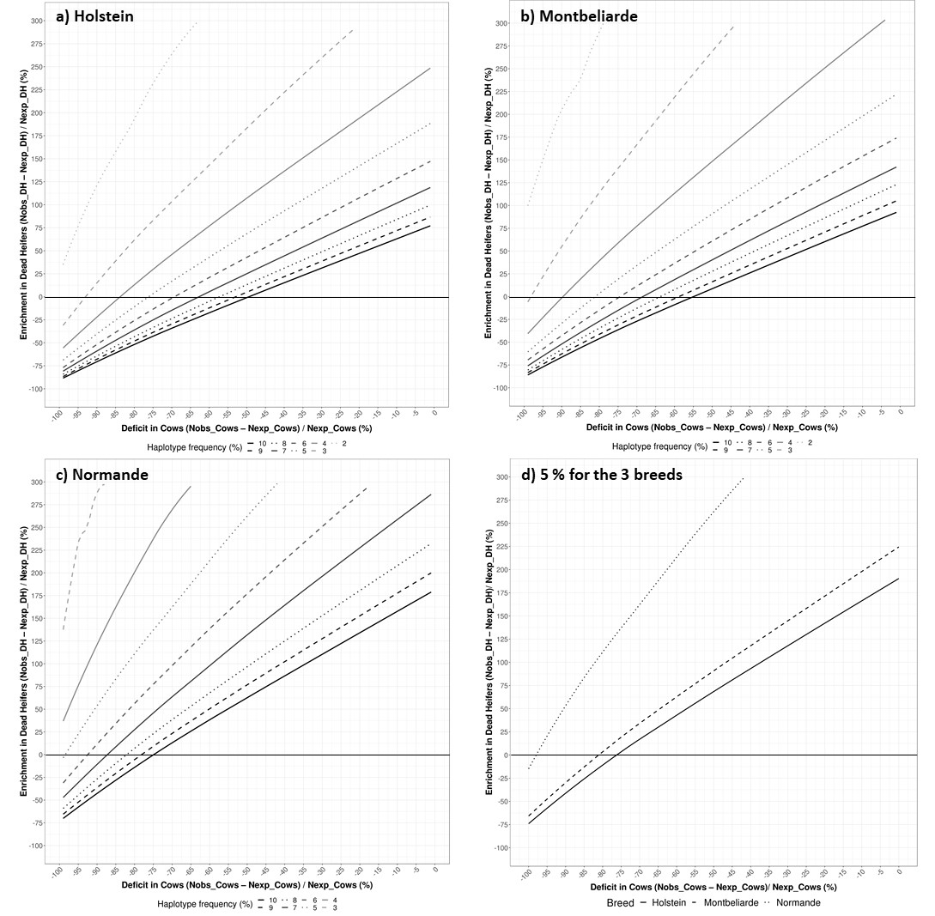
Supplementary Note S2 Fig. 1. Graphical representation of the results of simulations to define significant thresholds for HHED mapping in the three different data sets. a-c) Results obtained in each breed considering 8,203 cases and 291,529 controls in Holstein, 6,198 and 141,343 in Montbeliarde, and 2,254 and 57,349 in Normande, respectively. For ten fixed values of haplotype frequencies ranging between 1 and 10%, the curves represent the minimum (Nobs-Nexp)/Nexp ratio in the case group (dead heifers) for a given (Nobs-Nexp)/Nexp ratio in the control group (cows) to obtain a p-value ≤ 0.05 after calculating a Fisher's exact test on the Nobs and Nexp values in both groups and applying a chromosome-wide Bonferroni correction for multiple testing. d) Comparison of the curves obtained with 5% haplotype frequency between the three breeds. Note the difference in statistical power between breeds, with the larger cohorts (e.g. Holstein>Montbeliarde>Normande) requiring lower ratios in the case group for a given ratio in the control group to reach a chromosome-wide significant threshold of 0.05 after Bonferroni correction.

