Review History
First round of review
Reviewer 1

Were you able to assess all statistics in the manuscript, including the appropriateness of statistical tests used?
Yes, and I have assessed the statistics in my report.

Comments to author:
The shoot apical meristem (SAM) is responsible for the developmental pattern of plants, determining plant morphology as well as many agronomic traits. Several transcription factors are specifically expressed in SAM, and identifying the downstream genes regulated by them, constructing their regulatory networks, and understanding their functions are essential to understanding the roles of these TFs in SAM. Luo et al. analyzed HB family members specifically expressed in SAM, resolved their downstream targets by using the cut&tag technique, and predicted the binding sites specific to these TFs as well as their shared binding sites. Combined with transcriptome data from different tissues, the co-expression and TF-DNA regulatory network of these TFs were constructed. The approaches and information reported in the manuscript are valuable, I only have a few comments described as below.
1. From lines 133-183, the authors indicated their focus on 27 transcription factors (TFs) from three subfamilies: KNOX, WOX, and ZF-HD. It would be beneficial to specify the number of TFs in each subfamily and discuss the evolutionary relationships among these TFs in the main text.
2. The Language needs to be edited for clarity and accuracy. For example, lines 219-222, "Most (~80%) potential target genes were concurrently bound by more than one TF. Moreover, as the number of bound TFs increased, the number of target genes decreased, suggesting that most target genes are regulated by a few TFs rather than many". What is this statement supposed to say?
3. In line 251-251, the same words were repeated twice.
4. In Line 267, the shared binding motifs were listed as "TAAT" and "CCAA", however, in Line 193, they were listed as "ATTA" and "CCAA". Please verify the shared binding motifs for consistency.
5. Line 458, what is the PCO1274444?
6. Line 482, "We performed RNA-seq on the wild type and wox13a mutant". Which tissue was used to perform RNA-seq?
7. Line548" Notably, certain TFs can govern multiple pathways, while multiple TFs converge to regulate genes within the same pathway". How to understand the "certain TFs" and "multiple TFs" ?
Reviewer 2

Were you able to assess all statistics in the manuscript, including the appropriateness of statistical tests used?
Yes, and I have assessed the statistics in my report.
Comments to author:
The author integrates multiple transcriptome and translatome datasets across different tissues and developmental stages. Using previous expression and protein abundance data, they identify Homeobox-related proteins highly co-expressed with known regulators of development. Then, they selected several TFs candidates and performed csCUT&Tag. After quality control evaluation they keep 27 TFs for further analysis. Their analysis uncovered genes highly-targeted by Homeobox-related in maize (hub genes), differences and similarities in the regulatory landscape of each TF subfamily, and evolution variation between TF duplicates. They also integrated their predicted targets with previously published co-expression, co-translational networks, and ATAC-seq, which allows them to identify TF-target condition-specific. Finally, the author mapped their combined network of a list of height-related genes. Thus, using a luciferase reporter assay and a loss-of-function mutant, they test a few predicted interactions and TF functional prediction. Overall, the author found the work exciting and highly valuable for the field. The csCUT&Tag also appears to be an interesting alternative to chip-seq in protoplasts. However, this reviewer believes that the manuscript needs to address several issues related to the interpretation of the results and the extent of the conclusions based on the data generated (major point #7).
Major comment
1.The strategy for selecting the corresponding TFs needs to be clarified. The authors started, lines 146-148: "Focusing on the Homeobox family within the co-translation and co-expression integrated network of SAM functional genes, the results demonstrated that 7 Homeobox subfamilies can intricately engage in either co-expression or co-translation with SAM functional genes (Fig. 1B)." The first part suggested that the author selected Homeobox-related genes, but then, they talked about the enrichment of 7 in Homeobox subfamilies. The first part suggested that the author selected Homeobox-related genes, but then, they talked about the enrichment of 7 in Homeobox subfamilies. Is it not that expected if they preselected beforehand Homeobox-related?
2.In the study, the authors cloned 32 TFs previously identified by Burdo et al., 2014. About 60% of these TFs have a variant form, or isoform, identified in either the maize genome's third or newly updated fifth version. This detail is significant because the cloning of the maize TFome was done using information from the third version of the maize genome. While some clones were verified through experiments (in Burdo et al. 2014), this does not apply to all gene models. Therefore, this reviewer suggests adding a supplemental figure that would compare the sequences cloned in this study to the current isoforms listed for the fifth version of the maize genome. This comparison would be incredibly valuable to other researchers and help understand any potential discrepancies in future or past experiments involving these TFs.
3.In lines 219-223 the authors claim that "Most (~80%) potential target genes 220 were concurrently bound by more than one TF. Moreover, as the number of bound TFs increased, the number of target genes decreased, suggesting that most target genes are regulated by a few TFs rather than many". This may seem contradictory. Additionally, the histogram in Figure S5a could be enhanced by including the cumulative percentage of targets along with the number of TFs bound by targets. This might reveal a different situation, indicating that several TFs targeted numerous genes. I would also re-revisit the end of the paragraph because, with a P-value of 0.02 (Figure S5b), it is difficult to significantly increase the number of shared targets within families. Perhaps a KS test (to check for differences in distribution rather than hand averages) could help here.
4.The identification of HOT regions (section 3 of results) is relevant and interesting. But, it is important to prove that they are just not low-complexity regions on the genome, typically removed from this type of analysis. Perhaps, are they enrichment on enhancers? For instance, PMID: 31740773 and PMID: 28732548.
5.The whole section "KNOX, WOX, and ZF-HD subfamilies partially overlap in binding site specificity" is of significant relevance because it shows the regulatory potential uniqueness of each subfamily. However, the authors end the sections by saying: "Collectively, these results underscore the propensity of KNOX, WOX, ZF-HD subfamily TFs to frequently co-regulate the same loci." Again, this sounds contradictory to me—otherwise, the analysis description in Fig 3. B and C need to be clarified. Are they not based on targets bound by subfamily-only peaks?
6.Lines 404-405: The author indicates "ATAC-seq analysis unveiled 4,187-27,145 accessible chromatin regions spanning tissue stages, regulating 3,698-17,344 target genes." is it not clear to this review how an ATAC-seq peak regulates a target gene? This is an expression that the author used multiple times ("target genes regulated by SAM ATAC-seq" lines 421-422, for instance) which is particularly confusing. I guess that what they mean is that their tsCUT&TAG peaks overlap with open chromatin regions identity by ATAC-seq in other tissues, is this correct?
7.Related to the previous comment (#6). Recent evidence has shown that the protoplasting process triggers many transcriptional changes, largely driven by dramatic shifts in chromatin accessibility (PMID: 34380624). I think that it is of particular relevance. The authors need to discard, or at least clarify and discuss, the fraction of binding events that might be a by-product of the protoplasting itself.
8.Using a dual-luciferase reporter assay (Figure 6d), the author demonstrated that KNOX6 and Hb20 suppress the activity of Vt2 and that KNOX6 also activates Hb20. The method section explains that the promoters of Hb20 and Vt2 were attached to the front of the LUC gene. This raises two questions: How exactly was the promoter region defined? More crucially, why to test the binding on promoters if Figure 6d shows that KNOX6 and Hb20 mainly bind along the gene body of Vt2, not at its promoter, a pattern observed with KNOX6's interaction with Hb20 as well.
9.This review could not verify the availability of raw data and processed files (peaks and OCRs). For this reviewer, this is a significant issue that needs to be corrected to ensure reproducibility and data fairness.
Minor comment
1.Lines 120-122: the method name is presented twice.
2.Figure 1: defined "Co gene" and "co-network"
3.Lines 190-192. Authors claim a peak bias towards promoter regions. This needs to be statistically proven. Two easy options: GAT (https://gat.readthedocs.io/en/latest/contents.html) or booRanges (PMID: 37042725).
4.All supplemental tables need a better description. For instance, in lines 197 - 200, the authors described target genes enrichment of specific biological processes citing Table S6. But, that table has multiple GO descriptions with values that go from 0 - 5/6, is the log of P-value, FDR, odd ratio?
5.Lines 234-237: These lines are quite confusing. Does the author indicate that there are 3469 HOT regions targeting 2878 genes? And each HOT region has 12 or more TF bound to it?
6.Lines 241-224: what "low-complexity genes" means? Are genes with low numbers of regulatory associations? And why is it relevant?
7.Lines 316: Perhaps, what the author meant is: To test or to assay?
8.Figure 6e and 7e. What is treatment and that is control? With and without TF? Please clarify.

Reviewer 3

Were you able to assess all statistics in the manuscript, including the appropriateness of statistical tests used?
Yes, and I have assessed the statistics in my report.
Comments to author:
The manuscript provides a comprehensive analysis of the shoot apical meristem (SAM) in maize, focusing on the role of homeobox transcription factors (TFs) in regulating plant morphology and development. Utilizing a robust dataset comprising 46 transcriptome and 16 translatome datasets from the maize inbred line B73, the authors have constructed a dynamic regulome for 27 members of three SAM-related homeobox subfamilies: KNOX, WOX, and ZF-HD. This study integrates techniques such as tsCUT&Tag data combined with "machine learning models" (but not shown in Results part) to identify the targets of these TFs across various tissues and developmental stages. However, this study seems to simply compile a large amount of data without a clear experimental design.
Major Concerns:
1. The term "regulome" is more common in literature than "regulatome" and should be used consistently.
2. Lines 139-142: The rationale for choosing these 9 TFs (SAM functional genes) needs clarification. Table S1 lists gene names and descriptions but lacks references or evidence supporting their selection.
3. Lines 145-148: The co-expression and co-translation integrated networks (Nat Genet 55, 144-153 (2023)) appear complex. Are the co-expressed genes with these SAM functional genes exclusively from the 7 homeobox families? A full co-expressed subnetwork in a supplementary figure would be helpful.
4. The statistics in Fig 1C are unclear. If other TF subfamilies were tested, similar results might appear due to the inherent co-expression of genes within similar TF families. The random control used is confusing.
5. Line 149: The difference observed for DDT seems fine. Did you mean PHD?
6. Line 172: ATAC-seq measures chromatin accessibility and does not provide direct information about TFs, although TF footprints can be estimated. Clarify what is meant by "ATAC-seq of targets of TFs."
7. Fig. 2: In Fig 2D, the signal for the control experiment appears similar to tsCUT&Tag. Adjusting the range for the control experiment (e.g., [0 20]) and providing a plot similar to Fig 2C for the control experiment would be beneficial.
8. Lines 225-240: Do hub target genes exhibit higher expression levels than common genes?
9. In Fig 3A, are these motifs similar to known TF motifs? Do tsCUT&Tag experiments generate motifs similar to those from ChIP-seq experiments for the same TF?
10. Line 407: The statement "… TFs in this study are regulated by ATAC-seq" is incorrect. ATAC-seq is an experiment type, not a regulator. Revise the manuscript for such misleading descriptions.
11. Fig 5A: The tissue-specific dynamic networks are confusing. Networks constructed from different data levels may conflict. For example, an edge may be tissue-specific based on co-expression but not supported by TF-target relationships. Provide evidence for each edge and details how relationships are estimated.
12. Lines 393-397: Explain the rationale for constructing networks based on different data levels. Investigate the consistency or inconsistency of gene relationships at distinct regulatory levels.
13. In Fig 6, since the network is constructed based on multi-omic data, provide evidence at different regulatory levels for the relationships shown in Fig 6D-F.
14. Contextualize the findings by comparing them with previous studies on SAM-related TFs in maize and other plants to position this research within the broader field.
15. The manuscript's writing could be significantly improved for clarity and readability.
16. Inconsistency: The machine learning model is mentioned in the abstract but not in the results. Ensure that the use and impact of the machine learning model are clearly described and integrated into the results section.

Authors Response
Point-by-point responses to the reviewers’ comments:
Reviewer #1:
The shoot apical meristem (SAM) is responsible for the developmental pattern of plants, determining plant morphology as well as many agronomic traits. Several transcription factors are specifically expressed in SAM, and identifying the downstream genes regulated by them, constructing their regulatory networks, and understanding their functions are essential to understanding the roles of these TFs in SAM. Luo et al. analyzed HB family members specifically expressed in SAM, resolved their downstream targets by using the cut&tag technique, and predicted the binding sites specific to these TFs as well as their shared binding sites. Combined with transcriptome data from different tissues, the co-expression and TF-DNA regulatory network of these TFs were constructed. The approaches and information reported in the manuscript are valuable, I only have a few comments described as below.
Reply: Thank you very much for your evaluation and comments.

1. From lines 133-183, the authors indicated their focus on 27 transcription factors (TFs) from three subfamilies: KNOX, WOX, and ZF-HD. It would be beneficial to specify the number of TFs in each subfamily and discuss the evolutionary relationships among these TFs in the main text.
Reply: Thanks for your suggestion. We added details as follows:
“A dataset comprising 27 TFs, each with at least two biological replicates, was compiled. Among them, seven members belong to the KNOX subfamily and 10 each to the WOX and ZF-HD subfamilies. We delineated the genomic relationships among these homeobox TFs through a phylogenetic analysis, finding higher phylogenetic affinity within subfamilies except for the KNOX subfamily member Ns1, which is more closely related to the WOX subfamily members (Supplemental Fig. S4).”

2. The Language needs to be edited for clarity and accuracy. For example, lines 219-222, "Most (~80%) potential target genes were concurrently bound by more than one TF. Moreover, as the number of bound TFs increased, the number of target genes decreased, suggesting that most target genes are regulated by a few TFs rather than many". What is this statement supposed to say?
Reply: Thank you for your suggestion. We rephrased these sentences in our revised manuscript as follows:
“77.2% of potential target genes can be bound simultaneously by multiple TFs. As the number of binding TFs increases, the number of co-regulated target genes decreases, indicating that most TFs co-regulate a limited number of target genes (Supplemental Fig. S7A).”

3. In line 251-251, the same words were repeated twice.
Reply: Thanks for pointing this out. We revised in our manuscript.

4. In Line 267, the shared binding motifs were listed as "TAAT" and "CCAA", however, in Line 193, they were listed as "ATTA" and "CCAA". Please verify the shared binding motifs for consistency.
Reply: Thank you for pointing this out. TAAT and ATTA are reverse complementary sequences. To clarify this, we revised both Figure 3A and the description in Line 193 to use a consistent core sequence as follow:
“Shared-peak subsets were enriched for the core motifs ATTA and CCAA. However, WOX-only and KNOX-only peaks only returned one over-represented motif, CCAA. Notably, we detected ATTA-enriched motifs in ZF-HD-only peaks (Fig. 3A).”
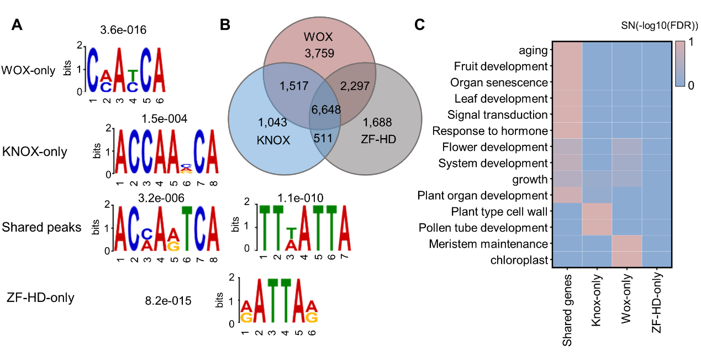

5. Line 458, what is the PCO1274444?
Reply: Zm00001eb403720 is named PCO127444 on NCBI and Hb20 on MaizeGDB. To avoid confusion, we opted to consistently use Hb20 in the revised manuscript.

6. Line 482, "We performed RNA-seq on the wild type and wox13a mutant". Which tissue was used to perform RNA-seq?
Reply: Thanks for this good suggestion. The sample for RNA-seq was taken from the internode at the V6 stage, which is associated with plant height. We rephrased this sentence as follows:
“We performed RNA-seq on internode samples at the V6 stage on the wild type (KN5585) and wox13a mutant, finding 490 DEGs (P < 0.05 and absolute Log2(FC) > 1) (Fig. 7C, Supplemental Table S15).’’

7. Line548" Notably, certain TFs can govern multiple pathways, while multiple TFs converge to regulate genes within the same pathway". How to understand the "certain TFs" and "multiple TFs" ?
Reply: We apologize for this confusion and have revised these statements throughout the manuscript as follows:
"Notably, all TFs investigated here regulate at least three distinct biological pathways, and at least two or more TFs converge to control genes within the same pathway, collectively revealing a multifaceted mode of transcriptional coordination."

Reviewer #2:
The author integrates multiple transcriptome and translatome datasets across different tissues and developmental stages. Using previous expression and protein abundance data, they identify Homeobox-related proteins highly co-expressed with known regulators of development. Then, they selected several TFs candidates and performed csCUT&Tag. After quality control evaluation they keep 27 TFs for further analysis. Their analysis uncovered genes highly-targeted by Homeobox-related in maize (hub genes), differences and similarities in the regulatory landscape of each TF subfamily, and evolution variation between TF duplicates. They also integrated their predicted targets with previously published co-expression, co-translational networks, and ATAC-seq, which allows them to identify TF-target condition-specific. Finally, the author mapped their combined network of a list of height-related genes. Thus, using a luciferase reporter assay and a loss-of-function mutant, they test a few predicted interactions and TF functional prediction. Overall, the author found the work exciting and highly valuable for the field. The tsCUT&Tag also appears to be an interesting alternative to chip-seq in protoplasts. However, this reviewer believes that the manuscript needs to address several issues related to the interpretation of the results and the extent of the conclusions based on the data generated (major point #7).
Reply: Thank you for your positive comments and constructive suggestions. In the revised manuscript, we have provided a more accurate analysis. We also reframed the rationale for choosing to study these three subfamilies, added a comparative analysis of transcription-factor protein sequences between the annotated V3 and V5 genomes, and included results from the enhancer-enrichment analysis of hub targets and hot regions.

Major comment
1.The strategy for selecting the corresponding TFs needs to be clarified. The authors started, lines 146-148: "Focusing on the Homeobox family within the co-translation and co-expression integrated network of SAM functional genes, the results demonstrated that 7 Homeobox subfamilies can intricately engage in either co-expression or co-translation with SAM functional genes (Fig. 1B)." The first part suggested that the author selected Homeobox-related genes, but then, they talked about the enrichment of 7 in Homeobox subfamilies. The first part suggested that the author selected Homeobox-related genes, but then, they talked about the enrichment of 7 in Homeobox subfamilies. Is it not that expected if they preselected beforehand Homeobox-related?
Reply: Thank you for your comment on this. The selection criteria were as follows. We first compiled a list of known SAM functional genes then screened for genes that are co-expressed and co-translated with these genes within the network. Given the role of the homeobox gene family in SAM development, we concentrated on this family and identified subfamilies that are enriched with genes that are co-expressed and co-translated together with the known SAM functional genes.
We collated 28 SAM functional genes and obtained a direct interaction network of genes co-expressed and co-translated simultaneously with them. Focusing on the homeobox family, analysis revealed co-expressed and co-translated genes were enriched in the KNOX, ZF-HD and WOX homeobox subfamilies. For simplicity and clarity, we presented only the information related to SAM functional genes belonging to this family in the paper. We have revised the figures and descriptions accordingly.
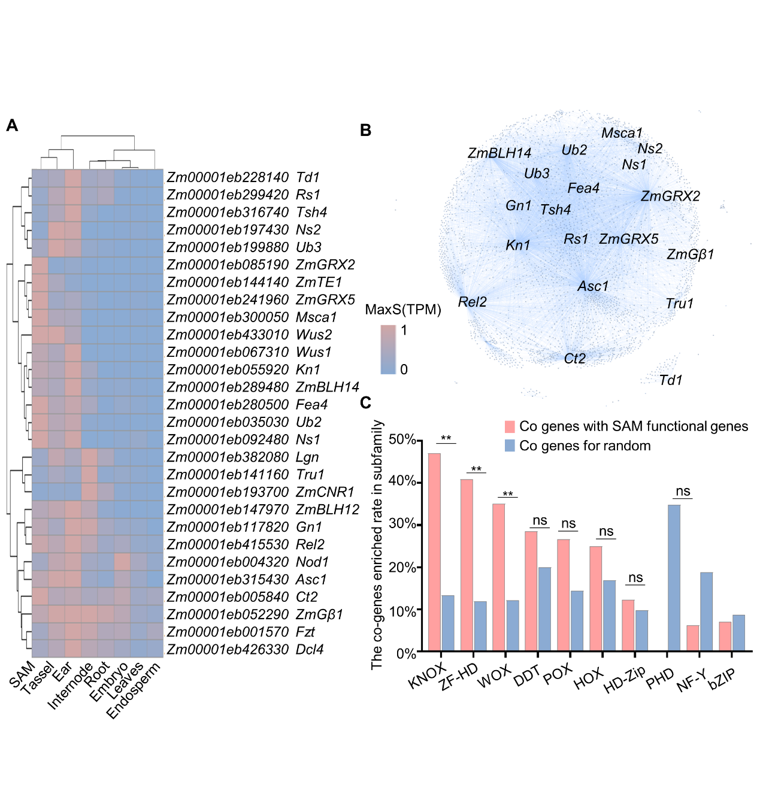
Fig. 1. Genes co-expressed and co-translated with known SAM functional genes are statistically significantly enriched in the KNOX, ZF-HD, and WOX subfamilies. (A) Heatmap representation of the expression levels of known SAM functional genes in the SAM, differentiated reproductive tissues, and other mature tissues. (B) Co-expression and co-translation genome networks of known SAM functional genes. MaxS: max scaling. (C) Proportion of known SAM functional genes in co-expression and co-translation networks for different homeobox subfamilies compared to random control genes (an equal random selection of genes in all co-networks). ** represents significance, ns represents no-significance.

2.In the study, the authors cloned 32 TFs previously identified by Burdo et al., 2014. About 60% of these TFs have a variant form, or isoform, identified in either the maize genome's third or newly updated fifth version. This detail is significant because the cloning of the maize TFome was done using information from the third version of the maize genome. While some clones were verified through experiments (in Burdo et al. 2014), this does not apply to all gene models. Therefore, this reviewer suggests adding a supplemental figure that would compare the sequences cloned in this study to the current isoforms listed for the fifth version of the maize genome. This comparison would be incredibly valuable to other researchers and help understand any potential discrepancies in future or past experiments involving these TFs.
Reply: Thank you for this suggestion. We have now included alignments between V3 and V5 sequences for each transcription factor (Supplementary Figure S2). Twenty-three of the 27 studied TFs have identical protein sequences between V3 and V5 annotations. Zm00001eb354880, Zm00001eb058930, Zm00001eb295920 and Zm00001eb217470 have minor differences between the two versions, which might be attributable to code optimization by Burdo et al.
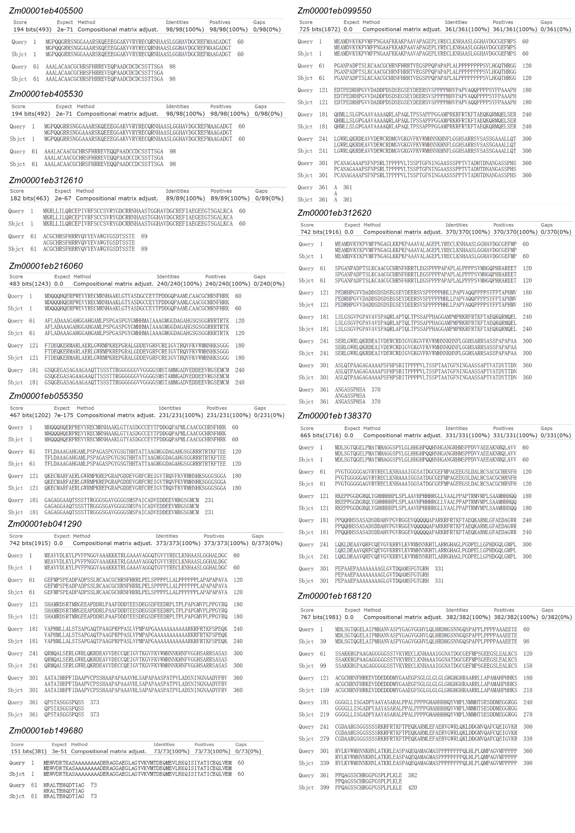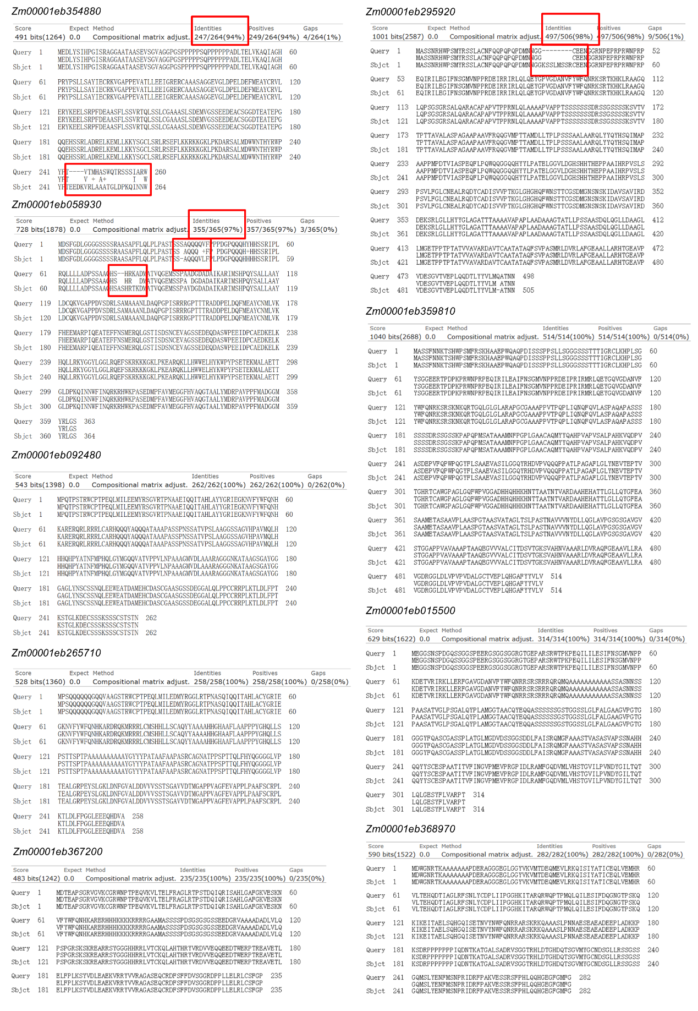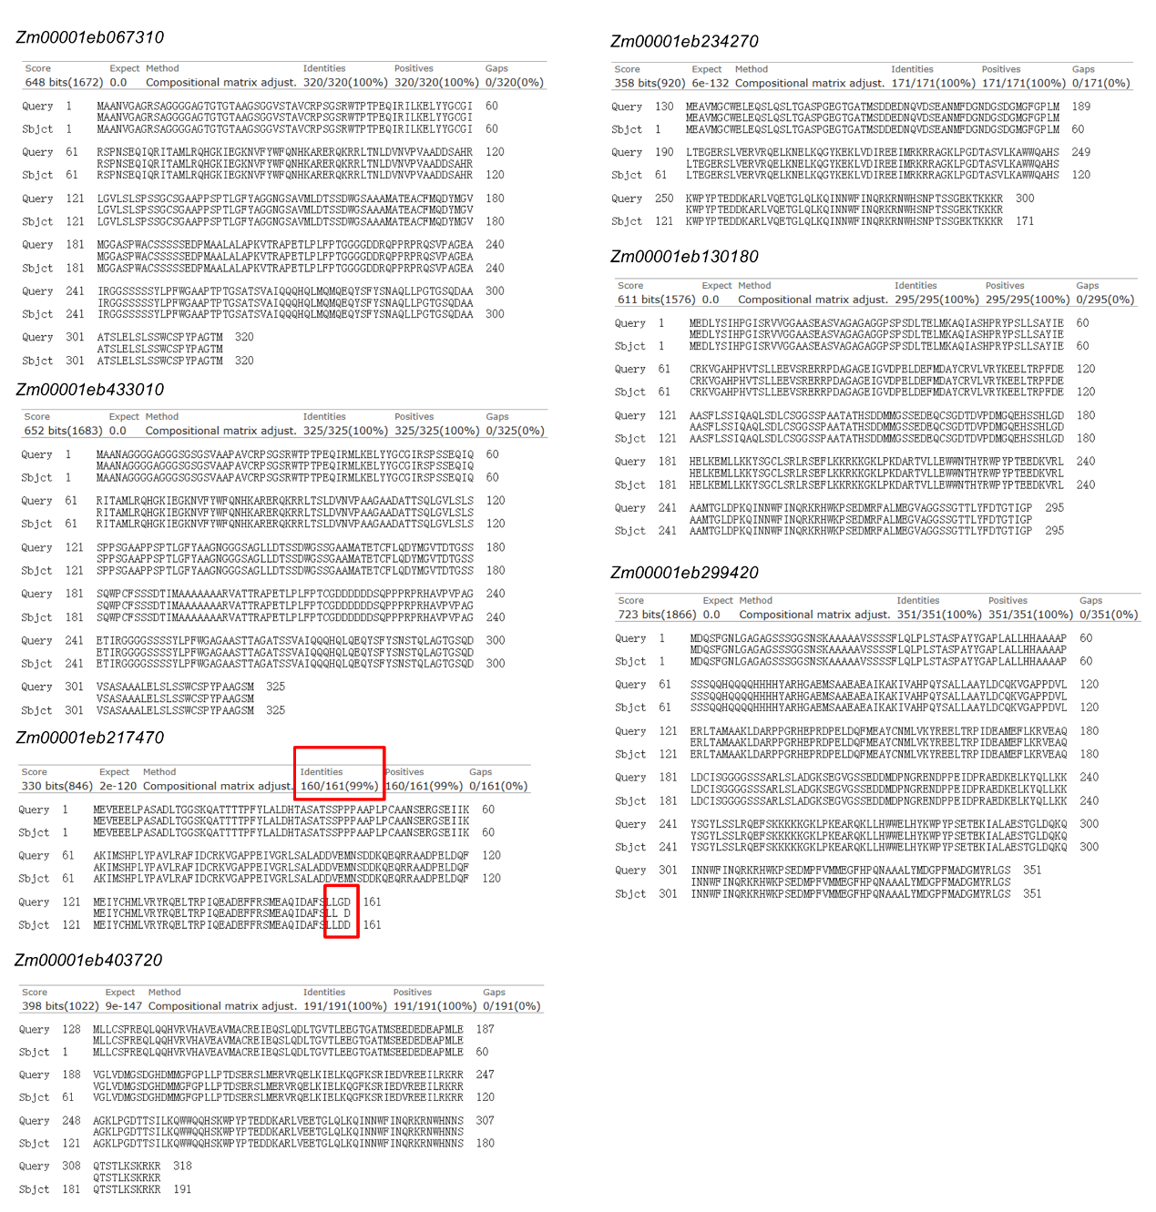
Supplemental Fig. S2. Alignment of TF V3 and V5 protein sequences for the 27 SAM TFs examined in this study. "Query" represents the V5 version, and "Sbjct" represents the V3 version.

3.In lines 219-223 the authors claim that "Most (~80%) potential target genes 220 were concurrently bound by more than one TF. Moreover, as the number of bound TFs increased, the number of target genes decreased, suggesting that most target genes are regulated by a few TFs rather than many". This may seem contradictory. Additionally, the histogram in Figure S5a could be enhanced by including the cumulative percentage of targets along with the number of TFs bound by targets. This might reveal a different situation, indicating that several TFs targeted numerous genes. I would also re-revisit the end of the paragraph because, with a P-value of 0.02 (Figure S5b), it is difficult to significantly increase the number of shared targets within families. Perhaps a KS test (to check for differences in distribution rather than hand averages) could help here.
Reply: Thank you for this helpful suggestion. We have rephrased these sentences, revised Figure S5a and added a KS test to Figure S7b.
“Genomic regions with high TF occupancy are frequently associated with important functions [1, 2]. Here, we aggregated all TF–target-gene interactions for the 27 tested TFs. 77.2% of potential target genes can be bound simultaneously by multiple TFs. As the number of binding TFs increases, the number of co-regulated target genes decreases, indicating that most TFs co-regulate a limited number of target genes (Supplemental Fig. S7A). Notably, the proportion of overlapping target genes regulated by TFs within subfamilies is statistically significantly higher than between subfamilies (P value = 0.004, KS-test) (Supplemental Fig. S7B).”
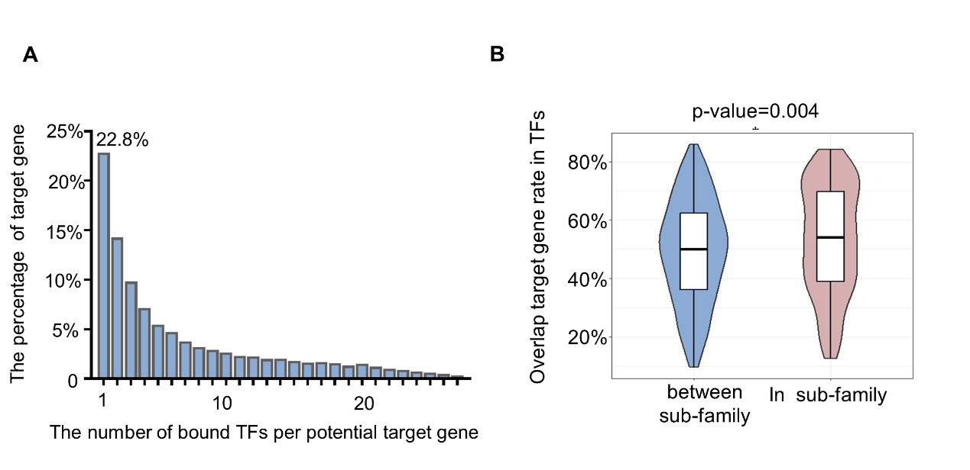
Supplemental Fig. S7. Characteristics of bound TFs per potential target gene. (A) Histogram showing the percentage of bound TFs per potential target gene. (B) Overlap for between-subfamily and within-subfamily TFs’ target genes. P value was calculated by KS-test.

4.The identification of HOT regions (section 3 of results) is relevant and interesting. But, it is important to prove that they are just not low-complexity regions on the genome, typically removed from this type of analysis. Perhaps, are they enrichment on enhancers? For instance, PMID: 31740773 and PMID: 28732548.
Reply: Thank you for sharing this thought. We analyzed all candidate enhancers identified by Oka et al. (PMID: 28732548) and our hot regions. 4.3% (136/3,189) of the hot regions overlap with candidate enhancers, suggesting that these are enhancer-enriched regions, which regulate 107 target genes. In contrast, the remaining 95.7% of the hot regions regulate 2,773 target genes. These findings demonstrate that approximately 4.3% of the regions and ~3% of hub targets show enhancer enrichment, while the majority of hot regions and hot genes do not show such enrichment.
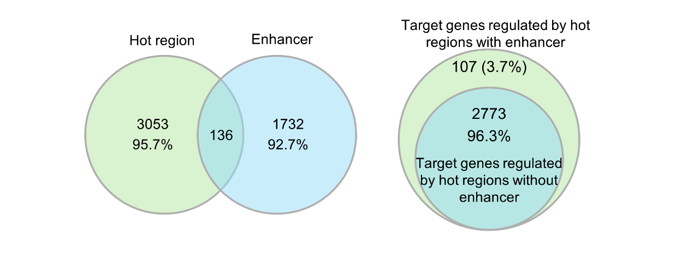
We revised the hub-target and hot-region results section of the manuscript as follows:
“Based on the 99th percentile values of the randomized distributions, we defined 3,168 potential target genes without enhancer enrichment, which are bound by 13 or more TFs, as hub targets (Supplemental Table S7). Complementary to hub target genes, we characterized ‘hot’ regions in the genome as regions bound by many TFs. Hot regions are distinct from hub genes in that they can be bound by many TFs at different locations. Their occupancy follows a negative exponential curve [3] (Supplemental Fig. S8B). A total of 3,053 hot regions without enhancer enrichment were identified, defined as regions bound by 12 or more TFs (Supplemental Table S7). These hot regions regulate 2,773 target genes. We observed that 2,608 (~82.3%) of 3,168 hub targets overlap with hot regions, with the remaining 17.7% of hub genes not being associated with hot regions because of the many TFs that bind to their loci target at different regions (Supplemental Fig. S8C).”

5.The whole section "KNOX, WOX, and ZF-HD subfamilies partially overlap in binding site specificity" is of significant relevance because it shows the regulatory potential uniqueness of each subfamily. However, the authors end the sections by saying: "Collectively, these results underscore the propensity of KNOX, WOX, ZF-HD subfamily TFs to frequently co-regulate the same loci." Again, this sounds contradictory to me—otherwise, the analysis description in Fig 3. B and C need to be clarified. Are they not based on targets bound by subfamily-only peaks?
Reply: Thank you for pointing this out. We have revised this section to more accurate describe it.
“Although different TFs within the same subfamily shared more target genes (53% average) than different TFs across different subfamilies (49% average; P value = 0.004, Supplemental Fig. S7B), we observed that at least 74–89% of all target genes from one of the three TF subfamilies were also among the target genes of at least one of the other two subfamilies (Fig. 3B). This indicates that the target genes specifically regulated by each subfamily accounted for only 10.7–26.4% of the total regulated by that subfamily.”
Therefore, we summarize that “Collectively, these results underscore the propensity of KNOX, WOX and ZF-HD subfamily TFs to frequently co-regulate the same loci.” Additionally, Fig. 3B is a Venn diagram showing the overlap of targets among the KNOX, ZF-HD and WOX subfamilies. Fig. 3C shows the functional enrichment of targets specifically regulated by each subfamily and those co-regulated by all three subfamilies, as delineated in Fig. 3B.

6.Lines 404-405: The author indicates "ATAC-seq analysis unveiled 4,187-27,145 accessible chromatin regions spanning tissue stages, regulating 3,698-17,344 target genes." is it not clear to this review how an ATAC-seq peak regulates a target gene? This is an expression that the author used multiple times ("target genes regulated by SAM ATAC-seq" lines 421-422, for instance) which is particularly confusing. I guess that what they mean is that their tsCUT&TAG peaks overlap with open chromatin regions identity by ATAC-seq in other tissues, is this correct?
Reply: Yes, thank you for pointing out this issue. We have revised the description in the manuscript as follows:
“ATAC-seq analysis unveiled 4,187–27,145 accessible-chromatin regions spanning tissue stages. Between these two datasets, 10–74% of the target genes identified by tsCUT&Tag overlap with ATAC-seq open regions in specific tissues or stages. Within accessible-chromatin regions across different tissues, each TF regulates 521–5,353 target genes (Supplemental Fig. S14, C and D).”

7.Related to the previous comment (#6). Recent evidence has shown that the protoplasting process triggers many transcriptional changes, largely driven by dramatic shifts in chromatin accessibility (PMID: 34380624). I think that it is of particular relevance. The authors need to discard, or at least clarify and discuss, the fraction of binding events that might be a by-product of the protoplasting itself.
Reply: Thank you for your raising this point. We have previously found that protoplast isolation might affect the gene-regulatory networks of certain TFs, particularly those related to chemical stimuli [51]. Previous studies have demonstrated that integrating data from techniques like ATAC-seq and RNA-seq of specific tissues can aid in constructing the tissue regulatory landscape of TFs and enhance the accuracy of analyzing tissue dynamic networks [51]. Our study integrates ATAC-seq and RNA-seq to preserve the authentic interaction relationships within tissues as much as possible. We have added more discussion around this point in the revised manuscript.

8.Using a dual-luciferase reporter assay (Figure 6d), the author demonstrated that KNOX6 and Hb20 suppress the activity of Vt2 and that KNOX6 also activates Hb20. The method section explains that the promoters of Hb20 and Vt2 were attached to the front of the LUC gene. This raises two questions: How exactly was the promoter region defined? More crucially, why to test the binding on promoters if Figure 6d shows that KNOX6 and Hb20 mainly bind along the gene body of Vt2, not at its promoter, a pattern observed with KNOX6's interaction with Hb20 as well.
Reply: Thank you for your comment on this. We have now provided a more detailed genome-browser view of Hb20 and Vt2. The promoter region is defined as 2 kb. As shown in the IGV image below, Vt2 has binding regions in the promoter, gene body and downstream regions, while Hb20 is only bound in the promoter region. The promoter region was uniformly chosen for subsequent LUC experimental validation.

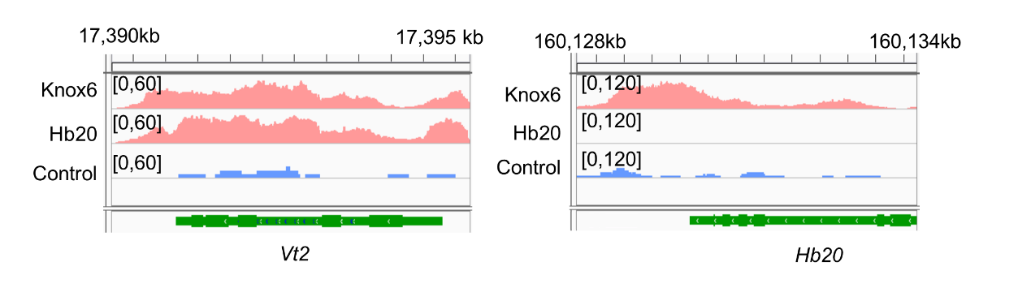
9.This review could not verify the availability of raw data and processed files (peaks and OCRs). For this reviewer, this is a significant issue that needs to be corrected to ensure reproducibility and data fairness.
Reply: Thank you for mentioning this. The sequencing data generated in this paper and BAM files have been deposited in the Genome Sequence Archive (GSA) under accession CRA012938. Additionally, some intermediate files have been uploaded to http://zeasystemsbio.hzau.edu.cn/dataset.html for public access.

Minor comment
1.Lines 120-122: the method name is presented twice.
Reply: Thanks for pointing this out. We rephrased the sentences in our revised manuscript.

2.Figure 1: defined "Co gene" and "co-network"
Reply: Thanks for your reminder on this. “Co gene with SAM functional genes” means the genes are co-expressed/co-translated with SAM functional genes.
“Co genes for random” means the genes are co-expressed/co-translated with randomly selected genes.
“Co network” represents the network of co-expression and co-translation. We added these details to the revised figure captions.

3.Lines 190-192. Authors claim a peak bias towards promoter regions. This needs to be statistically proven. Two easy options: GAT (https://gat.readthedocs.io/en/latest/contents.html) or booRanges (PMID: 37042725).
Reply: Thank you for this suggestion. We have added the P value to the revised manuscript, with an example of the revised phrasing as:
“The genomic distribution of binding peaks showed a bias toward the promoter regions of target genes, as previous study described [4] (Fig. 2, B and C, P-value < 7.2E-10).”

4.All supplemental tables need a better description. For instance, in lines 197 - 200, the authors described target genes enrichment of specific biological processes citing Table S6. But, that table has multiple GO descriptions with values that go from 0 - 5/6, is the log of P-value, FDR, odd ratio?
Reply: Thank you for pointing this out. We have revised the description of the supplemental tables. The values in Supplemental Table 6 were calculated using -log10(FDR). We have revised the description as follows:
“We performed gene-ontology (GO) enrichment analysis on the putative target genes of using -log10(FDR) as the enrichment standard. We saw statistically significant enrichment in functions related to transport processes, growth and development, and responses to hormones and stress (-log10(FDR) > 2) (Supplemental Table S6)”
“To ascertain the comprehensive functional relevance of these genes in SAM development, we first assembled 26 well-known SAM functional genes and described their mutant phenotypes (Fig. 1A, Supplemental Table S1).”

5.Lines 234-237: These lines are quite confusing. Does the author indicate that there are 3469 HOT regions targeting 2878 genes? And each HOT region has 12 or more TF bound to it?
Reply: Yes, we defined 3,469 hot regions, which are bound by 12 or more TFs. These HOT regions regulate 2,878 target genes. We have revised this phrasing:
“Hot regions are distinct from hub genes in that they can be bound by many TFs at different locations. Their occupancy follows a negative exponential curve [39] (Supplemental Fig. S8B). A total of 3,053 hot regions without enhancer enrichment were identified, defined as regions bound by 12 or more TFs (Supplemental Table S7). These hot regions regulate 2,773 target genes.”

6.Lines 241-224: what "low-complexity genes" means? Are genes with low numbers of regulatory associations? And why is it relevant?
Reply: Thank you for this comment. ‘Low-complexity genes’ refers to target genes that are bound only by a single TF. This category is defined to observe and highlight the functional complexity characteristics of hot target genes. We have defined it on line 241.

7.Lines 316: Perhaps, what the author meant is: To test or to assay?
Reply: Revised; we meant ‘test’.

8.Figure 6e and 7e. What is treatment and that is control? With and without TF? Please clarify.
Reply: ‘Treatment’ refers to the co-transformation of the pM999 vector containing the TF effector and the p0800 vector containing the 2-kb promoter region of the target gene. ‘Control’ refers to the co-transformation of the empty pM999 vector with the p0800 vector containing the 2-kb promoter.

Reviewer #3:
The manuscript provides a comprehensive analysis of the shoot apical meristem (SAM) in maize, focusing on the role of homeobox transcription factors (TFs) in regulating plant morphology and development. Utilizing a robust dataset comprising 46 transcriptome and 16 translatome datasets from the maize inbred line B73, the authors have constructed a dynamic regulome for 27 members of three SAM-related homeobox subfamilies: KNOX, WOX, and ZF-HD. This study integrates techniques such as tsCUT&Tag data combined with "machine learning models" (but not shown in Results part) to identify the targets of these TFs across various tissues and developmental stages. However, this study seems to simply compile a large amount of data without a clear experimental design.
Reply: Thank you for your comments. We have thoroughly revised the entire manuscript and expanded the machine-learning section. To investigate the functional differentiation of transcription factors from three subfamilies and their regulatory relationships in specific traits, we integrated multi-omics data. This revealed the functional differentiation characteristics of duplicated genes from the three subfamilies and their molecular relationships in regulating plant height functional genes. Additionally, it provides a resource for studying the regulatory mechanisms of key transcription factors in the SAM.

Major Concerns:
1. The term "regulome" is more common in literature than "regulatome" and should be used consistently.
Reply: Thank you for pointing that out. We now use ‘regulome’ in the whole revised manuscript.

2. Lines 139-142: The rationale for choosing these 9 TFs (SAM functional genes) needs clarification. Table S1 lists gene names and descriptions but lacks references or evidence supporting their selection.
Reply: Thank you for this suggestion. We have improved the descriptions and references for the known SAM functional genes (Supplementary Table 1).

3. Lines 145-148: The co-expression and co-translation integrated networks (Nat Genet 55, 144-153 (2023)) appear complex. Are the co-expressed genes with these SAM functional genes exclusively from the 7 homeobox families? A full co-expressed subnetwork in a supplementary figure would be helpful.
Reply: Thank you for this suggestion. We generated a genome-wide network of genes co-expressed and co-translated with SAM functional genes (Supplementary Table 2). In the original manuscript, we presented the network of HB family members co-expressed and co-translated with SAM functional genes. We have now visualized the entire network (Fig. 1B).
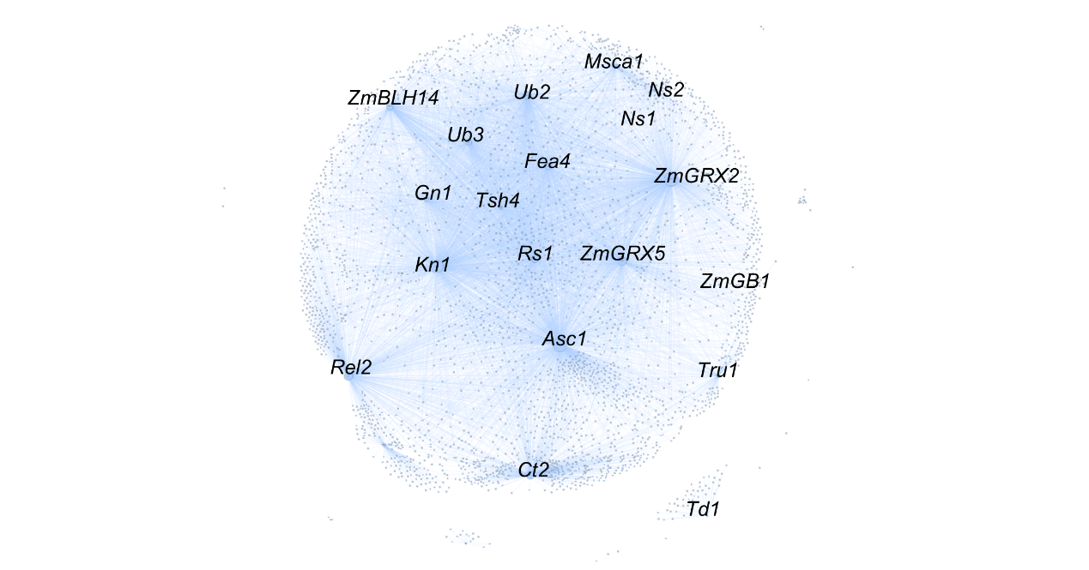

4. The statistics in Fig 1C are unclear. If other TF subfamilies were tested, similar results might appear due to the inherent co-expression of genes within similar TF families. The random control used is confusing.
Reply: Thank you for raising this. For simplicity and clarity, our paper presented only the information related to SAM functional genes belonging to the homeobox family. However, as shown in the figure below, all SAM functional genes also exhibit a consistent pattern. ‘Co genes for random’ represents generating an equal number of random node genes as SAM functional genes. Genes co-expressed and co-translated with random genes belong to the homeobox family. Furthermore, we also analyzed the proportion of genes from the NF-Y and bZIP families that are co-expressed and co-translated with SAM functional genes and added random controls. These two families did not show statistically significant co-expression and co-translation with known SAM functional genes, indicating that the enrichment of the homeobox family is biologically relevant. We have revised these figures and descriptions accordingly.
Fig. 1. Genes co-expressed and co-translated with known SAM functional genes are statistically significantly enriched in the KNOX, ZF-HD, and WOX subfamilies. (A) Heatmap representation of the expression levels of known SAM functional genes in the SAM, differentiated reproductive tissues, and other mature tissues. (B) Co-expression and co-translation genome networks of known SAM functional genes. MaxS: max scaling. (C) Proportion of known SAM functional genes in co-expression and co-translation networks for different homeobox subfamilies compared to random control genes (an equal random selection of genes in all co-networks). ** represents significance, ns represents no-significance.

5. Line 149: The difference observed for DDT seems fine. Did you mean PHD?
Reply: Yes; revised.

6. Line 172: ATAC-seq measures chromatin accessibility and does not provide direct information about TFs, although TF footprints can be estimated. Clarify what is meant by "ATAC-seq of targets of TFs."
Reply: Thank you for pointing this out. We have revised these sentences as follows:
“We conducted tsCUT&Tag experiments by integrating regular CUT&Tag in B73 protoplasts, and ATAC-seq and RNA-seq across various tissues and stages [29] to catalog genomic binding sites for each TF.”

7. Fig. 2: In Fig 2D, the signal for the control experiment appears similar to tsCUT&Tag. Adjusting the range for the control experiment (e.g., [0 20]) and providing a plot similar to Fig 2C for the control experiment would be beneficial.
Reply: Thank you for this suggestion. We have adjusted the range of the control in Fig. 2D to match the experimental group and included heatmaps for GFP-1 and GFP-2 near the transcription start site in Fig. 2C, using Ns1 as an example.
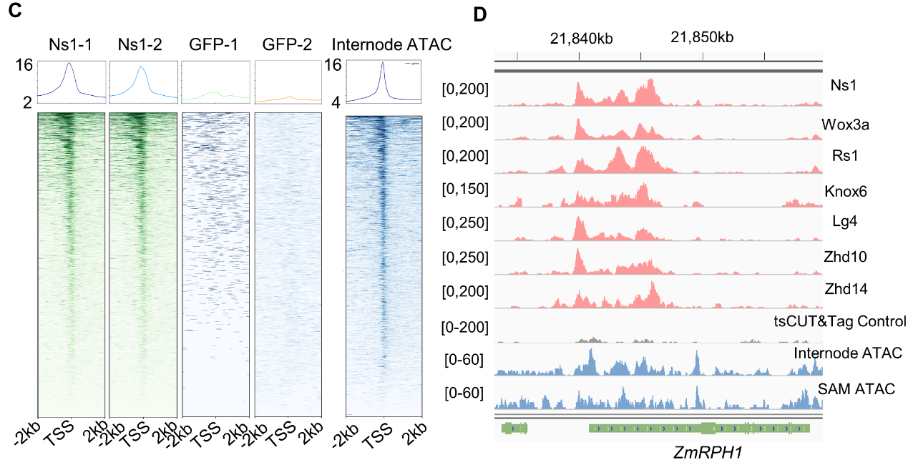

8. Lines 225-240: Do hub target genes exhibit higher expression levels than common genes?
Reply: We did not observe that trend in our datasets. We compared the expression levels of hub targets and targets bound by only one TF across several tissues. Statistically significant differences were observed only in internode samples (P value = 0.00029), while the expression of targets in most other tissues did not show statistically significant changes, as depicted below.
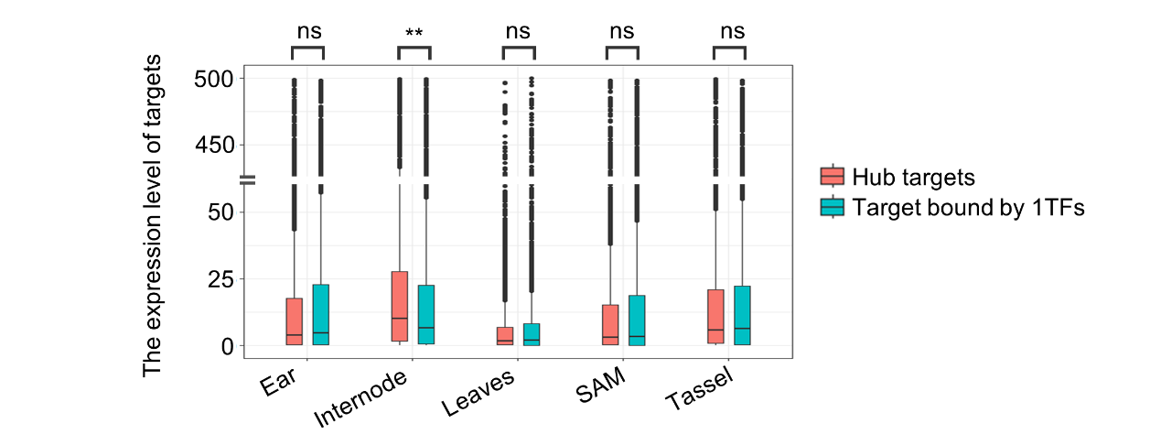

9. In Fig 3A, are these motifs similar to known TF motifs? Do tsCUT&Tag experiments generate motifs similar to those from ChIP-seq experiments for the same TF?
Reply: Yes, known motifs for the homeobox family in Arabidopsis show some similarity to the motifs we identified in maize.
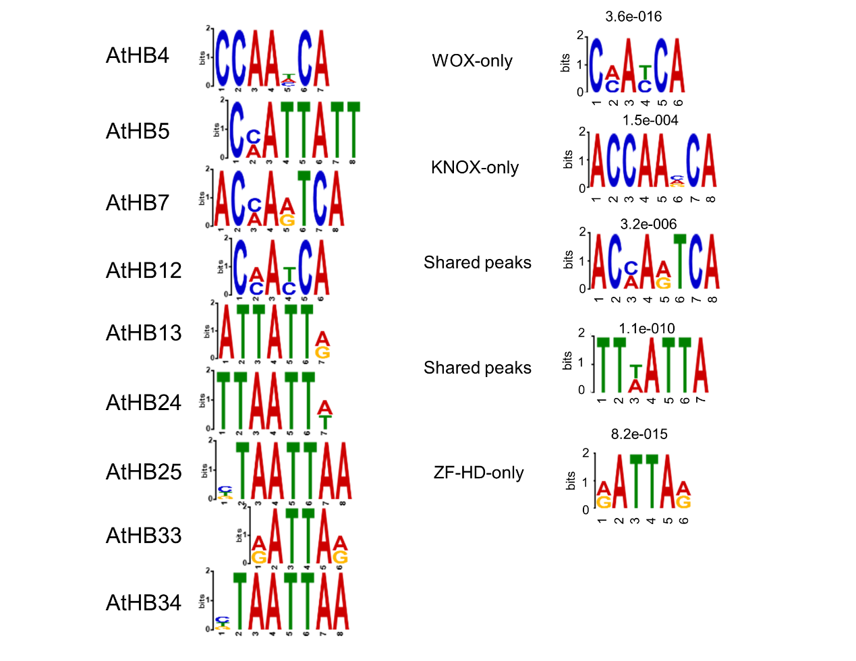

10. Line 407: The statement "… TFs in this study are regulated by ATAC-seq" is incorrect. ATAC-seq is an experiment type, not a regulator. Revise the manuscript for such misleading descriptions.
Reply: We have revised these descriptions throughout.

11. Fig 5A: The tissue-specific dynamic networks are confusing. Networks constructed from different data levels may conflict. For example, an edge may be tissue-specific based on co-expression but not supported by TF-target relationships. Provide evidence for each edge and details how relationships are estimated.
Reply: Thank you for this suggestion. We have revised the network files provided in Supplementary Table 11 as illustrated below. We now include the source of the SAM tissue dynamic network, along with the weights of edges at each network level. "NA" indicates non-existence at this level of the network. The final network weight is the sum of weights across all network levels. The objective in constructing the tissue network is to further refine the tsCUT&Tag-identified regulatory relationships based on gene-expression and translation levels. The GRN generated from RNA-seq and Ribo-seq focuses on gene regulation rather than co-expression, ensuring compatibility during network integration.

Gene1_ID | Gene2_ID | Regulatory relationship by tsCUT&Tag | GRN by Ribo-seq | GRN by RNA-seq
Zm00001eb403720 | Zm00001eb092880 | 0.030156392 | NA | 0.175081545
Zm00001eb403720 | Zm00001eb272300 | 0.030486298 | 0.249797381 | NA
Zm00001eb403720 | Zm00001eb037080 | 0.030630237 | 0.185924098 | 0.122519184
Zm00001eb149680 | Zm00001eb401590 | 0.030659105 | 0.170946448 | NA
Zm00001eb234270 | Zm00001eb312630 | 0.030710203 | 0.17736327 | NA
Zm00001eb403720 | Zm00001eb318630 | 0.030754822 | NA | 0.122363834
Zm00001eb403720 | Zm00001eb070790 | 0.030823046 | NA | 0.084914426

12. Lines 393-397: Explain the rationale for constructing networks based on different data levels. Investigate the consistency or inconsistency of gene relationships at distinct regulatory levels.
Reply: The reason we integrated such a diverse range of data is that the methods for uncovering gene-regulatory networks are varied and complex. Therefore, toward identifying reliable TF binding sites and transcriptional regulatory relationships, it is essential to combine experimental identification with algorithmic predictions, and integrate multi-level information such as gene-expression data and chromatin accessibility. This analysis pipeline allows for cross-correction and the establishment of a more reliable GRN. We acknowledge that the regulatory relationships identified by tsCUT&Tag will have some similarities and differences compared to those predicted by algorithms. The advantage however of our multi-method approach is that it aims to identify the high-confidence regulatory relationships that consistently appear across different methods.

13. In Fig 6, since the network is constructed based on multi-omic data, provide evidence at different regulatory levels for the relationships shown in Fig 6D-F.
Reply: Thank you for your comments on this. The network in Fig. 6 exclusively represents regulatory relationships. Our main focus is on how homeobox TFs function at the regulatory level to influence known height-related genes and, consequently, plant-height traits.

14. Contextualize the findings by comparing them with previous studies on SAM-related TFs in maize and other plants to position this research within the broader field.
Reply: Thanks for your suggestion. We added comparisons between the homeobox network and previous studies on SAM-related TFs in maize in Supplementary Figure 15 and the discussion to demonstrate the feasibility of our network.
“We compared the homeobox integrated network resource with the genes influenced by known SAM functional genes in maize. Our study found that 84.3% (4758/5647) of target genes identified by FEA4 ChIP-seq were present in our homeobox integrated network (Supplemental Fig. S15A). Additionally, 41.7% of the nodes in our generated SAM dynamic network overlapped with FEA4 target genes (Supplemental Fig. S15B). Approximately 62.6% of the differentially expressed genes between the grx triple mutant and wild type were also found in the homeobox integrated network (Supplemental Fig. S15C). Similarly, about 58% of DEGs between the ub2/ub3 double mutant tassel and wild-type tassel at the V5 stage were present in the homeobox integrated network (Supplemental Fig. S15D). These findings demonstrate that the targets of known SAM functional genes are significantly overpresented in the generated homeobox integrated network, validating its biological significance. Furthermore, the homeobox integrated network includes a larger number of network nodes and potential functions, providing an invaluable resource and foundation for in-depth exploration into the multifaceted functions of homeobox TFs within the context of maize growth and development.”

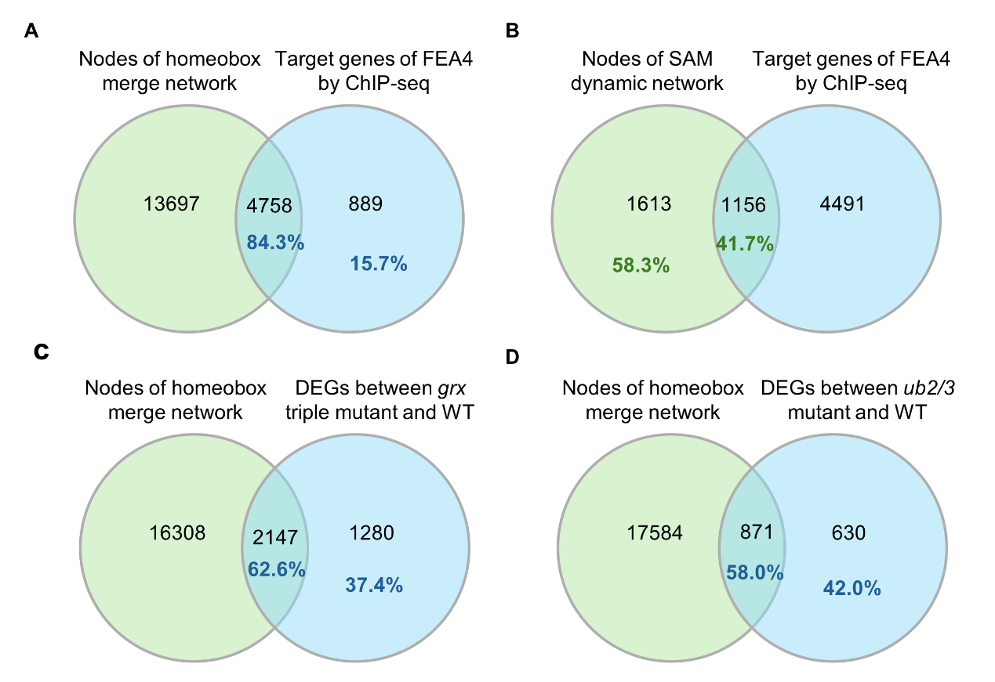
Supplemental Fig. S15. Overlapping genes between homeobox network and known SAM functional TFs’ targets. (A) Overlapping genes between homeobox merge network and FEA4 target genes by ChIP-seq of ∼2-5mm ear. (B) Overlapping genes between homeobox SAM dynamic network and FEA4 target genes by ChIP-seq of ∼2-5mm ear. (C) Overlapping genes between homeobox merge network and differentially expressed genes between grx triple mutant and wild type. (D) Overlapping genes between homeobox merge network and differentially expressed genes between ub2/3 double mutant and wild type.

15. The manuscript's writing could be significantly improved for clarity and readability.
Reply: We have revised the readability manuscript with the assistance of a suitably qualified individual.

16. Inconsistency: The machine learning model is mentioned in the abstract but not in the results. Ensure that the use and impact of the machine learning model are clearly described and integrated into the results section.
Reply: Thank you for pointing this out. We developed the tsCUT&Tag technique with the default bioinformatics pipeline of machine learning for the detection of target of transcription factors across different tissues or stages (https://doi.org/10.1111/jipb.13354). Yes, we agree with your idea about this that we should have clearly described in the current study. We have now clarified this in the revised manuscript at several relevant locations.

Second round of review
Reviewer 2
This reviewer appreciates the improvements and clarifications made by the authors. However, there are a few minor comments that should be addressed.
Line 90: "Homeobox TFs interacting with specific target genes within their promoter regions." This phrase needs work.
Line 138: first use of "co-network" work, add and definition, please.
Lines 181-182: The authors have introduced the term "regulated target genes" for the first time after discussing the binding sites for each transcription factor. However, it remains unclear whether these genes were identified by combining tsCUT&Tag data, co-expression, and co-translation or if they were predicted as targets based on the analysis of the colocalization between the transcription factor binding peaks and the corresponding promoter regions. This needs to be clarified: how the authors defined a target-gene and a regulated target gene?
Lines: 220-221: The authors indicate: "we defined 3,168 potential target genes without enhancer enrichment". What does "without enhancer enrichment" mean? Does it refer to the overlapping with enhancers? If that is true, the analysis should be presented before describing the results.
Lines: 227: the author indicates: "These hot regions regulate 2,773 target genes." It needs to be more accurate. Regions do not regulate genes; TF interacting with regulatory regions does. This may be a comment on the description style. Still, I think it could be more precise if the author refers to the hot areas and other cis-regulatory regions as "associated" or "linked" with the regulation of xx genes.

Reviewer 3
I am satisfied with the response. I have no further comments. Thanks.

Authors Response
Point-by-point responses to the reviewers’ comments:
Reviewer reports:
Reviewer #2: This reviewer appreciates the improvements and clarifications made by the authors. However, there are a few minor comments that should be addressed.
Reply: Thank you very much for your help and suggestions, which really improved the quality of our manuscript.

Line 90: "Homeobox TFs interacting with specific target genes within their promoter regions." This phrase needs work.
Reply: We rephased it as follow:
“Homeobox TFs interact with the promoter regions of specific target genes.”

Line 138: first use of "co-network" work, add and definition, please.
Reply: Thanks a lot for pointing this out. We defined it when its first use in the revised manuscript as follow:
“Focusing on the homeobox family within the co-translation and co-expression integrated network (co-network) of SAM functional genes, three homeobox subfamilies are either co-expressed or co-translated alongside SAM functional genes”

Lines 181-182: The authors have introduced the term "regulated target genes" for the first time after discussing the binding sites for each transcription factor. However, it remains unclear whether these genes were identified by combining tsCUT&Tag data, co-expression, and co-translation or if they were predicted as targets based on the analysis of the colocalization between the transcription factor binding peaks and the corresponding promoter regions. This needs to be clarified: how the authors defined a target-gene and a regulated target gene?
Reply: Thank very much for your question on this. We should have clearly clarified this in our previous manuscript. The first use of “regulated target genes” after the detection of binding sites for each transcription factor by tsCUT&Tag mainly refers to the target genes detected by tsCUT&Tag experiments. We clarified this in the revised manuscript as “regulated target genes detected by tsCUT&Tag experiments”

Lines: 220-221: The authors indicate: "we defined 3,168 potential target genes without enhancer enrichment". What does "without enhancer enrichment" mean? Does it refer to the overlapping with enhancers? If that is true, the analysis should be presented before describing the results.
Reply: Thank very much for your question on this. It is true because these 3,168 potential target genes without enhancer enrichment were detected by the randomization experiment where we built a random TF–target-gene distribution by randomizing the relationship between TFs and their potential target genes [50]. This randomization experiment is to rule out the effect of enrichers in the hot regions.

Lines: 227: the author indicates: "These hot regions regulate 2,773 target genes." It needs to be more accurate. Regions do not regulate genes; TF interacting with regulatory regions does. This may be a comment on the description style. Still, I think it could be more precise if the author refers to the hot areas and other cis-regulatory regions as "associated" or "linked" with the regulation of xx genes.
Reply: Thank very much for pointing this out and great suggestion on the description. Yes, the description of “These hot regions regulate 2,773 target genes.” is not accurate. We modified it as “These hot regions are linked with 2,773 target genes.” according to your suggestion.

Reviewer #3: I am satisfied with the response. I have no further comments. Thanks.
Reply: Really appreciate your evaluation and input on our manuscript, which improved our manuscript a lot.

