Supplemental materials

I. Species-specific alignment of mouse versus human reads

We investigated the potential for read misalignment between the human and mouse genomes by aligning data from single species to the same hybrid genome used in the main analysis. We obtained publicly available single-species samples, aligned them to the hybrid human-mouse genome, quantified the proportion of reads that aligned to the non-host genome, the number of non-host genes with altered expression resulting from misalignment, and the cNMF gene expression programs impacted.

For mouse, we downloaded raw sequence data from 10x Genomics Visium profiles of two healthy mouse brain coronal slices (Sample1 –Visium_V1_Adult_Mouse_Brain: https://www.10xgenomics.com/datasets/adult-mouse-brain-coronal-section-fresh-frozen-1-standard ; Sample2 – Visium_Fresh_Frozen_Adult_Mouse_Brain: https://www.10xgenomics.com/datasets/adult-mouse-brain-coronal-section-visium-ff-1-standard). After alignment of mouse-derived reads to the hybrid genome, only 0.02% of mouse reads aligned to human genes (Additional file 2: Fig. S8a-b). Across both samples, and considering all genes quantified with >50 UMIs (n=14,935 in sample1, n=13,721 in sample 2), only 10 genes had more than 10% of their reads mapping to the corresponding human gene (IGKC, IGHG4, ZIC2, KLF12, RBFOX1, ZBTB16, CIMP, AL627171.2, ANKRD11, PLCG2) (Additional file 2: Fig. S8c-d), and of these a single one (RBFOX1) stood out as having approximately equal read counts in both species plus high expression in mouse brain (Additional file 2: Fig. S8e-f). Of the 10 genes, RBFOX1 also had the highest expression resulting from misaligned reads (Additional file 2: Fig. S8g-h). A sequence comparison showed 100% homology between the 3’ end of mouse and human RBFOX1, explaining the misalignment profile. This gene represents the type of scenario that can potentially affect downstream analyses by boosting the human gene count inappropriately, and in a way that is independent of the presence and abundance of human tumor cells. In the Visium xenograft data, we confirmed high expression of both mouse and human RBFOX1, and an expression profile restricted to D0 regions (i.e. outside of the brain tumor, consistent with mouse as the source of signal) (Additional file 2: Fig. S8i). RBFOX1 had no contribution to human programs (i.e. it was neither a top scoring gene nor a hub gene; Additional file1: Table S2d). The lack of impact in downstream program-centric analyses suggests that our approach is robust to noise from this source (mouse-to-human misalignment).

A similar procedure with two publicly available human scRNA-seq data from GBM samples revealed that a very small proportion of human reads (0.15-0.2%) can align to the mouse genome (Additional file 2: Fig. S9a-b). For this analysis, Visium GBM samples were not accessible without additional permissions, so we analyzed scRNAseq GBM data as it has similar depth of gene expression coverage (Sample1 – scRNA_Brain_Tumor_3p: https://www.10xgenomics.com/datasets/2-k-sorted-cells-from-human-glioblastoma-multiforme-3-v-3-1-3-1-standard-6-0-0 ; Sample2 – scRNA_Parent_SC3v3_Glioblastoma: https://www.10xgenomics.com/datasets/human-glioblastoma-multiforme-3-v-3-whole-transcriptome-analysis-3-standard-4-0-0 ). Of all human genes quantifiable (n=19,863 in sample1; n=16,536 in sample2, with >50 UMIs), only 6 had more than 10% of reads aligning to a corresponding mouse gene (Gm42418, Lars2, Hmgb1, Rpl12, Malat1, mt-Co1) (Additional file 2: Fig. S9c-d). The most highly expressed of these stood out as having the vast majority of reads aligning to the mouse instead of human gene (Gm42418) (Additional file 2: Fig. S9e-h). In the Visium data, this gene contributed as a top-scoring gene in 3 programs (m9_Vascular_remodelling, m41_Excitatory_synapses, m87_NPC_proliferation), none of which were TME programs. The three programs affected comprise many other top-scoring genes without misalignment, and their annotation through pathway analyses was not affected by Gm42418, as this is a non-coding rRNA gene. Finally, a visual check of the spatial gene expression for Gm42418 shows it is localized in the D3-D4 regions (in the tumor), in line with the human data as the source of the signal (Additional file 2: Fig. S9i). Thus, human-to-mouse misalignment is not expected to alter our results and the conclusions that can be derived.

Altogether, based on these assessments, we conclude that (i) alignment specificity is high for both species, (ii) a very small number of genes have reproducible ambiguous mapping, and (iii) a program-centric analysis is robust to outlier genes with either mouse-to-human or human-to-mouse misalignments, limiting impact on downstream analyses.

II. Validation of human-mouse admixture
Our analyses use the human-mouse species admixture ratio derived from the sequencing data to determine the relative abundance of mouse and human cells in the tissue (i.e. as shown in Figure 1c). To further demonstrate that this ratio captures the expected distribution of cells from each species, we performed IHC staining for human nucleolin in additional tissue slices from each sample. This validation was possible since each sample was initially split in two (through cutting adjacent to the injection site), flash freezing the posterior half of the tumor for Visium, and preserving the anterior half in FFPE for IHC staining. Slices taken for Visium or IHC were closest to the initial cut made at the injection site, and therefore represent proximal regions of the tumor. Nucleolin staining thus provides an orthogonal measurement of the density and location of human cells within each sample, and serves as a ground truth for evaluation of the sequencing-derived species admixture. We observed high concordance between the nucleolin-based and sequencing-based admixture of human and mouse cells. A few examples that illustrate this concordance are included in Additional file 2: Fig. S10.

III. Benchmarking the 90 mouse cNMF programs against the ground-truth of mouse brain anatomy

One goal in this work was to show the extent to which the cNMF solution we selected for the mouse data (i.e. 90 programs) reflected the composition of the mouse brain and the glioblastoma TME. The examples we selected to showcase (endothelial cells/pericytes, the subventricular zone, and cortical layers) enable us to benchmark annotated programs and their usages against very well-known biology. This assessment is critical because one of the main user-specified parameters in cNMF is the number of programs (ranks) to solve for. So, when solving for 2 programs in the mouse brain data (rank=2), cNMF identifies the two most transcriptionally distinct regions - the cortical and subcortical regions. As the number of programs increases, cNMF begins to divide the cortex into the different cortical layers, then eventually finds vasculature, subtypes of neurons, etc. Although there are >300 major cell types in the brain, defined at the single-cell gene expression level^{33,34} together comprising 100’s of tissue structures (43 isocortical areas, 329 subcortical areas, 8 ventricle structures, and 81 fiber tracts)³⁷, we did not set out to exhaustively identify all of these. Rather, we sought a cNMF solution that could provide sufficient resolution to reveal important components of the tumor microenvironment. We found that between ranks 80-90, the mouse TME programs remained stable (i.e. not becoming further subdivided), so we selected rank 90 for program annotation. This was an important practical consideration, as annotation is a time consuming step that requires significant domain expertise - going to higher ranks would require more extensive annotation without gaining more insight into the TME. Our program benchmarking (described below) was therefore meant to determine the types of cells, activities, and structures discoverable at the selected resolution of 90 programs.

Our approach to program annotation was systematic, utilizing multiple resources to define whether programs represented cell types, activities, or structures (described in Methods). These include single cell references of normal brain and of the glioma TME, and a spatial transcriptome dataset of the normal mouse brain profiled with STARmap PLUS - a technology platform that profiles 1,022 genes in tissue slices at ~200nm resolution⁷³. This richly annotated dataset represents a high resolution molecular spatial atlas of the normal mouse brain, where each position has been computationally registered to the Allen Brain Atlas (ABA) Common Coordinate Framework v3 (CCFv3)³⁷. The CCFv3 is a definitive resource for brain anatomy/structure, and provides (within the ABA) a compendium of in situ hybridization (ISH) data spanning many genes, including those that distinguish (i.e. are markers for) anatomic regions. We note that directly registering our xenograft data to the CCFv3 was not feasible, as in many tissue sections the brain tumor creates a mass-effect that alters the expected morphology of brain structures.

Together with the single-cell resources included (Methods), the STARmap data and the ABA CCFv3 provide a ground truth for the diversity and relative abundance of cell types within the brain, and for the relative positioning and cellular composition of structures. We incorporate these resources to showcase sensitivity and specificity of the cNMF programs, through the selected examples below. Briefly, we show correspondence between the cNMF structure-specific programs and the anatomic structures defined in the CCFv3 (manually conducted by a neuropathologist, author JAC), and validate that the spatial distribution of CCFv3 ISH-based marker genes match that of the highly scoring genes in corresponding cNMF programs. We perform a similar analysis using molecularly defined anatomic regions in the STARmap data, using their region-specific and cell type-specific marker genes to show concordance to the identity and usage level of selected cNMF programs.

i. Cortical and subcortical structures

At a resolution of 90 cNMF programs, we expected to identify a subset of cNMF programs corresponding to anatomic structures rather than single cell types or activities. Such programs represent the transcriptional output of cell types often found together, and whose signals contribute together to the same Visium spots. The ability to tease apart the transcriptomes of the individual cell types would require that (i) they are individually profiled in at least a subset of the spots, and that (ii) the cNMF resolution is high enough that this distinction can be made among all the other programs (some of which will be more obviously distinct, or have more data to support delineation at any given rank). At k=90, we identified 42 programs that we could label as structures based on (i) lack of strong matches to individual cell types from single cell atlases, and (ii) concordance with anatomic structures annotated in the CCFv3. This concordance was assessed as described in the Methods, taking into account both the histology of each sample (hematoxylin and eosin [H&E] staining, which can be used to locate major anatomic landmarks such as various of the 81 fiber tracts), and the location of the cNMF program in question across all 23 samples. Examples of visual concordance of program spatial usage (in one sample) with several CCFv3 cortical structures are included in the Additional file 2: Fig. S11. We direct the reader to the Dryad repository for spatial usage maps of each program in all 23 samples.

The cerebral cortex is a complex six-layered structure that reflects the laminar organization of different neuronal cell types. Layers are distinguished by the composition, cell density and connectivity of these cell types. At a rank of 90 we find several programs that correspond to the cortical lamina (Additional File 2: Fig. S1f), as mentioned in the main text. A highlight is layer 6b, which at 20-30μm in thickness can only partially contribute to any given Visium spot (55μm). For this and other layers, we compared marker genes with those in the corresponding STARmap-defined layers, as well as layer-specific markers in the ABA (based on ISH). We show examples of concordance between program usage and marker gene expression in our data, with the expression of layer-specific marker genes in the STARmap and ABA (Additional file 2: Fig. S12, Additional file1: Table S8). In general, many of the top-scoring genes in the cortical layer programs were also marker genes in the STARmap or ABA data, or both (Additional file 2: Fig. S13a). In all these resources, some marker genes were shared among neighbouring layers (e.g. Tbr1 in layers 5 and 6a; Krt12 in layers 2/3 and 4), and reflect the cellular composition of each layer. For example, layers 2/3 and 4 share several cell types, as do layers 5 and 6a (Additional file 2: Fig. S13b). As a result, expression of layer-specific marker genes is usually enriched within the corresponding layer, but to some extent also observed in neighbouring layers in many cases, and with high concordance between the Visium and STARmap data in this regard (Additional file 2: Fig. S13c). Consistent with this, we observed through clustering that program co-usage per spot across the cohort recapitulates the cortical and subcortical organization of the brain (Additional file 2: Fig. S14).

ii. The blood brain barrier (BBB)

Endothelial cells and pericytes comprise key components of the blood-brain barrier along with astrocytic end-feet and vascular smooth muscle cells (VSMC). Together, these form intercellular tight junctions responsible for maintaining the integrity of the BBB and are dispersed throughout the brain without the larger-scale organization noted above for anatomic regions. Moreover, the vast majority of vessels in the mouse brain (~94%) are in the range of <10μm, posing a deconvolution challenge in the setting of a 55μm sampling resolution with the Visium platform. Despite general admixture of the BBB components, there was sufficient sampling of spots where each cell type was a major signal (e.g. since not all regions of a given vessel have pericytes, and some vessels in the brain have denser VSMC, along the midline for instance). At 90 ranks we were able to deconvolute four endothelial cell programs (m30_EndoHyp, m52_Endo1, m86_Endo2 and m59_EndoLV), one pericyte program (m48), and one VSMC program (m11). Both m52 and m59 had decreased prevalence in region of high tumor density, while m30 and m86 were enriched in the tumor. The pericyte and VSMC programs exhibited sparse but widespread use across both tumor and non-tumor regions. These programs had strong and specific matches to biological pathways and gene markers for endothelial cells, pericytes, and VSMC (Additional file1: Table S5b), and were consistent with markers identified in the STARmap data and the ABA ISH data (Additional file 2: Fig. S15a-c).

In terms of spatial organization, we found a tight association of endothelial cells and pericytes in the Visium data that was closely aligned to BBB composition expectations from the literature (Obermeier B et al., Nat Med 2013) (Additional file 2: Fig. S15d), with that observed in the STARmap data (Additional file 2: Fig. S15e). Briefly, after correcting for the overall level of vasculature among samples (Additional file 2: Fig. S15f-g), we observed that endothelial cells were most abundant, followed by VSMC and pericytes – a trend with high reproducibility in the cohort. Association between these cell types showed followed the same theme, with high co-incidence of pericytes with endothelial cells and VSMC (Additional file 2: Fig. S15h). This co-incidence reflects the intact composition of the BBB, which is essential for maintaining a microenvironment that enables neuronal circuits to function properly. BBB integrity is compromised in the context of brain tumors, with multiple consequences including poorly regulated flow of large molecules and increased trafficking of immune cells. Evidence for the BBB breakdown includes disruption of the endothelial cell-pericyte association in regions of higher tumor density (Additional file 2: Fig. S15i), with a significant decrease of pericyte coverage in vessels observed in D4 versus D0 regions (Wilcoxon rank sum test p-value = 0.029).

IV. Tumor program descriptions

Here we provide additional details regarding pathway annotations for individual programs observed in the human tumor cells.

A first set of six programs represented Progenitor, Cell Cycle, and Metabolic themes. The two Progenitor programs (h5_progenitor, h13_DNArepair) were distinguished from each-other based on cell state and pathways, with high scores for progenitor and G2M tumor cell states in h13_DNArepair (Fig. 2b, Additional file 2: Fig. S2a), and significant enrichment of multiple DNA damage repair terms including base excision and mismatch repair (Fig. 2a, Additional file1: Table S3a). In contrast, the h5_progenitor program showed higher scores for G1S and neuronal progenitor terms (Fig. 2b, Additional file 2: Fig. S2a). Both programs were present at all timepoints and across density regions, with significantly higher abundance observed in D4, indicating that progenitor states were more prevalent at high tumor cell density (Fig. 3e, Additional file 2: Fig. S2c, Additional file1: Table S3f). Next, two Cell Cycle programs (h7_telomere, h8_epigenetic) were enriched in DNA replication terms. h7_telomere was the most prevalent of the two, involving terms for telomere maintenance, and protein localization and degradation; in contrast, major pathway themes in h8_epigenetic focused on chromatin biology (e.g. histone modifications via lysine acetylation) (Fig. 2a, Additional file1: Table S3a). Finally, we identified two activity programs with clear pathway themes relating to Metabolism – h1_metabolism was defined by cholesterol biosynthesis and nucleotide and RNA metabolism, while h15_mito terms converged on cellular respiration and mitochondrial translation (Fig. 2a, Additional file1: Table S3a). We observed a consistent association of the Progenitor, Cell Cycle, and Metabolic programs with the vascular/astrocytic niche in D4, where these programs had the highest prevalence (Fig. 2e, Additional file1: Table S3e). A particularly high overlap of h7_telomere and h8_epigenetic programs with the Progenitor programs and m30_endoHyp – indicated that a subset of cycling progenitors was highly concentrated within an aberrant vascular niche in regions of hypoxia (Additional file1: Table S3e), in line with previous evidence for this stem cell niche^{53,54}.

A second set of programs represented OC-like, AC-like, and Invasion themes. Two programs (h12_OC1, h14_OC2) had strong matches to OC-like cell states (Fig 2b, Additional file 2: Fig. S2a), and were enriched in terms for regulation of oligodendrocyte differentiation (Fig. 2a, Additional file1: Table S3a). Assessment of genetic heterogeneity in the stRNAseq data revealed that h14_OC2 was a genetic subclone present in the BT143x cell line (Additional file 2: Fig. S2d-h), explaining its high similarity to h12_OC1, and its nested spatial localization (Fig. 3c). Both were most abundant in D4 where they occupied the vascular/astrocyte niche (Fig. 2e, Additional file 2: Fig. S2c, Additional file1: Table S3e,f). Next, two AC-like programs (h2_AC, h9_hypoxia) matched well to AC-like GBM states (Fig. 2b, Additional file 2: Fig. S2a), had pathway terms involving hypoxia response/regulation of angiogenesis (h9_hypoxia), the GBM developmental state (h2_AC), and moderate matches to the leading edge (LE_IvyGAP⁴⁰; both h2 and h9) (Fig. 2a, Additional file1: Table S3a). The h11_invasion program scored highly for LE_IvyGAP, comprised a majority of D1-D2 spots at early and late timepoints, and was the only tumor program with significant over-representation in D1 regions within individual patients (Fig 2e,g, Additional file1: Table S3g). Together, this trio of programs revealed a gradient of outward expansion, with h9_hypoxia most centrally located, h2_AC in the surrounding regions, and h11_invason in the most outlying parts of the tumor (Fig. 2e-g).

While the eleven programs described above were observed in nearly all lines from multiple patients, a final set of four programs was enriched in specific patients (Fig. 3e). h4_autophagy (BT161) was enriched in pathways involving senescence, autophagy, mitophagy, aggrephagy, and apoptosis (Fig. 2a, Additional file1: Table S3a). Additional (lower) matches to mesenchymal and PAN (Fig 2b) linked these states to autophagy. In BT238x, we observed high usage of h6_synaptic (Fig. 2d), with major pathway themes around synapse formation, and cell signaling and adhesion (Fig. 2a, Additional file1: Table S3a). Finally, we identified two programs that relate to angiogenesis (BT134). h3_vascular had strong matches to microvascular proliferation (Fig. 2b), and enrichment in pathways for vascular development, cell migration, and ECM-receptor interactions (Fig 2a, Additional file1: Table S3a). h10_IFN had weaker matches to PAN and mesenchymal states (Fig 2b), enrichment of angiogenesis terms, and of interferon signaling terms (Fig 2a, Additional file1: Table S3a). The observation that these programs were prevalent within individual patients suggested that specific tumor genotypes could be linked to unique repertoires of tumor cell programs, and that larger xenograft cohorts may therefore reveal additional insights. In our cohort we noted high program stability even when including an additional sample, and re-running program identification. The additional sample (BT238z) was a slow-growing and highly diffuse BTIC line established from the invasive front (z) of patient BT238. In this case, we observed nearly identical factorization results for both broadly-used (e.g. h11_invasion) and genotype-enriched programs (e.g. h6_synaptic specific to BT238) (data not shown).

V. Microenvironment program descriptions

Here we provide additional details regarding pathway annotations for individual programs observed in cells of the tumor microenvironment.

Astrocytic programs included both cell types (m74_Astro1, m44_AstroHY) and activities (m43_AstroReac, m49_AstroRNA). m74_Astro1 was widespread throughout the normal mouse brain, prevalent in the invasive tumor front and excluded from dense tumor regions (Fig. 4f,h, Additional file 2: Fig. S5d, Additional file1: Table S5e), and enriched in pathways characteristic of mature astrocytes including metabolic processes (glycolysis, nucleotide metabolism, cellular respiration), regulation of synapse structures and activities, and cellular response to hypoxia and reactive oxygen species (ROS) (Fig. 4d, Additional file1: Table S5a). Similarly, m49_AstroRNA showed broad usage across normal brain with exclusion from dense tumor (Fig. 4f,h, Additional file 2: Fig. S5d, Additional file1: Table S5e), likely representing normal astrocytic activities (RNA processing, proliferation, glutamatergic synapses) (Fig. 4d, Additional file1: Table S5a). In contrast, m44_AstroHY localized both to regions of tumor and normal brain (hypothalamus), suggesting it represents a regional astrocyte subtype that can be rapidly recruited to sites of injury, or alternatively, that it is a cell state which astrocytes in the TME can rapidly adopt (Fig. 4h, Additional file 2: Fig. S5d, Additional file1: Table S5e). Significant enrichment of terms relating to regulation of precursor cell proliferation highlighted a role for this otherwise normal program in the context of the GBM TME (Fig. 4d, Additional file1: Table S5a). Next, the m43_AstroReac program was the only one enacted across the full spectrum of tumor density, sustained at all timepoints of disease progression, and highly specific to regions of tumor (Fig. 2f,h, Additional file 2: Fig. S5d, Additional file1: Table S5e). Co-localization of m43_AstroReac with m74_Astro1 indicated that this was an activity enacted by normal astrocytes in the context of the TME (Additional file 2: Fig. S5c), a conclusion further supported by enrichment of terms relating to proliferation, inflammatory response, and ECM organization, and a strong match to a reactive astrocyte signature⁴⁸ (Fig. 4d, Additional file 2: Fig. S5e, Additional file1: Table S5a).

We annotated four endothelial programs, including m52_Endo1, m86_Endo2, m30_EndoHyp, and m59_EndoLV (Fig. 4a,c, Additional file 2: Fig. S1e,5a, Additional file1: Table S2b). Of these, m52_Endo1 best matched normal endothelial cells in reference datasets, had mature endothelial markers (Gkn3, Sema3g, Alpl, Pecam1; Additional file 2: Fig. S5a,b), and was widespread in the normal brain (Additional file 2: Fig. S1e,5d, Additional file1: Table S5e). m52_Endo1 had decreased prevalence within regions of high tumor density, where a second endothelial program (m86_Endo2) was the major vascular component (Fig. 2f, Additional file 2: Fig. S1e,5d, Additional file1: Table S5e). This tumor-enriched program (m86_Endo2) was distinguished by pathways relating to endothelial cell migration and proliferation, tight junction organization and assembly, leukocyte activation and cell-cell adhesion, and regulation of coagulation and hemostasis (Additional file 2: Fig. S4c, Additional file1: Table S5a). Together, these terms encompassed aspects of tumor vasculature and blood-brain-barrier remodeling positively associated with increasing tumor density. Another tumor-enriched program (m30_EndoHyp) was distinguished by pathways relating to cell proliferation and DNA replication, regulation of cell migration involved in sprouting angiogenesis, collagen fibril organization, and response to hypoxia (Additional file 2: Fig. S4c, Additional file1: Table S5a). This is an activity program sparsely present throughout the brain, but significantly enriched in denser tumor regions with low oxygen availability (Fig. 2f, Additional file 2: Fig. S1e,5d, Additional file1: Table S5e). Finally, we identified m59_EndoLV as highly scoring for lymph vessel morphogenesis, suggesting the possibility that lymphatic and vascular vessels in GBM are distinguishable with this deconvolution approach. m59_EndoLV showed a sparse pattern of usage throughout the brain largely corresponding to known locations of lymphatic vasculature⁴⁹ (meninges) and was also present across timepoints and tumor densities (Fig. 2f, Additional file 2: Fig. S1e,5d, Additional file1: Table S5e). In support of this program’s lymphatic identity, we observed high program scores for lymphangiogenic regulators including Lyve1, Clec14a, Ptpn14, Vwf, and others⁴⁹ (Additional file 2: Fig. S5f). Of these, Vwf (the second highest-scoring gene in m59_EndoLV; Additional file1: Table S2d) has a central role in vascular inflammation ⁵⁰, regulation of vessel permeability, and immune cell recruitment⁵⁰.

Multiple immune cell types were evident in our data (Fig. 4a,b, Additional file 2: Fig. S5a, Additional file1: Table S2b). Microglial programs (m7_MG1 and m77_MG2) were present diffusely throughout the normal brain (Fig. 4h), had an early response to sites of injury (injection tract, Fig 4h) and persisted long-term within lower density tumor areas (D2-D3) (Fig. 4f, Additional file 2: Fig. S5d, Additional file1: Table S5e). MG programs showed differential spatial abundance and distinct pathway enrichments, with m7_MG1 more abundant overall (Fig. 4f), and scoring strongly for IL-1, IL-1b, IL-2 production, for cell migration and response to injury, astrocyte activation, and antigen processing and presentation (Fig. 4b, Additional file1: Table S5a). In contrast, m77_MG2 was enriched for apoptotic cell clearance, and represented a higher percent of all microglia in dense regions (Fig. 4f). Two monocyte derived macrophage (MDM) programs (m40_MDM1, m84_MDM2), were absent from the normal brain but rapidly recruited to early lesions (Fig. 4h). These had distinct pathways, with m40_MDM1 enriched in terms relating to wound and injury response, cell-matrix adhesion, chemotaxis and migration, and m84_MDM2 scoring highly for macrophage proliferation, positive regulation of phagocytosis, engulfment, and membrane invagination (Fig. 4b, Additional file1: Table S5a). Finally, three monocyte programs (m12_Mo1, m55_Mo2, m78_Mo3) were characterized by interferon signaling (Ifit1, Ifit3, Ifit3b, Ifitm3, Ifit2, Ifitm6) (Fig. 4b, Additional file 2: Fig. S5a, Additional file1: Table S5a), were spatially co-localized to tumor borders, and did not associate strongly with the early wound response (Fig. 4h). They increased in abundance with time, particularly m78_Mo3 (Fig. 4h), which stood out as a proliferating monocyte program also enriched in TNF and IL-1 production, thereby linking monocyte inflammatory signaling with the IL-1 response observed in m59_EndoLV (Fig. 4b,d, Additional file1: Table S5a).

Four remaining programs represented immune cell activities (m20_MDM-ROS, m54_ECM-AP, m16_Chemokine, and m57_Cytotoxic) (Fig. 4a,b,i Additional file 2: Fig. S5a, Additional file1: Table S2b). The most prevalent of these (m20_MDM-ROS) had a poor cell type match to MGs/MDMs based on marker genes (Fig.5i, Additional file 2: Fig. S5a, Additional file1: Table S5b), however, spatial localization, pathway activities and TF profiles (Fig. 4b, Additional file 2: Fig. S5c, Additional file1: Table S5a-d), indicated this was an MDM activity primarily distinguished by a cellular response to oxidative stress and hypoxia, and regulation of apoptosis and autophagic cell death. m16_Chemokine was characterized by immunosuppressive Ccl3 and Ccl4 chemokines(involved in suppression of T/NK cells and in recruitment of Tregs) (Additional file 2: Fig. S5a). m54_ECM-AP was Lyz2 and CD74 high (denoting macrophage activation) and enriched in terms for ECM organization, antigen processing, and transmembrane transport (Fig. 4b, Additional file 2: Fig. S5a, Additional file1: Table S5a). Interestingly, m16_Chemokine and m54_ECM-AP both co-occurred with MG/MDM programs, but not with each-other, suggesting they are mutually exclusive immune cell activities (Fig. 5i, Additional file 2: Fig. S5c). Finally, m57_Cytotoxic was significantly enriched in pathways relating to cell killing, cytokine production and defense response, and found at all timepoints and across tumor densities (Fig. 4b,f,i, Additional file1: Table S5a). Relative to other immune cell activities, m57_Cytotoxic had the highest prevalence in D4, indicating that cytotoxicity plays a central role in dense regions (Fig. 4f,i, Additional file 2: Fig. S5d, Additional file1: Table S5e).

i. Additional supplementary methods related to sections IV and V

To investigate program stability, we re-factorized the primary cohort of 23 samples by including an additional xenograft established from a BT238z cell line. Raw data from BT238z was processed with a similar pipeline, where Illumina sequencing base call data (BCL) was converted to FASTQ files and mapped to hybrid genome refence sequence (GRCh38—mm10-2020-A) using SpaceRanger v1.3.1 (default parameters) followed by aggregation with samples from the primary cohort using SpaceRanger Aggr. The resulting matrix of human and mouse genes from a total of 24 samples were processed with the R package Seurat (v4.0.0) by removing genes with expression in less than 3 spots and spots with low number of detected genes (< 200) followed by normalization the LogNormalize() function. Next, over-dispersed human and mouse genes were selected using the restrictCorpus() function from the R package STDeconvolve(v1.7.0). The cNMF pipeline was then re-run separately for mouse and human gene expression data with steps, parameters and processing of resulting program usage matrices described previously (“Methods”). To speculate concordance between tumor programs identified in the primary cohort (cNMF1) and those with the additional BT238z sample (cNMF2), we inferred short-range spatial overlap (“Methods”) between programs in cNMF1 and cNMF2. At rank 15 in cNMF2, we find 98-100% concordance with programs from cNMF1. Further, we also find a one-to-one correlation in gene-scores between rank 15 in cNMF1 and cNMF2, thus indicating that identification of programs is robust to inclusion of additional samples.

Supplemental figures
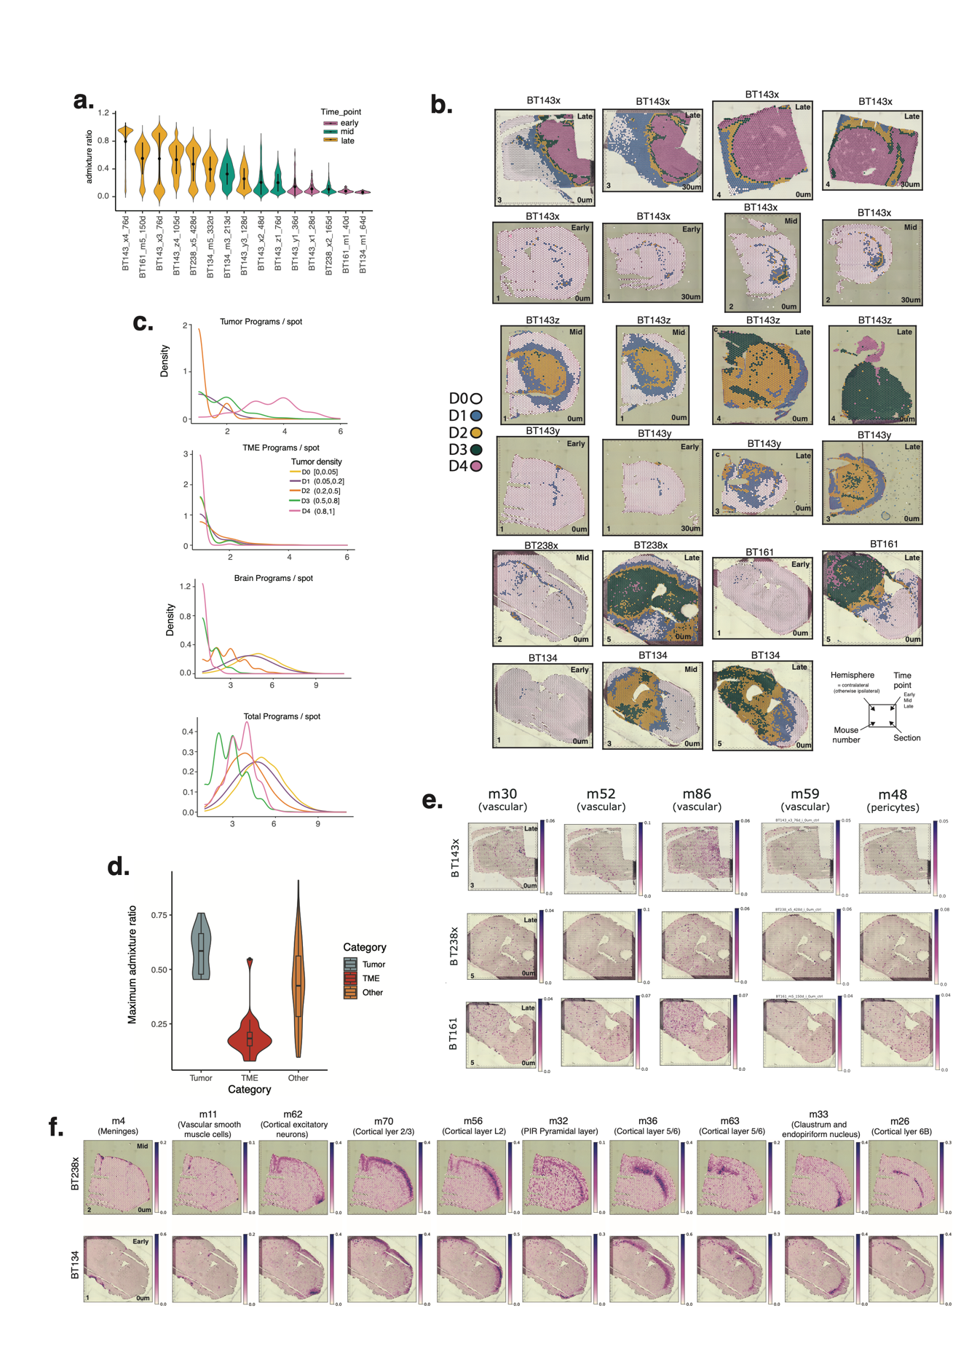

Fig. S1. Genome admixture characteristics
(a) Distribution of human-mouse admixture ratio per line and time-point (biological replicates merged). Sample nomenclature includes [Patient ID][Mouse number]_[Time point] as in Main Figure 1f. Violins are colored based on time-point and ordered by the mean admixture values. (b) Spatial plots overlayed with tumor cell density groups (D0-D4) based on human-mouse admixture ranges; D0: (0.0, 0.05], D1: (0.05, 0.2], D2: (0.2 – 0.5], D3: (0.5 – 0.8], D4: (0.8 – 1.0]. (c) Density plots of the number of tumor, TME, brain, and total (human and mouse) programs used per spot across tumor cell density groups, D0-D4. A usage threshold of 0.1 was set to define tumor programs and 0.05 for TME and other brain programs observed in each spot. (d) Violin plots indicate the range of usage values in tumor (n=15), TME(n=19) or other programs (n=81). (e-f) Spatial plots of program usage in (e) vascular, and (f) cortical layer programs.

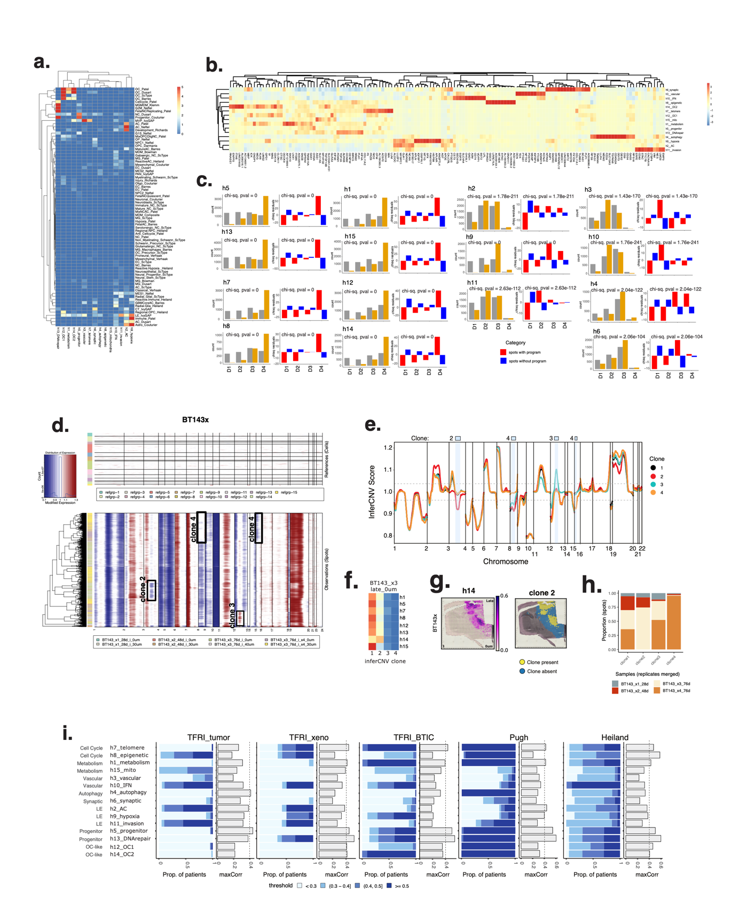

Fig. S2. Tumor programs
(a) Heatmap of marker-gene enrichment scores of tumor programs (columns) calculated with gene sets of GBM cell-states (rows) in external cohorts enumerated in Additional file1: Table S2a. (b) A hierarchically clustered heatmap of 10 genes in each program, based on rank ordered cNMF-derived gene scores. (c) Chi-square test results indicating the enrichment each tumor program, across tumor density groups D1-D4. Barplots depict the number of expected and observed spots with usage > 0.01 in a given program, and chi-squared residuals and associated p-values indicating the significance of difference between observed and expected numbers. (d) inferCNV output plot predicting copy number variation (CNV) profiles per spot (row) in BT143x samples, with clonal CNVs marked in black outline and labelled (bottom panel). CNV profiles of D0 cells were used as the reference set (top panel). (e) Smoothed inferCNV signal for the 4 clones in panel d, with regions of clonal copy number divergence highlighted in blue and labelled above the plot. Divergence is relative to the baseline clone 1, and above/below the score thresholds of 1.5 and 0.5. (f) Heatmap of spatial overlap i.e., concordance between CNV clones and tumor programs prevalent in BT143x3 and BT143x4 samples. (g) Spatial plots of h14 program usage (left) and clone2 spots (right) in BT143x3. (h) Barplot depicting the proportion of spots from BT143x samples (replicates merged) in each clone identified using inferCNV. (i) Prevalence (blue stacked barplots) and correlation (grey bars) to programs identified in external cohorts. Barplots show the maximum correlation obtained between each tumor program in the xenograft cohort programs derived from cNMF across a series of ranks in external cohorts. A vertical line is drawn at r=0.4 as a visual reference. Prevalence barplots represent the proportion of patients in the external dataset that have usage of the program with maximum correlation above a specific threshold.

Fig. S3. STRINGdb-based protein-protein interaction networks of tumor programs
(a) Network plot of top-scoring genes (yellow nodes) for the 15 tumor programs, with hub genes in orange, and labelled with gene name. Node size is proportional to the correlation between a gene’s usage in a program to its expression, and edges represent the functional associations. The network is plotted with a fruchterman.reingold layout using the R package iGraph (v1.4.2) and hub genes are defined as nodes with a PageRank score in the 95th percentile.
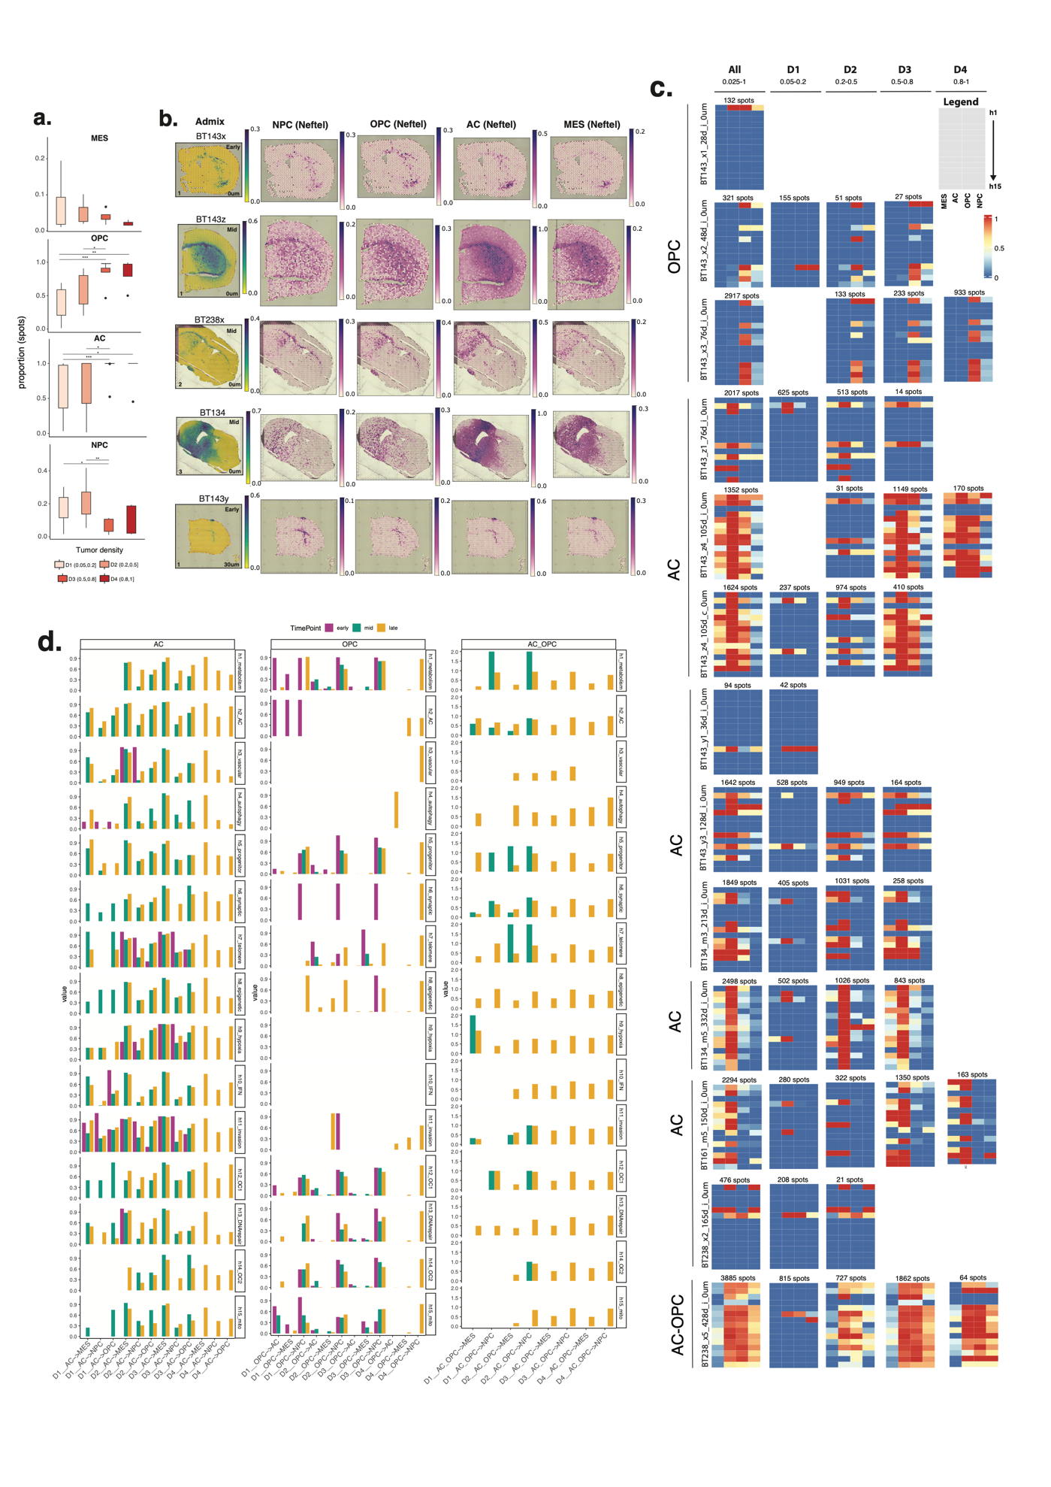

Fig. S4. Baseline and distribution of single-cell derived GBM cellular states
(a) Boxplot showing the proportion of spots in each GBM cell-state with increasing tumor density, D1 to D4. Significant differences across the four groups in each GBM cell-state are marked (wilcoxon rank-sum test ; ns: p > 0.05; *: p <=0.05; **: p <= 0.01). (b) Spatial plots of tumor admixture (left) and module scores for NPC, OPC, AC and MES-like states (right) calculated using AddModuleScore() from the R package Seurat. (c) Heatmaps depicting the proportion of spatial concordance between tumor programs (rows) and GBM cellular states (NPC, OPC, AC and MES; columns) in each sample stratified by tumor density (D1-D4). Tumor baseline states (labelled) correspond to the most abundant GBM cellular state across all samples from each tumor. (d) Barplots indicating cell-state transitions away from the baseline states (AC, OPC, AC-OPC) for tumor programs, stratified by tumor stage and density. Cell-state transition is calculated as the proportion of spots with each non-baseline state relative to spots with the baseline state. Spots are assigned to a tumor program if usage > 0.1.

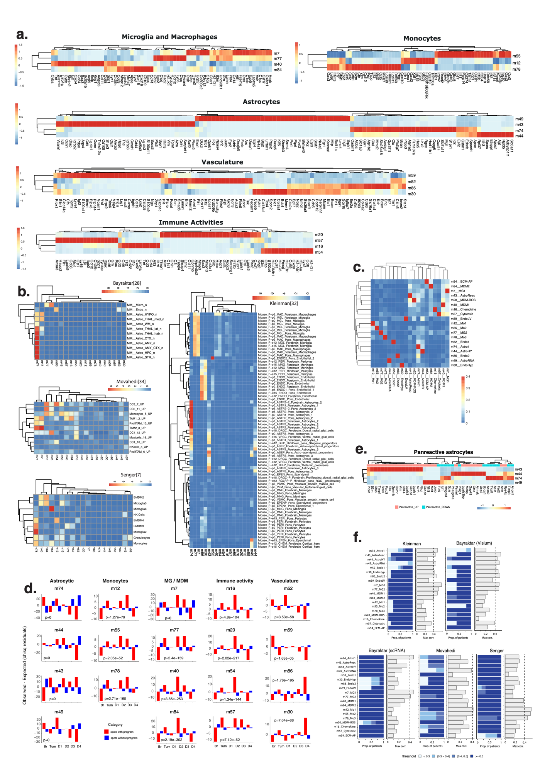

Fig. S5. TME programs: Annotation scores and prevalence in external cohorts
(a) Heatmaps indicating the inverse of ranks (1/rank) of the top 20 genes selected based on rank ordered cNMF-derived gene scores of TME programs. (b) Heatmaps of marker gene enrichment scores for each TME program (columns) calculated using gene sets of brain-resident and TME associated cell-types (rows) identified in external cohorts referenced in the figures’ scale legend and enumerated in Additional file1: Table S2a. (c) Spatial concordance among TME programs, calculated as the proportion of spots in one program (rows) that also have usage of another (columns). Spots with a minimum usage of 0.05 in a given program were selected for this analysis. (d) Barplots of chi-squared test residuals, where p-values specified indicate the significance of difference between observed and expected numbers of spots with usage > 0.01 in a TME program. The test was performed across individual tumor density ranges (D1-D4), all tumor regions together (Tum), and non-tumor regions (D0; Brain) (x-axis). (e) Row-scaled heatmaps indicating the inverse of ranks (1/rank) of pan-reactive astrocyte markers across the four astrocyte programs. (f) Prevalence (blue stacked barplots) and correlation (grey bars) to programs identified in external cohorts. Barplots show the maximum correlation obtained between each TME program in the xenograft cohort programs derived from cNMF across a series of ranks in external cohorts. A vertical line is drawn at r=0.4 as a visual reference. Prevalence barplots represent the proportion of samples in the external dataset that have usage of the program with maximum correlation above a specific threshold.

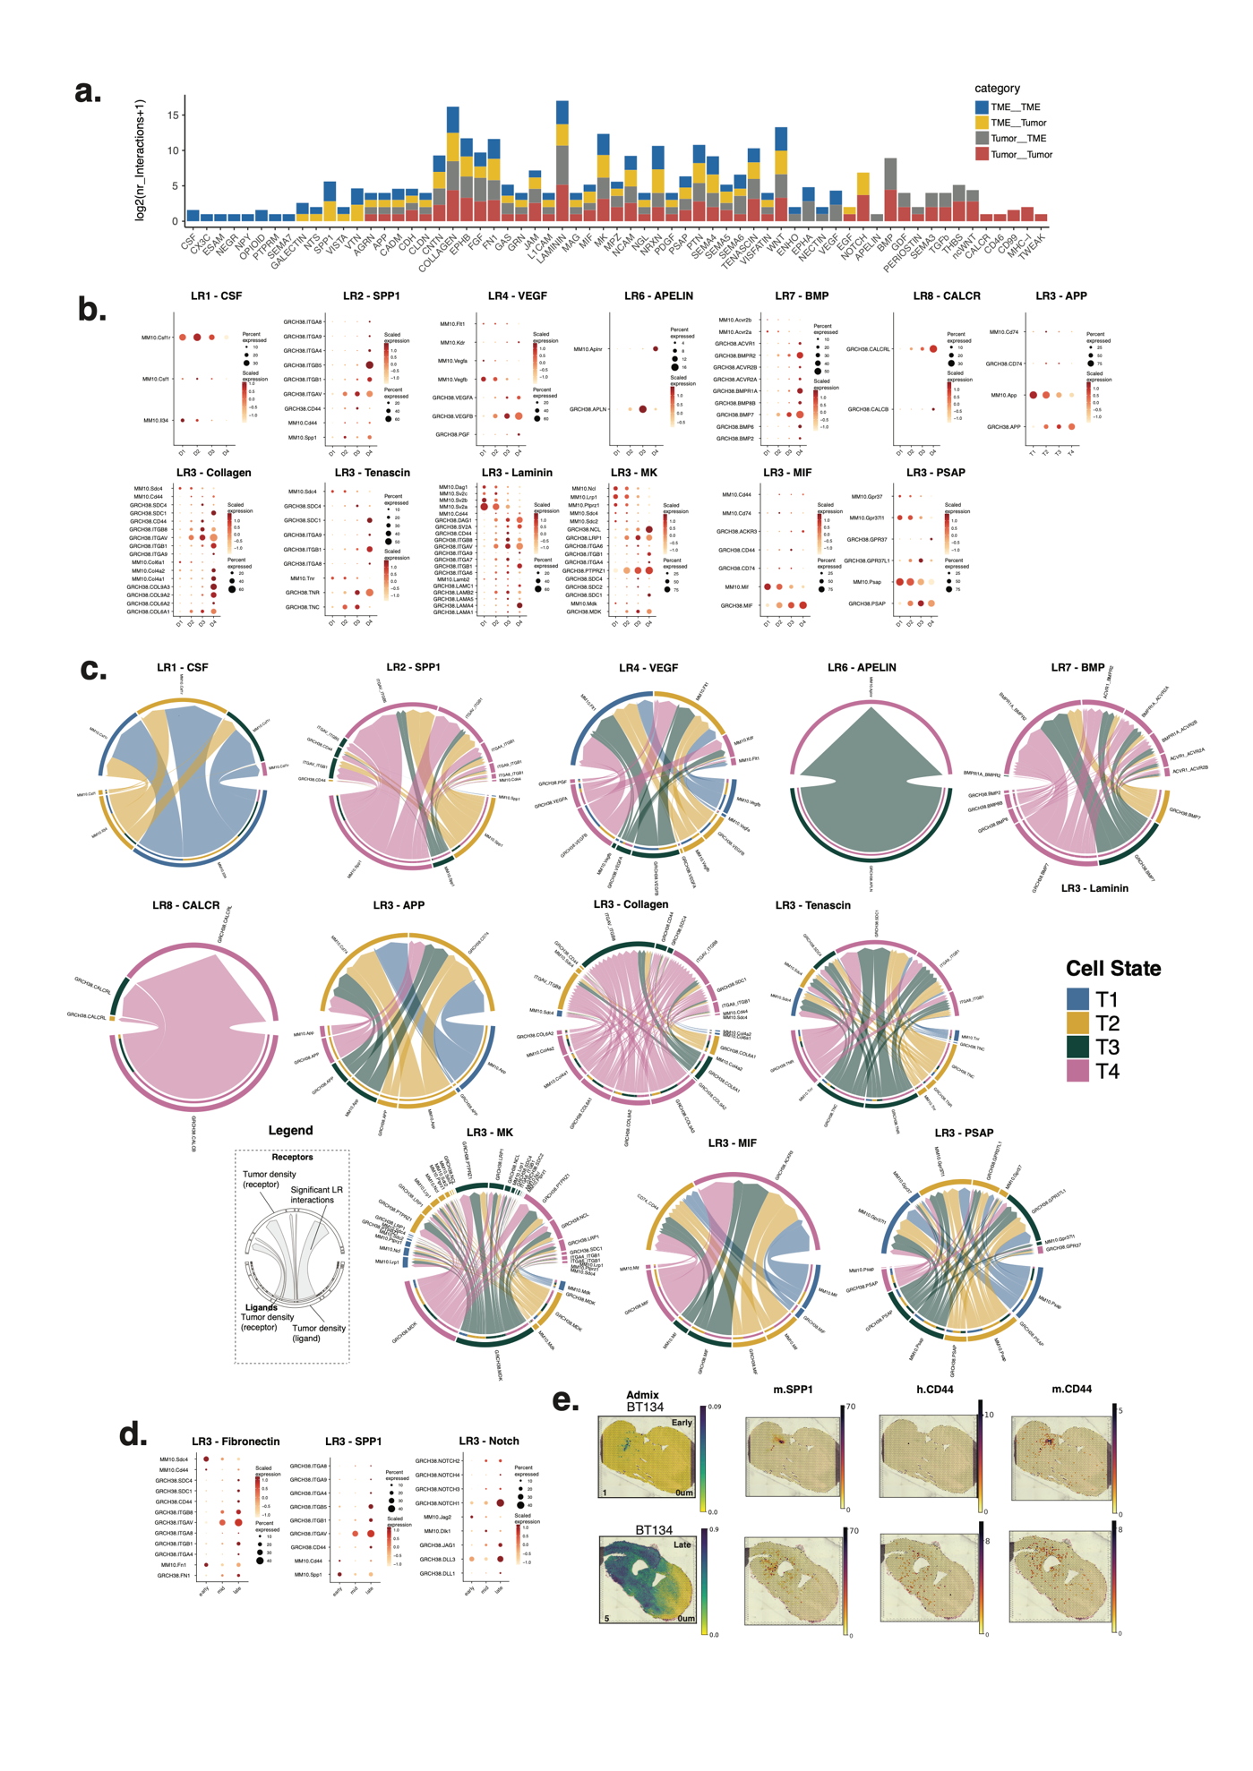

Fig. S6. Ligand-receptor signaling communication across tumor density groups
(a) Stacked barplot indicating the number of significant LR interactions per pathway. LR interactions are categorized and colored based on the species of the ligand and receptor involved, resulting in 4 interaction categories (ligand__receptor): TME__TME, TME__Tumor, Tumor__TME, and Tumor__Tumor. (b) Scaled expression levels (z-scores) of ligand and receptor genes for selected pathway, stratified by tumor density (D1-D4). (c) Chord diagrams show receptor (bottom) and ligand (top) interactions for selected pathways. Interactions are analyzed between all possible pairs of tumor-density groups which make up the sources (outer, lower semi-circle) and targets (upper semi-circle), with links representing the signaling strength of interactions between them (i.e. communication probability). (d) Scaled expression levels of ligand and receptor genes for selected pathways, stratified by tumor timepoint (early, mid, late). (e) Spatial plots of expression of selected genes (right panels) with tumor admixture for reference (left panels).

Fig. S7. Enrichment of mouse brain structures and signaling pathways within GBM invasion routes
(a) Chi-square test results indicating enrichment of D1 white-matter spots (left panels) and D1 caudoputamen spots (right panels) per time-point, calculated across individual tumor density ranges (D1-D4), all tumor regions together (Tum), and non-tumor regions (D0; Brain) (x-axis). Barplots depict the number of expected and observed spots with usage > 0.01 of selected programs, and chi-squared residuals and associated p-values indicate the significance of difference between observed and expected numbers. (b) UpSet plot indicating the overlap between spots assigned to the different invasion routes comprising white-matter (WM), parenchyma (Par) and peri-vasculature (m30, m52, m59, m86). (c) Stacked barplot of significant LR interactions per pathway obtained from CellChat analysis of D1 spots. (d-e). Barplots of the number of pathways and interactions within each D1 spots of each invasion route. (f) Barplot indicating the number of genes that overlap between top-scoring (left panel) or hub genes (right panel) of each tumor program and the differentially expressed genes that are high in Parenchyma.

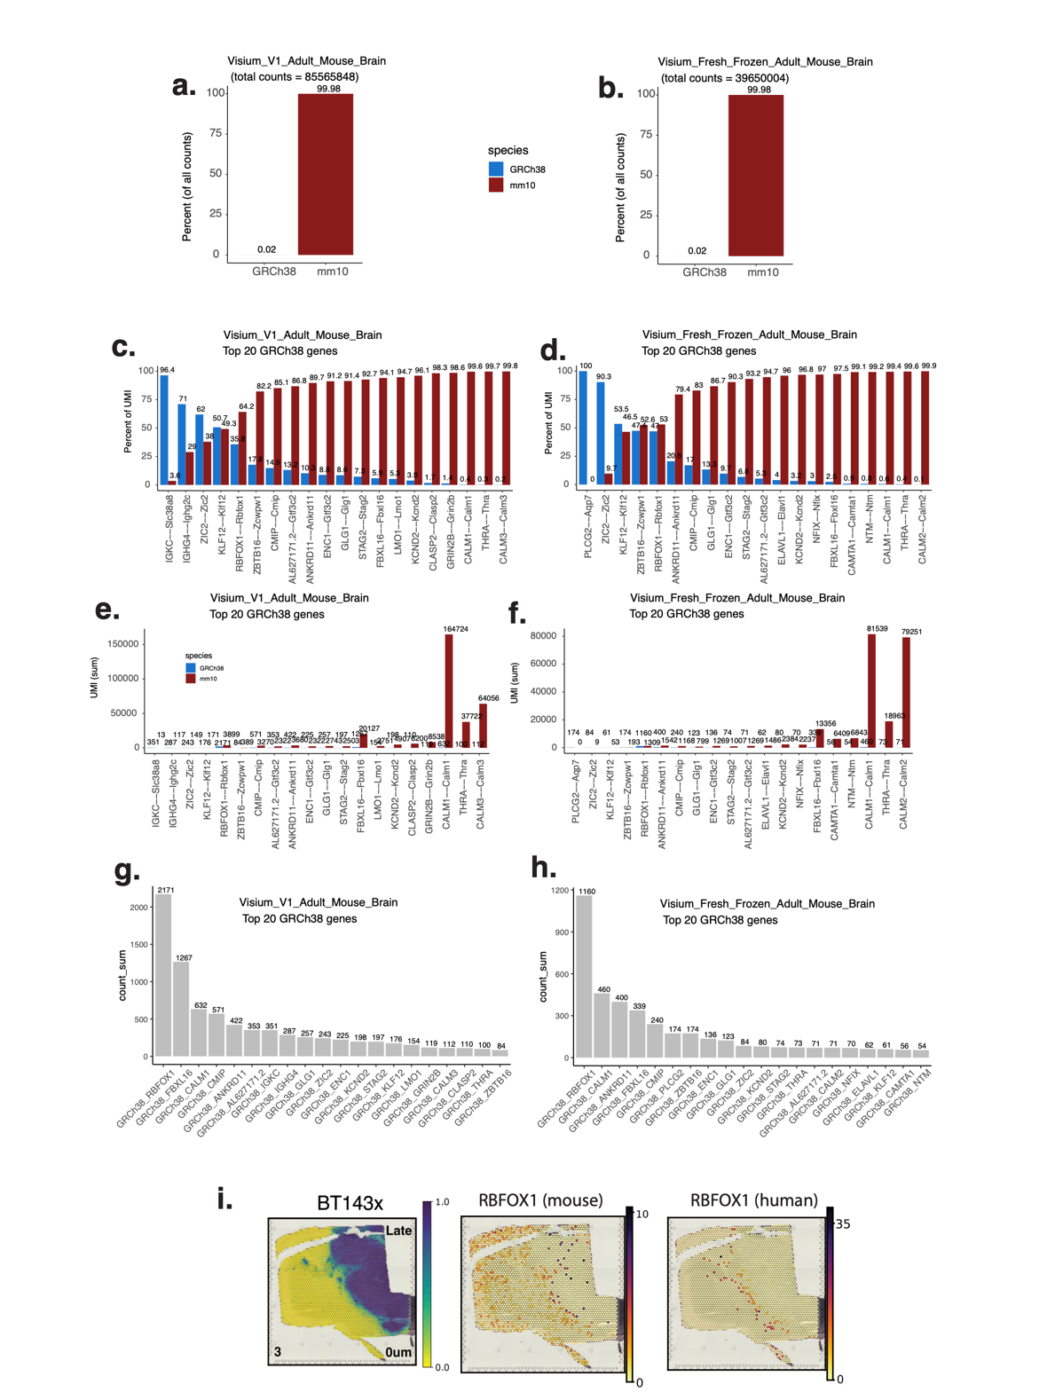

Fig. S8. Alignment of publicly available healthy mouse brain data (10x Visium) to the hybrid genome
(a,b) Barplots indicating the percentage of GRCh38 and mm10 UMIs quantified in (a) sample 1 – Visium_V1_Adult_Mouse_Brain and (b) sample 2 - Visium_Fresh_Frozen_Adult_Mouse_Brain. (c,d) Barplots depicting the top 20 human genes expressed in (c) sample1 and (d) sample 2 and their mouse orthologs (x-axis) as identified using BLAST, and the percentage of UMI contributed by a gene within an orthologous pair (y-axis). (e,f) Barplots depicting the top 20 human genes expressed in (c) sample1 and (d) sample2, and their mouse orthologs (x-axis) and UMI counts of the genes (y-axis). (g,h) Barplot of total UMI quantified in the top 20 human genes expressed in (g) sample1 and (h) sample2. (i) Spatial gene expression of Rbfox1 (mouse) and RBFOX1 (human) in BT143x_late sample. Spatial plot human:mouse admixture is provided as reference on the left.

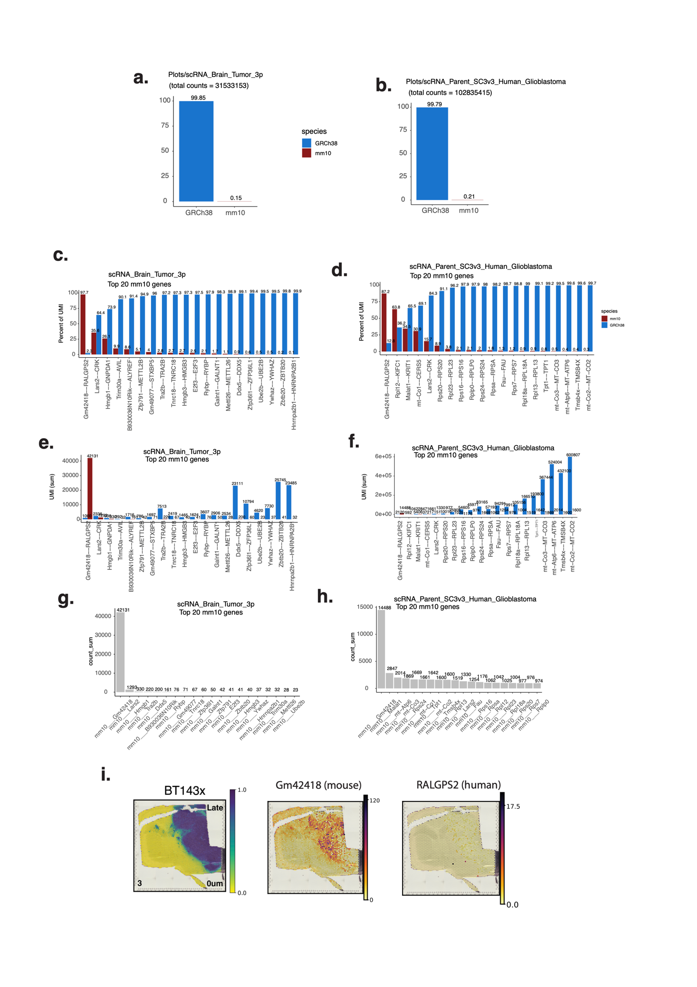

Fig. S9. Alignment of publicly available human GBM data (10x 3’ scRNA-seq) to the hybrid genome
(a,b) Barplots indicating the percentage of GRCh38 and mm10 UMIs quantified in (a) sample1 – scRNA_Brain_Tumor_3p and (b) sample2 - scRNA_Parent_SC3v3_Human_Glioblastoma. (c,d) Barplots depicting the top 20 mouse genes expressed in (c) sample1 and (d) sample2 and their human orthologs (x-axis) as identified using BLAST, and the percentage of UMI contributed by a gene within an orthologous pair (y-axis). (e,f) Barplots depicting the top 20 mouse genes expressed in (c) sample1 and (d) sample2, and their human orthologs (x-axis) and UMI counts of the genes (y-axis). (g,h) Barplot of total UMI quantified in the top 20 mouse genes expressed in (g) sample1 and (h) sample2. (i) Spatial gene expression of Gm42418 (mouse) and RALGPS2 (human) in BT143x_late sample. Spatial plot human:mouse admixture is provided as reference on the left.

Fig. S10. Human nucleolin IHC staining in xenograft tissue sections
This figure includes spatial plots of human:mouse admixture ratio as quantified from the Visium sequencing data, for a subset of late time-point samples. Human nucleolin IHC staining in proximal FFPE tissue sections demonstrates the distribution of human cells (brown nuclei). IHC nucleolin staining is presented at low (2X) and high (20X) resolutions, in the contralateral and injection sides, and within the corpus callosum and stratum when possible.

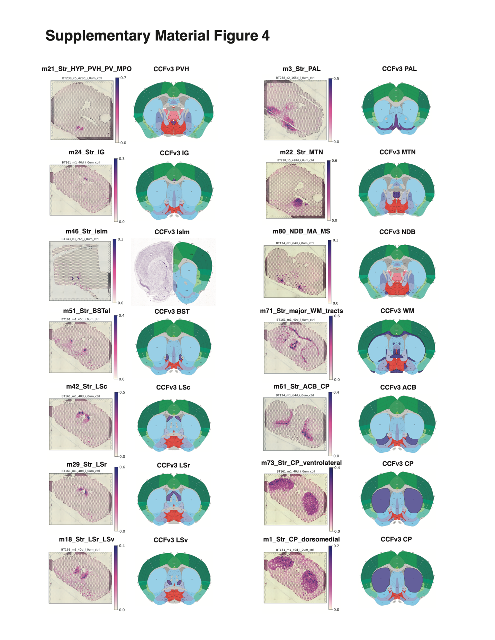
Fig. S11. Mouse brain structures in cNMF programs and CCFv3 registered sections from ABA
Spatial usage of selected structural programs identified using cNMF in our study and the corresponding anatomic structure in a corresponding CCFv3 coronal mouse brain section from the Allen Mouse Brain Atlas (region of interest highlighted in purple).
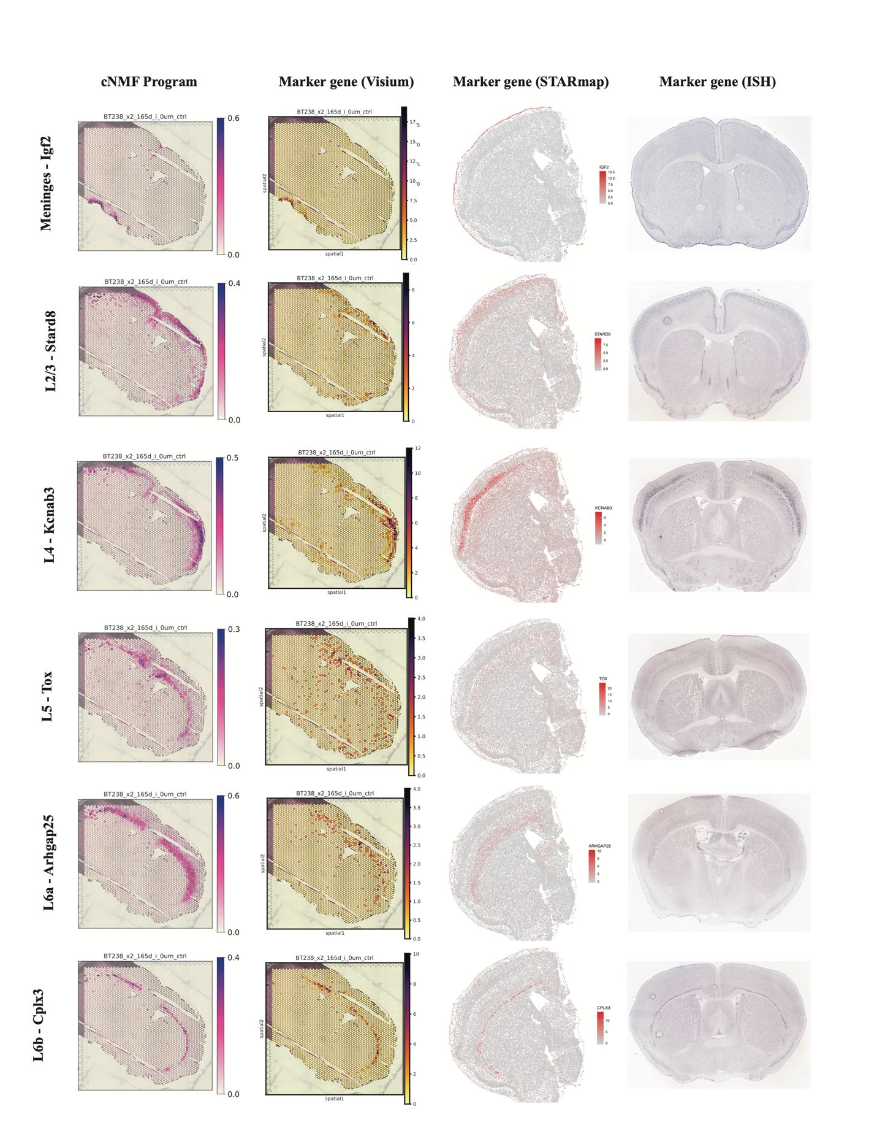

Fig. S12. Marker gene expression in cortical layers of the mouse brain
For each cortical layer (rows), the corresponding cNMF program usage in BT238x_early xenograft sample (column 1), expression of a layer-specific marker gene in BT238x_early sample profiled with Visium (column 2), coronal sample well3_5 profiled with STARmap (column 3) and as detected by ISH in a CCFv3 coronal tissue slice in the Allen Mouse Brain atlas. The genes selected are established markers of cortical layers in either the STARmap PLUS data or by ISH in the Allen Mouse Brain atlas.

Fig. S13. Concordance in gene expression patterns of mouse brain cortical layers between xenograft cNMF programs and reference STARmap data
(a) Heatmap indicating the inverse of ranks (1/rank) of a selected set of genes (column) in the six cortical layer programs (rows) identified in our analysis. The genes selected are established markers of cortical layers (annotation track - Layer) in either the STARmap PLUS data or ISH from Allen Mouse Brain Atlas, or both (annotation track – Data). (b) Heatmap showing z-scores of molecular cell-type percentage composition across tissue regions (column) within cortical layers (Annotation Track “Layer”) in the STARmap PLUS cohort. The cell-type compositions were obtained from available source data in the reference study, and subset to cell-types comprising tissue regions of interest. CTX, Cortex; MNG, Meninges; AC, Astrocytes; PVM, Perivascular macrophages; VLM, Vascular and leptomeningeal cells; PER, Pericytes; NGNBL, Non-glutamergic neuroblasts; TEGLU, Telencephalon projecting excitatory neurons; TEINH, Telencephelon inhibitory neurons; VEN, Vascular endothelial cells; MGL, Microglia. (c) Line plots indicating the proportion of cells (orange; from STARmap PLUS well3_5) or spots (green; from D0 of xenograft samples) expressing STARmap-derived cortical gene markers across the six layers (x-axis). Correlation between STARmap and PDX profiles are specified for each gene within the figure. Each row represents the set gene markers of individual layers (Meninges, L23, L4, L5, L6a or L6b). For each layer, analysis is restricted to cells from corresponding tissue regions (as shown in b) from the STARmap data. Among the xenograft programs, spots with usage > 0.01 in m4_Meninges, m70_L23, m56_L4, m63_L5, m36_L6a and m26_Lb were selected.

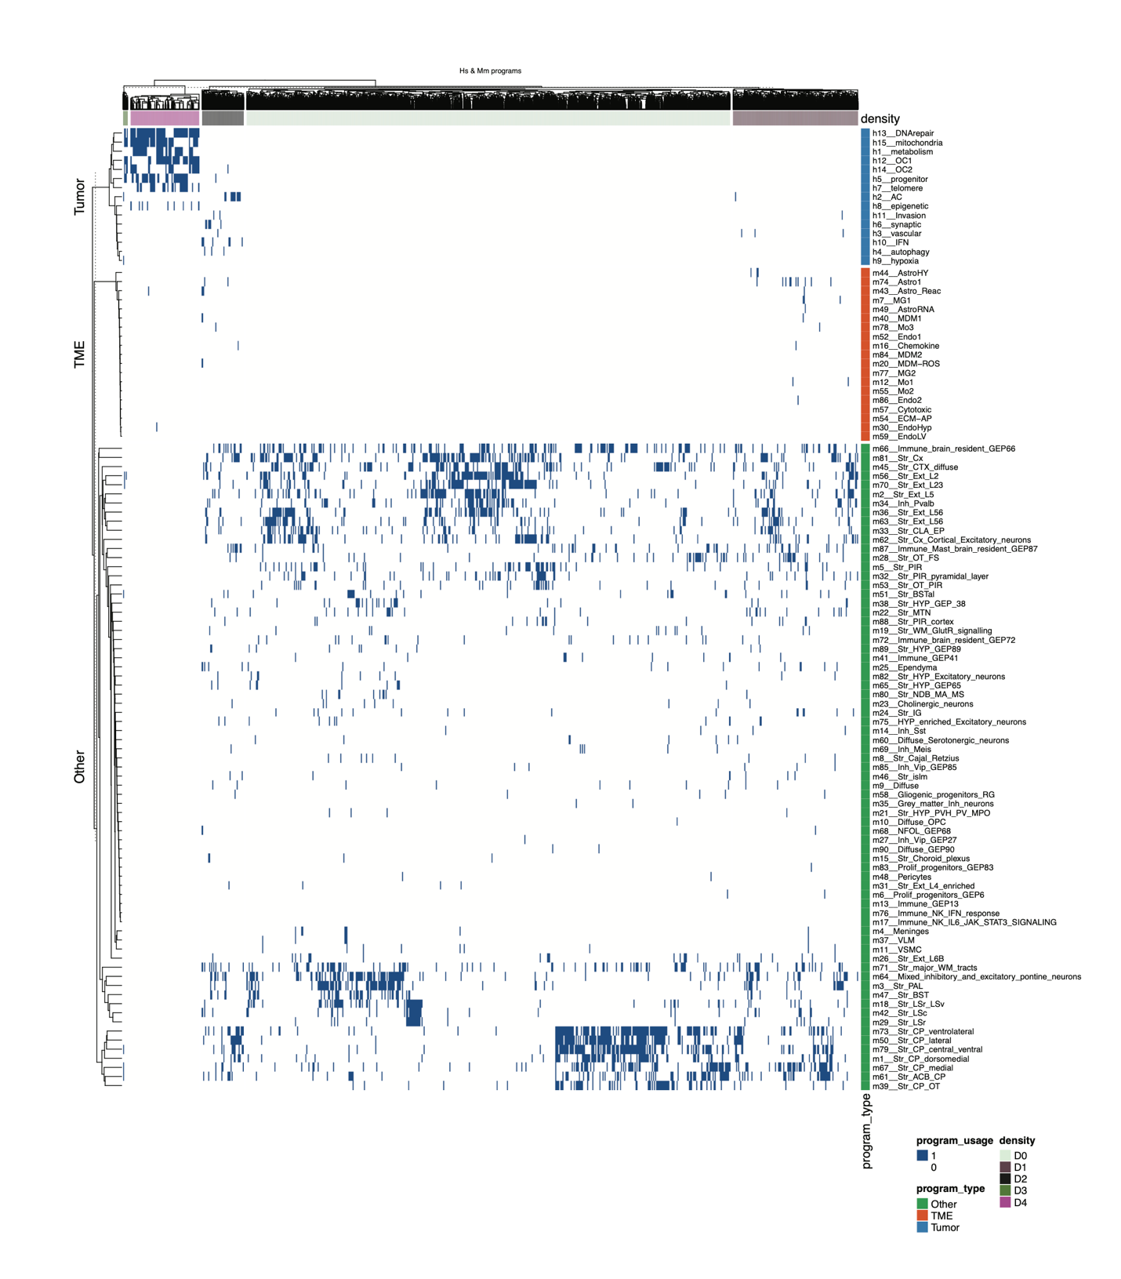

Fig. S14. Spot-level co-usage of programs
A hierarchically clustered binary heatmap (0 – NO, 1 – YES) indicating spots (columns) that exhibit usage of at least three human or mouse programs (rows). Column and row annotation tracks specify tumor density groups or program type (Tumor, TME, other) respectively.

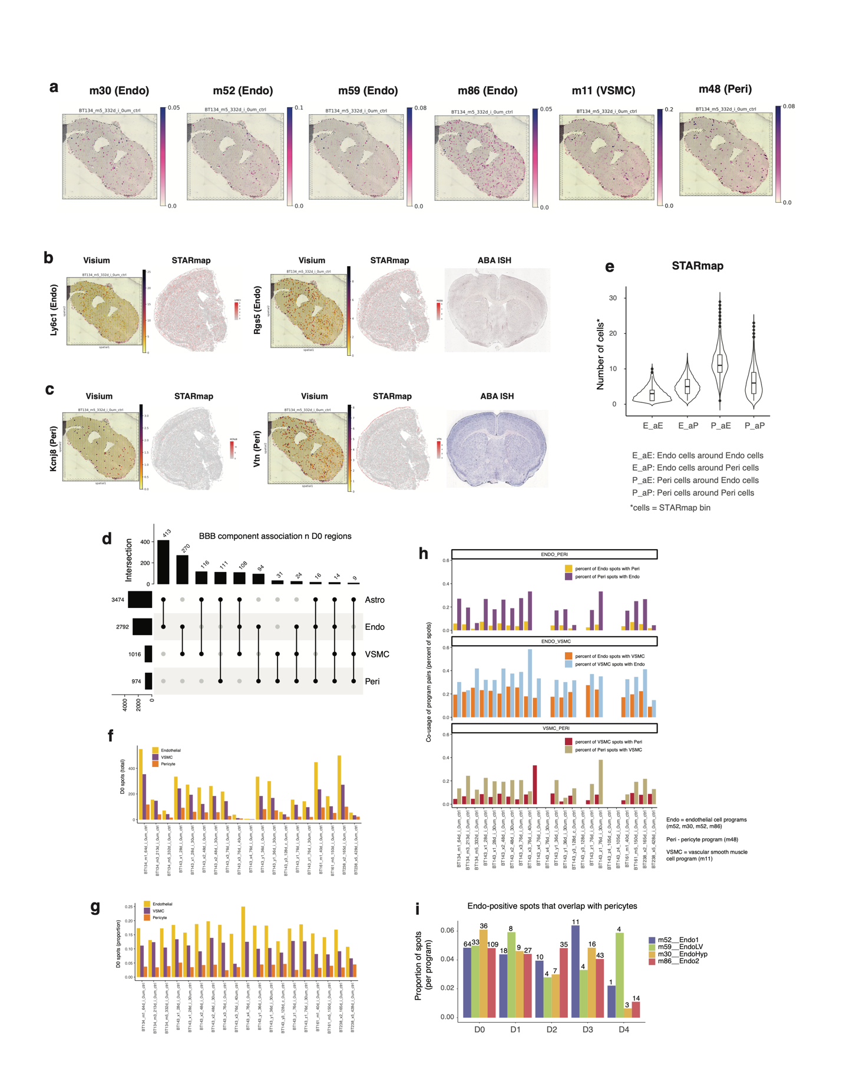

Fig. S15. Spatial organization of BBB components
(a) Spatial plots of endothelial (m30, m52, m59), VSMC (m11) and pericyte (m48) program usage in BT134_early sample. (b,c) Spatial gene expression of (b) endothelial cell markers Ly6c1 (left) and Rgs5 (right) and (c) pericyte marker Kcnj8 (left) and Vtn (right). For each gene in (b) and (c), expression in BT134_early profiled with 10x Visium and coronal well3_5 profiled with STARmap PLUS are provided. In addition, ISH data for Rgs5 and Vtn in a CCFv3 coronal tissue slice from the Allen Mouse Brain atlas are included. (d) UpSet plot indicating the overlap in spots with usage > 0.01 of programs of cell-types that comprise the BBB. Specifically, we consider m30_EndoHyp, m52_Endo1, m59_EndoLV, m86_Endo2, m48__Pericytes, m11_VSMC, m74_Astro, m44_AstroHY, m49_AstroRNA, and m43_AstroReac programs. In case of multiple programs per cell-type as observed for endothelial cells and astrocytes, the union of spots with usage > 0.01 of the cell-type specific programs were considered. (e) A violin plot indicating the distribution of the number of endothelial cells or pericytes observed around one another within a Euclidean distance <= 1000 calculated using the X-Y cartesian coordinates in the CCFV3 registered coronal well3_5 STARmap PLUS sample. (f) Barplots indicating the number of spots with endothelial, VSMC or pericyte program usage within D0 spots (genome admixture: 0.02-0.05) per sample in our xenograft Visium cohort. Spots with usage > 0.01 of corresponding cell-type programs in (a) are considered. In case of endothelial, we consider the union of spots with usage > 0.01 from the four programs. (g) Barplots indicating the proportion of endothelial, VSMC or pericyte spots in D0 region per sample. Spots are selected as described in (e). (h) For each pair of vascular cell-types (ENDO-PERI, ENDO-VSMC or VSMC-PERI), the barplots indicate the percentage of spots (y-axis) with one cell-type, that also includes the other in a pair. ENDO, Endothelial; PERI, Pericytes; VSMC, Vascular smooth muscle cells. (i) Grouped barplot showing the proportion of spots (y-axis) in each endothelial program that overlap with spots exhibiting usage of the pericyte program m48, stratified by tumor density groups. The significant difference between D0 and D4, in the number of observed spots with colocalization of endothelial and pericyte programs is marked. Wilcoxon rank-sum test was used to obtain the p-value. In e-h, a usage threshold of 0.01 was used to selected spots corresponding to a program.

