Additional File 1

Supplementary Materials for
TDFPS-Designer: an efficient toolkit for barcode design and selection in nanopore sequencing

S1: The relationship between the randomly selected sequence and the final set of barcodes
In this section, we study the impact of initial seed on TDFPS-Designer. The barcode selection strategy of TDFPS-Designer is to start with an initial signal and gradually get the final barcode set, where the initial signal is determined by random seed. We can be seen from Fig S1 that different initial signals have a slight impact on the size of the final barcode set, which implies that TDFPS-Designer can ensure to select the barcode set with almost optimal size.

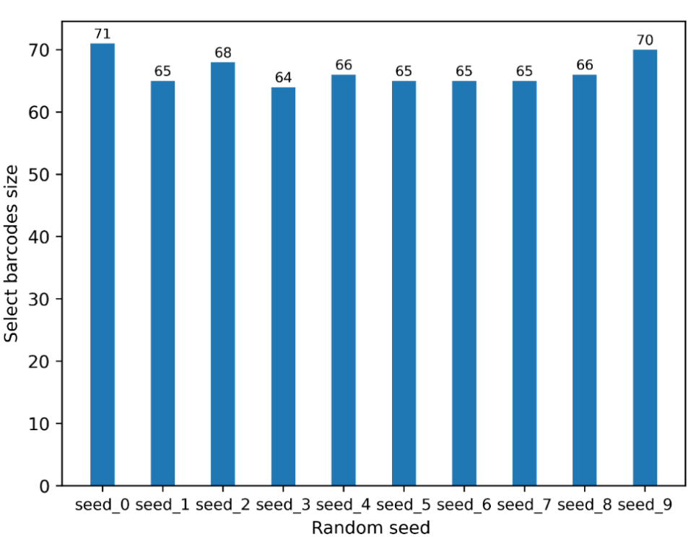
Fig S1 Set 10 random seeds to generate different initial signals, run TDFPS-Designer respectively, get 10 barcode sets, and count the size of these 10 barcode sets.

S2: Usage of TDFPS-Designer
S2.1 Design barcodes for muti-sample sequencing
TDFPS-Designer is an open source toolkit whose source code and data are available at https://github.com/junhaiqi/TDFPSDesigner.git. We provide two modes to design barcode. One is' k-mer 'mode, and the other is' fasta' mode. When users use the 'k-mer' mode to design barcode, that is, select some sequences with sufficient differences from each other from the entire k-mer space to form a barcode set, and users can use the following commands:

python selectBarcodeSeq.py --length 10 \
--qsize 10000 \
--outdir test_select_kmer \
--threshold 10 \
--thread-num 8 \
--mode kmer \
--seed 15 \
--training-precison-cutoff 0.95 \
--kit dna-r10-min

When the user uses the 'fasta' mode to design barcode, that is, select some sequences from the sequences contained in the fasta file as barcode sequences. The user can use the following command:

python selectBarcodeSeq.py --length 10 \
--qsize 10000 \
--outdir test_select_fasta \
--threshold 10 \
--thread-num 8 \
--mode fasta \
--fasta test_select_kmer/first_selected_barcodes.fa \
--seed 15 \
--training-precison-cutoff 0.95 \
--kit dna-r10-min

The parameter information about 'selectBarcodeSeq.py' is as follows:

-h, --help show this help message and exit
--length LENGTH Specify the length of the designed barcode.
--qsize QSIZE Specify the size of the initially selected sequence space, which is recommended to be more than 100000.
--outdir OUTDIR Specify the output file, which contains the final barcode sequences.
--seed SEED Specify a random seed to determine the initially selected barcode signal, have a slight impact on the size of the final barcode set.
--threshold THRESHOLD
Specify a value to control the threshold of the TDFPS algorithm, the recommended value is 0~30.
--thread-num THREAD_NUM
Specify the number of threads.
--mode {kmer,fasta} Specify the selected mode. If the mode is "fasta", then -f must be followed by a file of "fasta" type.
--fasta FASTA Specify a file(format: fasta). The sequences contained in this file must be of the same length. When the "--mode" is followed by "fasta", this parameter must be used. In other cases, it
has no effect.
--kit {dna-r9-min,dna-r9-prom,dna-r10-min,dna-r10-prom}
Specify ONT sequencing kit.
--adapter-seq ADAPTER_SEQ
Specify ONT adapter sequence for select barcodes again.
--top-flank-seq TOP_FLANK_SEQ
Specify ONT top flanking sequence for select barcodes again.
--bottom-flank-seq BOTTOM_FLANK_SEQ
Specify ONT bottom flanking sequence for select barcodes again.
--training-num-each-barcode TRAINING_NUM_EACH_BARCODE
Specify the training number for select barcodes again.
--training-precison-cutoff TRAINING_PRECISON_CUTOFF
Specify training precison cutoff for select barcodes again.
--training-recall-cutoff TRAINING_RECALL_CUTOFF
Specify training recall cutoff for select barcodes again.
--training-f1Score-cutoff TRAINING_F1SCORE_CUTOFF
Specify training F1-Score cutoff for select barcodes again.
--bio-criteria Based on biological criteria, sequences with a GC content lower than 0.4 or greater than 0.6, sequences containing reapte triples, sequences containing GGC, and self-complementary
sequences were filtered out.

S2.2 Demultiplexing based on TDFPS-Designer
Given a folder containing nanopore signals, barcode sequence, adpter sequence, and the length of the flanking sequence in barcode sequence, TDFPS-Designer can complete the whole process of demultiplexing. The following is a specific command line:

python demultiplexingByNanoporeSinal.py \
--iAF testData/testAdapter.fasta\
--iBF testData/testBarcode.fasta\
--iNS testData/testSigSet \
--iFL 8 \
--oRes test_dem \
--thread-num 8 \

The parameter information about 'demultiplexingByNanoporeSinal.py' is as follows:

-h, --help show this help message and exit
--iAF IAF Specify a input fasta file, which contains a adpter sequence.
--iBF IBF Specify an input fasta file, which contains barcode sequences with flanking sequence.
--iNS INS Specify an input folder, which contains nanopore signals (.txt) to be demultiplexed.
--oRes ORES Specifies an output folder, which contains the results of the demultiplexing.
--iFL IFL Specify the length of the flanking sequence in the barcode sequence. It needs to be specified when the length of the top flanking sequence is the same as the length of the tail flanking
sequence for better detection of barcode fragment in nanopore signal.
--kit {dna-r9-min,dna-r9-prom,dna-r10-min,dna-r10-prom}
Specify ONT sequencing kit.
--thread-num THREAD_NUM
Specifies the number of threads, which affects the speed of extracting barcde signals.

S3: Evaluate simulated signals
The simulated data we generated are all generated by Deepsimulator1.5, these simulated signals are input into Guppy3.1.5 and basecalling, we need to evaluate the rationality of these simulated signals. The criterion for assessing rationality is to check whether the conversion(bascalling) of simulated signals into DNA sequences ensures the same sequencing accuracy as real data.
Based on the Levenshtein module in python, we calculated the edit distances between basecalling sequences and original sequences. We recorded the results in the table below. We generated 100 reads using sample CP024223 as the original genome. We use our library building tool to build DNA libraries. We chose not to add linker sequences and barcode sequences. At the same time, we chose the default mixed distribution as the distribution function of read length. Finally, we performed full-length sequencing of these 100 sequences using Deepsimulator1.5.
We retained the fastq file after sequencing and the fasta file before sequencing for easy calculation of edit distance. We counted the sequence lengths before and after sequencing, and recorded them in the first and second columns of the table respectively. In the third column of the table, we record their edit distance. We obtained the sequencing accuracy by dividing the edit distance by the original sequence length. In the last row of the table, we list the average of these data.

 | Raw Sequence Length | Sequence Length After Sequencing | Edit Distance | Accuracy
 | 8074 | 8072 | 626 | 92.2467%
 | 20269 | 20229 | 1485 | 92.6735%
 | 7697 | 7638 | 660 | 91.4252%
 | 6534 | 6502 | 461 | 92.9446%
 | 1579 | 1573 | 137 | 91.3236%
 | 9458 | 9574 | 925 | 90.2199%
 | 14351 | 14349 | 1247 | 91.3107%
 | 6921 | 6945 | 576 | 91.6775%
 | 1836 | 1845 | 173 | 90.5773%
 | 5000 | 4971 | 410 | 91.8000%
 | 15903 | 15847 | 1227 | 92.2845%
 | 3298 | 3306 | 296 | 91.0249%
 | 1570 | 1546 | 132 | 91.5924%
 | 16678 | 16639 | 1388 | 91.6777%
 | 11207 | 11178 | 939 | 91.6213%
 | 11676 | 11624 | 957 | 91.8037%
 | 22071 | 22116 | 1813 | 91.7856%
 | 763 | 746 | 72 | 90.5636%
 | 4204 | 4194 | 379 | 90.9848%
 | 14023 | 14116 | 1152 | 91.7849%
 | 8878 | 8813 | 657 | 92.5997%
 | 3136 | 3135 | 309 | 90.1467%
 | 6821 | 6834 | 550 | 91.9367%
 | 3790 | 3713 | 328 | 91.3456%
 | 12386 | 12394 | 1054 | 91.4904%
 | 1075 | 1058 | 99 | 90.7907%
 | 4901 | 4893 | 408 | 91.6752%
 | 9342 | 9316 | 751 | 91.9610%
 | 18299 | 18307 | 1436 | 92.1526%
 | 8617 | 8601 | 734 | 91.4820%
 | 12686 | 12682 | 1020 | 91.9596%
 | 1050 | 1030 | 84 | 92.0000%
 | 2593 | 2556 | 249 | 90.3972%
 | 945 | 939 | 99 | 89.5238%
 | 6588 | 6583 | 591 | 91.0291%
 | 20521 | 20447 | 1561 | 92.3932%
 | 2202 | 2177 | 195 | 91.1444%
 | 3962 | 3922 | 325 | 91.7971%
 | 13695 | 13643 | 1117 | 91.8437%
 | 8951 | 8951 | 781 | 91.2747%
 | 935 | 922 | 110 | 88.2353%
 | 8311 | 8335 | 691 | 91.6857%
 | 5434 | 5414 | 474 | 91.2771%
 | 4672 | 4663 | 381 | 91.8450%
 | 10005 | 9972 | 870 | 91.3043%
 | 20109 | 20053 | 1594 | 92.0732%
 | 3989 | 3974 | 335 | 91.6019%
 | 10587 | 10538 | 816 | 92.2924%
 | 4137 | 4136 | 365 | 91.1772%
 | 2608 | 2552 | 263 | 89.9156%
 | 994 | 974 | 94 | 90.5433%
 | 1288 | 1258 | 93 | 92.7795%
 | 13957 | 13943 | 1148 | 91.7747%
 | 18441 | 18403 | 1394 | 92.4408%
 | 6642 | 6579 | 503 | 92.4270%
 | 22791 | 22755 | 1741 | 92.3610%
 | 7615 | 7578 | 625 | 91.7925%
 | 15326 | 15306 | 1276 | 91.6743%
 | 2957 | 2932 | 251 | 91.5117%
 | 10285 | 10290 | 843 | 91.8036%
 | 1669 | 1669 | 145 | 91.3122%
 | 9530 | 9522 | 865 | 90.9234%
 | 14241 | 14251 | 1129 | 92.0722%
 | 4036 | 3999 | 314 | 92.2200%
 | 7890 | 7900 | 668 | 91.5336%
 | 12720 | 12692 | 942 | 92.5943%
 | 25745 | 25721 | 1832 | 92.8841%
 | 5454 | 5447 | 482 | 91.1624%
 | 6329 | 6276 | 485 | 92.3369%
 | 14163 | 14155 | 1140 | 91.9509%
 | 12006 | 11960 | 888 | 92.6037%
 | 10795 | 10750 | 921 | 91.4683%
 | 14337 | 14320 | 1176 | 91.7974%
 | 14075 | 14016 | 1100 | 92.1847%
 | 4078 | 4054 | 357 | 91.2457%
 | 2415 | 2387 | 236 | 90.2277%
 | 6445 | 6414 | 430 | 93.3282%
 | 614 | 604 | 57 | 90.7166%
 | 11620 | 11634 | 886 | 92.3752%
 | 6072 | 6081 | 557 | 90.8267%
 | 4129 | 4133 | 350 | 91.5234%
 | 14034 | 14013 | 1090 | 92.2331%
 | 11239 | 11234 | 925 | 91.7697%
 | 6373 | 6386 | 583 | 90.8520%
 | 2090 | 2077 | 133 | 93.6364%
 | 2327 | 2306 | 176 | 92.4366%
 | 3927 | 3891 | 303 | 92.2842%
 | 1402 | 1376 | 129 | 90.7989%
 | 3282 | 3251 | 275 | 91.6210%
 | 1478 | 1472 | 165 | 88.8363%
 | 2804 | 2765 | 238 | 91.5121%
 | 15730 | 15660 | 1222 | 92.2314%
 | 8590 | 8593 | 630 | 92.6659%
 | 18611 | 18555 | 1580 | 91.5104%
 | 2655 | 2633 | 193 | 92.7307%
 | 1906 | 1898 | 178 | 90.6611%
 | 11346 | 11315 | 998 | 91.2039%
 | 7721 | 7729 | 614 | 92.0477%
 | 3968 | 3979 | 370 | 90.6754%
 | 881 | 872 | 91 | 89.6708%
Average Value | 8133.6 | 8115.71 | 661.23 | 91.5745%
Table S1: Basecalling accuracy of guppy on a simulated set

It can be seen from Table S1 that the basecalling accuracy of Guppy3.1.5 on simulated signals is basically consistent with the current sequencing accuracy, which implies that experiments based on simulated signals can almost fully evaluate our algorithm.

S4: Detailed description of the dataset
S4.1 Dataset T1~T3
In order to further test TDFPS-Designer, we built three small data sets: T1~T3 The specific generation process of T1~T3 is as follows: First, we select n sequences (n=20, 50100) with a length of 45bp, and then use random seeds with different numbers (5, 3, 2) set. The random seeds and sequences are input into DeepSimulator 1.5 to generate T1~T3.

Dataset | Type | No. of groups | Group size | NO.of signal
test data0 (T1) | simulated nanopore signals | 20 | 5 | 100
test data1 (T2) | simulated nanopore signals | 50 | 3 | 150
test data2 (T3) | simulated nanopore signals | 100 | 2 | 200
Table S2: Details of dataset T1~T3.

We study the relationship between the barcode signal selected based on TDFPS-Designer and the whole signal space. As can be seen from Fig S2 (a ~ c), the DTW distance values generated by barcode signal sets are relatively large, implying that these barcode signals belong to different categories. a ~ f further demonstrates this view. These experimental results further prove that TDFPS-Designer can always select sequences with enough differences to generate the final barcode set.

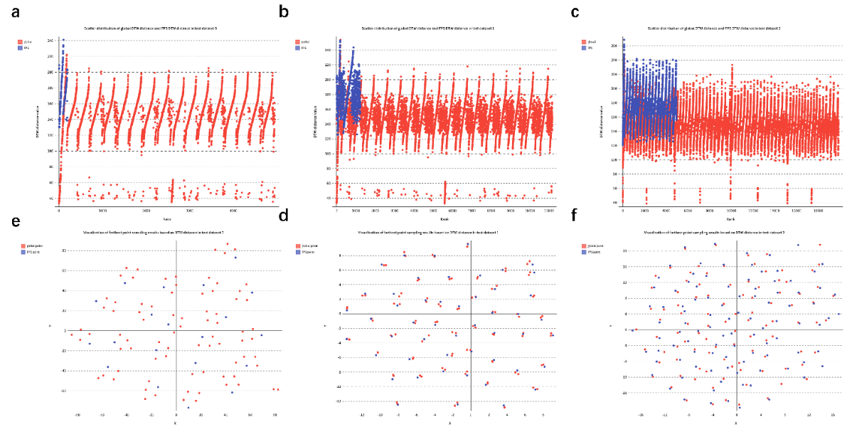
Fig S2 Based on TDFPS-Designer, select barcodes on data sets T1~T3, calculate the DTW distance matrix of T1~T3 and the DTW distance matrix between the selected barcode signals, and obtain the distance distribution (a ~ c). Based on the distance matrix, the TSNE algorithm is used to embed all signals in the data set into the two-dimensional space (d ~ f). The blue dot in a ~ c represents the DTW distance value generated by barcode signal, and the red dot represents the DTW distance value generated by all signals. The blue dot in e ~ f represents the selected barcode signal, and the red dot represents all signals.

There is enough difference between the barcodes designed by TDFPS-Designer. The success of demultiplexing depends on the differences between barcodes, with greater differences resulting in higher success rates. In this study, we measured the differences between our designed barcodes using the DTW distance in both 15-mer and 20-mer spaces under various thresholds. We selected the same number of barcodes using both the TDFPS-Designer and random strategy and computed the DTW distance matrix between barcode signals. Fig S3 displays the resulting distance distribution plots.

Our analysis reveals that the difference between our selected barcodes is larger than that of the randomly selected barcodes, indicating that our designed barcodes are more easily demultiplexed. Furthermore, the distance distribution plot generated by the random selection strategy exhibits narrow and elongated `tips' (DTW distance values less than 20) at the bottom of the piano-shaped graph (Fig S3), suggesting that some of the selected barcodes are too similar, making it challenging to demultiplex data generated by these barcodes. In contrast, the selection scheme of TDFPS-Designer, applied to carefully categorized datasets, always selects barcodes from different categories, ensuring a better chance of successful demultiplexing.

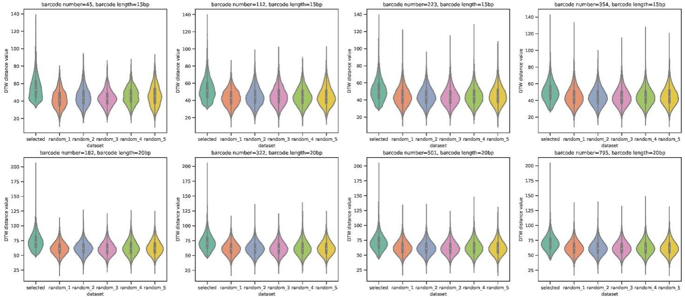
Fig S3 Under different parameters, different types of barcode sets are obtained based on TDFPS-Designer. For each barcode set, we randomly select (5 times), resulting in 5 `random barcode sets', which have the same size as the barcode set obtained by TDFPS-Designer. We obtain a total of 45 barcode sets with different attributes. Details are in datasets D1-D8 (S4.5). A DTW distance matrix is computed for each barcode set. `selected' in the abscissa means the barcode set selected by TDFPS-Designer, and random_n (n = 1,2,3,4,5) means the barcode set randomly selected. The ordinate represents the DTW distance values generated by different barcode sets, which are derived from the corresponding distance matrix.

S4.2 Detailed description of the multi-sample sequencing simulator
S4.2.1 overview
Based on the multi-sample sequencing library construction scheme provided by Oxford Nanopore, we propose this simulator (Fig S4). In addition to the library preparation kit provided by Oxford Nanopore, we also provide an interface where users can add custom barcode kits according to their needs. The steps of library preparation are as follows:
- loading the raw files.
- Fragment the original sequence.
- Select the required sequencing kit, access primers and sequencing adapters.
- (Optional) Use DeepSimulator1.5 (https://github.com/liyu95/DeepSimulator) to simulate the Oxford nanopore sequencing process.
The relevant code is at https://github.com/JustLeeee/ONT-sequencing-data-library-preparation-pipeline.
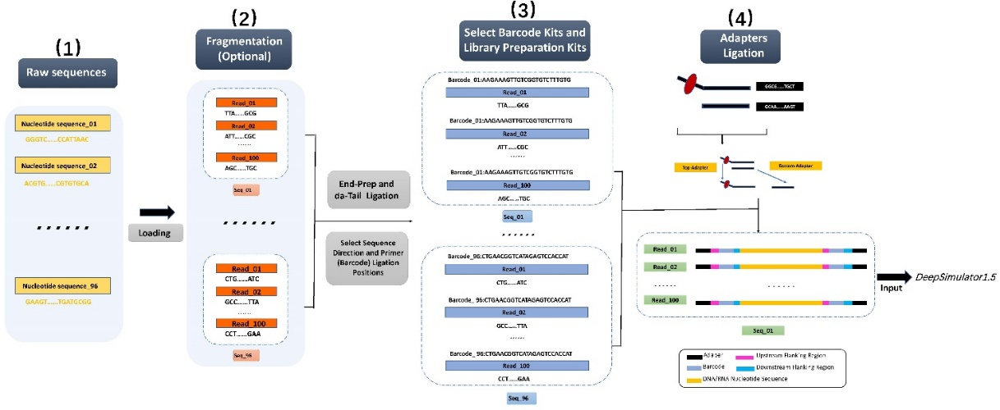
Fig S4 Workflow of the multi-sample sequencing data simulator. (1) The process of fragmentation of the raw sequence. During use, we provide three ways to simulate the distribution of fragmented sequences. (2) Add the primer sequences (or barcode sequences) needed by the user. In this step, the user is required to specify the reading direction of the sequence. Several barcodes officially used by Oxford Nanopore are available. At the same time, users can also provide their own designed barcode sequences for library preparation according to their needs. (3) Add the library preparation sequence kit (or barcode kit) that the user needs. The same barcode sequences use different head-flanking or tail-flanking sequences due to the biological conditions of library preparation and the needs of the users. Therefore, when using this library preparation tool, it is necessary to very clearly indicate the flanking sequences. (4) Finally, add the sequencing adapter sequences and input DeepSimulator1.5 to simulate the final data. Users can provide custom adapter sequences or use adapter sequences from ONT.

S4.2.2 Install
If you want to use DeepSimulator1.5 to simulate the process of nanopore sequencing, you need to choose to install Anaconda2 (https://www.anaconda.com/distribution/) or Minoconda2 (https://conda.io/miniconda.html). For example, users may download and install the following Anaconda2 package:

wget \ https://repo.anaconda.com/archive/Anaconda2-2018.12-Linux-x 86_64.sh
bash Anaconda2-2018.12-Linux-x86_64.sh

Packages：
You need to install a python interpreter[recommended version: python 3.7.1 or above, then run the following command in a terminal to install the necessary packages to enable the program to run:

pip install -v numpy==1.20.3
pip install -v scipy==1.6.2
pip install -v tqdm==4.55.1
pip install -v biopython==1.74
pip install -v pathlib==1.0.1

S4.2.3 Download
If you want to use this pipeline, you need to download the package. You can run the following command to complete the download step:
- Deploy the pipeline package:

git clone \ https://github.com/lykaust15/DeepSimulator.git
cd ./lib_pre_v.1/

- Download the DeepSimulator package：

cd ./tools/
git clone https://github.com/lykaust15/C.git
cd ./DeepSimulator/
./install.sh

S4.2.4 Run Commands
You can run this program by running the following command in a terminal. Here are two simple instructions to use this program:

python lib_make_v.1.py -i ./example/CP024223.1.fasta -k 8
python lib_make_v.1.py -i ./example/data_for_96_ETEC -k 3

You can run the following command to use the barcode-kits function:

python lib_make_v.1.py \
-i ./example/data_for_12_ETEC \
-k 1 \
-b ./model/barcode_kits/template2/Native_Barcoding_Expansion _1-12_and_13-24.csv

In this simulator, it has built-in barcode sequences and corresponding kits for these sequences, which are commonly used by Oxford Nanopore Sequencing. The supported Oxford Nanopore barcode kits are as follows:

EXP-NBD103 | EXP-PBC096
EXP-NBD104 | SQK-PBK004
EXP-NBD114 | SQK-PCB109
SQK-RBK004 | SQK-RPB004
EXP-PBC001 | SQK-RAB204
SQK-16S024

The barcode sequences provided by this pipeline can be found in the following folder:

./lib_pre_v.1/model/barcode_kits/template2/

This simulator allows users to provide custom barcodes and flanking sequences on demand. You can run the following command to use this function:

python lib_make_v.1.py \
-i ./example/data_for_12_ETEC \
-f ./model/flanking_template/flanking2.fasta \
-k 7 -b ./model/barcode_kits/User_template.csv

You will need to provide your flanking sequences and barcode sequences in the following format:

# -f: the input flanking sequences file, 'FASTA' format.

We recommend that users place the flanking sequence files in the folder: “./model/flanking_template/”. we recommend that the use the file name like 'XXXXX.fasta 'and the content format as follows:

>0
The upstream flanking region for the front part.
>1
The upstream flanking region for the rear part.
>2
The upstream flanking region for the rear part.
>3
The downstream flanking region for the rear part.

If users only need to add the barcode on one single end, please provide the flanking sequence in the following order:

>0
The upstream flanking region.
>1
The downstream flanking region.
# -k 7: flag to enable custom barcode feature
-b: the input barcode sequences file, 'CSV' format.

We recommend that users place the barcode sequences file in the folder: “./model/barcode_kits/”
we recommend that the use the file name like “XXXXX_user_barcodes.csv” and the content format as follows:

|Seq_ID|Reverse Sequence|Forward Sequence|

S4.2.5 Run Deepsimulator1.5
You can run this program by running the following command to run the process of simulating nanopore sequencing. So that you can get the data after nanopore sequencing, including electrical signal files (saved in 'txt' format) and sequencing results (saved in 'FASTQ' format):

python ./to_nanopore_seq.py -i ./XXXXXXX/ (input files path) -o ./XXXXXXX/ (output files path)

The final sequencing results will be saved in this folder 'XXXX_lib_fastq' in 'FASTQ' format. The sequencing results for each raw sequence are stored in a file. If you want to use more functions of DeepSimulator1or1.5 change the sequencing parameters, you can modify this script: “./ to_nanopore_seq.py” according to your needs.

S4.2.6 Explanation of the Content in the Output Folder
Within the output folder, there are several folders and files. If you run the program with the parameter “L” turned off, then, within the folder 'XXXXXXPre_Flies', there are four folders: 'results_loading', 'dis_create', 'barcode_kits', 'lib_results'. Let us explain all of them in chronological order. 'results_loading' contains all the sequences that will be used for library preparation. One sequence is stored in each file. 'dis_create' contains the fragmented results of the raw sequences. All reads from fragmentation of each raw sequence are stored in a file. 'barcode_kits' contains the results of each reading connected to the flanking sequences and barcode sequences. 'lib_results' contains the final results of library building preparation. And the reads generated from each raw sequence will be stored in a file. If you run the program with the parameter “L” turned on, you won't get the 'results_loading' folder.

S4.2.7 Parameters
The following table describes the parameters of our simulator in detail:
-i | inputfile | The input file path.
-o | output_file | The output file for loading the raw sequences. 0: The default output path. Others: User specified output path.
-l | len_mean | The rough mean of the read length. It is recommended to set it 8000.
-n | seq_num | The number of output sequences. The default setting is 100.
-s | seed | The random seed, for reproducibility. The default setting is 0.
-c | coverage | Spacify the simulation coverage, the nubmer of read will be calculated. We use the larger one compared with seq_num. The default setting is 0.
-d | dis | Choose from the following distribution: 1: beta_distribution, 2: exponential_distribution, 3: mixed_gamma_dis.The default: 3. The default setting is 3.
-b | barcode | Choose barcode sequences. The default setting is Native Barcoding Expansion 96.
-e | ending | Choose whether to add barcode only in one segment: N: No. Y: Yes. The default setting is No.
-f | flanking | The path to the user-defined flanking sequence file.
-R | RLB12A | Choose barcode-RLB12A. 0: No. 1: Yes. The default setting is 0.
-dir | direction | Sequence direction, F: Forward. R: Reverse. The default setting is F.
-k | kit | Choose barcode library kit. 1: Native_Barcoding_Expansion. 2: Rapid_Barcoding_Kit. 3: PCR_Barcoding_Expansion. 4: PCR_Barcoding_Kit. 5: Rapid_PCR_Barcoding_Kit. 6: Barcoding_16S_Kit. 7: User_Custom_Kit. 8: No barcode.
-P | PCR | Choose PCR processing. -1: No. Others: Number of PCR. The default setting is -1.
-A | Poly_A | Choose how to add the A tail: -1: Default---Only one base is added. (The other is the length of adding A tail.)
-T | Poly_T | Choose how to add the T tail: -1: Default---Only one base is added. (The other is the length of adding T tail.)
-a | adapter | Choose an adapter. 1. 1D-adapter. Other: The fasta file path of User custom adapter. The default setting is 1.

S4.3: Detailed generation process of benchmark datasets
We obtained whole-genome sequences for 17 Enterotoxigenic Escherichia coli strains (PMID: 29326203), 45 historical Shigella strains (PMID: 29650580), and 67 Shiga Toxin producing Escherichia coli strains (PMID: 29748405) to construct multisample sequencing datasets. The raw genome sequence information was organized into a table and is presented in detail in S4.4, containing a total of 129 different species of E. coli genome sequences. We used our simulator to generate datasets (S-ET_ONT12, S-ET_ONT24, S-ET_ONT96, M-ESH_TD795, M-ESH_TD1093 and M-ESH_TD2120) by determining the raw genome sequences and following a mixture distribution to generate 1000 reads (5000 reads for L-ESH_TD137, L-ESH_TD410, and L-ESH_TD1779) per raw genome. Barcode sequence sets Native barcoding Expansion (1-12), Barcoded 16 s kit, and PCR barcoding kit (96) were used, followed by ligation of corresponding flanking and adapter sequences. Only the raw genomes of S-ET_ONT12, S-ET_ONT24 and S-ET_ONT96 directly used the real E. coli genome, while the raw genomes used in other datasets were generated by randomly sampling the corresponding number of 129 different species of E. coli genome sequences. On the other hand, to thoroughly assess the demultiplexing ease of the designed barcodes, we introduced 1% negative sample sequences into datasets L-ESH_TD137, L-ESH_TD410, and L-ESH_TD1779. A negative sample sequence refers to a sequence that has not been successfully inserted into the barcode region (the barcode region is completely missing or incomplete), and the relevant codes can be accessed through https://github.com/junhaiqi/MSNANOSIM.git. In particular, to study the impact of sequencing errors on barcode design, datasets M-ESH_TD795, M-ESH_TD1093, M-ESH_TD2120, L-ESH_TD137, L-ESH_TD410 and L-ESH_TD1779 were introduced with different sequencing errors based on two Badread sequencing error models (nanopore 2020, nanopore 2023), which correspond to data generated by sequencers R9.4 and R10.4 reported by ONT.

S4.4 Raw genome sequence information
The following table describes in detail the raw sequence information we used in the process of simulating data.

Samples | Strain ID | Serotype | Chromosomal GenBank  accession no. | Chromosome  size (bp) | Average  coverage (×) | Whole-genome sequences
Enterotoxigenic Escherichia coli (ETEC) | 2014EL-1345-2 | O169:H41 | CP024223 | 4,943,397 | 92.3 | Yes
Enterotoxigenic Escherichia coli (ETEC) | ATCC 43886 or E2539C1 (5, 6) | O25:H16 | CP024256 | 4,914,654 | 148.1 | Yes
Enterotoxigenic Escherichia coli (ETEC) | D181 (7) | O182:H21 | CP024252 | 4,891,230 | 101.6 | Yes
Enterotoxigenic Escherichia coli (ETEC) | 90-9281 (8) | O128:H27 | CP024243 | 4,978,613 | 117.5 | Yes
Enterotoxigenic Escherichia coli (ETEC) | 90-9280 (8) | O114:H49 | CP024240 | 4,966,338 | 188.6 | Yes
Enterotoxigenic Escherichia coli (ETEC) | 90-9272 (8) | O15:H11 | CP024239 | 4,906,680 | 48.3 | Yes
Enterotoxigenic Escherichia coli (ETEC) | ATCC 43896 (or TX1) (9, 10) | O78:H12 | CP024278 | 5,088,038 | 107.7 | Yes
Enterotoxigenic Escherichia coli (ETEC) | M9682-C1 (11) | O6:H16 | CP024275 | 4,778,550 | 156.6 | Yes
Enterotoxigenic Escherichia coli (ETEC) | B4103-1 (12) | O27:H7 | CP024245 | 4,708,118 | 83.1 | Yes
Enterotoxigenic Escherichia coli (ETEC) | F6326-C1 | O169:H41 | CP024263 | 4,934,701 | 78.1 | Yes
Enterotoxigenic Escherichia coli (ETEC) | 2014EL-1343-2 | O25:H16(genotypic),  O25:NM(phenotypic) | CP024228 | 4,848,034 | 91.4 | Yes
Enterotoxigenic Escherichia coli (ETEC) | F5656C1 (14) | O6:H16 | CP024260 | 4,733,683 | 63.8 | Yes
Enterotoxigenic Escherichia coli (ETEC) | 2014EL- 1346-6 | O6:H16 | CP024232 | 4,872,840 | 98.8 | Yes
Enterotoxigenic Escherichia coli (ETEC) | F9792 (14, 15) | O169:H41 | CP024273 | 4,875,605 | 92.2 | Yes
Enterotoxigenic Escherichia coli (ETEC) | F5505-C1 | O25:H16 | CP024257 | 4,886,938 | 94.3 | Yes
Enterotoxigenic Escherichia coli (ETEC) | F6699 | O6:H16 | CP024266 | 4,881,899 | 42.3 | Yes
Enterotoxigenic Escherichia coli (ETEC) | F8111-1SC3 (14) | O169:H41 | CP024269 | 4,905,023 | 78.6 | Yes
Shiga toxin-producing Escherichia coli (STEC) | 2015C-3163 | O103:H2 | CP027219 | 5,500,189 | 73.1 | Yes
Shiga toxin-producing Escherichia coli (STEC) | 2015C-3101 | O111:H8 | CP027221 | 5,313,278 | 70.3 | Yes
Shiga toxin-producing Escherichia coli (STEC) | 2015C-3108 | O111:H8 | CP027307 | 5,364,442 | 75.2 | Yes
Shiga toxin-producing Escherichia coli (STEC) | 2014C-4135 | O113:H21 | CP027310 | 4,949,048 | 111.0 | Yes
Shiga toxin-producing Escherichia coli (STEC) | 2013C-3181 | O113:H21 | CP027312 | 5,167,951 | 110.4 | Yes
Shiga toxin-producing Escherichia coli (STEC) | 2015C-3107 | O121:H19 | CP027317 | 5,388,260 | 120.9 | Yes
Shiga toxin-producing Escherichia coli (STEC) | 2014C-3084 | O145:H28 | CP027319 | 4,717,123 | 103.5 | Yes
Shiga toxin-producing Escherichia coli (STEC) | 2013C-3033 | O146:H21 | CP027323 | 5,426,201 | 230.8 | Yes
Shiga toxin-producing Escherichia coli (STEC) | 2013C-4830 | O165:H25 | CP027325 | 5,135,675 | 122.9 | Yes
Shiga toxin-producing Escherichia coli (STEC) | 2013C-3277 | O26:H11 | CP027331 | 5,438,694 | 44.0 | Yes
Shiga toxin-producing Escherichia coli (STEC) | 2014C-3051 | O71:H11 | CP027338 | 5,597,475 | 92.7 | Yes
Shiga toxin-producing Escherichia coli (STEC) | 2015C-3121 | O91:H14 | CP027340 | 5,366,577 | 64.7 | Yes
Shiga toxin-producing Escherichia coli (STEC) | 2014C-4587 | OUND:H19 | CP027342 | 5,040,163 | 89.3 | Yes
Shiga toxin-producing Escherichia coli (STEC) | 2014C-3946 | O111:H8 | CP027344 | 5,264,938 | 39.5 | Yes
Shiga toxin-producing Escherichia coli (STEC) | 2013C-4361 | O111:H8 | CP027347 | 5,317,846 | 81.4 | Yes
Shiga toxin-producing Escherichia coli (STEC) | 2014C-3655 | O121:H19 | CP027351 | 5,442,537 | 56.0 | Yes
Shiga toxin-producing Escherichia coli (STEC) | 2012C-4606 | O26:H11 | CP027352 | 5,647,195 | 80.6 | Yes
Shiga toxin-producing Escherichia coli (STEC) | 2013C-4390 | O76:H19 | CP027484 | 5,353,719 | 57.2 | Yes
Shiga toxin-producing Escherichia coli (STEC) | 2013C-4991 | O80:H2 | CP027355 | 5,367,251 | 96.5 | Yes
Shiga toxin-producing Escherichia coli (STEC) | 2014C-4639 | O26:H11 | CP027361 | 5,325,246 | 98.3 | Yes
Shiga toxin-producing Escherichia coli (STEC) | 95-3192 | O145:H28 | CP027362 | 5,385,516 | 121.4 | Yes
Shiga toxin-producing Escherichia coli (STEC) | 88-3001 | O165:H25 | CP027363 | 5,195,753 | 121.4 | Yes
Shiga toxin-producing Escherichia coli (STEC) | 89-3156 | O174:H21 | CP027366 | 5,065,883 | 99.3 | Yes
Shiga toxin-producing Escherichia coli (STEC) | 2014C-3307 | O178:H19 | CP027368 | 4,965,987 | 126.9 | Yes
Shiga toxin-producing Escherichia coli (STEC) | 2015C-3905 | O181:H49 | CP027371 | 4,901,620 | 185.6 | Yes
Shiga toxin-producing Escherichia coli (STEC) | 05-3629 | O8:H16 | CP027373 | 4,904,151 | 169.9 | Yes
Shiga toxin-producing Escherichia coli (STEC) | 2013C-4404 | O91:H14 | CP027376 | 5,009,822 | 166.0 | Yes
Shiga toxin-producing Escherichia coli (STEC) | 2013C-3250 | O111:H8 | CP027380 | 5,401,672 | 98.1 | Yes
Shiga toxin-producing Escherichia coli (STEC) | 2014C-3057 | O26:H11 | CP027387 | 5,645,983 | 81.3 | Yes
Shiga toxin-producing Escherichia coli (STEC) | 2011C-4251 | O45:H2 | CP027388 | 5,440,026 | 100.4 | Yes
Shiga toxin-producing Escherichia coli (STEC) | 2015C-4944 | O26:H11 | CP027390 | 5,802,748 | 86.5 | Yes
Shiga toxin-producing Escherichia coli (STEC) | 97-3250 | O26:H11 | CP027599 | 5,942,969 | 113.5 | Yes
Shiga toxin-producing Escherichia coli (STEC) | 2014C-3599 | O121:H19 | CP027435 | 5,400,138 | 119.1 | Yes
Shiga toxin-producing Escherichia coli (STEC) | 2012C-4221 | O101:H6 | CP027437 | 5,012,557 | 94.0 | Yes
Shiga toxin-producing Escherichia coli (STEC) | 2012C-4502 | O185:H28 | CP027440 | 4,892,666 | 127.9 | Yes
Shiga toxin-producing Escherichia coli (STEC) | 2013C-3252 | O69:H11 | CP027442 | 5,636,732 | 81.8 | Yes
Shiga toxin-producing Escherichia coli (STEC) | 2013C-3492 | O172:H25 | CP027445 | 5,196,105 | 93.1 | Yes
Shiga toxin-producing Escherichia coli (STEC) | 2014C-3075 | O36:H42 | CP027447 | 5,168,620 | 157.5 | Yes
Shiga toxin-producing Escherichia coli (STEC) | 2014C-3097 | O181:H49 | CP027449 | 5,077,228 | 60.3 | Yes
Shiga toxin-producing Escherichia coli (STEC) | 2014C-3338 | O183:H18 | CP027452 | 4,799,014 | 44.2 | Yes
Shiga toxin-producing Escherichia coli (STEC) | 2014C-4423 | O121:H19 | CP027454 | 5,338,915 | 69.5 | Yes
Shiga toxin-producing Escherichia coli (STEC) | 88-3493 | O137:H41 | CP027457 | 5,001,754 | 222.4 | Yes
Shiga toxin-producing Escherichia coli (STEC) | 90-3040 | O172:H25 | CP027459 | 5,253,712 | 185.9 | Yes
Shiga toxin-producing Escherichia coli (STEC) | 95-3322 | O22:H5 | CP027461 | 5,095,223 | 149.2 | Yes
Shiga toxin-producing Escherichia coli (STEC) | 07-4299 | O130:H11 | CP027462 | 4,847,172 | 120.3 | Yes
Shiga toxin-producing Escherichia coli (STEC) | 2013C-4248 | O186:H2 | CP027464 | 5,243,827 | 157.8 | Yes
Shiga toxin-producing Escherichia coli (STEC) | 2014C-3050 | O118:H16 | CP027472 | 5,671,594 | 47.1 | Yes
Shiga toxin-producing Escherichia coli (STEC) | 2013C-3264 | O103:H25 | CP027544 | 5,486,407 | 79.7 | Yes
Shiga toxin-producing Escherichia coli (STEC) | 2013C-4187 | O71:H11 | CP027546 | 5,509,931 | 69.9 | Yes
Shiga toxin-producing Escherichia coli (STEC) | 2014C-3061 | O156:H25 | CP027548 | 5,303,935 | 67.8 | Yes
Shiga toxin-producing Escherichia coli (STEC) | 2014C-4705 | O112:H21 | CP027640 | 5,329,029 | 70.7 | Yes
Shiga toxin-producing Escherichia coli (STEC) | 2015C-4136CT1 | O145:H34 | CP027550 | 4,836,918 | 78.1 | Yes
Shiga toxin-producing Escherichia coli (STEC) | 2015C-4498 | O117:H8 | CP027552 | 5,434,442 | 118.3 | Yes
Shiga toxin-producing Escherichia coli (STEC) | 2013C-3513 | O186:H11 | CP027555 | 5,584,939 | 121.6 | Yes
Shiga toxin-producing Escherichia coli (STEC) | 2013C-4081 | O111:H8 | CP027573 | 5,411,943 | 136.0 | Yes
Shiga toxin-producing Escherichia coli (STEC) | 2013C-4225 | O103:H11 | CP027577 | 5,646,446 | 76.7 | Yes
Shiga toxin-producing Escherichia coli (STEC) | 2013C-4282 | O77:H45 | CP027579 | 5,030,044 | 98.2 | Yes
Shiga toxin-producing Escherichia coli (STEC) | 2013C-4538 | O118:H16 | CP027582 | 5,680,428 | 94.4 | Yes
Shiga toxin-producing Escherichia coli (STEC) | 2014C-3003 | O76:H19 | CP027672 | 5,234,640 | 128.6 | Yes
Shiga toxin-producing Escherichia coli (STEC) | 2015C-3125 | O145:H28 | CP027763 | 5,471,132 | 83.7 | Yes
Shiga toxin-producing Escherichia coli (STEC) | 00-3076 | O113:H21 | CP027584 | 4,997,979 | 186.1 | Yes
Shiga toxin-producing Escherichia coli (STEC) | 2012EL-2448 | O91:H14 | CP027586 | 5,272,286 | 169.2 | Yes
Shiga toxin-producing Escherichia coli (STEC) | 2013C-4974 | O5:H9 | CP027587 | 5,235,560 | 96.6 | Yes
Shiga toxin-producing Escherichia coli (STEC) | 2014C-3011 | O177:H25 | CP027591 | 5,168,350 | 143.0 | Yes
Shiga toxin-producing Escherichia coli (STEC) | 86-3153 | O5:H9 | CP027597 | 5,342,528 | 151.4 | Yes
Shiga toxin-producing Escherichia coli (STEC) | 88-3510 | O172:H25 | CP027675 | 5,140,386 | 58.8 | Yes
Shiga toxin-producing Escherichia coli (STEC) | 2013C-3342 | O117:H8 | CP027766 | 5,489,451 | 119.1 | Yes
Historical Shigella | BU53M1(6) | S.dysenteriae 1 | CP024466 | 4,409,083 | 203.0 | Yes
Historical Shigella | 94-3007(6) | S.flexneri 7 | CP024473 | 4,533,699 | 385.0 | Yes
Historical Shigella | ATCC 8700 | S. boydii 2 | CP026731 | 4,575,738 | 36.0 | Yes
Historical Shigella | NCTC 9850 | S. boydii 3 | CP026762 | 4,575,797 | 61.0 | Yes
Historical Shigella | 04-3145 | S.flexneri 7 | CP026765 | 4,571,921 | 182.0 | Yes
Historical Shigella | 59-248 | S. boydii 14 | CP026766 | 4,678,058 | 152.0 | Yes
Historical Shigella | 93-3063 | S.flexneri Y | CP026768 | 4,628,330 | 75.0 | Yes
Historical Shigella | ATCC 13313 | S.dysenteriae 1 | CP026774 | 4,395,762 | 59.0 | Yes
Historical Shigella | 98-3193 | S.flexneri 7 | CP026776 | 4,508,802 | 201.0 | Yes
Historical Shigella | 69-3818 | S.dysenteriae 1 | CP026777 | 4,390,268 | 64.0 | Yes
Historical Shigella | 53-3937 | S.dysenteriae 1 | CP026780 | 4,382,743 | 207.0 | Yes
Historical Shigella | 08-3380 | S.dysenteriae 1 | CP026782 | 4,464,195 | 163.0 | Yes
Table S3:
* Samples: Sample strain name.
* Strain ID: Our data are derived from the experimental data in these references. They all come from different strains. We list these different strains in this table. The ID of the strains were assigned by the authors of the references. We didn't modify it.
* Serotype: A serotype or serovar is a distinct variation within a species of bacteria or virus or among immune cells of different individuals. These organisms are classified together based on their surface antigens, allowing the epidemiologic classification of organisms to the subspecies level.. These serotypes are given by the authors of the references. We list the different serotypes of the different strains in the table. We have not modified this information.
* Chromosomal GenBank accession no.: This is GenBank database search index. Readers can use this number to directly search for sequence data in the GenBank database.
* Chromosome size (bp): These sequences are all chromosomal sequences. We list the lengths of these sequences.
* Average coverage (×): This refers to the average number of times each base is sequenced. That is, the total amount of sequenced data divided by the size of the genome. Average coverage is considered one of the best measures of sequencing data quality.
* Whole-genome sequences: Here we indicate whether the sequence is a whole-genome sequence.

S4.5 96 datasets for testing barcode design strategy
D1a~D16f contain a total of 96 barcode sets. For each barcode set, we generate a data set. The data set generation process is as follows: For each sequence in the barcode set, we set 100 random seeds. These random seeds and sequences are input into DeepSimulator 1.5 to generate a data set. These data sets have obvious classification. For example, D16f generated a data set containing 33100 signals. The data set contains 331 groups in total, and each group contains 100 signals.

The following 96 tables describe the details of D1-D16.
Subdataset ID | D1a | D1b | D1c | D1d | D1e | D1f
Selection Method | our | Random | Random | Random | Random | Random
The Random Seed When Generating | __ | 0 | 1 | 2 | 3 | 4
Barcode Length(bp) | 15 | 15 | 15 | 15 | 15 | 15
Size of Barcode Set | 45 | 45 | 45 | 45 | 45 | 45
Initial Selecting Quantity | 1,000,000 | 1,000,000 | 1,000,000 | 1,000,000 | 1,000,000 | 1,000,000
Threshold Control | 15 | __ | __ | __ | __ | __
Table S4: Details about dataset D1.

Subdataset ID | D2a | D2b | D2c | D2d | D2e | D2f
Selection Method | our | Randomly selected | Randomly selected | Randomly selected | Randomly selected | Randomly selected
The Random Seed When Generating | __ | 0 | 1 | 2 | 3 | 4
Barcode Length(bp) | 15 | 15 | 15 | 15 | 15 | 15
Size of Barcode Set | 112 | 112 | 112 | 112 | 112 | 112
Initial Selecting Quantity | 1,000,000 | 1,000,000 | 1,000,000 | 1,000,000 | 1,000,000 | 1,000,000
Threshold Control | 20 | __ | __ | __ | __ | __
Table S5: Details about dataset D2.

Subdataset ID | D3a | D3b | D3c | D3d | D3e | D3f
Selection Method | our | Randomly selected | Randomly selected | Randomly selected | Randomly selected | Randomly selected
The Random Seed When Generating | __ | 0 | 1 | 2 | 3 | 4
Barcode Length(bp) | 15 | 15 | 15 | 15 | 15 | 15
Size of Barcode Set | 223 | 223 | 223 | 223 | 223 | 223
Initial Selecting Quantity | 1,000,000 | 1,000,000 | 1,000,000 | 1,000,000 | 1,000,000 | 1,000,000
Threshold Control | 23 | __ | __ | __ | __ | __
Table S6: Details about dataset D3.

Subdataset ID | D4a | D4b | D4c | D4d | D4e | D4f
Selection Method | our | Randomly selected | Randomly selected | Randomly selected | Randomly selected | Randomly selected
The Random Seed When Generating | __ | 0 | 1 | 2 | 3 | 4
Barcode Length(bp) | 15 | 15 | 15 | 15 | 15 | 15
Size of Barcode Set | 354 | 354 | 354 | 354 | 354 | 354
Initial Selecting Quantity | 1,000,000 | 1,000,000 | 1,000,000 | 1,000,000 | 1,000,000 | 1,000,000
Threshold Control | 25 | __ | __ | __ | __ | __
Table S7: Details about dataset D4.

Subdataset ID | D5a | D5b | D5c | D5d | D5e | D5f
Selection Method | our | Randomly selected | Randomly selected | Randomly selected | Randomly selected | Randomly selected
The Random Seed When Generating | __ | 0 | 1 | 2 | 3 | 4
Barcode Length(bp) | 20 | 20 | 20 | 20 | 20 | 20
Size of Barcode Set | 182 | 182 | 182 | 182 | 182 | 182
Initial Selecting Quantity | 1,000,000 | 1,000,000 | 1,000,000 | 1,000,000 | 1,000,000 | 1,000,000
Threshold Control | 30 | __ | __ | __ | __ | __
Table S8: Details about dataset D5.

Subdataset ID | D6a | D6b | D6c | D6d | D6e | D6f
Selection Method | our | Randomly selected | Randomly selected | Randomly selected | Randomly selected | Randomly selected
The Random Seed When Generating | __ | 0 | 1 | 2 | 3 | 4
Barcode Length(bp) | 20 | 20 | 20 | 20 | 20 | 20
Size of Barcode Set | 322 | 322 | 322 | 322 | 322 | 322
Initial Selecting Quantity | 1,000,000 | 1,000,000 | 1,000,000 | 1,000,000 | 1,000,000 | 1,000,000
Threshold Control | 33 | __ | __ | __ | __ | __
Table S9: Details about dataset D6.

Subdataset ID | D7a | D7b | D7c | D7d | D7e | D7f
Selection Method | our | Randomly selected | Randomly selected | Randomly selected | Randomly selected | Randomly selected
The Random Seed When Generating | __ | 0 | 1 | 2 | 3 | 4
Barcode Length(bp) | 20 | 20 | 20 | 20 | 20 | 20
Size of Barcode Set | 501 | 501 | 501 | 501 | 501 | 501
Initial Selecting Quantity | 1,000,000 | 1,000,000 | 1,000,000 | 1,000,000 | 1,000,000 | 1,000,000
Threshold Control | 35 | __ | __ | __ | __ | __
Table S10: Details about dataset D7.

Subdataset ID | D8a | D8b | D8c | D8d | D8e | D8f
Selection Method | our | Randomly selected | Randomly selected | Randomly selected | Randomly selected | Randomly selected
The Random Seed When Generating | __ | 0 | 1 | 2 | 3 | 4
Barcode Length(bp) | 20 | 20 | 20 | 20 | 20 | 20
Size of Barcode Set | 795 | 795 | 795 | 795 | 795 | 795
Initial Selecting Quantity | 1,000,000 | 1,000,000 | 1,000,000 | 1,000,000 | 1,000,000 | 1,000,000
Threshold Control | 37 | __ | __ | __ | __ | __
Table S11: Details about dataset D8.

NOTE: Datasets D1~D8 are obtained by TDFPS-Designer running on the k-mer space (k=15,20).

