Relating Ecological Diversity to Genetic Discontinuity across Bacterial Species
Hemanoel Passarelli-Araujo^{1,2,*}, Thiago M. Venancio^{3,*}, William P. Hanage¹

¹Center for Communicable Disease Dynamics, Department of Epidemiology, Harvard TH Chan School of Public Health, Boston, Massachusetts, USA
²Departamento de Bioquímica e Imunologia, Instituto de Ciências Biológicas, Universidade Federal de Minas Gerais, Belo Horizonte, MG, Brazil
³Laboratório de Química e Função de Proteínas e Peptídeos, Centro de Biociências e Biotecnologia, Universidade Estadual do Norte Fluminense Darcy Ribeiro, Campos dos Goytacazes, RJ, Brazil
*Corresponding authors
Av. Alberto Lamego 2000, P5 sala 217; Parque Califórnia
Campos dos Goytacazes, RJ, Brazil
CEP: 28013-602

Supplementary Figures

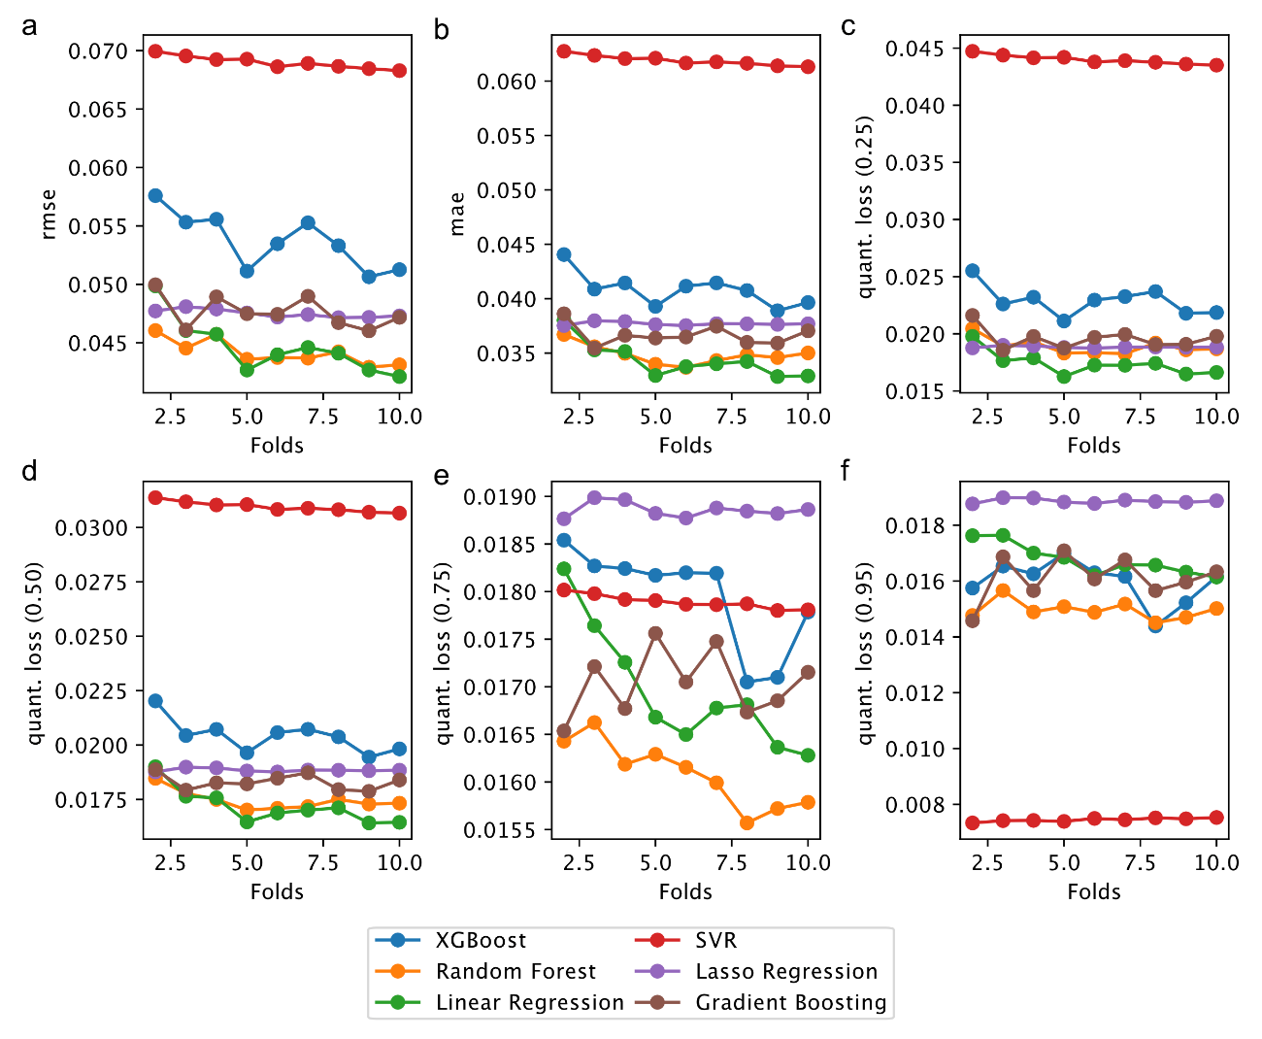
Fig. S1. Model evaluation through k-fold cross validation using different metrics. a) Root Mean Squared Error (RMSE). b) Mean Absolute Error (MAE). c-f) Quantile Loss across four quantiles ($τ=[0.25, 0.50, 0.75, 0.95]$).

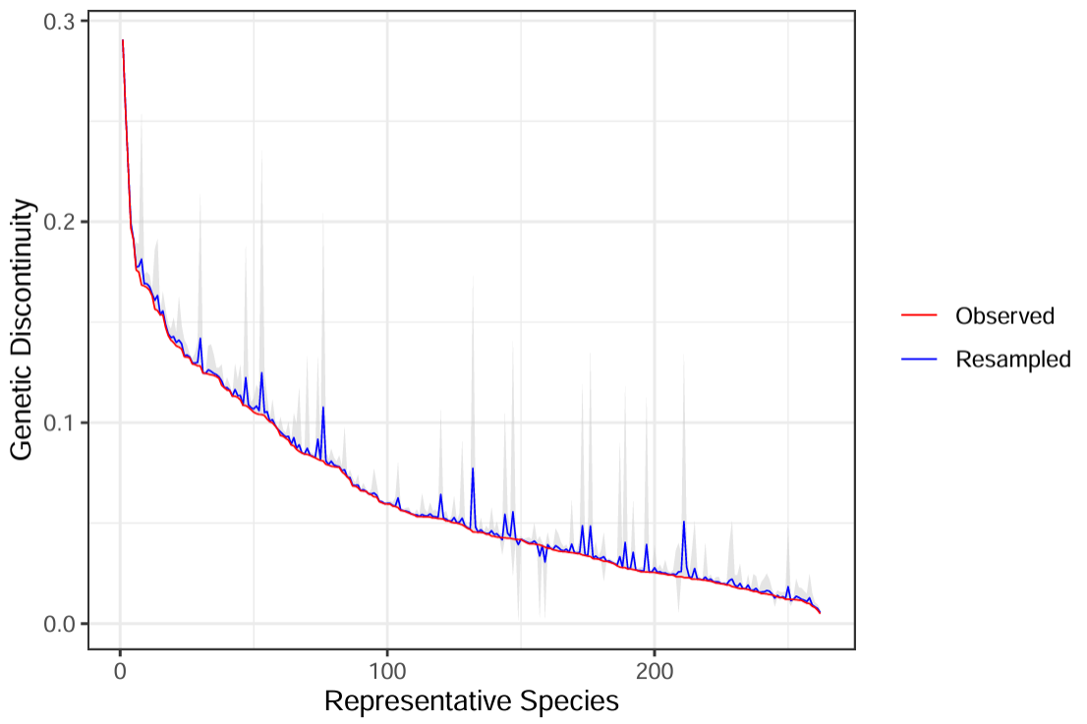
Fig. S2. Jackknife resampling of genetic discontinuity across representative bacterial species. The red line shows observed discontinuity values, while the blue line represents estimates from jackknife resampling, where 20% of genomes are excluded per iteration (n=100). Gray shadows represent 95% confidence intervals. The x-axis lists species sorted by discontinuity, and the y-axis measures discontinuity magnitude.

