Review History
First round of review
Reviewer 1

Were you able to assess all statistics in the manuscript, including the appropriateness of statistical tests used?
Yes: N/A

Were you able to directly test the methods?
Yes

Comments to author:
In their manuscript Shi et al. present a tensor factorization approach for dimensionality reduction of microbiome time series data across multiple subjects. They show that their approach performs better compared to some of the current methods in classifying host phenotypes in simulated as well as real datasets. In my opinion, the main novelty of the presented approach is the use of continuous temporal components that do not require the data collected across multiple subjects to be perfectly aligned. This makes the presented approach highly applicable for diverse set of studies.
However, I have several technical issues with the manuscript. I believe that they need to be addressed before I can recommend it for publication. Moreover, the manuscript, perhaps prepared for a letter-like format is extremely sparse on details and cryptic to read. If that is the case, in my opinion, this manuscript is not suitable for the short article format. The work is potentially interesting but needs to describe the approach in much more detail.
My technical issues are as follows.
1. In the methods section, the authors add 0.5 to their counts prior to log transform. This is an arbitrary choice that is never justified. This is surprising because some of the authors have previously used sparse SVD to overcome the problem of zero counts (Martino et al. mSystems, 2019). The authors should justify their choice and show that their results do not depend on the choice of this constant.
2. It appears that the individual components are learnt in a sequential manner by freezing up the previously learnt components. This will clearly give a unique decomposition. However, it is unclear whether this is the most accurate decomposition of dimension "r". Authors should justify this choice of learning model parameters.
3. On a related note, the authors never show the accuracy of reconstruction of their method and its dependence on "r". If they are presenting a dimensionality reduction method that is explicitly approximating the data, we must know how good/bad their method is and performing that task. The authors must show the accuracy of reconstruction for their method and others when using the same number of components. In fact, I couldn't really find the number of dimensions "r" used for individual datasets. The authors should also provide a rationale for their choice of the number of low dimensional components. Did the authors perform cross-validation? Did they use information theoretic criteria, etc.
4. The authors mention four previous temporal approaches CTF, microTensor, TCAM, and EMBED. However, they have performed comparisons only with three of the four methods. Exclusion of one method is somewhat suspicious. In all their analysis, the authors must compare their method with EMBED as well.
5. The description of figures is very sparse and make them quite difficult to understand. The captions and figures will benefit from more explanation.
6. Two definitions of the beta diversity are given (Eq. 5 and unnumbered equation). Which one is relevant? Both definitions seem quite confusing and ad hoc. The authors should justify this choice. Also, please number all equations.
Other minor issues:
1. Page 19, line 12 has a typo, there needs to be a square.

Reviewer 2
Were you able to assess all statistics in the manuscript, including the appropriateness of statistical tests used?
Yes: The statistics in the manuscript were presented correctly with the appropriate statistical tests.

Were you able to directly test the methods?
Yes
Comments to author:
This paper presents a new method for decomposition of longitudinal microbiome observations. I find the methodology novel and the presentation clear. I also appreciate the conciseness of the manuscript - it does a great job of conveying the main message clearly and economically.
I only have three major/moderate comments.
1. In my opinion, there are two main innovations of the authors' method: a) enforcing temporal smoothness, and b) "subtracting" the overall mean structure before decomposition to remove inter-individual, time-independent signals. a) is highlighted in the manuscript, but b) is only mentioned in Methods as an optional procedure. I wonder if the authors could discuss b) a bit more, especially since the human microbiome is known to harbor strong inter-individual heterogeneity.
For example, in both simulation and real-world studies, did the authors adopt the optional mean subtraction? This should be clarified. If mean subtraction was indeed adopted, I wonder how much of the performance gain of TEMPTED compared to other methods can be attributable to b) versus a). One way to evaluate this would be to also test TEMPTED's performance without the mean subtraction.
2. The temporal smoothness is controlled by the tuning parameter, C_ksi. Would the authors have recommendations on how to choose this tuning parameter? Also please clarify what values were used for the simulation/real-data analyses in the paper.
3. For the evaluated methods that do not incorporate temporal smoothness, it seems that applying them directly to per-subject longitudinal microbiome profiles as ordered by only temporal sequence would be a bit inappropriate. I'm not sure if I understood the authors' approach in applying these methods, but as currently implemented, is it possible for one subject's temporal microbiome sequence to be e.g. months 1, 2, 3, but another subject's sequence to be months 4, 5, 6? If so, wouldn't this cause a misalignment in the temporal signals learned by these methods?
It seems that a more appropriate approach to apply these methods would be to encode temporal sequences by equal time intervals with missing values. In this case, the above example then becomes 1, 2, 3, NA, NA, NA for subject 1, and NA, NA, NA, 4, 5, 6 for subject 2. The temporal signals learned by these methods would then have the same interpretation as in TEMPTED (but still without the enforced smoothness).

Authors Response
Point-by-point responses to the reviewers’ comments:
Thank you for your thorough review, constructive critiques, and valuable suggestions. We have carefully considered the reviewers' comments and addressed them with detailed point-by-point responses, as outlined below. For the convenience of the reviewers and editors, we made the newly added edits red colored. We are very grateful for the reviewers’ insightful comments that helped us strengthen our manuscript.
Reviewer #1:
In their manuscript Shi et al. present a tensor factorization approach for dimensionality reduction of microbiome time series data across multiple subjects. They show that their approach performs better compared to some of the current methods in classifying host phenotypes in simulated as well as real datasets. In my opinion, the main novelty of the presented approach is the use of continuous temporal components that do not require the data collected across multiple subjects to be perfectly aligned. This makes the presented approach highly applicable for diverse set of studies.
However, I have several technical issues with the manuscript. I believe that they need to be addressed before I can recommend it for publication. Moreover, the manuscript, perhaps prepared for a letter-like format is extremely sparse on details and cryptic to read. If that is the case, in my opinion, this manuscript is not suitable for the short article format. The work is potentially interesting but needs to describe the approach in much more detail.
Reply: We thank the reviewer for recognizing the novelty of our paper and providing constructive feedback. In this revision, we have added more details to the methods section and moved some content from the methods section to the main text. We reformatted our manuscript using the LaTex template from the Genome Biology website. We also added simulation analyses evaluating the performance of our methods for different choices of model parameters.
1. In the methods section, the authors add 0.5 to their counts prior to log transform. This is an arbitrary choice that is never justified. This is surprising because some of the authors have previously used sparse SVD to overcome the problem of zero counts (Martino et al. mSystems, 2019). The authors should justify their choice and show that their results do not depend on the choice of this constant.
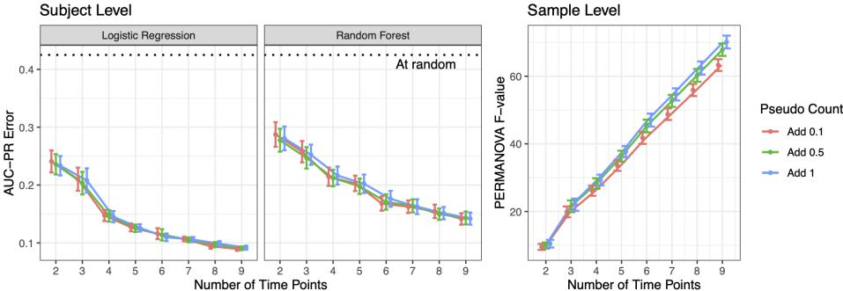
Reply: We thank the reviewer for bringing up this important issue. The addition of 0.5 was justified by Shi, Zhou, and Zhang, Biometrika 2021, which is now explained in detail in the methods section in this revision. We also added a simulation analysis that compares the performance of TEMPTED when the pseudocount is changed to 0.1 and 1 (Fig. A2; also see below).

Our results show that while using the pseudocount of 0.1 has a slightly worse performance, choosing between 0.5 and 1 does not make a big difference. The current implementation of TEMPTED treats zeros as observed values instead of missing values because handling missing tensor entries in the TEMPTED algorithm is a difficult open problem, and we found that pseudocounts provide a simple solution with performance insensitive to the choice of their value. We appreciate the reviewer for bringing up this interesting future direction where the robust centered log ratio method (rclr) could be incorporated into TEMPTED to accommodate individual missing entries of the data tensor. This has been added to the discussion section.
2. It appears that the individual components are learnt in a sequential manner by freezing up the previously learnt components. This will clearly give a unique decomposition. However, it is unclear whether this is the most accurate decomposition of dimension "r". Authors should justify this choice of learning model parameters.
Reply: The benefit of using sequential decomposition mentioned by the reviewer is exactly why we adopted this approach. Freezing up the previously learned components also allows users to explore a higher rank r as needed, making them less dependent on the choice or r. It is true that this sequential approach mayyield suboptimal reconstruction accuracy in the decomposition of dimension r, and a clarification of this has been added to both the discussion section and the methods section. In the methods section, we have added the formula for reconstruction error, suggesting users utilize it to guide the choice of r in the same fashion as choosing the number of components for principal component analysis.
3. On a related note, the authors never show the accuracy of reconstruction of their method and its dependence on "r". If they are presenting a dimensionality reduction method that is explicitly approximating the data, we must know how good/bad their method is and performing that task. The authors must show the accuracy of reconstruction for their method and others when using the same number of components. In fact, I couldn't really find the number of dimensions "r" used for individual datasets. The authors should also provide a rationale for their choice of the number of low dimensional components. Did the authors perform cross-validation? Did they use information theoretic criteria, etc.
Reply: We want to thank the reviewer for pointing out the issue of reconstruction accuracy. In response, we have added the description of the reconstruction error in the methods section. We also added simulation results comparing the reconstruction accuracy among TEMPTED, FTSVD, and CTF for a range of r (Fig. A1; also see below).

TCAM was not benchmarked because it uses a different type of decomposition and retains a much higher degree-of-freedom ((n+p)*(number of time points)) in its first component, while CTF, FTSVD, and TEMPTED use CP-type decomposition that only retains a degree-of-freedom of (n+p+(number of time points)) for each component. Therefore, we believe that comparing TCAM with CP-type decomposition in terms of reconstruction error is unfair. We did not compare with microTensor because it models counts directly with Dirichlet Multinomial distribution and decomposes the underlying parameters instead of the observed data. Their reconstruction is focused on the proportions and does poorly in reconstructing the CLR-transformed count data. In contrast, CTF, FTSVD, and TEMPTED aim to minimize the L2 loss of the tensor decomposition, so it is more appropriate for CLR-transformed data and should not be used to reconstruct proportions. We do not think the reconstruction error for proportions is comparable to the reconstruction error for CLR data because their objectives are different.
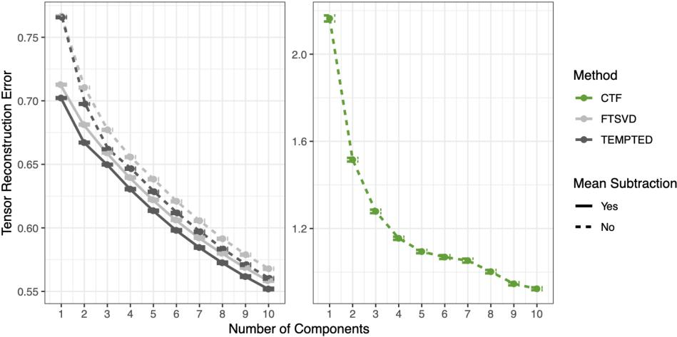
Because top components are the most frequently inspected components by researchers, in the simulation shown in Figure 2, the number of components was chosen to be 2 for all methods to show how the methods perform in capturing key information in their top components. In the real data analysis, we did not use cross-validation or the reconstruction error to choose the rank. This is because we found the phenotypic signal of interest associated with

one of the first three components in each case study and increasing the rank will not change those top components. It is possible that other components may contain useful information but they were not illustrated in the manuscript because we have not been able to link them to the available phenotype data. We have added the choice of r for each dataset in the methods section in the revised manuscript.
- The authors mention four previous temporal approaches CTF, microTensor, TCAM, and EMBED. However, they have performed comparisons only with three of the four methods. Exclusion of one method is somewhat suspicious. In all their analysis, the authors must compare their method with EMBED as well.
Reply: We did not compare to EMBED in Figure 2 because EMBED aims at characterizing temporal structures without offering dimension reduction for hosts or samples. We have clarified this in the caption of Figure 2 in this revision.
- The description of figures is very sparse and make them quite difficult to understand. The captions and figures will benefit from more explanation.
Reply: Thank you for your suggestions. We have added more explanation to some figures in this revision.
- Two definitions of the beta diversity are given (Eq. 5 and unnumbered equation). Which one is relevant? Both definitions seem quite confusing and ad hoc. The authors should justify this choice. Also, please number all equations.
Reply: We have numbered all equations in the manuscript in this revision. We provide two approaches to utilize the feature loading. Eq. 5 (now Eq. 2) aggregates all features and does not require a quantile cutoff. It is more suitable for sample-level beta analysis. It is not limited to compositional data or microbiome studies and can be used for any temporal tensor data. Eq 6 (now Eq. 3) is more meaningful for compositional data in the setting of microbiome studies. It allows the user to narrow down to a small number of

features and construct trajectories of their log-ratios, which is more convenient for interpretation and translational purposes. We have added more clarification to the corresponding section.
Minor issues: Page 19, line 12 has a typo, there needs to be a square.
Reply: Thank you for pointing out the typo. It has been corrected in this revision.
Reviewer #2:
This paper presents a new method for decomposition of longitudinal microbiome observations. I find the methodology novel and the presentation clear. I also appreciate the conciseness of the manuscript - it does a great job of conveying the main message clearly and economically.
Reply: Thank you very much for your encouraging comments!
1. In my opinion, there are two main innovations of the authors' method: a) enforcing temporal smoothness, and b) "subtracting" the overall mean structure before decomposition to remove inter-individual, time-independent signals. a) is highlighted in the manuscript, but b) is only mentioned in Methods as an optional procedure. I wonder if the authors could discuss b) a bit more, especially since the human microbiome is known to harbor strong inter-individual heterogeneity.
For example, in both simulation and real-world studies, did the authors adopt the optional mean subtraction? This should be clarified. If mean subtraction was indeed adopted, I wonder how much of the performance gain of TEMPTED compared to other methods can be attributable to b) versus a). One way to evaluate this would be to also test TEMPTED's performance without the mean subtraction.
Reply: We appreciate the reviewer for recognizing the novelty of our method. We agree with the reviewer that the mean subtraction can be crucial to the

algorithm. In this revision, we have moved the mean subtraction from the section for preprocessing to the section for algorithm and added more details. We have adopted the mean subtraction in all our real data analysis and simulation, except for the newly added simulation Fig. A1 where reconstruction accuracy was compared between TEMPTED with and without mean subtraction. The reconstruction accuracy of TEMPTED with mean subtraction at rank r is comparable to TEMPTED without mean subtraction at rank r+1. Our observation is that in the ECAM dataset, without mean subtraction, the \xi(t) function in the first component of TEMPTED is nearly constant, while the other components are very similar to TEMPTED with mean subtraction, suggesting the possibility of TEMPTED capturing the mean structure in some of its components.
2. The temporal smoothness is controlled by the tuning parameter, C_ksi. Would the authors have recommendations on how to choose this tuning parameter? Also please clarify what values were used for the simulation/real-data analyses in the paper.
Reply: We thank the reviewer for raising this important question. The algorithm implementation controls the smoothness of temporal loading through C_K (C_ksi in the earlier version), a detail of which is now moved to the methods section from the supplementary materials. We used C_K=0.0001 for all our case studies and found it to work well for most datasets we analyzed with more than four time points. This is validated by a newly added sensitivity analysis of C_K using the ECAM-based simulated data (Fig. A3; also see below).

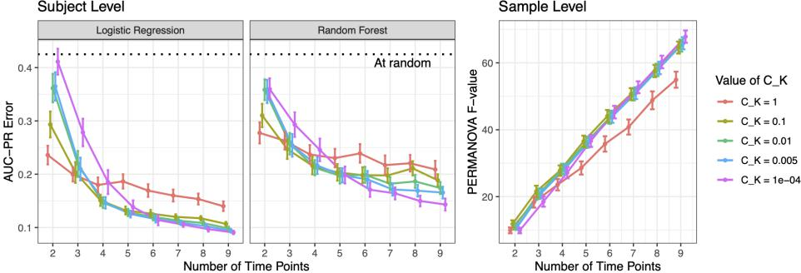
Our results also indicate that while sample-level beta diversity derived from feature loadings is insensitive to the choice of C_K, a larger C_K is needed for a smaller number of time points to ensure good performance in the subject-level beta-diversity analysis. The C_K used to generate Figure 2 matches with the best C_K indicated by this sensitivity analysis. In this revision, we have stated the value for C_K used in the simulation and real data analysis in the methods section.
3. For the evaluated methods that do not incorporate temporal smoothness, it seems that applying them directly to per-subject longitudinal microbiome profiles as ordered by only temporal sequence would be a bit inappropriate. I'm not sure if I understood the authors' approach in applying these methods, but as currently implemented, is it possible for one subject's temporal microbiome sequence to be e.g. months 1, 2, 3, but another subject's sequence to be months 4, 5, 6? If so, wouldn't this cause a misalignment in the temporal signals learned by these methods?
It seems that a more appropriate approach to apply these methods would be to encode temporal sequences by equal time intervals with missing values. In this case, the above example then becomes 1, 2, 3, NA, NA, NA for subject 1, and NA, NA, NA, 4, 5, 6 for subject 2. The temporal signals learned by these methods would then have the same interpretation as in TEMPTED (but still without the enforced smoothness).

Reply: Since TCAM and FTSVD cannot handle missing time points, we coded the time points as their temporal order in the ECAM-based simulation. In the FARMM-based simulation, we specifically compared the methods capable of handling missing time points and coded the time points as is with NA representing the missing time points. This approach ensured a fair comparison among methods under both scenarios of complete and incomplete time series data.
References
[1] Shi, P., Zhou, Y., & Zhang, A. R. (2022). High-dimensional log-error-in-variable regression with applications to microbial compositional data analysis. Biometrika, 109(2), 405-420.

Second round of review
Reviewer 1
I am overall satisfied with most of the extensive revision made by the authors. However, I have one major issue with the manuscript which is based on the use of linear L2 norm-based approximation methods. This precludes me from accepting this manuscript for publication in its current form.
Sequencing-based relative abundance measurements are integer count data. These data are multinomially distributed (Dirichlet or simple) and therefore have a specific noise structure. Arbitrary positive offsetting followed by log transformations followed by L2 norm minimization as a way of reducing dimensionality of the data assumes an isotropic Gaussian distributed noise model which is clearly a wrong assumption for multinomial count data. Amongst other issues, one central problem in log transformation followed by L2 norm minimization is that it by treats relative changes in all species on an equal footing regardless of their abundance. As a result, these approaches erroneously fit to sampling variation in low abundance species. In recent works, this issue has been well appreciated in other sequencing-based data (see for example Breda et al. Nature Biotech 2021 and Booeshaghi et al. biorXiv, 2022) where it has been argued that rigorous probabilistic modeling is a must.
With this context, I asked that the authors test their method against EMBED (or any other probabilistic dimensionality reduction method) because EMBED appears to directly fit to the multinomial count data thereby correctly modeling expected variation due to sampling noise. While the authors are correct that EMBED in its presented format does not appear to provide an embedding separately for hosts and OTUs, its reconstruction performance can be tested on a single subject time series where it does provide a lower dimensional embedding for the OTUs. Alternatively, the tensor factorization in EMBED (and the associated likelihoods) can easily be generalized to a Tucker decomposition similar to the one used by the authors and then tested against the authors’ approach.
Rigorous probabilistic modeling of sequencing data is a point of central importance in microbiome studies. Excessive pre-processing (offsetting followed by log transformation followed by L2 norm minimization of low rank matrix products) of multinomial count data, as is done in the current manuscript, introduces biases and errors and incorrectly fits to noise. Therefore, in my opinion, comparison of the presented approach with a fully probabilistic method like EMBED is essential.

Reviewer 2
I appreciate the authors' response! My questions have been mostly addressed. However, I do still have two comments:
1. (Regarding my old comment #1). I appreciate new Supplementary Figure A1 to compare the performance of TEMPTED with and without mean subtraction. Could the authors please also make this comparison for the main findings in Figure 2? I ask of this because the performance difference (if there is one) would be bioligically interesting. I _think_ it would suggest that the "exposures" in the two studies (delivery mode for ECAM, diet for FARMM) have more "transient" than temporally stable effects on the microbiome.
2. (Regarding my old comment #3). I'm afraid I'll need to push for better temporal alignment in ECAM. The infant microbiome is known to be highly developmental. As such, aligning months 1, 2, 3 for one infant as the same timepoints as months 4, 5, 6 of another infant would be inappropriate. Looking at Figure A4, it does seem that this misalignment can be severe for certain subjects. At least for the methods that can include missingness, alignment of timepoints at coarse temporal intervals should be doable (e.g., age in months). For the methods that cannot handle missingness, the issue of misalignment should be highlighted in the manuscript text. The authors can highlight this as a practical advantage of TEMPTED over other, "tabular"-based methods.

Authors Response
Point-by-point responses to the reviewers’ comments:

Thank you for your thorough review of our revised manuscript and for providing another set of valuable suggestions. We have carefully addressed them with detailed point-by-point responses outlined below. For the convenience of the reviewers and editors, we made the newly added edits red colored and quoted the newly added figure here. Your comments have helped us further strengthen our manuscript.
Review #1:
I am overall satisfied with most of the extensive revision made by the authors. However, I have one major issue with the manuscript which is based on the use of linear L2 norm-based approximation methods. This precludes me from accepting this manuscript for publication in its current form.
Sequencing-based relative abundance measurements are integer count data. These data are multinomially distributed (Dirichlet or simple) and therefore have a specific noise structure. Arbitrary positive offsetting followed by log transformations followed by L2 norm minimization as a way of reducing dimensionality of the data assumes an isotropic Gaussian distributed noise model which is clearly a wrong assumption for multinomial count data. Amongst other issues, one central problem in log transformation followed by L2 norm minimization is that it by treats relative changes in all species on an equal footing regardless of their abundance. As a result, these approaches erroneously fit to sampling variation in low abundance species. In recent works, this issue has been well appreciated in other sequencing-based data (see for example Breda et al. Nature Biotech 2021 and Booeshaghi et al. biorXiv, 2022) where it has been argued that rigorous probabilistic modeling is a must.
With this context, I asked that the authors test their method against EMBED (or any other probabilistic dimensionality reduction method) because EMBED appears to directly fit to the multinomial count data thereby correctly modeling expected variation due to sampling noise. While the authors are correct that EMBED in its presented format does not appear to provide an embedding separately for hosts and OTUs, its reconstruction performance can be tested on a single subject time series where it does provide a lower dimensional embedding for the OTUs. Alternatively, the tensor factorization in EMBED (and the associated likelihoods) can easily be generalized to a Tucker decomposition similar to the one used by the authors and then tested against the authors’ approach.
Rigorous probabilistic modeling of sequencing data is a point of central importance in microbiome studies. Excessive pre-processing (offsetting followed by log transformation followed by L2 norm minimization of low rank matrix products) of multinomial count data, as is done in the current manuscript, introduces biases and errors and incorrectly fits to noise. Therefore, in my opinion, comparison of the presented approach with a fully probabilistic method like EMBED is essential.
Reply: Thank you for acknowledging our efforts in the last revision. One of the methods we benchmarked against, microTensor, models the count data using a Dirichlet-Multinomial framework without pseudo-counts and log transformation, a fully probabilistic method as suggested by the reviewer. But it is still outperformed by our method. We have added an emphasis on this in the Methods/Microbiome Data Preprocessing section in the revised manuscript.
We acknowledge that the EMBED and TEMPTED both provide OTU embeddings, but this would be benchmarked by model-based data simulation where the true embedding is known. Model-based data simulation favors methods that assume the same model setting, which is why we opt for real-data-based simulations where we have no knowledge of what the true OTU embedding should be.
Review #2:
I appreciate the authors' response! My questions have been mostly addressed. However, I do still have two comments:
1. (Regarding my old comment #1). I appreciate new Supplementary Figure A1 to compare the performance of TEMPTED with and without mean subtraction. Could the authors please also make this comparison for the main findings in Figure 2? I ask of this because the performance difference (if there is one) would be biologically interesting. I _think_ it would suggest that the "exposures" in the two studies (delivery mode for ECAM, diet for FARMM) have more "transient" than temporally stable effects on the microbiome.

Reply: Thank you for confirming that our revision mostly addressed your questions! In this revision, we replicated Figure 2 using TEMPTED without mean subtraction, and the comparison of it with the regular TEMPTED is illustrated in Supplementary Figure A4 (also pasted below) in a newly added subsection focusing on mean subtraction. In this comparison, TEMPTED with mean subtraction was run with rank=2 as in Figure 2, and TEMPTED without mean subtraction was run with rank=2 and rank=3 respectively. We can see that without mean subtraction, the top two components of TEMPTED perform much worse in capturing the group differences. Depending on the dataset, this decrease in performance is partly or overcompensated by adding one more component to the classification. A summary of this result has been added to the paragraph describing mean subtraction in the Methods section.
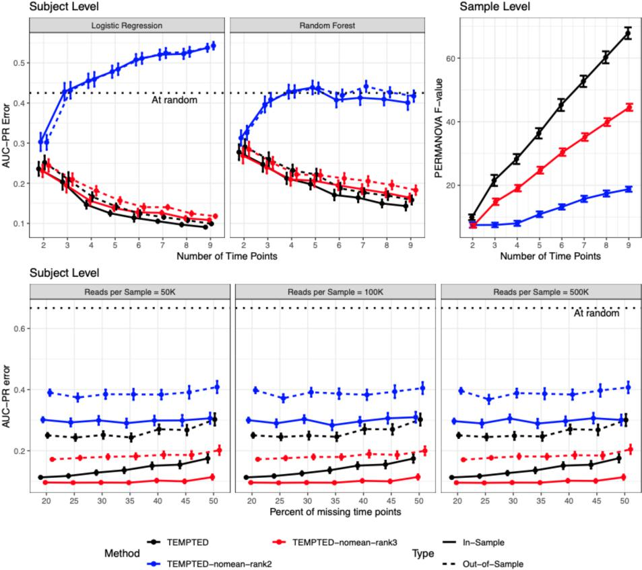

2. (Regarding my old comment #3). I'm afraid I'll need to push for better temporal alignment in ECAM. The infant microbiome is known to be highly developmental. As such, aligning months 1, 2, 3 for one infant as the same timepoints as months 4, 5, 6 of another infant would be inappropriate. Looking at Figure A4, it does seem that this misalignment can be severe for certain subjects. At least for the methods that can include missingness, alignment of timepoints at coarse temporal intervals should be doable (e.g., age in months). For the methods that cannot handle missingness, the issue of misalignment should be highlighted in the manuscript text. The authors can highlight this as a practical advantage of TEMPTED over other, "tabular"-based methods.
Reply: Thank you for your comments. We have emphasized the ability of the mentioned methods to handle flexible temporal sampling in the main text. Additionally, we recreated Figure 2’s ECAM-based simulation using month of age as time points for CTF and microTensor. The results are summarized in Supp Fig. A5 (also pasted below), which showed worse performance for microTensor and slight improvement for CTF.
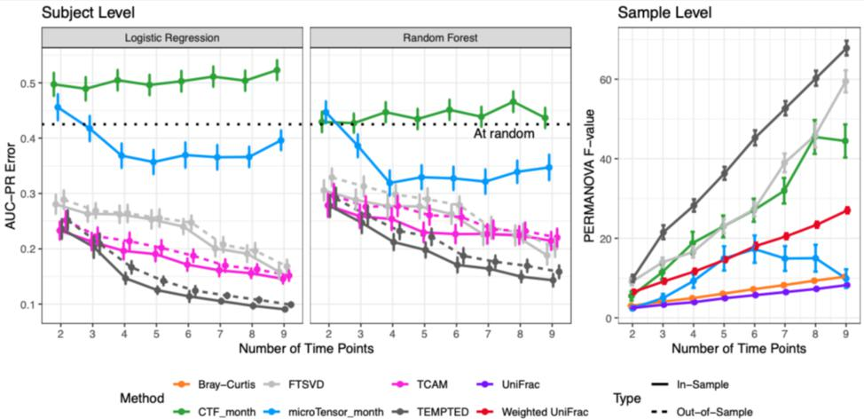

Third round of review
Reviewer 1
The authors have answered all my questions

Reviewer 2
I appreciate the authors addressing my comments. I have no further questions.

