Additional File 1

This file contains Figures S1-35 to support the methodology and the main results.

Figure S1: Post-mortem damage patterns in ancient DNA-like simulated data after mapping to the linear reference genome. The y-axis shows different mutation rates and the x-axis shows the position from the read 5’-end (left panels) or the 3’-end (right panels).

Figure S2: Comparing reference bias under three different alignment strategies using (A) simulated aDNA-like genomes, (B) shotgun and 1240K capture ancient genomes with available raw FASTQ files, and (C) shotgun and 1240K capture ancient genomes with already processed BAM files. Same as Figure 1, but using reads with MAPQ>25 instead.

Figure S3: Number of reads mapped to heterozygous sites with MAPQ>30 or MAPQ<30 using 10X simulated genomic data. (A) Distribution of read mapping quality. (B) Distribution of the number of mismatches in reads. (C) Distribution of read lengths. REF and ALT refer to reads carrying reference or alternative alleles.

Figure S4: Reference bias in simulated sequencing datasets representing data from double-standed and single-stranded ancient DNA libraries under high and low levels of PMD (Methods), using (A) MAPQ>30 or (B) MAPQ>25 as filtering threshold. Single-stranded ancient DNA libraries show higher bias using the LINEAR strategy due to additional PMD beyond 10 bp. This can be corrected via MASKED or GRAPH strategies, but only if mapDamage is not used.

Figure S5: Absolute deviations from 50% on heterozygote sites on aDNA-like simulated data between different mapping strategies without applying any PMD correction. The distributions were obtained using 100 replicates at different coverages (rows). The p-values were calculated on pairwise comparisons using the Mann-Whitney U test.

Figure S6 : Absolute deviations from 50% on heterozygote sites on published ancient genomes (A) with available raw FASTQ files and (B) with already processed BAM between different mapping strategies without applying any PMD correction. The distributions were obtained using 100 replicates for each sample. The p-values were calculated on pairwise comparisons using the Mann-Whitney U test.

Figure S7 The proportion of the reads with mapping quality (MAPQ) <30 for each sample after aligning them to linear human reference genome. The published BAM files with practically no reads with MAPQ <30 can be assumed to be already quality-filtered.

Figure S8: Proportion of genotyping errors and missingness for 10X simulated genomes with a double-stranded half-UDG-treated library, a single-stranded library with medium damage (35% at 5’C), a double-stranded high-level damage (51% at 5’C) and double-stranded low-level damage (17% at 5’C) (See also Figure S9 for frequency of type of genotyping errors for each PMD-correction).

Figure S9: Frequency of type of genotyping errors for each PMD-correction method for 10X simulated genomes with a double-stranded half-UDG-treated library, a single-stranded library with medium damage (35% at 5’C), a double-stranded high-level damage (51% at 5’C) and double-stranded low-level damage (17% at 5’C) (See also Figure S9 for frequency of type of genotyping errors for each PMD-correction)

Figure S10: Performance of different alignment strategies and PMD correction strategies on simulated aDNA-like genomes with 5X coverage. (A) The proportion of genotyping errors and missingness. (B) The frequency of the type of genotyping errors for each PMD correction strategy.

Figure S11: Absolute deviations from 50% on heterozygote sites on aDNA-like simulated data using the mapDamage2, ATLAS, trimBam and bamRefine strategies for PMD correction and using all three mapping strategies. The distributions were obtained using 100 replicates at different coverages (rows). The p-values were calculated on pairwise comparisons using the Mann-Whitney U test.

Figure S12: Distributions of different types of genotyping error introduced without any PMD-correction on simulated aDNA-like genomes with 10X coverage. The results were calculated using three alternative alignment strategies, shown on the right side. The panel titles show errors; e.g. “Homozygous Reference > Heterozygous” indicates a real homozygous reference genotype called heterozygous.

Figure S13: Distributions of different types of genotyping error introduced using mapDamage2 for PMD-correction on simulated aDNA-like genomes with 10X coverage. The results were calculated using three alternative alignment strategies, shown on the right side. The panel titles show errors; e.g. “Homozygous Reference > Heterozygous” indicates a real homozygous reference genotype called heterozygous.

Figure S14: Distributions of different types of genotyping error introduced using ATLAS for PMD-correction on simulated aDNA-like genomes with 10X coverage. The results were calculated using three alternative alignment strategies, shown on the right side. The panel titles show errors; e.g. “Homozygous Reference > Heterozygous” indicates a real homozygous reference genotype called heterozygous.

Figure S15: Distributions of different types of genotyping error introduced using trimBam for PMD-correction on simulated aDNA-like genomes with 10X coverage. The results were calculated using three alternative alignment strategies, shown on the right side. The panel titles show errors; e.g. “Homozygous Reference > Heterozygous” indicates a real homozygous reference genotype called heterozygous.

Figure S16: Distributions of different types of genotyping error introduced using bamRefine for PMD-correction on simulated aDNA-like genomes with 10X coverage. The results were calculated using three alternative alignment strategies, shown on the right side. The panel titles show errors; e.g. “Homozygous Reference > Heterozygous” indicates a real homozygous reference genotype called heterozygous.

Figure S17: Distributions of different types of genotyping error introduced using mapDamage2 for PMD-correction on simulated aDNA-like genomes with 10X coverage with half-UDG-treated library. The results were calculated using three alternative alignment strategies, shown on the right side. The panel titles show errors; e.g. “Homozygous Reference > Heterozygous” indicates a real homozygous reference genotype called heterozygous.

Figure S18: Distributions of different types of genotyping error introduced using ATLAS for PMD-correction on simulated aDNA-like genomes with 10X coverage with half-UDG-treated library. The results were calculated using three alternative alignment strategies, shown on the right side. The panel titles show errors; e.g. “Homozygous Reference > Heterozygous” indicates a real homozygous reference genotype called heterozygous.

Figure S19: Distributions of different types of genotyping error introduced using trimBam for PMD-correction on simulated aDNA-like genomes with 10X coverage with half-UDG-treated library. The results were calculated using three alternative alignment strategies, shown on the right side. The panel titles show errors; e.g. “Homozygous Reference > Heterozygous” indicates a real homozygous reference genotype called heterozygous.

Figure S20: Distributions of different types of genotyping error introduced using bamRefine for PMD-correction on simulated aDNA-like genomes with 10X coverage with half-UDG-treated library. The results were calculated using three alternative alignment strategies, shown on the right side. The panel titles show errors; e.g. “Homozygous Reference > Heterozygous” indicates a real homozygous reference genotype called heterozygous.

Figure S21: Comparing reference bias in simulated aDNA-like genomes at transition SNPs using different alignment strategies (rows, indicated on the right) and PMD correction strategies (columns, indicated in the panel title) and different coverages (indicated as x-axis labels). The plot shows the proportion of alternative alleles after randomly selecting one allele from heterozygote sites 100 times by pileupCaller. Here we only considered transition SNPs (see Figure 3). The reason for the relationship between reference bias and coverage in this data is not obvious to us.

Figure S22: Comparing reference bias in simulated aDNA-like genomes at transversion SNPs using different alignment strategies (rows, indicated on the right) and PMD correction strategies (columns, indicated in the panel title) and different coverages (indicated as x-axis labels). The plot shows the proportion of alternative alleles after randomly selecting one allele from heterozygote sites 100 times. Here we only considered transversion SNPs (see Figure 3). The reason for the higher reference bias at 0.05X is not obvious to us.

Figure S23: Comparing reference bias in simulated ancient genomes aligned with different reference genomes and PMD-effects reduced with different approaches by using reads either with MAPQ>30 or with MAPQ>25 for genotyping. The plot shows the proportion of alternative alleles after randomly selecting one allele from heterozygote sites 100 times.

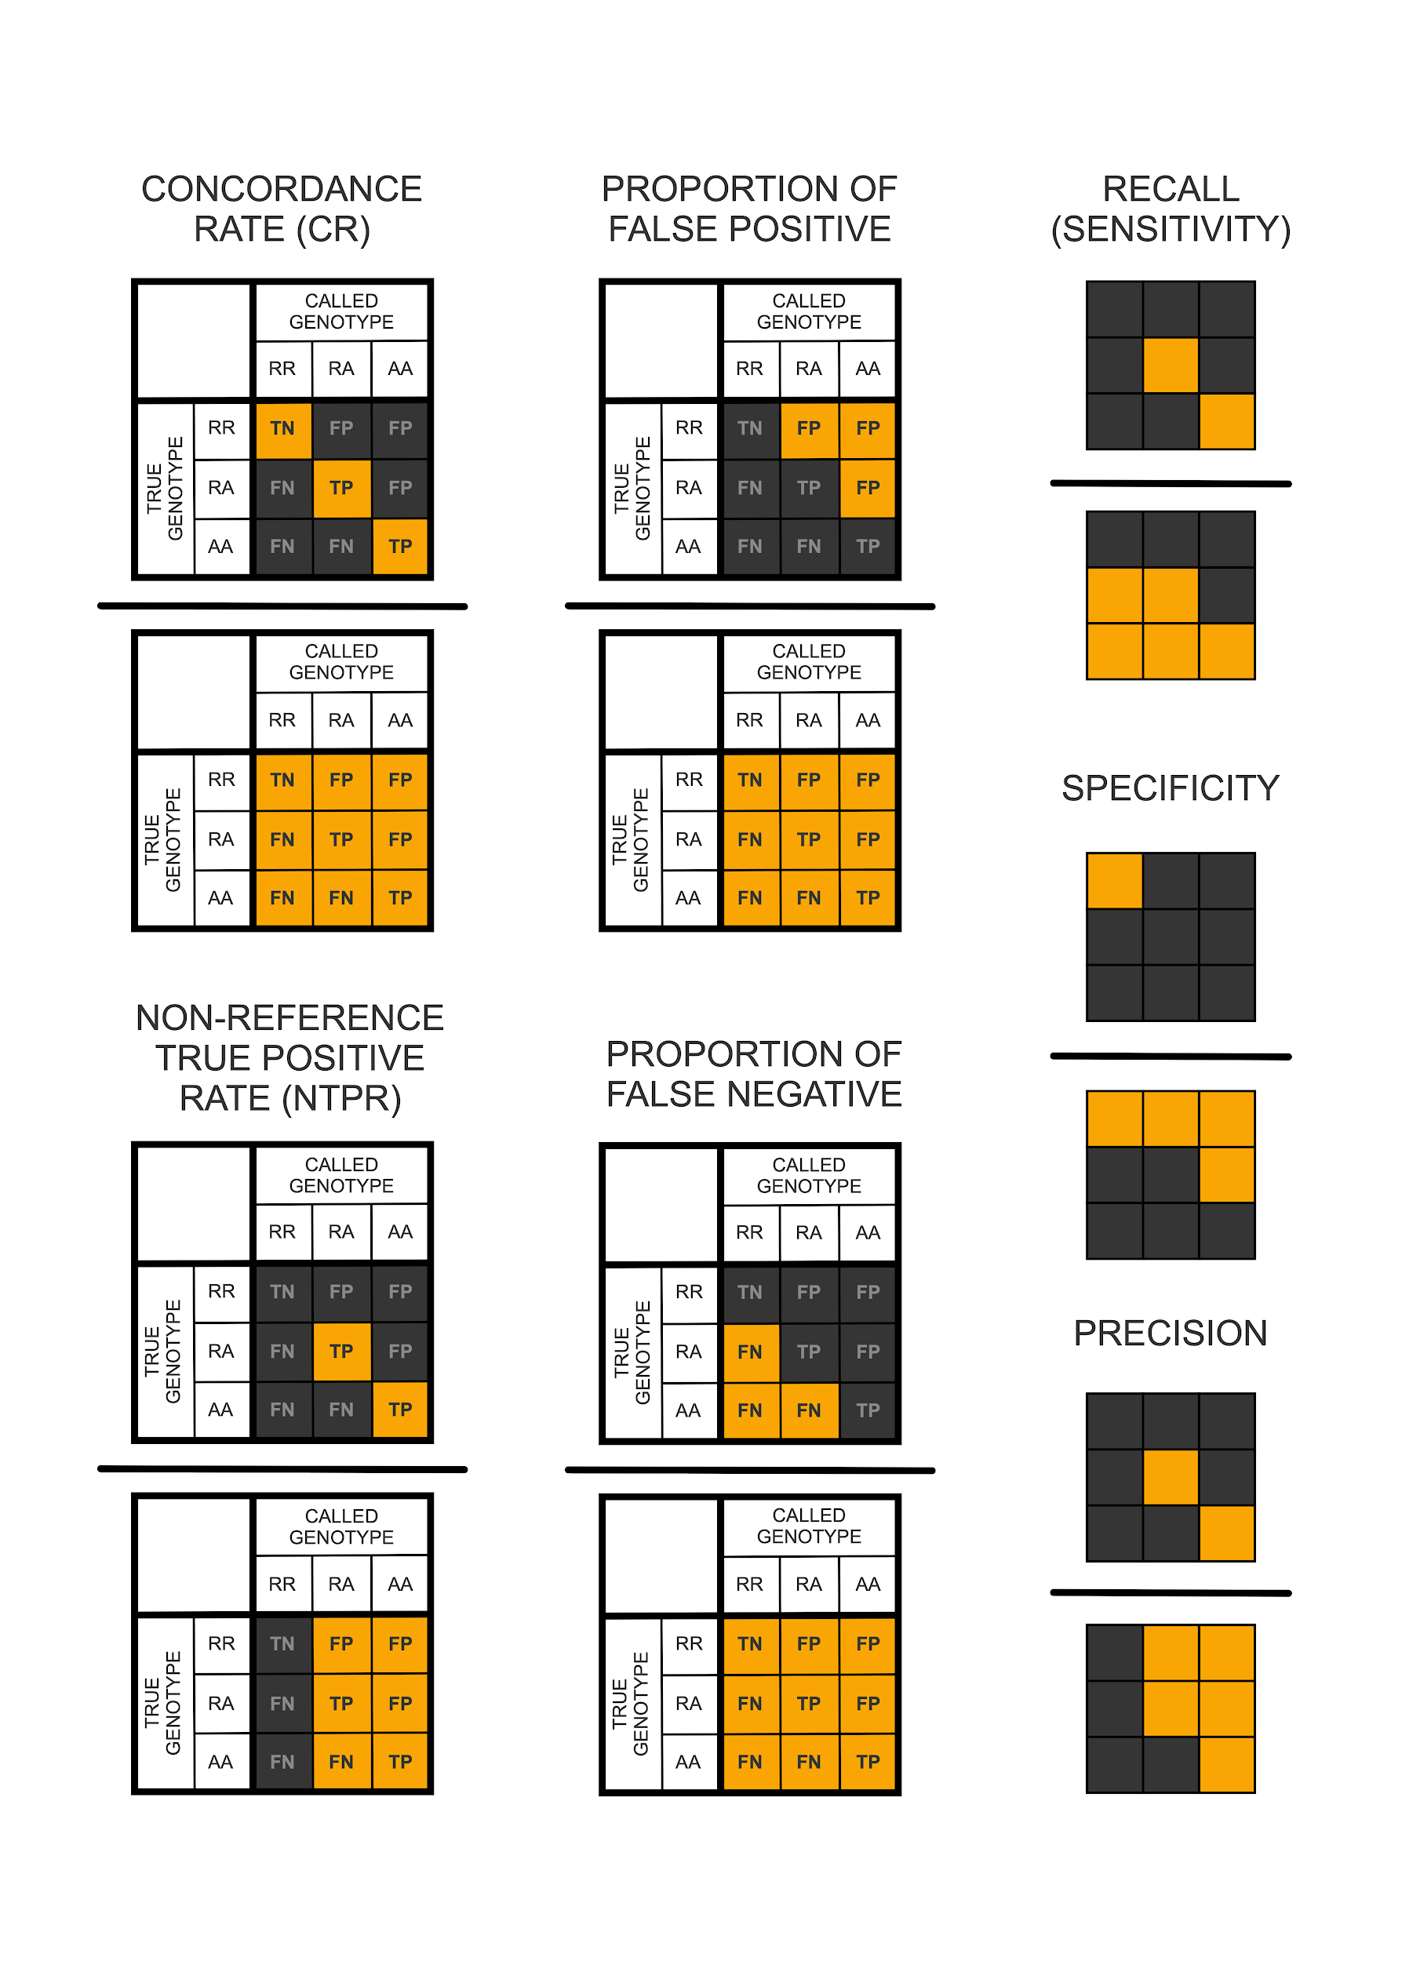
Figure S24: Genotype concordance measures used for Figure 4. All combinations of the genotyped positions [182,515 homozygous reference (RR), 53,391 homozygous alternative (AA), 77,841 heterozygous (RA)] were used for simulation. The panels show how the concordance rate (CR), false negative (FN) proportion, false positive (FP) proportion, non-reference true positive rate (NTPR), recall (or sensitivity), specificity and precision are calculated with the alternative allele as a pivot. The horizontal lines stand for division. The yellow-coloured cells are the frequencies included in the calculation for each statistic (e.g. CR is calculated by summing TN and the two TP frequencies and dividing by the total frequency of all observations). We also calculated the F-score, which is the harmonic mean of precision and recall values, by the following formula: 2 x [(Precision x Recall) / (Precision + Recall)]. TN: True Negative, TP: True Positive, FP: False Positive, FN: False Negative. The figure was adopted from Kishikawa et al., 2019.

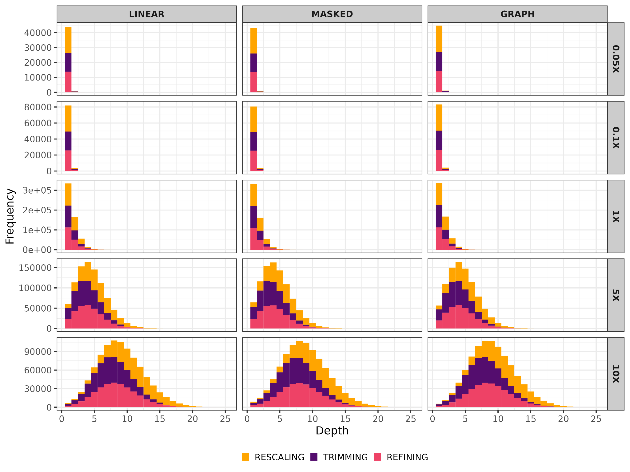
Figure S25: Depth-of-coverage at variable positions used for genotyping in aDNA-like simulated genomes at different coverages (rows), using three different alignment strategies (columns), and using three different PMD correction strategies (colours). The per variant coverage values were calculated based on ‘samtools mpileup’ results, which were later used for creating pseudo-haploid genotypes (Methods).

Figure S26: Comparing PMD-correction performances of “mapDamage”, “ATLAS”, “trimBam”, and “bamRefine” on simulated ancient genomes, calculated by comparing diploid calls with true genotypes (Figure S24) by using reads either with MAPQ>30 or with MAPQ>25 for genotyping. “NTPR” stands for non-reference true positive rate, “FN” for false negatives, “FP” for false positives.

Figure S27: Post-mortem damage patterns in published ancient genomes with available raw FASTQ files after mapping to the linear reference genome. The y-axis shows different mutation rates and the x-axis shows the position from the read 5’-end (left panels) or the 3’-end (right panels).

Figure S28: Post-mortem damage patterns in published ancient genomes with already processed BAM files after mapping to the linear reference genome. The y-axis shows different mutation rates and the x-axis shows the position from the read 5’-end (left panels) or the 3’-end (right panels).

Figure S29: Comparing reference bias in published ancient genomes that FASTQ file available aligned with different reference genomes and PMD-effects reduced with different approaches. The plot shows the proportion of alternative alleles after randomly selecting one allele from heterozygote sites 100 times. Same as Figure 5, but using reads with MAPQ>25 instead.
Figure S30: Comparing reference bias in published ancient genomes with only published BAM files. These were published already filtered or unfiltered for mapping quality. The data was subject to alignment to different reference genomes and two PMD-correction approaches. The plot shows the proportion of alternative alleles after randomly selecting one allele from heterozygote sites 100 times by pileupCaller.

Figure 31: Comparing reference bias in published ancient genomes with only published BAM files. These were published already filtered or unfiltered for mapping quality. The data was subject to alignment to different reference genomes and two PMD-correction approaches. The plot shows the proportion of alternative alleles after randomly selecting one allele from heterozygote sites 100 times by pileupCaller. Same as Figure S30, but using reads with MAPQ>25 instead.

Figure S32: Absolute deviations from 50% on heterozygote sites on published ancient genomes with available raw FASTQ files using the trimBam and bamRefine strategies for PMD correction and using all three mapping strategies. The distributions were obtained using 100 replicates for each sample.

Figure S33: Absolute deviations from 50% on heterozygote sites on published ancient genomes with already processed BAM files using trimBam and bamRefine strategies for PMD correction and using all three mapping strategies. The distributions were obtained using 100 replicates for each sample. The p-values were calculated on pairwise comparisons using the Mann-Whitney U test. The reason why bamRefine performs slightly worse than trimBam in quality filtered shotgun data is not obvious to us.

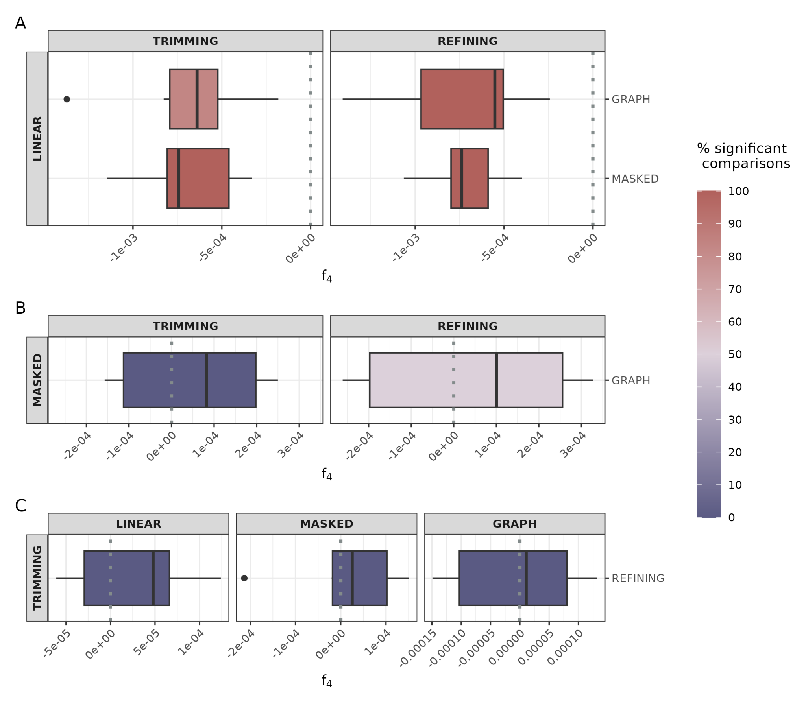
Figure S34: Reference bias measured using f₄ tests. Results from the model A) f₄(Chimp, Human Reference Genome; Ind1_LINEAR, Ind1_MASKED|GRAPH), B) f₄(Chimp, Human Reference Genome; Ind1_MASKED, Ind1_GRAPH) for both PMD correction strategies and C) f₄(Chimp, Human Reference Genome; Ind1_TRIMMED, Ind1_REFINED) for all mapping strategies by using ancient genomes that only BAM files available. The chimpanzee is the outgroup, and we are testing whether the Human Reference Genome is equally distant to the genetic data from the same individual but processed using alternative strategies (e.g. Ind1_LINEAR versus Ind1_MASKED). f₄ distributions shifted to the left or right suggest the reference genome shares more alleles with the genetic data processed using the methods indicated in the left or right, respectively. The colour gradient from blue to red represents the fraction of comparisons that are nominally significant (|Z|>3).

Figure S35: Comparing performances of “GRAF” and “vg-giraffe” on 10X simulated ancient genomes, calculated by comparing diploid calls with true genotypes (Figure S24). “NTPR” stands for non-reference true positive rate, “FN” for false negatives, “FP” for false positives.

