Supplementary Figures
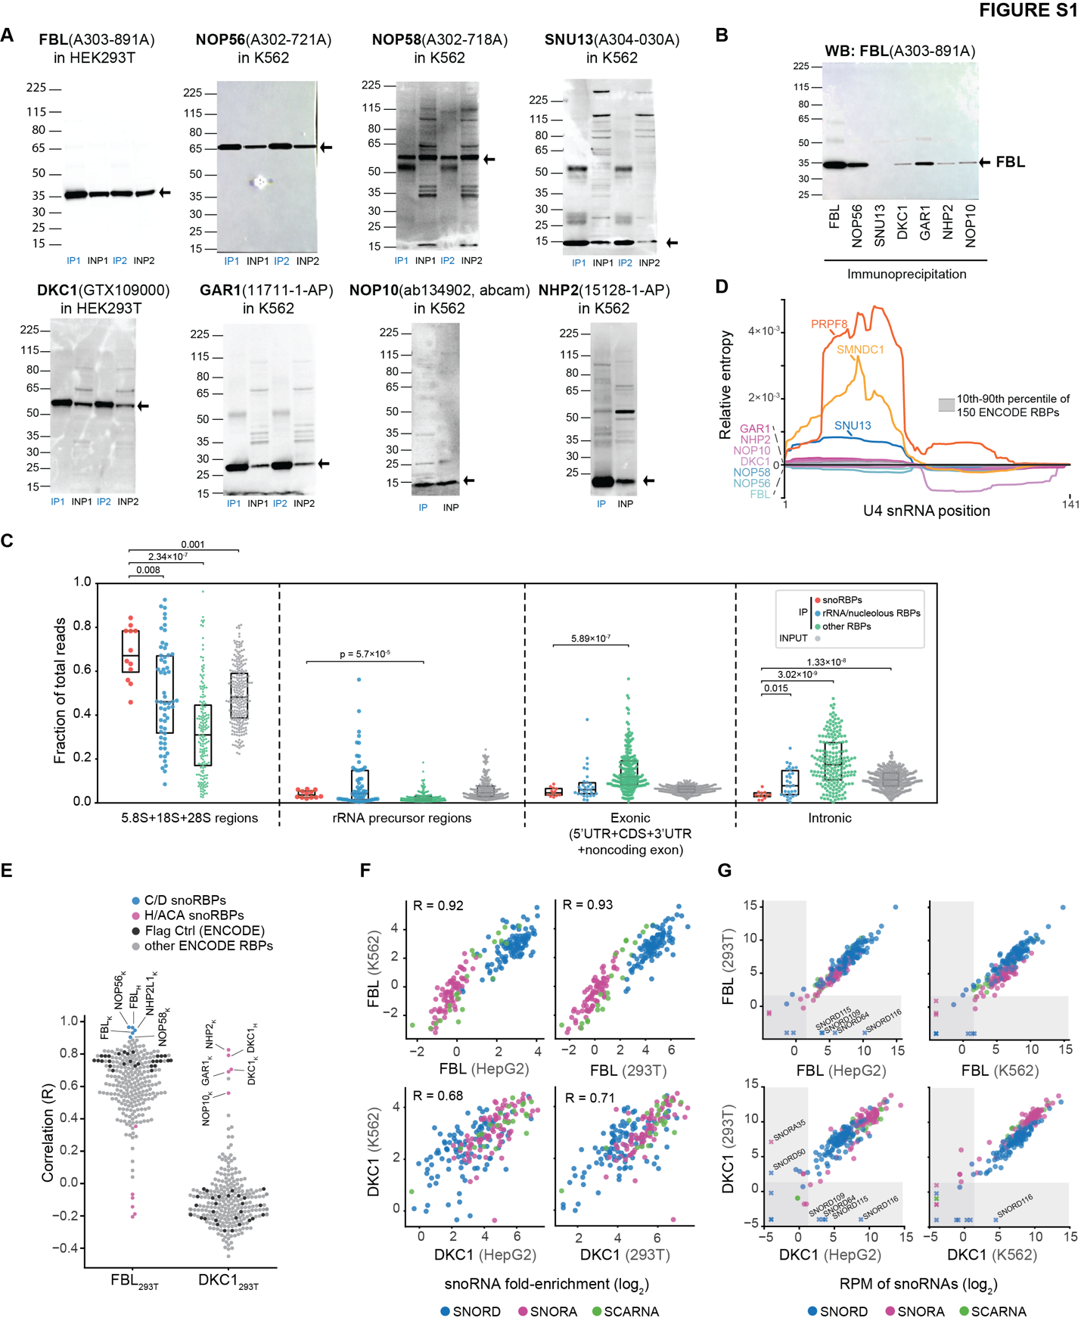

Fig. S1. snoRNP proteins comparison in snoRNA enrichment.
(A) Western blot confirmation of snoRBP immunoprecipitation (IP) during eCLIP in K562 cells. INP, input.
(B) Western blot for FBL following immunoprecipitation of core snoRBPs during eCLIP.
(C) Points indicate the fraction of reads from each eCLIP dataset mapping to the indicated RNA elements for (red) snoRBPs profiled here, (blue/green) ENCODE eCLIP datasets separated into (blue) RBPs with either ribosomal function or nucleolar localization or (green) other RBPs, and (grey) input datasets. P-values indicated were calculated by two-sample Kolmogorov-Smirnov test.
(D) eCLIP relative entropy (along U4 snRNA for (colors) indicated RBPs and (grey) all ENCODE RBPs.
(E) Pearson correlation coefficient of snoRNA fold-enrichment between all profiled RBPs and (left) FBL or (right) DKC1 in 293T cells. Subscripts indicate cell lines; K562 (_{K}) and HepG2 (_{H}).
(F) Correlation of snoRNA fold-enrichment across (top) FBL or (bottom) DKC1 eCLIP in different cell lines. Pearson correlations (R) are indicated.
(G) snoRNA abundance (RPM, reads per million sequenced reads) across (top) FBL or (bottom) DKC1 eCLIP in different cell lines. Data points symbolized with an ‘x’ are missing values in one cell line.
Data shown is average of 2 replicates per RBP.

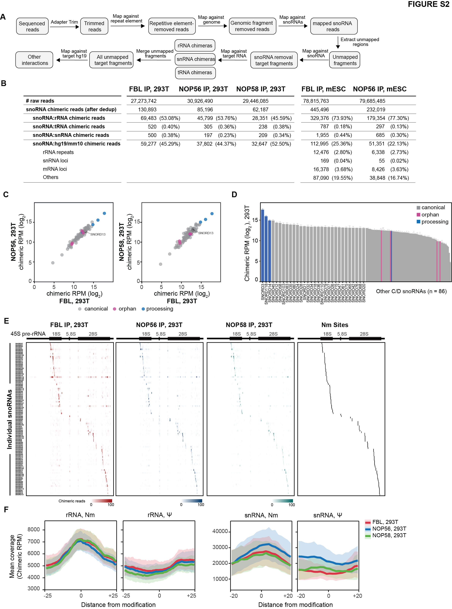
Fig. S2. Chimeric eCLIP of core C/D snoRNP proteins recover known C/D snoRNA interactions in 293T cells.
(A) Flowchart of chimeric eCLIP sequence data analysis.
(B) Summary table of chimeric eCLIP sequencing reads.
(C) Correlation of snoRNA chimeric read abundance from FBL, NOP56, and NOP58 chimeric eCLIP.
(D) Chimeric read abundance for individual snoRNAs colored according to snoRNA functional class. The y-axis indicates average chimeric RPM in FBL, NOP56, and NOP58 chimeric eCLIP.
(E) Heatmap of chimeric read coverage across pre-rRNA from FBL, NOP56, and NOP58 chimeric eCLIP for canonical snoRNAs. Known Nm target sites are shown in black.
(F) Metagene plots of chimeric read coverage flanking Nm and pseudouridine sites in rRNA and snRNA.
Chimeric RPM, reads per million chimeric reads. Data shown is from 1 replicate per RBP.

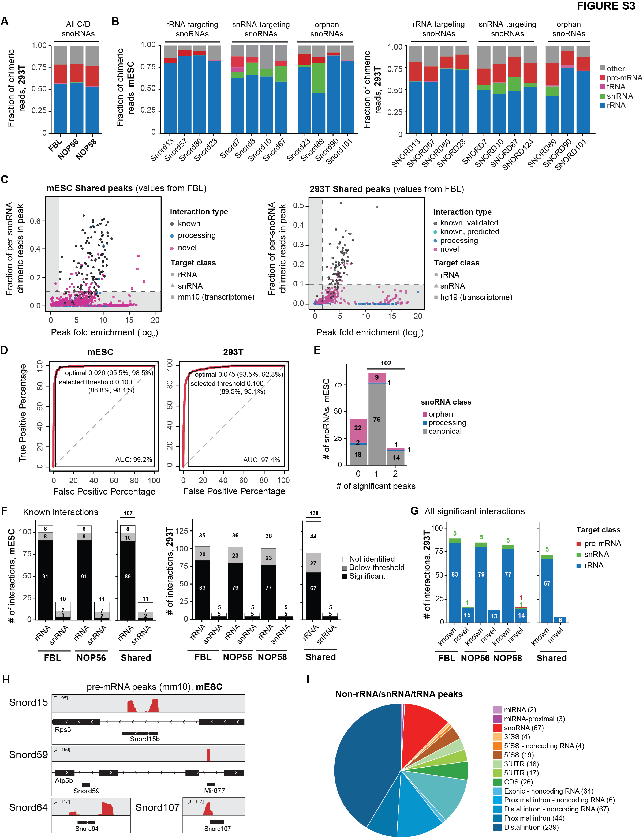
Fig. S3. Transcriptomic mapping of C/D snoRNA chimeras in mouse and human cells
(A) Fraction of C/D snoRNA chimeric reads mapping to distinct classes of possible target RNAs in 293T cells from FBL, NOP56, and NOP58 chimeric eCLIP.
(B) Distribution of individual snoRNA chimeric reads captured by FBL to distinct classes of possible target RNAs from (left) mESC and (right) 293T cells.
(C) Implementation of “peak fold-enrichment” and “fraction of per-snoRNA chimeric reads in peak” to determine high-confidence peaks in (left) mESC and (right) 293T cells. Each datapoint indicates a peak. Colors and shapes indicate interaction status (known, previously assigned; processing, interaction of a processing snoRNA; novel, previously unassigned) and target RNA class. "Shared peaks" plots show values from FBL chimeric eCLIP of peaks confidently detected by all snoRBPs.
(D) (Left) ROC curves to determine the best threshold of the “fraction of per-snoRNA chimeric reads in peak” parameter from mESC and 293T cells. Chimeric eCLIP peaks overlapping known rRNA modification sites were considered as positive values to construct the curve. (Right) The sensitivity and specificity for calling known snoRNA-rRNA interactions at the optimal and selected peak fraction thresholds are shown.
(E) Bar chart showing the number of significant peaks per snoRNA identified in both FBL and NOP56 chimeric eCLIP from mESC.
(F) Number of known snoRNA-target interactions identified by chimeric eCLIP for indicated snoRBP from (left) mESC and (right) 293T cells. Colors indicate status of each peak (Not identified - known interactions from database but not detected in this study; Below threshold - known interactions supported by chimeric reads but falling below threshold; and significant – known interactions overlapping high-confidence peaks above threshold established in this study).
(G) Number of high-confidence snoRNA-target interactions identified by chimeric eCLIP in 293T cells according to interaction status and target class.
(H) Genome browser tracks showing above-threshold putative snoRNA:pre-mRNA interactions identified in mESCs that may reflect annotation artifacts.
(I) Numbers in parentheses indicate the number of peaks (without input-enrichment cutoffs) from snoRNA:genomic (hg19)-mapped chimeric reads in 293T FBL chimeric eCLIP. For intronic regions, the 5′SS and 3′SS annotations refer to 100nt adjacent to the 5′ and 3′ splice sites, with the next 400nt annotated as ‘proximal intron’ and the remainder as ‘distal intron’.

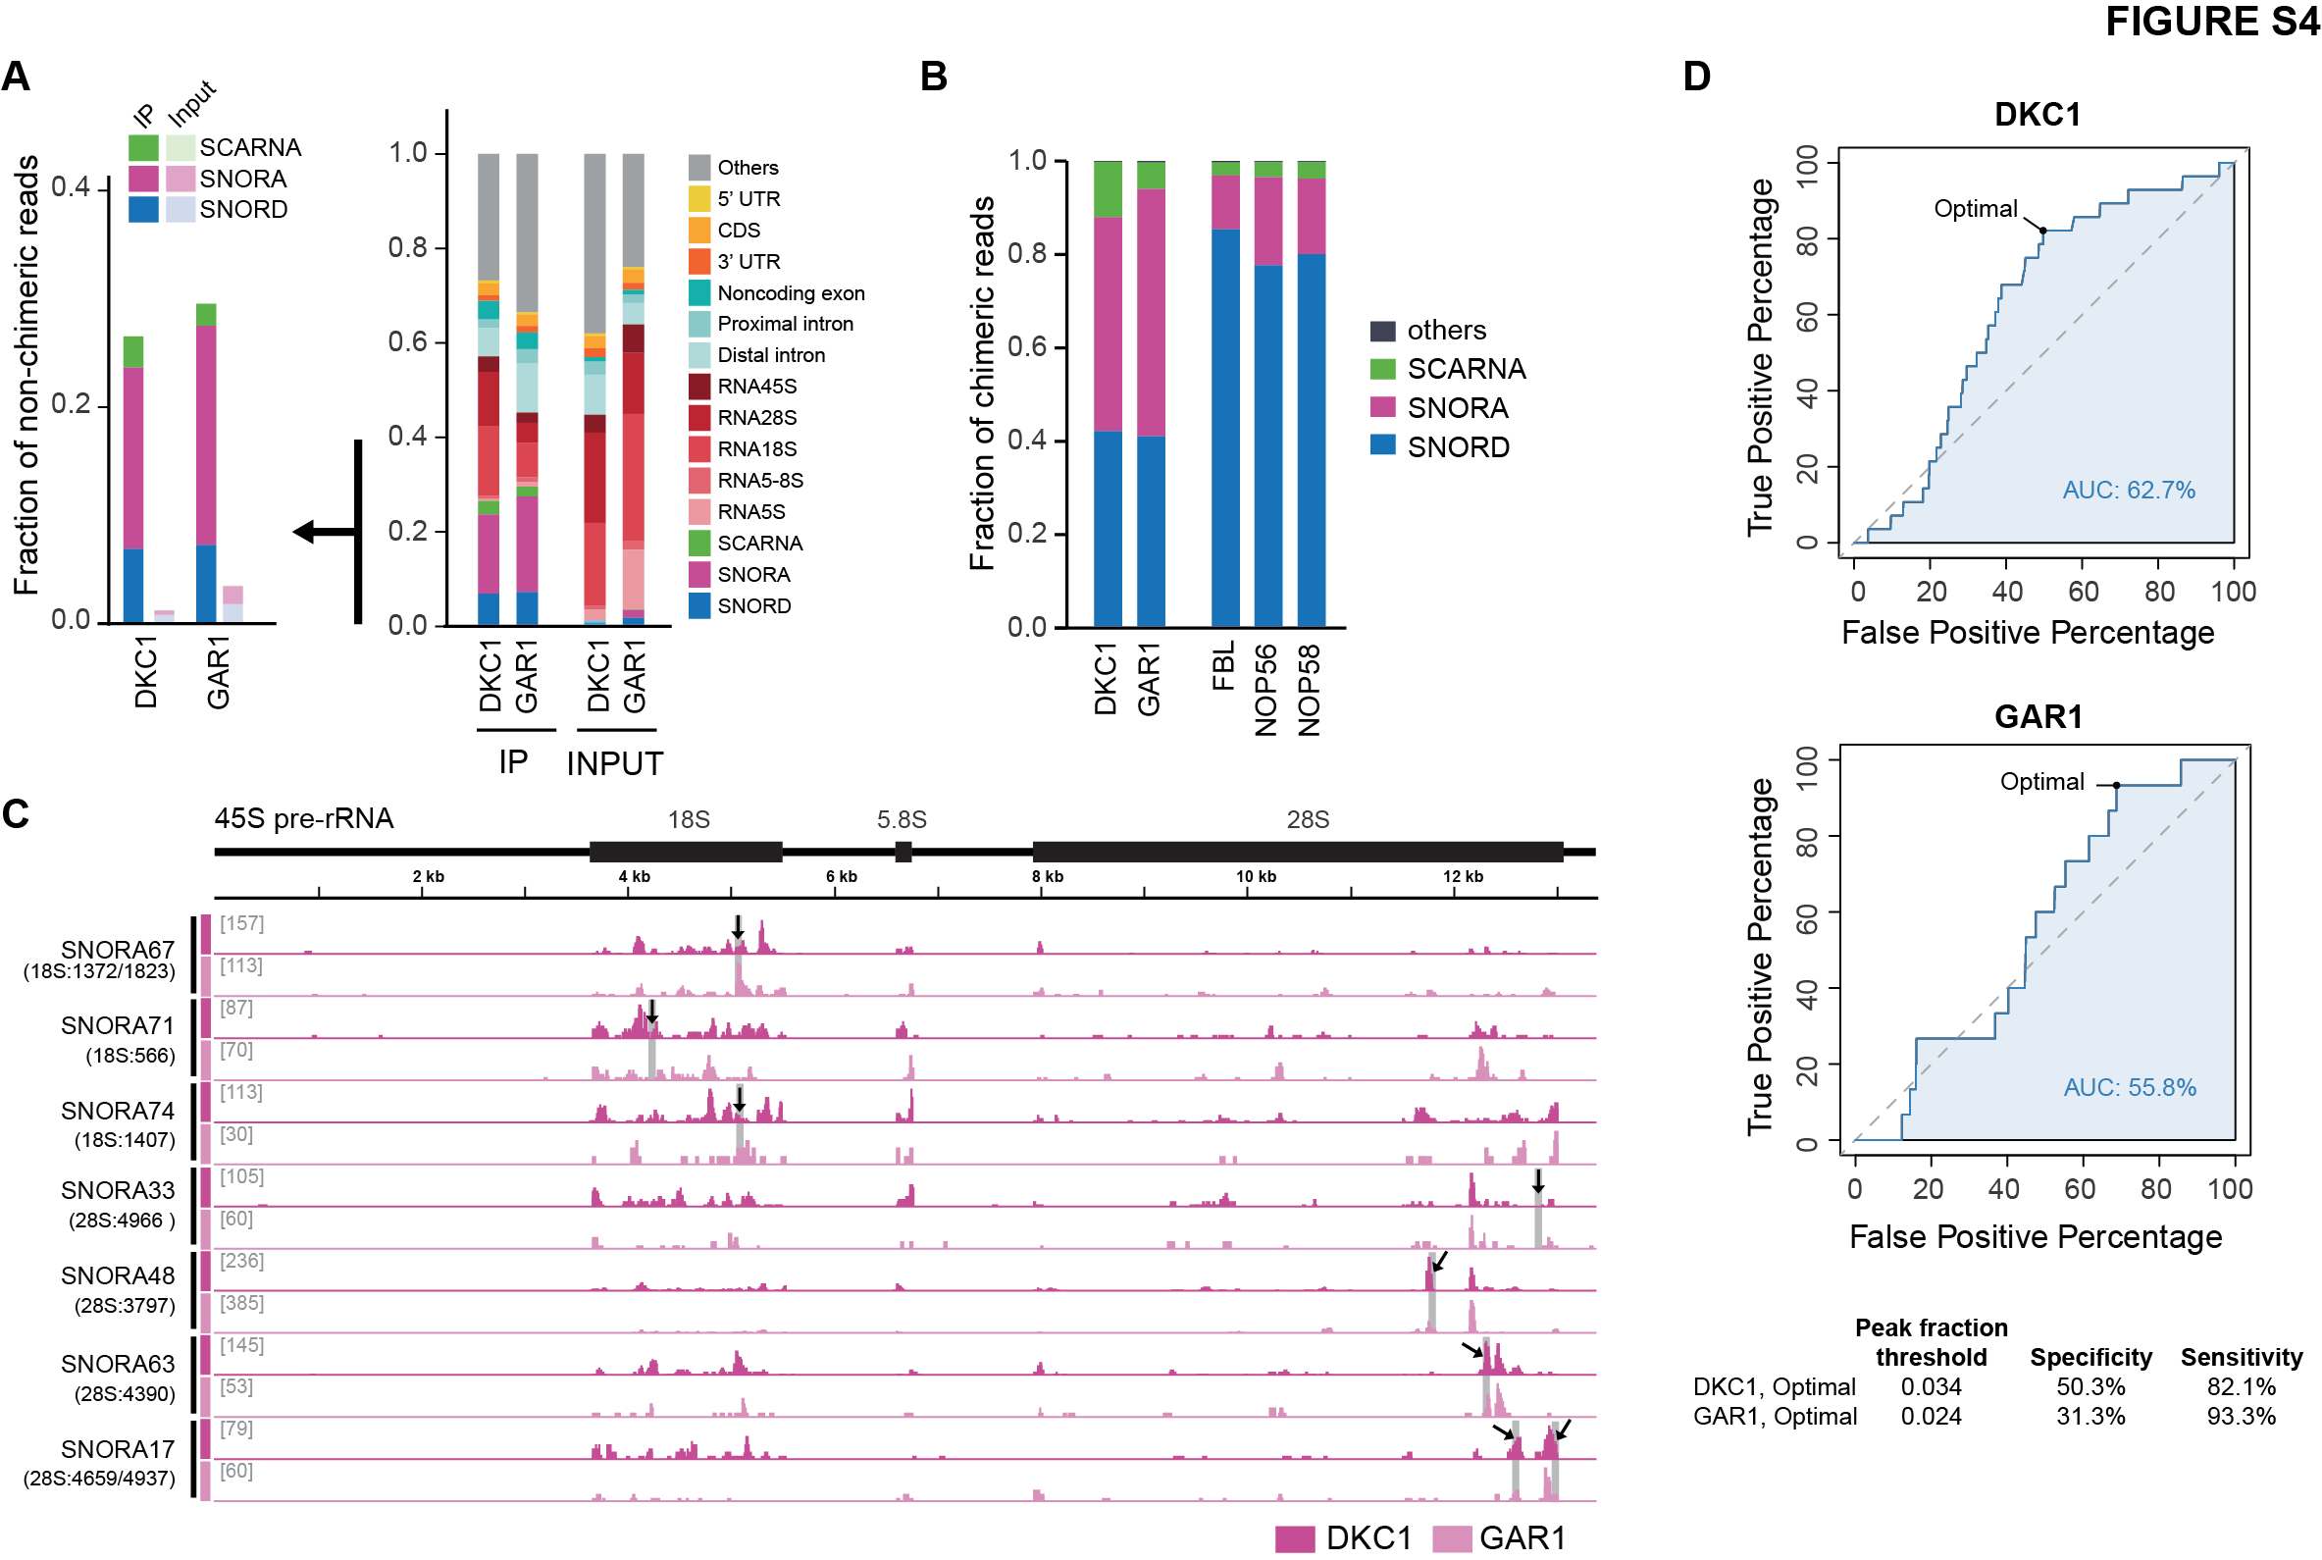
Figure S4. Chimeric eCLIP of core H/ACA snoRNP proteins in 293T cells.
(A) Distribution of non-chimeric reads of (left) snoRNA classes and (right) other major RNA classes captured by DKC1 or GAR1 chimeric eCLIP.
(B) Proportion of chimeric reads containing the indicated snoRNA classes.
(C) Browser tracks of snoRNA chimeric reads mapped to pre-rRNA as captured by DKC1 or GAR1 chimeric eCLIP. Known pseudouridylation sites assigned to each snoRNA guide are indicated with black arrows and grey rectangles.
(D) (Top) ROC curve from DKC1 and GAR1 snoRNA-rRNA chimeric reads to determine the threshold of the “fraction of per-snoRNA chimeric reads in peak” parameter. Chimeric eCLIP peaks overlapping known rRNA modification sites were considered as positive values to construct the curve. (Bottom) Optimal peak fraction threshold values are shown, along with sensitivity (%) and specificity (%) values.
Data shown is from 1 replicate per RBP.

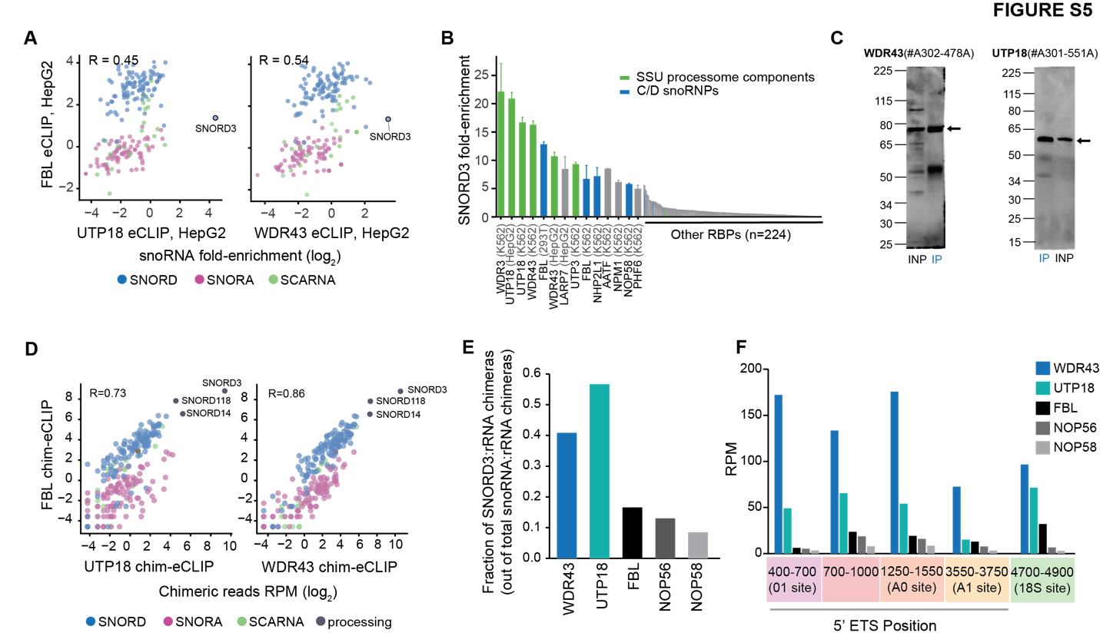

Fig. S5. RBPs that function in ribosomal RNA processing highly enrich for SNORD3.
(A) Correlation of snoRNA fold-enrichment in FBL versus ribosomal RNA-associated RBP in HepG2 cells. Pearson correlation (R) is shown. Only snoRNAs with 5 or more reads in IP were plotted.
(B) Bars indicate SNORD3 fold-enrichment in eCLIP of (blue) C/D snoRNP proteins, (green) Small Subunit Processome (SSU) RBPs, and (grey) all other RBPs profiled by ENCODE.
(C) Immunoprecipitation (IP)-western blot performed during eCLIP for indicated SSU proteins. INP, input.
(D) Correlation of snoRNA chimeric read abundance (RPM) in chimeric eCLIP of FBL versus (left) UTP18 or (right) WDR43 chimeric eCLIP in K562 cells. Pearson correlation (R) is shown.
(E) Bars indicate the fraction of rRNA chimeric reads containing SNORD3 versus other snoRNAs captured by chimeric eCLIP using the indicated RBPs as bait.
(F) Bars indicate the abundance of SNORD3 chimeras (RPM) on different processing sites in the 5’ ETS region of pre-rRNA across the indicated RBPs.
RPM: read per million sequenced reads. eCLIP data shown is average of 2 replicates per RBP; chimeric eCLIP results shown are a single replicate per RBP.

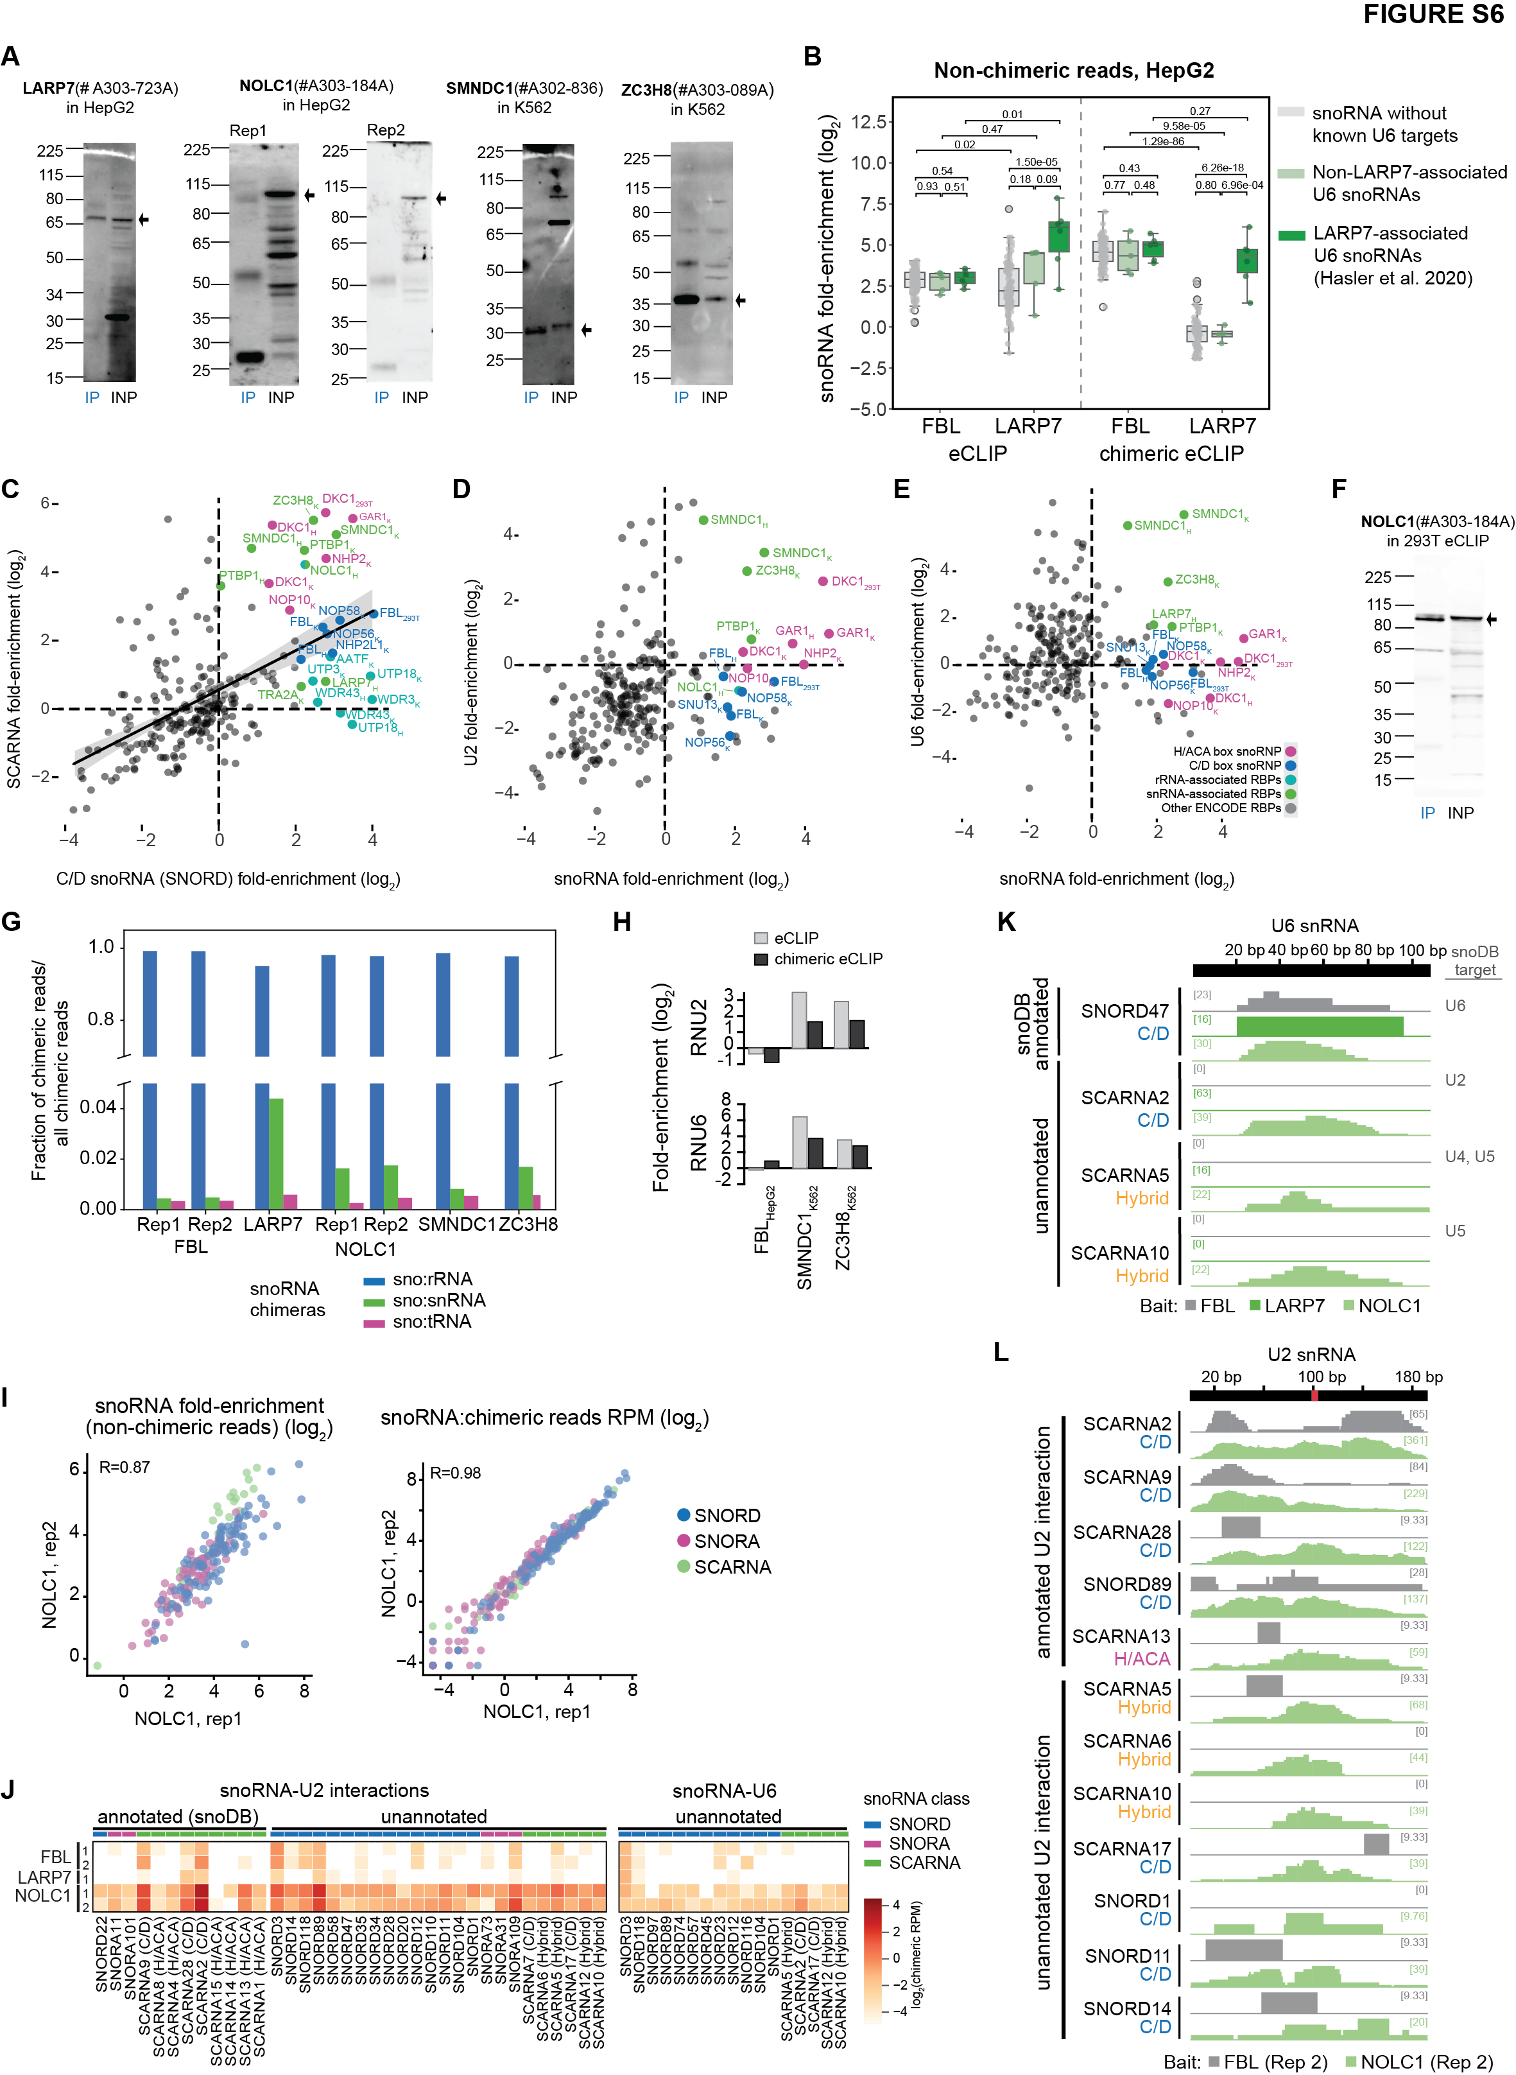
Fig. S6. Visualization of snoRNA:snRNA chimeric reads recovered by snRNA-associated RBPs.
(A) Immunoprecipitation (IP)-western blot performed during chimeric eCLIP for indicated proteins. INP, input.
(B) Points indicate snoRNA fold-enrichment in (left) standard eCLIP and (right) non-chimeric reads from chimeric eCLIP recovered from FBL and LARP7 experiments in HepG2. Colors indicate snoRNAs classified as (green) LARP7-driven U6 targeting, (light green) LAPR7-independent U6 targeting, and (grey) all other snoRNAs. P-values shown are from unpaired two sample t-test.
(C) Points indicate fold-enrichment for (x-axis) all C/D box snoRNAs versus (y-axis) SCARNAs for ENCODE eCLIP and snoRNP proteins eCLIP datasets generated in this work. Labeled RBPs are as in Fig. 5A.
(D) Points indicate fold-enrichment for (x-axis) all snoRNAs versus (y-axis) U2 snRNA for ENCODE eCLIP and snoRNP proteins eCLIP datasets generated in this work. Labeled RBPs are as in Fig. 5A.
(E) Points indicate fold-enrichment for (x-axis) all snoRNAs versus (y-axis) U6 snRNA for ENCODE eCLIP and snoRNP proteins eCLIP datasets generated in this work. Labeled RBPs are as in Fig. 5A.
(F) Immunoprecipitation (IP)-western blot performed during eCLIP for NOLC1. INP, input.
(G) Bar indicates the fraction of chimeric reads captured by chimeric eCLIP of the indicated bait proteins that map to different target RNA classes.
(H) Bars indicate fold-enrichment of U2 or U6 snRNA in (grey) standard eCLIP and (black) non-chimeric reads from chimeric eCLIP profiling of indicated RBPs.
(I) Points indicate (left) fold-enrichment in NOLC1 IP versus input and (right) chimeric reads per million per snoRNA (out of total sequenced reads) comparing two replicates of NOLC1 chimeric eCLIP performed in HepG2 cells.
(J) Heatmap color scale indicates the abundance (RPM) for (left) snoRNA:U2 chimeric reads and (right) snoRNA:U6 chimeric reads recovered by chimeric eCLIP for indicated RBPs. Cutoff for unannotated interactions shown in heatmap is 10 reads for U2 interactions and 5 reads for U6 interactions in at least one sample.
(K) Browser tracks show read density (per million chimeric reads) for snoRNA:U6 chimeras along the U6 snRNA for known and novel candidate U6-interacting snoRNAs.
(L) As in Figure 5J, browser tracks show read density (per million chimeric reads) for snoRNA:U2 chimeras along the U2 snRNA. This figure shows a second replicate of both FBL and NOLC1 chimeric eCLIP.
RPM: reads per million sequenced reads. Unless otherwise indicated, data shown is average of two replicates (FBL, NOLC1) or a single replicate (LARP7).

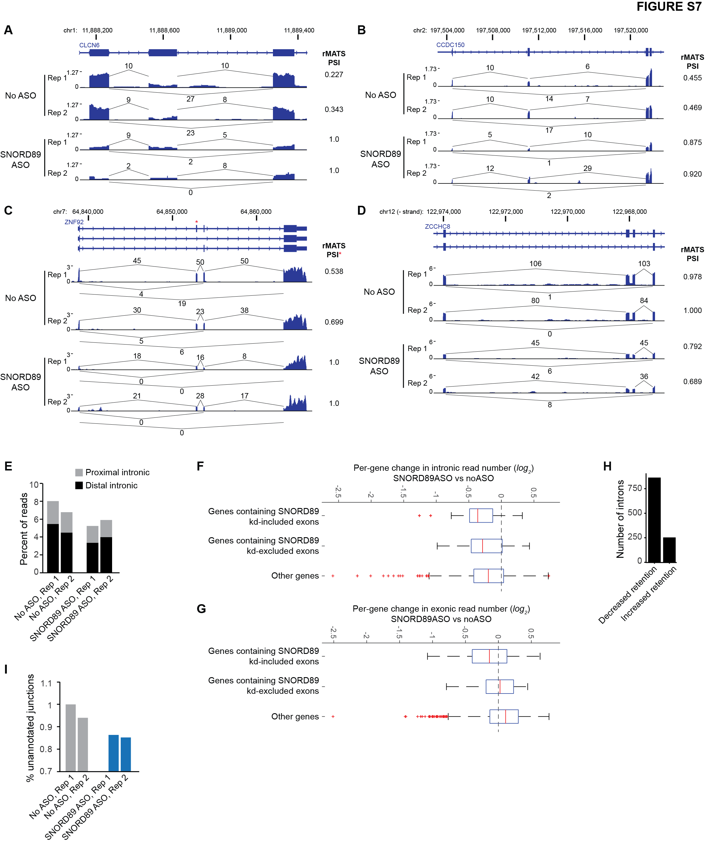
Fig. S7. SNORD89 knockdown decreases retained introns and utilization of unannotated splice junctions.
(A-D) Genome browser figures show RNA-seq read density (per million mapped reads) for (A-C) three example events with increased inclusion in SNORD89 ASO and (D) one example event with exclusion in SNORD89 ASO. Overlaid numbers indicate the number of reads observed supporting the indicated splice junction. On right, value indicates the PSI calculated by rMATS analysis. In (C), rMATS-calculated PSI values are for the exon indicated with red asterisk.
(E) Bars indicate the percent of mapped reads mapping to proximal (<500nt from splice site) or distal (other) intronic regions from RNA-seq performed in SNORD89 ASO or no ASO control.
(F-G) All genes with exonic TPM>10 and intronic TPM>10 were separated by presence or absence of SNORD89 ASO-altered exons within the gene as indicated, and box-plot indicates the distribution of fold-change (log2) of (F) exonic or (G) intronic read density in SNORD89 ASO versus no ASO control. Red line indicates median and boxes indicate 25th and 75th percentiles, with outliers indicated with red ‘+’ symbol.
(H) Bars indicate the number of introns with significantly altered retention upon SNORD89 knockdown.
(I) Bars indicate the percent of spliced reads for which the junction was not annotated in GENCODE (v19) or lncipedia (v5.0).

