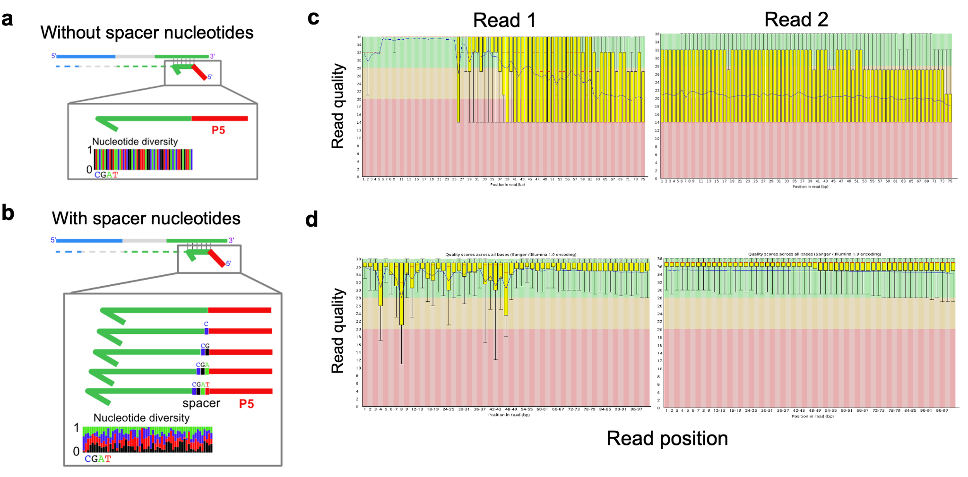
Figure S1. Sequencing quality improvement by the incorporation of spacer sequences before the P5. a. Schematic representation of TE display sequencing library preparation without spacer nucleotides between P5 adapter and TE sequence. Nucleotide diversity per position is shown. b. Schematic representation of TEd-seq library preparation with spacer nucleotides between P5 adapter and TE sequence. Note the homogeneous nucleotide diversity per position. c and d. Per base sequence quality of sequenced TE display sequence libraries lacking (c) or containing (d) different numbers of spacer nucleotides before the P5 adapter. These modifications drastically improve library diversity and overall sequencing quality.

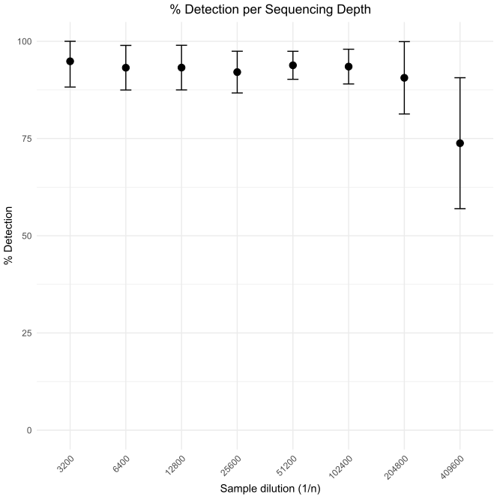
Figure S2. Determination of the sensitivity of TE insertion detection sensitivity by consecutive subsampling of TEd-seq sequencing data. Error bars correspond to the sensitivity standard deviation across TEA lines.

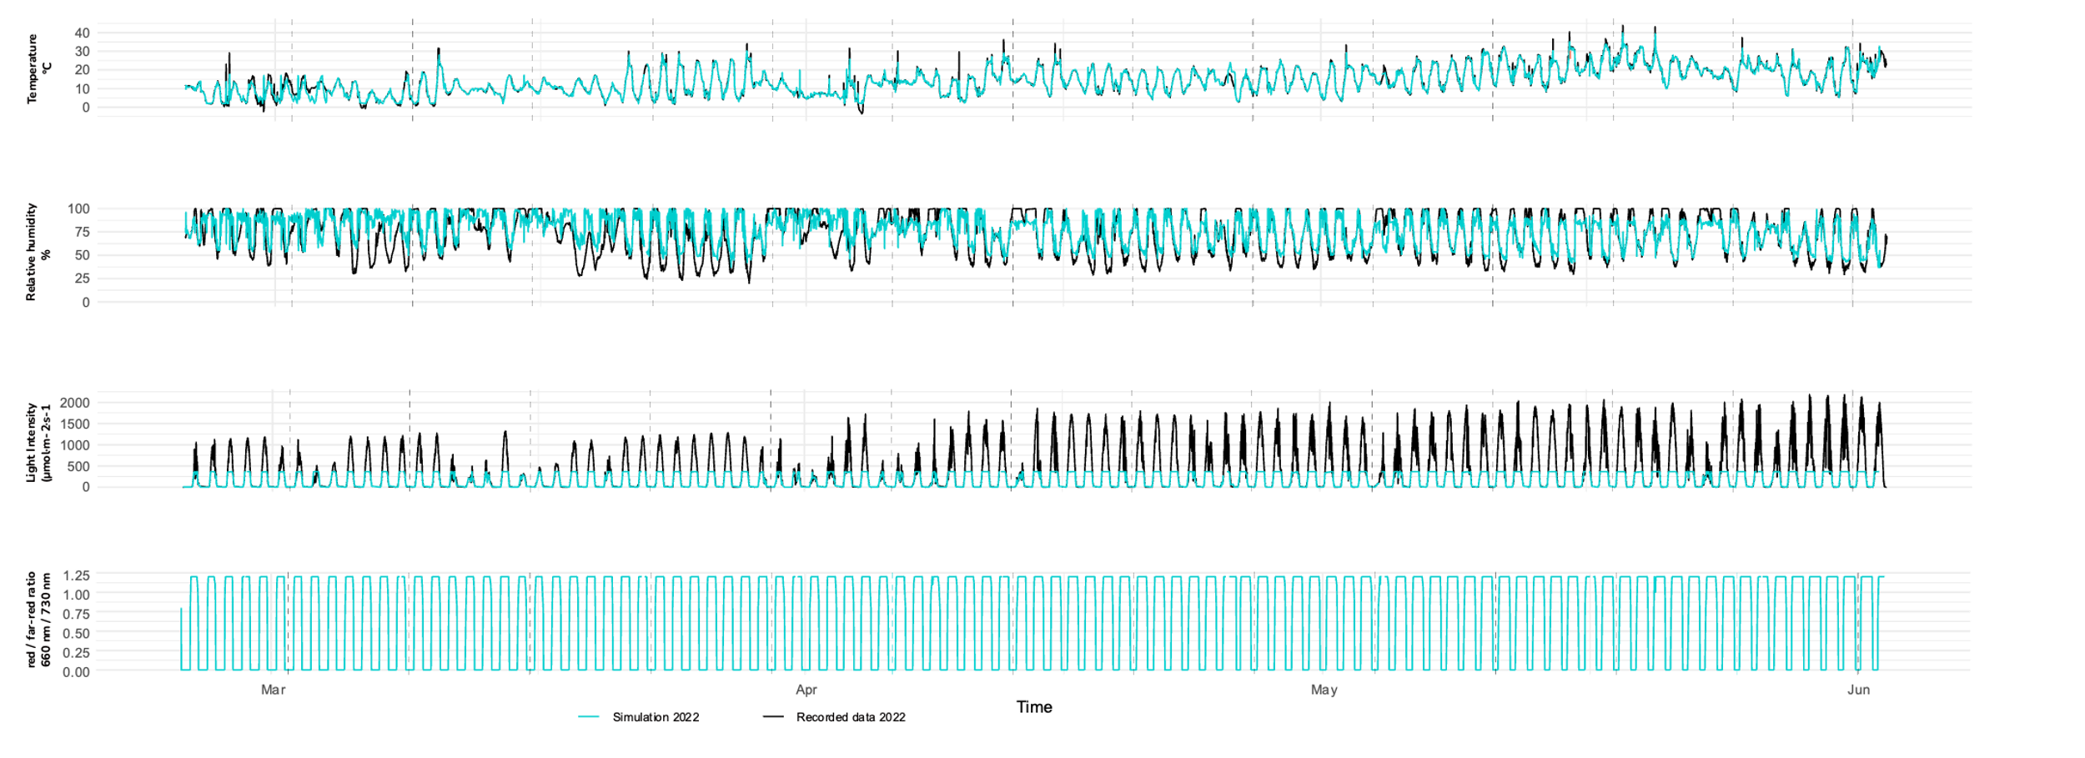
Figure S3. Environmental variables reproduced in the E&R experiment.

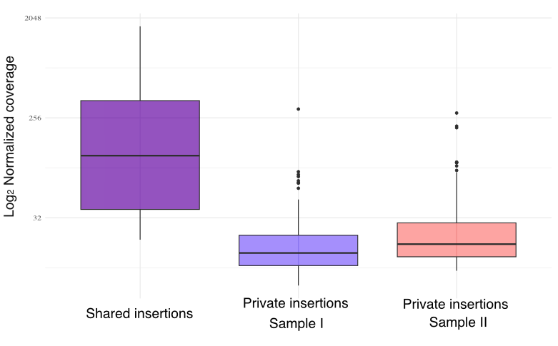
Figure S4. Number of TEd-seq reads supporting shared and private insertions in sample I and II of G1 Pop. 1.

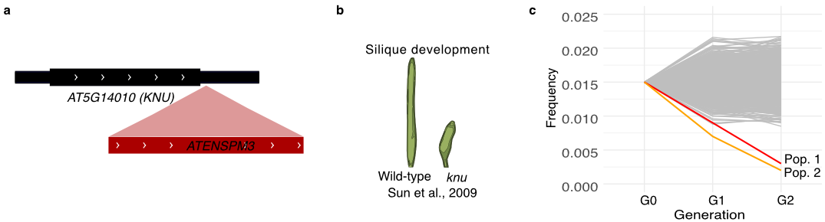

Figure S5. Example of a TE insertion showing significant changes in allele frequency across generations and its described phenotypic effects. a. localization of ATENSPM3 insertion with KNU gene. b. schematic representation of phenotypic effect of loss-of-function mutation in KNU gene described in Sun et al., 2009. c. Alleles frequency changes across generation in Pop. 1 and Pop.1 of the TE insertion within KNU. Expected allele frequencies changes under genetic drift model are indicated in gray.

Table S1. List of TEA lines, dilution factor, and number of non-reference TE-insertions per line. Dilutions of TEA DNA were performed on Col-0 DNA.

TEA line | Dilution (TEd-seq method) | Non-reference ATCOPIA93 insertions | Non-reference ATENSPM3 insertions | Non-reference VANDAL21 insertions
238+112 | 1/3200 (short-reads) | 23 | NA | NA
439 | 1/200 (short-reads) | 25 | NA | NA
394+46 | 1/400 (short-reads) | 17 | NA | NA
454 | 1/100 (short-reads)  1/10 (long-reads) | 26 | 1 | 3
458 | 1/1600 (short-reads) | 19 | NA | NA
500 | 1/2 (short-reads) 1/200 (long-reads) | 36 | 0 | 7
556 | 1/6400 (short-reads) | 66 | NA | NA

Table S2. List of primers used in this study
Name | Sequence | Modifications
P7_adapter_up | GTGACTGGAGTTCAGACGTGTGCTCTTCCGATC*t | *t phosphorothioate bond
P7_adapter_bottom | pGATCGGAAGAGCATC** | p 5’phosphate , ** dideoxy-C
TEDseq_outer_for | GTGACTGGAGTTCAGACGTG | NA
P7_primer_index | CAAGCAGAAGACGGCATACGAGATXXXXXXGTGACTGGAGTTCAGACGTG | XXXXXX correspond to multiplexing barcode
TE_outer_rev_ATCOPIA93 | GTGAGTCCTCTTCAACGGCT | NA
TE_outer_rev_VANDAL21 | GGTTCGGATGGTTTGGTTCGG | NA
TE_outer_rev_ATENSPM3 | CGAAGCTGTAGAGGGAAGTG | NA
P5_ATCOPIA93_1 | AATGATACGGCGACCACCGAGATCTACACTCTTTCCCTACACGACGCTCTTCCGATCTGCCCACTCTCTTGTAGTACATATC | NA
P5_ATCOPIA93_2 | AATGATACGGCGACCACCGAGATCTACACTCTTTCCCTACACGACGCTCTTCCGATCTTGCCCACTCTCTTGTAGTACATATC | NA
P5_ATCOPIA93_3 | AATGATACGGCGACCACCGAGATCTACACTCTTTCCCTACACGACGCTCTTCCGATCTATGCCCACTCTCTTGTAGTACATATC | NA
P5_ATCOPIA93_4 | AATGATACGGCGACCACCGAGATCTACACTCTTTCCCTACACGACGCTCTTCCGATCTCATAGCCCACTCTCTTGTAGTACATATC | NA
P5_ATCOPIA93_5 | AATGATACGGCGACCACCGAGATCTACACTCTTTCCCTACACGACGCTCTTCCGATCTGAATTGCCCACTCTCTTGTAGTACATATC | NA
P5_VANDAL21_1 | AATGATACGGCGACCACCGAGATCTACACTCTTTCCCTACACGACGCTCTTCCGATCTCGGATGGAGATATACTAGTAATATCC | NA
P5_VANDAL21_2 | AATGATACGGCGACCACCGAGATCTACACTCTTTCCCTACACGACGCTCTTCCGATCTTCGGATGGAGATATACTAGTAATATCC | NA
P5_VANDAL21_3 | AATGATACGGCGACCACCGAGATCTACACTCTTTCCCTACACGACGCTCTTCCGATCTATCGGATGGAGATATACTAGTAATATCC | NA
P5_VANDAL21_4 | AATGATACGGCGACCACCGAGATCTACACTCTTTCCCTACACGACGCTCTTCCGATCTCACGGATGGAGATATACTAGTAATATCCTA | NA
P5_VANDAL21_5 | AATGATACGGCGACCACCGAGATCTACACTCTTTCCCTACACGACGCTCTTCCGATCTGAATTCGGATGGAGATATACTAGTAATATCC | NA
P5_ATENSPM3_1 | AATGATACGGCGACCACCGAGATCTACACTCTTTCCCTACACGACGCTCTTCCGATCTGTATTTTACATTCCCGCTAGAGGAT | NA
P5_ATENSPM3_2 | AATGATACGGCGACCACCGAGATCTACACTCTTTCCCTACACGACGCTCTTCCGATCTTGTATTTTACATTCCCGCTAGAGGAT | NA
P5_ATENSPM3_3 | AATGATACGGCGACCACCGAGATCTACACTCTTTCCCTACACGACGCTCTTCCGATCTATGTATTTTACATTCCCGCTAGAGGAT | NA
P5_ATENSPM3_4 | AATGATACGGCGACCACCGAGATCTACACTCTTTCCCTACACGACGCTCTTCCGATCTCATAGTATTTTACATTCCCGCTAGAGGAT | NA
P5_ATENSPM3_5 | AATGATACGGCGACCACCGAGATCTACACTCTTTCCCTACACGACGCTCTTCCGATCTGAATTGTATTTTACATTCCCGCTAGAGGAT | NA

