Supporting Information

ASPM mediates nuclear entrapment of FOXM1 via liquid-liquid phase separation to promote progression of hepatocarcinoma

Xunliang Jiang, Jun Liu, Ke Wang, Jianyong Sun, Huilong Yin, Yu Jiang, Yongkang Liu, Ningbo Wang, Xiaochen Ding, Pu Gao, Lin Li, Xiang Zhang*, Jipeng Li*, Rui Zhang*

*Corresponding author:
e-mail address: biozx@fmmu.edu.cn(X.Z); jipengli1974@aliyun.com(J.L); ruizhang@fmmu.edu.cn(R.Z)

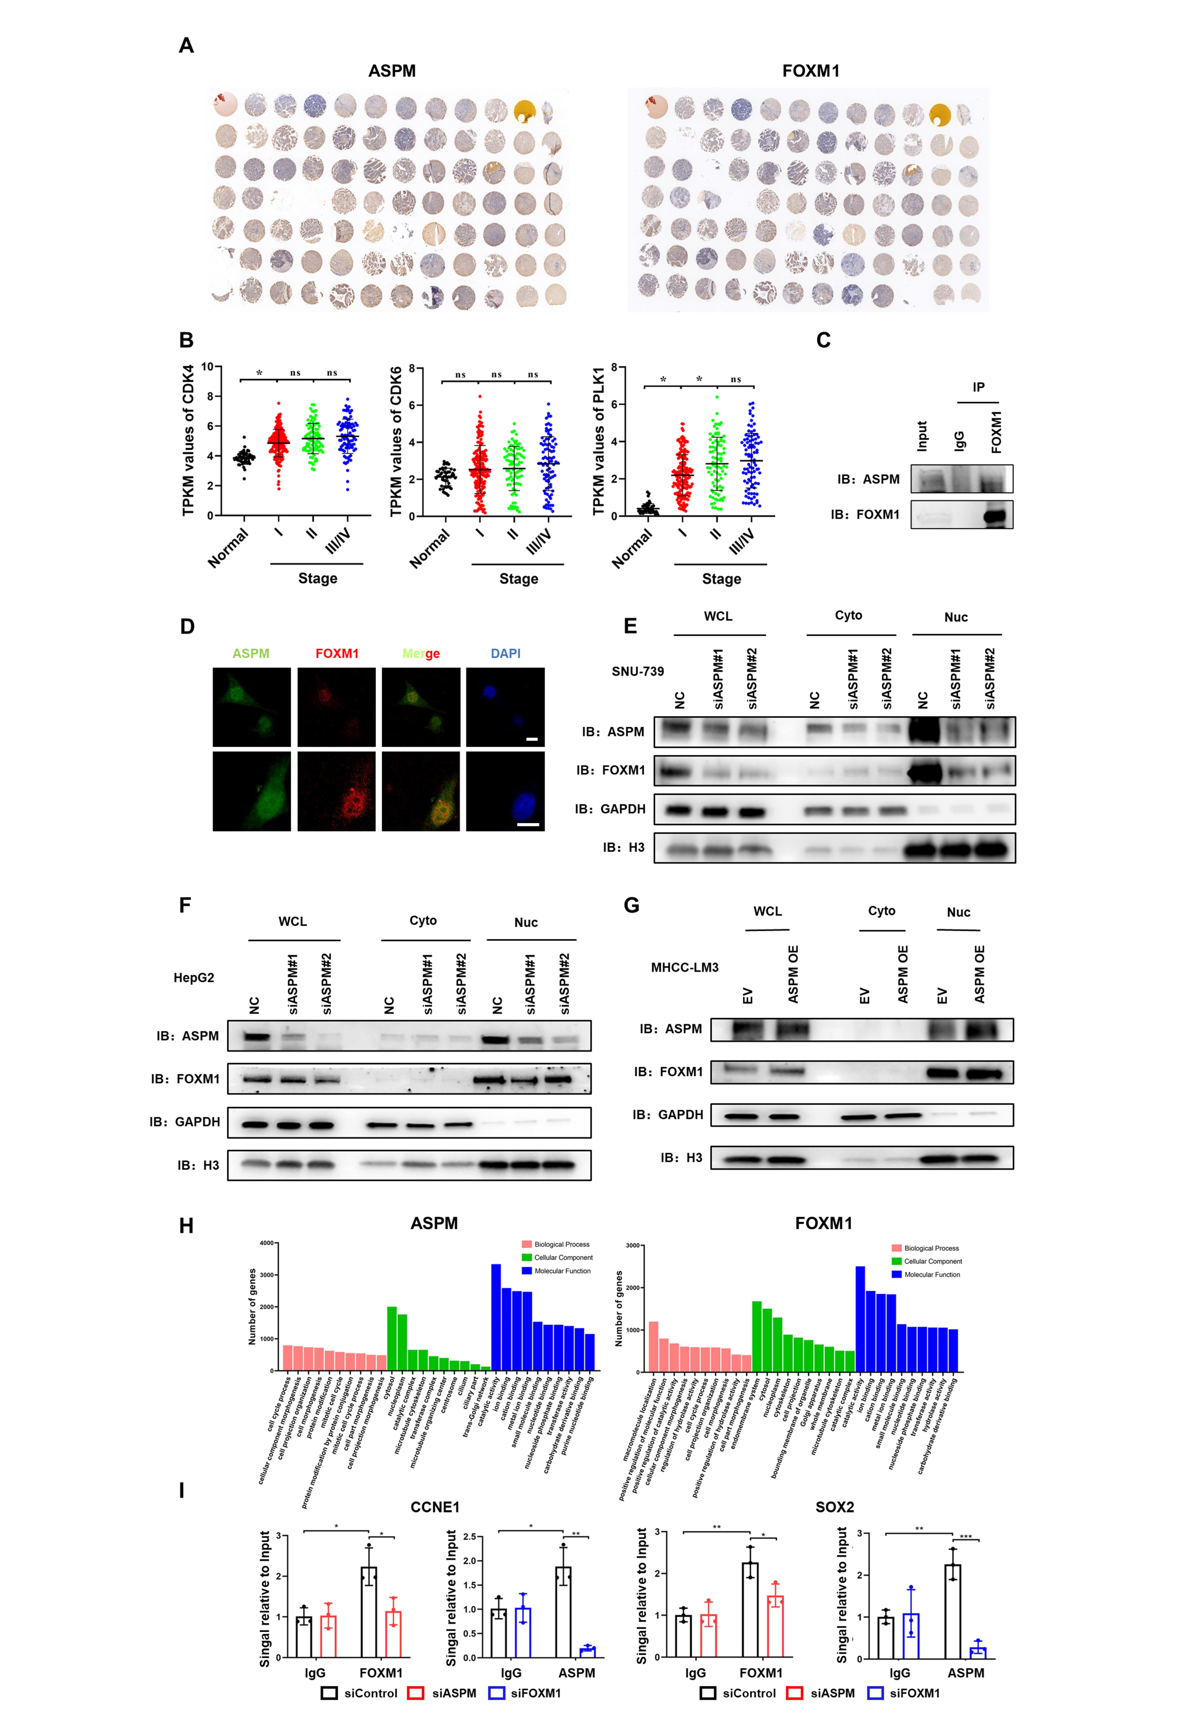
Fig. S1. A genome-wide screen identifies ASPM involved in phase separation of FOXM1 in nucleus and promoting transcription activity of FOXM1 in HCC. Related to Figure 1.
- Immunohistochemistry staining of HCC tissue microarrays for ASPM (left) and FOXM1 (right).
- The TPKM values of CDK4/6 and PLK1 in TCGA LIHC data.
- IP experiments were performed on human HCC tissue samples. After immunoprecipitation with an anti-FOXM1 antibody, the immunoprecipitation was analyzed for ASPM and FOXM1 by immunoblotting, respectively.
- The localization of ASPM and FOXM1 in HepG2 cells was analyzed by immunofluorescence. The nuclei (blue) were stained with DAPI, the ASPM (green) was labeled with Alexa Fluor 488 and the FOXM1 (red) was labeled with Alexa Flour 555. The images were captured at 20× (top) and 40× (bottom) magnification, and the scale bar is 10 μm.
- Location of ASPM and FOXM1 was detected by Western blot after nuclear cytoplasmic separation in different ASPM-level SNU-739 cells.
- Location of ASPM and FOXM1 was detected by Western blot after nuclear cytoplasmic separation in different ASPM-level HepG2 cells.
- Location of ASPM and FOXM1 was detected by Western blot after nuclear cytoplasmic separation in different ASPM-level MHCC-LM3 cells.
- GO annotation classification statistics of ASPM (left) and FOXM1 (right) ChIP-seq peaks
- The ChIP-qPCR was performed to determine the binding of ASPM or FOXM1 on the promoter region of two FOXM1 classical downstream genes (CCNE1 and SOX2). The data were presented as the mean ± SD of three independent experiments. The significance was analyzed by the student’s t-test. *p < 0.05, **p < 0.01, ***p < 0.001.
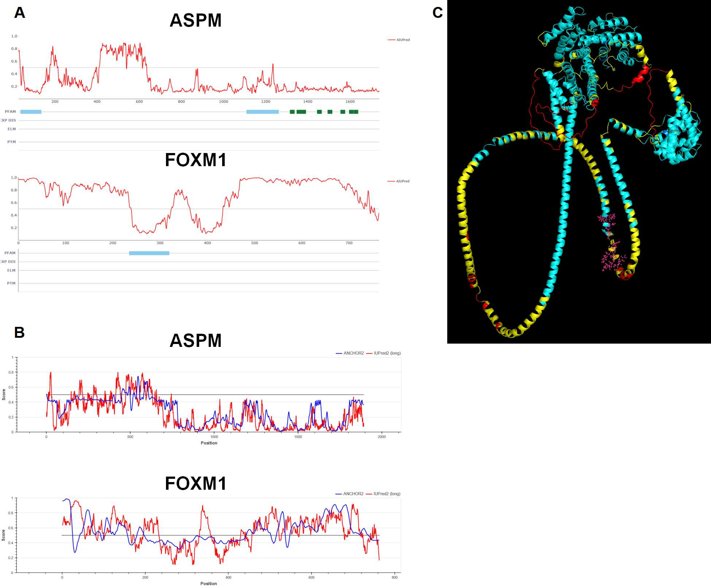 Fig. S2. FOXM1 interacts and forms dynamic condensates with ASPM. Related to Figure 2.
- Predicting the IDRs of ASPM and FOXM1 by AIUPred in ANCHOR2 website.
- Predicting the IDRs and disordered binding regions of ASPM and FOXM1 by IUPred2A and ANCHOR2.
- Predicted structure of ASPM without N-terminal IDR by AlphaFold2. Model Confidence: Blue, 90 > pLDDT > 70; Yellow, 70 > pLDDT > 50; Red, pLDDT < 50. Rose-red cloud indicates amino acid residues of ASPM that should interact with DNA binding domain of FoxM1 in Figure 1F.
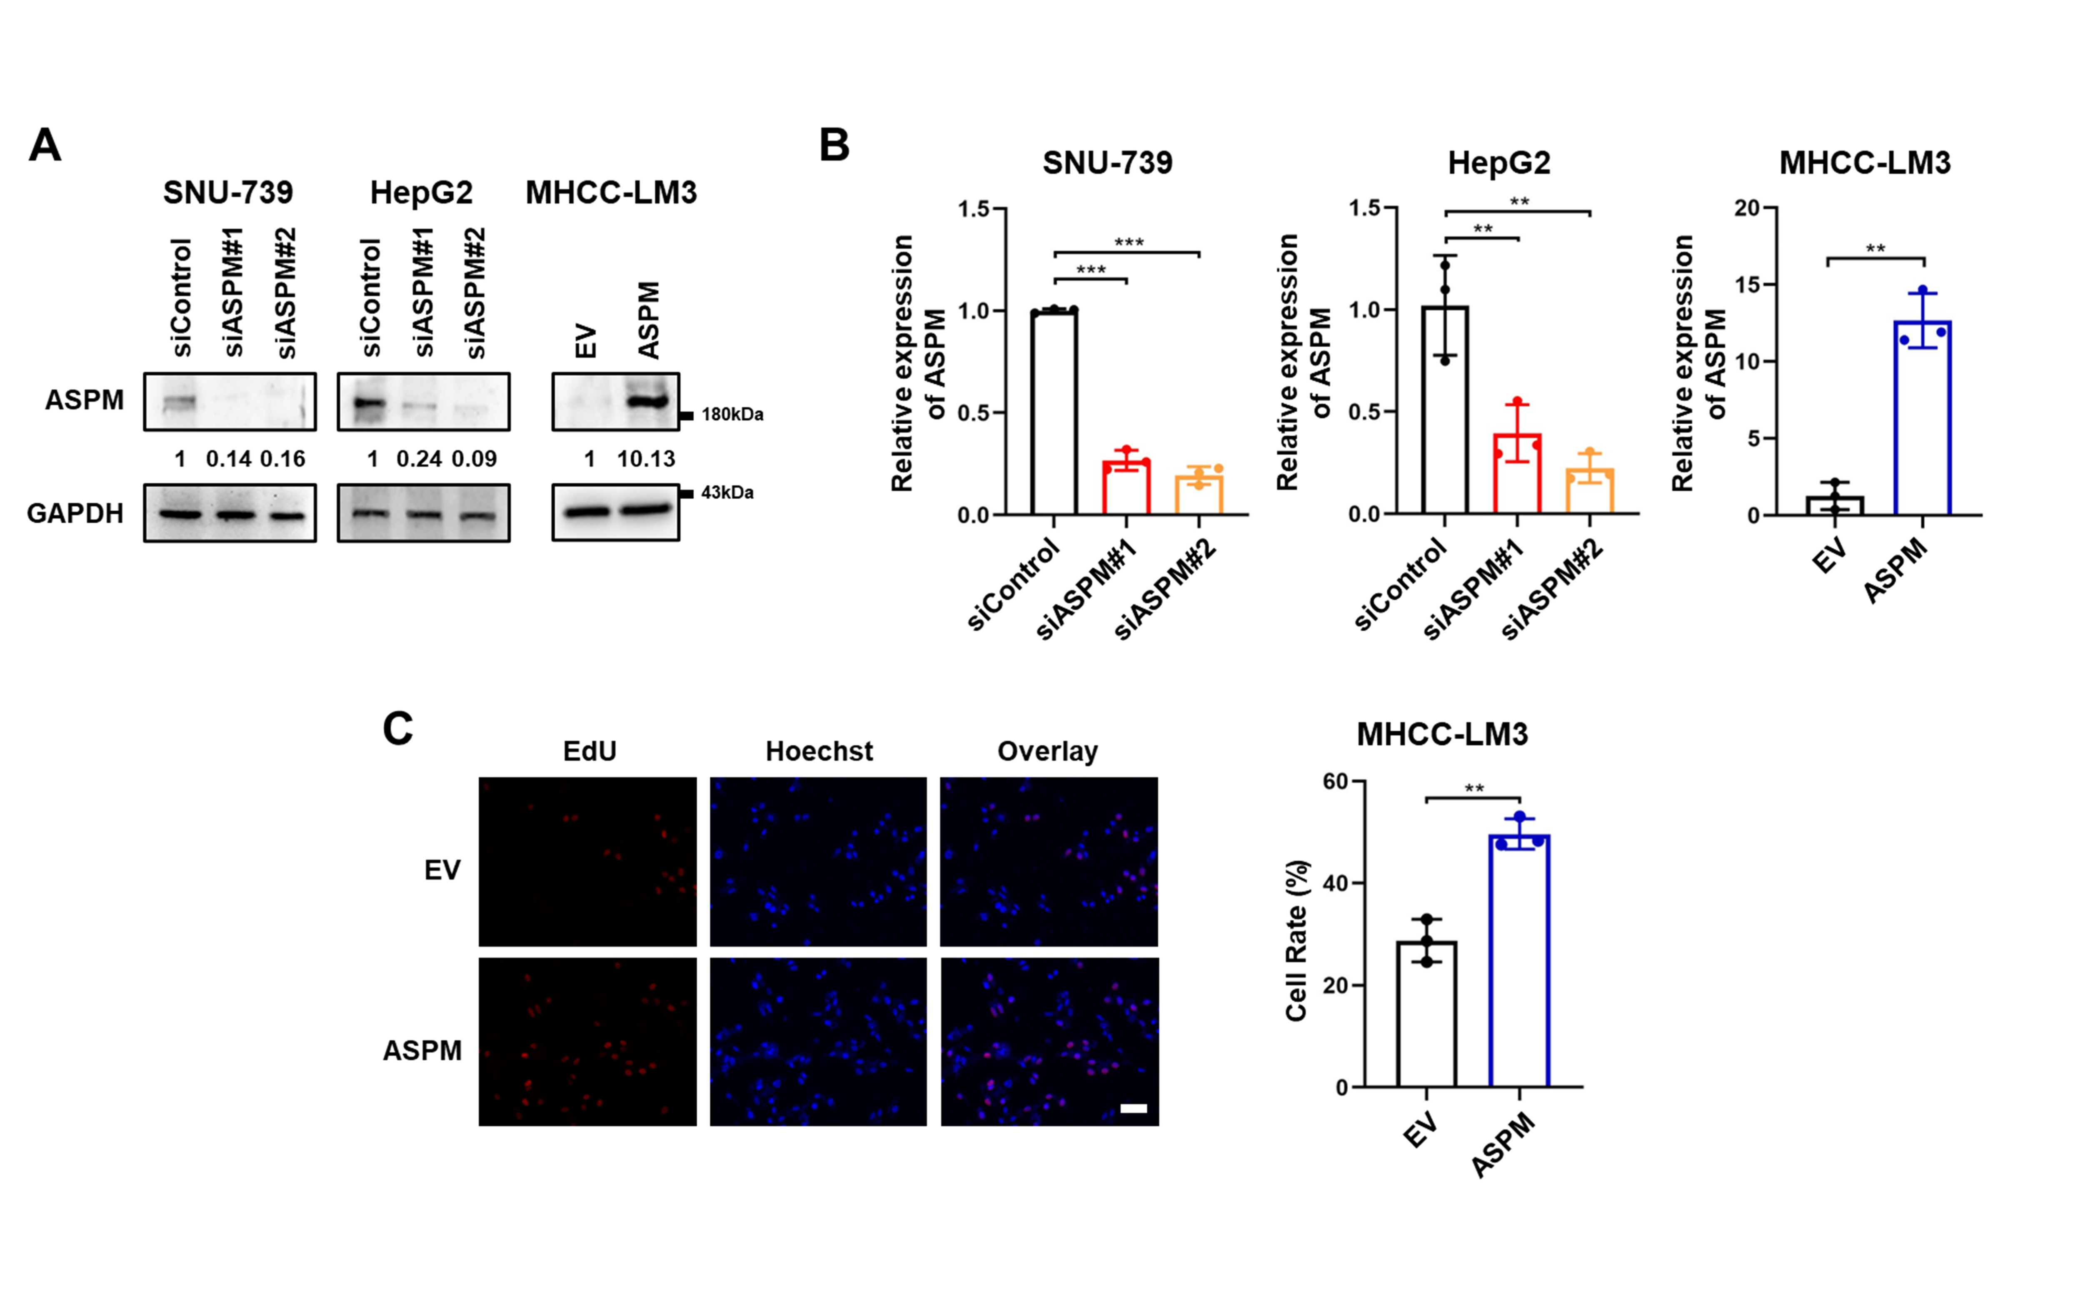
Fig. S3. Decreased HCC cells proliferation was caused by ASPM silencing. Related to Figure 4.
- ASPM-targeted siRNAs or expression plasmids were transfected into the HCC cell line SNU-739, HepG2 and MHCC-LM3. ASPM expression levels were detected by Western blot.
- The qRT-PCR assay was performed to detect the mRNA expression of ASPM in ASPM-knockdown or over-expressed cell lines. The data were presented as the mean ± SD of three independent experiments. The significance was analyzed by one-way ANOVA (left and middle) and student’s t-test (right). **p < 0.01, ***p < 0.001.
- Cell proliferation of HCC cells was detected by using EdU staining assay. The cell rate was the ratio of the number of EdU-stained cells to the total cells. The data were presented as the mean ± SD of three independent experiments. The significance was analyzed by student’s t-test. *p < 0.05. The scale bar is 50 μm.

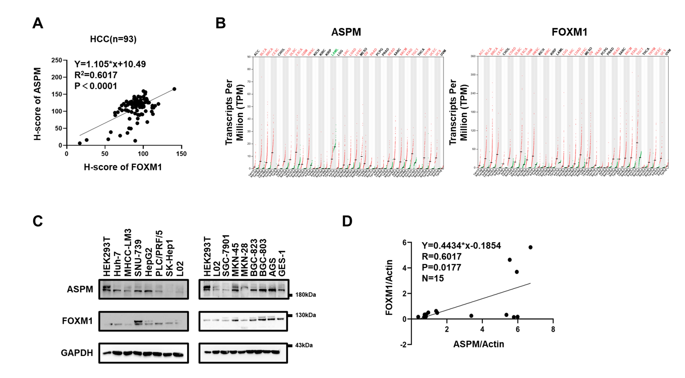 Fig. S4. ASPM and FOXM1 have positive correlation in multiple cancers. Related to Figure 6.
- The correlation of ASPM and FOXM1 was analyzed by linear regression analysis. The H-scores were from immunohistochemical staining samples in supplementary Figure 1A.
- The gene expression profile of ASPM (left) and FOXM1 (right) in all tumor samples and paired normal tissues from the GEPIA platform.
- The expression of FOXM1 and ASPM in six hepatocellular carcinoma cell lines (Huh-7, MHCC-LM3, SNU-739, HepG2, PLC/PRF/5, SK-Hep1), six gastric cancer cell lines (SGC-7901, MKN-45, MKN-28, BGC-823, BGC-803, AGS), a human hepatocyte cell line (L02), a human gastric mucosal epithelial cell line (GES-1) and a human embryonic kidney epithelial cell line (HEK293T).
- The correlation of ASPM and FOXM1 was analyzed by linear regression analysis in 15 cell lines detected in supplementary Figure 4C. The values were obtained by grayscale analysis of western blot results via Image J.

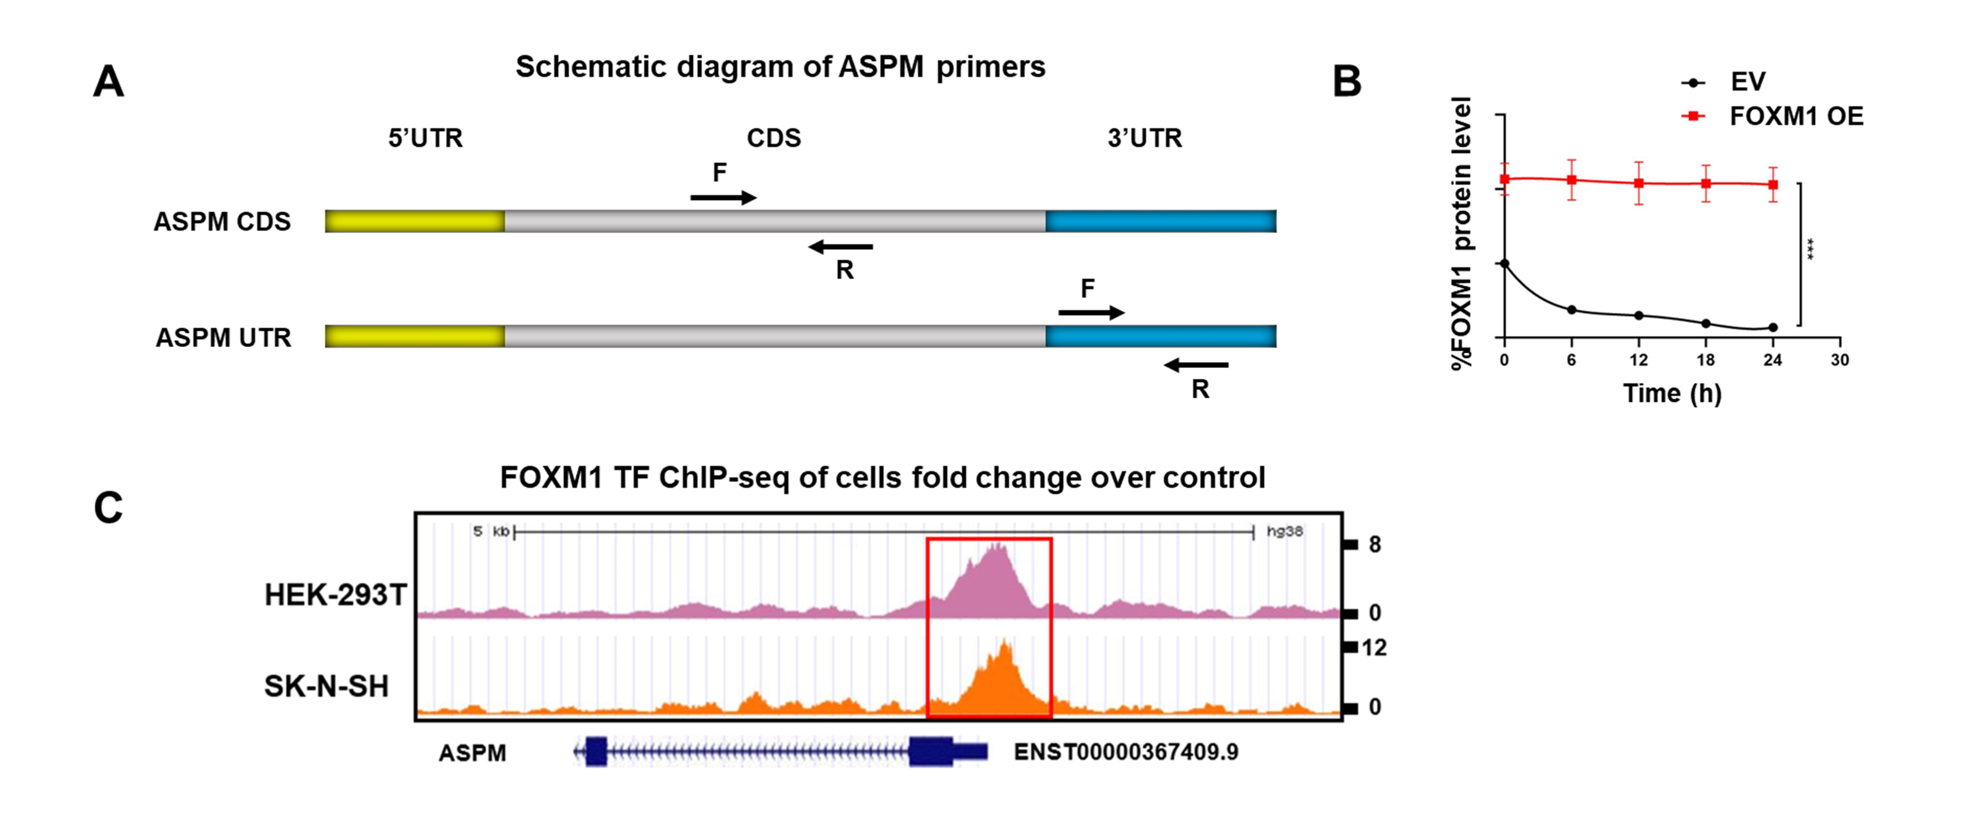 Fig. S5. FOXM1 transcriptionally activates ASPM in HCC cells. Related to Figure 7.
- Schematic diagram of ASPM primers at different positions in ASPM mRNA. CDS, coding sequence; UTR, untranslated region; F, forward; R, reverse.
- Statistical chart of Figure 7B. FOXM1 were quantified by Image J and graphed. The experiments were performed triplicates. And the line graph statistics was drawn according to the FOXM1 value of immunoblotting. The significance was analyzed by the student’s t-test. ***p < 0.001.
- Analysis of the ChIP-seq data of FOXM1 in HEK293T and SK-N-SH cells from the ENCODE database, respectively. The red box showed the binding peaks of FOXM1 on the ASPM genomic locus.

Table S1
Clinicopathological characteristics of 62 HCC patients

Patient NO. | Gender | Age | Stage | Location in liver | Pathology
1 | Male | 39 | II | right lobe | Highly differentiated HCC
2 | Male | 63 | I | right lobe | Moderately differentiated HCC
3 | Male | 70 | II | right lobe | Moderately differentiated HCC
4 | Male | 70 | I | liver | Highly differentiated HCC
5 | Male | 52 | II | liver | Moderately differentiated HCC
6 | Male | 44 | II | liver | Moderately differentiated HCC
7 | Female | 52 | II | superior segment of right anterior lobe | Moderately differentiated HCC
8 | Male | 59 | II | liver | Moderately differentiated HCC
9 | Male | 41 | I | left lobe | Highly differentiated HCC
10 | Male | 71 | II | right lobe | Highly/Moderately differentiated HCC
11 | Male | 61 | II | liver | Moderately differentiated HCC
12 | Male | 48 | II | liver | Moderately differentiated HCC
13 | Male | 41 | II | liver | Moderately differentiated HCC
14 | Male | 59 | II | right posterior lobe | HCC
15 | Male | 64 | II | right lobe | Moderately differentiated HCC
16 | Female | 64 | II | right lobe | HCC
17 | Male | 43 | III | right lobe | HCC
18 | Male | 34 | III | liver | HCC
19 | Male | 54 | I | liver | HCC
20 | Male | 34 | II | right posterior lobe | HCC
21 | Male | 53 | I | liver | HCC
22 | Male | 53 | II | liver | Moderately differentiated HCC
23 | Male |  | II | right lobe | HCC
24 | Male | 34 | II | left lobe | HCC
25 | Female | 36 | II | right lobe | Moderately differentiated HCC
26 | Female | 31 | II | right lobe | Moderately differentiated HCC
27 | Male | 55 | II | left lobe | Moderately differentiated HCC
28 | Male | 67 | II | right lobe | Moderately differentiated HCC
29 | Male | 51 | II | caudate lobe | Moderately differentiated HCC
30 | Female | 51 | III | liver | Moderately/Poorly differentiated HCC
31 | Male | 66 | II | middle lobe | Moderately differentiated HCC
32 | Male | 44 | III | left lobe | Moderately/Poorly differentiated HCC
33 | Male | 54 | II | liver | Moderately differentiated HCC
34 | Female | 72 | III | liver | Poorly differentiated HCC
35 | Male | 65 | I | liver | Highly differentiated HCC
36 | Male | 65 | II | liver | HCC
37 | Male | 70 | I | liver | Highly differentiated HCC
38 | Male | 43 | II | liver | Moderately differentiated HCC
39 | Male | 33 | III | left lobe | Poorly differentiated HCC
40 | Male | 52 | III | liver | Poorly differentiated HCC
41 | Male | 55 | II | liver | Moderately differentiated HCC
42 | Male | 58 | III | liver | Moderately differentiated HCC
43 | Male | 58 | II | liver | Moderately/Poorly differentiated HCC
44 | Male | 50 | II | liver | Moderately differentiated HCC
45 | Male | 27 | II | liver | Moderately differentiated HCC
46 | Female | 55 | II | left lobe | Poorly differentiated HCC
47 | Male | 73 | II | right anterior lobe | Highly/Moderately differentiated HCC
48 | Male | 54 | I | right lobe | Highly differentiated HCC
49 | Male | 44 | III | right lobe | Moderately/Poorly differentiated HCC
50 | Male | 59 | II | right femur | Moderately differentiated HCC
51 | Male | 72 | I | liver | Highly differentiated HCC
52 | Female | 38 |  | liver | HCC
53 | Male | 48 | II | liver | HCC
54 | Male | 45 | II | liver | Moderately differentiated HCC
55 | Female |  | II | liver | Highly/Moderately differentiated HCC
56 | / | / | I | right lobe | Highly differentiated HCC
57 | Male | 63 | II | left lobe | Moderately differentiated HCC
58 | Male | 46 | III | liver | HCC
59 | Male | 66 | I | liver | Highly differentiated HCC
60 | Male | 45 | I | right lobe | Highly differentiated HCC
61 | Male | 58 | I | liver | Highly differentiated HCC
62 | Male | 48 | I | liver | Highly/Moderately differentiated HCC

Table S2
Numbers of different intermolecular forces between indicated proteins and FOXM1. Data were from Protein-Ligand Interaction Profiler.

Gene symbol | Hydrogen Bonds | Salt Bridges | Hydrophobic Interactions
ASPM | 33 | 13 | 4
CDC27 | 23 | 12 | 3
PHF20L1 | 23 | 9 | 3
ZFP91  MORC3 | 22  19 | 18  12 | 2  6

Table S3
Docking analysis of ASPM and FOXM1 by Protein-Ligand Interaction Profiler

ID of donor atom | ID of acceptor atom
813[O3]  816 [Nam]  825 [O3]  2301 [O3]  4401 [Nam]  4429 [Nam]  4442 [Nam]  264 [O3]  1156 [Nam]  2316 [Npl]  1188 [Nam]  1194 [O3]  469 [Ng+]  476 [Nar]  2295 [Npl]  501 [O3]  4694 [Nam]  4700 [Nam]  4709 [Nam]  2096 [O3]  4771 [Nam]  4791 [Nam]  7127 [Ng+]  2421 [O3]  7139 [Nam]  2403 [O3]  12899 [Nam]  12938 [N3]  12964 [Nam]  2198 [O3]  15371 [O3]  15395 [Nam]  15426 [Ng+] | 2218 [O3]  2239 [O2]  2260 [O2]  4383 [O2]  2300 [O2]  2342 [O2]  2342 [O2]  2137 [O3]  2279 [O3]  1187 [O2]  2288 [Nar]  2280 [O2]  2172 [Nar]  2211 [O2]  1220 [N2]  2176 [O3]  2014 [O3]  2033 [O2]  2032 [O3]  4770 [O2]  2096 [O3]  2115 [O3]  2421 [O3]  7125 [Ng+]  2421 [O3]  7159 [O2]  2259 [O3]  2228 [O2]  2238 [O3]  13027 [O3]  2382 [O2]  2404 [O2]  2362 [O3]

Table S4
Manders' Colocalization Coefficients (MCC)

Figure | M1 | M2
Figure1E | 0.881 | 0.697
Figure2A | 0.845 | 0.863
Figure2F | 0.929 | 0.913
 | 0.479 | 0.389
 | 0.627 | 0.560
 | 0.427 | 0.469
 | 0.411 | 0.469
 | 0.483 | 0.400
FigureS1D up | 0.77 | 0.674
FigureS1D down | 0.734 | 0.699

Table S5
Sequences of shRNA.

Target |  | Sequences
shASPM-1 |  | CCGGGCCGTTTGTTTACTTCTGAAACTCGAGTTTCAGAAGTAAACAAACGGCTTTTTG
shASPM-2 |  | CCGGATGCTAACAAGCAGGTTAATTCTCGAGAATTAACCTGCTTGTTAGCATTTTTTG
shFOXM1-1 |  | CCGGGCCAATCGTTCTCTGACAGAACTCGAGTTCTGTCAGAGAACGATTGGCTTTTTG
shFOXM1-2 |  | CCGGGCCCAACAGGAGTCTAATCAACTCGAGTTGATTAGACTCCTGTTGGGCTTTTTG

Sequences of siRNA.

Target | Sense | Antisense
siASPM#1 | GCUACUUUCAUCCAGUCUATT | UAGACUGGAUGAAAGUAGCTT
siASPM#2 | GCAGCAUGCCGUUUGUUUATT | UAAACAAACGGCAUGCUGCTT

Table S6
Primers used for qPCR.

Targets | Forward primer (5’-3’) | Reverse primer (5’-3’)
ASPM-CDS | TGCAGTGGGTGAACATGAAAA | CGAAGAGGGTGTTACCTCGTTT
FOXM1-CDS | ATACGTGGATTGAGGACCACT | TCCAATGTCAAGTAGCGGTTG
ASPM-UTR | ATGTAAACATTTTCAGTATG | TTTCATCTTATGACATATT
GAPDH-CDS | CGGCACCACCATGTACCCTG | ACACGGAGTACTTGCGCTCA

Table S7
Primers used for ChIP-qPCR.

Primer name | Forward primer (5’-3’) | Reverse primer (5’-3’)
Primer1 (+111~+117) | TGCGAGTTTATTGGGCTTGT | GATCCGGGACTTACGCTGA
Primer2 | TGGAAACCGCAATGATTACTACA | ACCCGGGGCTTAGAATTGAA
(-236~-230) | TGGAAACCGCAATGATTACTACA | ACCCGGGGCTTAGAATTGAA
Primer3 | GGCGGGGTATGCATATGAGA | ACCCGGGGCTTAGAATTGAA
(-260~-266) | GGCGGGGTATGCATATGAGA | ACCCGGGGCTTAGAATTGAA
Primer4 | TGAGTCCCTGCTATGTTGTCA | GCATACCCCGCCCAGAATTA
(-374~-368) | TGAGTCCCTGCTATGTTGTCA | GCATACCCCGCCCAGAATTA
Primer5 | GTCTCAAACCCCTGACCTCA | CACCTGAAGTTGGACCTTAACA
(-1354~-1348) | GTCTCAAACCCCTGACCTCA | CACCTGAAGTTGGACCTTAACA
Cyclin E1 | CCTTGGGAGTAGATAGTTGCCA | CATCCTGTGCCCGTTAGGAA
SOX2 | CCTTGAGCCCCTTTGCGG | CCATGCCTCCCCGTAAGAAG

